file S1: Detailed search strategies: 2
table S1: Detailed characteristics of included trials 5
table S2: GRADE evidence profiles (EP) of Guizhi Decoction associated formulas versus Western medicine 8
table S3: GRADE evidence profiles (EP) of Guizhi Decoction associated formulas plus Western medicine versus Western medicine 11
table S4: GRADE evidence profiles (EP) of Guizhi Decoction associated formulas plus acupoint-based therapy versus Western medicine 13
table S5: GRADE evidence profiles (EP) of Guizhi Decoction associated formulas versus Guizhi Decoction associated formulas plus TCM external therapy 15
figure S1: The flow diagram of the study selection process 17
figure S2: Guizhi Decoction associated formulas versus Western medicine 18
Figure S3: Guizhi Decoction associated formulas versus Western medicine 19
Figure S4: Guizhi Decoction associated formulas versus Western medicine-continued 20
figure S5: Guizhi Decoction associated formulas plus Western medicine versus Western medicine 21
Figure S6: Guizhi Decoction associated formulas plus acupoint-based therapy versus Western medicine 22
figure S7: Guizhi Decoction associated formulas versus Guizhi Decoction associated formulas plus TCM external therapy 23

file S1: Detailed search strategies:
(1) Search strategy for Pubmed:
(allergic rhinitis[Title/Abstract] OR rhinallergosis[Title/Abstract] OR nasal allergy[Title/Abstract] OR AR[Title/Abstract] OR anaphylactic rhinitis[Title/Abstract]) AND (Guizhi decoction[Title/Abstract] OR Guizhi Tang[Title/Abstract] OR ramuli cinnamomi decoction[Title/Abstract] OR Cinnamon Twig Decoction[Title/Abstract] OR Guizhi[Title/Abstract] OR ramuli cinnamomi[Title/Abstract] OR Cinnamon Twig Decoction[Title/Abstract])
(2) Search strategy for Embase:
('allergic rhinitis':ab OR rhinallergosis:ab OR 'nasal allergy':ab OR AR:ab OR 'anaphylactic rhinitis':ab) AND ('Guizhi decoction':ab OR 'Guizhi Tang':ab OR 'ramuli cinnamomi decoction':ab OR 'Cinnamon Twig Decoction':ab OR Guizhi:ab OR 'ramuli cinnamomi':ab OR 'Cinnamon Twig Decoction':ab)
(3) Search strategy for Cochrane Library
#1 allergic rhinitis[Title Abstract Keyword]
#2 rhinallergosis
#3 nasal allergy
#4 AR
#5 anaphylactic rhinitis
#6 #1 OR #2 OR #3 OR #4 OR #5
#7 Guizhi decoction
#8 Guizhi Tang
#9 ramuli cinnamomi decoction
#10 Cinnamon Twig Decoction
#11 Guizhi
#12 ramuli cinnamomic
#13 Cinnamon Twig Decoction
#14 #7 OR #8 OR #9 OR #10 OR #11 OR #12 OR #13
#15 #6 AND #14
(4) Search strategy for the China National Knowledge Infrastructure (CNKI):
(SU='Bian ying xing bi yan' OR SU=' Guo min xing bi yan' OR SU='Qiu ti' OR SU='Bi qiu' OR SU='Hua fen zheng') AND (SU='Gui zhi tang' OR SU='Tiao he yin wei' OR SU=' Gui zhi ')
(5) Search strategy for the Wanfang Data Information Site:
Subject:(" Bian ying xing bi yan" or " Guo min xing bi yan" or " Qiu ti " or " Bi qiu " or " Hua fen zheng ") and Subject:(" Gui zhi tang " or " Tiao he yin wei " or " Gui zhi ")
(6) Search strategy for the Technology Periodical Database (VIP) and the SinoMed (CBM):
(M=( Bian ying xing bi yan OR Guo min xing bi yan OR Qiu ti OR Bi qiu OR Hua fen zheng)) AND (M=( Gui zhi tang OR Tiao he yin wei OR Gui zhi))

table S1: Detailed characteristics of included trials
Study | Age (E/C) | Duration (E/C) | Male (E/C) | Female (E/C) | Interventions (E/C) | Period of treatment (E/C) | Outcomes | Advert events (E/C)
Chen 2005 | 10-65 (41.60±4.36)/11-65 (39.45±7.12) Y | 1-20/1-18 Y | 35/16 | 21/14 | GZD (qd) + YPFP (qd)/ Terfenadine tablet (qd) | 1M | 1. Recovery rate; 2. Accumulative marked effective rate; 3. Accumulative effective rate; 4. Recurrence rate (3M/6M/1Y). | NR
Deng 2011 | 16-52 (31.6±9.78) Y | NR | 61 | 53 | CHGZD (bid) + Levocetirizine tablets (bid)/ Levocetirizine tablets (bid) | 20D | 1. Recovery rate; 2. Accumulative marked effective rate; 3. Accumulative effective rate; 4. Symptom score. | NR
Dong 2019 | 18-59 (33.13±8.51)/18-50 (35.33±9.86) Y | 0.5-40/0.5-20 Y | 15/14 | 15/16 | Heat-sensitive moxibustion (NR) + GZD (bid)/ Fluticasone propionate nasal spray (qd-bid) + Loratadine tablet (qd) | 20D | 1. Recovery rate (with follow-up for 2W); 2. Accumulative effective rate (with follow-up for 2W); 3. Nasal symptom and sign score; 4. RQLQ score. | Y/ Y
Feng 2004 a | 18-64 (37.74±14.57)/18-65 (38.17±14.21) Y | 0.6-11 (6.1±4.3)/1-27 (11.31±8.17) Y | 22/22 | 21/21 | Allergic rhinitis oral liquid (tid)/ Normal saline (oral administration) (tid) | 4W | 1. Accumulative marked effective rate; 2. Accumulative effective rate; 3. Serum IL-4; 4. Serum IgE. | NR
Feng 2004 b | 18-64 (37.74±14.57)/18-65 (39.87±14.36) | 0.6-11 (6.1±4.3)/0.6-10 (5.4±3.3) Y | 22/20 | 21/23 | Allergic rhinitis oral liquid (tid)/ Biyankang tablet (tid) | 4W | 1. Accumulative marked effective rate; 2. Accumulative effective rate; 3. Serum IL-4; 4. Serum IgE. | NR
Hu 2017 | 9-65 (37.6±9.9)/10-66 (38.8±9.1) Y | 0.6-11 (6.1±4.3)/0.6-10 (5.4±3.3) Y | 24/22 | 18/20 | GZPFD (qd) / GZPFD (qd) + Acupuncture (NR) + Moxibustion (NR) | 1W | 1. Recovery rate; 2. Accumulative effective rate; 3. Advert event rate. | NR
Hu 2018 | 39.20±11.71/38.10±12.22 Y | NR | 12/13 | 18/17 | HQGZWWD (bid) + CEZP (bid)/ Budesonide nasal spray (bid) | 30D | 1. Accumulative marked effective rate; 2. Accumulative effective rate; 3. Total score of TCM symptoms; 4. CD4+, CD25+ and Treg (Peripheral blood). | NR
Lei 2015 | 9-65 (36.1±15.1)/10-68 (37.0±15.2) Y | NR | 20/21 | 20/19 | GZPFD (tid) + Acupuncture (tid) + Moxibustion (tid)/ Ordinary Western medicine | NR | 1. Accumulative marked effective rate; 2. Accumulative effective rate. | NR
Lin 2010 | 18-45 (mean=29.1)/18-47 (men=30.4) Y | 3 (M)-11 (2.5)/4 (M)-12 (3.1) Y | 13/15 | 17/15 | XQGZD (qd) + Nuckear dairy injection (biw)/ Biyankang tablet (tid) + Nuckear dairy injection (biw) | 14D | 1. Recovery rate; 2. Accumulative effective rate. | N/ Y
Liu 2017 | 18-60 (41.0±8.9)/18-59 (42.0±9.6) Y | 2-15 (8.8±2.9)/2-14 (8.3±3.2) Y | 52/27 | 48/23 | GZD + CEZP + Acupoint application (1 per 3D) / Loratadine dispersible tablets (qd)+ Azostyne nasal spray (bid) | 2W | 1. Recovery rate; 2. Accumulative effective rate; 3. Advert event rate. | Y/ Y
Luo 2016 | 18-60 (31.5±5.4) Y | 1-5 (2.1±0.7) Y | 72 | 62 | GZHQD (qd) + Levocetirizine hydrochloride tablets (qd) + Budesonide nasal spray (qd)/ Levocetirizine hydrochloride tablets (qd) + Budesonide nasal spray (qd) | 60D | 1. Accumulative marked effective rate; 2. Accumulative effective rate; 3. T lymphocyte subsets (Peripheral blood); 4. IgA; 5. IgM; 6. IgG. | NR
Lv 2010 | 15-53 (mean=35)/14-55 (men=34) Y | 50 (D)-15 (mean=4.9)/2 (M)-16 (men=4.7) Y | 29/28 | 26/27 | GZLGMLD (qd)/ Loratadine tablet (qd) | 30D | 1. Recovery rate; 2. Accumulative marked effective rate; 3. Accumulative effective rate. | NR
Sun 2014 | 18-52 (37.13±11.11) Y | 1-12 (7.33±3.56) Y | 33 | 31 | GZD (bid)/ Desloratadine citrate disodium tablets (qd) | 14D | 1. Symptom score; 2. RQLQ score. | NR
Xu 2019 | 29-58 (37.28±16.38)/26-63 (36.91±17.05) Y | 8.35±1.47/8.41±1.50 Y | 17/15 | 13/15 | Levocetirizine hydrochloride dispersible tablets (qd) +GZD (bid) + Auricular point pressing (5-7/D) /Levocetirizine hydrochloride dispersible tablets (qd) | NR | 1. Recovery rate; 2. Accumulative marked effective rate; 3. Accumulative effective rate; 4. TCM symptom score. | NR
Xuan 2019 | 19-64 (34.05±9.84)/20-62 (33.87±10.05) Y | 1-5 (2.97±1.06)/1-4 (2.34±0.95) Y | 51/49 | 29/31 | GZD (qd) + MHFZXXD (qd)/ Loratadine tablet(bid) | 4W | 1. Recovery rate; 2. Accumulative effective rate; 3. TCM symptom score; 4. Recurrence rate (3M/6M). | NR
Ye 2015 | 18-65 (32.50±10.12)/18-65 (34.66±12.63) Y | 9-48 (27.86±9.30)/12-56 (29.73±10.56) M | 18/20 | 14/12 | GZD (bid) + MHFZXXD (bid) / Loratadine tablet (qd) + Transfer factor capsule (tid) | 28D | 1. Recovery rate; 2. Accumulative marked effective rate; 3. Accumulative effective rate; 4. Cases of disappearance of main symptoms; 5. Recurrence rate (3M/6M). | NR
You 2013 | 10-60/12-58 Y | NR | 21/25 | 19/15 | GZD (qd) + XSP (qd)/ Loratadine tablet (qd) + Transfer factor capsule (tid) | 28D | 1. Recovery rate; 2. Accumulative marked effective rate; 3. Accumulative effective rate; 4. Cases of disappearance of main symptoms; 5. Recurrence rate (3M/6M); 6. Advert event rate. | N/ Y
Zhang 2008 | 13-70 (mean=28)/5-70 (men=30) Y | 3-17 (mean=4.3)/2-16 (men=3.9) Y | 43/38 | 77/62 | YPFP + GZD + CEZP (oral administration only) (qd)/YPFP + GZD + CEZP (oral administration and nasal fumigation) (qd) | 45D | 1. Recovery rate; 2. Accumulative effective rate. | NR
Zhang 2015 | 17-49 (mean=36)/18-48 (men=38) Y | 2-7/2-6 Y | 43/40 | 22/20 | YPFP (bid) + GZD (bid)/ Terfenadine tablet (bid) | 20D | 1. Accumulative marked effective rate; 2. Accumulative effective rate. | NR
Zhang 2017 | 34.1±3.9/33.7±4.1 Y | 3.6±0.7/3.4±0.9 Y | 33/31 | 24/26 | CHGZD (bid) + Cetirizine hydrochloride tablets (qd)/ Cetirizine hydrochloride tablets(qd) | 3M | 1. Recovery rate; 2. Accumulative marked effective rate; 3. Accumulative effective rate; 4. Clinical symptom disappearance time; 5. Score of symptoms and signs; 6. Inflammatory cytokine level. | NR
Zhao 2005 | 8-43 (mean=21.7) Y | A* | 50 | 34 | GZPFD (qd) + Acupuncture (qd) + Moxibustion (qd)/ Ordinary Western medicine* | NR | Scores of symptoms and signs. | NR
Zhou 2017 | 15-65 (28.5±7.0)/15-64 (30.0±5.4) Y | 1-28/10 (M)-29 Y | 38/36 | 22/24 | HQGZWWD (tib)/ Loratadine tablet (qd) | 30D | 1. Accumulative marked effective rate; 2. Accumulative effective rate; 3. Total score of symptoms and signs; 4.IL-6; 5. IL-8. | Y/ Y
Zhu 2015 | 13-68 (41.2±3.6)/21-71 (42.6±4.2) Y | 3(W)-10 (6.2±2.8)/4(W)-11 (6.8±2.5) Y | 26/23 | 14/17 | CHGZD (bid) + Cetirizine tablets (qd)/ Cetirizine tablets (qd) | 20D | 1. Accumulative marked effective rate; 2. Accumulative effective rate; 3. IgE; 4. Symptom score. | Y/ Y
Y: Yeay; M: Month; W: Week; D: Day; A*: 6M-1Y: 20, 1Y-2Y: 49, >2Y: 15; NR: Not reported; N: None; Y: Yes; GZD: Guizhi Decoction; YPFP: Yu-Ping-Feng Powder; CHGZD: Chaihu Guizhi Decoction; GZPFD: Guizhi-Ping-Feng Decoction; HQGZWWD: Huangqi Guizhi Wuwu Decoction; CEZP: Cang-Er-Zi Powder; XQGZD: Xinqi Guizhi Decoction; Guizhi and Longgu Muli Decoction: GZLGMLD; Mahuang Fuzi Xixin Decoction: MHFZXXD; Xingsu Powder: XSP; Ordinary Western medicine*: such as antihistamines and glucocorticoids; RQLQ: Rhinoconjunctivitis Quality of Life Questionnaire.

table S2: GRADE evidence profiles (EP) of Guizhi Decoction associated formulas versus Western medicine
Certainty assessment |  |  |  |  |  |  | No. of patients |  | Effect |  | Certainty | Importance
No. of studies | Design | Risk of bias | Inconsistency | Indirectness | Imprecision | Other considerations | GZDAF | WM | Relative  (95% CI) | Absolute  (95% CI) | Certainty | Importance
A1 - Recovery rate
5 | RCT | Serious | Not serious | Serious | Not serious | None | 137/263 (52.1%) | 71/237 (30.0%) | RR 1.67  (1.34 to 2.08) | 201 more per 1,000  (from 102 more to 324 more) | ⨁⨁◯◯  LOW | N/A
A1 - Accumulative marked improvement rate
9 | RCT | Serious | Not serious | Serious | Not serious | Publication bias | 254/461 (55.1%) | 135/430 (31.4%) | RR 1.73  (1.47 to 2.02) | 229 more per 1,000  (from 148 more to 320 more) | ⨁◯◯◯  VERY LOW | N/A
A1 - Accumulative effective rate
9 | RCT | Serious | Not serious | Serious | Not serious | None | 424/461 (92.0%) | 329/430 (76.5%) | RR 1.20  (1.13 to 1.27) | 153 more per 1,000  (from 99 more to 207 more) | ⨁⨁◯◯  LOW | N/A
A2 A3 A4 - Recurrence rate (3 months)
4 | RCT | Serious | Not serious | Serious | Not serious | None | 4/180 (2.2%) | 39/137 (28.5%) | RR 0.14  (0.04 to 0.47) | 245 fewer per 1,000  (from 273 fewer to 151 fewer) | ⨁⨁◯◯  LOW | N/A
A2 A3 A4 - Recurrence rate (6 months)
4 | RCT | Serious | Not serious | Serious | Not serious | None | 12/180 (6.7%) | 57/137 (41.6%) | RR 0.20  (0.10 to 0.44) | 333 fewer per 1,000  (from 374 fewer to 233 fewer) | ⨁⨁◯◯  LOW | N/A
A2 A3 A4 - Cases with main symptoms disappeared (subgroup 1)
1 | RCT | Serious | Serious | Not serious | Serious | None | 26/32 (81.3%) | 18/32 (56.3%) | RR 1.44  (1.02 to 2.05) | 247 more per 1,000  (from 11 more to 591 more) | ⨁◯◯◯  VERY LOW | N/A
A2 A3 A4 - Cases with main symptoms disappeared (subgroup 2)
1 | RCT | Serious | Serious | Not serious | Serious | None | 33/40 (82.5%) | 12/40 (30.0%) | RR 2.75  (1.68 to 4.51) | 525 more per 1,000  (from 204 more to 1,000 more) | ⨁◯◯◯  VERY LOW | N/A
CI: Confidence interval; RR: Risk ratio; GZDAF: Guizhi Decoction associated formulas; WM: Western medicine.

table S3: GRADE evidence profiles (EP) of Guizhi Decoction associated formulas plus Western medicine versus Western medicine
Certainty assessment |  |  |  |  |  |  | No. of patients |  | Effect |  | Certainty | Importance
No. of studies | Design | Risk of bias | Inconsistency | Indirectness | Imprecision | Other considerations | GZDAF+WM | WM | Relative  (95% CI) | Absolute  (95% CI) | Certainty | Importance
B1 - Recovery rate
2 | RCT | Serious | Not serious | Not serious | Not serious | None | 59/124 (47.6%) | 47/124 (37.9%) | RR 1.26  (0.94 to 1.68) | 99 more per 1,000  (from 23 fewer to 258 more) | ⨁⨁⨁◯  MODERATE | N/A
B1 - Accumulative marked improvement rate
4 | RCT | Serious | Not serious | Serious | Not serious | None | 136/240 (56.7%) | 120/240 (50.0%) | RR 1.13  (0.96 to 1.33) | 65 more per 1,000  (from 20 fewer to 165 more) | ⨁⨁◯◯  LOW | N/A
B1 - Accumulative effective rate
4 | RCT | Serious | Not serious | Serious | Not serious | None | 224/240 (93.3%) | 184/240 (76.7%) | RR 1.22  (1.13 to 1.32) | 169 more per 1,000  (from 100 more to 245 more) | ⨁⨁◯◯  LOW | N/A
CI: Confidence interval; RR: Risk ratio; GZDAF: Guizhi Decoction associated formulas; WM: Western medicine.

table S4: GRADE evidence profiles (EP) of Guizhi Decoction associated formulas plus acupoint-based therapy versus Western medicine
Certainty assessment |  |  |  |  |  |  | No. of patients |  | Effect |  | Certainty | Importance
No. of studies | Design | Risk of bias | Inconsistency | Indirectness | Imprecision | Other considerations | GZDAF+ABT | WM | Relative  (95% CI) | Absolute  (95% CI) | Certainty | Importance
C1 - Recovery rate
1 | RCT | Very serious | Serious | Not serious | Serious | None | 62/100 (62.0%) | 21/50 (42.0%) | RR 1.48  (1.03 to 2.12) | 202 more per 1,000  (from 13 more to 470 more) | ⨁◯◯◯  VERY LOW | N/A
C1 - Accumulative marked improvement (subgroup 1)
1 | RCT | Very serious | Serious | Serious | Serious | None | 6/30 (20.0%) | 10/30 (33.3%) | RR 0.60  (0.25 to 1.44) | 133 fewer per 1,000  (from 250 fewer to 147 more) | ⨁◯◯◯  VERY LOW | N/A
C1 - Accumulative marked improvement (subgroup 2)
1 | RCT | Very serious | Serious | Not serious | Serious | None | 25/40 (62.5%) | 15/40 (37.5%) | RR 1.67  (1.05 to 2.66) | 251 more per 1,000  (from 19 more to 623 more) | ⨁◯◯◯  VERY LOW | N/A
C1 - Accumulative effective rate (subgroup 1)
2 | RCT | Very serious | Not serious | Serious | Not serious | None | 118/130 (90.8%) | 69/80 (86.3%) | RR 1.05  (0.94 to 1.17) | 43 more per 1,000  (from 52 fewer to 147 more) | ⨁◯◯◯  VERY LOW | N/A
C1 - Accumulative effective rate (subgroup 2)
1 | RCT | Very serious | Serious | Not serious | Serious | None | 38/40 (95.0%) | 27/40 (67.5%) | RR 1.41  (1.12 to 1.77) | 277 more per 1,000  (from 81 more to 520 more) | ⨁◯◯◯  VERY LOW | N/A
CI: Confidence interval; RR: Risk ratio; GZDAF: Guizhi Decoction associated formulas; ABT: acupoint-based therapy; WM: Western medicine.

table S5: GRADE evidence profiles (EP) of Guizhi Decoction associated formulas versus Guizhi Decoction associated formulas plus TCM external therapy
Certainty assessment |  |  |  |  |  |  | No. of patients |  | Effect |  | Certainty | Importance
No. of studies | Design | Risk of bias | Inconsistency | Indirectness | Imprecision | Other considerations | GZDAF | GZDAF+TCMET | Relative  (95% CI) | Absolute  (95% CI) | Certainty | Importance
C1 - Recovery rate
1 | RCT | Very serious | Serious | Not serious | Serious | None | 62/100 (62.0%) | 21/50 (42.0%) | RR 1.48  (1.03 to 2.12) | 202 more per 1,000  (from 13 more to 470 more) | ⨁◯◯◯  VERY LOW | N/A
C1 - Accumulative marked improvement (subgroup 1)
1 | RCT | Very serious | Serious | Serious | Serious | None | 6/30 (20.0%) | 10/30 (33.3%) | RR 0.60  (0.25 to 1.44) | 133 fewer per 1,000  (from 250 fewer to 147 more) | ⨁◯◯◯  VERY LOW | N/A
C1 - Accumulative marked improvement (subgroup 2)
1 | RCT | Very serious | Serious | Not serious | Serious | None | 25/40 (62.5%) | 15/40 (37.5%) | RR 1.67  (1.05 to 2.66) | 251 more per 1,000  (from 19 more to 623 more) | ⨁◯◯◯  VERY LOW | N/A
C1 - Accumulative effective rate (subgroup 1)
2 | RCT | Very serious | Not serious | Serious | Not serious | None | 118/130 (90.8%) | 69/80 (86.3%) | RR 1.05  (0.94 to 1.17) | 43 more per 1,000  (from 52 fewer to 147 more) | ⨁◯◯◯  VERY LOW | N/A
C1 - Accumulative effective rate (subgroup 2)
1 | RCT | Very serious | Serious | Not serious | Serious | None | 38/40 (95.0%) | 27/40 (67.5%) | RR 1.41  (1.12 to 1.77) | 277 more per 1,000  (from 81 more to 520 more) | ⨁◯◯◯  VERY LOW | N/A
CI: Confidence interval; RR: Risk ratio; GZDAF: Guizhi Decoction associated formulas; TCMET: TCM external therapy.

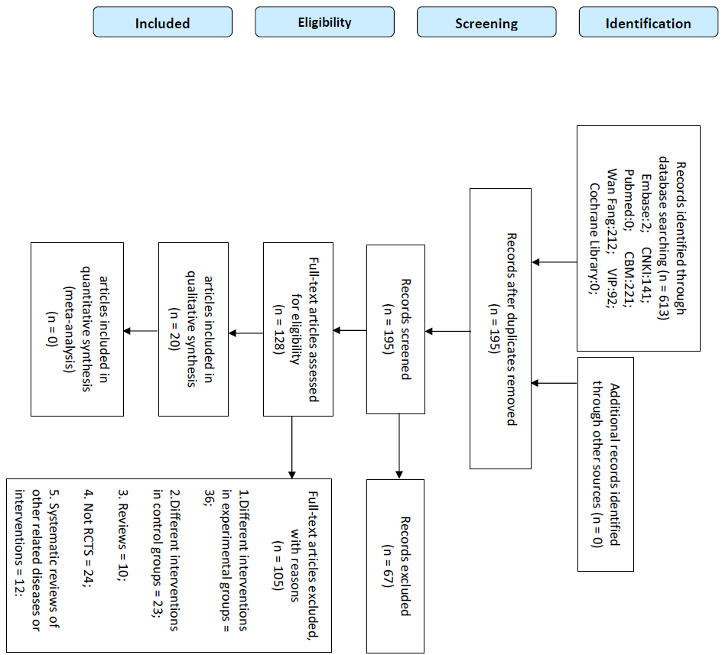
figure S1: The flow diagram of the study selection process
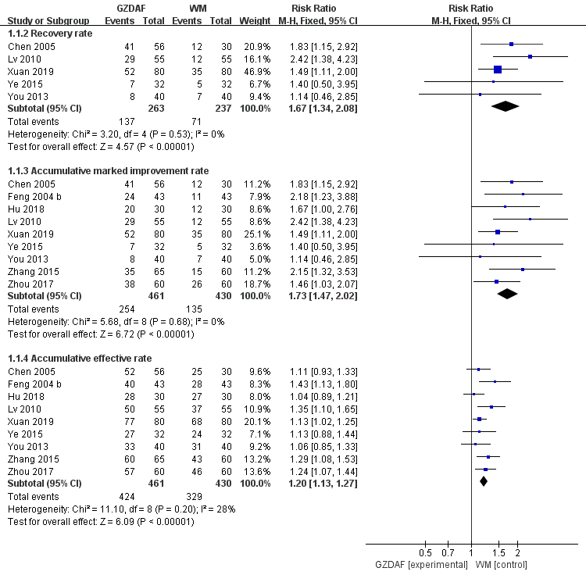
figure S2: Guizhi Decoction associated formulas versus Western medicine
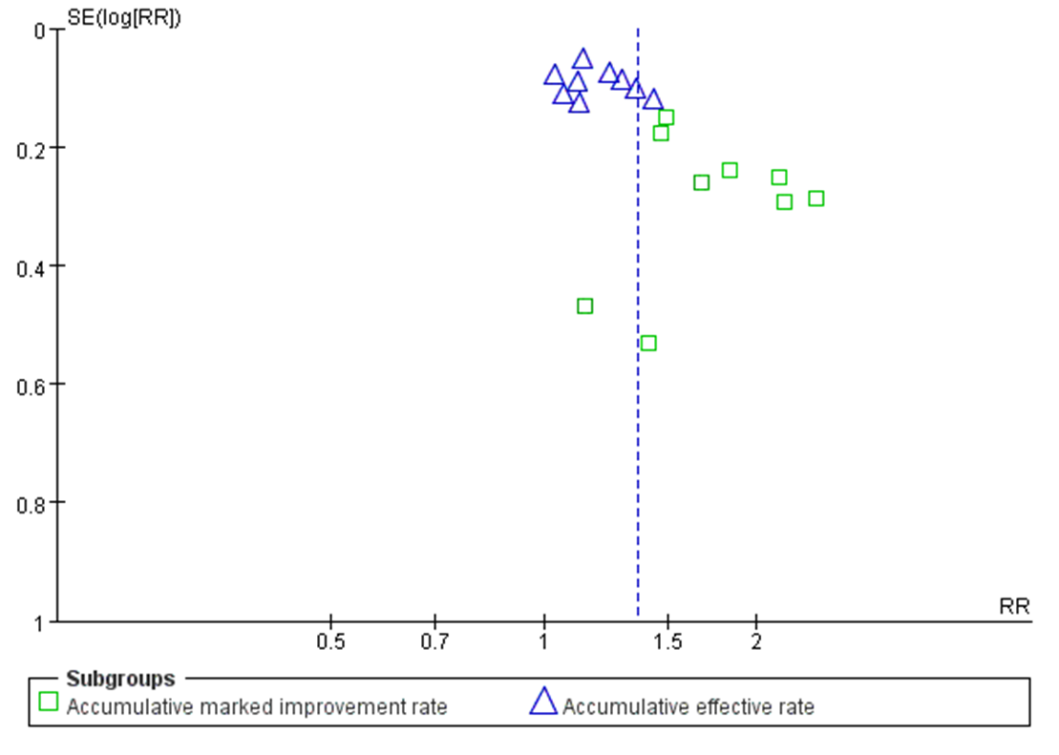
Figure S3: Guizhi Decoction associated formulas versus Western medicine

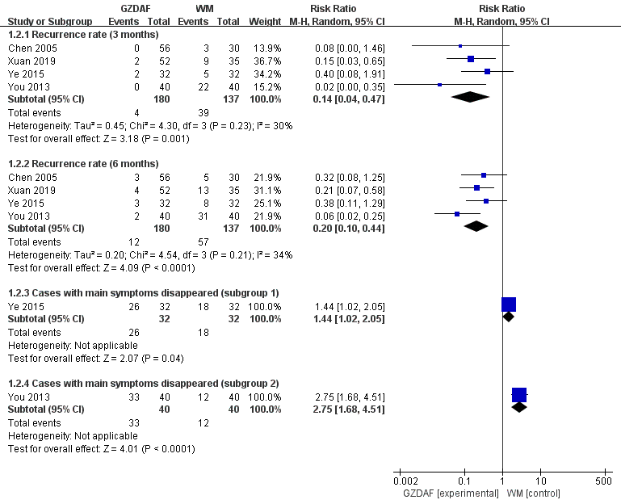
Figure S4: Guizhi Decoction associated formulas versus Western medicine-continued
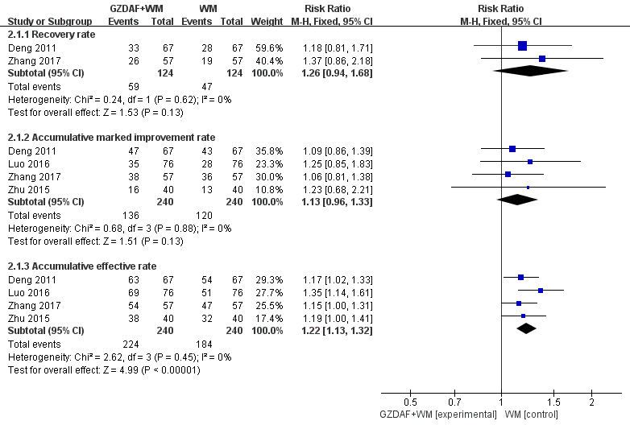
figure S5: Guizhi Decoction associated formulas plus Western medicine versus Western medicine
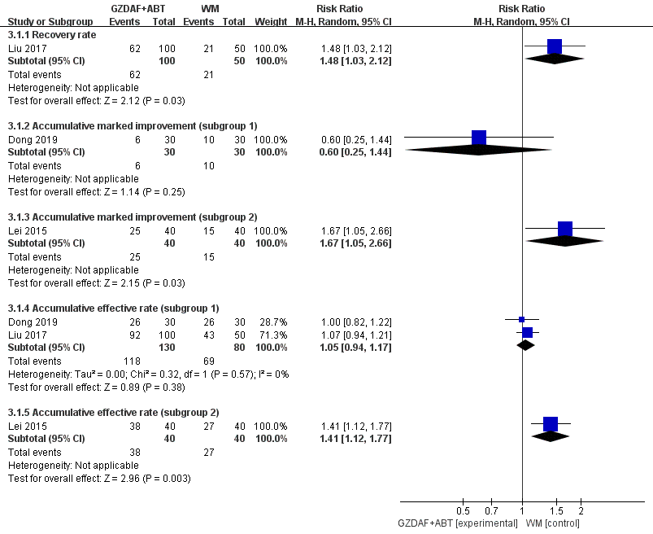
Figure S6: Guizhi Decoction associated formulas plus acupoint-based therapy versus Western medicine
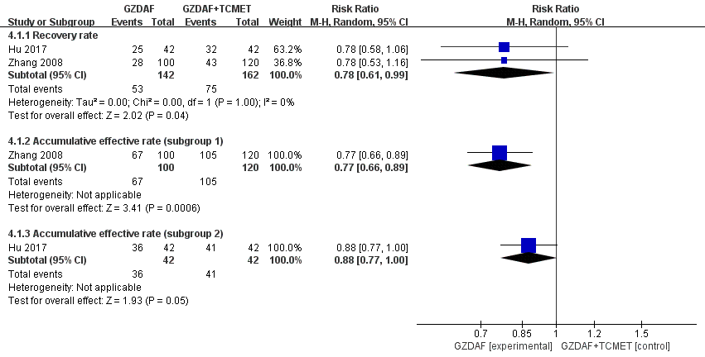
figure S7: Guizhi Decoction associated formulas versus Guizhi Decoction associated formulas plus TCM external therapy

