Supplementary Figures
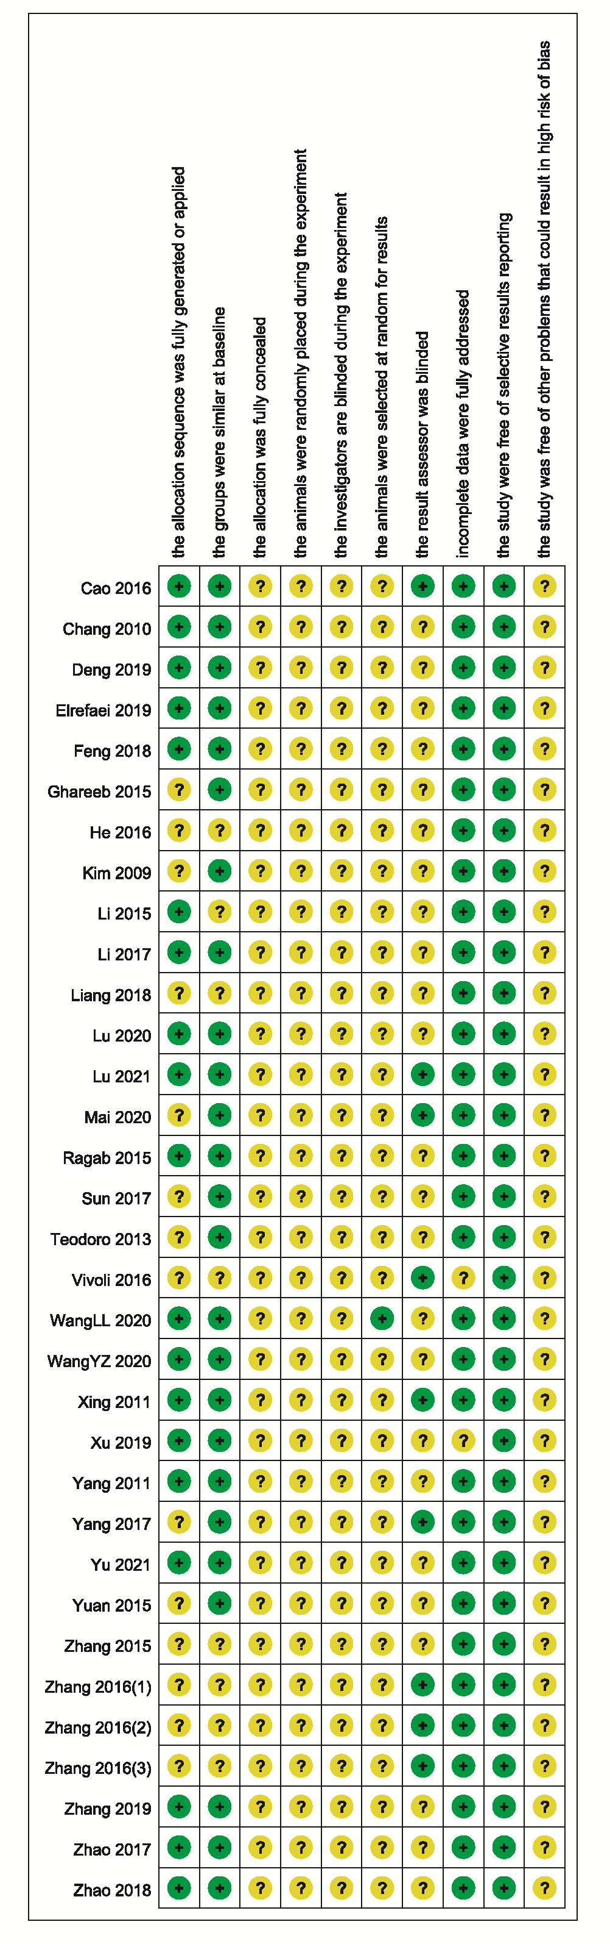

Supplementary Figure 1. Risk of bias summary of included studies.
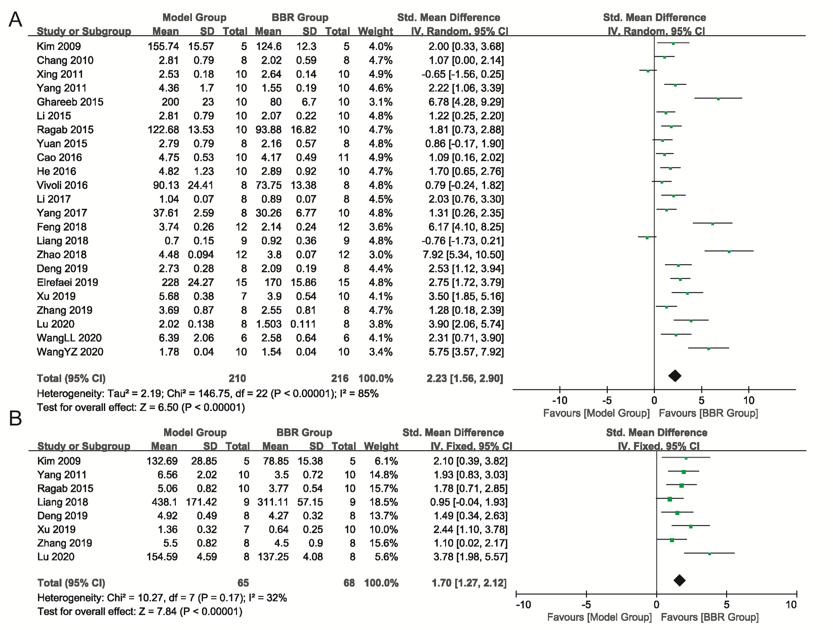
Supplementary Figure 2. Forest plot of comparison. (A) Blood TC; (B) Liver tissue TC; I² and P were taken as the heterogeneity test of the criterion. TC: total cholesterol.

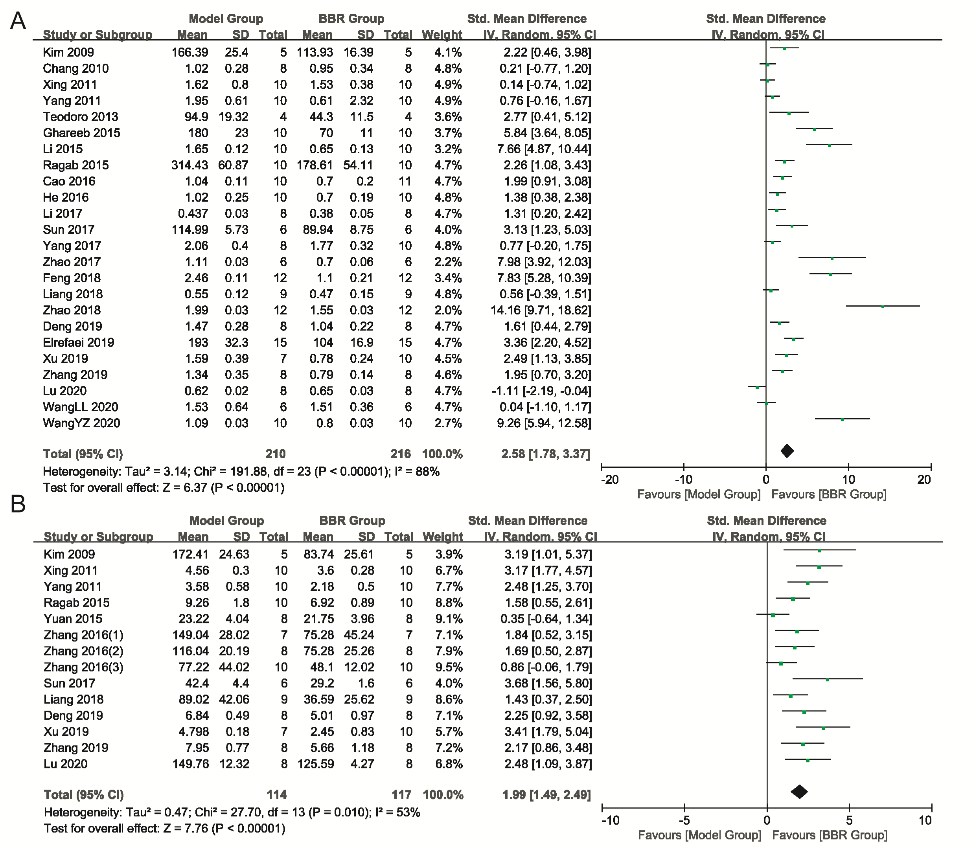
Supplementary Figure 3. Forest plot of comparison. (A) Blood TG; (B) Liver tissue TG; I² and P were taken as the heterogeneity test of the criterion. TG: triglycerides.

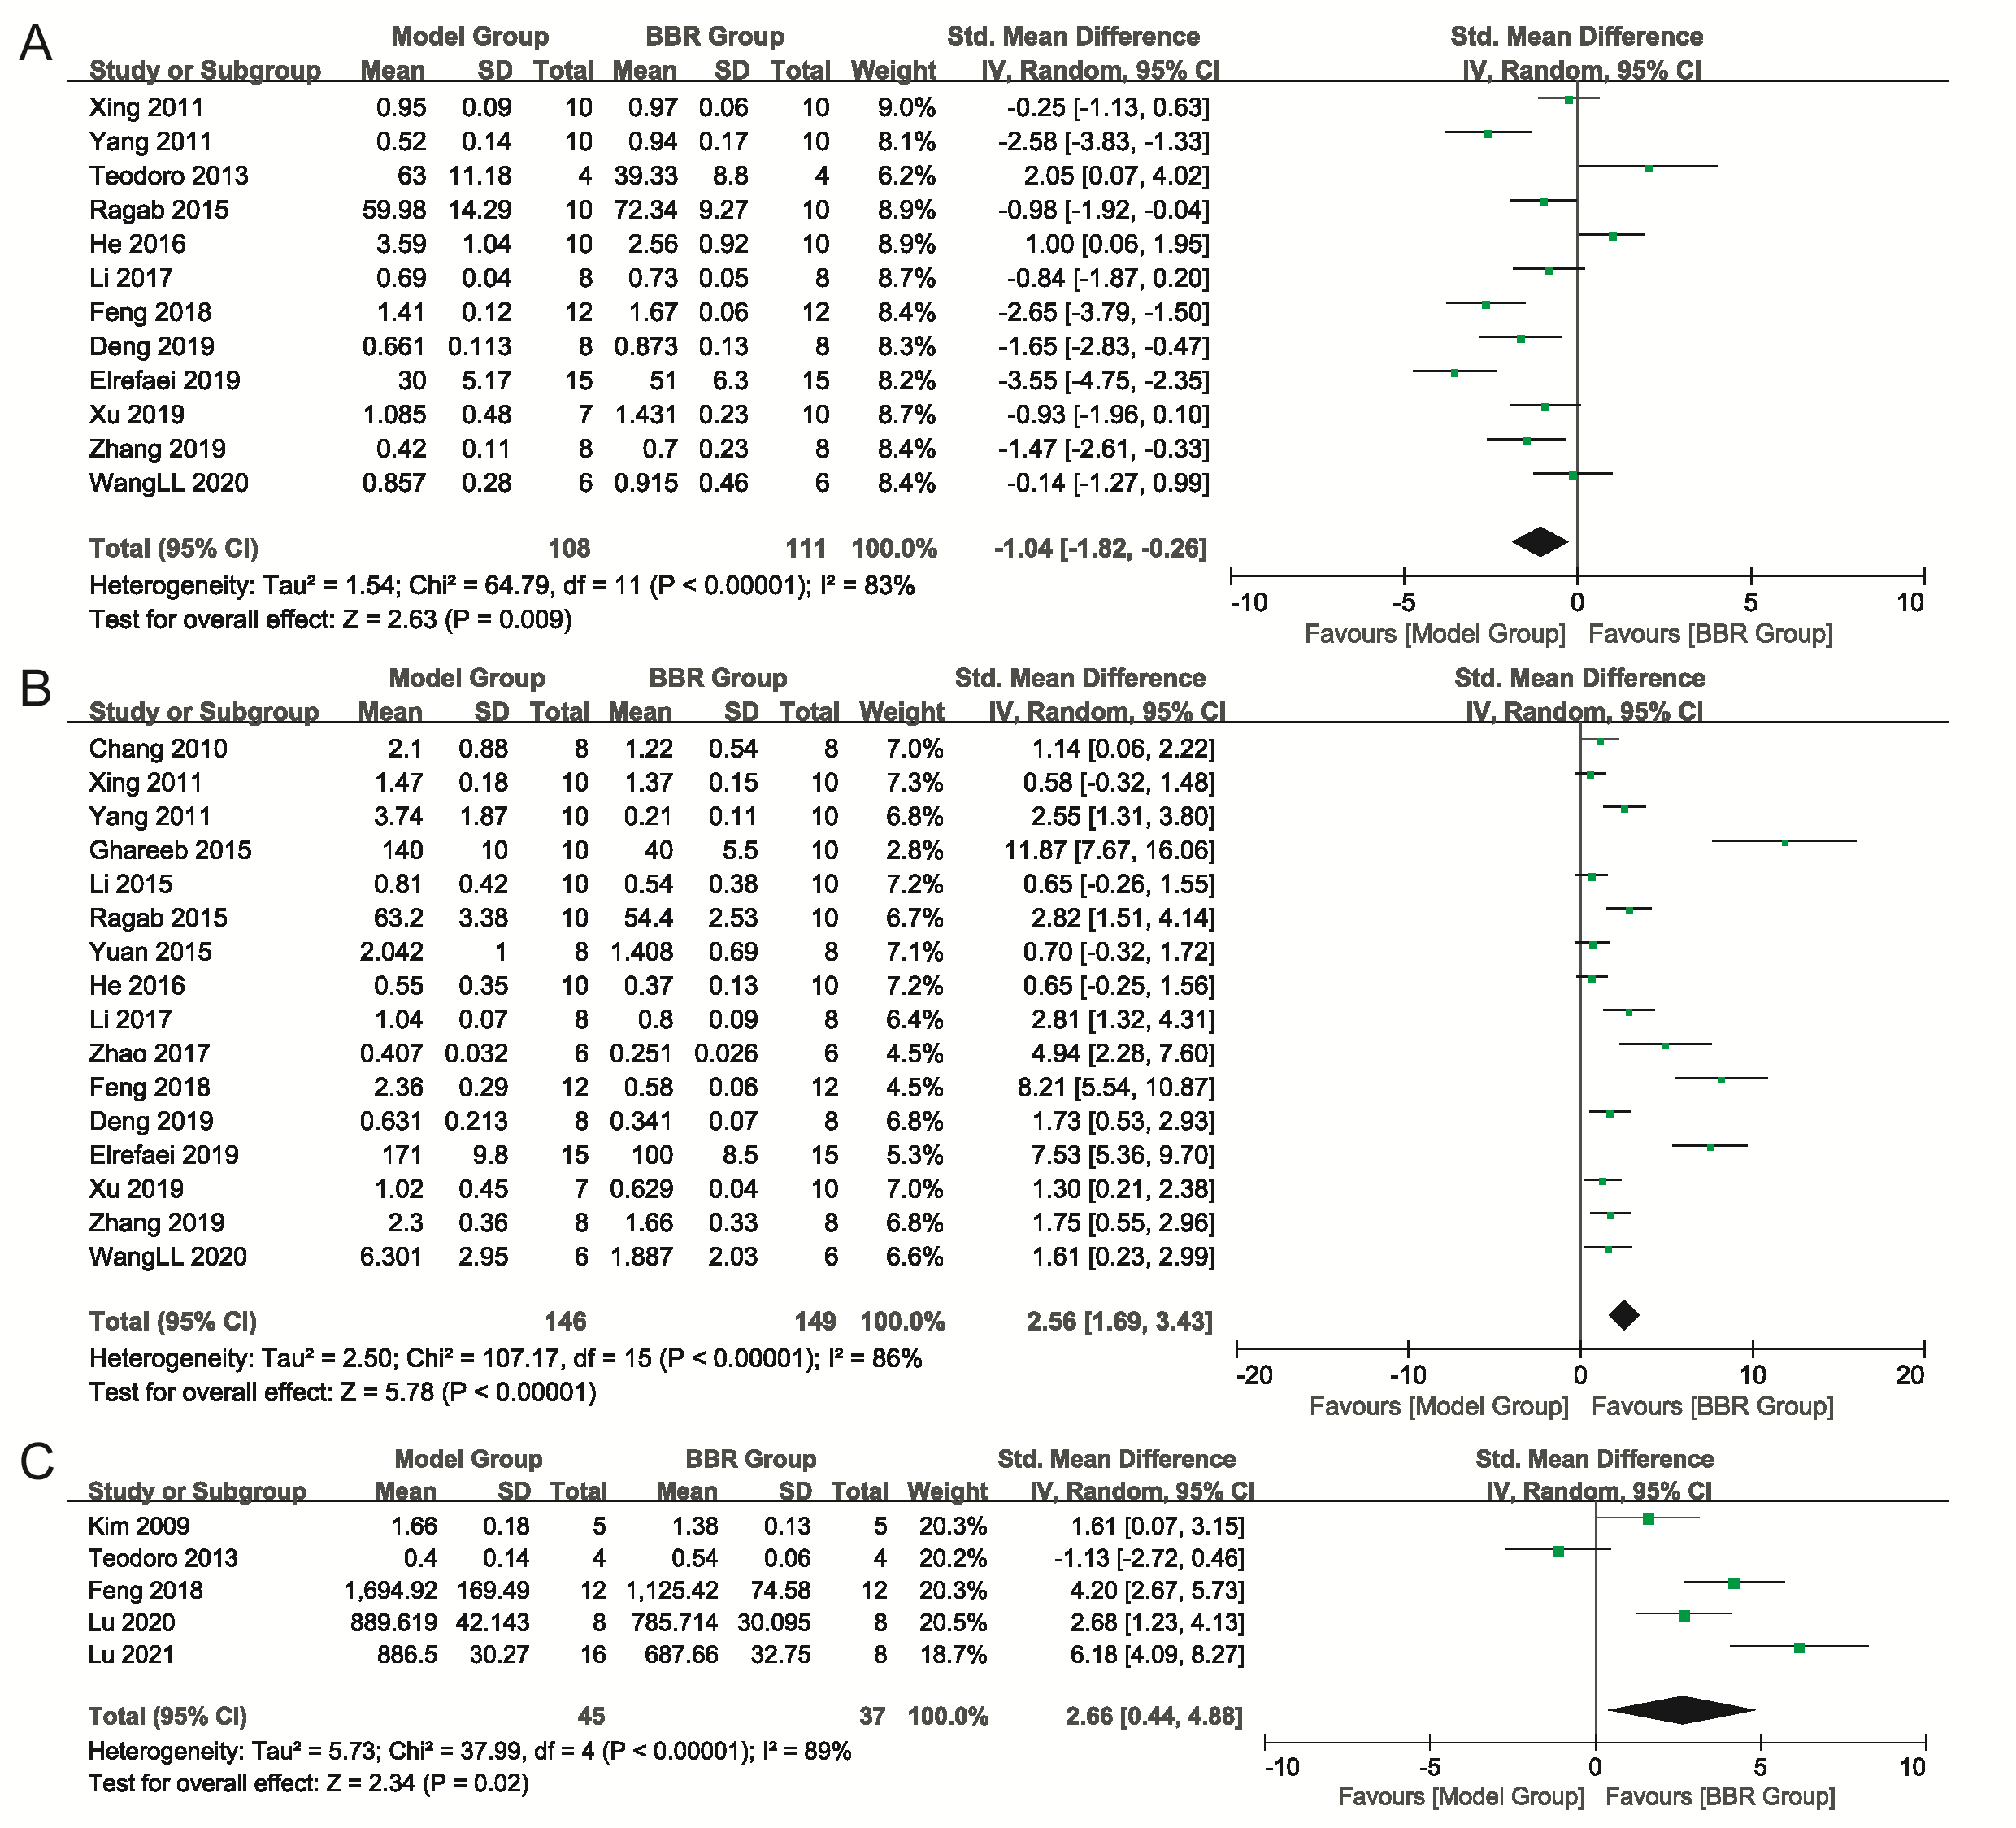
Supplementary Figure 4. Forest plot of comparison. (A) HDL-C; (B) LDL-C; (C) FFA; I² and P were taken as the heterogeneity test of the criterion. HDL-C: high-density lipoprotein cholesterol; LDL-C: low-density lipoprotein cholesterol; FFA: free fat acid.

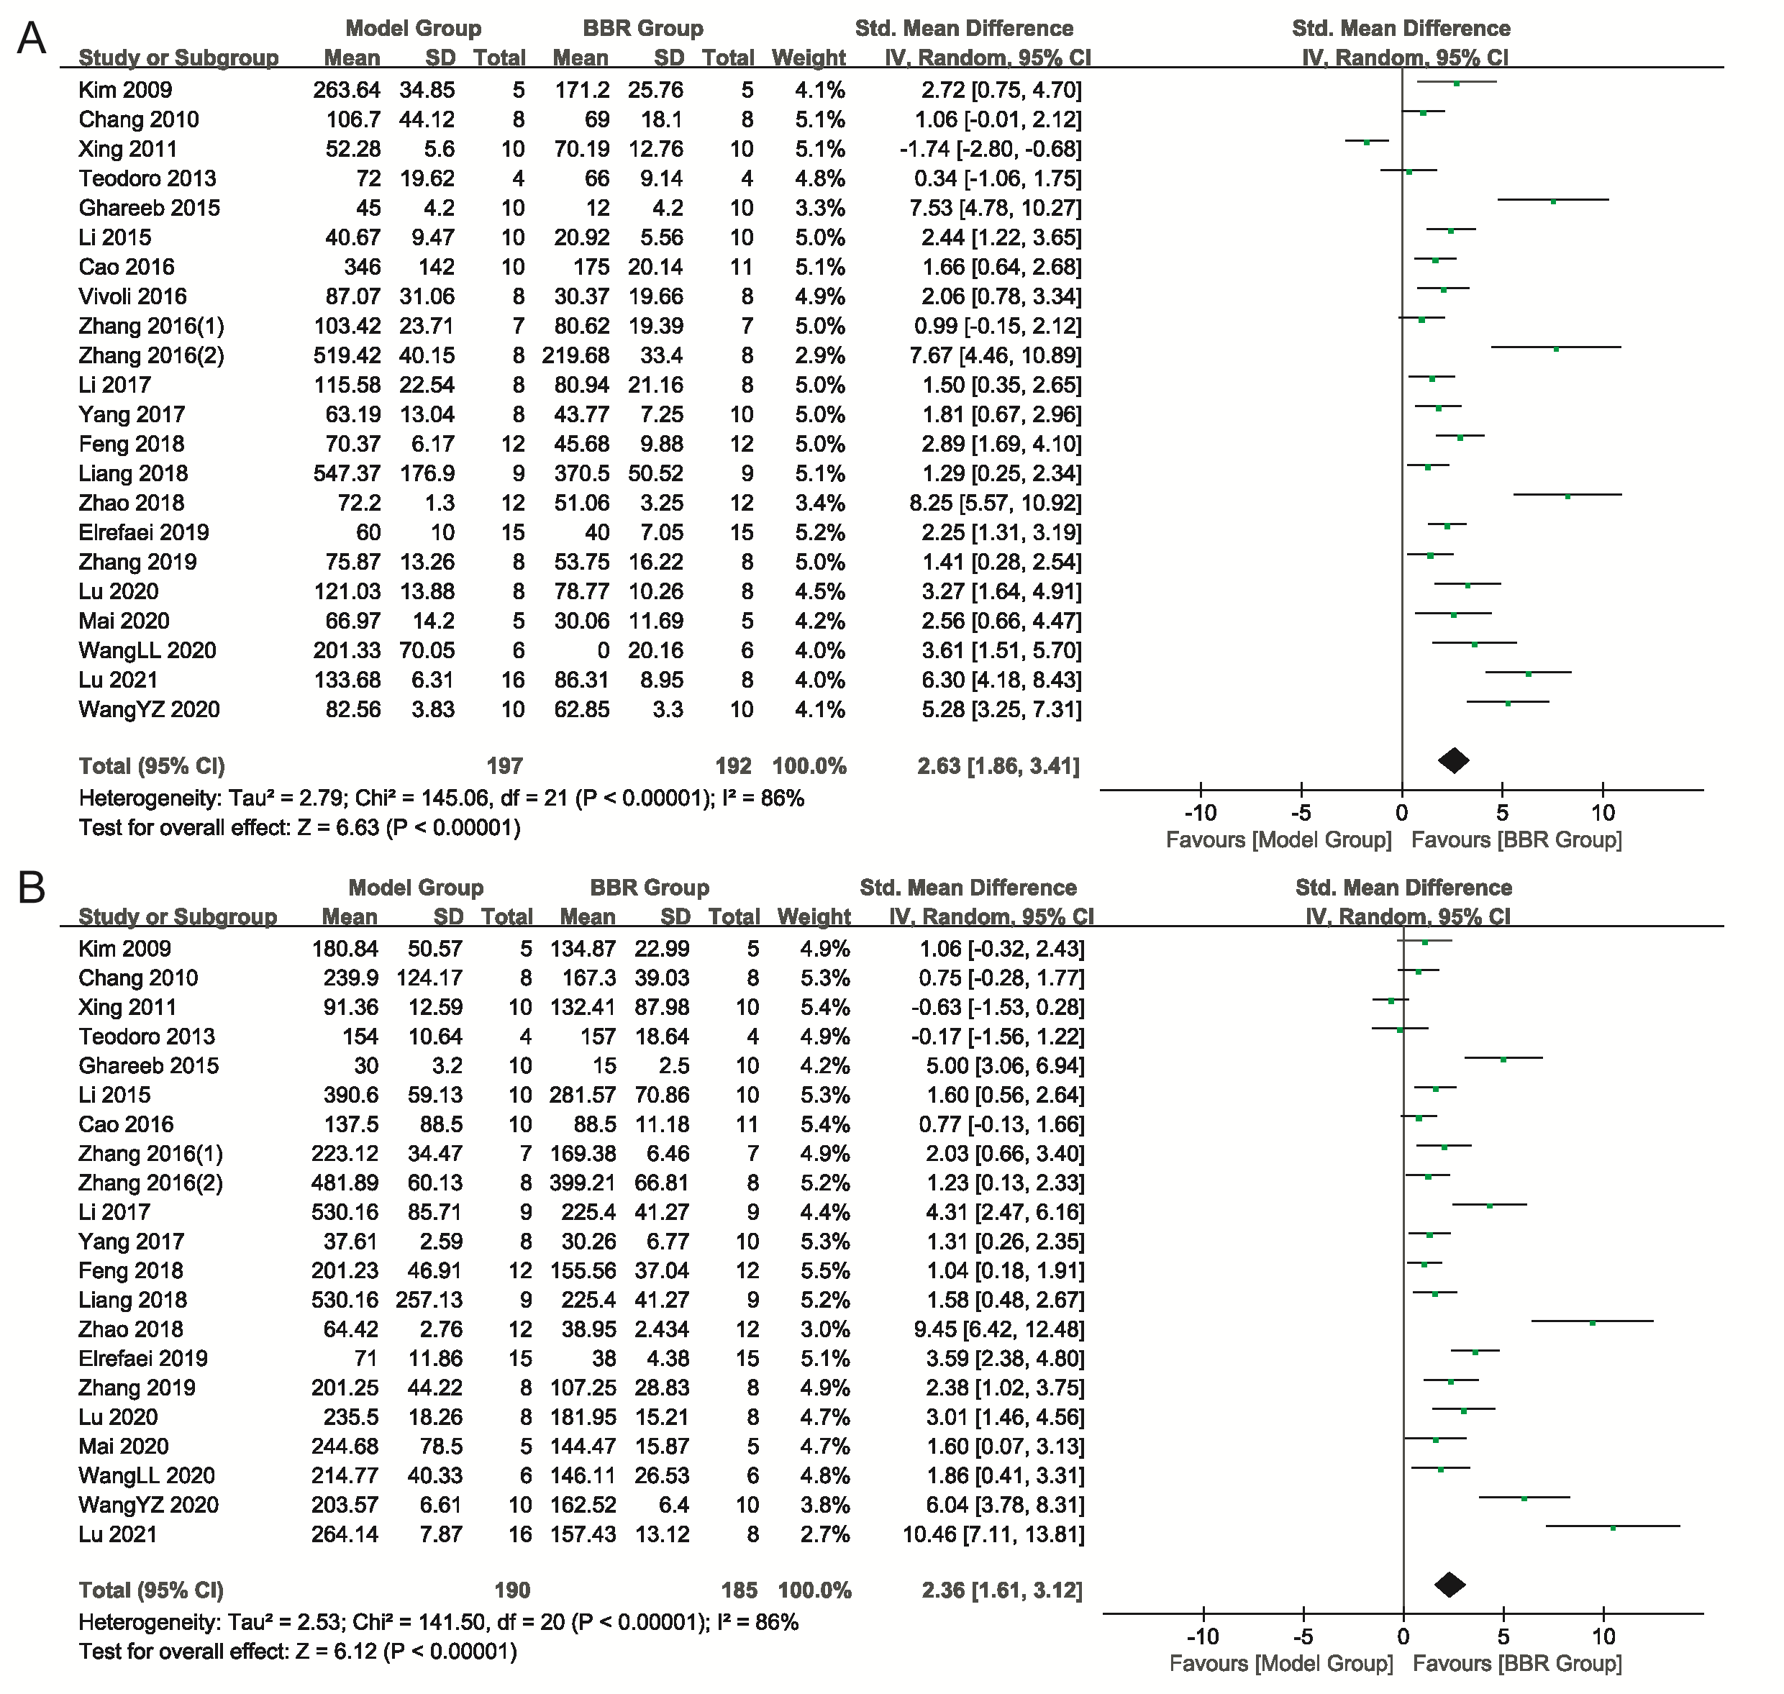Supplementary Figure 5. Forest plot of comparison. (A) ALT; (B) AST; I² and P were taken as the heterogeneity test of the criterion. ALT: alanine aminotransferase; AST: aspartate amino-transferase.

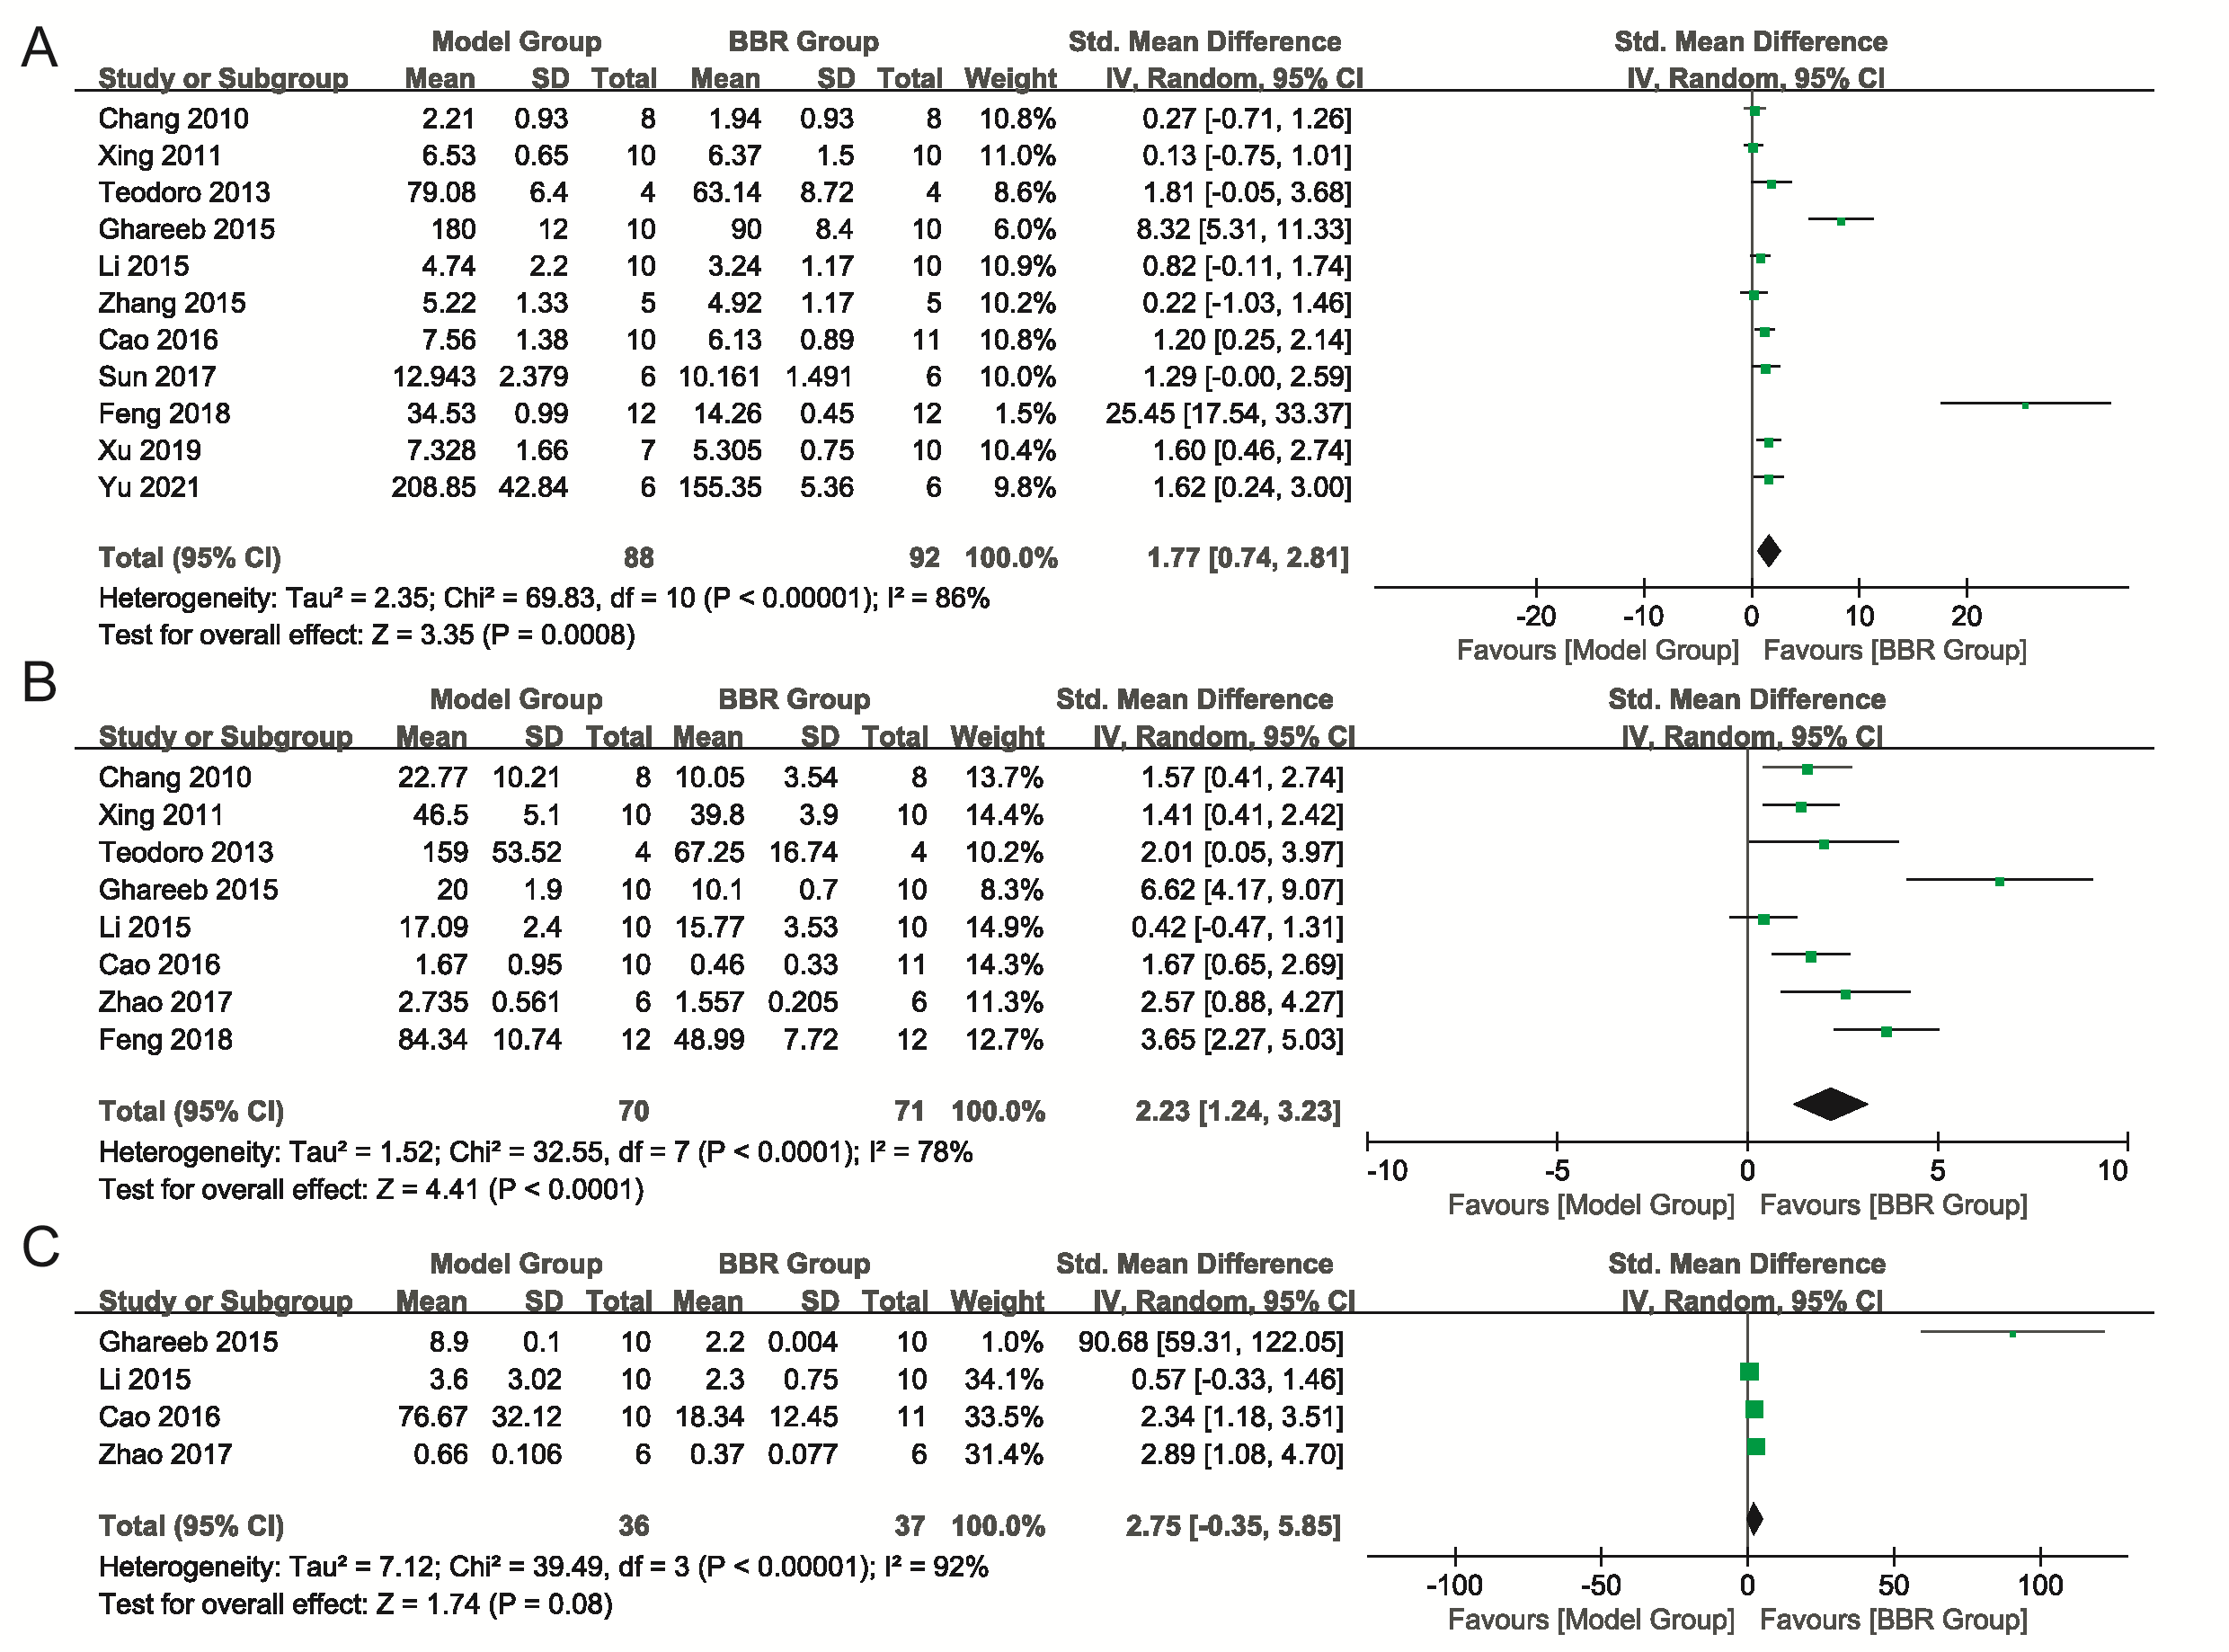Supplementary Figure 6. Forest plot of comparison. (A) FBG; (B) FINS; (C) HOMA-IR; I² and P were taken as the heterogeneity test of the criterion. FBG: fasting blood glucose; FINS: fasting insulin; HOMA-IR: homeostasis model assessment-insulin resistance.

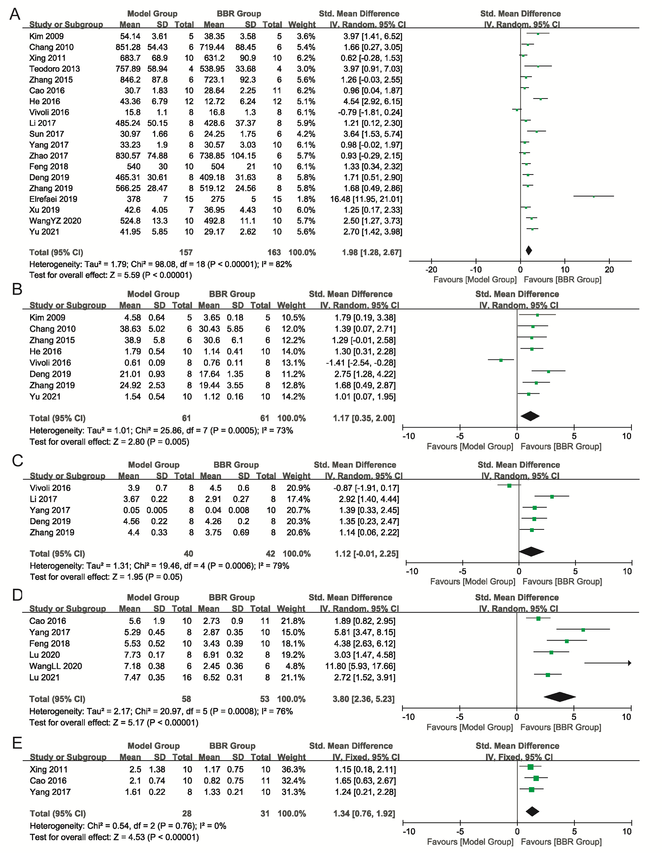
Supplementary Figure 7. Forest plot of comparison. (A) Body weight; (B) Liver weight; (C) Liver index; (D) NAS; (E) Steatosis score; I² and P were taken as the heterogeneity test of the criterion. NAS: NAFLD activity score.

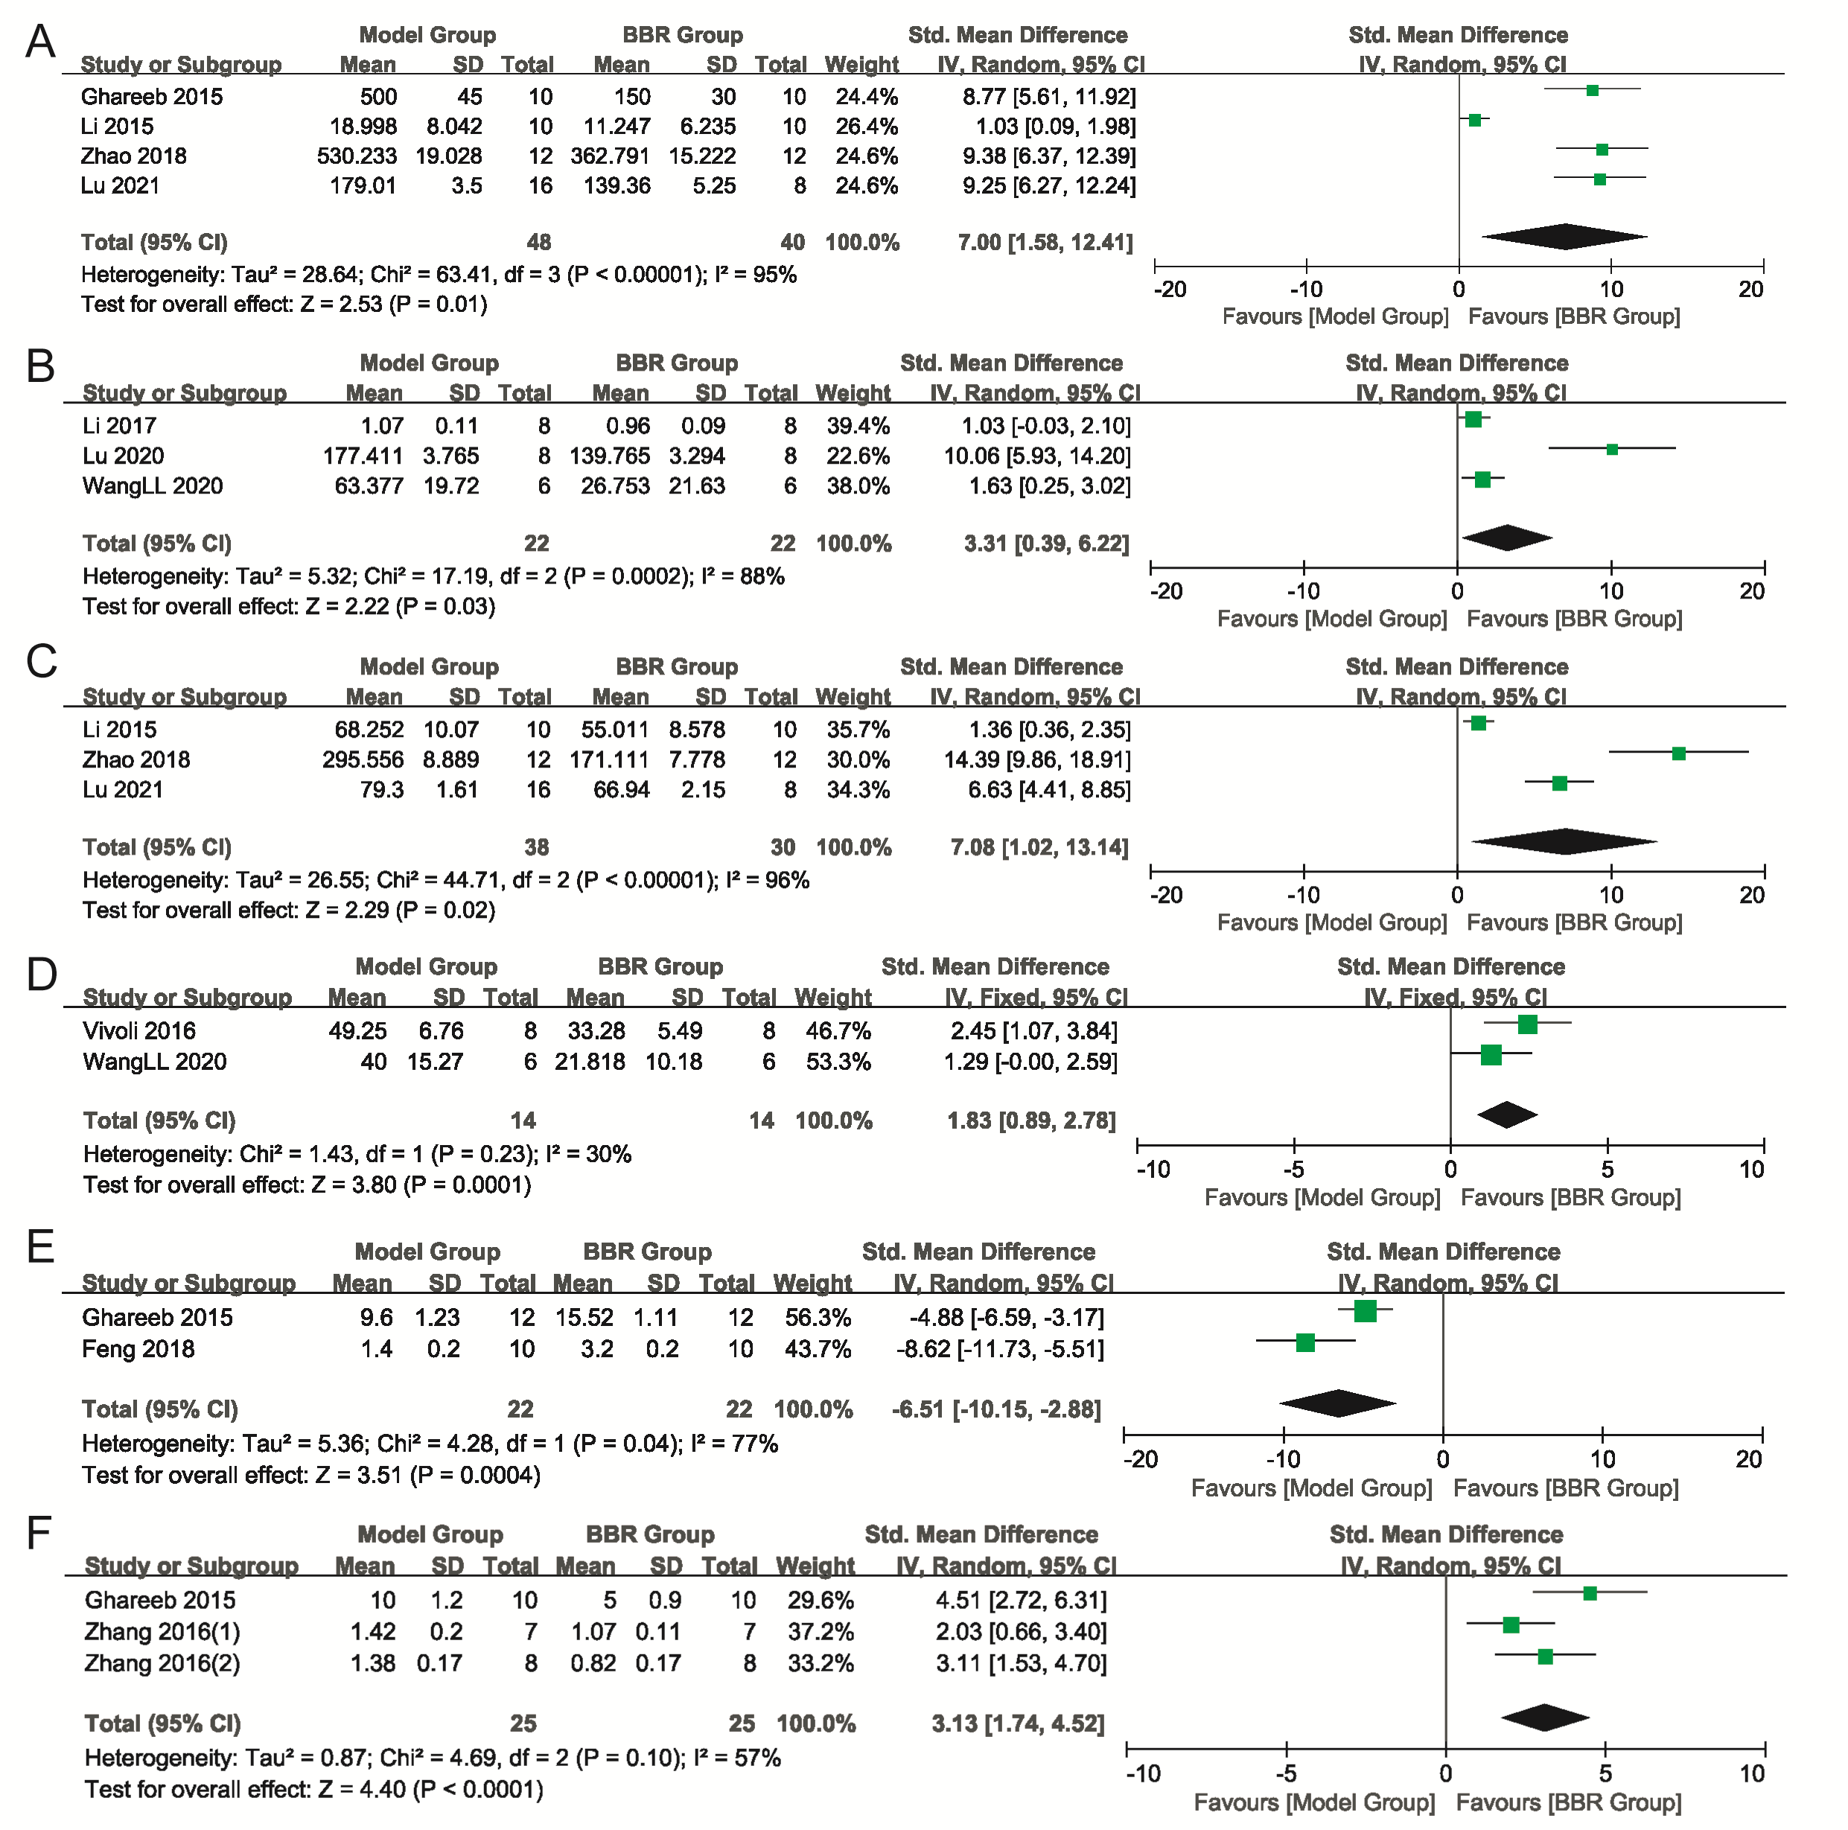
Supplementary Figure 8. Forest plot of comparison. (A) TNF-α; (B) Liver TNF-α; (C) IL-6; (D) IL-1β; (E) GSH; (F) TBARS; I² and P were taken as the heterogeneity test of the criterion. TNF-α: tumor necrosis factor-α; IL-6: interleukin-6; IL-1β: interleukin-1β; GSH: glutathione; TBARS: thiobarbituric acid reactive substances.

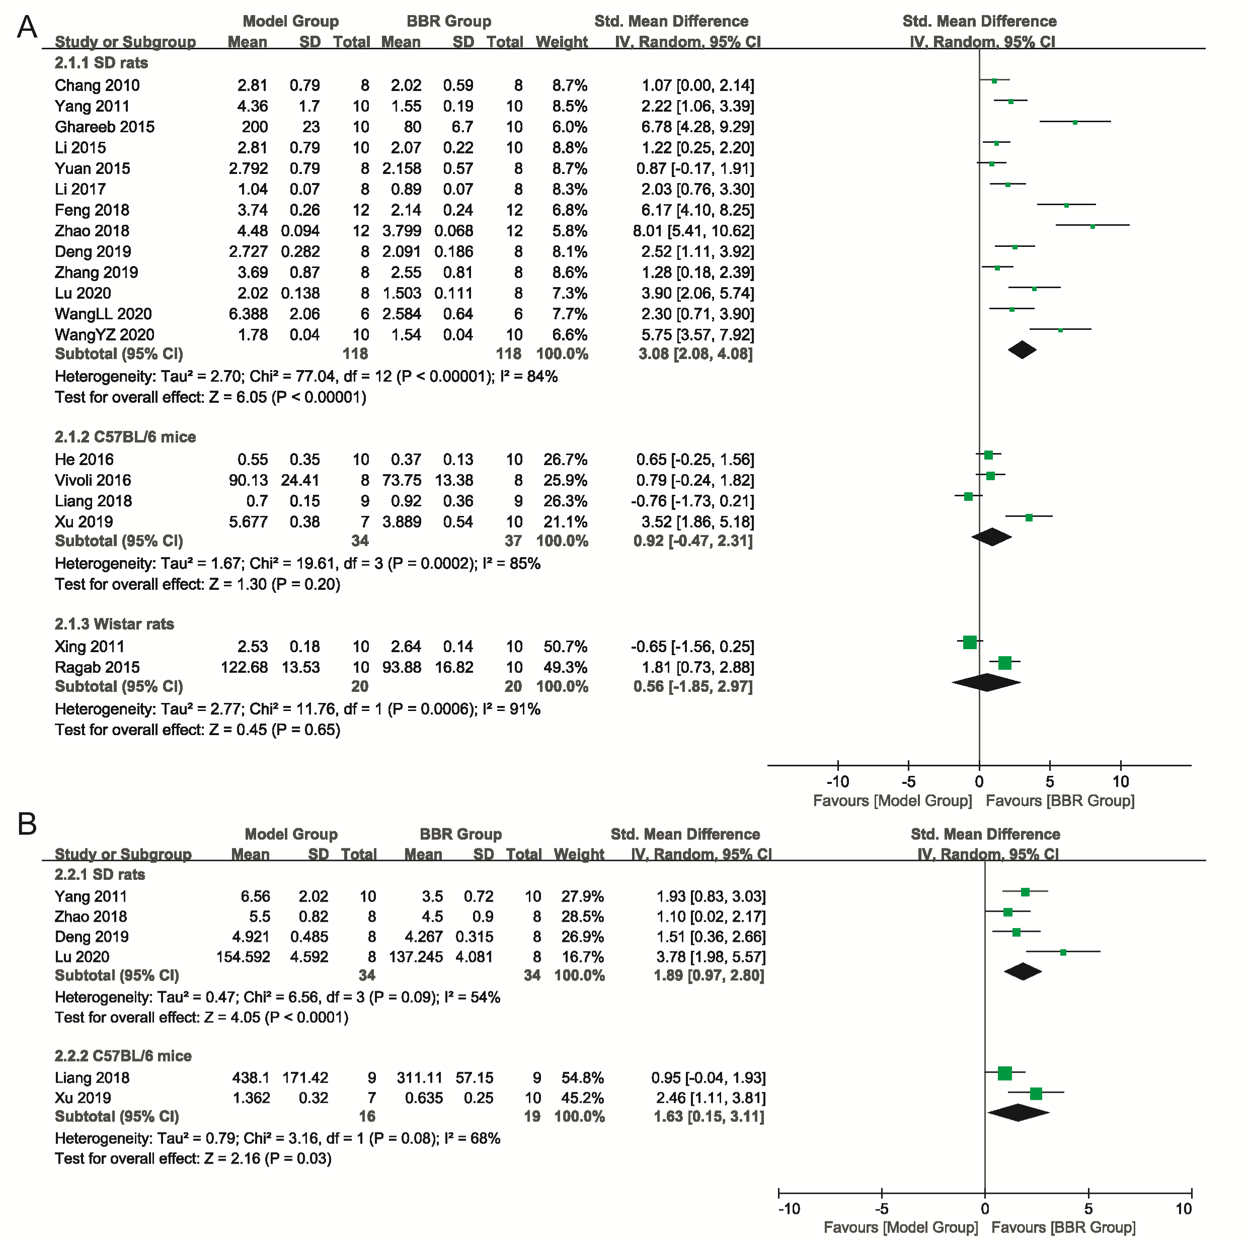
Supplementary Figure 9. Forest plot of comparison for subgroup of different animal breeds. (A) Blood TC; (B) Liver tissue TC; I² and P were taken as the heterogeneity test of the criterion. TC: total cholesterol.

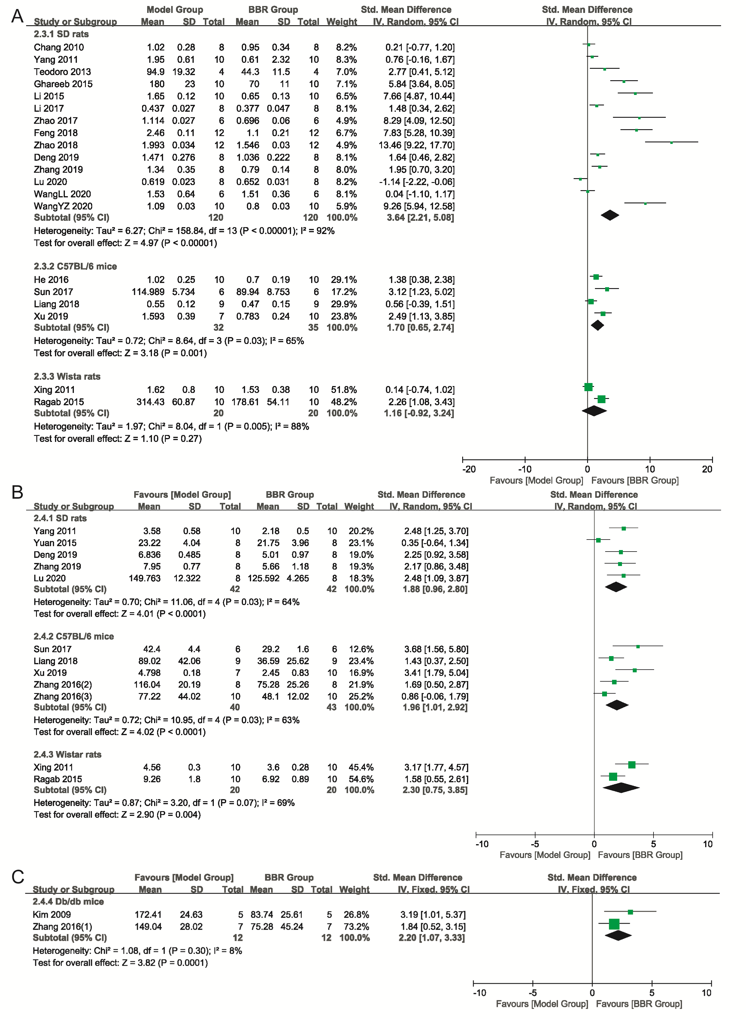
Supplementary Figure 10. Forest plot of comparison for subgroup of different animal breeds. (A) Blood TG; (B) Liver tissue TG; I² and P were taken as the heterogeneity test of the criterion. TG: triglycerides.

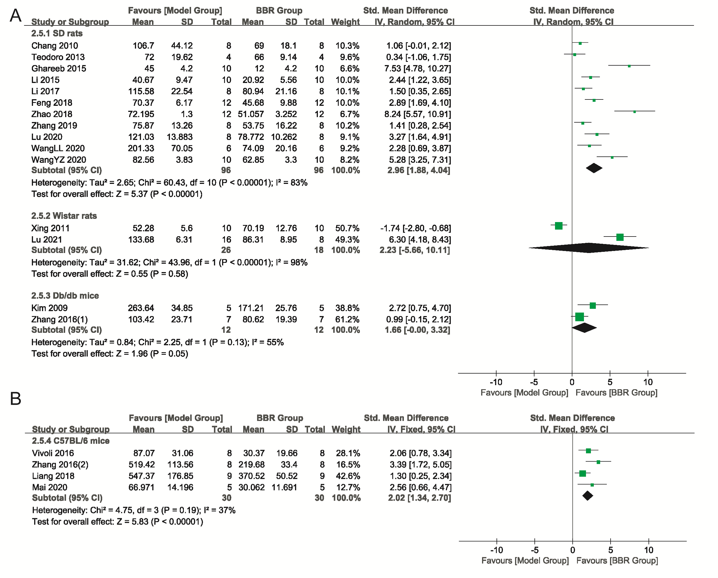
Supplementary Figure 11. Forest plot of comparison for subgroup of different animal breeds. (A-B) ALT; I² and P were taken as the heterogeneity test of the criterion. ALT: alanine aminotransferase.

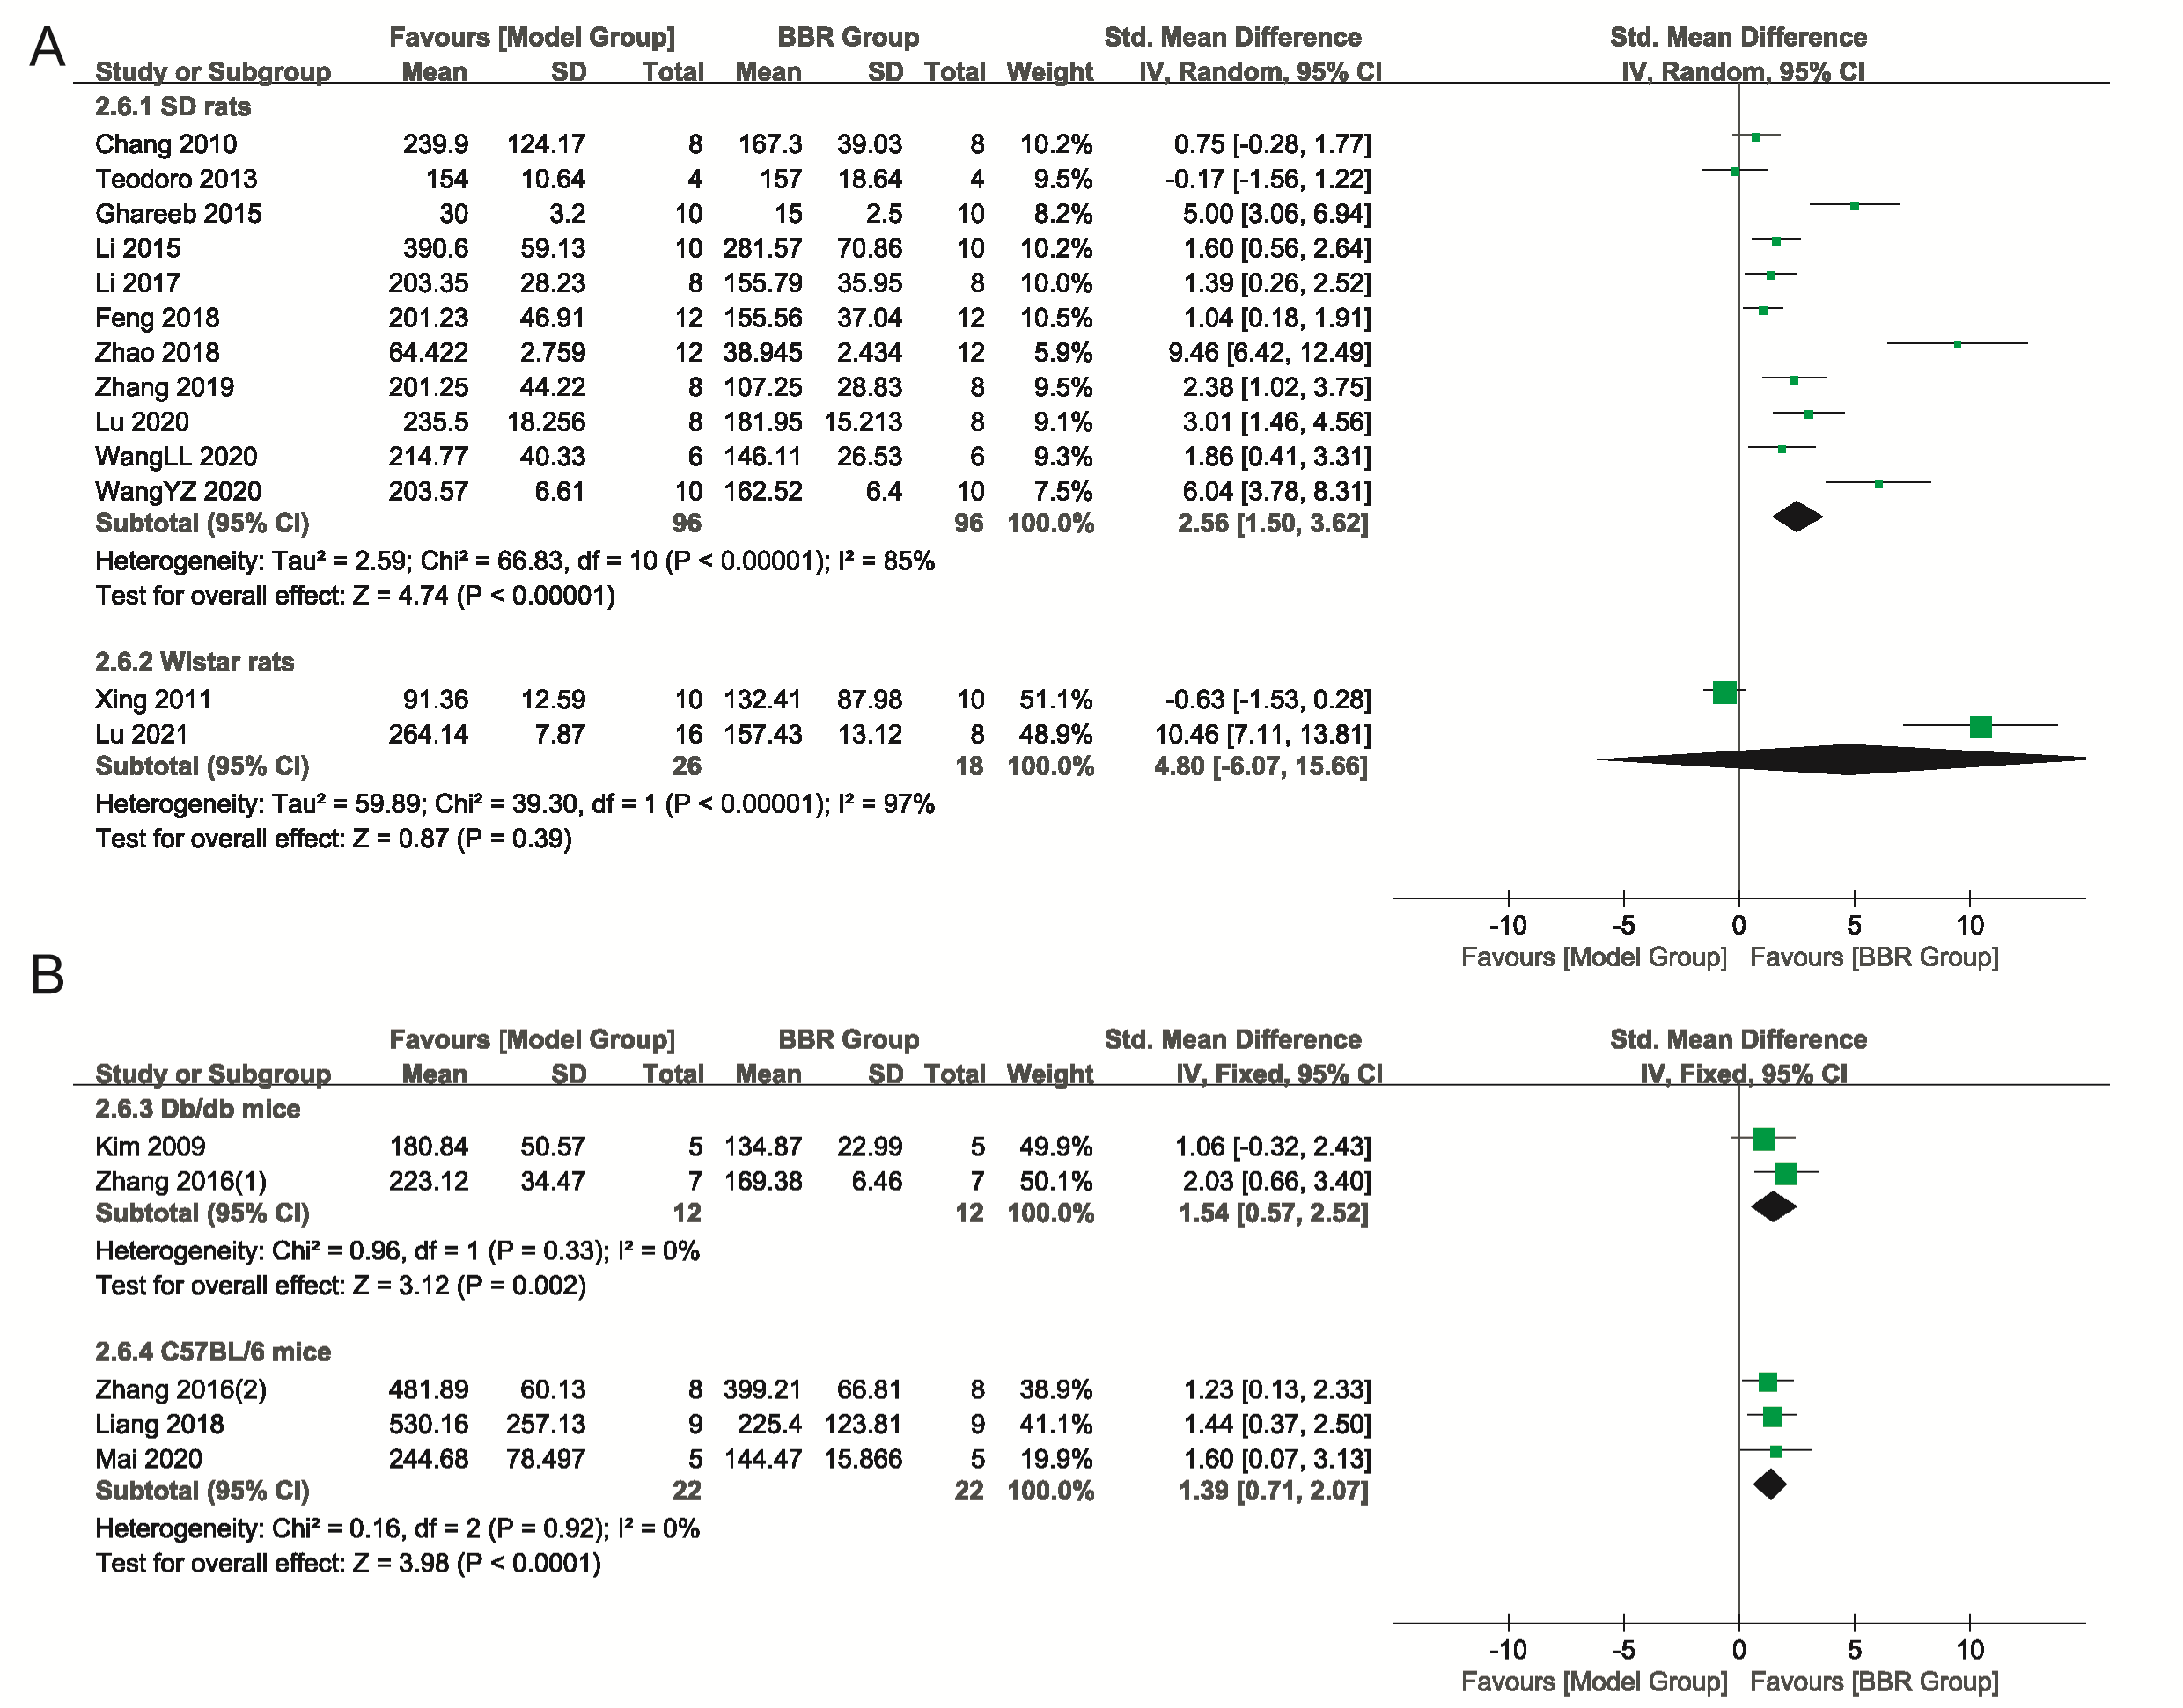
Supplementary Figure 12. Forest plot of comparison for subgroup of different animal breeds. (A-B) AST; I² and P were taken as the heterogeneity test of the criterion. AST: aspartate amino-transferase.

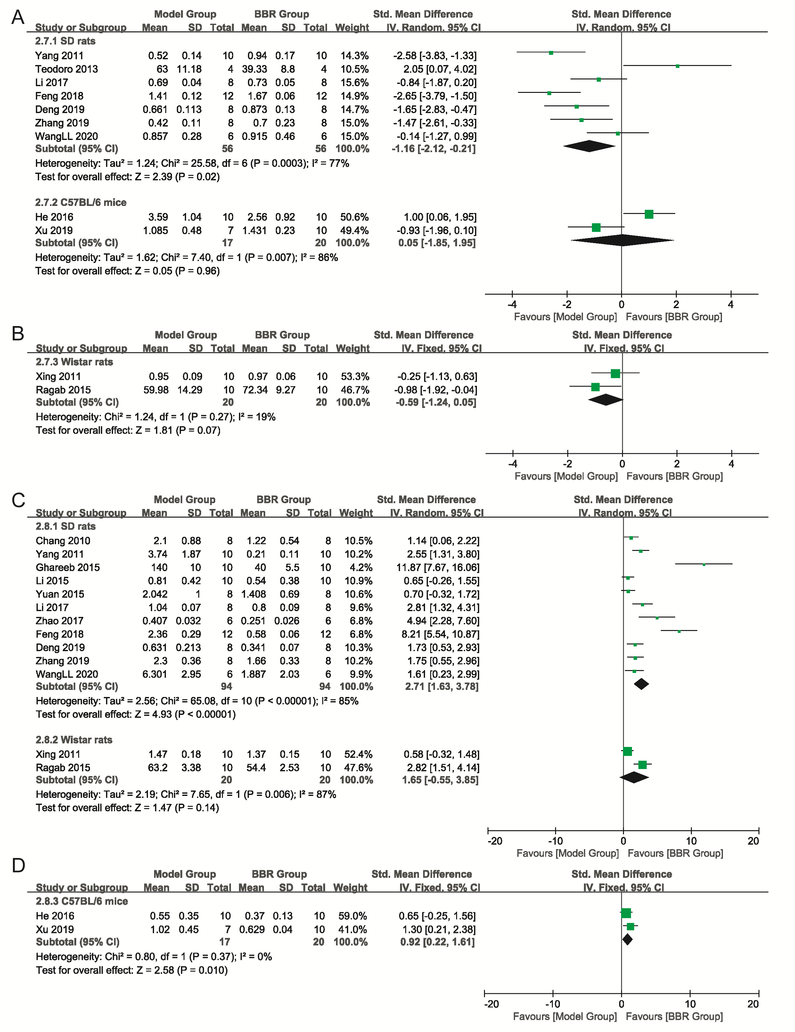
Supplementary Figure 13. Forest plot of comparison for subgroup of different animal breeds. (A-B) HDL-C; (C-D) LDL-C. I² and P were taken as the heterogeneity test of the criterion. HDL-C: high-density lipoprotein cholesterol; LDL-C: Low-density lipoprotein cholesterol.

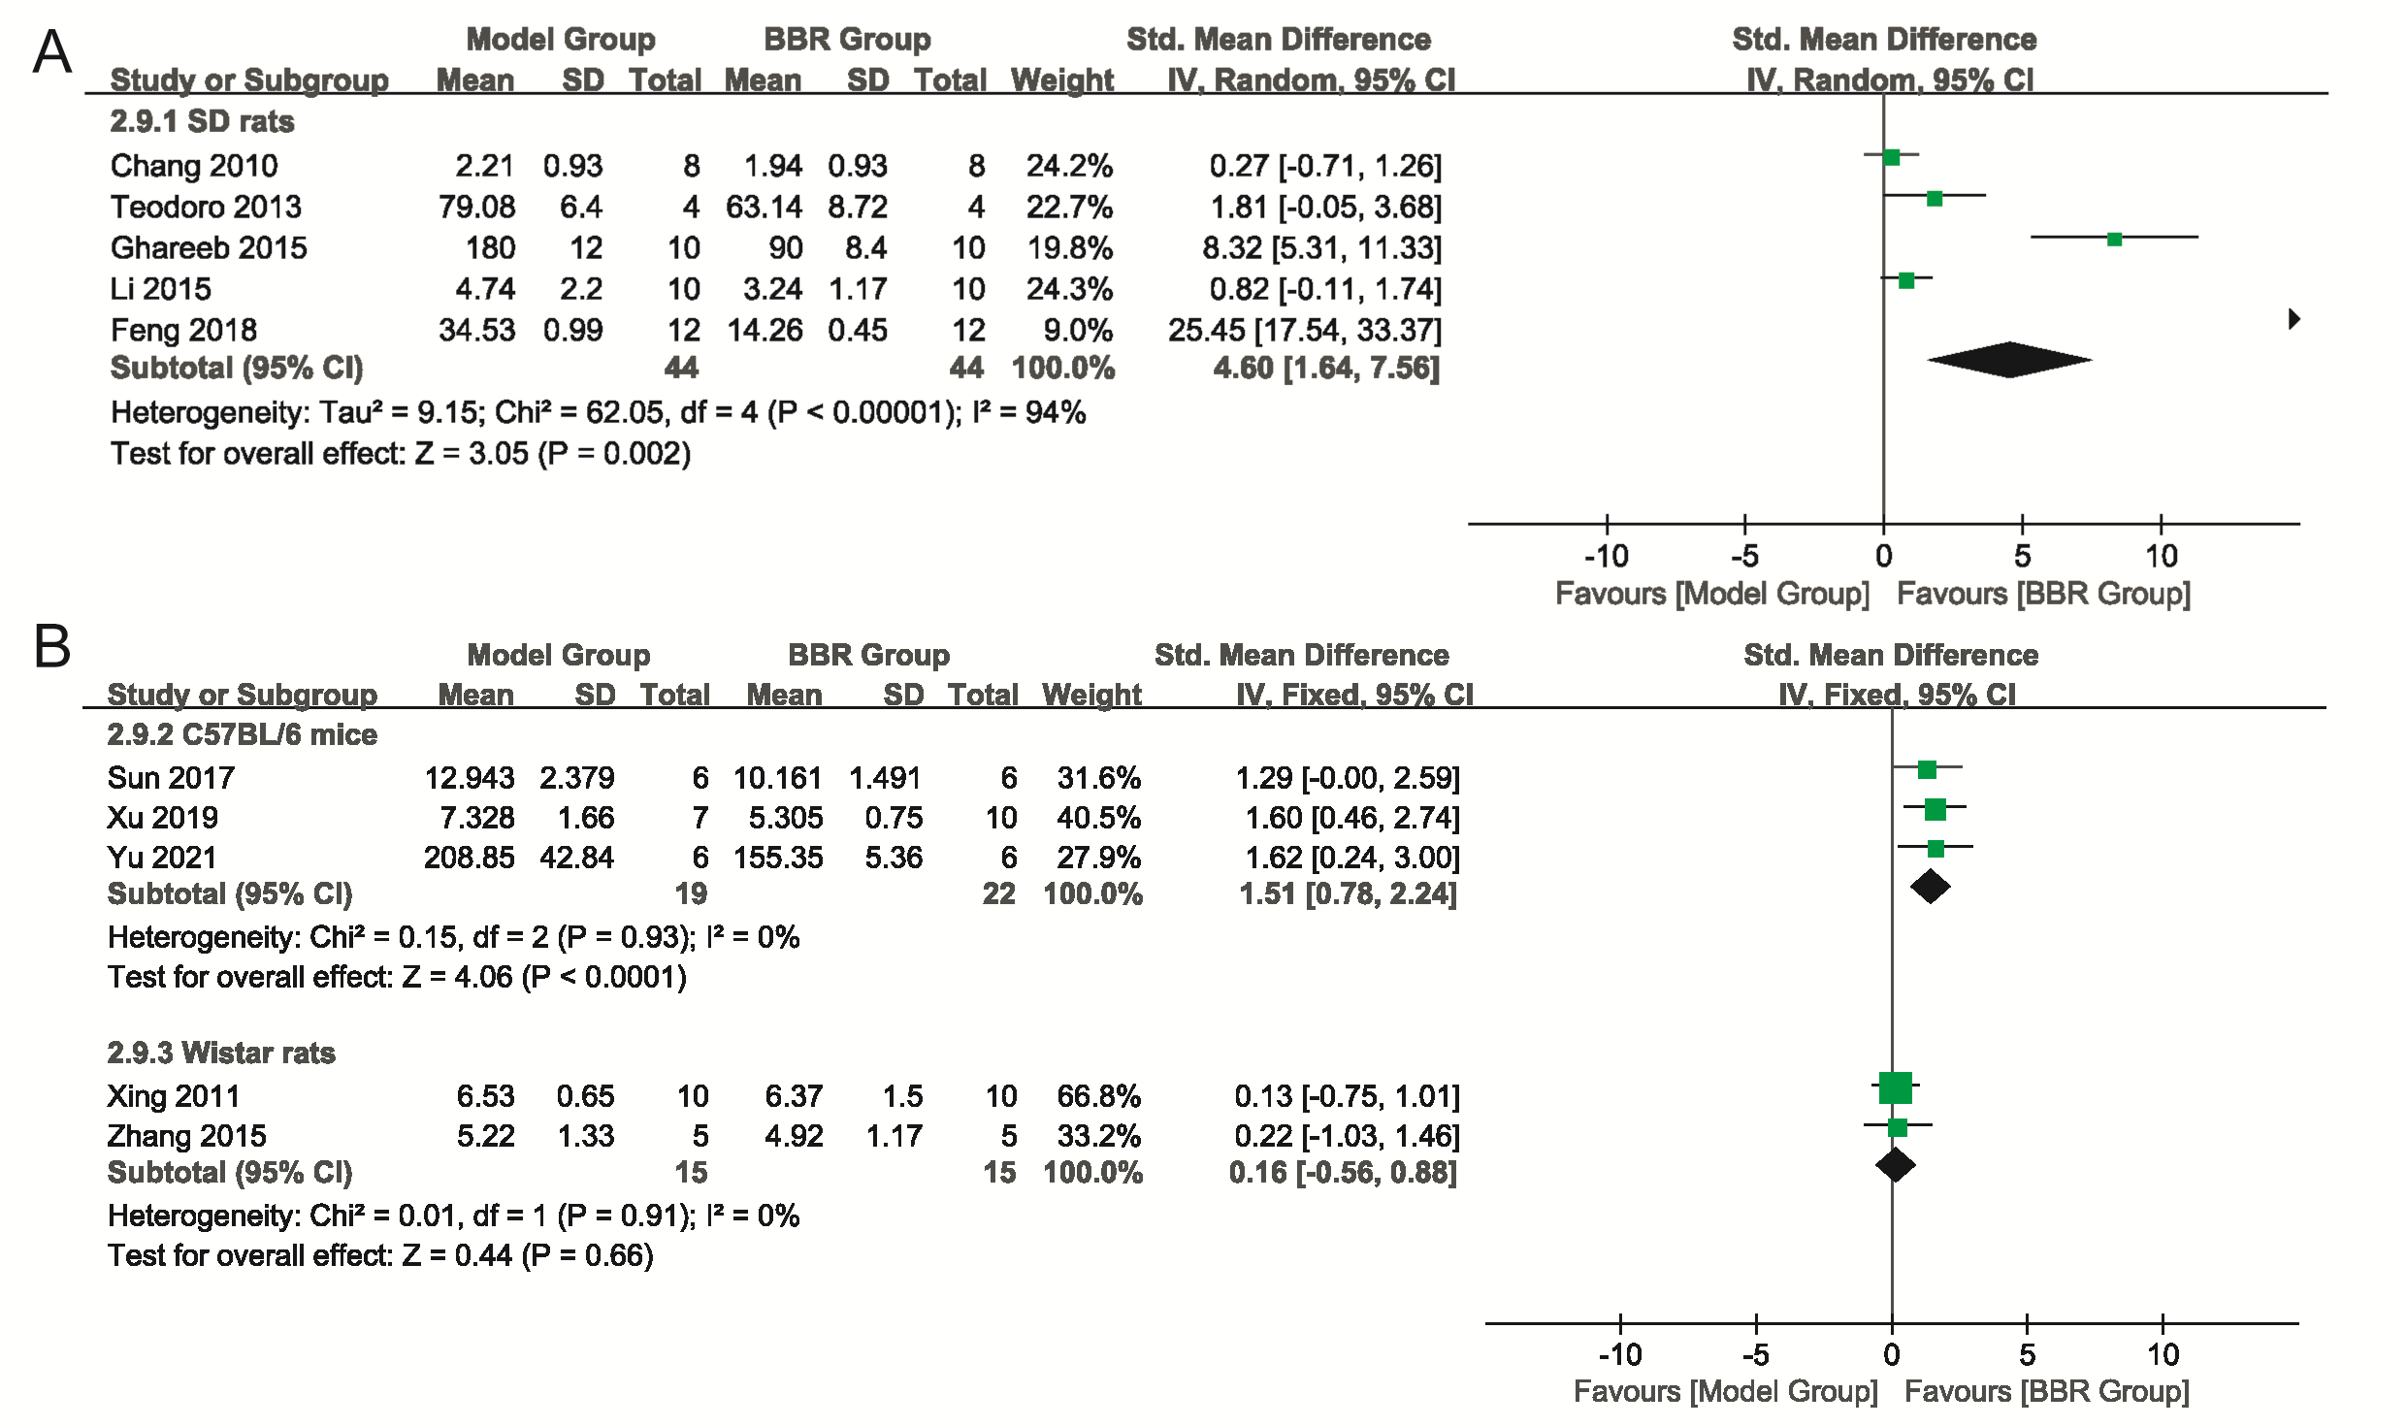Supplementary Figure 14. Forest plot of comparison for subgroup of different animal breeds. (A-B) FBG; I² and P were taken as the heterogeneity test of the criterion. FBG: fasting blood glucose.

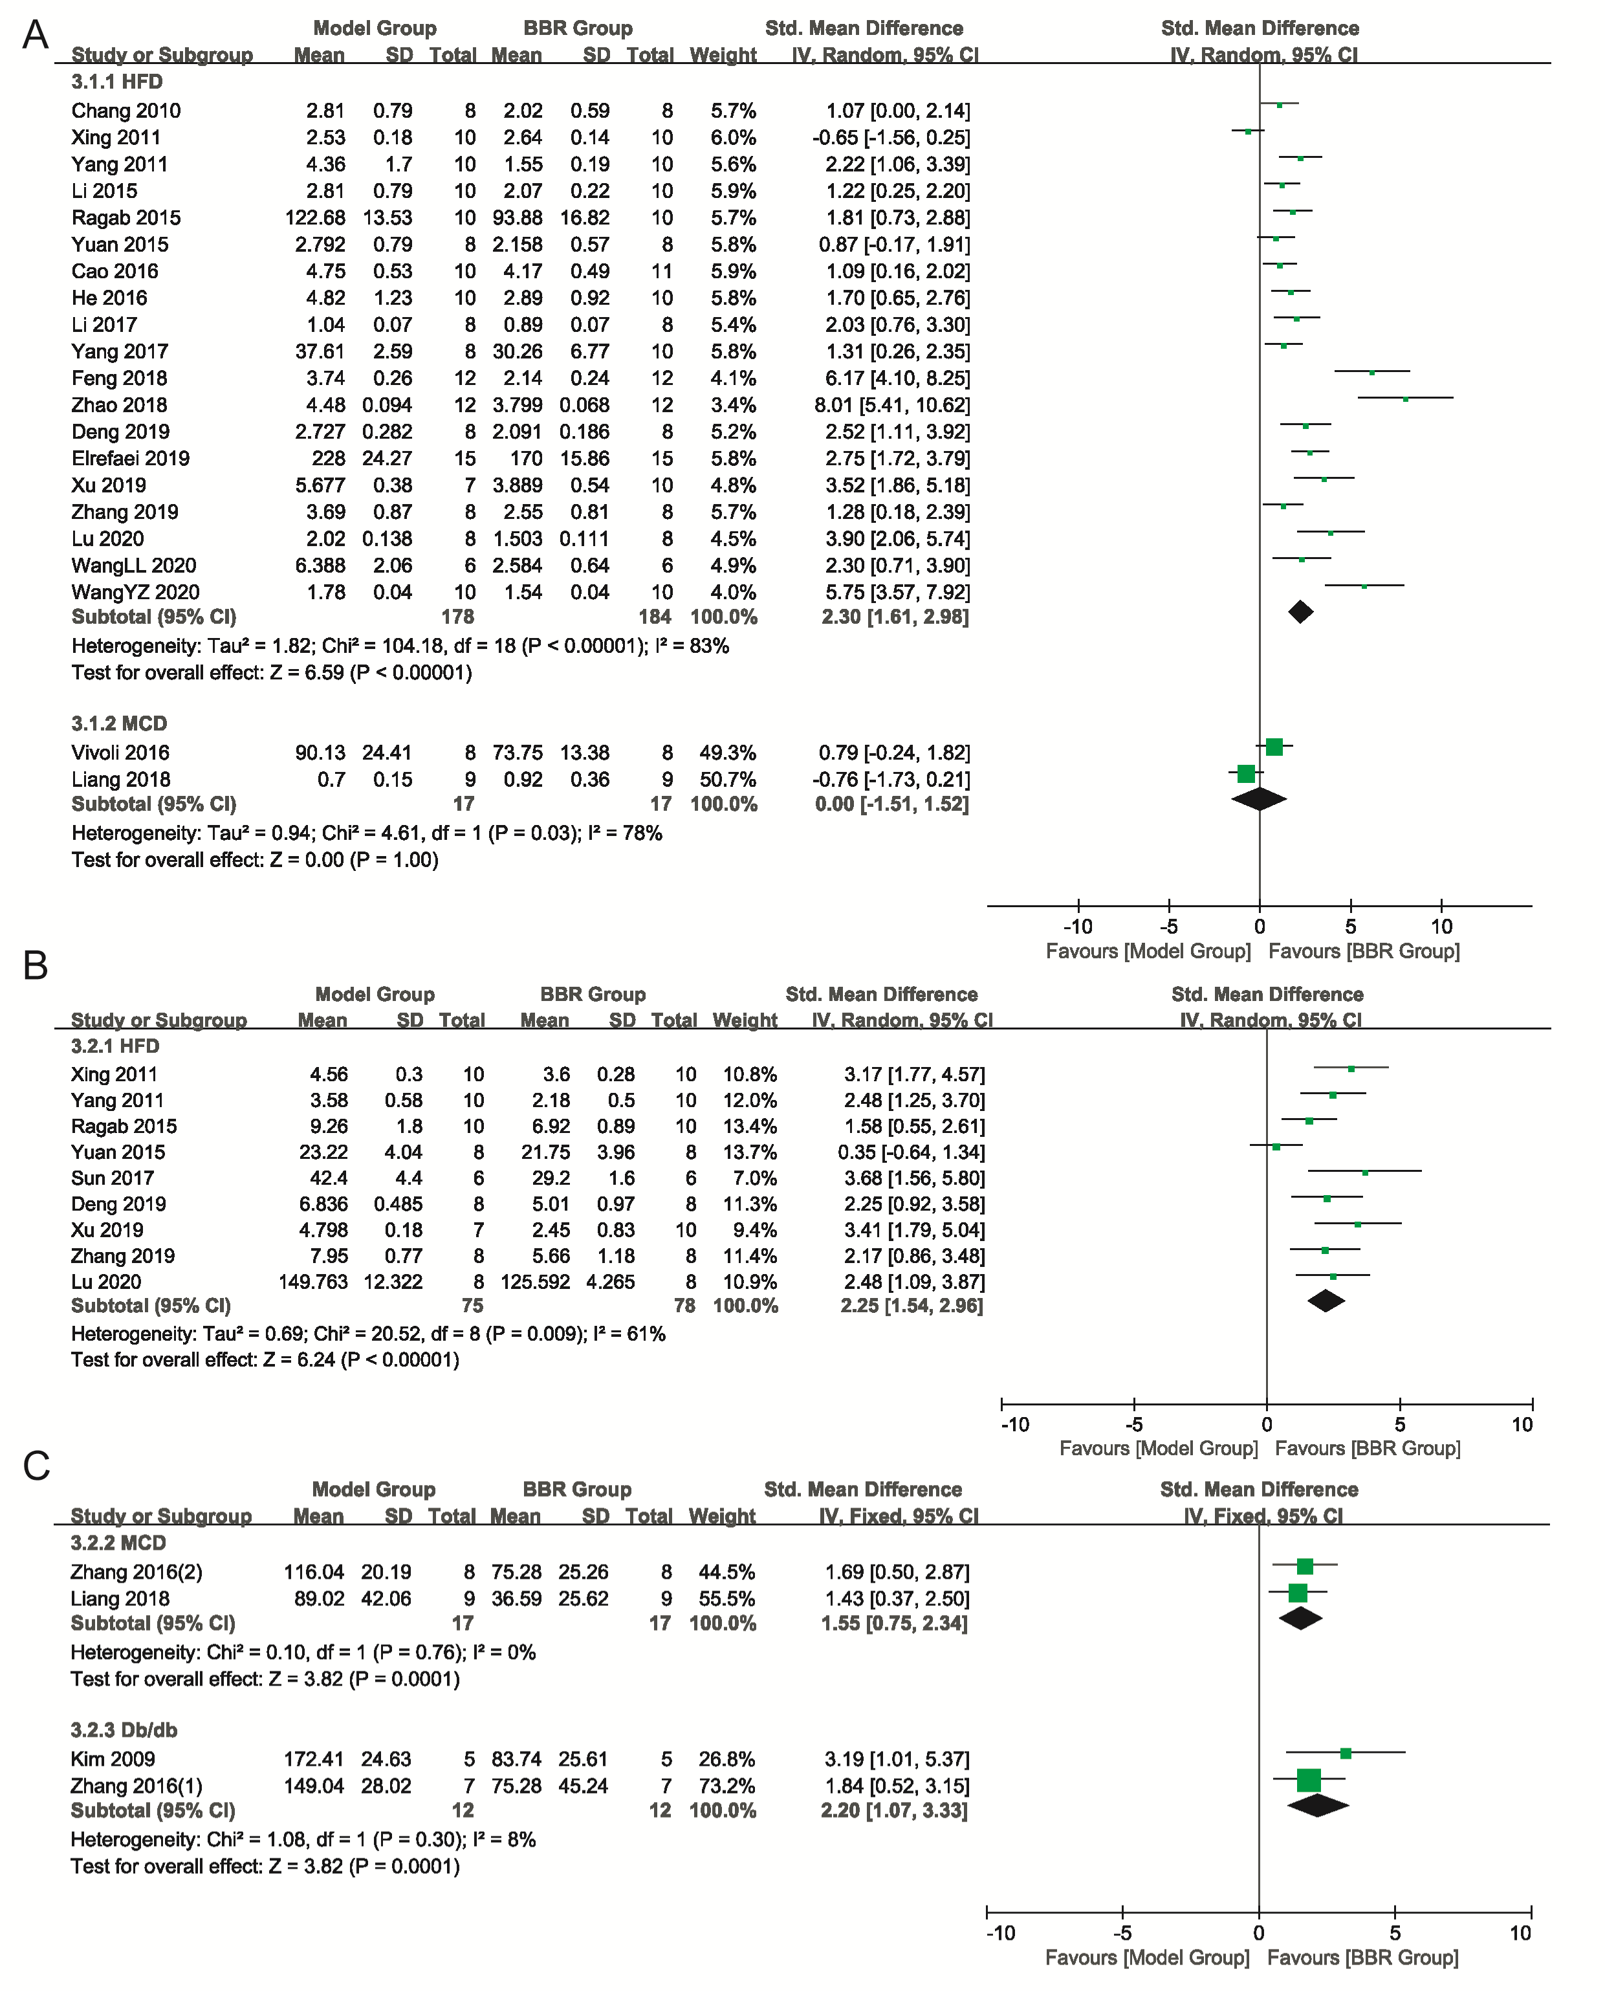
Supplementary Figure 15. Forest plot of comparison for subgroup of different animal models. (A) Blood TC; (B-C) Liver tissue TG; I² and P were taken as the heterogeneity test of the criterion. TC: total cholesterol; TG: triglycerides.

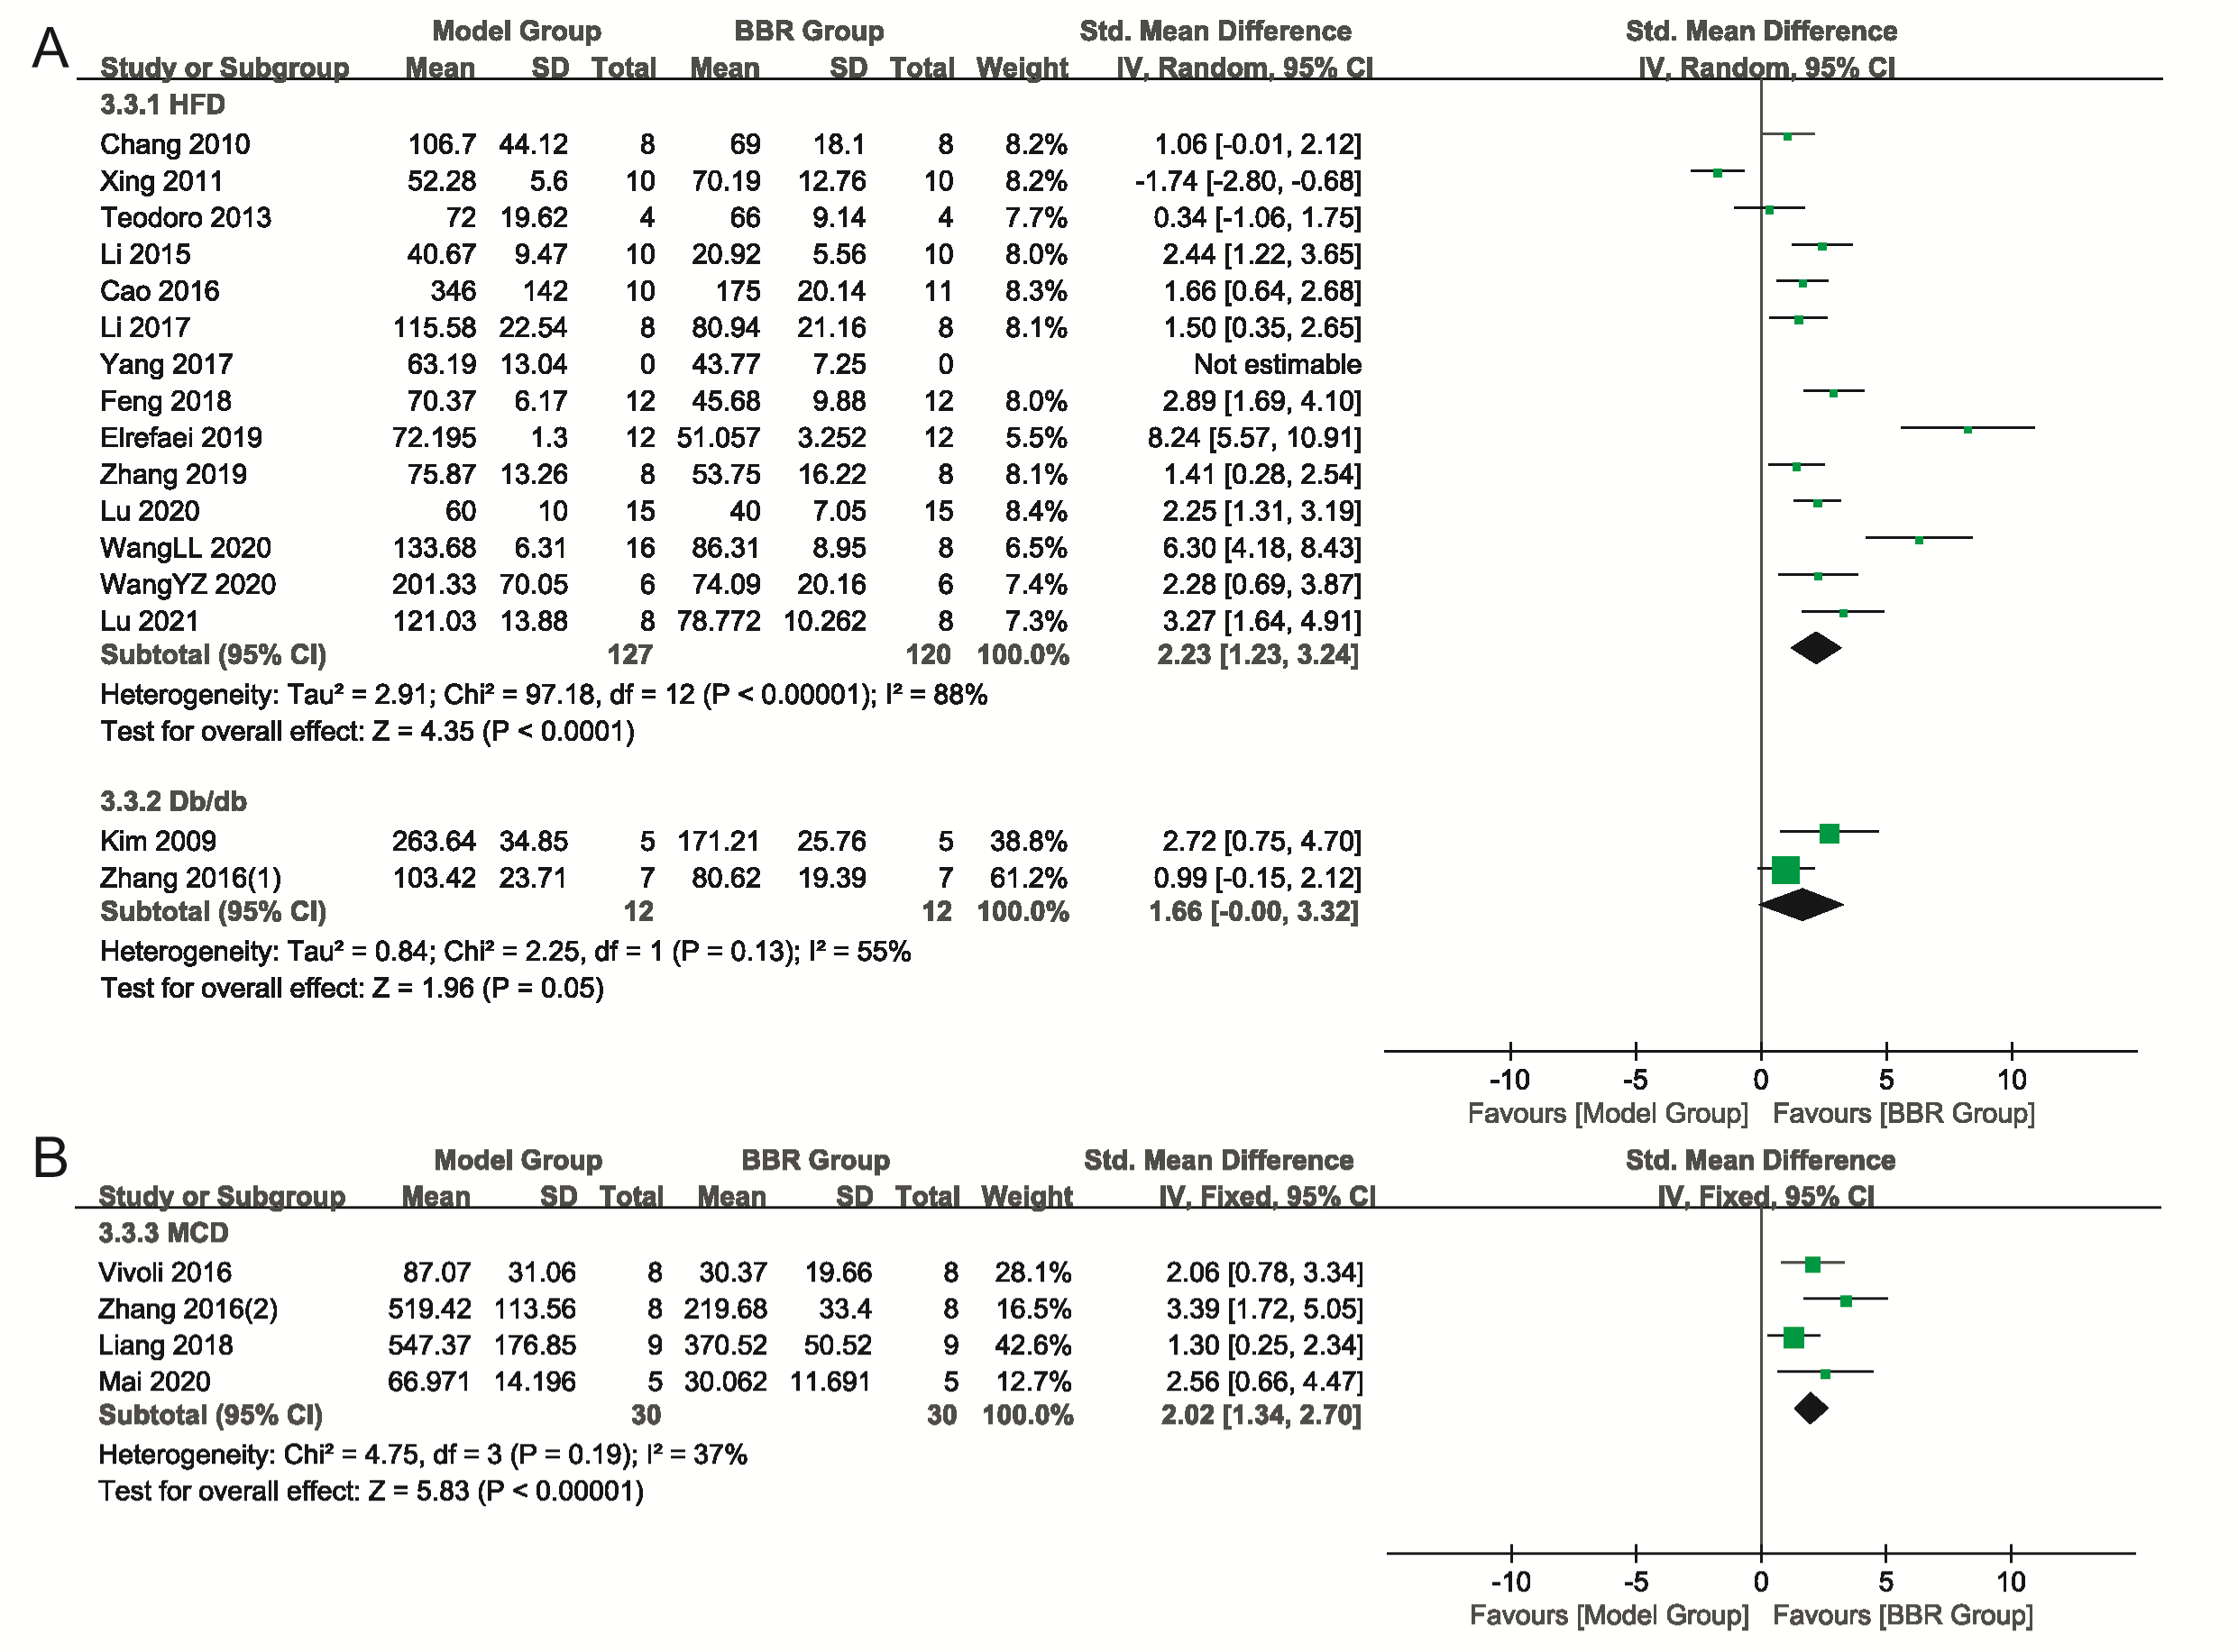
Supplementary Figure 16. Forest plot of comparison for subgroup of different animal models. (A-B) ALT; I² and P were taken as the heterogeneity test of the criterion. ALT: alanine aminotransferase.

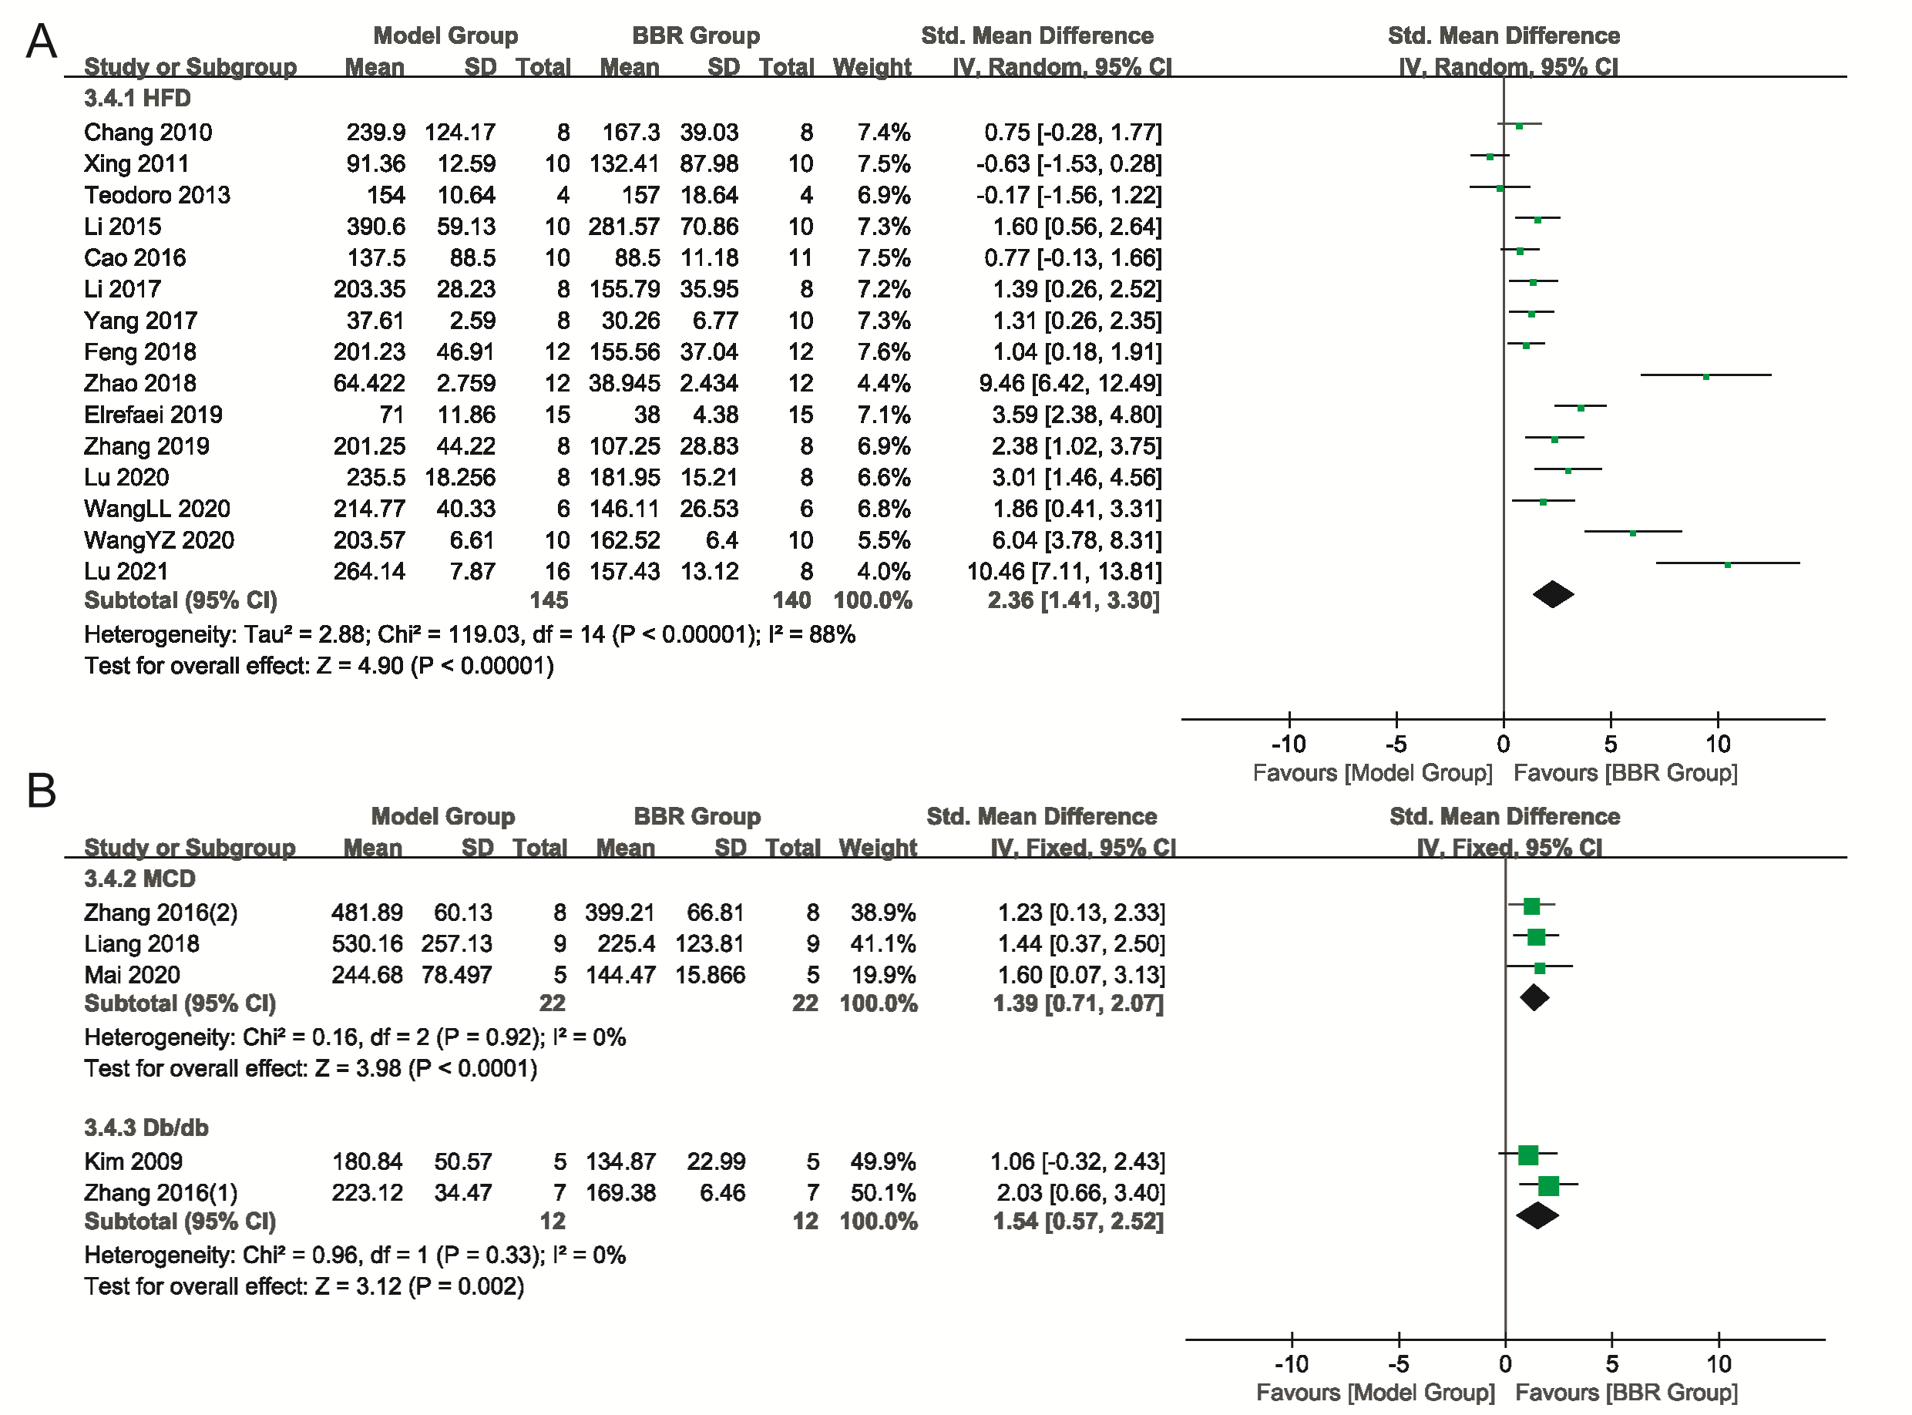
Supplementary Figure 17. Forest plot of comparison for subgroup of different animal models. (A-B) AST; I² and P were taken as the heterogeneity test of the criterion. AST: aspartate amino-transferase.

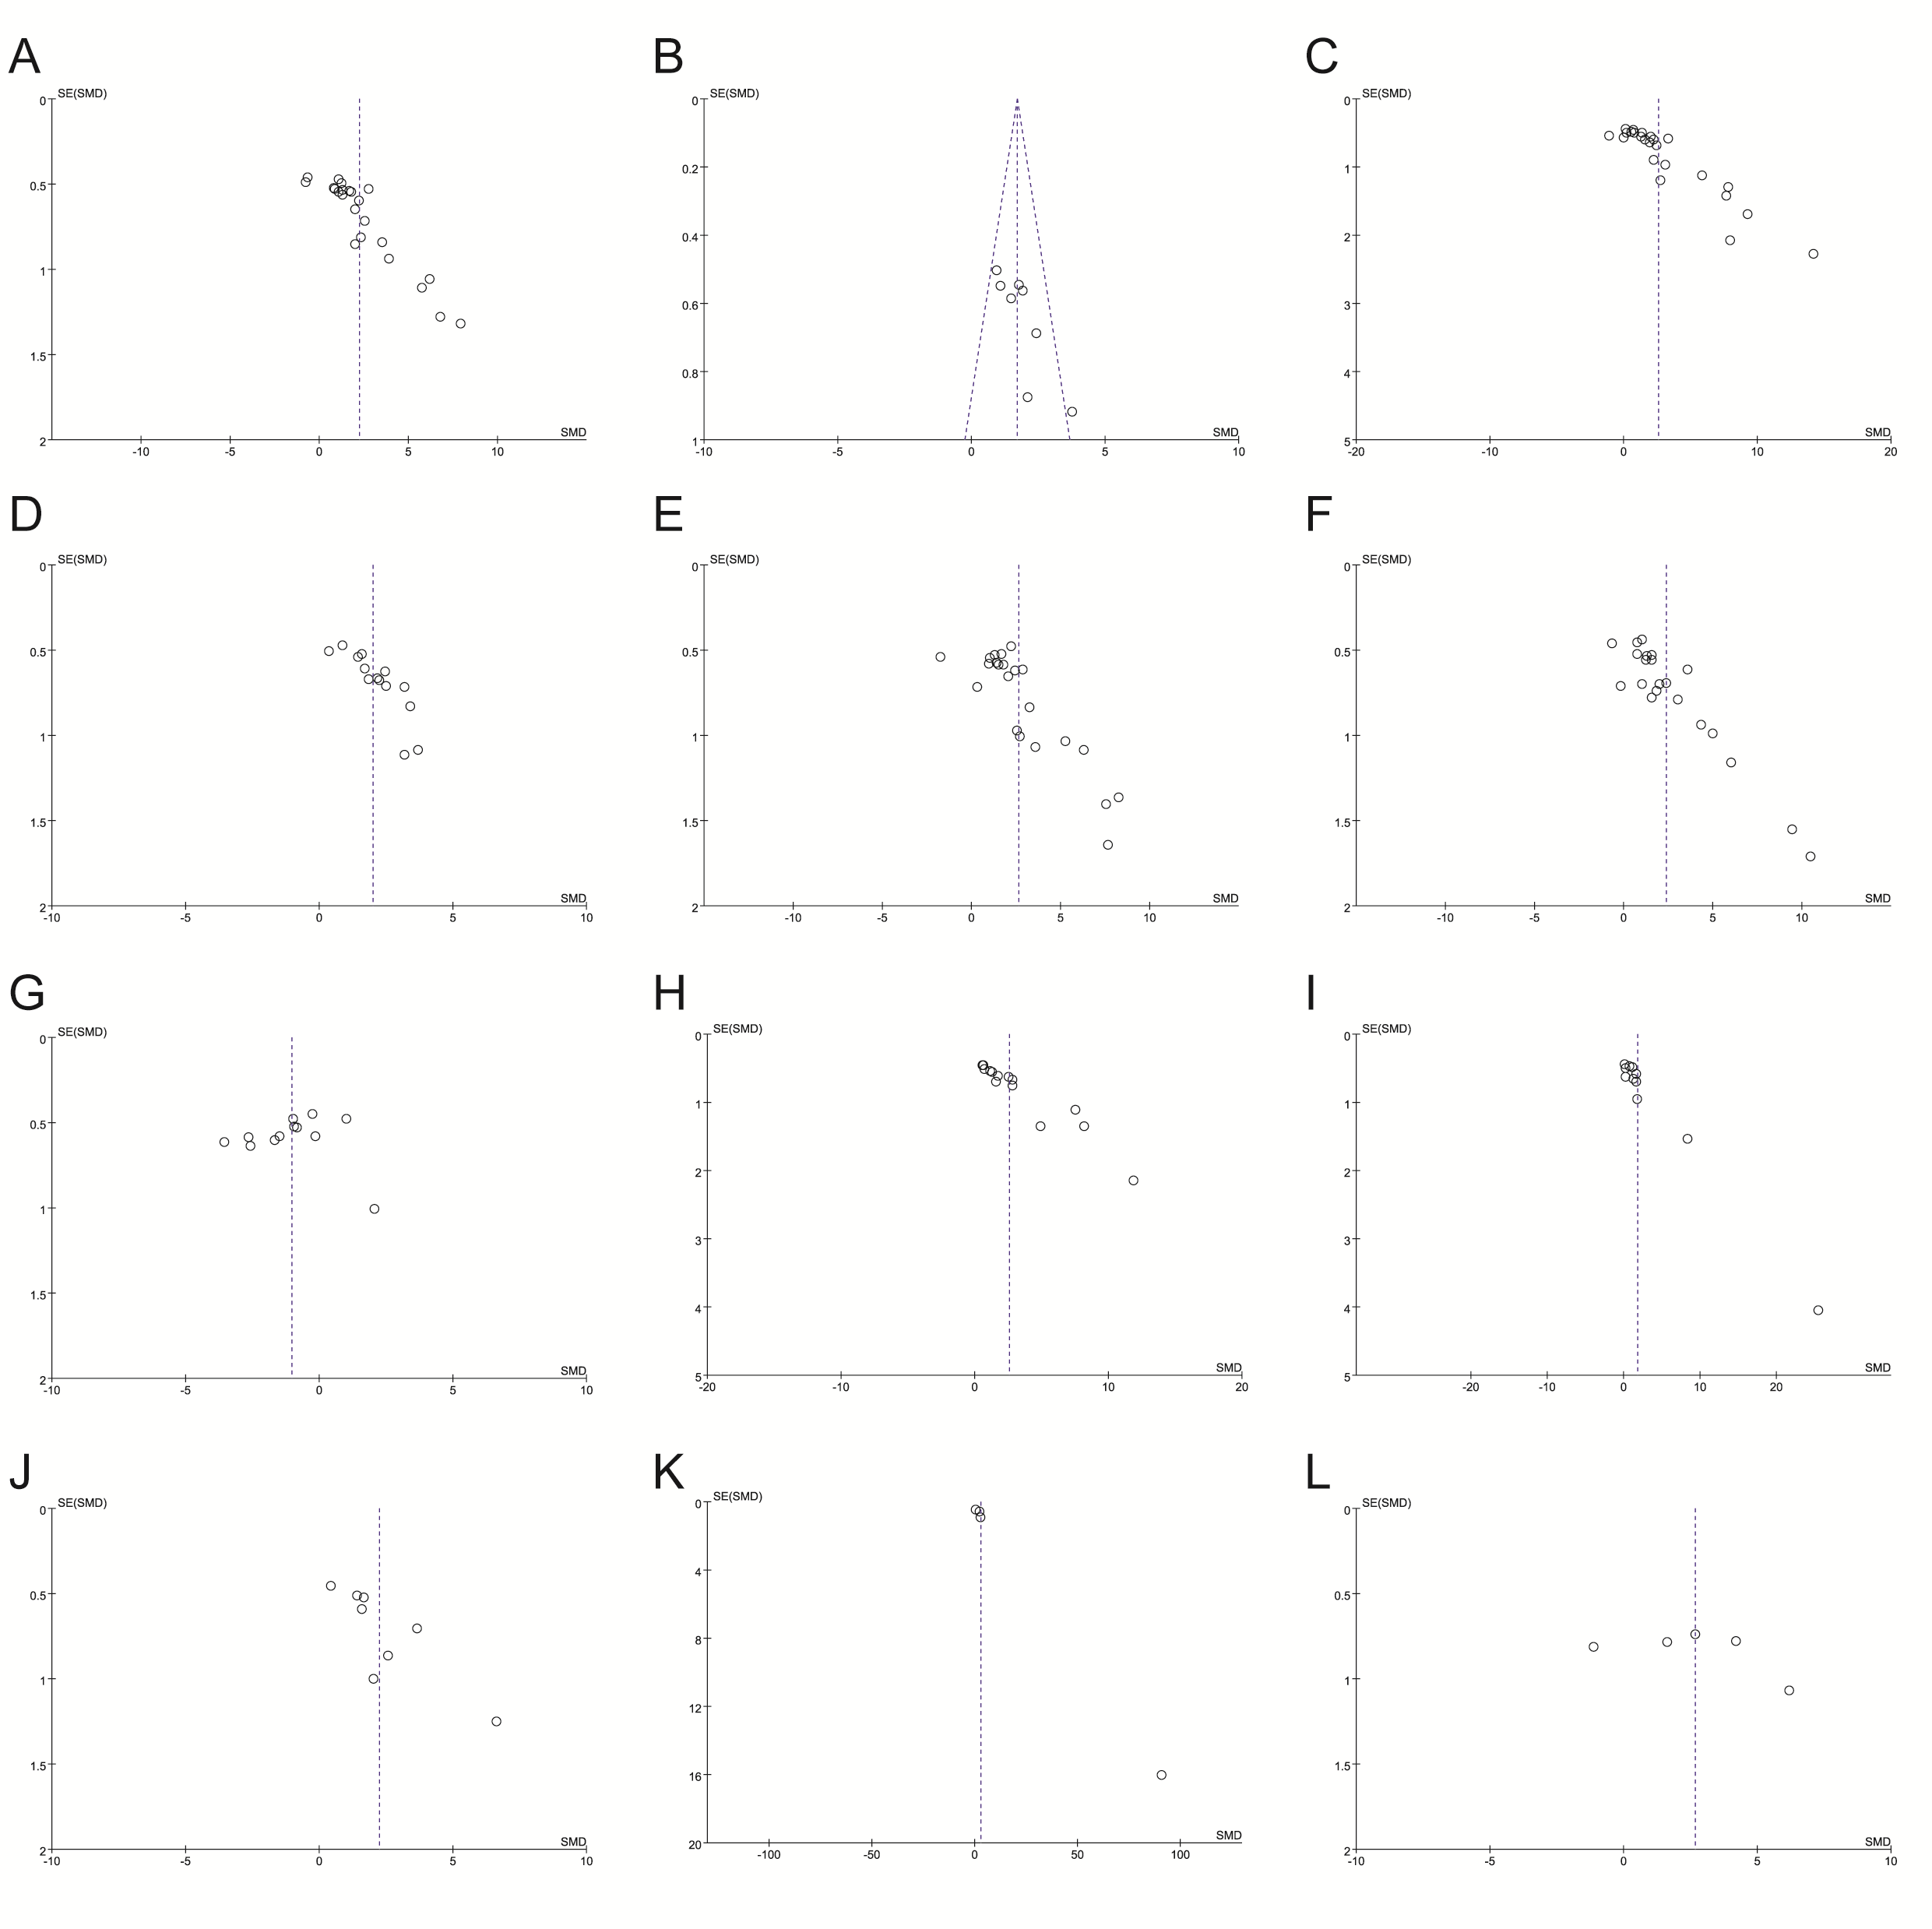Supplementary Figure 18. Funnel plot for the publication bias. (A) blood TC; (B) liver tissue TC; (C) blood TG; (D) liver tissue TG; (E) ALT; (F) AST; (G) HDL-C; (H) LDL-C; (I) FBG; (J) FINS; (K) HOMA-IR; (L) FFA;
Supplementary Table 1. The characteristics of the included studies
Author (years) | Special/strain | Model group | BBR group | N (M/T) | Outcome measures | Secondary outcomes
Kim et al., 2009 | mice/Db/db | Db/db | 5mg/kg i.p., 3w | 10(5/5) | blood TG, TC, FFA, ALT, AST; tissue TG, TC | body weight, liver weight
Chang et al., 2010 | rat/SD | HFD, 24w | 200mg/kg, 16w | 16(8/8) | blood TC, LDL-C, TG, ALT, AST, FBG, FIN | body weight, liver weight
Xing et al., 2011 | rat/Wistar | HFD, 8w | 187.5mg/kg, 4w | 20(10/10) | blood ALT, AST, TG, TC, HDL-C, LDL-C, FBG FIN; tissue TG | body weight, steatosis score
Yang et al., 2011 | rat/SD | HFD, 10w | 162/324mg/kg, 12w | 20(10/10) | blood TG, TC, HDL-C, LDL-C; tissue TG, TC
Teodoro et al., 2013 | rat/SD | HFD, 12w | 100mg/kg, 4w | 8(4/4) | blood HDL-C, LDL-C, FFA, TG, ALT, AST, FBG, FIN, | body weight
Ghareeb et al., 2015 | rat/SD | 50μl/kg CCl₄ i.p, 3 times/w, 3w | 50mg/kg, 3w | 20(10/10) | blood AST, ALT, TG, TC, LDL-C, FBG, FIN, HOMA-IR | TNF-α, GSH, TBARS
Li et al., 2015 | rat/SD | HFD | 200mg/kg, 8w | 20(10/10) | blood ALT, AST, TG, TC, LDL, FBG, FIN, HOMA-IR | TNF-α, IL-6
Ragab et al., 2015 | rat/Wistar | HFD, 6w | 50mg/kg, 6w | 20(10/10) | blood TC, TG, HDL-C, LDL-C; tissue TC, TG
Yuan et al., 2015 | rat/SD | HFD, 24w | 200mg/kg, 16w | 16(8/8) | blood TC, LDL-C; tissue TG
Zhang et al., 2015a | rat/Wistar | HFD, 24w | 200mg/kg, 16w | 10(5/5) | blood FSG | body weight, liver weight
Cao et al., 2016 | mice/BALB/c | HFD, 13w | 200mg/kg, 8w | 21(10/11) | blood TC, TG, ALT, AST, FBG, FIN, HOMA-IR | body weight, NAS, steatosis score
He et al., 2016 | mice/C57BL/6 | HFD, 12w | 50mg/kg, 4w | 20(10/10) | blood TC, TG, HDL-C, LDL-C | body weight, liver weight
Vivoli et al., 2016 | mice/C57BL/6 | MCD, 28d | 5mg/kg i.p., 28d | 16(8/8) | blood ALT, TC | body weight, liver weight, liver index, tissue IL-1β
Zhang et al., 2016 | mice/Db/db | Db/db | 200mg/kg, 5w | 14(7/7) | tissue TG, ALT, AST | TBARS
 | mice/C57BL/6 | MCD, 2w | 200mg/kg, 4w | 16(8/8) | tissue TG, ALT, AST | TBARS
 | mice/C57BL/6 | TM (1 mg/kg) i.p., 24h | 200mg/kg, 3d | 20(10/10) | tissue TG
Li et al., 2017 | rat/SD | HFD, 8w | 150mg/kg, 4w | 16(8/8) | blood TG, TC, HDL-C, LDL, ALT, AST | body weight, liver index, tissue TNF-α
Sun et al., 2017 | mice/C57BL/6 | HFD | 150mg/kg, 8w | 12(6/6) | blood FSG, TG; tissue TG | body weight
Yang et al., 2017 | mice/C57BL/6 J ApoE^{-/-} | HFD | 200mg/kg | 18(8/10) | blood ALT, AST, TC, TG | body weight, liver index, NAS, steatosis score
Zhao et al., 2017 | rat/SD | HFD,16w | 150mg/kg, 16w | 12(6/6) | blood TG, LDL-C, FINS, HOMA-IR | body weight
Feng et al., 2018 | rat/SD | HFD, 12w | 100mg/kg, 8w | 24(12/12) | blood TC, TG, HDL-C, LDL-C, FFA, AST, ALT, FSG, FIN, | body weight, NAS, GSH
Liang et al., 2018 | mice/C57BL/6 | MCD,6w | 200mg/kg, 4w | 18(9/9) | blood ALT, AST, TC, TG; tissue TG, TC
Zhao et al., 2018 | rat/SD | HFD, 4w | 250mg/kg, 4/8w | 24(12/12) | blood ALT, AST, TC, TG, | TNF-α, IL-6
Deng et al., 2019 | rat/SD | HFD, 8w | 100mg/kg, 8w | 16(8/8) | blood TC, TG, HDL-C, LDL-C; Tissue TC, TG | body weight, liver weight, liver index, GSH
Elrefaei et al., 2019 | rat/albino | HFD, 6w | 200mg/kg, 6w | 30(15/15) | blood ALT, AST, TG, TC, HDL-C, LDL-C | body weight
Xu et al., 2019 | mice/C57BL/6 | HFD,8w | 300mg/kg, 4w | 17(7/10) | blood TG, TC, LDL-C, HDL-C, FBG; tissue TC, TG | body weight
Zhang et al., 2019 | rat/SD | HFD | 100mg/kg, 8/16w | 16(8/8) | blood TC, TG, HDL-C, LDL-C, ALT, AST; tissue TC, TG | body weight, liver weight, liver index
Lu et al., 2020 | rat/SD | HFD, 4w | 300mg/kg, 8w | 16(8/8) | blood ALT, AST, TC, TG, FFA; tissue TG, TC | NAS, tissue TNF-α
Mai et al., 2020 | mice/C57BL/6 | MCD, 5w | 100mg/kg, 2w | 10(5/5) | blood ALT, AST,
WangLL et al., 2020 | rat/SD | HFD, 12w | 200mg/kg, 12w | 24(12/12) | blood ALT, AST, TG, TC, HDL-C, LDL-C; | NAS, tissue TNF-α, IL-1β
WangYZ et al., 2020 | rat/SD | HFD, 12w | 150mg/kg, 4W | 22(11/11) | blood ALT, AST, TC, TG, | body weight, IL-1βTNF-α
Lu et al., 2021 | rat/Wistar | HFD, 4w | 300mg/kg, 8w | 24(16/8) | blood ALT, AST, FFA | NAS, TNF-α, IL-6
Yu et al., 2021 | mice/C57BL/6J | HFD, 20w | 1.4g/kg blended into the HFD, 20w | 20(10/10) | blood FSG | body weight, liver weight
Abbreviations: BBR: berberine; N(M/B): number (model/BBR group); Db/db: Obese and diabetic C57BLKS/J-Lepr^{db}/Lepr^{db} mice; TM: tunicamycin; SD: Sprague–Dawley; HFD: high-fat diet; MCD: methionine and choline-deficient diet;

