Supplementary table 1. Search string for MEDLINE (PubMed) and Embase (Ovid).
MEDLINE (PubMed) | (Ileal neoplasms [Mesh] OR Ileal neoplasm* [Tiab] OR ileum [tiab] OR ileal [tiab] OR jejunal neoplasms [Mesh] OR jejunal neoplasm* [Tiab] OR jejunum [tiab] OR jejunal [tiab] OR Small bowel [tiab] OR small intestine [tiab] OR midgut [tiab])  AND  (neuroendocrine Tumors [Mesh] OR neuroendocrine Tumo* [Tiab] OR Neuroendocrine Tumo* [Tiab] OR neuroendocrine [tiab] OR Gastro-enteropancreatic neuroendocrine tumor [Supplementary Concept] OR gastroenteropancreatic [tiab])  AND  (Cytoreduction Surgical procedures [Mesh] OR Cytoreduction Surgical procedures [Tiab] OR Surgical Procedures, Operative [Mesh] OR Surgical Procedures, Operative [Tiab] OR surgical oncology [Mesh] OR surgical oncology [Tiab] OR Surgical [Mesh] Or Surgical [Tiab] OR resection [tiab] or surgery [tiab])  AND  (eng [la])  NOT  (case reports [publication type] OR non-neuroendocrine [ti] OR nonneuroendocrine [ti] OR case report [ti] OR melan* [ti] OR Guideline [Publication Type] OR Editorial [Publication Type] OR Letter [Publication Type] OR News [Publication Type] OR Comment [Publication Type] OR Historical Article [Publication Type] OR Anecdotes as Topic [Mesh] OR letter* [ti] OR comment* [ti] OR abstracts [ti])
Embase (Ovid) | 1. exp Ileum tumor/ OR exp ileum cancer/ OR ileum*.ti,ab,kw. OR exp ileum/ OR exp jejunum tumor/ OR exp jejunum cancer/ OR jejunum*.ti,ab,kw OR jejunum/ OR exp small intestine/ OR small bowel.ti,ab,kw OR small intestine.ti,ab,kw  2. exp neuroendocrine tumor/ OR neuroendocrine tumo#r.ti,ab,kw OR neuroendocrine neoplasm*.ti,ab,kw  3. exp small intestine resection/ OR exp surgery/  4. 1 and 2 and 3  5. animal/ not (animal/ and human/)  6. 4 not 5  7. (child/ or child*.ti,ab,kw.) and adult/  8. 6 not 7  9. "review"/ or "systematic review"/ or exp practice guideline/ or editorial/ or letter/ or literature/ or (letter* or comment* or abstracts).ti.  10. 8 not 9  11. limit 10 to (english)  12. limit 11 to yr= "2000-2020"

Supplementary Table 2. JBI criteria
Were there clear inclusion criteria? | Low: SB-NEN  Unclear: Not mentioning primary tumour location  High: Gastroenteropancreatic NEN
Was the condition measured in a standard, reliable way for all participants? | Low: Histopathologic prove of SB-NEN  Unclear: Histopathology not mentioned  High: no criteria described
Were valid methods used for identification of condition for all participants? | Low: Definition mortality including period (i.e. 30 day, 90 day) and description of morbidity including classification according to Clavien-Dindo or comparable  High: Missing one of above
Did the case series have consecutive inclusion of participants? | Low: Consecutive or all mentioned  Unclear: Consecutive or all missing  High: selected cases
Did the case series had complete inclusion of participants? | Low: Follow up and/or drop-outs described  High: Missing follow up and/or drop-outs
Was there clear reporting of the demographics of the participants? | Low: includes age, sex specific for group of interest  High: Missing age or sex
Was there clear reporting of clinical information of the participants? | Low: TNM classification/WHO stage  High: Missing one of above
Were the outcome or follow up results of cases clearly reported? | Low: mortality and morbidity (subdivided per complication) as described in methods  High: Missing one of above
Was there clear reporting of the presenting site(s) demographics information? | Low: Single center or in multicenter described per center  Unclear: Multicenter and not described per center
Was statistical analysis appropriate? | Low: statistical analysis described  Unclear: not described  High: inappropriate test used

Supplementary Table 3. Reported complications
Complications within 30 days | Total | Addeo [19] | Figueiredo [21] | Horwitz [30] | Kaçmaz [33] | Pasquer 2015 [23] | Pasquer 2016 [24] | Reissman [26]
Ileus | 8 |  |  | 1 | 2 | 4 |  | 1
Intra-abdominal bleeding | 7 |  | 3 |  |  | 4
Cystitis | 6 |  |  |  |  | 6
Reoperation | 6 | 1 | 3 |  | 2
Abdominal wall dehiscence |  | 1 |  |  | 1
Abdominal wall hematoma |  |  | 1
Anastomotic leak |  |  |  | 1 | 1
Intra-abdominal bleeding |  |  | 2
Wound infection | 6 |  |  |  | 5 |  |  | 1
Sepsis | 5 |  |  |  | 1 | 4
Anastomotic leak | 4 | 0 |  | 2 | 1 | 1
Wound abscess | 3 |  |  |  |  | 3
Abdominal wall dehiscence | 2 | 1 |  |  | 1
Gastropareses | 2 |  |  |  | 2
Pneumonia | 2 |  |  |  | 1 | 1
Scar defects | 2 |  |  |  |  | 2
Abdominal abscess | 1 |  |  |  |  | 1
Abdominal wall hematoma | 1 |  | 1
Acute pancreatitis | 1 |  |  |  |  | 1
Cholecystitis | 1 |  |  |  |  | 1
Chyle leak | 1 |  |  | 1
Gastric ulcer | 1 |  |  |  |  | 1
Lymphorrhea | 1 |  |  |  |  |  | 1
Rectal bleeding due to haemorrhoids | 1 |  |  |  |  |  | 1

Supplementary Table 4. Risk of bias in individual studies.
Author |  | Inclusion criteria? | Condition measurement? | Identification of condition? | Consecutive inclusion? | Complete inclusion? | Demographics of participants? | Clinical information? | Outcomes or follow-up results? | Presenting site demographic information? | Was statistical analysis appropriate?
Addeo [19] |  | low | low | low | low | low | low | high | low | low | low
Evers [32] |  | low | low | low | low | low | low | low | low | low | low
Figueiredo [21] |  | low | low | low | unclear | low | low | high | low | low | low
Fisher [29] |  | low | low | high | unclear | low | low | low | high | low | low
Folkestad [28] |  | low | low | low | unclear | low | low | low | low | low | low
Horwitz [30] |  | low | low | low | unclear | low | low | low | low | low | low
Kaçmaz [33] |  | low | low | low | low | low | low | low | low | low | low
Norlen [22] |  | low | low | low | low | low | high | high | low | high | low
Pasquer 2015 [23] |  | low | low | low | low | low | low | low | low | low | low
Pasquer 2016 [24] |  | low | low | high | low | low | low | low | low | low | low
Pedrazzani [25] |  | low | low | high | unclear | low | low | low | low | low | low
Reissman [26] |  | low | low | high | low | low | low | low | high | low | low
Wang [31] |  | low | low | low | unclear | low | low | low | low | low | low

Supplementary Figure 1A. Pooled 30-day mortality in low volume centers
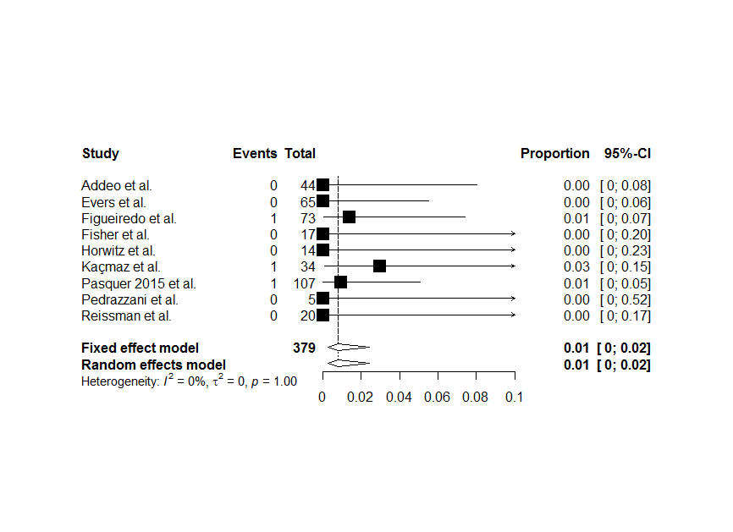
Supplementary Figure 1B. Pooled 30-day mortality in high volume centers
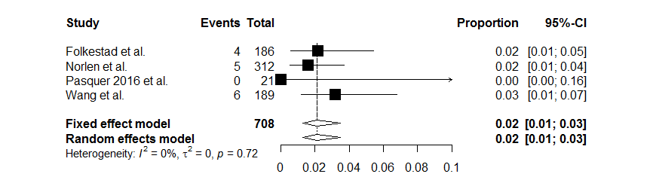
Supplementary Figure 1C. Pooled 90-day mortality in low volume centers

Supplementary Figure 1D. Pooled 90-day mortality in high volume centers
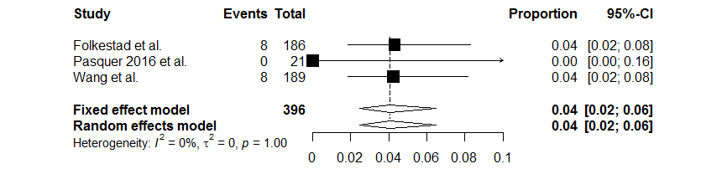
Supplementary Figure 1E. Pooled in-hospital mortality in low volume centers
Supplementary Figure 1F. Pooled overall morbidity in low volume centers
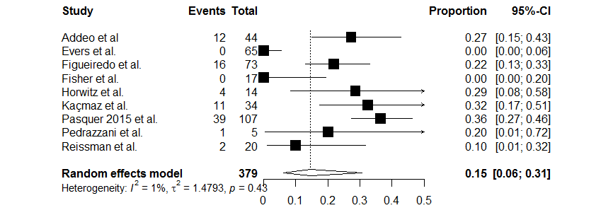

Supplementary Figure 1G. Pooled overall morbidity in high volume centers
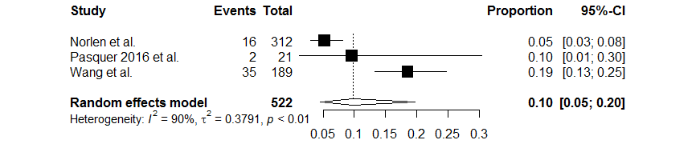
Supplementary Figure 1H. Pooled severe morbidity in low volume centers
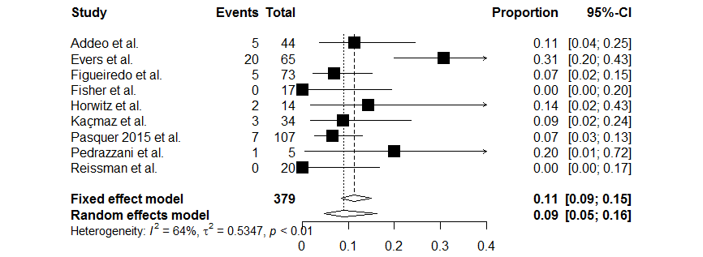
Supplementary Figure 1I. Pooled severe morbidity in high volume centers
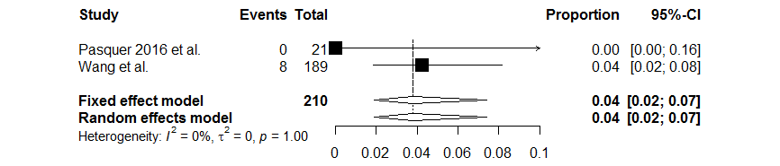

Supplementary Figure 2A. Pooled overall morbidity rates for MIS
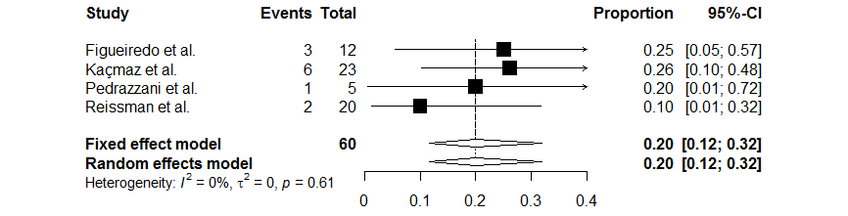
Supplementary Figure 2B. Pooled severe morbidity rates for MIS
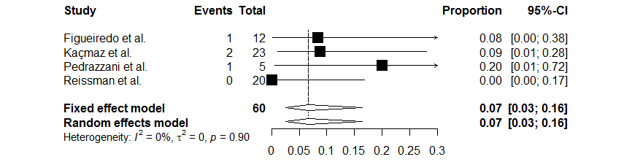
Supplementary Figure 3A. Funnel plot of severe morbidity, Clavien Dindo grade III-IV.
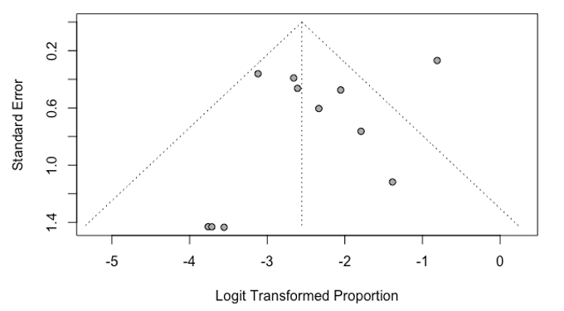

Supplementary Figure 3B. Funnel plot of 30-day mortality
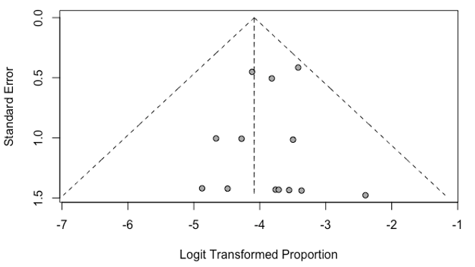
Supplementary Figure 3C. Funnel plot of 90-day mortality
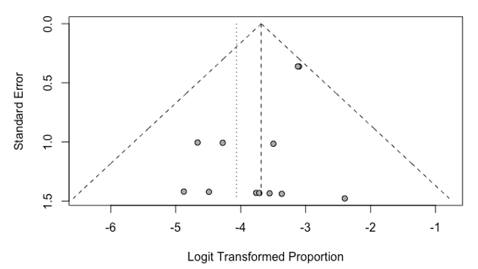
Supplementary Figure 3D. Funnel plot of in-hospital mortality
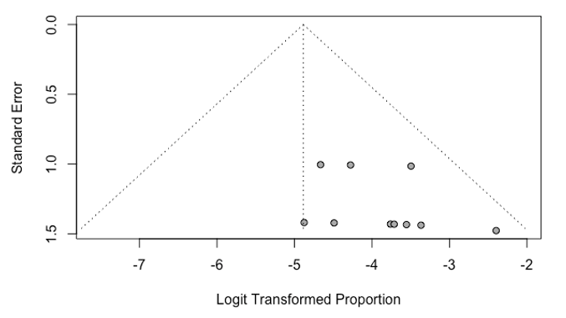
Supplementary Figure 4A. Funnel plot of overall morbidity for MIS
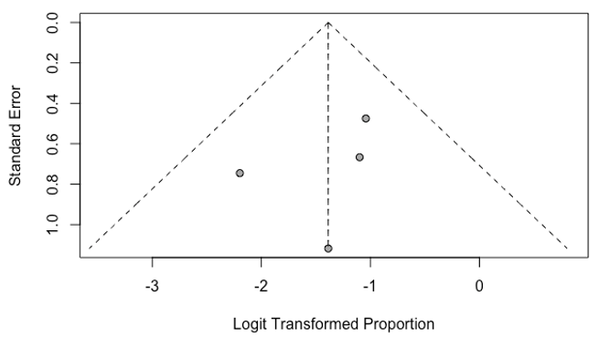
Supplementary Figure 4B. Funnel plot of severe morbidity for MIS
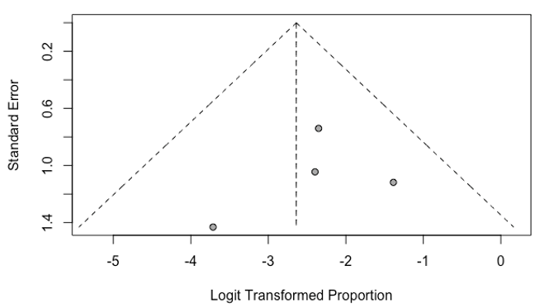
Supplementary figure 5A. Funnel plot of 30-day mortality in low volume hospitals
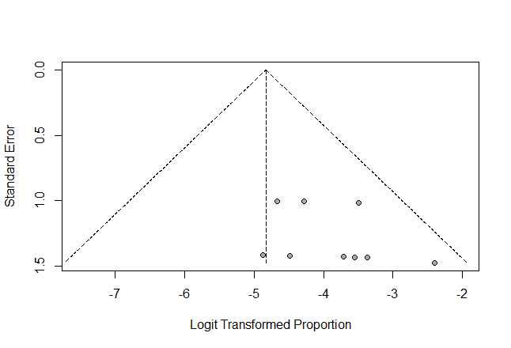
Supplementary figure 5B. Funnel plot of 30-day mortality in high volume hospitals
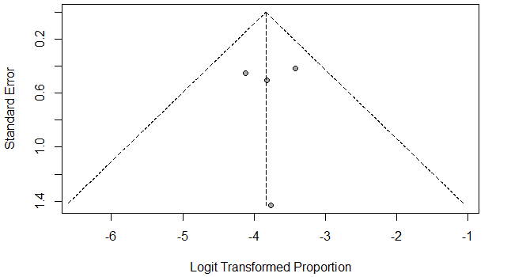
Supplementary figure 5C. Funnel plot of 90-day mortality in low volume hospitals
Supplementary figure 5D. Funnel plot of 90-day mortality in high volume hospitals


