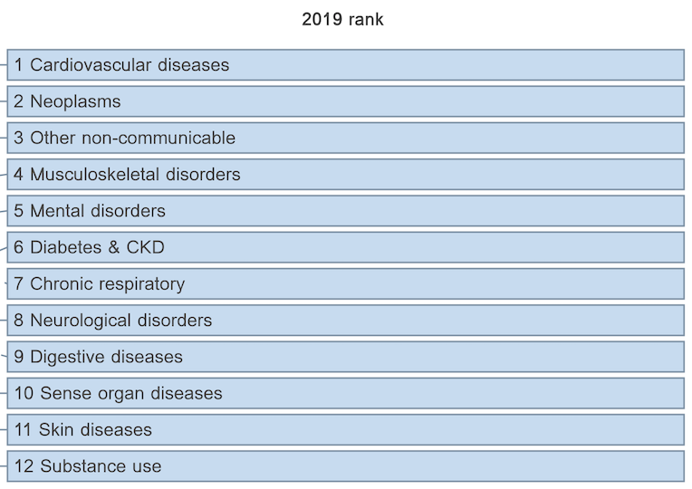

List of NCD risk factors to be included in the review
Tobacco use
Physical Inactivity
Harmful use of alcohol
Unhealthy diet
Raised blood pressure
Overweight/Obesity
High blood glucose
Hyperlipidemia

