Supplementary Figures
Factors that affect heart rate variability following acute resistance exercise: A systematic review and meta-analysis.

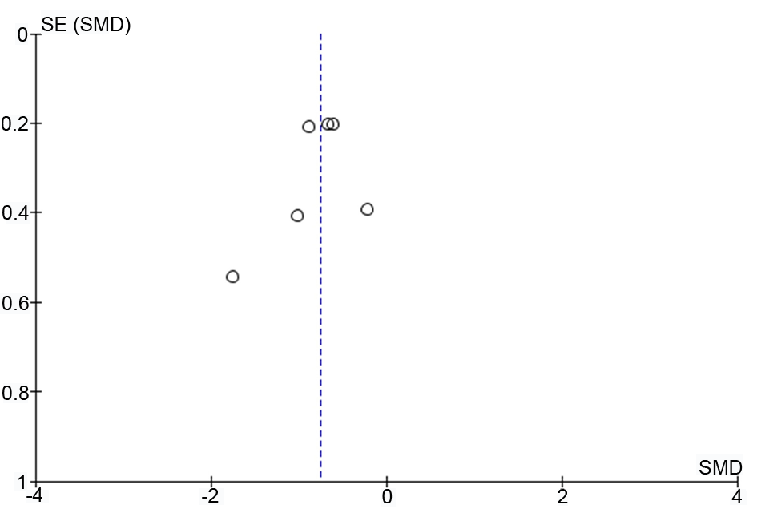
Fig. S1. Funnel plot RMSSD control - treatment groups

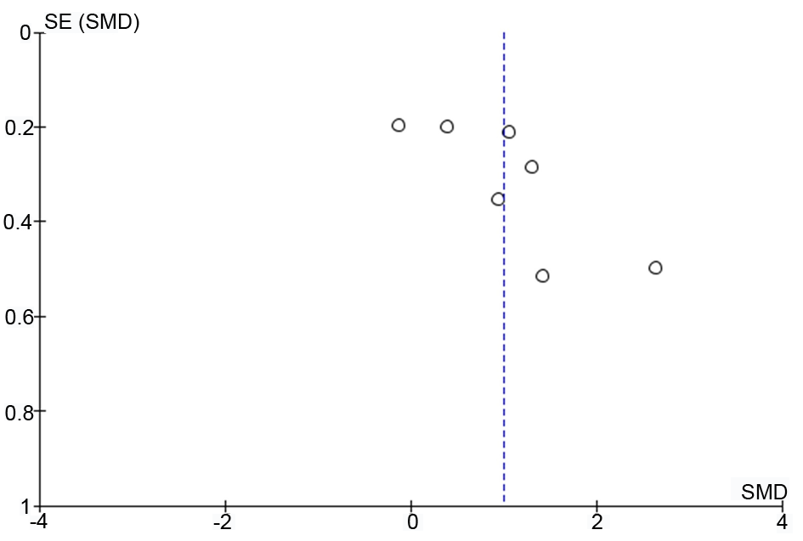
Fig. S2: Funnel plot LFnu control - treatment groups
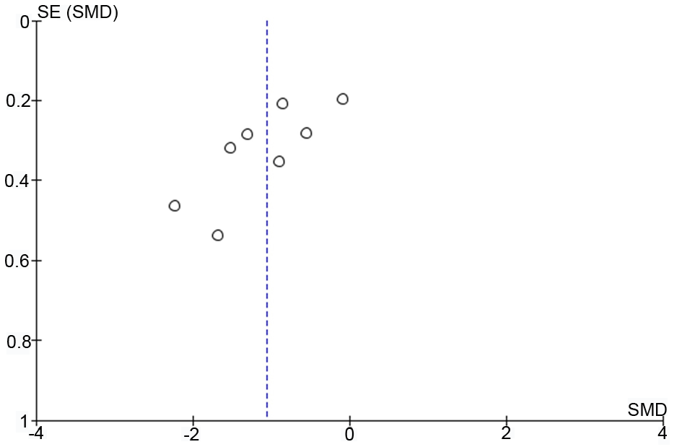
Fig. S3: Funnel plot HFnu control - treatment groups
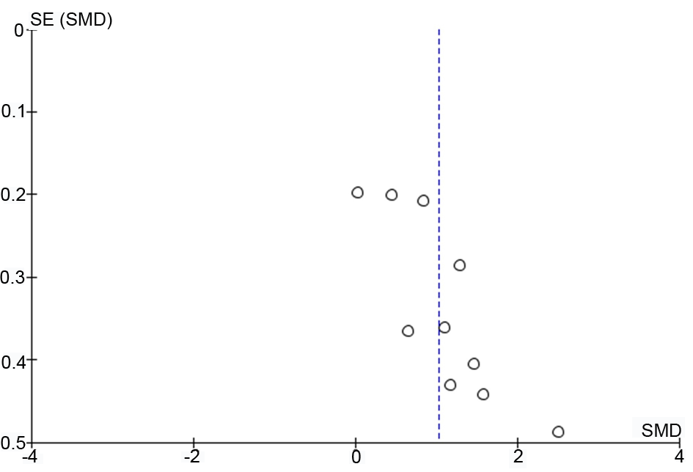
Fig. S4: Funnel plot LF/HF ratio - control group vs. treatment group

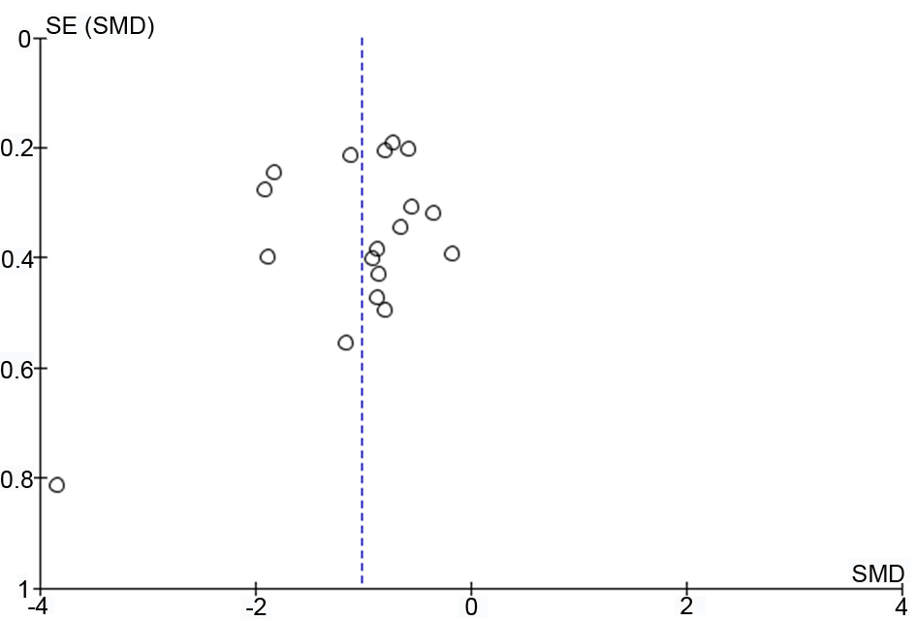
Fig. S5: Funnel plot RMSSD - pre-post test

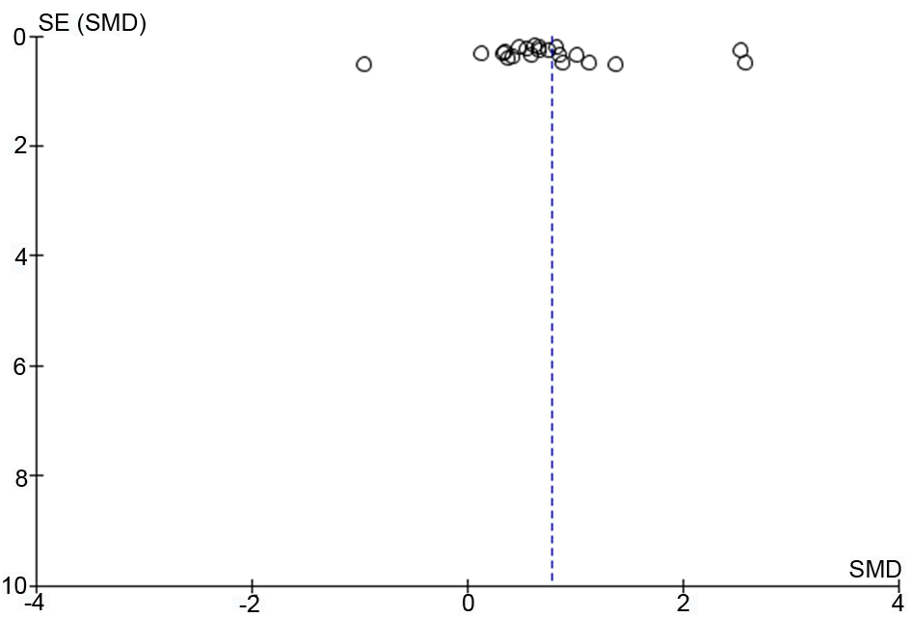
Fig. S6: Funnel plot LFnu - pre-post test

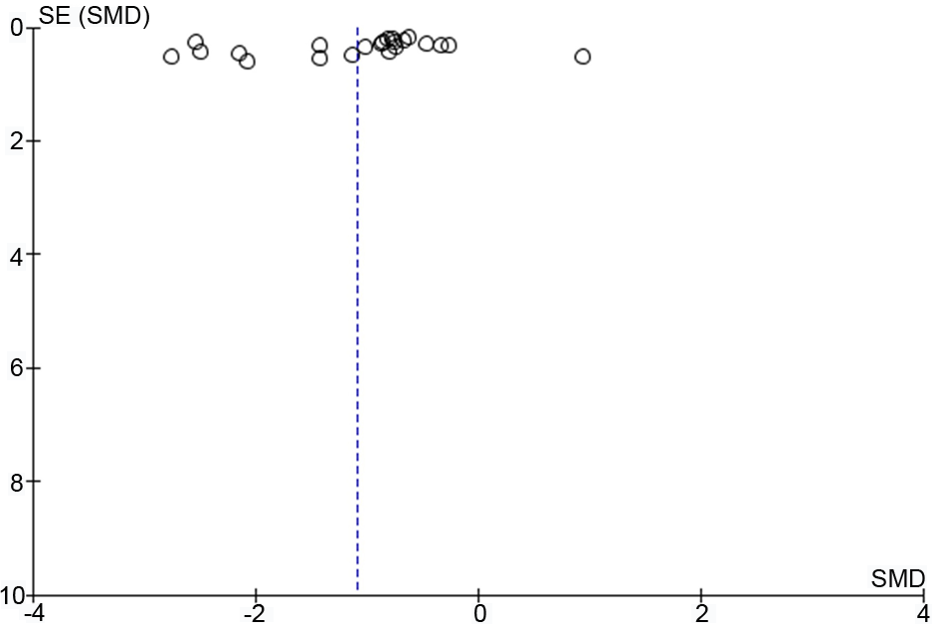
Fig. S7: Funnel plot HFnu - pre-post test

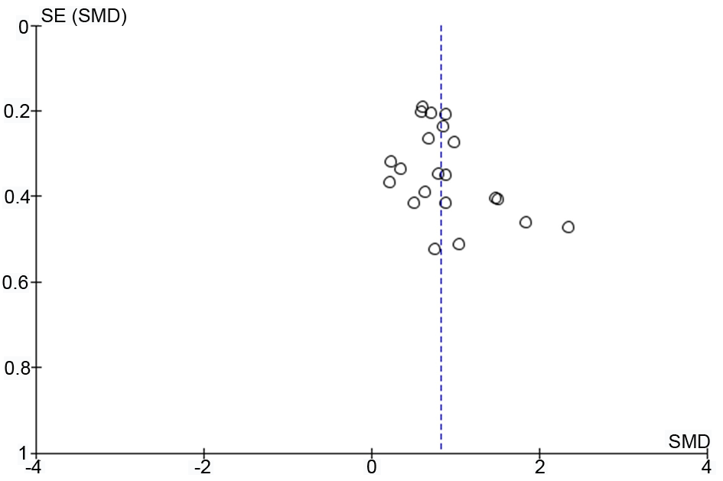
Fig. S8: Funnel plot LF/HF ratio - pre-post test
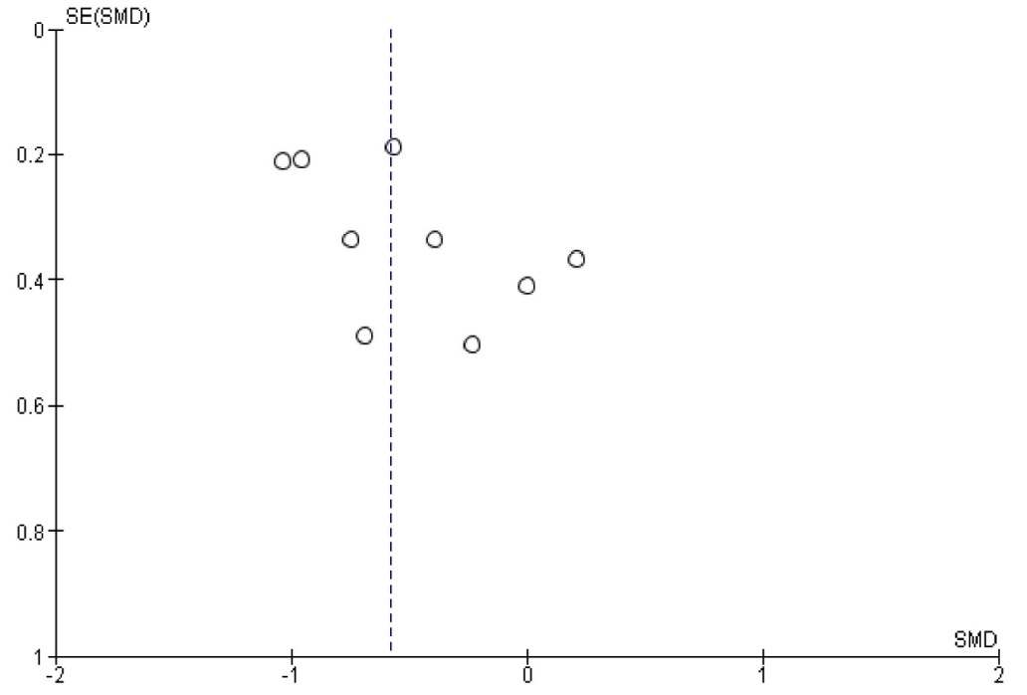
Fig. S9: Funnel plot SDNN - pre-post test

