SUPPLEMENTARY MATERIAL

Review
Immediate effect of high-intensity exercise on brain-derived neurotrophic factor in healthy young adults: A systematic review and meta-analysis
Running head: Immediate effect of high-intensity exercise on BDNF
Rubén Fernández-Rodríguezª, Celia Álvarez-Bueno^{a,b,}*, Isabel A Martínez-Ortegaª, Vicente Martínez-Vizcaíno^{a,c}, Arthur Eumann Mesas^{a,d}, Blanca Notario-Pachecoª
ª Health and Social Research Center, Universidad de Castilla-La Mancha, Cuenca 16071, Spain.
^{b} Universidad Politécnica y Artística del Paraguay, Asunción 2024, Paraguay.
^{c} Faculty of Medicine, Universidad Autónoma de Chile, Talca 3460000, Chile.
^{d} Postgraduate Program in Public Health, Universidad Estadual de Londrina, Londrina 86051-990, Brazil.
*Corresponding author.
Email address: Celia.AlvarezBueno@uclm.es (C. Álvarez-Bueno).

Index:

ID | Subheading | Page number(s)
Table s1 | Search strategy for Medline | 3
TAble s2 | Characteristics of the RCTs included for the systematic review. | 4-5
table s3 | Characteristics of the non-RCTs included for the systematic review. | 6-7
Table S4 | GRADE Summary of findings | 8
table S5 | Sensitivity analysis | 9
table S6 | Subgroup analyses | 10
Table s7 | Publication bias | 10
Table s8 | Commercial ELISA kits and power analyses | 11
 | Risk of bias appendix | 12
figure s1 | Risk of bias of randomized controlled trials | 13
figure s2 | Risk of bias of non-randomized controlled trials | 14
figure s3 | Forest plot of the pooled effect size on serum BDNF for the effect of high intense interval- vs non-interval exercise. | 15
figure s4 | Forest plot of the mean raw differences in serum BNDF of high intense interval- vs non-interval exercise. | 15
figure s5 | Meta-regression model based on minutes | 16
figure s6 | Meta-regression model based on cardiorespiratory fitness | 17

Table S1. Search strategy for the Medline.

Search set Medline
#1 brain derived neutrophic factor [All Fields]
#2 brain derived neutrophic factor [MeSH Terms]
#3 BDNF [All Fields]
#4 High intensity interval training [All Fields]
#5 HIIT [All Fields]
#6 SIT [All Fields]
#7 vigorous physical exercise [All Fields]
#8 young adults [All Fields]
#9 RCT [All Fields]
#10 randomized controlled trial [All Fields]
#11 controlled trial [All Fields]
#12 clinical trial [All Fields]
#13 non-randomized clinical trial [All Fields]
#14 intervention [All Fields]
#15 1 OR 2 OR 3
#16 4 OR 5 OR 6 OR 7
#17 9 OR 10 OR 11 OR 12 OR 13 OR 14
#18 15 AND 8 AND 16 AND 17

Table S2. Characteristics of the RCTs included for the systematic review.
Table S2. Characteristics of the RCTs included for the systematic review.
Author, Year | Country | Design | Gender | VO2 Max (ml/kg/min) | Age | n_{T} | Groups | Intervention | HI type | Comparison | BDNF measure | Main results
Antunes et al. (2019)⁴⁷ | Brazil | RCT crossover | Male | 50.5 | IG: 28.8±5.6 | 28 | n = 28  IG1, IG2, IG3 | IG1: LIE; <60% VO2max  IG2: MIE; 60-75% VO2max  IG3: HIE; >90% VO2max  Time: until exhaustion or 60 min  Type: Aerobic  48h recovery between sessions | Aerobic | LIE, MIE | NR (pg/mL) | Increase of BDNF post HI exercise compared with other modalities.
Baird et al. (2018)³⁰ | USA | RCT crossover | Mixed | 40.91 | IG1: 22.8±3.3  IG2: 23.2±2.9  CG: 24.1±3.4 | 48 | IG1 = 16  IG2 = 16  CG = 16 | IG1: LIE; 40 % max resistance  IG2: HIE; 80% max resistance  CG: Rest (sit quietly for 20 min)  Time: until expended 200 kcals (16.75-28.67 min)  Type: Aerobic (cyclo-ergometer) | Aerobic (cyclo-ergometer) | LIE, resting | Plasma (pg/mL) | Increment of BDNF post-exercise was not significant.
Cabral-Santos et al. (2016)⁴⁸ | Brazil | RCT crossover | Male | 59.94 | IG: 25.2±1.7 | 10 | n = 10  IG1, IG2 | IG1: HIIT 1.25km (1' at 100%Vo2 peak with 1' of passive recovery)  IG2: HIIT 2.5km  Time: until complete km  Type: Aerobic (treadmill)  72h recovery between sessions | Aerobic (treadmill) | HIE (different distance) | Serum (ng/mL) | Increase of BDNF post HI exercise compared with other modalities.
Roh et al. (2016)⁴⁶ | Republic of Korea | RCT crossover | Male | 55.1 | IG: 20.8±1.1 | 15 | n = 15  IG1, IG2, IG3 | IG1: LIE; 50% VO2max  IG2: MIE; 65% VO2max  IG3: HIE; 85% VO2max  Time: until reached 300kcal with Bruce Protocol  Type: Aerobic (running)  7 days of wash-out period | Aerobic (treadmill) | LIE and MIE | Serum (ng/mL) | Serum BDNF was significantly higher after moderate and HI exercises.
Saucedo-Marquez et al. (2015)⁴⁹ | Belgium | RCT crossover | Male | 56.6 | IG: 27.5±4.5 | 29 | n = 29  IG1, IG2, CG | IG1: Continuous protocol; 70% MWR  IG2: HIE; 1x90% MWR, 1x 60W  CG: Rest  Time: 20’  Type: Aerobic (cyclo-ergometer)  7 days of wash-out period | Aerobic (cyclo-ergometer) | MICT and resting | Serum (pg/mL) | Both exercises protocols significantly increased BDNF compared with control condition.
Slusher et al. (2018)³⁶ | USA | RCT crossover | Male | 43.62 | IG: 23.6±1.1 | 13 | n = 13  IG1, IG2 | IG1: HIE (10xall out 20’’; active recovering 10’’)  IG2: Seated rest (5’)  Type: Aerobic (cyclo-ergometer)  2wk between interventions | Aerobic (cyclo-ergometer) | Resting | Both (ng/mL) | Serum BDNF concentrations were significantly higher immediately following HI. No differences in control condition.

Table S2. Characteristics of the RCTs included for the systematic review (continue).
Author, Year | Country | Design | Gender | VO2 Max (ml/kg/min) | Age | n_{T} | Groups | Intervention | HI type | Comparison | BDNF measure | Main results
Domínguez-Sánchez et al. (2018)⁵¹ | Colombia | RCT parallel | Male | 40.9 | IG1: 24.5±3.7  IG2: 22.8±3.1  IG3: 22.2±3.4  CG: 24.7±3.4 | 51 | IG1 = 14  IG2 = 12  IG3 = 13  CG = 12 | IG1: HIIT (4x4 85-95% HRmax)  IG2: Resistance (12-15reps,50-70% 1RM, 60’’ rest)  IG3: Combined HIIT and resistance  CG: non-exercising | Aerobic | Resistance and non-exercising | Plasma (ng/mL) | Greater increment of BDNF for the combined training group.
Helm et al. (2017)⁵² | USA | RCT parallel | Mixed | - | IG: 24.5±2.8  CG: 23.9±2.4 | 54 | IG = 27  CG = 27 | IG: HIE (80% HR max)  CG: Learning + rest  Type: Aerobic | Aerobic | Resting | Serum (ng/mL) | Increase of circulating BDNF on HI group.
Etnier et al. (2016)³⁵ | USA | RCT crossover | Mixed (43.8%) | - | 23.06±2.2 | 16 | IG = 16 | IG: HIE at VO2 max intensity (27’) | Aerobic (treadmill) | VT-20% | Serum (pg/mL) | Significant increment of serum BDNF from baseline for HI at VO2 max.
Hwang et al. (2016)⁴⁵ | USA | RCT parallel | Mixed (44.85% female) | 38.12 | IG: 22.8±3.1  CG: 24.3±3.0 | 58 | IG = 29  CG = 29 | IG: HIE (85-90% VO2 max) 20’ (2’ warm-up/5’adjusting speed and incline/10’ target intensity/3’cool down)  CG: 10’ sitting quietly  Type: Aerobic | Aerobic | Resting | Serum (ng/mL) | BDNF significantly increased immediately on HI group, but returned to baseline levels at post 30 min-exercise.
Inoue et al. (2020)²⁸ | Brazil | RCT parallel | Male | - | 30.0±5.4 | 20 | n = 20  IG1 = 10  IG2 = 10 | IG1: HIE (10x1 at 100% maximal aerobic velocity, 1’ passive recovery between intervals)  IG2: MICT at 65% maximal aerobic velocity  Time: 40'  Type: Aerobic (treadmill) | Aerobic (treadmill) | MICT | Serum (ng/mL) | Significant difference between pre-post exercise at week 1 and 6 for mBDNF.
Rentería et al. (2019)⁵⁰ | Mexico | RCT parallel | Female | - | IG: 22±1.6  CG: 21.3±0.8 | 17 | IG = 9  CG = 8 | IG: HIIT (3-5bouts of 30’’ 80% MAP - 4’ 40% MAP), 3xwk/4wks  CG: rest  Type: Aerobic | Aerobic | Resting | Serum (pg/mL) | BDNF significantly increased immediately post HIIT exercise.
Abbreviation: BDNF: Brain-derived neurotrophic factor; CG: control group; HI: high intensity; HIIT: high intensity interval training; HR: heart rate; IG: intervention group; LI: low intensity; MAP: maximal aerobic power; MI: moderate intensity; MICT: moderate intensity continuous training; MWR: maximal work rate; NR: not reported; n_{T}: total sample size; RCT: randomized controlled trial; VO2max: maximal oxygen consumption; VT: ventilatory threshold; W: watt; wks: weeks.

Table S3. Characteristics of the non-RCTs included for the systematic review.
Table S3. Characteristics of the non-RCTs included for the systematic review.
Author, Year | Country | Design | Gender | VO2 Max (ml/kg/min) | Age | n_{T} | Groups | Intervention | HI type | Comparison | BDNF measure | Main results
Battista et al. (2018)³⁷ | Canada | non-RCT | Male | 43.3 | 28.8±5.3 | 11 | IG = 11 | IG: HIE (8-12 x 60’ at 100% peak power output, 75’’ rest at 50W) | Aerobic (cyclo-ergometer) | - | Plasma (pg/mL) | Significant acute increase of BDNF post HI exercise.
García-Suárez et al. (2020)⁴⁴ | Mexico | non-RCT | Female | 38.1 | 30.0±0.9 | 17 | n= 17 | IG: HIIT (30''x90% MAP, interspersed with 90-120'' at 40% MAP), Time: 12 min | Aerobic (treadmill) | GXT (cyclo-ergometer graded exercise test) | Serum (ng/mL) | The magnitude of change was small in both groups
Gmiat et al. (2017)⁶ | Poland | non-RCT | Female | 33 | IG1: 20±4  IG2: 41±7 | 14 | IG1  (Young) = 8  IG2  (Middle) = 6 | IG: HIE ‘Circuit training’ (many repetitions as possible within 30’’)  Time: 7’ x 3 sets (2’ rest)  Type: Calisthenics resistance | Resistance | - | Serum (ng/mL) | Trivial increase of BDNF 24 hours post-exercise in both groups.
Mang et al. (2014)³⁸ | Canada | non-RCT | Mixed (50%) | 45.36 | IG: 23.9±3.7 | 16 | n = 16  IG = 16 | IG: HIE (90% of maximal power out in watts), 20’  CG: Learning + rest  Type: Aerobic (cyclo-ergometer) | Aerobic (cyclo-ergometer) | Resting | Serum (pg/mL) | Increase of BDNF post HI exercise.
Martínez-Díaz et al. (2020) | Spain | non-RCT | Male | 47.1 | 21.7 | 25 | n= 25 | IG: HIIT (10x1 at VO2peak with 1 min of passive recovery between intervals) Time: X | Aerobic (cyclo-ergometer) | - | Plasma (pg/mL) | Significant increase of BDNF post high intensity exercise
Nicolini et al. (2020)³⁹ | Canada | non-RCT | Male | 34.7 | IG: 23±3  CG: 25±4 | 40 | n = 40  IG1 = 21  CG = 19 | IG1: HIE (3' at 50W, 5x1' intervals at 105-125% Wpeak interspersed with 1.5' of active recovery at 30% Wpeak, 2' cool down at 50W)  CG: Sitting (27.5')  Time: 17.5'  Type: Aerobic (cyclo-ergometer) | Aerobic (cyclo-ergometer) | Resting | Serum (pg/mL) | Significant increase of BDNF after 30 min of HI exercise, not change in control condition.
Pereira et al. (2018)⁴¹ | Brazil | non-RCT | Male | - | IG: 31±5 | 10 | n = 10  IG = 10 | IG: HIE (as many reps as possible), 9’  Type: Resistance (3 exercises: clean/wall ball and doble-single-under) | Resistance | - | Serum (pg/mL) | Significant increase of BDNF post HI exercise.
Reycraft et al. (2019)⁴² | Canada | non-RCT | Male | 51.2 | IG: 23±3 | 8 | n = 8  IG1, IG2, IG3, CG | IG: Moderate (MICT 65% VO2max)  IG2: Vigorous (VICT 85% VO2max)  IG3: SIT  CG: non-exercising  Type: Resistance (3 exercises: clean/wall ball and doble-single-under)  Random order of each training method | Resistance | MICT, resting and non-exercising | Plasma (pg/mL) | Significant increase of BDNF post SIT exercise, with plasma concentrations recovering 30- and 90-min post-exercise.

Table S3. Characteristics of the non-RCTs included for the systematic review (continue).
Author, Year | Country | Design | Gender | VO2 Max (ml/kg/min) | Age | n_{T} | Groups | Intervention | HI type | Comparison | BDNF measure | Main results
Rodríguez et al. (2018)²⁹ | USA | non-RCT | Male | Obese: 33.88 Normal weight: 51.77 | IG: 25±1.7  CG: 22.6±0.7 | 12 | n = 12  IG1 = 6 (obese)  IG2 = 6 (normal weight) | IG1, IG2: HIIT (4x4’ intervals at 80-90% VO2max/ 3’ 50-60% VO2max) 3xwk/4wks  IG1, IG2: Continuous protocol (38’ at 50-60% VO2 max)  Type: Aerobic  Both interventions were caloric equated | Aerobic | MICT | Serum (ng/mL) | BDNF increment was greater after HIIT in obese than in normal weight males. No differences in BDNF after continuous training protocol in both groups.
Schmidt-Kassow et al. (2012)⁴³ | Germany | non-RCT | Mixed | - | IG: 22.5±2.4 | 40 | n = 40  20 men/ 20women | IG1: HIE (150bpm)  IG2: LIE (130bpm)  Time: 30’  Type: Aerobic (cyclo-ergometer)  48h between sessions | Aerobic (cyclo-ergometer) | LIE | Serum (pg/mL) | No differences between HI and LI exercises at baseline and recovery (10-30’ post).
Abbreviation: BDNF: Brain-derived neurotrophic factor; CG: control group; HIE: high intensity exercise; HIIT: high intensity interval training; HR: heart rate; IG: intervention group; LIE: low intensity exercise; MAP: maximal aerobic power; MIE: moderate intensity exercise; MICT: moderate intensity continuous training; MWR: maximal work rate; NR: not reported; n_{T}: total sample size; RCT: randomized controlled trial; VO2max: maximal oxygen consumption; VT: ventilatory threshold; W: watt; wks: weeks.

Table S4. GRADE assessment.
Certainty assessment |  |  |  |  |  |  | № of patients |  | Effect |  | Certainty | Importance
№ of studies | Study design | Risk of bias | Inconsistency | Indirectness | Imprecision | Other considerations | HIE | MI, LI or control conditions | Relative  (95% CI) | Absolute  (95% CI) | Certainty | Importance
Serum brain-derived neurotrophic factor (pg/ml) (assessed with: Enzyme-linked immunosorbent assay (ELISA) and multiplexing assay; Scale from: 0 to 26125.10)
12 | randomised trials | serious ª | serious ^{b} | not serious | serious ^{c} | strong association | 248 | 219 | - | SMD 0.78 SD higher  (0.35 higher to 1.25 higher) | ⨁⨁◯◯  LOW | IMPORTANT
CI: Confidence interval; SMD: Standardized mean difference

Explanations
a. Among the included studies, seven were rated as 'some concerns' and five as 'low risk of bias'. Mainly due to the randomization process, the deviations of intended interventions and the measurement of the outcome.
b. The inconsistency showed by meta-analysis represented 'substantial' heterogeneity levels (73.8%).
c. Results among included studies showed not high precision levels in the 95% CI related with the effects of exercise in BDNF levels since some studies reported not significant changes on the BDNF measures.

Table S5. Sensitivity analysis.
Excluding one by one
Study | ES | LL | UL
Baird et al, 2018 (b) | 0.808 | 0.335 | 1.282
Domínguez-Sánchez et al, 2018 | 0.853 | 0.401 | 1.304
Baird et al, 2018 (a) | 0.844 | 0.385 | 1.302
Helm et al, 2017 | 0.811 | 0.324 | 1.297
Rentería et al, 2019 | 0.732 | 0.280 | 1.185
Roh et al, 2016 (a) | 0.732 | 0.280 | 1.184
Antunes et al, 2019 (a) | 0.768 | 0.278 | 1.258
Saucedo-Marquez et al, 2015 | 0.590 | 0.335 | 0.846
Inoue et al, 2020 | 0.848 | 0.397 | 1.299
Antunes et al, 2019 (b) | 0.786 | 0.293 | 1.279
Roh et al, 2016 (b) | 0.825 | 0.367 | 1.283

Table S6. Subgroup analyses.
Study | ES | LL | UL
Intensity
HIE versus control group (n:4) | 0.55 | 0.12 | 0.98
HIE versus LIE (n:3) | 0.78 | 0.15 | 1.40
HIE versus MIE (n:4) | 0.93 | -0.16 | 2.02
Duration
< 30 minutes (n:5) | 1.03 | 0.17 | 1.88
> 30 minutes (n:4) | 0.54 | 0.13 | 0.96
Kcal goal (n:2) | 0.83 | -0.30 | 1.96
Gender
Mixed (n:3) | 0.44 | 0.07 | 0.82
Men (n:7) | 0.87 | 0.23 | 1.52
Women (n:1) | 1.42 | 0.35 | 1.52
BDNF assessment
Plasma (n:3) | 0.27 | -0.15 | 0.70
Serum (n:8) | 0.98 | 0.45 | 1.52

Table S7. Publication bias.
 | Coefficient | SE | p-value
BNDF measure (n:8) | 1.11 | 3.03 | 0.726

Table S8. ELISA kit commercials and power analyses across the studies.
Study | ELISA kit commercial | Power analysis
Antunes, 2019 | R&D System | Not reported
Baird, 2018 | Promocell | Not reported
Cabral-Santos, 2016 | R&D System | Performed with G*Power Software
Domínguez-Sánchez, 2018 | R&D System | Performed by formula for the comparison of two means
Gmiat, 2017 | R&D System | Not reported
Helm, 2017 | R&D System | Not reported
Hwang, 2016 | R&D System | Performed with G*Power program
Mang, 2014 | R&D System | Not reported
Pereira 2018 | R&D System | Supported by literature (not calculated)
Rentería, 2019 | Abcam | Not reported
Reycraft, 2019 | Millipore | Not reported
Rodríguez, 2018 | Promega | Performed with G*Power Software
Roh, 2016 | R&D System | Not reported
Saucedo-Marquez, 2015 | R&D System | Not reported
Schmidt-Kassow, 2012 | R&D System | Not reported
Slusher, 2018 | Promega | Not reported
Inoue, 2020 | R&D System | Performed with G*Power Software
Nicolini, 2020 | R&D System | Not reported
Martínez-Díaz, 2020 | AbnovaTM kit KA0329 | Performed with G*Power Software
García-Suárez, 2020 | Abcam | Not reported
Etnier, 2016 | ALPCO | Not reported
Battista, 2018 | MULTI-ARRAY | Not reported

Risk of bias appendix:
According to the risk of bias assessment through ROBINS-I tool, there are some domains mainly distinct from the assessment of randomized trials (RoB2) such as the confounding, selection of participants and classification of interventions, while ROB2 consider the domain related with the randomization process as a source of potential bias. For instance, the risk of bias due to confounding occurs when: (i) at least one factor (prognostic variable) that predicts the outcome (BDNF) could be also implicated in the intervention received at baseline; (ii) individuals switch between the interventions being compared; and (iii) post-baseline prognostic variables affect the intervention received at baseline. There are several statistical methods to solve this such as stratification, regression, matching, standardization, g-estimation, and inverse probability weighting. In this sense, our systematic review pointed out some confounding factors that should be stated such age, health and smoking status or alcohol consumption, the presence of a single nucleotide polymorphism that may alter BDNF secretion and the trained status of the individuals due to those with a higher capacity to use BDNF who may also have higher cardiorespiratory fitness could show lower levels of serum BDNF after exercise. Consequently, most non-randomized studies were rated with moderate or serious risk of bias in this domain (4/10; 3/10, respectively). Selection of participants could be biased when each trial excludes: (i) some eligible participants; (ii) initial follow-up time of some participants; or (iii) some outcomes events, related to both intervention and outcome. The selection bias did not refer to issues of indirectness, thus, it only considers those biases that are internal to the study. Therefore, selection bias was reported when the above-mentioned items affected the estimated effect of the intervention. The third domain which differs from the assessment of RoB2 it would be the bias in classification of interventions. This bias is more related with case-control studies and cohorts, and it occurs when the interventions are defined and categorized with the knowledge of subsequent outcomes (non-differential misclassification or differential misclassification).
Deviations from intended interventions. This domain may represent bias when: (i) an intervention was not implemented successfully; (ii) participants did not adhere to interventions; or (iii) because important co-interventions were not balance between groups.
Missing data. Related with (i) the loss to follow up; (ii) incomplete data collection; and (iii) participants excluded from analyses by primary investigators.
Measurement of outcomes. As the BDNF is an objective outcome, detection bias was low for most of studies. This domain is affected if: (i) outcome assessors are aware of intervention status (particularly in subjective outcomes); (ii) different methods are used to assess the outcome; or (iii) measurement errors are related to intervention status or effects.
Selection of reported results may be biased when: (i) the study was selective for reporting a particular outcome measurement form multiple measurements; (ii) the results are selected form intervention effects estimated in multiple ways; or (iii) the results are reported based on a subgroup of participants from a larger cohort.
The judgement of each domain was rated as having a low (the study was comparable to a well performed randomized trial), moderate (the study sound for a non-randomized trial but cannot be compared to a well performed randomized trial), serious (the study had some important problems) or critical risk of bias (the study was too problematic to provide any useful evidence on the effects of intervention).

Figure S1. Risk of bias of randomized controlled trials.

Study ID | Experimental | Outcome | D1 | D2 | D3 | D4 | D5 | Overall
Baird, 2018 | RCT crossover | Plasma BDNF | ! | + | + | ! | + | !
Cabral-Santos, 2016 | RCT crossover | Serum BDNF | ! | ! | + | + | + | !
Domínguez-Sánchez, 2018 | RCT parallel | Plasma BDNF | + | + | + | + | + | +
Helm, 2017 | RCT parallel | Serum BDNF | ! | ! | + | + | + | !
Hwang, 2016 | RCT parallel | Serum BDNF | + | + | + | ! | + | !
Rentería, 2019 | RCT parallel | Serum BDNF | + | + | + | + | + | +
Roh, 2016 | RCT crossover | Serum BDNF | ! | + | + | + | + | !
Saucedo-Marquez, 2015 | RCT crossover | Serum BDNF | + | + | + | + | + | +
Etnier, 2016 | RCT crossover | Serum BDNF | ! | + | + | + | + | 
Inoue, 2020 | RCT parallel | Serum BDNF | + | + | + | + | + | +
Antunes, 2019 | RCT crossover | NA | ! | + | + | + | +
Slusher, 2018 | RCT crossover | Plasma/serum BDNF | + | + | + | + | + | +
-
!
+
: Low risk; : Some concerns; : High risk;

D1: Randomisation process; D2: Deviations from the intended interventions; D3: Missing outcome data; D4: Missing outcome data; D5: Selection of the reported result; NA: Not available.

Figure S2. Risk of bias of non-randomized controlled trials.

Author, Year | BDNF measure | Confounding | Selection of participants | Classification of interventions | Deviations from intended interventions | Missing data | Measurement of the outcomes | Selection of reported results | Overall risk of bias
Battista, 2018 | Plasma | Serious | Serious | Low | Low | Low | Low | Low | Serious
Gmiat, 2017 | Serum | Low | Low | Low | Low | Low | Low | Low | Low
Mang, 2014 | Serum | Moderate | Low | Low | Low | Low | Low | Low | Moderate
Pereira 2018 | Plasma | Moderate | Serious | Low | Low | Low | Moderate | Moderate | Serious
Reycraft, 2019 | Plasma | Low | Low | Low | Low | Low | Low | Low | Low
Rodríguez, 2018 | Serum | Serious | Moderate | Low | Low | Low | Low | Low | Serious
Schmidt-Kassow, 2012 | Serum | Moderate | Low | Low | Low | Low | Low | Low | Moderate
Nicolini, 2020 | Serum | Low | Low | Low | Low | Low | Low | Low | Low
Martínez-Díaz, 2020 | Plasma | Moderate | Low | Low | Low | Low | Low | Low | Moderate
García-Suárez, 2020 | Serum | Serious | Low | Low | Low | Low | Low | Moderate | Serious

Figure S3. Forest plot of the pooled effect size on serum BDNF for the effect of high intense interval- vs non-interval exercise. BDNF = brain-derived neurotrophic factor; SMD = standardised mean difference; HIE = high-intensity exercise; LIE = low-intensity exercise; MIE = moderate-intensity exercise. NOTE: Weights are from random effects analysis.
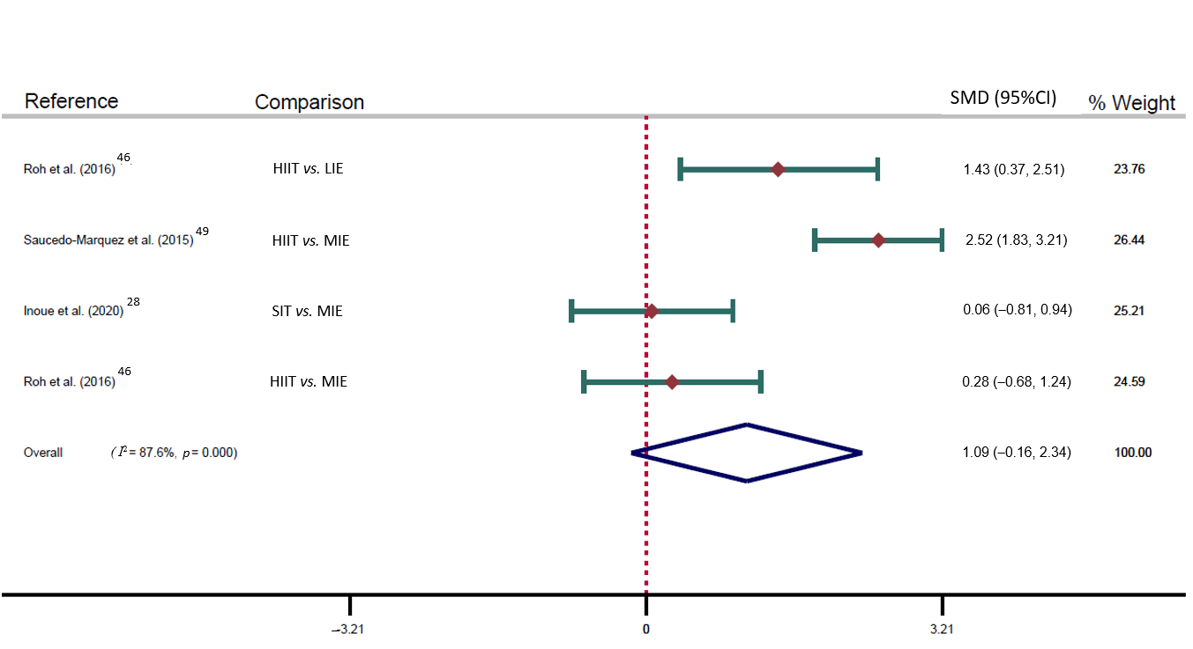

Figure S4. Forest plot of the mean raw differences in serum BNDF of high intense interval- vs non-interval exercise. BDNF = brain-derived neurotrophic factor; SMD = standardised mean difference; HIE = high-intensity exercise; LIE = low-intensity exercise; MIE = moderate-intensity exercise. NOTE: Weights are from random effects analysis.
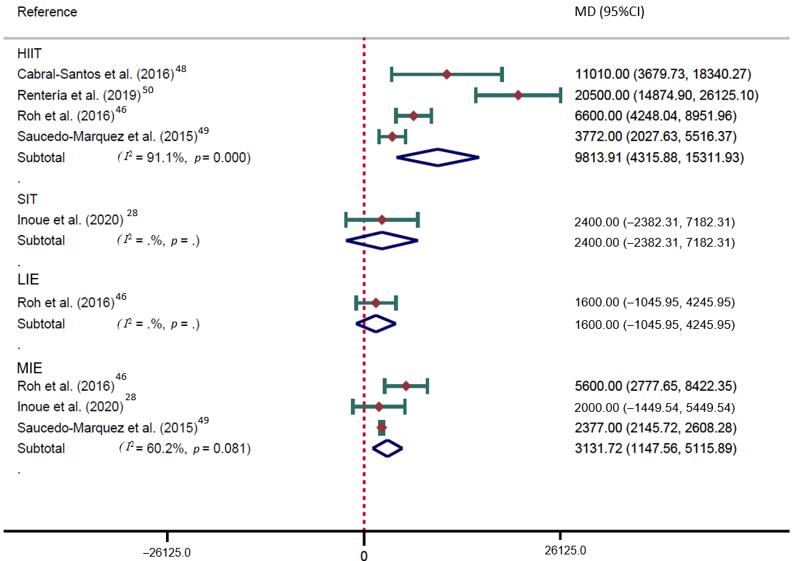
Figure S5. Meta-regression model by minutes.

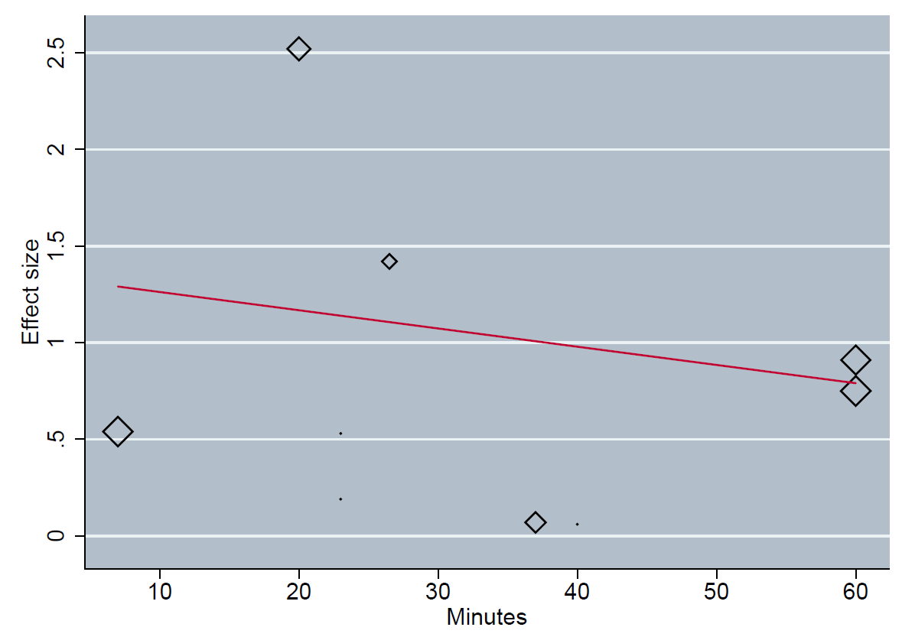

Number of observations | 9
Coef | -0.01
SE | 0.02
p | 0.63

Figure S6. Meta-regression model by cardiorespiratory fitness.
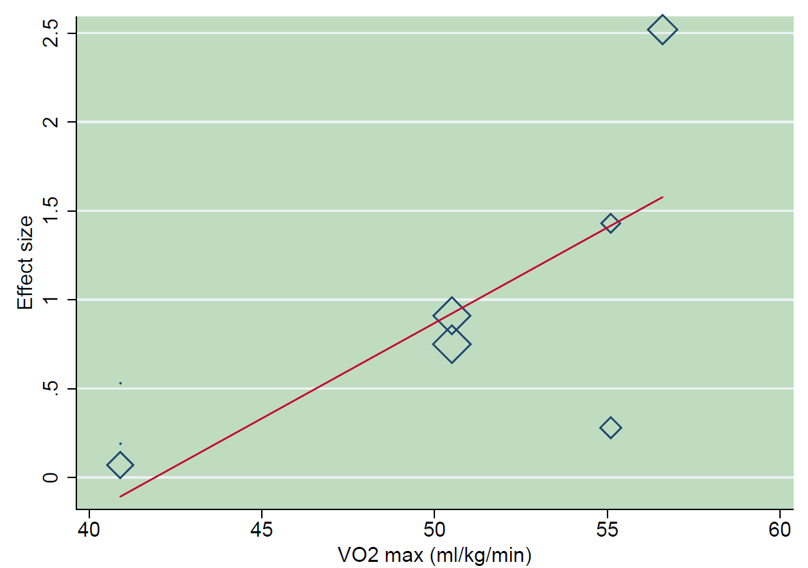

Number of observations | 8
Coef | 0.11
SE | 0.05
p | 0.10

