Supplemental Figure 2: Cochrane collaborative tool for assessing RCTs

251658240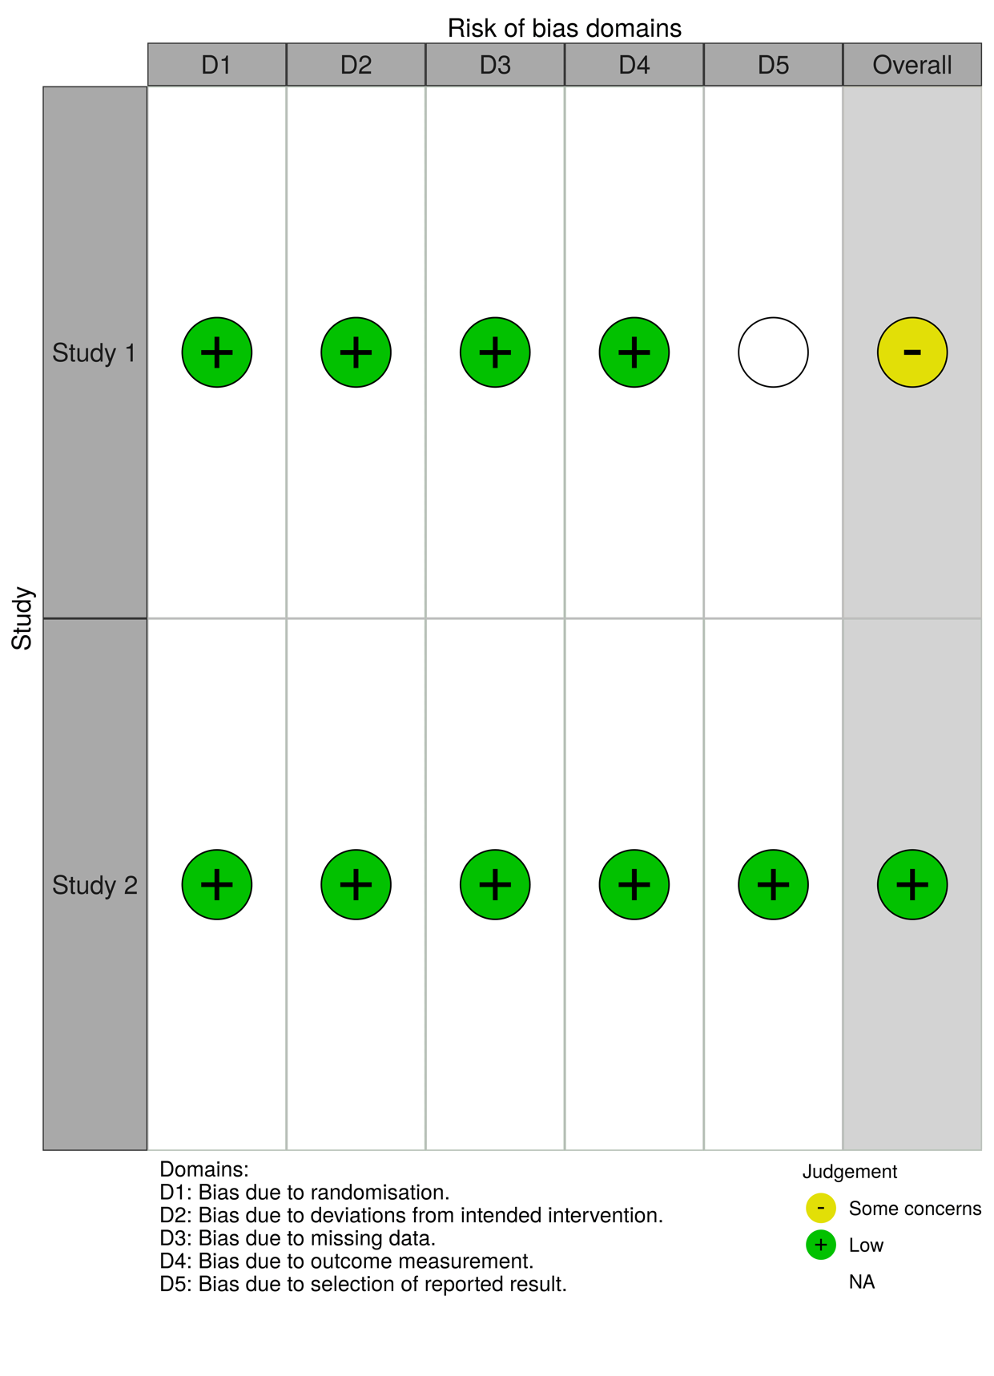

Supplemental table 1: Search string.
Study ID | Selection | Comparability | Outcome
Lambert's A | **** | ** | ***
Lambert's C | **** | ** | ***
Hamon | **** | ** | ***
Lemsle | **** | ** | ***
Fischer | **** | ** | ***
Patti | **** | ** | ***
Note: A study can receive a maximum of one for each numbered item within the Selection and Outcome categories. A maximum of two can be given for Comparability
Selection
1) Representativeness of the exposed cohort
a) truly representative of the average (describe) in the community b) somewhat representative of the average in the community c) selected group of users
d) no description of the derivation of the cohort
2) Selection of the non-exposed cohort
a) drawn from the same community as the exposed cohort
b) drawn from a different source
c) no description of the derivation of the non-expose cohort
3) Ascertainment of exposure
a) secure record (eg surgical records) b) structured interview c) written self report
d) no description
4) Demonstration that outcome of interest was not present at start of study a) yes b) no
Comparability
1) Comparability of cohorts on the basis of the design or analysis
a) study controls for (select the most important factor)
b) study controls for any additional factor.
Outcome
1) Assessment of outcome
a) independent blind assessment Ø b) record linkage
c) self report
d) no description
2) Was follow-up long enough for outcomes to occur
a) yes (select an adequate follow up period for outcome of interest) b) no
3) Adequacy of follow up of cohorts
a) complete follow up - all subjects accounted for
b) subjects lost to follow up unlikely to introduce bias - small number lost - >% (select an adequate %) follow up, or description provided of those lost) c) follow up rate < % (select an adequate %) and no description of those lost
d) no statement

