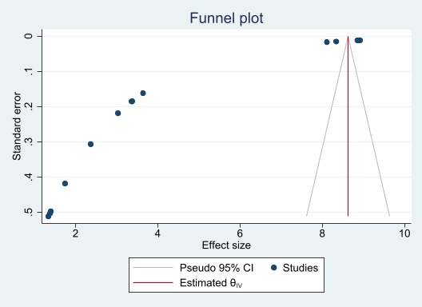
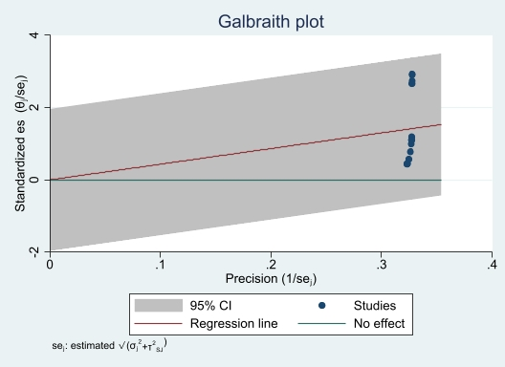
B
A

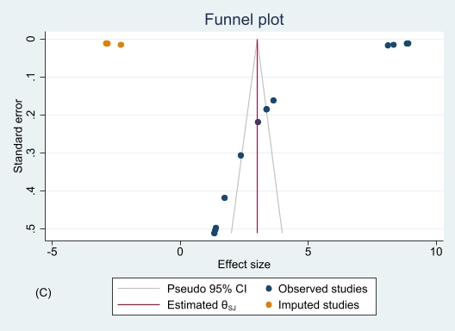

S2 Fig. Galbraith plot (A), funnel plot (B), and trim-and-fill analysis funnel plot using R₀ (C) of the incidence of childhood acute lymphoblastic leukemia. The observed effect size for the trim-and-fill analysis is 4.32 (95% CI 2.66-5.99), while the observed and imputed effect size is 3.00 (95% CI 1.07-4.92).

