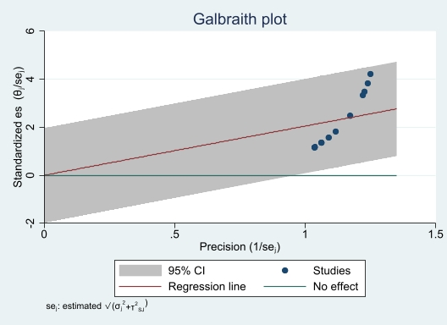
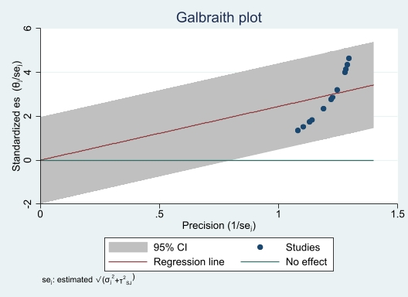
S3 Fig. Galbraith plot of childhood acute lymphoblastic leukemia incidence in males (A) and females (B).
B
A

