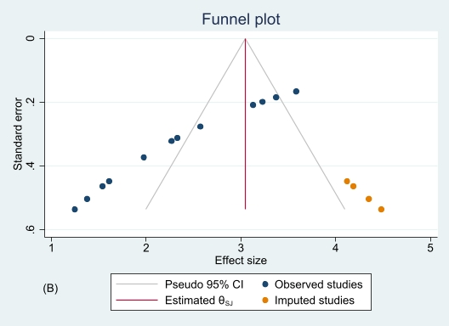
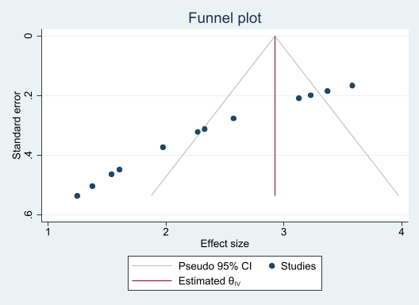

A

S4 Fig. Funnel plot (A) and trim-and-fill analysis using R₀ (B) of the incidence of childhood acute lymphoblastic leukemia in males. The observed effect size for the trim-and-fill analysis is 2.93 (95% CI 2.76-3.08), while the observed and imputed effect size is 3.05 (95% CI 2.90-3.19).

