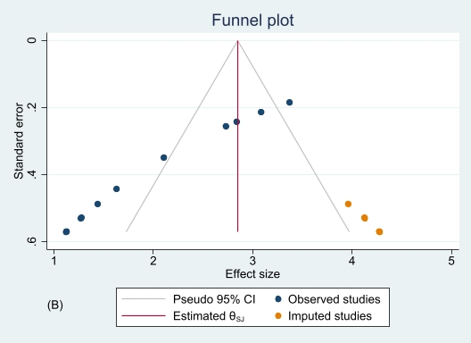
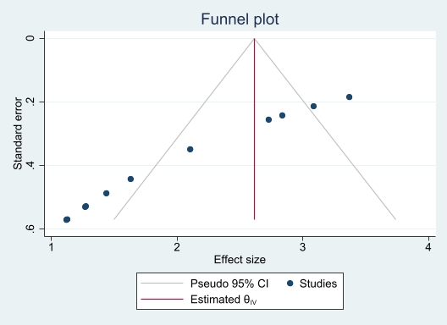

A

S5 Fig. Funnel plot (A) and trim-and-fill analysis using R₀ (B) of the incidence of childhood acute lymphoblastic leukemia in females. The observed effect size for the trim-and-fill analysis is 2.62 (95% CI 2.44-2.80), while the observed and imputed effect size is 2.85 (95% CI 2.68-3.02).

