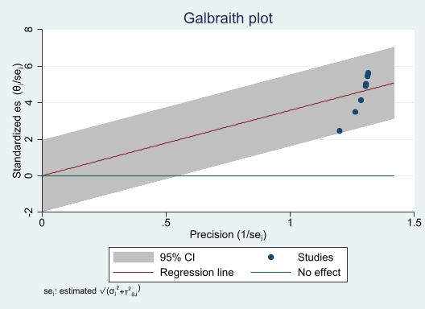

S6 Fig. Galbraith plot of the case fatality rate of childhood acute lymphoblastic leukemia.

