Supplementary Figure 1: Single-arm meta-analysis of overall pooled outcome rate of hemorrhagic complications in the ASA Con-Group
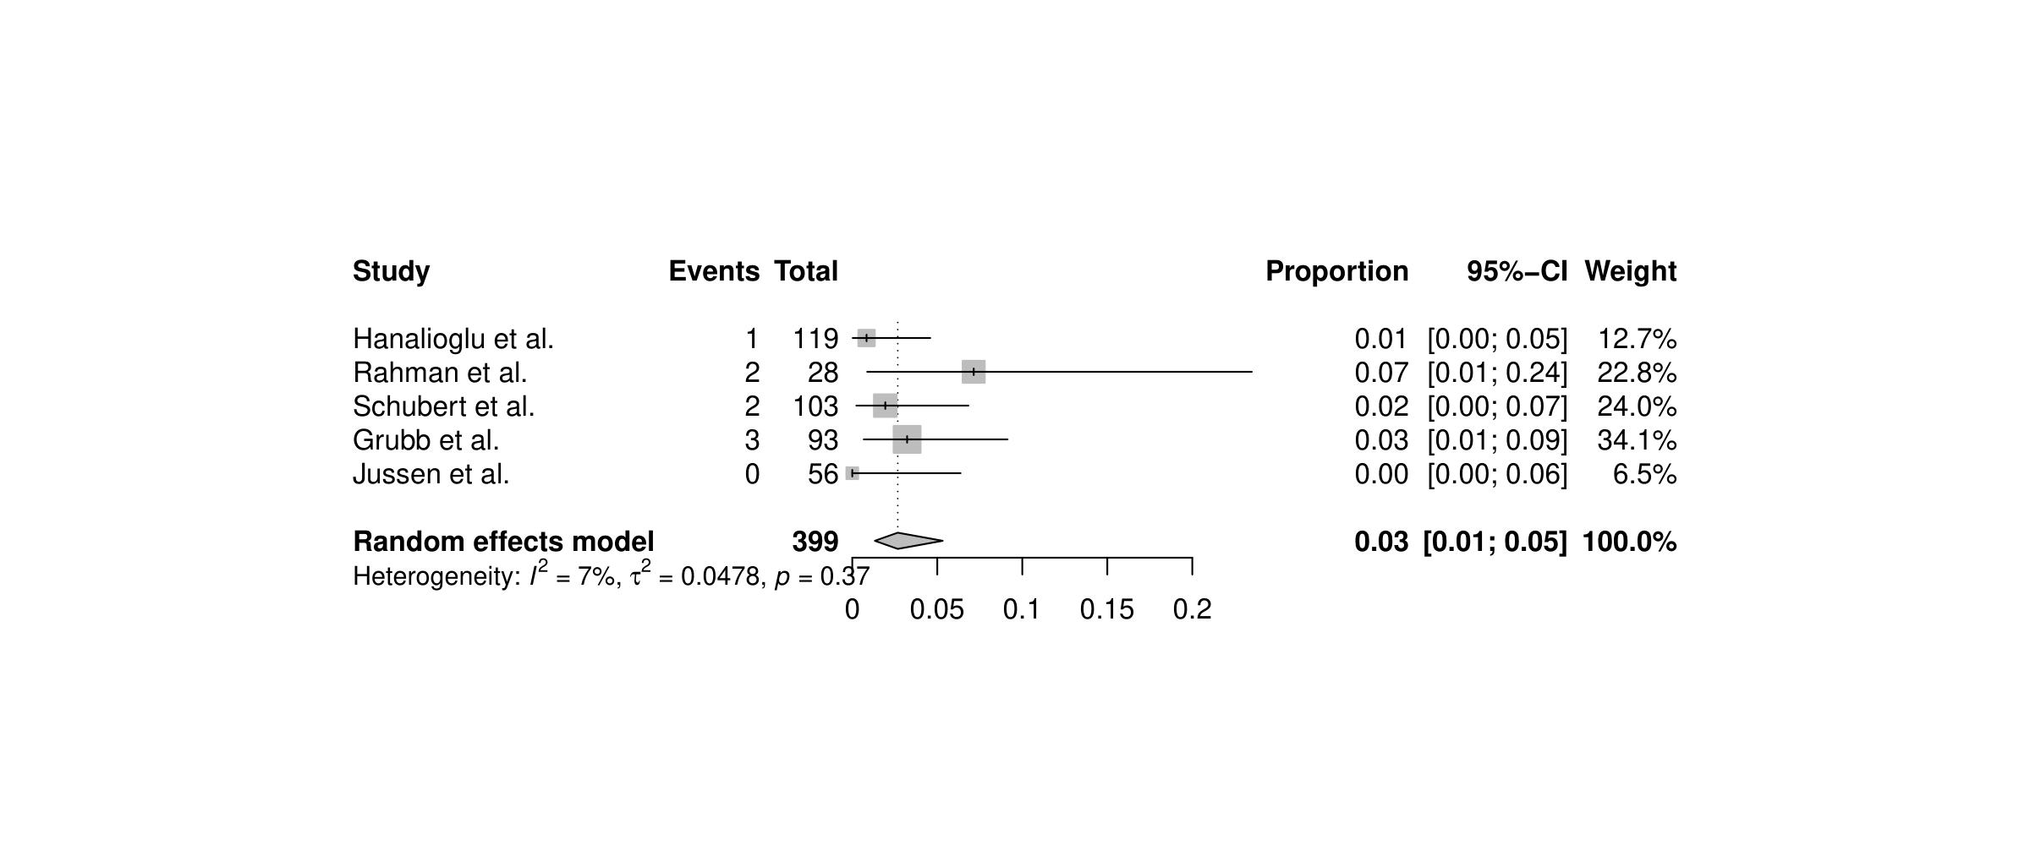Supplementary Figure 2: Single-arm meta-analysis of overall pooled outcome rate of hemorrhagic complications in the ASA Disc-Group
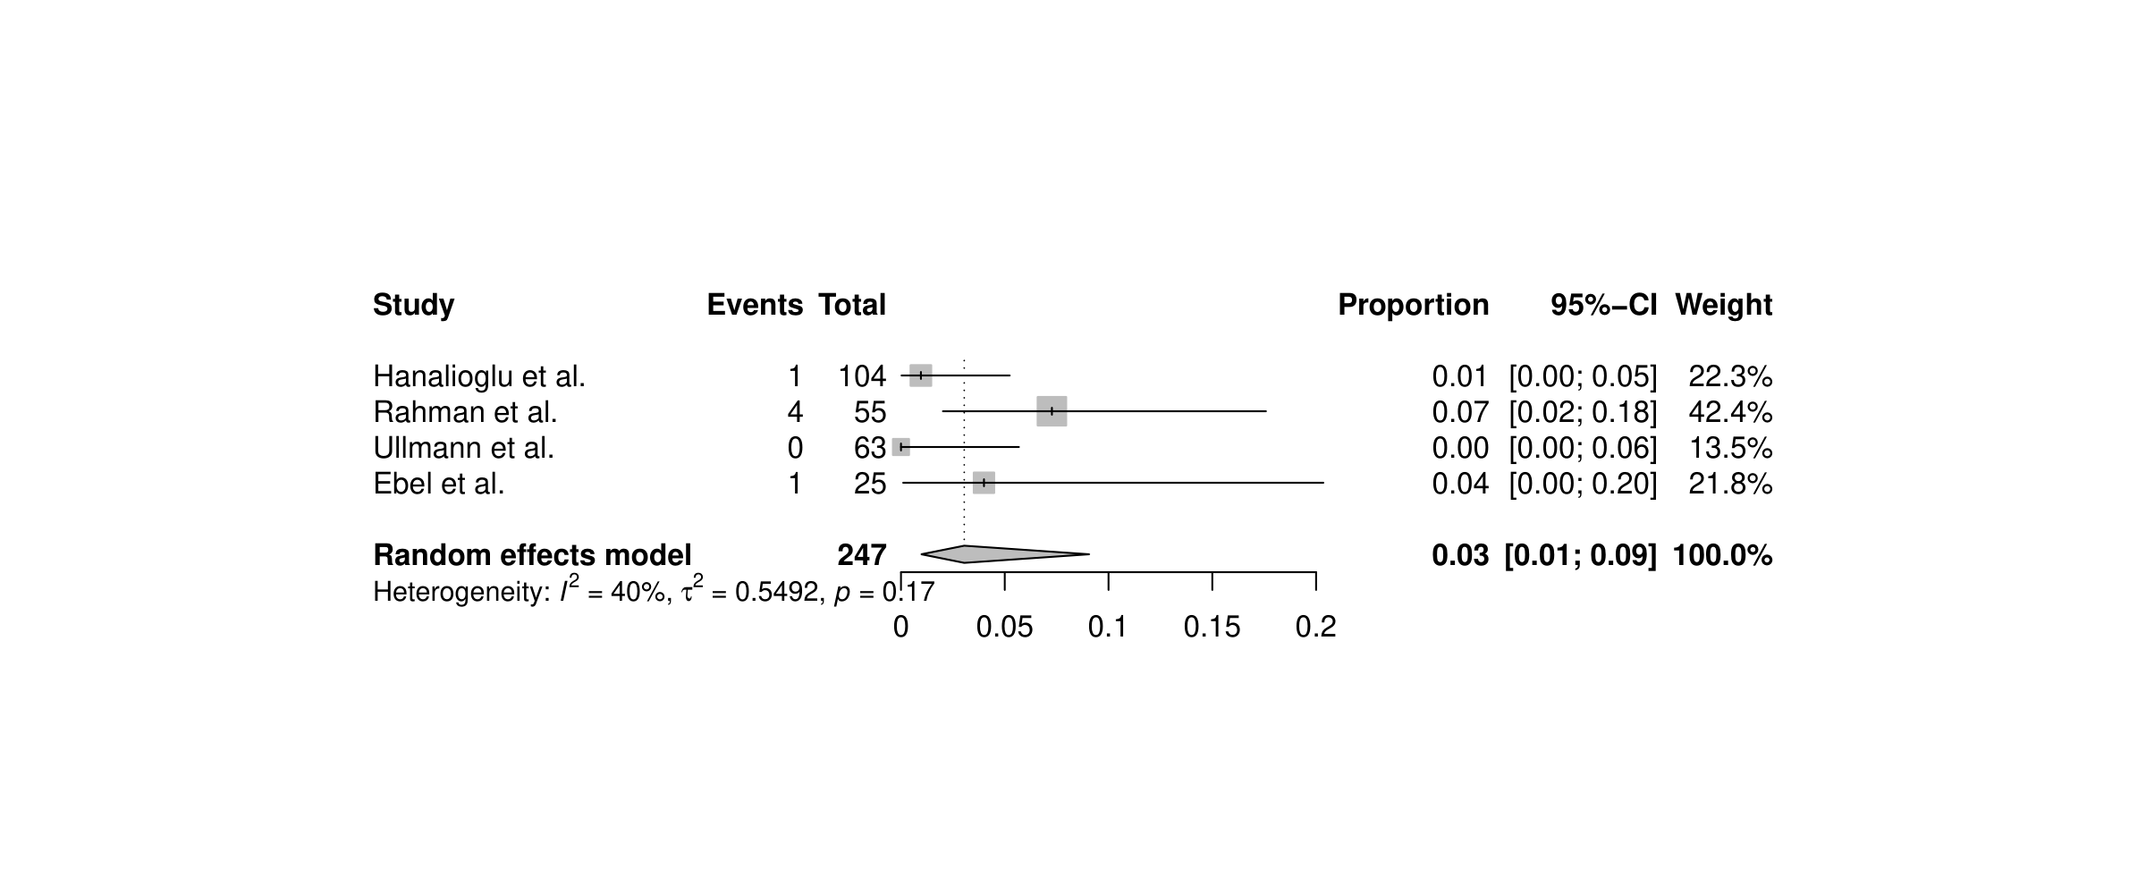Supplementary Figure 3: Single-arm meta-analysis of overall pooled outcome rate of thromboembolic complications in the ASA Con-Group
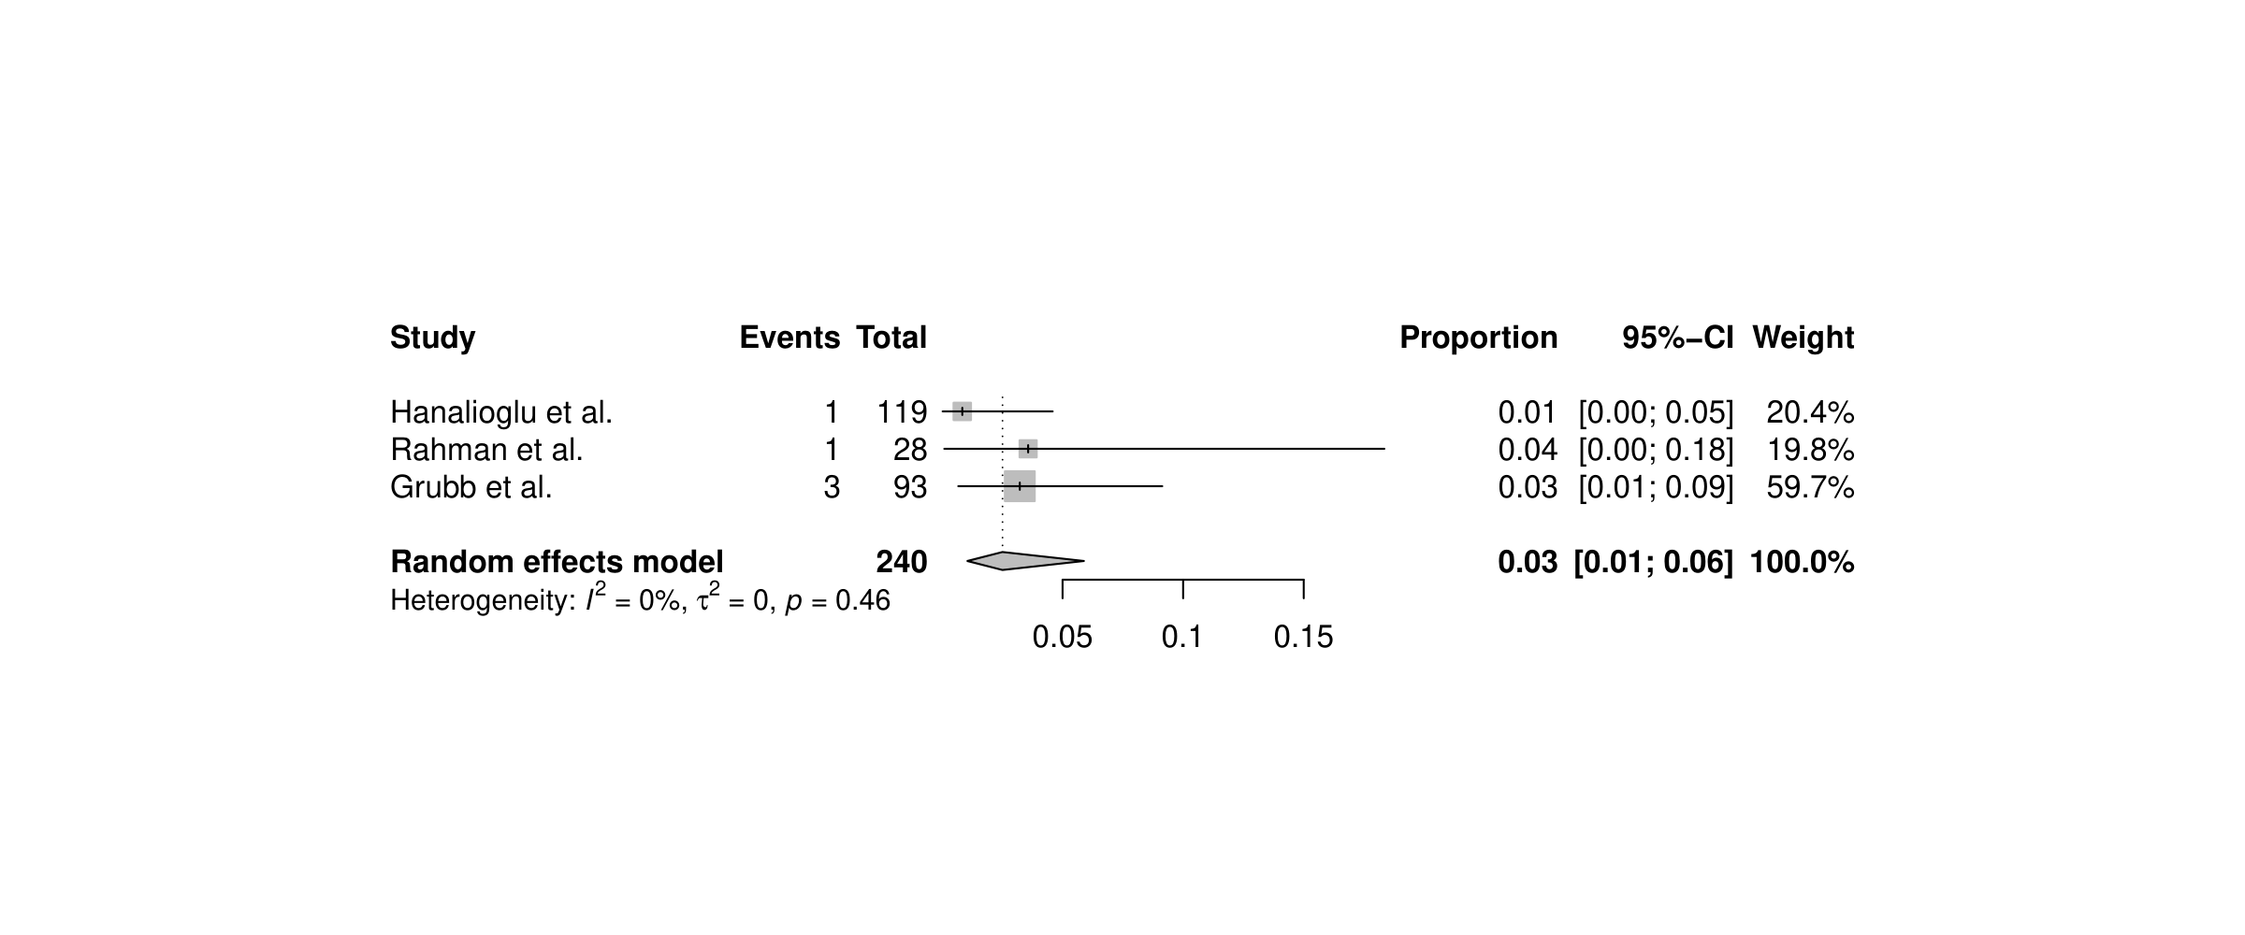

Supplementary Figure 4: Single-arm meta-analysis of overall pooled outcome rate of thromboembolic complications in the ASA Disc-Group
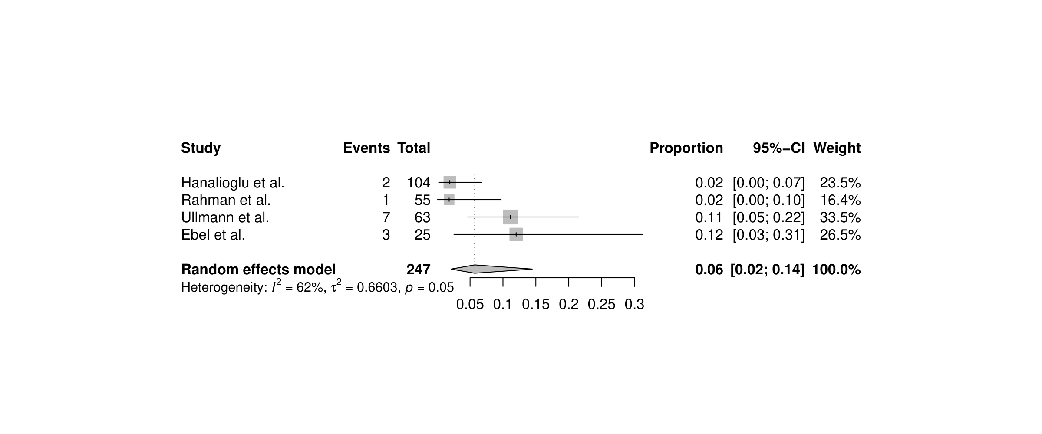Supplementary Figure 5: Single-arm meta-analysis of overall pooled outcome rate of hemorrhagic complications in the ASA Con-Group in the subgroup without bypass surgeries

Supplementary Figure 6: Single-arm meta-analysis of overall pooled outcome rate of hemorrhagic complications in the ASA Disc-Group in the subgroup without bypass surgeries

Supplementary Figure 7: Single-arm meta-analysis of overall pooled outcome rate of thromboembolic complications in the ASA Con-Group in the subgroup without bypass surgeries

Supplementary Figure 8: Single-arm meta-analysis of overall pooled outcome rate of thromboembolic complications in the ASA Disc-Group in the subgroup without bypass surgeries

Abbreviations:
ASA: Aspirin; Con-Group: Continuation Group; Disc-Group: Discontinuation Group

