Supplemental material

Redefining the epidemiology of cardiac amyloidosis.
A systematic review of screening studies

Alberto Aimo^{1,2}, Marco Merlo³, Aldostefano Porcari³, Georgios Georgiopoulos^{1,4,5}, Linda Pagura³, Giuseppe Vergaro^{1,2}, Gianfranco Sinagra³, Michele Emdin^{1,2}, Claudio Rapezzi^{6,7}
1. Institute of Life Sciences, Scuola Superiore Sant'Anna, Pisa, Italy; 2. Cardiology Division, Fondazione Toscana Gabriele Monasterio, Pisa, Italy; 3. Centre for Diagnosis and Treatment of Cardiomyopathies, Cardiovascular Department, Azienda Sanitaria Universitaria Giuliano-Isontina (ASUGI), University of Trieste, Trieste, Italy; 4. School of Biomedical Engineering & Imaging Sciences, King's College London, St Thomas' Hospital Campus, London, UK; 5. Department of Clinical Therapeutics, National and Kapodistrian University of Athens School of Medicine, Greece; 6. Cardiology Centre, University of Ferrara, Italy; 7. Maria Cecilia Hospital, GVM Care & Research, Cotignola (Ravenna), Italy.

Section and Topic | Item # | Checklist item | Location where item is reported
TITLE
Title | 1 | Identify the report as a systematic review. | 1
ABSTRACT
Abstract | 2 | See the PRISMA 2020 for Abstracts checklist. | 2
INTRODUCTION
Rationale | 3 | Describe the rationale for the review in the context of existing knowledge. | 3
Objectives | 4 | Provide an explicit statement of the objective(s) or question(s) the review addresses. | 3
METHODS
Eligibility criteria | 5 | Specify the inclusion and exclusion criteria for the review and how studies were grouped for the syntheses. | 4
Information sources | 6 | Specify all databases, registers, websites, organisations, reference lists and other sources searched or consulted to identify studies. Specify the date when each source was last searched or consulted. | 4
Search strategy | 7 | Present the full search strategies for all databases, registers and websites, including any filters and limits used. | 4
Selection process | 8 | Specify the methods used to decide whether a study met the inclusion criteria of the review, including how many reviewers screened each record and each report retrieved, whether they worked independently, and if applicable, details of automation tools used in the process. | 4
Data collection process | 9 | Specify the methods used to collect data from reports, including how many reviewers collected data from each report, whether they worked independently, any processes for obtaining or confirming data from study investigators, and if applicable, details of automation tools used in the process. | 4
Data items | 10a | List and define all outcomes for which data were sought. Specify whether all results that were compatible with each outcome domain in each study were sought (e.g. for all measures, time points, analyses), and if not, the methods used to decide which results to collect. | 4
Data items | 10b | List and define all other variables for which data were sought (e.g. participant and intervention characteristics, funding sources). Describe any assumptions made about any missing or unclear information. | 4
Study risk of bias assessment | 11 | Specify the methods used to assess risk of bias in the included studies, including details of the tool(s) used, how many reviewers assessed each study and whether they worked independently, and if applicable, details of automation tools used in the process. | 4
Effect measures | 12 | Specify for each outcome the effect measure(s) (e.g. risk ratio, mean difference) used in the synthesis or presentation of results. | 4
Synthesis methods | 13a | Describe the processes used to decide which studies were eligible for each synthesis (e.g. tabulating the study intervention characteristics and comparing against the planned groups for each synthesis (item #5)). | 4-5
Synthesis methods | 13b | Describe any methods required to prepare the data for presentation or synthesis, such as handling of missing summary statistics, or data conversions. | 4-5
Synthesis methods | 13c | Describe any methods used to tabulate or visually display results of individual studies and syntheses. | 4-5
Synthesis methods | 13d | Describe any methods used to synthesize results and provide a rationale for the choice(s). If meta-analysis was performed, describe the model(s), method(s) to identify the presence and extent of statistical heterogeneity, and software package(s) used. | 5
Synthesis methods | 13e | Describe any methods used to explore possible causes of heterogeneity among study results (e.g. subgroup analysis, meta-regression). | 5
Synthesis methods | 13f | Describe any sensitivity analyses conducted to assess robustness of the synthesized results. | 5
Reporting bias assessment | 14 | Describe any methods used to assess risk of bias due to missing results in a synthesis (arising from reporting biases). | 5
Certainty assessment | 15 | Describe any methods used to assess certainty (or confidence) in the body of evidence for an outcome. | 5
RESULTS
Study selection | 16a | Describe the results of the search and selection process, from the number of records identified in the search to the number of studies included in the review, ideally using a flow diagram. | 5
Study selection | 16b | Cite studies that might appear to meet the inclusion criteria, but which were excluded, and explain why they were excluded. | 5
Study characteristics | 17 | Cite each included study and present its characteristics. | 5
Risk of bias in studies | 18 | Present assessments of risk of bias for each included study. | 5
Results of individual studies | 19 | For all outcomes, present, for each study: (a) summary statistics for each group (where appropriate) and (b) an effect estimate and its precision (e.g. confidence/credible interval), ideally using structured tables or plots. | 5-9
Results of syntheses | 20a | For each synthesis, briefly summarise the characteristics and risk of bias among contributing studies. | 5-9
Results of syntheses | 20b | Present results of all statistical syntheses conducted. If meta-analysis was done, present for each the summary estimate and its precision (e.g. confidence/credible interval) and measures of statistical heterogeneity. If comparing groups, describe the direction of the effect. | 5-9
Results of syntheses | 20c | Present results of all investigations of possible causes of heterogeneity among study results. | 5-9
Results of syntheses | 20d | Present results of all sensitivity analyses conducted to assess the robustness of the synthesized results. | 5-9
Reporting biases | 21 | Present assessments of risk of bias due to missing results (arising from reporting biases) for each synthesis assessed. | 5-9
Certainty of evidence | 22 | Present assessments of certainty (or confidence) in the body of evidence for each outcome assessed. | 5-9
DISCUSSION
Discussion | 23a | Provide a general interpretation of the results in the context of other evidence. | 9-12
Discussion | 23b | Discuss any limitations of the evidence included in the review. | 9-12
Discussion | 23c | Discuss any limitations of the review processes used. | 9-12
Discussion | 23d | Discuss implications of the results for practice, policy, and future research. | 9-12
OTHER INFORMATION
Registration and protocol | 24a | Provide registration information for the review, including register name and registration number, or state that the review was not registered. | 5
Registration and protocol | 24b | Indicate where the review protocol can be accessed, or state that a protocol was not prepared. | 5
Registration and protocol | 24c | Describe and explain any amendments to information provided at registration or in the protocol. | 5
Support | 25 | Describe sources of financial or non-financial support for the review, and the role of the funders or sponsors in the review. | 1
Competing interests | 26 | Declare any competing interests of review authors. | 1
Availability of data, code and other materials | 27 | Report which of the following are publicly available and where they can be found: template data collection forms; data extracted from included studies; data used for all analyses; analytic code; any other materials used in the review. | 5

From: Page MJ, McKenzie JE, Bossuyt PM, Boutron I, Hoffmann TC, Mulrow CD, et al. The PRISMA 2020 statement: an updated guideline for reporting systematic reviews. BMJ 2021;372:n71. doi: 10.1136/bmj.n71
For more information, visit: http://www.prisma-statement.org/

Supplemental Figure 1. Flowchart of study selection.
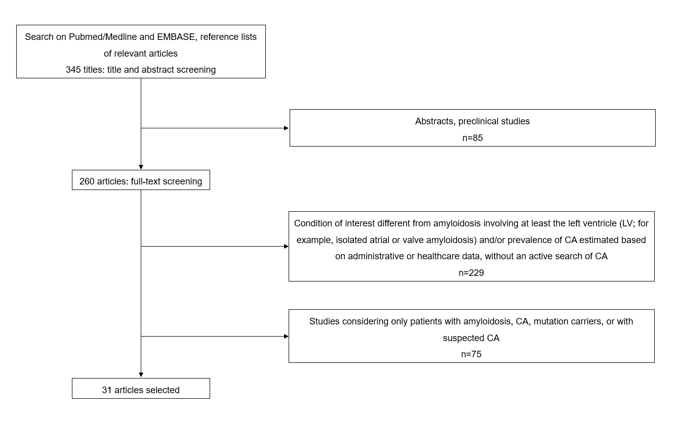
CA, cardiac amyloidosis; LV, left ventricle.
Supplemental Figure 2. Prevalence of cardiac amyloidosis (CA) in studies on bone scintigraphy: forest plot.
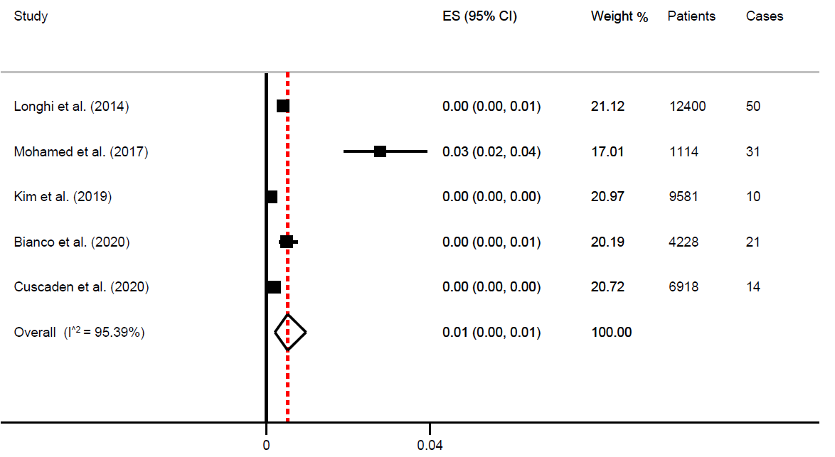
See text for further details. CI, confidence interval; ES, effect size.

Supplemental Figure 3. Prevalence of cardiac amyloidosis in studies on heart failure with preserved ejection fraction: forest plot.
See text for further details. CI, confidence interval; ES, effect size.

Supplemental Figure 4. Prevalence of cardiac amyloidosis in studies on aortic stenosis: forest plot.

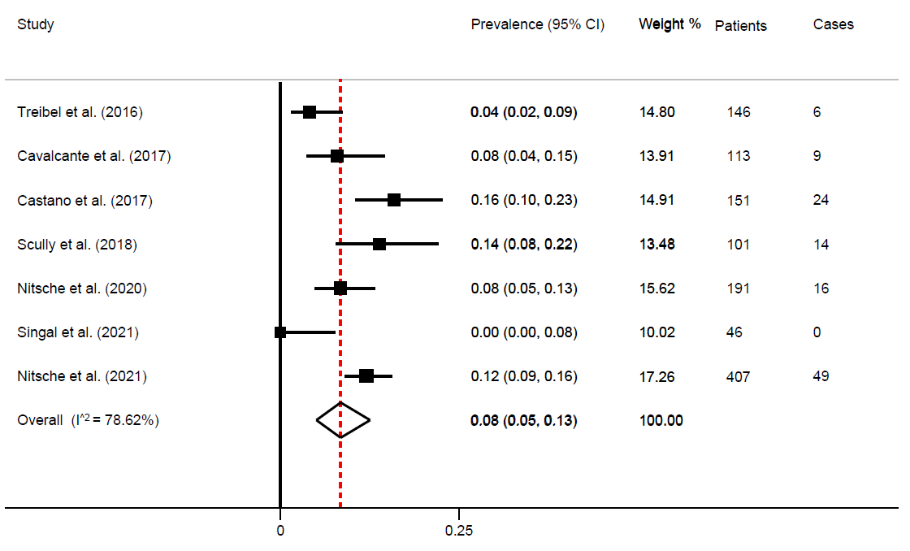
See text for further details. CI, confidence interval; ES, effect size.

Supplemental Figure 5. Prevalence of cardiac amyloidosis in autopsy studies: forest plot.

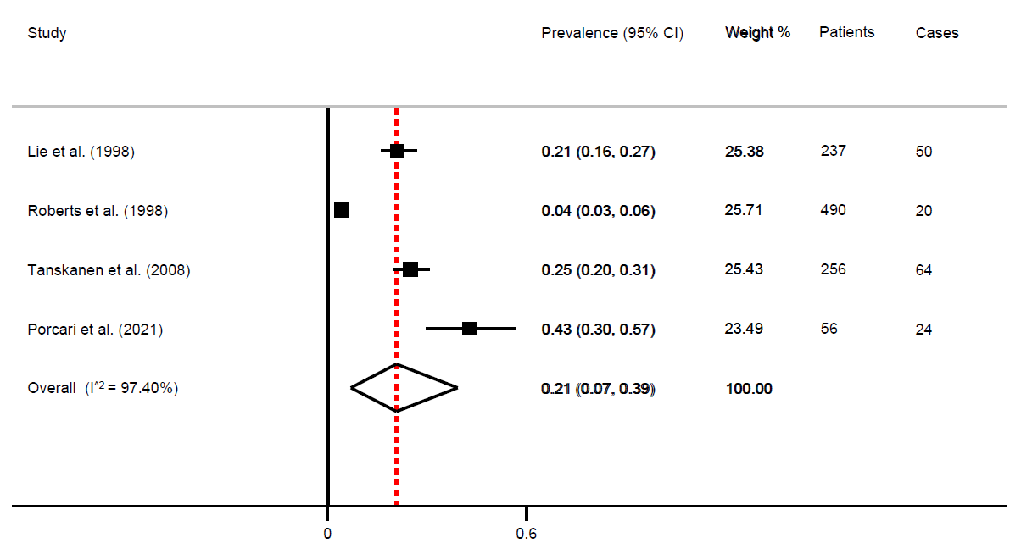

See text for further details. CI, confidence interval; ES, effect size.

Supplemental Table 1. Screening studies on cardiac amyloidosis (CA) in different settings.

Author, year (ref.) | Indication to screening | Broad setting | Study design | CA diagnosis | Bone tracer | Criteria for positive scan | Confirmation of positive scans through SPECT? (yes/no)
Cuscaden C, 2020¹ | Bone scan for non-cardiac reasons | Bone scan for non-cardiac reasons | Retrospective | Scintigraphy (alone) | ^{99m}Tc-HMDP or MDP | Cardiac uptake ≥rib AND heart/whole body ratio (H/WB) >0.0388 | Yes  (Perugini grade ≥1)
Bianco M, 2020² | Bone scan for  any reason | Bone scan for non-cardiac reasons | Retrospective | Scintigraphy (alone) | ^{99m}Tc-HDP or DPD | Perugini grade 2-3 | No
Longhi S, 2014³ | Bone scan for non-cardiac reasons | Bone scan for non-cardiac reasons | Retrospective | Scintigraphy  (subgroup with scintigraphy+: ECG, echo, EMB in selected cases) | ^{99m}Tc-DPD | Perugini grade 2-3 | No
Mohamed-Salem L, 2017⁴ | Bone scan for non-cardiac reasons, ≥75 years | Bone scan for non-cardiac reasons | Retrospective | Scintigraphy (alone) | ^{99m}Tc-DPD, HDP, HMDP | Perugini grade 2-3 | No
Kim HM, 2019⁵ | Bone scan for non-cardiac reasons | Bone scan for non-cardiac reasons | Retrospective | Scintigraphy (alone) | ^{99m}Tc-DPD | Perugini grade 2-3 | No
Lindmark K, 2021⁶ | HF clinic, IVS >14 mm | HFpEF | Prospective | Scintigraphy, monoclonal protein, biopsy when needed | ^{99m}Tc-DPD | Perugini grade 2-3* | Yes
Gonzalez-Lopez E, 2015⁷ | HFpEF, LV wall thickness ≥12 mm, ≥60 years | HFpEF | Prospective | Scintigraphy, monoclonal protein, biopsy when needed | ^{99m}Tc-DPD | Perugini grade 2-3 | No
Hahn VS, 2020⁸ | HFpEF with unclear aetiology | HFpEF | Prospective | Histology (EMB) | N/A | N/A | N/A
AbouEzzeddine OF ⁹ | HF, LVEF ≥40%, LV wall thickness ≥12 mm, age ≥60 years | HFpEF* | Prospective | Scintigraphy, monoclonal protein, biopsy when needed | ^{99m}Tc-PYP | “Diffuse” tracer update greater than background blood pool on SPECT/CT AND H/CL ≥1.3 | No (SPECT/CT performed systematically)
Bennani Smires Y, 2016¹⁰ | HFpEF, ≥65 years, no CAD | HFpEF | Prospective | CMR, scintigraphy, monoclonal protein, biopsy when needed | ^{99m}Tc-DPD | Perugini grade 3 | N/A
Arvanitis M, 2017¹¹ | African Americans >60 years with (1) an ICD-9/10 diagnosis of HF and (2) mean LV wall thickness ≥12 mm | HFpEF | Prospective | Genetic testing for V122I genotype, then confirmatory tests | ^{99m}Tc-PYP | N/A | N/A
Devesa A, 2021¹² | HFpEF, LV wall thickness <12 mm | HFpEF | Prospective | Scintigraphy, monoclonal protein, biopsy when needed | ^{99m}Tc-DPD | Perugini grades 1-3 | No
Lopez-Sainz A, 2019¹³ | 1) CD requiring PM implantation; 2) hospitalized HF, LVEF <50%, >60 years, LV wall thickness ≥12 mm | 1) CD  2) HFrEF/HFmrEF | Prospective | Scintigraphy, monoclonal protein, biopsy when needed | ^{99m}Tc-DPD | Perugini grade 2-3 | No
Goland S, 2021¹⁴ | Unexplained LV systolic dysfunction | HFrEF/HFmrEF | Prospective | Scintigraphy, monoclonal protein, biopsy when needed | ^{99m}Tc-PYP | Perugini grade 2-3 | Yes
Vianello PF, 2021¹⁵ | Men undergoing bilateral CTS surgery | CTS | Prospective | Scintigraphy (+exclusion of a monoclonal protein) | ^{99m}Tc-HMDP | Perugini grade 2-3 | No
Sperry BW, 2018¹⁶ | CTS surgery in men ≥50 years and women ≥60 years | CTS | Prospective | Histology +: cardiac screening | ^{99m}Tc-PYP | N/A | Yes
Zegri-Reiriz I, 2018¹⁷ | CTS surgery, ≥60 years, LV wall thickness ≥12 mm | CTS | Prospective | Scintigraphy, monoclonal protein, biopsy when needed | ^{99m}Tc-DPD | Perugini grade 2-3 | No
Sperry BW, 2021¹⁸ | Surgery for idiopathic trigger finger, ≥50 years | - | Prospective | Histology of the surgical specimen + "cardiac screening" if positive histology | ^{99m}Tc-PYP | N/A | N/A
Damy T, 2015¹⁹ | Initial diagnosis of HCM | HCM | Prospective | TTR gene testing, then scintigraphy, CMR, biopsy | “^{99m}Tc-biphosphonate scintigraphy” | N/A | N/A
Maurizi N, 2019²⁰ | Initial diagnosis of HCM | HCM | Prospective | TTR mutations; if no mutation found but ≥1 red flag, blood/urine tests, abdominal fat biopsy and/or scintigraphy and ApoAI sequencing | ^{99m}Tc-DPD | Perugini grade 2-3 | N/A
Cavalcante JL, 2017²¹ | Moderate/severe AS referred to CMR | AS | Retrospective | CMR (suspected CA) | N/A | N/A | N/A
Treibel TA, 2016²² | AS referred to SAVR | AS | Prospective | Histology (intraoperative biopsy) | N/A | N/A | N/A
Singal AK, 2021²³ | AS referred to SAVR, ≥65 years | AS | Prospective | Histology* | N/A | N/A | N/A
Nitsche C, 2020²⁴ | AS referred to TAVR | AS | Prospective | Scintigraphy, monoclonal protein, biopsy when needed | ^{99m}Tc-DPD | Perugini grade 2-3 | No
Nitsche C, 2021²⁵ | AS referred to TAVR | AS | Prospective | Scintigraphy, monoclonal protein, biopsy when needed | ^{99m}Tc-DPD | Perugini grade 2-3 | Not in all centres
Castano A, 2017²⁶ | AS referred to TAVR | AS | Prospective | Scintigraphy | ^{99m}Tc-PYP | Perugini grade 2-3 AND H/CL ≥1.5 | No
Scully P, 2018²⁷ | AS referred to TAVR | AS | Prospective | Scintigraphy, monoclonal protein, biopsy when needed | ^{99m}Tc-DPD | Perugini grade 1-3 | No
Lie JT, 1988²⁸ | Autopsy 90-105 years | Autopsy | N/A | Histology (Congo red + ≥1 of the following: methyl violet, thioflavine T, and  sulfate-alcian blue | N/A | N/A | N/A
Roberts CW, 1998²⁹ | Autopsy ≥80 years | Autopsy | N/A | Histology (no details provided) | N/A | N/A | N/A
Tanskanen M, 2008³⁰ | Autopsy >85 years | Autopsy | N/A | Histology | N/A | N/A | N/A
Porcari A, 2021³¹ | Autopsy ≥75 years | Autopsy | N/A | Histology | N/A | N/A | N/A

* Patients referred to further evaluation also if Perugini grade 1.
** Planar scintigraphy was performed as well, with diverging results from cardiac histology.
When the diagnosis was primarily made through histology, additional scintigraphy exams were not considered.
^{99m}Tc-DPD, technetium-99m-labelled 3,3-diphosphono-1,2-propanodicarboxylic acid; ^{99m}Tc-HMDP, technetium-99m-labelled hydroxydiphosphonate; ^{99m}Tc-HMDP, technetium-99m-labelled hydroxymethylene diphosphonate; ^{99m}Tc-MDP, methyl diphosphonate; ^{99m}Tc-PYP, technetium-99m-labelled pyrophosphate; AS, aortic stenosis; CAD, coronary artery disease; CD, conduction disorder; CMR, cardiac magnetic resonance; CTS, carpal tunnel syndrome; HCL, heart-to-controlateral lung; HCM, hypertrophic cardiomyopathy; HFmrEF, heart failure with mid-range ejection fraction; HFpEF, heart failure with preserved ejection fraction; HFrEF, heart failure with reduced ejection fraction; ICD, International Classification of Diseases; IVS, interventricular septum; LV, left ventricle; LVEF, left ventricular ejection fraction; N/A, not available; PM, pacemaker; SAVR, surgical aortic valve replacement; SPECT(/CT), single photon emission computed tomography (/computed tomography); TAVR, transcatheter aortic valve replacement.

References

1. Cuscaden C, Ramsay SC, Prasad S, Goodwin B, Smith J. Estimation of prevalence of transthyretin (ATTR) cardiac amyloidosis in an Australian subpopulation using bone scans with echocardiography and clinical correlation. Journal of nuclear cardiology : official publication of the American Society of Nuclear Cardiology. 2020.
2. Bianco M, Parente A, Biolè C, et al. The prevalence of TTR cardiac amyloidosis among patients undergoing bone scintigraphy. Journal of nuclear cardiology : official publication of the American Society of Nuclear Cardiology. 2021;28(3):825-830.
3. Longhi S, Guidalotti PL, Quarta CC, et al. Identification of TTR-related subclinical amyloidosis with 99mTc-DPD scintigraphy. JACC Cardiovascular imaging. 2014;7(5):531-532.
4. Mohamed-Salem L, Santos-Mateo JJ, Sanchez-Serna J, et al. Prevalence of wild type ATTR assessed as myocardial uptake in bone scan in the elderly population. International journal of cardiology. 2018;270:192-196.
5. Kim HM, Sohn DW, Paeng JC. Prevalence of Positive (99 m)Tc-DPD Scintigraphy as an Indicator of the Prevalence of Wild-type Transthyretin Amyloidosis in the Elderly. International heart journal. 2019;60(3):643-647.
6. Lindmark K, Pilebro B, Sundström T, Lindqvist P. Prevalence of wild type transtyrethin cardiac amyloidosis in a heart failure clinic. ESC heart failure. 2021;8(1):745-749.
7. González-López E, Gallego-Delgado M, Guzzo-Merello G, et al. Wild-type transthyretin amyloidosis as a cause of heart failure with preserved ejection fraction. European heart journal. 2015;36(38):2585-2594.
8. Hahn VS, Yanek LR, Vaishnav J, et al. Endomyocardial Biopsy Characterization of Heart Failure With Preserved Ejection Fraction and Prevalence of Cardiac Amyloidosis. JACC Heart failure. 2020;8(9):712-724.
9. AbouEzzeddine OF, Davies DR, Scott CG, et al. Prevalence of Transthyretin Amyloid Cardiomyopathy in Heart Failure With Preserved Ejection Fraction. JAMA cardiology. 2021;6(11):1267-1274.
10. Bennani Smires Y, Victor G, Ribes D, et al. Pilot study for left ventricular imaging phenotype of patients over 65 years old with heart failure and preserved ejection fraction: the high prevalence of amyloid cardiomyopathy. The international journal of cardiovascular imaging. 2016;32(9):1403-1413.
11. Arvanitis M, Chan GG, Jacobson DR, Berk JL, Connors LH, Ruberg FL. Prevalence of mutant ATTR cardiac amyloidosis in elderly African Americans with heart failure. Amyloid : the international journal of experimental and clinical investigation : the official journal of the International Society of Amyloidosis. 2017;24(4):253-255.
12. Devesa A, Camblor Blasco A, Pello Lázaro AM, et al. Prevalence of transthyretin amyloidosis in patients with heart failure and no left ventricular hypertrophy. ESC heart failure. 2021;8(4):2856-2865.
13. López-Sainz Á, de Haro-Del Moral FJ, Dominguez F, et al. Prevalence of cardiac amyloidosis among elderly patients with systolic heart failure or conduction disorders. Amyloid : the international journal of experimental and clinical investigation : the official journal of the International Society of Amyloidosis. 2019;26(3):156-163.
14. Goland S, Volodarsky I, Fabricant Y, et al. Wild-type TTR amyloidosis among patients with unexplained heart failure and systolic LV dysfunction. PloS one. 2021;16(7):e0254104.
15. Vianello PF, La Malfa G, Tini G, et al. Prevalence of transthyretin amyloid cardiomyopathy in male patients who underwent bilateral carpal tunnel surgery: The ACTUAL study. International journal of cardiology. 2021;329:144-147.
16. Sperry BW, Reyes BA, Ikram A, et al. Tenosynovial and Cardiac Amyloidosis in Patients Undergoing Carpal Tunnel Release. Journal of the American College of Cardiology. 2018;72(17):2040-2050.
17. Zegri-Reiriz I, de Haro-Del Moral FJ, Dominguez F, et al. Prevalence of Cardiac Amyloidosis in Patients with Carpal Tunnel Syndrome. Journal of cardiovascular translational research. 2019;12(6):507-513.
18. Sperry BW, Khedraki R, Gabrovsek A, et al. Cardiac Amyloidosis Screening at Trigger Finger Release Surgery. The American journal of cardiology. 2021;160:96-98.
19. Damy T, Costes B, Hagège AA, et al. Prevalence and clinical phenotype of hereditary transthyretin amyloid cardiomyopathy in patients with increased left ventricular wall thickness. European heart journal. 2016;37(23):1826-1834.
20. Maurizi N, Rella V, Fumagalli C, et al. Prevalence of cardiac amyloidosis among adult patients referred to tertiary centres with an initial diagnosis of hypertrophic cardiomyopathy. International journal of cardiology. 2020;300:191-195.
21. Cavalcante JL, Rijal S, Abdelkarim I, et al. Cardiac amyloidosis is prevalent in older patients with aortic stenosis and carries worse prognosis. Journal of cardiovascular magnetic resonance : official journal of the Society for Cardiovascular Magnetic Resonance. 2017;19(1):98.
22. Treibel TA, Fontana M, Gilbertson JA, et al. Occult Transthyretin Cardiac Amyloid in Severe Calcific Aortic Stenosis: Prevalence and Prognosis in Patients Undergoing Surgical Aortic Valve Replacement. Circulation Cardiovascular imaging. 2016;9(8).
23. Singal AK, Bansal R, Singh A, et al. Concomitant Transthyretin Amyloidosis and Severe Aortic Stenosis in Elderly Indian Population: A Pilot Study. JACC CardioOncology. 2021;3(4):565-576.
24. Nitsche C, Aschauer S, Kammerlander AA, et al. Light-chain and transthyretin cardiac amyloidosis in severe aortic stenosis: prevalence, screening possibilities, and outcome. European journal of heart failure. 2020;22(10):1852-1862.
25. Nitsche C, Scully PR, Patel KP, et al. Prevalence and Outcomes of Concomitant Aortic Stenosis and Cardiac Amyloidosis. Journal of the American College of Cardiology. 2021;77(2):128-139.
26. Castaño A, Narotsky DL, Hamid N, et al. Unveiling transthyretin cardiac amyloidosis and its predictors among elderly patients with severe aortic stenosis undergoing transcatheter aortic valve replacement. European heart journal. 2017;38(38):2879-2887.
27. Scully PR, Treibel TA, Fontana M, et al. Prevalence of Cardiac Amyloidosis in Patients Referred for Transcatheter Aortic Valve Replacement. Journal of the American College of Cardiology. 2018;71(4):463-464.
28. Lie JT, Hammond PI. Pathology of the senescent heart: anatomic observations on 237 autopsy studies of patients 90 to 105 years old. Mayo Clinic proceedings. 1988;63(6):552-564.
29. Roberts WC, Shirani J. Comparison of cardiac findings at necropsy in octogenarians, nonagenarians, and centenarians. The American journal of cardiology. 1998;82(5):627-631.
30. Tanskanen M, Peuralinna T, Polvikoski T, et al. Senile systemic amyloidosis affects 25% of the very aged and associates with genetic variation in alpha2-macroglobulin and tau: a population-based autopsy study. Annals of medicine. 2008;40(3):232-239.
31. Porcari A, Bussani R, Merlo M, et al. Incidence and Characterization of Concealed Cardiac Amyloidosis Among Unselected Elderly Patients Undergoing Post-mortem Examination. Frontiers in cardiovascular medicine. 2021;8:749523.

