Appendix and Supplementary File
Appendix 1. Search Strategy and Details on Included Studies
Appendix 1.1 Details on Included Studies
Three studies reported subscale scores for the DERS but not a total score, and the authors did not respond to our request for information (49, 50, 65). For these studies, we calculated the total score from the subscale values. In addition, we estimated the mean and standard deviation for two studies that presented graphs of the mean and standard deviation but did not report the values (53, 54). The authors of these studies also did not respond to our request for information.
Appendix 1.2 PubMed Search Strategy Conducted on April 18, 2021
Search # | Query | Items found
1 | Difficulties emotion regulation scale OR DERS OR emotional regulation scale | 2,044
2 | "Emotional Regulation"[Mesh] OR "Self-Control"[Mesh] OR "emotion regulation"[tiab] OR "emotion dysregulation"[tiab] OR "emotion impairment"[tiab] OR regulate emotion[tiab] | 14,988
3 | #1 OR #2 | 15,822
4 | "Substance-Related Disorders"[Mesh] OR substance use disorder[tiab] OR substance use[tiab] OR drug abuse[tiab] OR drug dependence[tiab] OR drug addiction[tiab] OR addiction[tiab] OR use disorder[tiab] | 335, 499
5 | (Alcohol OR cocaine OR opioid OR amphetamine OR nicotine OR cannabis OR marijuana) AND (users OR patients OR dependent OR “use disorder” OR “related disorder”) | 443,580
6 | #4 OR #5 | 666,512
7 | "Case-Control Studies"[Mesh] OR "matched controls" OR "healthy controls" OR compar* OR controls OR "control group" OR "no addiction"[tiab] OR nonsmokers[tiab] | 10,232,962
8 | #3 AND #6 AND #7 | 640

Appendix 1.3 PsycINFO Search Strategy Conducted on May 1, 2021
Search # | Query | Items found
1 | (regulating emotions) OR (emotions regulation) OR (emotion dysregulation) | 26,590
2 | (substance use) OR (Substance Use Disorders) OR (drug abuse) OR (drug dependence) OR (drug addiction) | 191,682
3 | (alcohol OR cocaine OR opioid OR amphetamine OR nicotine OR cannabis OR marijuana) AND (users OR patients OR dependent OR misuse) | 89,418
4 | 2 OR 3 | 224,224
5 | (case control study) OR (matched controls) OR (healthy controls) OR (control group) OR compar* OR controls OR (no addiction) OR nonsmokers | 1,346,285
6 | 1 AND 4 AND 5 | 713

Appendix 1.4 Secondary Analysis - PubMed Search Strategy conducted on February 23, 2022
Search # | Query | Items
1 | Difficulties emotion regulation scale OR DERS OR emotional regulation scale | 2,389
2 | "Emotional Regulation"[Mesh] OR "Self-Control"[Mesh] OR "emotion regulation"[tiab] OR "emotion dysregulation"[tiab] OR "emotion impairment"[tiab] OR regulate emotion[tiab] | 17,102
3 | #1 OR #2 | 18,043
4 | "Substance-Related Disorders"[Mesh] OR substance use disorder[tiab] OR substance use[tiab] OR drug abuse[tiab] OR drug dependence[tiab] OR drug addiction[tiab] OR addiction[tiab] OR use disorder[tiab] | 350,307
5 | (Alcohol OR cocaine OR opioid OR amphetamine OR nicotine OR cannabis OR marijuana) AND (users OR patients OR dependent OR “use disorder” OR “related disorder”) | 463,551
6 | #4 OR #5 | 694,909
7 | "Case-Control Studies"[Mesh] OR "matched controls" OR "healthy controls" OR compar* OR controls OR "control group" OR "no addiction"[tiab] OR nonsmokers[tiab] | 10,788,439
8 | #3 AND #6 AND #7 | 725
9 | #2 AND #6 AND #7 | 690

Appendix 1.5 Secondary Analysis - PsycINFO Search Strategy Conducted on February 23, 2022
Search # | Query | Items found
1 | (regulating emotions) OR (emotions regulation) OR (emotion dysregulation) | 26,590
2 | (substance use) OR (Substance Use Disorders) OR (drug abuse) OR (drug dependence) OR (drug addiction) | 191,682
3 | (alcohol OR cocaine OR opioid OR amphetamine OR nicotine OR cannabis OR marijuana) AND (users OR patients OR dependent OR misuse) | 89,418
4 | 2 OR 3 | 224,224
5 | (case control study) OR (matched controls) OR (healthy controls) OR (control group) OR compar* OR controls OR (no addiction) OR nonsmokers | 1,346,285
6 | 1 AND 4 AND 5 | 713

Appendix 1.6 Secondary Analysis - Embase Search Strategy Conducted on February 23, 2022
Search # | Query | Items found
1 | exp emotion assessment/ or "cognitive emotion regulation questionnaire (cerq)"/ or "emotion regulation questionnaire (erq)"/ or toronto alexithymia scale/ or emotion regulation/ | 7,698
2 | (emotion* adj3 (regulat* or dysregulat* or impairment* or control)).ab. | 26,243
3 | exp drug dependence/ | 273,673
4 | ((substance or drug or alcohol or cocaine or opioid or amphetamine or nicotine or cannabis or marijuana) and (abuse* or dependen* or patients or users)).ab. | 1,076,025
5 | exp case control study/ | 202,632
6 | ((matched or healthy) adj control*).ab. | 385,470
7 | (control group or no addiction or nonsmokers or compar*).ab. | 8,242,589
8 | 1 or 2 | 30,930
9 | 3 or 4 | 1,245,407
10 | 5 or 6 or 7 | 8,439,946
11 | 8 and 9 and 10 | 874

Appendix 2. Quality Assessment Tool (modified National Heart, Lung, and Blood Institute‘s Quality Assessment Tools for Observational Cohort and Cross-Sectional Studies)
The original assessment tool contained 14 yes-or-no based questions to rate the quality of the study. We decided to eliminate seven of these questions, as they applied specifically to longitudinal cohorts and were therefore not relevant to our review. The seven questions that applied to cross-sectional studies were included in our assessment. A scoring system was created for this review, with higher scores indicating better quality studies. The scores range from 0-4 (poor), 5-8 (fair) and 9-13 (good). Two independent reviewers (KX, JS) evaluated each study and gave a rating of poor, fair or good. The independent ratings were used to conduct inter-rater reliability between the scores, and 82% agreement was observed for full DERS study, with kappa = 0.69. The kappa for studies using short versions of the DERS and ERQ was low due to the small sample size (0.3 [95% CI = -0.23 - 0.83]). Discrepancies in categorical rating were resolved by having the third reviewer (EG) evaluate the paper. The majority rule was used for the final rating. Ratings for papers using the full DERS are presented in Table 1 and ratings for papers using shortened versions of the DERS and the ERQ are presented in Supplementary Table 2.

NIH items | Score guidance | Scores
1. Was the research question or objective in this paper clearly stated? | Was the research question or objective in this paper clearly stated? | 1 point - Yes  0 point - No
2. Was the study population clearly specified and defined? | Did the study describe the study group?  Where were they recruited? How were they selected? | 2 points - Yes for SUD group and control group  1 point - Yes for SUD group  0 point - No
4. Were all the subjects selected or recruited from the same or similar populations (including the same time period)? Were inclusion and exclusion criteria for being in the study prespecified and applied uniformly to all participants? | Were the controls matched to the cases on age and gender?  Recruited at the same time? From similar populations? | 1 point - Yes  0 point - No
5. Was a sample size justification, power description, or variance and effect estimates provided? | Was a sample size justification, power description, or variance and effect estimates provided? | 1 point - Yes for sample size justification/power description  1 point - Yes for variance  1 point - Yes for effect estimates  0 point - No
9. Were the exposure measures (independent variables) clearly defined, valid, reliable, and implemented consistently across all study participants? | Were the cases assessed for SUDs using a validated diagnostic tool?  Were the controls assessed in the same way as the cases for SUD?  Were the criteria for diagnosis clearly defined? | 1 point - Yes for using a validated diagnostic tool for SUD  1 point - Controls were assessed in the same way as the SUD group  1 point - Criteria for diagnosis was clearly defined for SUD group and control group  0.5 point - Criteria for diagnosis was clearly defined for SUD group
11. Were the outcome measures (dependent variables) clearly defined, valid, reliable, and implemented consistently across all study participants? | Was the DERS or ERQ administered in the same way for cases and controls? | 1 point - Yes  0 point - No
14. Were key potential confounding variables measured and adjusted statistically for their impact on the relationship between exposure(s) and outcome(s)? | Did they adjust for age? Or match on age?  Did they adjust for other confounders? | 1 point - Yes for adjusting/matching on age  1 point - Yes for adjusting for other confounders  0 point - No
Total scores: 13
0-4 = Poor
5-8 = Fair
9-13 = Good
NIH= National Institutes of Health, SUD = substance use disorder
Appendix 3. Additional Synthesis and Calculation Methods and Discrepancies
Three studies did not report DERS total score, but they reported subscale scores (49, 50, 65). The total DERS score was estimated by summing the subscale scores. The variance (SD) of the summed score was calculated as the sum of the variance of the subscale scores (which were available) plus the sum of the covariance terms (which were not available). The sum of the covariance terms was estimated by using 10 studies that reported both total DERS score and subscale scores. For these 10 studies, both the variance of the total score and the sum of the variance of the subscales were available. For each one, the sum of the covariance terms could be estimated, and the average was used in the 3 studies with missing total DERS score.
One study had 3 SUD arms and one control arm (63). All SUD arms were similar and met the inclusion criteria for our study. Another study (49) had an opium user group and a methadone maintenance treatment group, which we combined to form the SUD group for our analysis. Following suggestions in the Cochrane Handbook of Systematic Reviews of Interventions (28), the additional arms were summarized into a single SUD or control arm by calculating the weighted mean and standard deviation of the studies. One study had another group with food addiction (56), and another study had a problematic internet use group (66), however these studies had separate control groups, so these groups were not included in the analysis. One study contained an additional community group with substance misuse (27). This group consisted of individuals who tested positive at urinalysis screening for the presence of cannabis, cocaine, or opioids; received a current or lifetime DSM-IV SUD diagnosis related to alcohol, cannabis, opioids, cocaine, polysubstance, or "other" substance use; had any history of inpatient or outpatient treatment for a SUD; or any history of detoxification treatment for substance use. Many of the individuals in this group would have met our inclusion criteria, but the entire group did not, which was why this sample was included in a sensitivity analysis but not the primary analysis. Studies that contain additional groups are specified in Table 1 and Supplementary Table 2.
One study that used a shortened version of the DERS (32) reported a total DERS score of 53.11 for the SUD group and 36.00 for the control group, which did not match the sum of the reported subscale scores (55.56 for the SUD group and 35.75 for the control group). We chose to complete our analysis using the reported values. Another study (33) reported a total sample size of 82 individuals. However, the reported number of females and males in the study were 39 and 42 respectively, which adds up to a total sample size of 81 individuals. We used the latter number, as the percentages in the manuscript’s table matched with the male and female sample size. The same study reported 119 individuals for the SUD group in the abstract, but 118 individuals in the actual paper and the figures, so the latter was used in our analysis.
Appendix 4. Testing for Heterogeneity
Testing for Heterogeneity by Country
Country effect was tested by grouping the studies into US, Iran, Europe and Other Countries. American studies had a summary effect size of 17.65 (95% CI = 14.03 - 21.26, p < 0.0001); Iranian studies had a pooled effect size of 26.00 (95% CI = 9.57 - 42.43, p = 0.0019); European studies had a pooled effect size of 23.64 (95% CI = 7.03 - 40.26, p = 0.0053); and Other Countries had a pooled effect size of 26.71 (95% CI = 10.86 - 42.57, p = 0.001). No association between the different countries and the heterogeneity level was found (test of moderators: QM(df = 3) = 2.0482, p = 0.5625).
Testing for Heterogeneity by Sex
There was a wide variation of sex distribution in the reviewed studies. No association was found between percent of females in the study and study effect size (test of Moderators: QM(df = 1) = 0.0628, p = 0.8021).
Testing for Heterogeneity by Age
There was variation in the age of the reviewed study populations, with most studies being conducted in adults with an average age in the 30s. No association was found between average age and study effect size (test of Moderators: QM(df = 1) = 0.4650, p = 0.4953).
Testing for Heterogeneity by Year of Publication:
No association was found between year of publication and effect size (test of Moderators: QM(df = 1) = 1.1614, p = 0.2812).
Appendix 5. Details on Analyses of Studies Using the Emotion Regulation Questionnaire and Shortened Versions of the Difficulties in Emotion Regulation Scale
With regards to studies using shortened versions of the DERS, two studies (32, 68) reported results from 4 subscales and one study (29) reported results from 5 subscales. Each study also excluded different subscales; one study excluded the Impulse and Strategies subscales (32); one study excluded the Impulse and Clarity subscales (68); and one study excluded only the Awareness subscale (29). Explanations for the exclusions were not often provided. We noted that one study (29) reported total DERS scores and subscale scores that were below the possible minimum values, these values were assumed to be item means rather than item sum means. The values were converted into sum means and their standard deviation was estimated by multiplying the value by the number of items.
As the shortened versions of the DERS has fewer subscales and a lower total DERS score, the data were calculated as sum of the available subscales and analyzed according to standardized means. Furthermore, mean sums and SDs had to be estimated for 1 paper with a shortened version of the DERS (29) and 2 papers with the ERQ (30, 31) due to papers reporting the average score of each individual item rather than the average total score for each questionnaire. According to the manual, the standard way to report the ERQ is to report the average of each item, however the majority of our included studies reported total scores, so that is what we used in our analysis.

Appendix 6. Difficulties in Emotion Regulation Subscale Scores
The summary effects of each subscale were as follows: Non-acceptance = 2.69 (95% CI = 1.77 - 3.60, p < 0.0001); Goals = 2.37 (95% CI = 1.44 - 3.31, p < 0.0001); Impulse = 3.46 (95% CI = 2.31 - 4.61, p < 0.0001); Awareness = 2.37 (95% CI = 1.49 - 3.26, p < 0.0001); Strategies = 4.88 (95% CI = 3.73 - 6.02, p < 0.0001); Clarity = 2.61 (95% CI = 1.85 - 3.36, p < 0.0001).
Similar to the mean difference, the standardized mean difference for the Strategies subscale was the highest, Hedge’s g = 1.01 (95% CI = 0.77 - 1.26, p < 0.001), followed by Impulse, Hedge’s g = 0.81 (95% CI = 0.58 - 1.04, p < 0.001). The rest of the subscales had a medium effect size with standardized mean difference over 0.5: Non-acceptance Hedge’s g = 0.57 (95% CI = 0.38 - 0.75, p < 0.0001); Goals Hedge’s g = 0.55 (95% CI = 0.34 - 0.76, p < 0.001); Awareness Hedge’s g = 0.55 (95% CI = 0.34 - 0.75, p < 0.0001); Clarity Hedge’s g = 0.67 (95% CI = 0.50 - 0.85, p < 0.0001).

Supplementary Table 1.1 Excluded studies from DERS analysis (n=14)
Reason for Exclusion | Study Title
Duplicate paper and study (n=1) | Kopera, M., Trucco, E. M., Suszek, H., Kobyliński, P., Wiśniewski, P., Wojnar, M., & Jakubczyk, A. (2021). Pain Sensitivity, Negative Affect, and Alcohol Use Disorder Status: A Moderated Mediation Study of Emotion Dysregulation. Journal of Clinical Medicine, 10(6), 1321. https://www.mdpi.com/2077-0383/10/6/1321 (44)
Only one DERS subscale reported in study (n=1) | Fox, H. C., Bergquist, K. L., Casey, J., Hong, K. A., & Sinha, R. (2011). Selective Cocaine-Related Difficulties in Emotional Intelligence: Relationship to Stress and Impulse Control. The American Journal on Addictions, 20(2), 151-160. https://doi.org/https://doi.org/10.1111/j.1521-0391.2010.00108.x (43)
Entire SUD sample diagnosed with comorbid condition (n=2) | Claudat, K., Brown, T. A., Anderson, L., Bongiorno, G., Berner, L. A., Reilly, E., Luo, T., Orloff, N., & Kaye, W. H. (2020). Correlates of co-occurring eating disorders and substance use disorders: a case for dialectical behavior therapy. Eating Disorders, 28(2), 142-156. https://doi.org/10.1080/10640266.2020.1740913 (41)  Magd, S., Rakhawy, M., Mamdouh, R., & Shaheen, S. (2019). Impulsivity, suicidality, and emotional dysregulation in women having borderline personality disorder with and without substance dependence. Egyptian Journal of Psychiatry, 40(2), 59-63. https://doi.org/10.4103/ejpsy.ejpsy_16_18 (16)
Missing DERS data on control group (n=2) | Berlingeri, M., Losasso, D., Girolo, A., Cozzolino, E., Masullo, T., Scotto, M., Sberna, M., Bottini, G., & Paulesu, E. (2017). Resting state brain connectivity patterns before eventual relapse into cocaine abuse. Behavioural Brain Research, 327, 121-132. https://doi.org/https://doi.org/10.1016/j.bbr.2017.01.002 (42)  Li, C., Huang, C., Yan, P., Bhagwagar, Z., Milivojevic, V., & Sinha, R. (2008). Neural correlates of impulse control during stop signal inhibition in cocaine-dependent men.” Neuropsychopharmacology, 33,8, 1798-806. https://doi.org/10.1038/sj.npp.1301568 (45)
Not in English (n=4) | Árpási-Kmoskó, E., & Szemán-Nagy, A. (2021). [Examination of emotion regulation difficulties, coping, impulsivity, external-internal control and sensation seeking among occasional and regular marijuana users]. Psychiatria Hungarica : A Magyar Pszichiatriai Tarsasag tudomanyos folyoirata, 36(1), 53-66. http://europepmc.org/abstract/MED/33686015 (34)  Charfi, N., Mseddi, N., Sallemi, R., Zahaf, A., Maâlej-Bouali, M., Omri, S., Feki, R., Zouari, L., Ben Thabet, J., & Maâlej, M. (2019). Tempéraments affectifs des toxicomanes : étude cas-témoins. L'Encephale, 45(3), 226-231. https://doi.org/https://doi.org/10.1016/j.encep.2018.09.012 (35)  Lillaz, C., & Varescon, I. (2012). [Emotion regulation among psychostimulants drug users at techno parties]. L'Encephale, 38(5), 390-396. https://doi.org/10.1016/j.encep.2011.11.009 (36)  Ejei, J., Gholamali Lavasani, M., & Erami, H. (2015). Comparison of Emotional Regulation in Substance Abuser and Normal Subjects. Journal of Psychology, 19(2 (74)), 137-146. https://www.sid.ir/en/journal/ViewPaper.aspx?id=487114 (46)
No validated SUD diagnosis or sample not recruited from an SUD treatment or recovery setting (n=4) | Faulkner, P., Dean, A. C., Ghahremani, D. G., & London, E. D. (2020). Neural Basis of Smoking-Related Difficulties in Emotion Regulation. International Journal of Neuropsychopharmacology, 23(7), 409-416. https://doi.org/10.1093/ijnp/pyaa015 (37)  Ivezaj, V., Saules, K. K., & Schuh, L. M. (2014). New-Onset Substance Use Disorder After Gastric Bypass Surgery: Rates and Associated Characteristics. Obesity Surgery, 24(11), 1975-1980. https://doi.org/10.1007/s11695-014-1317-8 (38)  Prosek, E. A., Giordano, A. L., Woehler, E. S., Price, E., & McCullough, R. (2018). Differences in Emotion Dysregulation and Symptoms of Depression and Anxiety among Illicit Substance Users and Nonusers. Substance Use & Misuse, 53(11), 1915-1918. https://doi.org/10.1080/10826084.2018.1436563 (39)  Migliore, S., Paolucci, M., Quintiliani, L., Altamura, C., Maffi, S., D’Aurizio, G., Curcio, G., & Vernieri, F. (2020). Psychopathological Comorbidities and Clinical Variables in Patients With Medication Overuse Headache. Frontiers in Human Neuroscience, 14(519). https://doi.org/10.3389/fnhum.2020.571035 (40)
SUD= substance use disorder, N= sample size.

Supplementary Table 1.2 Excluded studies in secondary analysis (n=34)
Reason for Exclusion | Study Title
Duplicate paper and study (n=1) | Kopera, M., Trucco, E. M., Suszek, H., Kobyliński, P., Wiśniewski, P., Wojnar, M., & Jakubczyk, A. (2021). Pain Sensitivity, Negative Affect, and Alcohol Use Disorder Status: A Moderated Mediation Study of Emotion Dysregulation. Journal of Clinical Medicine, 10(6), 1321. https://www.mdpi.com/2077-0383/10/6/1321 (44)
Only one DERS subscale reported in study (n=1) | Fox, H. C., Bergquist, K. L., Casey, J., Hong, K. A., & Sinha, R. (2011). Selective Cocaine-Related Difficulties in Emotional Intelligence: Relationship to Stress and Impulse Control. The American Journal on Addictions, 20(2), 151-160. https://doi.org/https://doi.org/10.1111/j.1521-0391.2010.00108.x (43)
Entire SUD sample diagnosed with comorbid condition (n=2) | Claudat, K., Brown, T. A., Anderson, L., Bongiorno, G., Berner, L. A., Reilly, E., Luo, T., Orloff, N., & Kaye, W. H. (2020). Correlates of co-occurring eating disorders and substance use disorders: a case for dialectical behavior therapy. Eating Disorders, 28(2), 142-156. https://doi.org/10.1080/10640266.2020.1740913 (41)  Magd, S., Rakhawy, M., Mamdouh, R., & Shaheen, S. (2019). Impulsivity, suicidality, and emotional dysregulation in women having borderline personality disorder with and without substance dependence. Egyptian Journal of Psychiatry, 40(2), 59-63. https://doi.org/10.4103/ejpsy.ejpsy_16_18 (16)
Missing DERS data on control group (n=2) | Berlingeri, M., Losasso, D., Girolo, A., Cozzolino, E., Masullo, T., Scotto, M., Sberna, M., Bottini, G., & Paulesu, E. (2017). Resting state brain connectivity patterns before eventual relapse into cocaine abuse. Behavioural Brain Research, 327, 121-132. https://doi.org/https://doi.org/10.1016/j.bbr.2017.01.002 (42)  Li, C., Huang, C., Yan, P., Bhagwagar, Z., Milivojevic, V., & Sinha, R. (2008). Neural correlates of impulse control during stop signal inhibition in cocaine-dependent men.” Neuropsychopharmacology, 33,8, 1798-806. https://doi.org/10.1038/sj.npp.1301568 (45)
Not in English (n=6) | Árpási-Kmoskó, E., & Szemán-Nagy, A. (2021). [Examination of emotion regulation difficulties, coping, impulsivity, external-internal control and sensation seeking among occasional and regular marijuana users]. Psychiatria Hungarica : A Magyar Pszichiatriai Tarsasag tudomanyos folyoirata, 36(1), 53-66. http://europepmc.org/abstract/MED/33686015 (34)  Charfi, N., Mseddi, N., Sallemi, R., Zahaf, A., Maâlej-Bouali, M., Omri, S., Feki, R., Zouari, L., Ben Thabet, J., & Maâlej, M. (2019). Tempéraments affectifs des toxicomanes : étude cas-témoins. L'Encephale, 45(3), 226-231. https://doi.org/https://doi.org/10.1016/j.encep.2018.09.012 (35)  Lillaz, C., & Varescon, I. (2012). [Emotion regulation among psychostimulants drug users at techno parties]. L'Encephale, 38(5), 390-396. https://doi.org/10.1016/j.encep.2011.11.009 (36)  Ejei, J., Gholamali Lavasani, M., & Erami, H. (2015). Comparison of Emotional Regulation in Substance Abuser and Normal Subjects. Journal of Psychology, 19(2 (74)), 137-146. https://www.sid.ir/en/journal/ViewPaper.aspx?id=487114 (46)  Ogel, K., Sarp, N., Gurol, D., & Ermagan, E. (2014). Investigation of mindfulness and affecting factors of mindfulness among substance users and non users. Anatolian Journal of Psychiatry, 15(4), 282. https://doi.org/10.5455/apd.169583 (71)  Vierhaus, M., Ewering, J., Klein, F., Ködding, C., & Petry, J. (2012). Zur Validität des Modells zur psychischen Vulnerabilität der Glücksspielsucht. SUCHT, 58(3), 183–193. https://doi.org/10.1024/0939-5911.a000183 (72)
No validated SUD diagnosis (n=9) | Faulkner, P., Dean, A. C., Ghahremani, D. G., & London, E. D. (2020). Neural Basis of Smoking-Related Difficulties in Emotion Regulation. International Journal of Neuropsychopharmacology, 23(7), 409-416. https://doi.org/10.1093/ijnp/pyaa015 (37)  Ivezaj, V., Saules, K. K., & Schuh, L. M. (2014). New-Onset Substance Use Disorder After Gastric Bypass Surgery: Rates and Associated Characteristics. Obesity Surgery, 24(11), 1975-1980. https://doi.org/10.1007/s11695-014-1317-8 (38)  Prosek, E. A., Giordano, A. L., Woehler, E. S., Price, E., & McCullough, R. (2018). Differences in Emotion Dysregulation and Symptoms of Depression and Anxiety among Illicit Substance Users and Nonusers. Substance Use & Misuse, 53(11), 1915-1918. https://doi.org/10.1080/10826084.2018.1436563 (39)  Migliore, S., Paolucci, M., Quintiliani, L., Altamura, C., Maffi, S., D’Aurizio, G., Curcio, G., & Vernieri, F. (2020). Psychopathological Comorbidities and Clinical Variables in Patients With Medication Overuse Headache. Frontiers in Human Neuroscience, 14(519). https://doi.org/10.3389/fnhum.2020.571035 (40)  Eiden, R. D., Godleski, S. A., Colder, C. R., Livingston, J. A., Leising, M. C., & Leonard, K. E. (2020). Early Childhood Risk and Protective Factors Predicting Resilience against Adolescent Substance Use. Adversity and Resilience Science, 1(2), 107–119. https://doi.org/10.1007/s42844-020-00007-5 (73)  Wammes, M., Ford, K. A., Neufeld, R. W., Mitchell, D., Théberge, J., Williamson, P., & Osuch, E. A. (2014). Unique functional abnormalities in youth with combined marijuana use and depression: An FMRI study. Frontiers in Psychiatry, 5, 130. https://doi.org/10.3389/fpsyt.2014.001 (85)  Monteschi, M., Ignacio de Padua, A., Riva Perez, C., Vera Castellano, M., Cedano, S., Luiz Rodrigues-Júnior, A., & Baddini-Martinez, J. (2018). A simple test to assess the emotional status of smokers. The Clinical Respiratory Journal, 12(11), 2606–2612. https://doi.org/10.1111/crj.12964 (74)  Sheets, E. S., Bujarski, S., Leventhal, A. M., & Ray, L. A. (2015). Emotion differentiation and intensity during acute tobacco abstinence: A comparison of heavy and light smokers. Addictive Behaviors, 47, 70–73. https://doi.org/10.1016/j.addbeh.2015.03.024 (75)  Tang, Y.-Y., Tang, R., & Posner, M. I. (2016). Mindfulness meditation improves emotion regulation and reduces drug abuse. Drug and Alcohol Dependence, 163 Suppl 1, S13-18. https://doi.org/10.1016/j.drugalcdep.2015.11.041 (76)
Abstract only (n = 3) | Irmak R., Yuncu Z., Kayan B., Unsel G., Gurcay E., Aydin C., Eremis H.S., Bildik T., Ozbaran B., & Kose S. (2014). Emotional dysregulation in substance use disorders; a study in adolescents. Klinik Psikofarmakoloji Bulteni / 2014;24(SUPPL. 1)  Kaiser R.H., Seo D., Lacadie C.M., & Sinha R. (2013). Self-reported deficits in emotion regulation predict brain response to stress in alcohol-dependent adults Alcoholism: Clinical and Experimental Research / 2013;37(SUPPL. 2):33A. Blackwell Publishing Ltd 2013 /doi: 10.1111/acer.12162  Zois E., Vollstadt-Klein S., & Kiefer F. (2014) Grey matter deficits in alcohol dependence and their association with positive & negative affect, relapse and subjective craving. European Neuropsychopharmacology / 2014;24(SUPPL. 2):S673
Not an ER questionnaire (n = 7) | Jakubczyk, A., Trucco, E. M., Kopera, M., Kobyliński, P., Suszek, H., Fudalej, S., Brower, K. J., & Wojnar, M. (2018). The association between impulsivity, emotion regulation, and symptoms of alcohol use disorder. Journal of Substance Abuse Treatment, 91, 49–56. https://doi.org/10.1016/j.jsat.2018.05.004 (77)  Moselhy, H. F., Fahmy, E., Mikhael, V. S., & El-Sheikh, H. (2012). Emotional Control in Patients With Opioid Dependence Syndrome and Reported History of Negative Life Events. Addictive Disorders & Their Treatment, 11(2), 93–100. https://doi.org/10.1097/ADT.0b013e3182273c4d (78)  Okasha, T., Abd Elsamie, A., Azzam, H., Elserafi, D., Morsy, M., & Shorub, E. (2021). Emotional Regulation as a Mediating Factor in Substance Use Disorders. Addictive Disorders & Their Treatment, 20(3), 202–210. https://doi.org/10.1097/ADT.0000000000000241 (79)  Okasha, T., Abdelsamie, A., Azzam, H., Elserafi, D., Shorub, E. M., ElHawary, Y., & Morsy, M. (2021). Emotion Regulation, Impulsivity, and Personality Profile Among Egyptian Patients With Substance Use Disorders. Addictive Disorders & Their Treatment, 20(2), 85–90. https://doi.org/10.1097/ADT.0000000000000213 (80)  Ramirez, V., Wiers, C. E., Wang, G.-J., & Volkow, N. D. (2020). Personality traits in substance use disorders and obesity when compared to healthy controls. Addiction (Abingdon, England), 115(11), 2130–2139. https://doi.org/10.1111/add.15062 (81)  Spada, M. M., & Wells, A. (2010). Metacognitions across the continuum of drinking behaviour. Personality and Individual Differences, 49(5), 425–429. https://doi.org/10.1016/j.paid.2010.04.011 (82)  Tsavou, E., & Petkari, E. (2020). Associations of Personality Traits and Emotional Intelligence: Comparing Individuals in Rehabilitation from Drug Misuse, Occasional Users and Non-Users. Substance Use & Misuse, 55(2), 252–260. https://doi.org/10.1080/10826084.2019.1663359 (83)
No non-SUD control group (n = 1) | Ramezani, S., Afkhamzadeh, A. R., Qorbani, H., Naimi, S., & Rahmani, S. (2019). Effect of Mindfulness-based Cognitive Therapy on Substance Dependence Intensity and Cognitive Emotion Regulation in Patients Under Methadone Maintenance Treatment. Practice in Clinical Psychology, 225–234. https://doi.org/10.32598/jpcp.7.3.225 (84)
Study used ER measures other than the DERS or ERQ (n=2, see Supplementary Table 1.3) | Petit, G., Luminet, O., Maurage, F., Tecco, J., Lechantre, S., Ferauge, M., Gross, J. J., & de Timary, P. (2015). Emotion Regulation in Alcohol Dependence. Alcoholism, Clinical and Experimental Research, 39(12), 2471–2479. https://doi.org/10.1111/acer.12914 (69)  Berking, M., Margraf, M., Ebert, D., Wupperman, P., Hofmann, S. G., & Junghanns, K. (2011). Deficits in emotion-regulation skills predict alcohol use during and after cognitive-behavioral therapy for alcohol dependence. Journal of Consulting and Clinical Psychology, 79(3), 307–318. https://doi.org/10.1037/a0023421 (70)
SUD = substance use disorder, ER = emotion regulation, N= sample size
Supplementary Table 2. Studies Using the ERQ and Shortened Versions of the DERS
Author [Year] | Country | Groups | N | Age  Mean (SD) | HCs matched by | Questionnaire | Recruitment Source | Diagnostic Tool | NIH Quality Assessment
Akbari et al. [2021] (66) | Iran | Cannabis Use Disorder  Control¹ | 48 (22F / 26M)  48 (28F / 20M) | 22.73 (2.54)  24.04 (2.40) | ND | ERQ | Convenience sample of students from three universities in Tehran | SCID for DSM-5 | Fair
Balducci et al. [2018] (32) | Mexico | Cocaine Dependence  Control² | 19 (1F / 18M)  20 (2F /18M) | 31 (6)  32 (8) | Sex, age, handedness, economic status | DERS validated in Mexico (24 items, Impulse and Strategies subscales removed) | Outpatient Addiction Clinic and the Borderline Personality Disorder Clinic at the Instituto Nacional de Psiquiatría “Ramón de la Fuente Muñiz” and the Xochimilco Toxicological Medical Unit in Mexico City | MINI for cocaine dependence, self-report version of SCID-II for DSM-IV and Diagnostic Interview for Borderlines Revised (DIB-R) for BPD. | Good
Ding et al. [2021] (67) | China | Opioid Use Disorder (Heroin)  Control | 33 (0F/33M)  30 (0F/30M) | 45.48 (9.25)  45.53 (10.2) | Sex | ERQ | Drug rehabilitation hospital  Recruited from community | ND | Poor
Ghorbani et al. [2017] (55) | Iran | Alcohol Dependence  Control | 205 (51F/ 154M)  100(40F/60M) | 32.36 (10.26)  30.32 (9.98) | ND | ERQ | Outpatient addiction treatment clinic in Karaj, Iran  Control group included undergraduate students from Tehran University | AD Group: DSM-IV TR diagnosis of alcohol dependence  Controls: SCID-I for DSM-IV-TR | Good
Hiebler-Ragger et al. [2021] (30) | Austria | SUD (Polydrug)  Control | 18 (0F/18M)  16 (0F/16M) | 28.11 (4.78)  24.50 (3.76) | Sex, Handedness | ERQ | Clinical inpatient group  “From the normal population” | SUD group met ICD-10 criteria but no structured diagnostic tool was mentioned | Fair
McDonnell et al. [2018] (68) | Ireland | SUD  (Polydrug)  Control | 52 (19F / 33M)  70 (39F / 31M) | 38.8 (9.93)  37.9 (13.17) | Education, gender | Shortened version of DERS ( Impulse and Clarity subscales not reported) | Poster advertisements in the waiting room of an addiction treatment center  Poster advertisements in an adult education center | SUD group met ICD-10 criteria for substance abuse or dependence, but no structured diagnostic tool was mentioned | Good
Wolff et al. [2016] (29) | Germany | SUD  Control | 105 (33F / 72M)  54 (42F / 12M) | 38.64 (10.52)  36.56 (13.59) | ND | Shortened version of DERS (missing Awareness subscale) | Drug Rehabilitation Centers and Therapy Facilities around Heidelberg, Hamburg, and Cologne  Advertisements in Newspapers and public institutions | SCID for DSM-IV | Fair
Xin et al. [2014] (31)³ | China | Opioid Dependence (Heroin)  Control | 25 (0F/25M)  25 (0F/25M) | 35.3 (8.5)  31.5 (9.8) | Sex | ERQ | Labor Penitentiary in Gansu, China  Labor Penitentiary in Gansu, China | DSM-IV criteria for opioid dependence but no structured diagnostic tool mentioned | Fair
SUD= Substance Use Disorder, N= Sample Size, ND= No Data, DERS = Difficulties in Emotion Regulation Scale, ERQ = Emotion Regulation Questionnaire, DSM = Diagnostic and Statistical Manual of Mental Disorder, SCID = Structured Clinical Interview for DSM, MINI = Mini-International Neuropsychiatric Interview, MMSE = Mini Mental State Examination, AD = Alcohol Dependence
- Akbari et al. 2021 recruited a third group with problematic internet use (N = 48) that was not included in our analyses.
- Balducci et al. 2018 had four groups: a group with borderline personality disorder (BPD) and cocaine dependence (N = 20), a group with cocaine dependence and no BPD (N = 19), a group with BPD and no cocaine dependence (N = 10), and a control group without psychopathology (N = 20). For our analyses, we only used data from the cocaine dependence without BPD group and the control group.
- Xin et al. 2014: all participants in this study were prisoners convicted of burglary.
Supplementary Figure 1 – Systematic Review Search Process including Embase (Secondary Search)
Identification of studies via databases and other sources

Records removed before screening:
Duplicate records removed (n = 468)

Records identified from (n=2,365):
PubMed, PsycINFO, Embase, Other source

Identification

Records excluded
(n = 1,834)
Records screened
(n = 1,897)

Screening

Reports excluded:
Duplicate paper and study (n = 1)
Only one DERS subscale reported in study (n = 1)
Entire SUD sample diagnosed with comorbid condition (n = 2)
Missing DERS data on control group (n = 2)
Not in English (n = 6)
No validated SUD diagnosis (n = 9)
Abstract only (n = 3)
Not an ER questionnaire (n = 7)
No non-SUD control group (n = 1)
Study used ER measures other than the DERS or ERQ (n = 2)

Reports assessed for eligibility
(n = 63)

Other Emotion Regulation Questionnaires (n=8)*

Shortened versions of the DERS (n = 3)
Emotion Regulation Questionnaire (n = 5)

Eligible studies to be included in the secondary analysis
(n = 29)
Included

N = sample size, SUD = substance use disorder, DERS = Difficulties in Emotion Regulation Scale, ER = Emotion Regulation. Other source = articles from preliminary search.
*One study administered both the DERS and ERQ and is included in both of our analyses

Supplementary Figure 2. Forest Plot for Standardized Mean Differences (SMD)
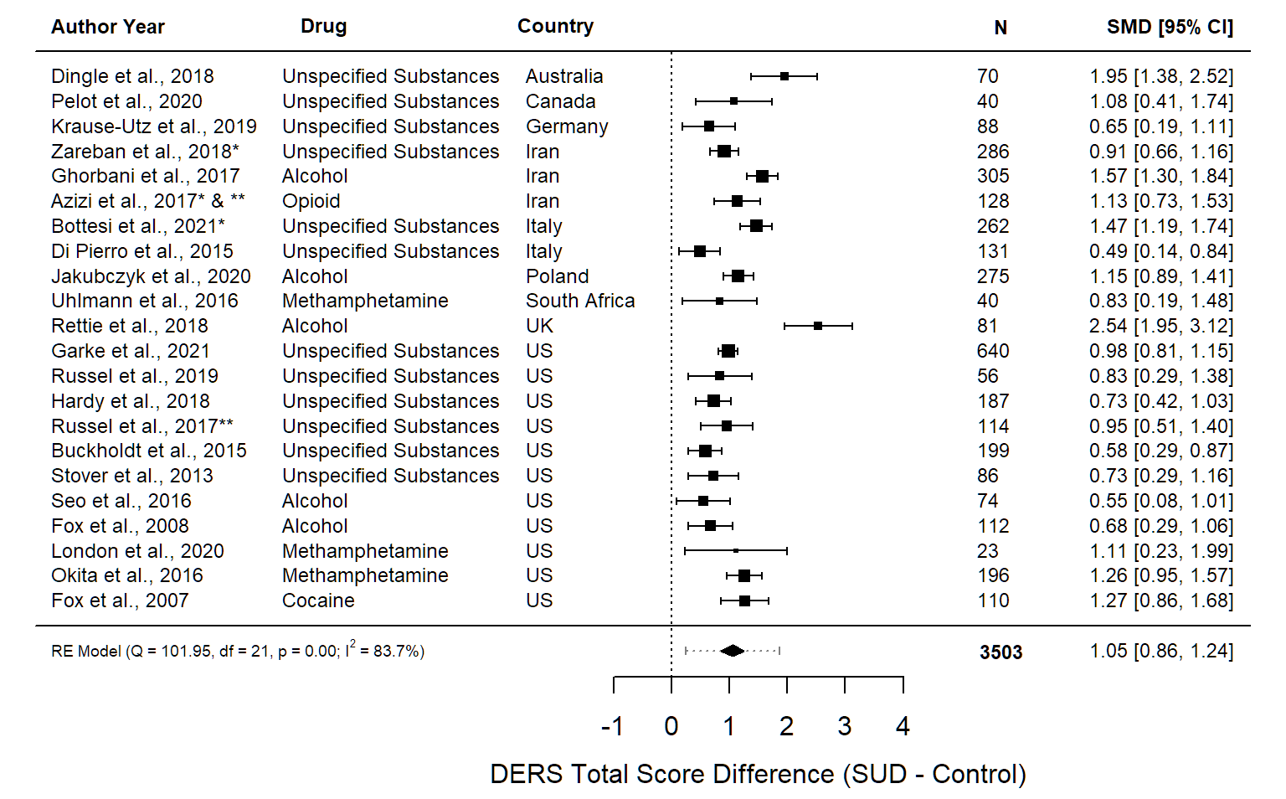 Error bars for the individual studies represent the 95% confidence interval (95% CI). The 95% CI for the summary effect is represented by the diamond width. Dashed error bars for the summary effect represent the prediction interval. The prediction interval represents a prediction of the range of possible effect sizes that could be found were a new study to be conducted. N = sample size, MD = mean difference, CI = confidence interval. *Studies with total DERS score calculated from DERS subscale scores. **Studies with multiple SUD arms and one control arm: multiple SUD means and SDs were pooled into one.

Supplementary Figure 3.1. Forest Plot Organized by Geographical Region of Each Study
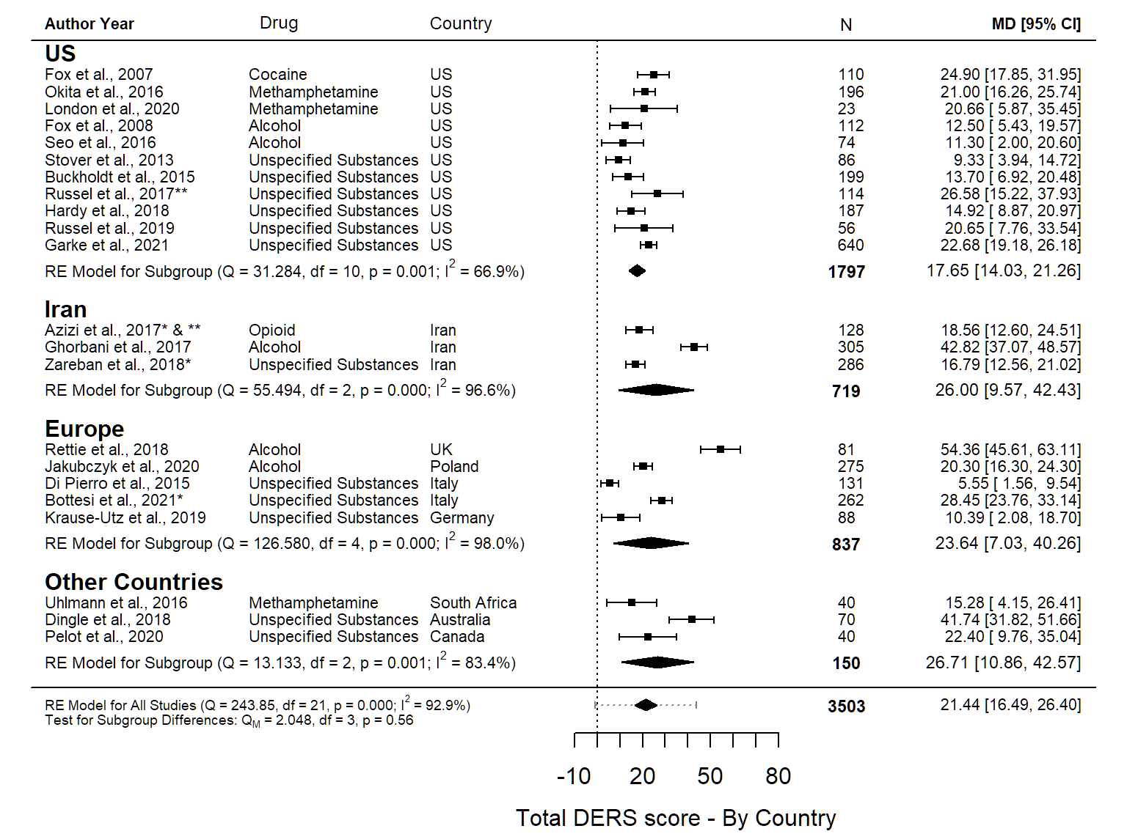Error bars for the individual studies represent the 95% confidence interval (95% CI). The 95% CI for the summary effect is represented by the diamond width. Dashed error bars for the summary effect represent the prediction interval. The prediction interval represents a prediction of the range of possible effect sizes that could be found were a new study to be conducted. N = sample size, MD = mean difference, CI = confidence interval. *Studies with total DERS score calculated from DERS subscale scores. **Studies with multiple SUD arms and one control arm: multiple SUD means and SDs were pooled into one.

Supplementary Figure 3.2. Forest Plot Organized by Year of Publication of Each Study
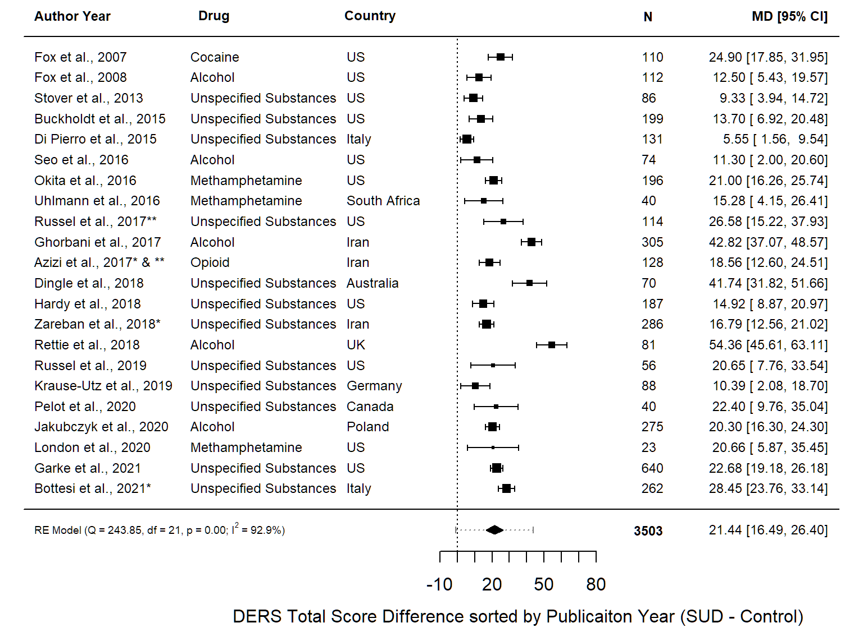
Error bars for the individual studies represent the 95% confidence interval (95% CI). The 95% CI for the summary effect is represented by the diamond width. Dashed error bars for the summary effect represent the prediction interval. The prediction interval represents a prediction of the range of possible effect sizes that could be found were a new study to be conducted. N = sample size, MD = mean difference, CI = confidence interval. *Studies with total DERS score calculated from DERS subscale scores. **Studies with multiple SUD arms and one control arm: multiple SUD means and SDs were pooled into one.

Supplementary Figure 3.3. Forest Plot Organized by Sex Distribution of Each Study
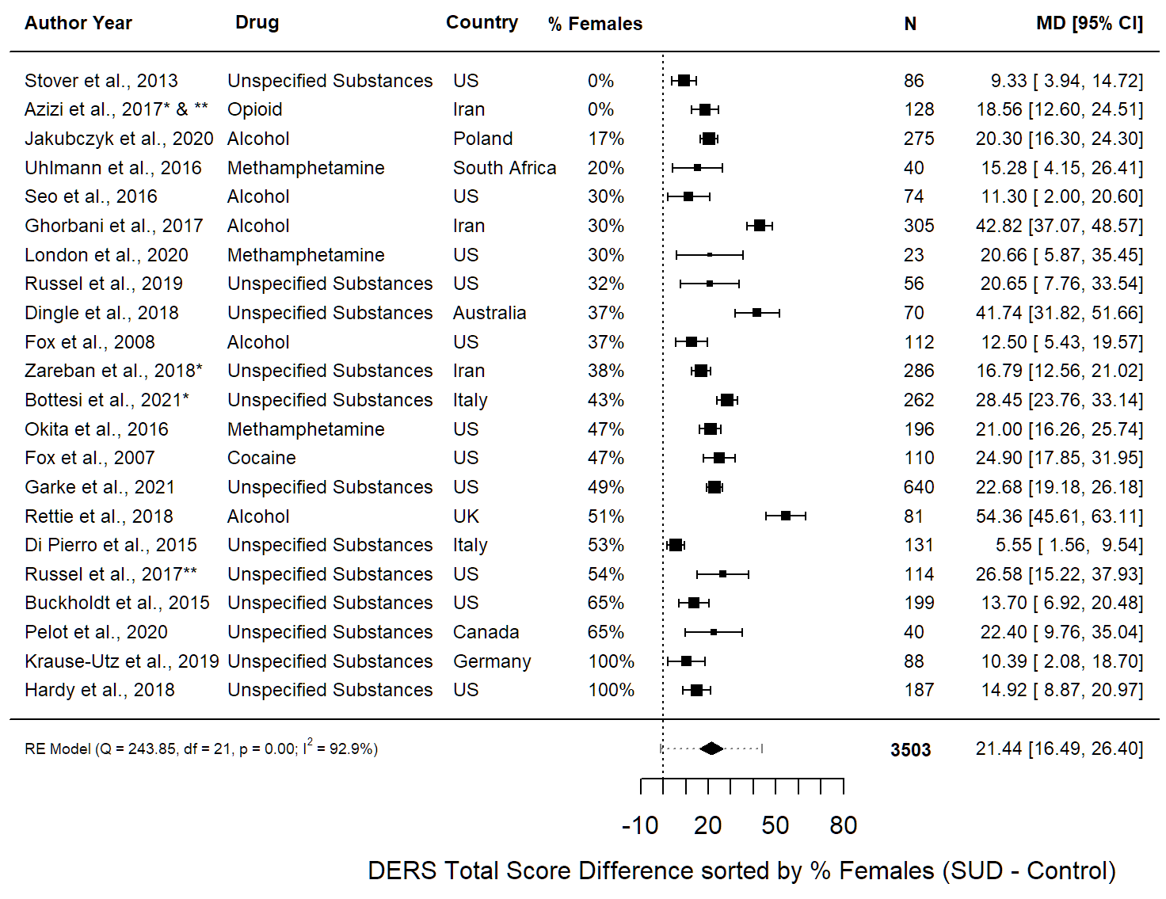Error bars for the individual studies represent the 95% confidence interval (95% CI). The 95% CI for the summary effect is represented by the diamond width. Dashed error bars for the summary effect represent the prediction interval. The prediction interval represents a prediction of the range of possible effect sizes that could be found were a new study to be conducted. N = sample size, MD = mean difference, CI = confidence interval, ND = no data. *Studies with Total DERS score calculated from DERS subscale scores. **Studies with multiple SUD arms and one control arm: multiple SUD means and SDs were pooled into one.

Supplementary Figure 3.4. Forest Plot Organized by Average Age of Each Study
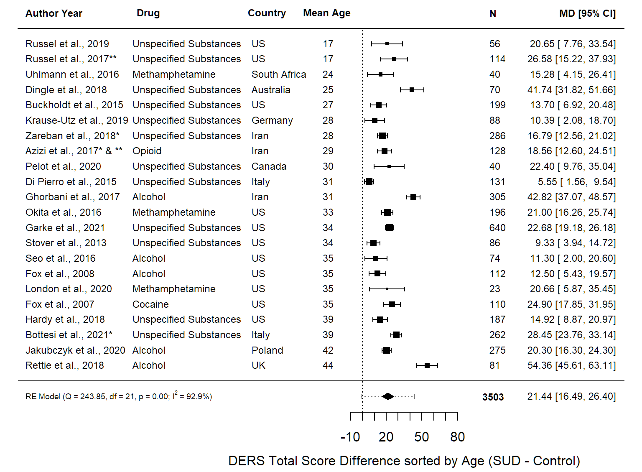Error bars for the individual studies represent the 95% confidence interval (95% CI). The 95% CI for the summary effect is represented by the diamond width. Dashed error bars for the summary effect represent the prediction interval. The prediction interval represents a prediction of the range of possible effect sizes that could be found were a new study to be conducted. N = sample size, MD = mean difference, CI = confidence interval, ND = no data. *Studies with total DERS score calculated from DERS subscale scores. **Studies with multiple SUD arms and one control arm: multiple SUD means and SDs were pooled into one.

Supplementary Figure 4.1. Sensitivity Analysis with Exclusion of Three Studies that were Missing Total DERS Score
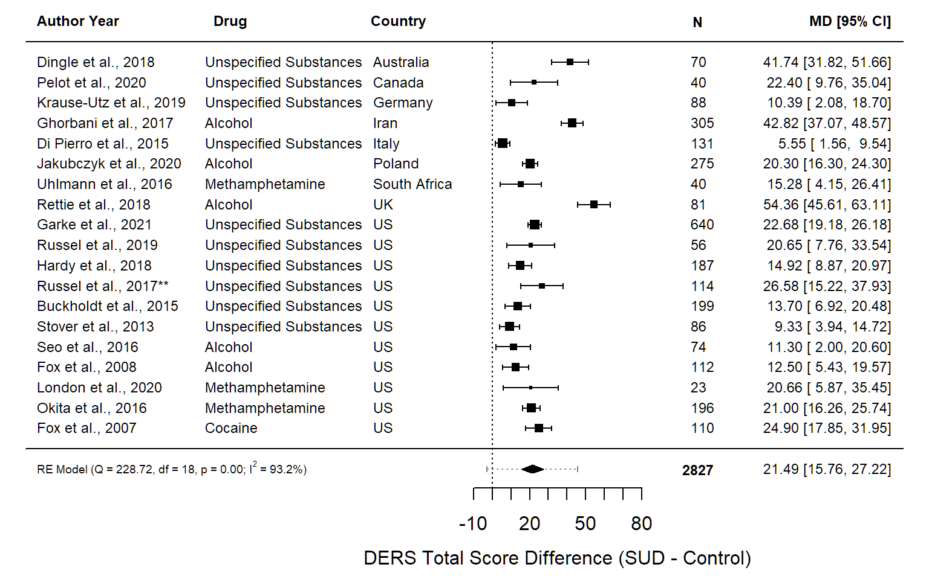Three studies were removed that were missing total DERS scores (49, 50, 65). Error bars for the individual studies represent the 95% confidence interval (95% CI). The 95% CI for the summary effect is represented by the diamond width. Dashed error bars for the summary effect represent the prediction interval. The prediction interval represents a prediction of the range of possible effect sizes that could be found were a new study to be conducted. N = sample size, MD = mean difference, CI = confidence interval. **Study with multiple SUD arms and one control arm: multiple SUD means and SDs were pooled into one.

Supplementary Figure 4.2. Sensitivity Analysis with Studies Categorized as ‘Poor’, ‘Fair’, or ‘Good’ Based on the Modified NIH Quality Assessment Tool
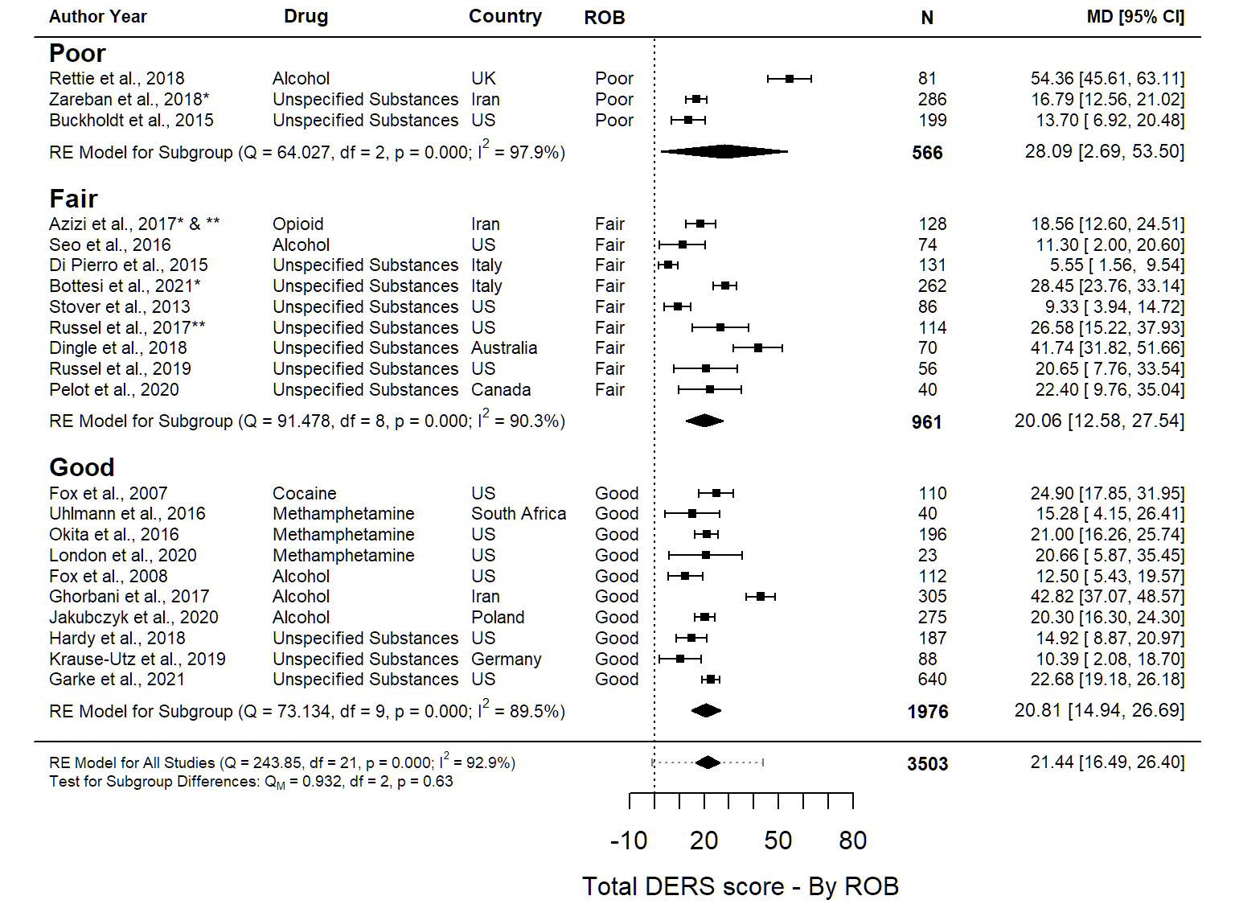Error bars for the individual studies represent the 95% confidence interval (95% CI). The 95% CI for the summary effect is represented by the diamond width. Dashed error bars for the summary effect represent the prediction interval. The prediction interval represents a prediction of the range of possible effect sizes that could be found were a new study to be conducted. N = sample size, MD = mean difference, CI = confidence interval. *Studies with total DERS score calculated from DERS subscale scores. **Studies with multiple SUD arms and one control arm: multiple SUD means and SDs were pooled into one.

Supplementary Figure 4.3. Sensitivity Analysis with Exclusion of Three Outlier Studies with Mean Difference Between Cases and Controls > 40
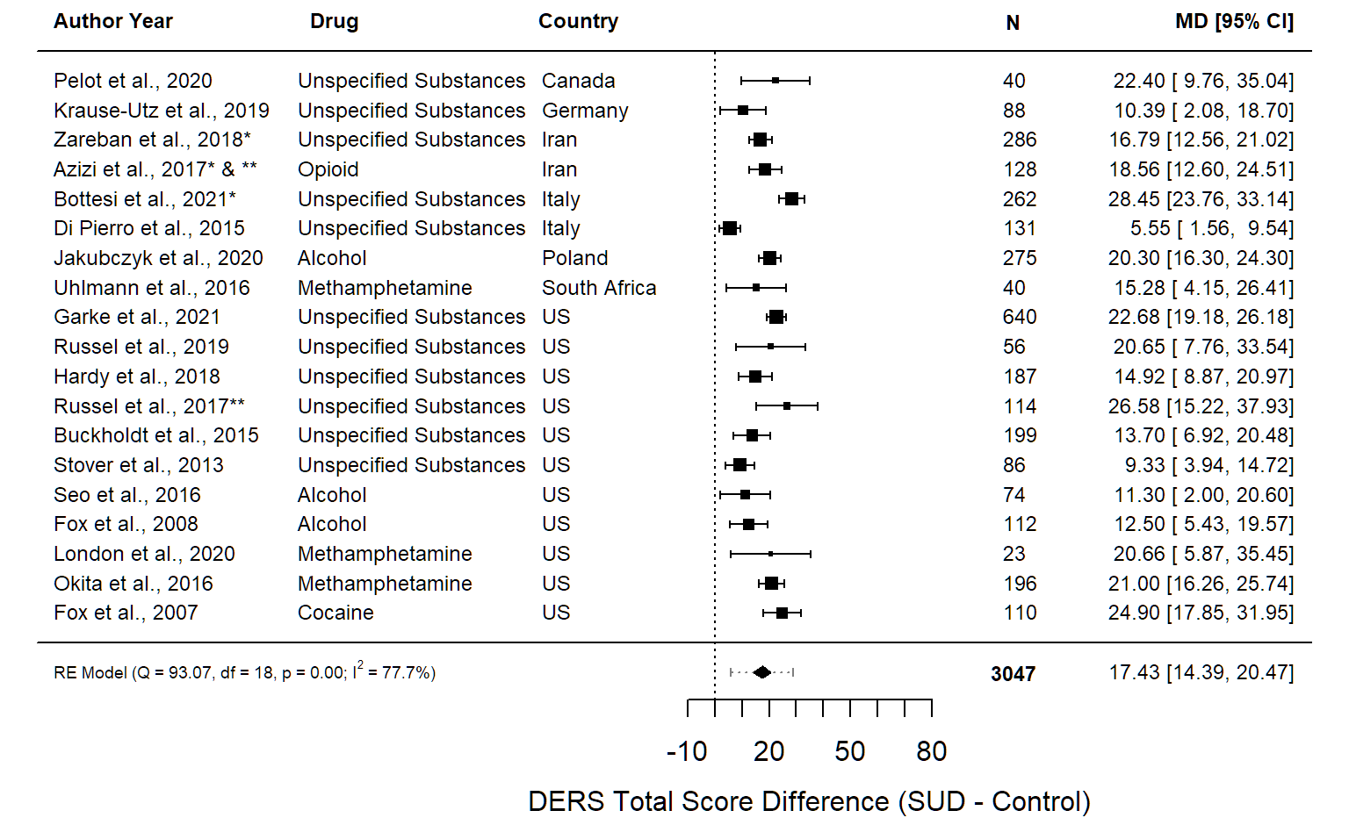Mean differences for effect sizes between SUD group and controls with removal of three outlier studies with mean differences of over 40 (52, 55, 62). Error bars for the individual studies represent the 95% confidence interval (95% CI). The 95% CI for the summary effect is represented by the diamond width. Dashed error bars for the summary effect represent the prediction interval. The prediction interval represents a prediction of the range of possible effect sizes that could be found were a new study to be conducted. N = sample size, MD = mean difference, CI = confidence interval. *Studies with total DERS score calculated from DERS subscale scores. **Studies with multiple SUD arms and one control arm: multiple SUD means and SDs were pooled into one.

Supplementary Figure 4.4. Sensitivity Analysis with Exclusion of Studies with DERS Score Values Estimated from Graphs
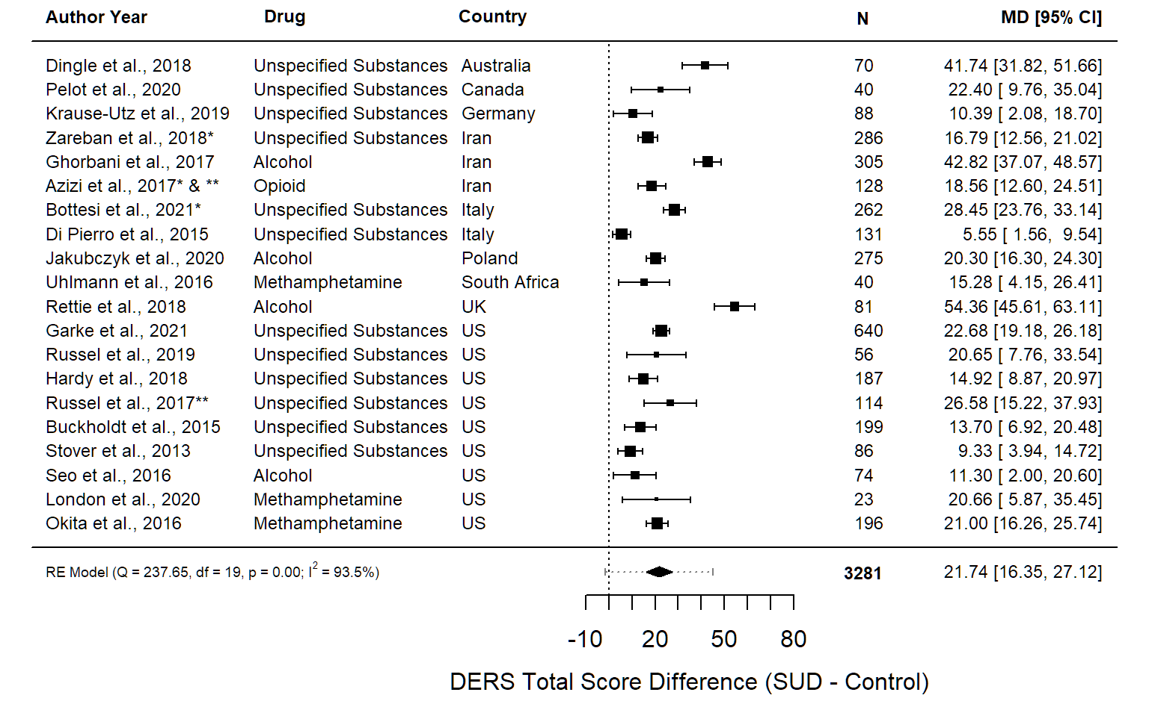Forest plot with removal of papers in which the DERS score was estimated from values on bar graphs (53, 54). Error bars for the individual studies represent the 95% confidence interval (95% CI). The 95% CI for the summary effect is represented by the diamond width. Dashed error bars for the summary effect represent the prediction interval. The prediction interval represents a prediction of the range of possible effect sizes that could be found were a new study to be conducted. N = sample size, MD = mean difference, CI = confidence interval. *Studies with total DERS score calculated from DERS subscale scores. **Studies with multiple SUD arms and one control arm: multiple SUD means and SDs were pooled into one.

Supplementary Figure 4.5. Sensitivity Analysis with Exclusion of Studies that did not Assess Controls Using a Validated Assessment Tool for SUD Diagnosis
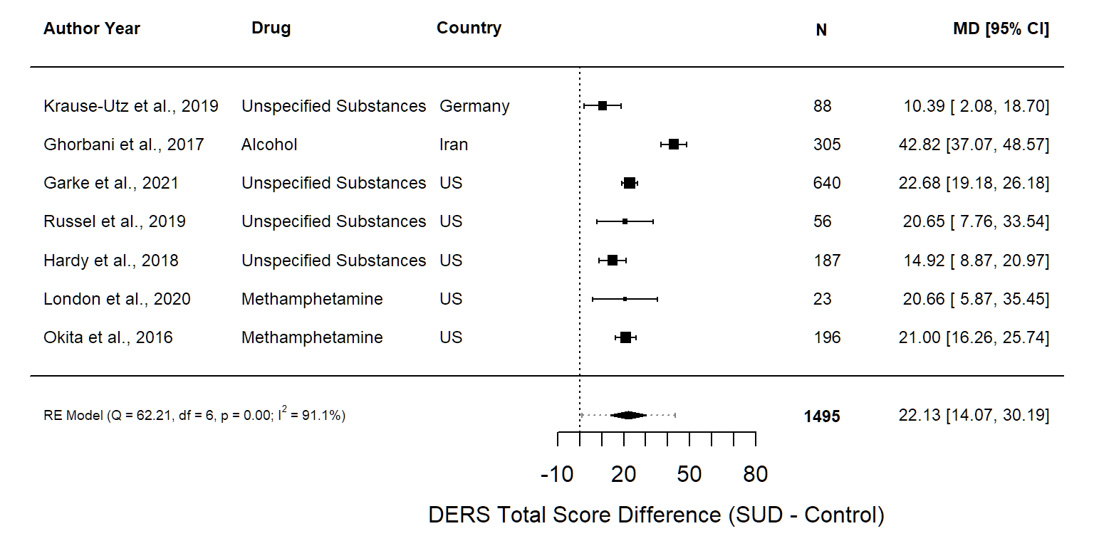Error bars for the individual studies represent the 95% confidence interval (95% CI). The 95% CI for the summary effect is represented by the diamond width. Dashed error bars for the summary effect represent the prediction interval. The prediction interval represents a prediction of the range of possible effect sizes that could be found were a new study to be conducted. N = sample size, MD = mean difference, CI = confidence interval.

Supplementary Figure 4.6. Sensitivity Analysis with Addition of a Community Substance Misuse Group
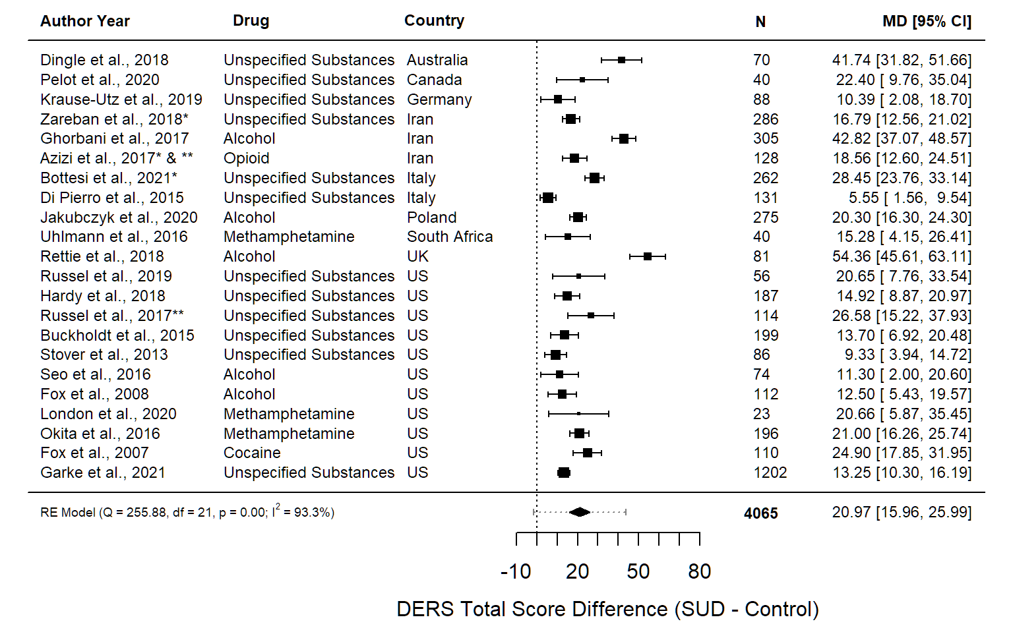 Forest plot with the addition of a large community group with substance misuse (27), which was excluded from our primary analysis. Error bars for the individual studies represent the 95% confidence interval (95% CI). The 95% CI for the summary effect is represented by the diamond width. Dashed error bars for the summary effect represent the prediction interval. The prediction interval represents a prediction of the range of possible effect sizes that could be found were a new study to be conducted. N = sample size, MD = mean difference, CI = confidence interval. *Studies with total DERS score calculated from DERS subscale scores. **Studies with multiple SUD arms and one control arm: multiple SUD means and SDs were pooled into one.

Supplementary Figure 5.1. Forest Plot for Nonacceptance Subscale Scores
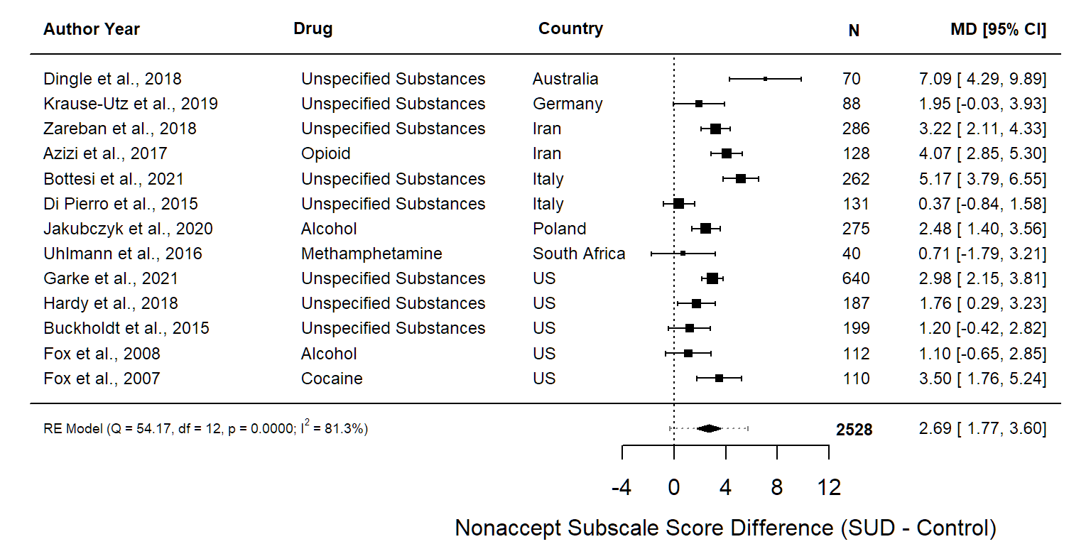Error bars for the individual studies represent the 95% confidence interval (95% CI). The 95% CI for the summary effect is represented by the diamond width. Dashed error bars for the summary effect represent the prediction interval. The prediction interval represents a prediction of the range of possible effect sizes that could be found were a new study to be conducted. N = sample size, MD = mean difference, CI = confidence interval.

Supplementary Figure 5.2. Forest Plot for Goals Subscale Scores
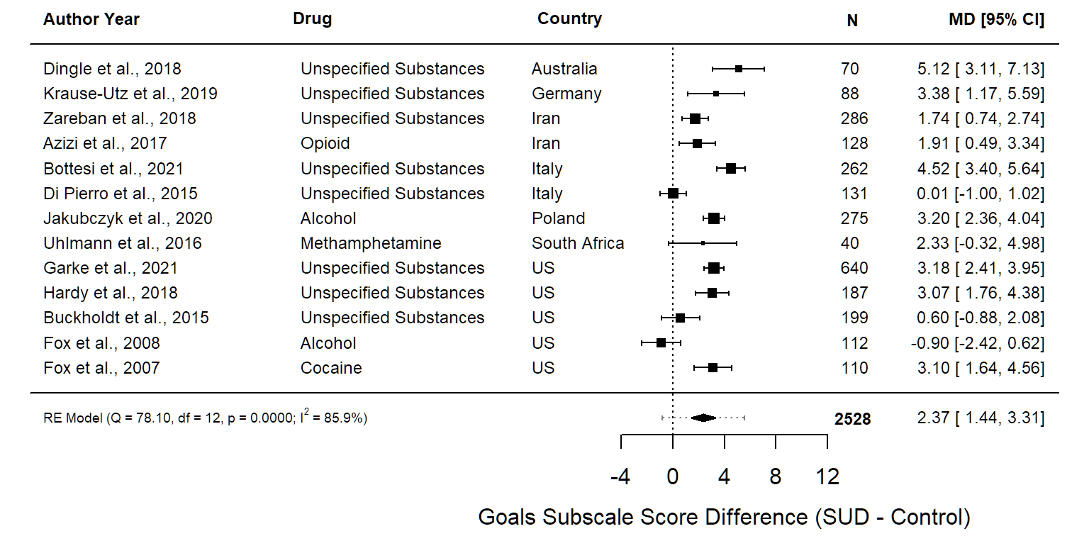Error bars for the individual studies represent the 95% confidence interval (95% CI). The 95% CI for the summary effect is represented by the diamond width. Dashed error bars for the summary effect represent the prediction interval. The prediction interval represents a prediction of the range of possible effect sizes that could be found were a new study to be conducted. N = sample size, MD = mean difference, CI = confidence interval.

Supplementary Figure 5.3. Forest Plot for Impulse Subscale Scores
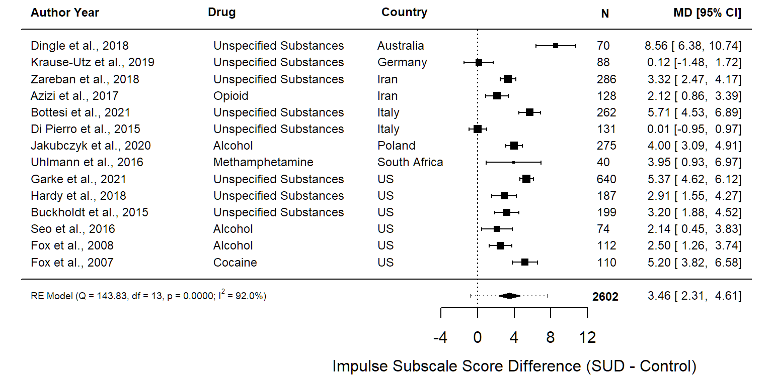
Error bars for the individual studies represent the 95% confidence interval (95% CI). The 95% CI for the summary effect is represented by the diamond width. Dashed error bars for the summary effect represent the prediction interval. The prediction interval represents a prediction of the range of possible effect sizes that could be found were a new study to be conducted. N = sample size, MD = mean difference, CI = confidence interval.

Supplementary Figure 5.4. Forest Plot for Awareness Subscale Scores
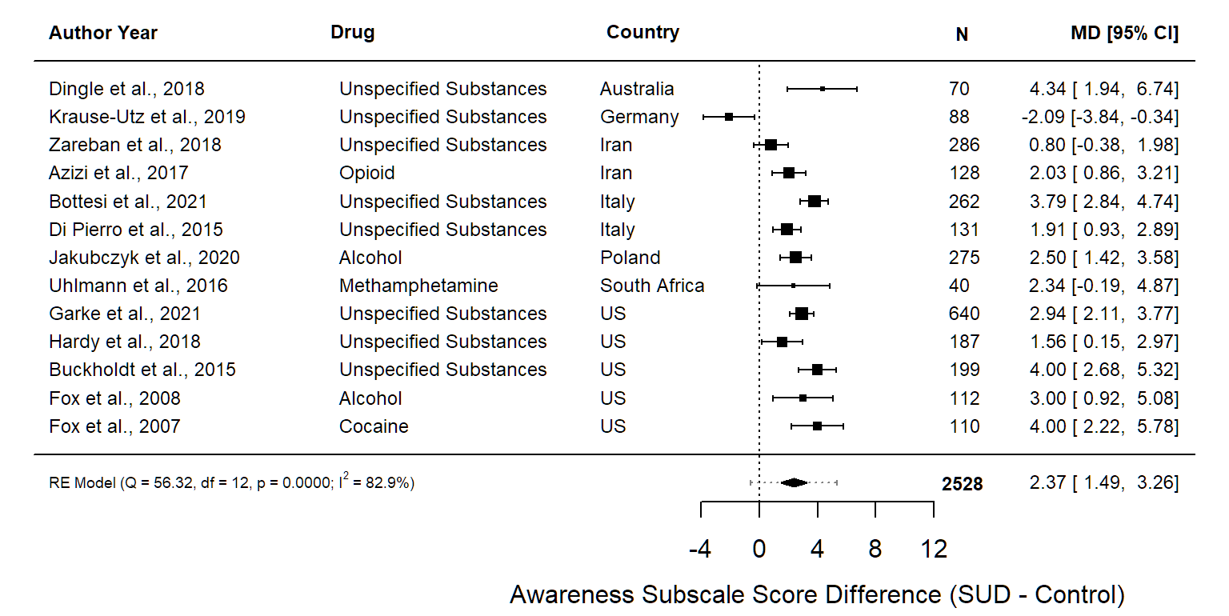Error bars for the individual studies represent the 95% confidence interval (95% CI). The 95% CI for the summary effect is represented by the diamond width. Dashed error bars for the summary effect represent the prediction interval. The prediction interval represents a prediction of the range of possible effect sizes that could be found were a new study to be conducted. N = sample size, MD = mean difference, CI = confidence interval.

Supplementary Figure 5.5. Forest Plot for Strategies Subscale Scores
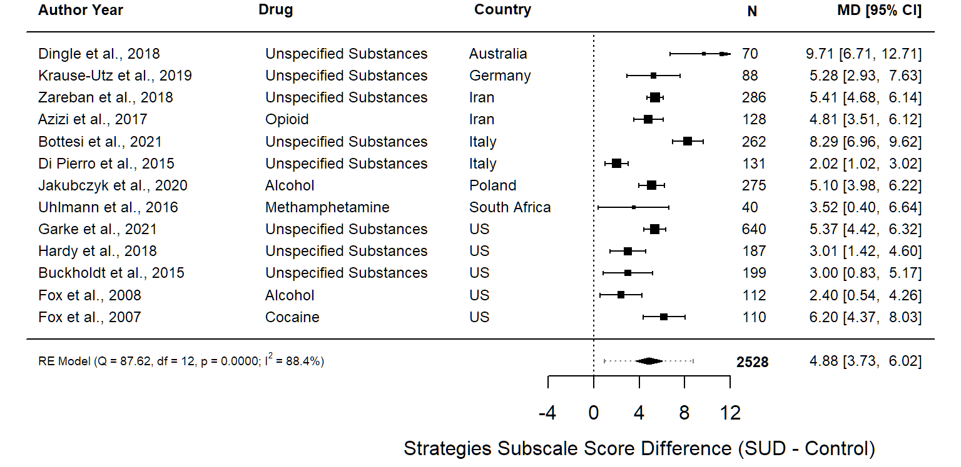Error bars for the individual studies represent the 95% confidence interval (95% CI). The 95% CI for the summary effect is represented by the diamond width. Dashed error bars for the summary effect represent the prediction interval. The prediction interval represents a prediction of the range of possible effect sizes that could be found were a new study to be conducted. N = sample size, MD = mean difference, CI = confidence interval.

Supplementary Figure 5.6. Forest Plot for Clarity Subscale Scores
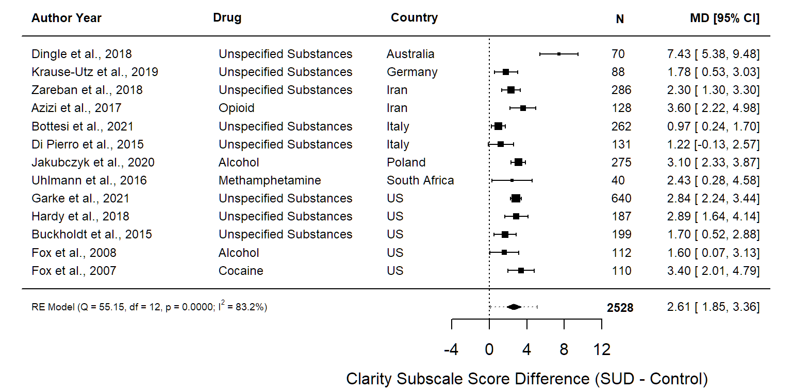Error bars for the individual studies represent the 95% confidence interval (95% CI). The 95% CI for the summary effect is represented by the diamond width. Dashed error bars for the summary effect represent the prediction interval. The prediction interval represents a prediction of the range of possible effect sizes that could be found were a new study to be conducted. N = sample size, MD = mean difference, CI = confidence interval.

Supplementary Figure 6. Forest Plot with Shortened Versions of the DERS Included in the Primary Analysis
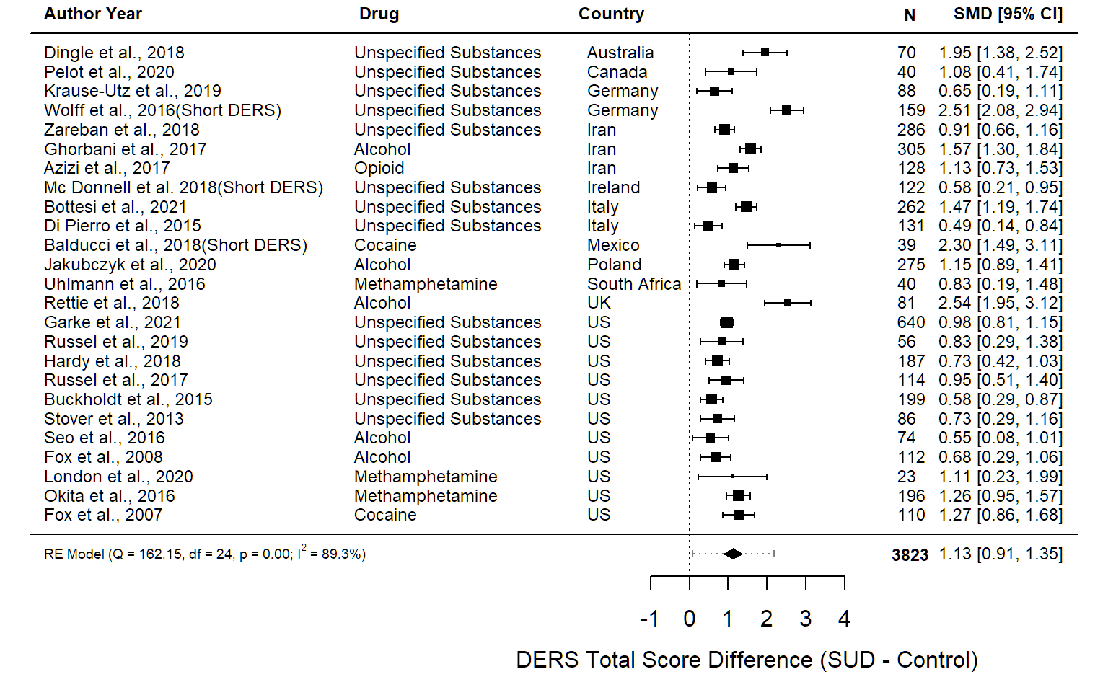Error bars for the individual studies represent the 95% confidence interval (95% CI). The 95% CI for the summary effect is represented by the diamond width. Dashed error bars for the summary effect represent the prediction interval. The prediction interval represents a prediction of the range of possible effect sizes that could be found were a new study to be conducted. N = sample size, MD = mean difference, CI = confidence interval.

