Supplementary Material
Table 1. Quality assessment of included studies according to the Newcastle-Ottawa scale for cohort studies.
Author ^{ref} | Year | Selection | Comparability | Exposure/outcome | Total (9/9)
Van de Ven et al.⁸ | 2020 | ★★★★ | ★ | ★★★ | 8
Yoshida et al.²² | 2020 | ★★★★ | ★★ | ★ | 7
Chen et al.³³ | 2019 | ★★★★ | ★ | ★ | 6
Yamaguchi et al.²⁵ | 2018 | ★★★ | ★ | ★★★ | 7
Otowa et al.²⁶ | 2016 | ★★★★ | ★★ | ★★★ | 9
Hu et al.²³ | 2015 | ★★★★ | ★★ | ★★★ | 9
Lee et al.²⁴ | 2013 | ★★★★ | ★★ | ★★★ | 9
Chuang et al.³⁴ | 2008 | ★★★★ | ★ | ★ | 6
Natsugoe et al.²⁷ | 2005 | ★★★★ | ★★ | ★★★ | 9
Motoyama et al. ²¹ | 2003 | ★★★★ | ★ | ★★★ | 9
Kokawa et al²⁹ | 2001 | ★★★★ | ★★ | ★ | 7
Kumagai et al.²⁸ | 2001 | ★★★★ | ★★ | ★ | 7
Nagasawa et al.³⁰ | 2000 | ★★★★ | ★★ | ★ | 7
Ribeiro Jùnior et al.³⁵ | 1999 | ★★★★ | ★ | ★ | 6
Poon et al.²⁰ | 1998 | ★★★★ | ★★ | ★★★ | 9
Voormolen et al.³¹ | 1995 | ★★★★ | ★ | ★★★ | 8
Fekete et al.³² | 1994 | ★★ | ★ | ★ | 4
Fogel et al.³⁶ | 1985 | ★★ | ★ | ★ | 4
Fitzpatrick et al.³⁷ | 1984 | ★★★★ | ★ | ★ | 6
Fink-Neuboeck et al.⁵⁷ | 2020 | ★★★★ | ★★ | ★★ | 8
Komatsu et al.⁴⁷ | 2019 | ★★★★ | ★★ | ★★★ | 9
Faehling et al.⁴² | 2018 | ★★★★ | ★ | ★★★ | 8
Abdel-Rahman et al.³⁸ | 2017 | ★★★★ | ★ | ★ | 6
Shan et al.⁵¹ | 2017 | ★★★★ | ★ | ★ | 6
Su et al.⁵³ | 2017 | ★★★★ | ★ | ★★ | 7
Li et al.⁴⁹ | 2015 | ★★★★ | ★ | ★ | 6
Coyte et al.⁴⁰ | 2014 | ★★★★ | ★ | ★ | 6
Reinmuth et al.⁵⁰ | 2013 | ★★★★ | ★ | ★★★ | 8
Son et al.⁵² | 2013 | ★★★★ | ★★ | ★ | 7
Chuang et al.³⁹ | 2010 | ★★★★ | ★ | ★ | 6
Haraguchi et al.⁴³ | 2007 | ★★★★ | ★★ | ★ | 7
Takigawa et al.⁵⁴ | 2006 | ★★★ | 0 | ★★★ | 6
Duchateau et al.⁴¹ | 2005 | ★★★★ | ★ | ★ | 6
Shimizu et al.⁵⁶ | 2001 | ★★★★ | 0 | ★★★ | 7
Teppo et al.⁵⁵ | 2001 | ★★★★ | ★ | ★★ | 7
Kaneko et al.⁴⁵ | 1999 | ★★★★ | ★ | ★★ | 7
Levi et al.⁴⁸ | 1999 | ★★★★ | ★ | ★★★ | 8
Kawahara et al.⁴⁶ | 1998 | ★★★★ | 0 | ★★★ | 7
Hsieh et al.⁴⁴ | 1997 | ★★★★ | ★ | ★ | 6

Table 2. Study characteristics and quality assessment of included studies performed in patients with ESCC.
Author ^{ref} | Year | Country | Study design | ESCC, n | LSPTs, n (%) | Time to SPTs investigated |  |  | Quality (NOS)
 |  |  |  |  |  | History of LC | Synchronous LSPTs | Metachronous LSPTs | Quality (NOS)
Van de Ven et al.⁸ | 2020 | Netherlands | Retro | 9,058 | 219 (2.4) | - | + | + | 8/9
Yoshida et al.²² | 2020 | Japan | Retro | 766 | 22 (2.9) | + | + | + | 7/9
Chen et al.³³ | 2019 | USA | Retro | 14,540 | 229 (1.6) | - | +^{b} |  | 6/9
Yamaguchi et al.²⁵ | 2018 | Japan | Retro | 185 | 5 (2.7) | - | - | + | 7/9
Otowa et al.²⁶ | 2016 | Japan | Retro | 273 | 6 (2.2) | + | + | + | 9/9
Hu et al.²³ | 2015 | China | Retro | 512 | 13 (2.5)ª | - | +^{b} |  | 9/9
Lee et al.²⁴ | 2013 | Korea | Retro | 601 | 18 (3.0) | + | + | + | 9/9
Chuang et al.³⁴ | 2008 | World | Retro | 30,121 | 338 (1.1) | + | + | + | 6/9
Natsugoe et al.²⁷ | 2005 | Japan | Retro | 652 | 13 (2.0) | + | + | + | 9/9
Motoyama et al.²¹ | 2003 | Japan | Retro (1972-1988)  Pro (1989-2001) | 325 | 9 (2.8) | - | - | + | 9/9
Kokawa et al.²⁹ | 2001 | Japan | Retro | 368 | 13 (3.5) | + | + | + | 7/9
Kumagai et al.²⁸ | 2001 | Japan | Retro | 733 | 5 (0.7) | + | + | +^{c} | 7/9
Nagasawa et al.³⁰ | 2000 | Japan | Retro | 268 | 3 (1.1) | + | +^{b} |  | 7/9
Ribeiro Jùnior et al.³⁵ | 1999 | Brazil | Retro | 264 | 2 (0.8) | + | + | + | 6/9
Poon et al.²⁰ | 1998 | China | Pro | 1,055 | 8 (0.8) | + | + | + | 9/9
Voormolen et al.³¹ | 1995 | Netherlands | Retro | 242 | 3 (1.2) | + | + | + | 8/9
Fekete et al.³² | 1994 | France | Retro | 1,294 | 39 (3.0) | + | + | + | 4/9
Fogel et al.³⁶ | 1985 | USA | Retro | 198 | 2 (1.0) | + | + | + | 4/9
Fitzpatrick et al.³⁷ | 1984 | Canada | Retro | 1,469 | 6 (0.4) | + | + | + | 6/9
ESCC, esophageal squamous cell carcinoma; LSPT, lung second primary tumor; NOS, Newcastle-Ottawa Scale quality assessment for cohort studies; Pro, prospective; Retro, retrospective; SPTs, second primary tumor; USA, united States of America.
ª Hu et al. excluded all lung squamous cell carcinoma (n=11), which occurred within the first 5 years after the diagnosis of ESCC, as potential LSPTs.
^{b} Synchronous and metachronous LSPTs were registered jointly as subsequent SPTs.
^{c} Metachronous LSPTs were defined as SPTs detected more than 1 year after the diagnosis of ESCC.

Table 3. Study characteristics and quality assessment of included studies performed in patients with LC.
Author ^{ref} | Year | Country | Study design | LC type | LC, n | ESPTs, n (%) | Time to SPTs investigated |  |  | Quality (NOS)
 |  |  |  |  |  |  | History of EC | Synchronous ESPTs | Metachronous ESPTs | Quality (NOS)
Fink-Neuboeck et al.⁵⁷ | 2020 | Austria | Pro | NSCLC | 324 | 1 (0.3) | + | +^{b} |  | 8/9
Komatsu et al.⁴⁷ | 2019 | Japan | Retro | NSCLC | 521 | 27 (5.2) | - | +^{b} |  | 9/9
Faehling et al.⁴² | 2018 | Germany | Retro | NSCLC | 1,252 | 3 (0.2) | +ª | + | - | 8/9
Abdel-Rahman et al.³⁸ | 2017 | USA | Retro | LC | 223,274 | 251 (0.1) | - | + | +^{c} | 6/9
Shan et al.⁵¹ | 2017 | China | Retro | LC | 27,642 | 10 (0.04) | + | + | - | 6/9
Su et al.⁵³ | 2017 | Taiwan | Retro | LC | 18,372 | 16 (0.09) | - | - | +^{c} | 7/9
Li et al.⁴⁹ | 2015 | China | Retro | LC | 5,405 | 17 (0.3) | + | + | + | 6/9
Coyte et al.⁴⁰ | 2014 | Scotland | Retro | LC | 10,764 | 4 (0.04) | - | +^{b} |  | 6/9
Reinmuth et al.⁵⁰ | 2013 | Germany | Retro | LC | 2,816 | 1 (0.04) | - | + | +^{d} | 8/9
Son et al.⁵² | 2013 | Korea | Retro | NSCLC | 632 | 4 (0.6) | + | + | + | 7/9
Chuang et al.³⁹ | 2010 | World | Retro | LC | 258,559 | 159 (0.06) | - | + | + | 6/9
Haraguchi et al.⁴³ | 2007 | Japan | Retro | LC | 1,013 | 4 (0.4) | - | + | +^{c} | 7/9
Takigawa et al.⁵⁴ | 2006 | Japan | Retro | NSCLC | 90 | 2 (2.2) | - | +^{b} |  | 6/9
Duchateau et al.⁴¹ | 2005 | Netherlands | Retro | NSCLC | 860 | 2 (0.2) | + | + | +^{d} | 6/9
Shimizu et al.⁵⁶ | 2001 | Japan | Pro | LC | 32 | 1 (3.1) | - | +^{b} |  | 7/9
Teppo et al.⁵⁵ | 2001 | Finland | Retro | LC | 77,548 | 28 (0.04) | - | + | +^{e} | 7/9
Kaneko et al.⁴⁵ | 1999 | Japan | Retro | LC | 6,935 | 28 (0.4) | - | + | - | 7/9
Levi et al.⁴⁸ | 1999 | Switzerland | Retro | LC | 5,794 | 5 (0.09) | - | +^{b} |  | 8/9
Kawahara et al.⁴⁶ | 1998 | Japan | Retro | SCLC | 70 | 2 (2.9) | - | - | +^{d} | 7/9
Hsieh et al.⁴⁴ | 1997 | Taiwan | Retro | LC | 6,412 | 10 (0.2) | + | + | + | 6/9
ESPT, esophageal second primary tumor; LC, lung cancer; NOS, Newcastle-Ottawa Scale quality assessment for cohort studies; NSCLC, non-small cell lung cancer; SCLC, small cell lung cancer; Pro, prospective; Retro, retrospective; SPT, second primary tumor; USA, United States of America.
ª History of EC was defined as the detection of EC more than 3 months before the diagnosis of LC.
^{b} Synchronous and metachronous ESPTs were registered jointly as subsequent SPTs.
^{c} Metachronous ESPTs were defined as SPTs detected more than 1 year after the diagnosis of LC.
^{d} Metachronous ESPTs were defined as SPTs detected more than 2 years after the diagnosis of LC.
^{e} Metachronous ESPTs were defined as SPTs detected during follow-up (i.e. after first admission for LC).

Figure 1. Funnel plots to assess the risk of publication bias.
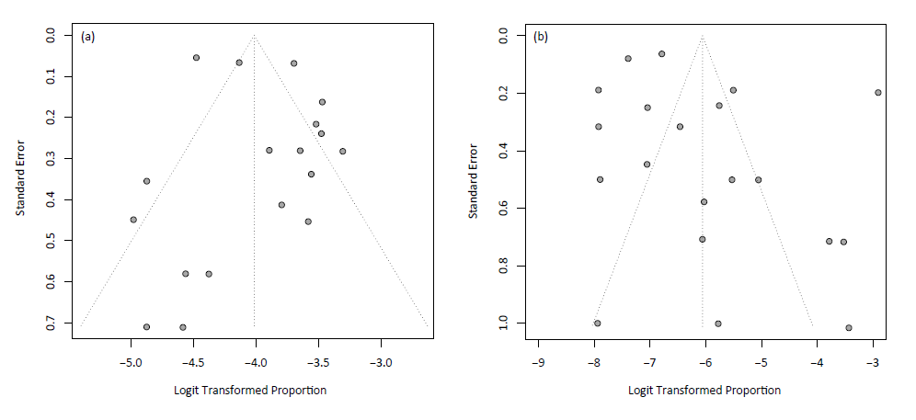
The risk for publication bias for studies (a) performed in patients with ESCC to detect LSPTs (P = 0.11) and (b) performed in patients with LC to detect ESPTs (P = 0.16).
ESCC, esophageal squamous cell carcinoma; ESPTs, esophageal second primary tumors; LC, lung cancer; LSPTs, lung second primary tumors.

Figure 2. Overview of the prevalence of LSPTs in patients with ESCC in Asian and non-Asian countries.
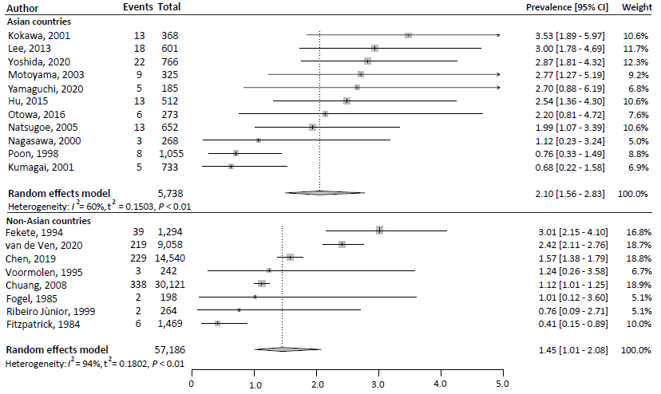
CI, confidence interval; ESCC, oesophageal squamous cell carcinoma; LSPT, lung second primary tumour; I², inconsistency index; τ², tau-squared represents the extent of variation among the effects observed in different studies.
ª Hu et al. excluded all lung squamous cell carcinoma (n=11), which occurred within the first 5 years after the diagnosis of ESCC, as potential LSPTs.²³

Figure 3. Overview of the prevalence of LSPTs in patients with ESCC during recent decades.
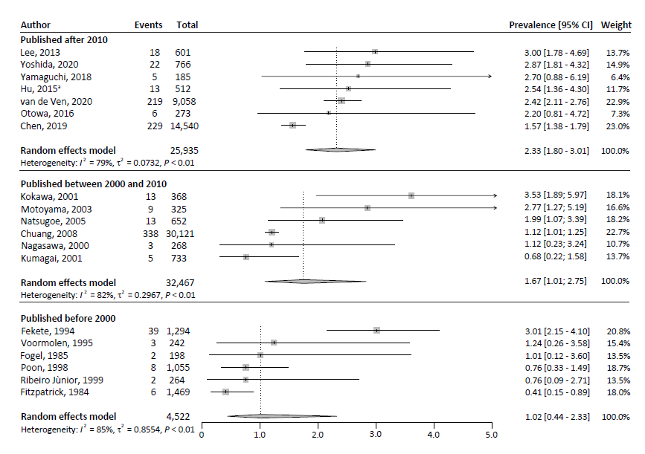
CI, confidence interval; ESCC, oesophageal squamous cell carcinoma; LSPT, lung second primary tumour; I², inconsistency index; τ², tau-squared represents the extent of variation among the effects observed in different studies.
ª Hu et al. excluded all lung squamous cell carcinoma (n=11), which occurred within the first 5 years after the diagnosis of ESCC, as potential LSPTs.²³
Figure 4. Overview of the prevalence of ESPTs in patients with LC in Asian and non-Asian countries.
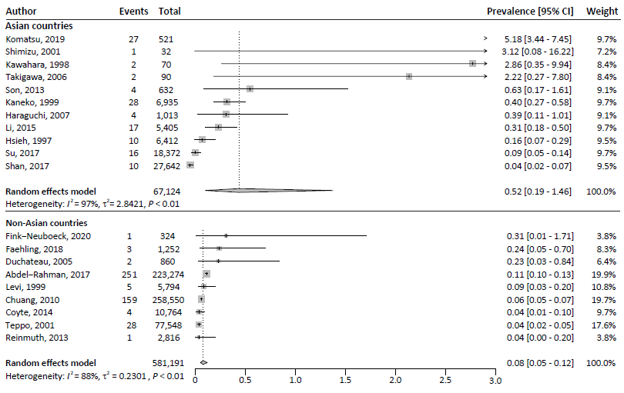
CI, confidence interval; ESPT, oesophageal second primary tumour; LC, lung cancer; I², inconsistency index; τ², tau-squared represents the extent of variation among the effects observed in different studies.
Figure 5. Overview of the prevalence of ESPTs in patients with LC during recent decades.
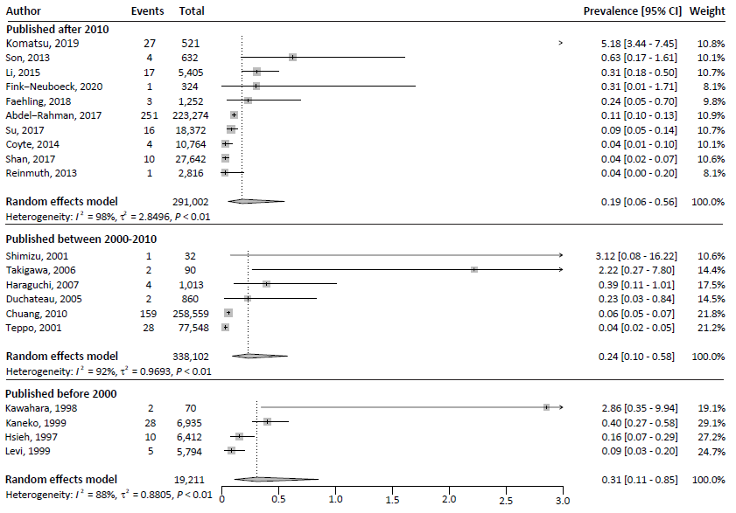
CI, confidence interval; ESPT, oesophageal second primary tumour; LC, lung cancer; I², inconsistency index; τ², tau-squared represents the extent of variation among the effects observed in different studies.

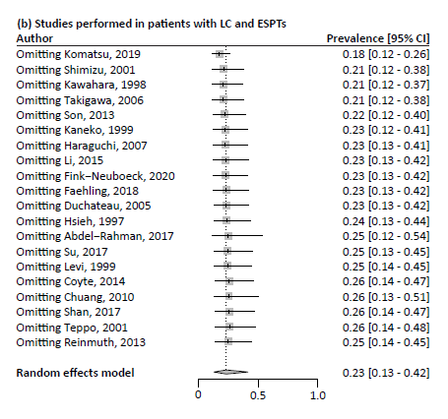
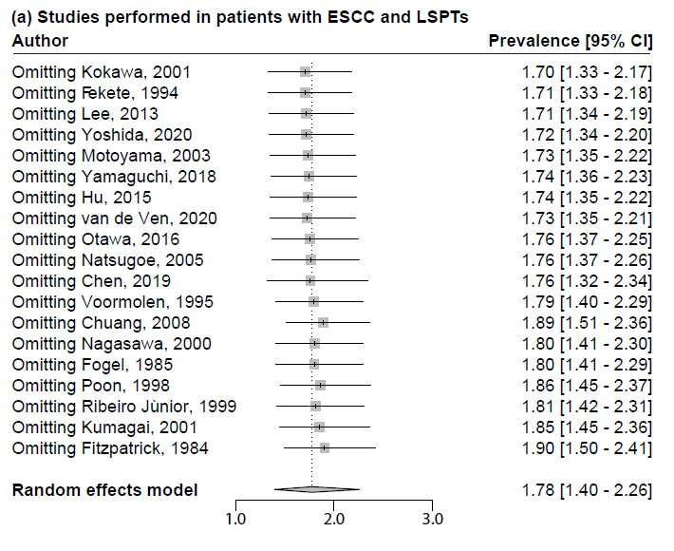
Figure 6. Excessive influence analysis of the included studies.

ESCC, esophageal squamous cell carcinoma; ESPT, esophageal second primary tumor; LC, lung cancer; LSPT, lung second primary tumor.

Appendix 1. The full search strategy
Embase
('second cancer'/de OR (((Metachronous OR Synchronous) NEAR/6 (tumo* OR malignan* OR carcin* OR neoplas* OR cancer*)) OR ((Second OR Multiple OR double OR triple OR quadruple OR quintuple OR subsequen* OR Simultan*) NEAR/3 (primar*) NEAR/6 (tumo* OR malignan* OR carcin* OR neoplas* OR cancer*))):ab,ti,kw) AND ('esophagus tumor'/exp OR 'lung tumor'/exp OR ((esophag* OR oesophag* OR lung OR pulmonar* OR upper-aerodigest* OR upper-digest*) NEAR/6 (tumo* OR cancer* OR neoplas*)):ab,ti,kw) NOT [conference abstract]/lim NOT ([animals]/lim NOT [humans]/lim) AND [English]/lim

Medline
(Neoplasms, Second Primary/ OR Neoplasms, Multiple Primary/ OR (((Metachronous OR Synchronous) ADJ6 (tumo* OR malignan* OR carcin* OR neoplas* OR cancer*)) OR ((Second OR Multiple OR double OR triple OR quadruple OR quintuple OR subsequen* OR Simultan*) ADJ3 (primar*) ADJ6 (tumo* OR malignan* OR carcin* OR neoplas* OR cancer*))).ab,ti,kf.) AND (exp Esophageal Neoplasms/ OR exp Lung Neoplasms/ OR ((esophag* OR oesophag* OR lung OR pulmonar* OR upper-aerodigest* OR upper-digest*) ADJ6 (tumo* OR cancer* OR neoplas*)).ab,ti,kf.) NOT (exp animals/ NOT humans/) AND english.la.

Web of science
TS=(((((Metachronous OR Synchronous) NEAR/5 (tumo* OR malignan* OR carcin* OR neoplas* OR cancer*)) OR ((Second OR Multiple OR double OR triple OR quadruple OR quintuple OR subsequen* OR Simultan*) NEAR/2 (primar*) NEAR/5 (tumo* OR malignan* OR carcin* OR neoplas* OR cancer*)))) AND (((esophag* OR oesophag* OR lung OR pulmonar* OR upper-aerodigest* OR upper-digest*) NEAR/5 (tumo* OR cancer* OR neoplas*)))) AND DT=(Article OR Review OR Letter OR Early Access) AND LA=(english)

Cochrane
((((Metachronous OR Synchronous) NEAR/6 (tumo* OR malignan* OR carcin* OR neoplas* OR cancer*)) OR ((Second OR Multiple OR double OR triple OR quadruple OR quintuple OR subsequen* OR Simultan*) NEAR/3 (primar*) NEAR/6 (tumo* OR malignan* OR carcin* OR neoplas* OR cancer*))):ab,ti,kw) AND (((esophag* OR oesophag* OR lung OR pulmonar* OR upper-aerodigest* OR upper-digest*) NEAR/6 (tumo* OR cancer* OR neoplas*)):ab,ti,kw)

Google scholar
"Metachronous|Synchronous tumors|malignancies|neoplasms|cancers"|"Second|Multiple|double|triple primary tumor|malignancy|carcinoma|neoplasm|cancer" esophagus|oesophagus|esophageal|oesophageal|lung|pulmonary incidence|prevalence
'Metachronous|Synchronous tumors|malignancies|neoplasms|cancers'|'Second|Multiple|double|triple primary tumor|malignancy|carcinoma|neoplasm|cancer' esophagus|oesophagus|esophageal|oesophageal|lung|pulmonary incidence|prevalence

