Supplementary Table 1. Extracted baseline variables and outcomes
Baseline variables | Outcomes
Age | CPB time
Male | ACC time
Acute aortic dissection | HCA time
Chronic dissection | Cerebral perfusion time
Degenerative | ACP time
Other | RCP time
Hypertension | Operative mortality
History of CVA | Postoperative permanent CVA
Marfan | Transit postoperative CVA
COPD | Paraplegia
Previous heart surgery | Resternotomy
CAD | Dialysis
DM | Respiratory failure
No cerebral perfusion | Tracheostoma
Unilateral ACP | New onset AF
Bilateral ACP | AKI
RCP | Mediastinitis
CABG | Pacemaker
Hemiarch replacement | ICU stay
Total arch replacement | Hospital stay
Aortic root replacement
ET
FET
Lowest rectal temperature
ACC, aortic cross clamp; ACP, antegrade cerebral perfusion; AF, atrial fibrillation; AKI, acute kidney insufficiency; CABG, coronary artery bypass grafting; CAD, coronary artery disease; COPD, chronic obstructive pulmonary disease; CPB, cardiopulmonary bypass; CVA, cerebrovascular accident; DM, diabetes mellitus; ET, elephant trunk; FET, frozen elephant trunk; HCA, hypothermic circulatory arrest; ICU, intensive care unit; RCP, retrograde cerebral perfusion.
Supplementary Table 2. Summary of critical appraisal of included observational studies using the Newcastle-Ottawa Quality Assessment Scale for Cohort Studies
Author Year | Selection | Comparability | Outcome
Abdelgawad (2017) [1] | **** | ** | **
Algarni (2014) [2] | **** | ** | ***
Arnaoutakis (2016) [3] | **** | ** | ***
Bashir (2014) [4] | **** | ** | ***
Cook (2006) [5] | **** | ** | ***
Fang (2019) [6] | **** | ** | *
Hata (2009) [7] | **** | ** | ***
Hata (2018) [8] | **** | ** | ***
Kaneda (2005) [9] | **** | ** | *
Keenan (2016) [10] | **** | ** | ***
Lee (2009) [11] | **** | ** | ***
Legras (2013) [12] | **** | ** | ***
Leshnower (2012) [13] | **** | ** | *
Leshnower (2015) [14] | **** | ** | ***
Livesay (1983) [15] | **** | ** | ***
Manduit (2021) [16] | **** | * | ***
Milewski (2010) [17] | **** | * | *
Miyamoto (2018) [18] | **** | ** | ***
Mulller (2004) [19] | **** | * | ***
Numata (2012) [20] | **** | ** | ***
Perreas (2016) [21] | **** | ** | ***
Preventza (2017) [22] | **** | ** | ***
Pupovac (2021) [23] | **** | ** | ***
Samanidis (2021) [24] | **** | * | ***
Seese (2021) [25] | **** | ** | ***
Shen (2018) [26] | **** | ** | ***
Sundt (2008) [27] | **** | * | ***
Watanabe (2011) [28] | **** | ** | ***
Wiedemann (2013) [29] | **** | * | ***
Wu (2017) [30] | **** | ** | ***
Wu (2021) [31] | **** | ** | ***
Zierer (2005) [32] | **** | ** | ***

Selection
1) Representativeness of intervention cohort - a) truly representative of the average in the community *; b) somewhat representative of the average; c) only selected group of users; d) no description of the derivation of the cohort.
2) Selection of non-intervention cohort – a) drawn from same community as intervention cohort*; b) drawn from a different source; c) no description of the derivation of the non-exposed cohort.
3) Ascertainment of exposure - a) secure record*; b) structured interview*; c) written self-report; d) no description.
4) Demonstration that outcome of interest was not present at start of study - a) yes*; b) no.
Comparability
1) Comparability of cohorts on the basis of the design or analysis - a) study controls for age, and gender*; b) study controls for any additional factor*.
Outcome
1) Assessment of outcome - a) independent blind assessment*; b) record linkage*; c) self-report; d) no description.
2) Was follow-up long enough for outcomes to occur - a) yes*; b) no
3) Adequacy of follow up of cohorts - a) complete follow up*; b) subjects lost to follow up unlikely to introduce bias - < 20 % lost follow up*; c) follow up rate < 80% and no description of those lost; d) no statement.

Supplementary Table 3. The Cochrane Collaboration’s tool for assessing risk of bias in randomized trials
 |  | RANDOM SEQUENCE GENERATION | ALLOCATION CONCEALMENT | BLINDING OF PARTICIPANTS | BLINDING OF OUTCOME ASSESSMENT | INCOMPLETE OUTCOME DATA | SELECTIVE REPORTING | OTHER SOURCES OF BIAS
Harrington (2004) [33] |  | + | + | + | ? | + | + | ?
Kamenskaya (2017) [34] |  | + | + | + | ? | + | + | ?
 |  | + | Low Risk
 |  | ? | Uncertain
 |  | - | High Risk

Supplementary Table 4. Baseline characteristics of individual studies
First author | Year of publication | No. of patients | Study type | Mean age (y) | Male (%) | Etiology (most frequent) | Emergency surgery (%) | Previous cardiac surgery (%) | Concomitant AVR (%) | Cerebral perfusion strategy | CPB time (min) | ACC time (min) | Lowest temperature (rectal)
Deep hypothermia
Livesay | 1983 | 20 | Retrospective | 56 | 80 | Degenerative | - | 30 | 15 | None | 111 ± 5 | 44 ± 4 | 18 ± 0.4 (nasal)
Harrington | 2004 | 21 | RCT | 60 | 66.7 | Degenerative | - | 4.8 | - | None | 221 ± 63.7 | 145 ± 42.4 | 15.3 ± 0.7 (nasal)
Muller | 2004 | 34 | Retrospective | 63 | 47.1 | Acute aortic dissection | - | - | - | None/RCP | 191.5 ± 69.5 | 88 ± 37 | 20 ± 2
Zierer | 2005 | 56 | Retrospective | 59.8 | 66.1 | Acute aortic dissection | - | 3.6 | - | biACP | 138 ± 45.5 | 84.6 ± 30.1 | 18
Kaneda | 2005 | 17 | Retrospective | 67.3 | 41.2 | Acute aortic dissection | 58.8 | - | - | RCP | 300 ± 162 | - | 18
Cook | 2006 | 52 | Retrospective | 66.8 | 57.7 | Degenerative | 15.4 | 34.6 | 30.7 | uACP | 251 ± 12.6 | 172.4 ± 11.4 | 18.4 ± 0.3
Sundt | 2008 | 273 | Retrospective | 66 | 57.5 | Degenerative | 31.5 | 28.9 | 9.9 | None/RCP | 148 | - | 16 (nasal)
Lee | 2009 | 64 | Retrospective | 58.2 | 53.1 | Acute aortic dissection | 71.9 | 6.3 | 12.5 | uACP | 274.7 ± 119.5 | 157.5 ± 79.4 | 18.4 ± 2.1 (nasal)
Hata | 2009 | 43 | Retrospective | 69.2 | 30.2 | Acute aortic dissection | 100 | - | - | biACP | 182.1 ± 55.1 | - | 20.4 ± 1.1
Milewski | 2010 | 94 | Retrospective | 64.1 | 63.8 | Degenerative | - | 21.3 | 22.3 | RCP | 171.2 ± 50.3 | 121.3 ± 35.6 | 18 (nasal)
Legras | 2013 | 29 | Retrospective | 59.5 | 72.4 | Acute aortic dissection | - | 0 | - | None | 254 | 142 | 15.5 ± 1.6 (nasal)
Wiedemann | 2013 | 238 | Retrospective | 57.9 | 66 | Acute aortic dissection | - | 5.9 | 32.4 | RCP/None | 187.8 | 110.6 | 18
Bashir | 2014 | 81 | Retrospective | 65.3 | 50.6 | Degenerative | 0 | 30.9 | 64.2 | uACP | 358 | 201 | 20
Algarni | 2014 | 75 | Retrospective | 60.6 | 72 | Acute aortic dissection | - | - | - | RCP/uACP | 159 ± 71 | 90 ± 59 | 18 ± 0.5
Perreas | 2016 | 199 | Retrospective | 63.7 | 77.9 | Degenerative | 49.7 | 3 | - | RCP | - | - | 18
Keenan | 2016 | 155 | Retrospective | 60 | 67.7 | Degenerative | 13.5 | 16.1 | - | uACP | 205 | 133 | 17
Arnaoutakis | 2016 | 471 | Retrospective | 60.4 | 68.8 | Degenerative | - | 14.6 | 32.9 | RCP | 205 | 154 | 17.5 ± 3.1
Abdelgawad | 2017 | 25 | Retrospective | 58.5 | 88 | Degenerative | 28 | - | - | RCP | 208 ± 30 | 150.2 ± 26.2 | 18
Wu | 2017 | 59 | Retrospective | 50.2 | 56 | Acute aortic dissection | - | 6.1 | - | uACP | 207 ± 20.9 | 115.9 ± 16.2 | 18
Kamenskaya | 2017 | 29 | RCT | 54.2 | 79.3 | Chronic aortic dissection | - | - | - | None | 241.3 | 132.4 | 18 (nasal)
Preventza | 2017 | 116 | Retrospective | 66 | 60.3 | Degenerative | 37.9 | 42.2 | 27.6 | ACP | 137 | 89 | 17
Fang | 2019 | 340 | Retrospective | 47.2 | 74.1 | Acute aortic dissection | - | 8.2 | - | uACP | 189.3 ± 51.0 | 101.5 ± 26.7 | 21.2 ± 2
Manduit | 2020 | 350 | Retrospective | 60.4 | 65.4 | Degenerative | - | 13.4 | - | None | 168.6 ± 64.9 | 120.5 ± 53.8 | 18.4 ± 0.9
Pupovac | 2021 | 362 | Retrospective | 59.3 | 67.4 | Acute aortic dissection | - | 9.1 | 27.6 | - | 195 | 105 | 18
Samanidis | 2021 | 173 | Retrospective | 61 | 80.3 | Acute aortic dissection | - | - | 5.8 | RCP | 231 | 129 | 18.4
Seese | 2021 | 662 | Retrospective | 63.2 | - | - | - | 32.5 | 70.2 | uACP/biACP | 197 | 132 | 20
Total |  | 4038
Moderate hypothermia
Livesay | 1983 | 40 | Retrospective | 54 | 70 | Acute aortic dissection | - | 25 | 47.5 | None | 87 ± 5 | 45 ± 4 | 24 ± 0.2 (nasal)
Harrington | 2004 | 21 | RCT | 67 | 57.1 | Degenerative | - | 14.3 | - | biACP | 203 ± 41.8 | 152 ± 23.7 | 24.9 ± 0.4 (nasal)
Mulller | 2004 | 30 | Retrospective | 66 | 66.7 | Acute aortic dissection | - | - | 3.3 | biACP | 201±108 | 108±50 | 22±2
Zierer | 2005 | 18 | Retrospective | 58 | 44.4 | Acute aortic dissection | - | 0 | - | uACP | 123 ± 56 | 74 ± 41 | 25
Kaneda | 2005 | 20 | Retrospective | 68.2 | 55 | Acute aortic dissection | 80 | - | - | ACP | 217 ± 96.5 | - | 25
Cook | 2006 | 20 | Retrospective | 63.7 | 40 | Degenerative | 15 | 15 | 35 | uACP | 259.5 ± 15.8 | 180.8 ± 13 | 23.6 ± 0.5
Sundt | 2008 | 74 | Retrospective | 64 | 51.4 | Degenerative | 39.2 | 35.1 | 12.2 | uACP | 188 | - | 25 (nasal)
Lee | 2009 | 40 | Retrospective | 58.6 | 47.5 | Acute aortic dissection | 85 | 5 | 10 | uACP | 190.2 ± 76.5 | 118.3 ± 45.6 | 25.2 ± 1.9 (nasal)
Hata | 2009 | 42 | Retrospective | 64.5 | 52.4 | Acute aortic dissection | 100 | 7.1 | - | None | 85.3 ± 17.2 | - | 26.9 ± 1.3
Milewski | 2010 | 682 | Retrospective | 59.9 | 68.5 | Degenerative | - | 24.6 | 14.4 | biACP | 222.9 ± 63.7 | 163.8 ± 59.7 | 23.5 (nasal)
Watanabe | 2011 | 27 | Retrospective | 59.4 | 74.1 | Acute aortic dissection | - | 0 | - | biACP | 197 ± 46.3 | 123.6 ± 46.3 | 23.1 ± 3
Leshnower | 2012 | 223 | Retrospective | 57.9 | 71.8 | Degenerative | 34.5 | - | 16.1 | uACP | 197 ± 60 | 154 ± 62 | 24.3
Numata | 2012 | 82 | Retrospective | 68 | 53.7 | Acute aortic dissection | 51.2 | - | - | biACP | 188 ± 45 | 48 ± 21 | 26 ± 1
Legras | 2013 | 34 | Retrospective | 65.5 | 73.5 | Acute aortic dissection | - | 5.9 | - | None | 264 | 152 | 18.1 ± 2.1 (nasal)
Wiedemann | 2013 | 91 | Retrospective | 62 | 69.2 | Acute aortic dissection | - | 5.5 | 23.1 | ACP | 161 | 109 | 25
Bashir | 2014 | 140 | Retrospective | 64.3 | 65.7 | Degenerative | 0 | 10 | 87.1 | RCP | 299 | 174 | 25
Algarni | 2014 | 53 | Retrospective | 60.5 | 75.5 | Acute aortic dissection | - | - | - | RCP/uACP | 174 ± 60 | 89 ± 44 | 24 ± 1.8
Leshnower | 2015 | 82 | Retrospective | 55 | 73.2 | Acute aortic dissection | - | 8.5 | 18.3 | uACP | 214 ± 73 | 141 ± 65 | 21.6 ± 2.1
Perreas | 2016 | 49 | Retrospective | 60.4 | 63.3 | Acute aortic dissection | 77.6 | 8.2 | - | ACP | - | - | 23
Keenan | 2016 | 155 | Retrospective | 58 | 68.4 | Degenerative | 14.2 | 16.1 | - | uACP | 182 | 117 | 24
Arnaoutakis | 2016 | 118 | Retrospective | 61.9 | 74.6 | Degenerative | - | 16.9 | 18.6 | uACP | 178 | 135 | 26.4 ± 2.3
Abdelgawad | 2017 | 18 | Retrospective | 60.2 | 88.9 | Degenerative | 33.3 | - | - | uACP | 179.8 ± 45.5 | 125.6 ± 39.2 | 25
Wu | 2017 | 50 | Retrospective | 54 | 56 | Acute aortic dissection | - | 2 | - | uACP | 263.4 ± 20.9 | 111.4 ± 58.4 | 25
Kamenskaya | 2017 | 29 | RCT | 52 | 75.9 | Chronic aortic dissection | - | - | - | uACP | 213.4 | 144.7 | 25 (nasal)
Preventza | 2017 | 262 | Retrospective | 64 | 65.6 | Degenerative | 35.5 | 43.1 | 34 | ACP | 141 | 97 | 24
Shen | 2018 | 52 | Retrospective | 47.5 | 80.8 | Acute aortic dissection | - | - | 1.9 | uACP | 212 ± 68.3 | 84 ± 24.9 | 24.2 ± 0.7 (nasal)
Miyamoto | 2018 | 27 | Retrospective | 71.2 | 59.3 | Degenerative | - | 14.8 | - | biACP | 217.5 ± 42.1 | 103.9 ± 27.2 | 25.5 ± 0.7
Hata | 2018 | 130 | Retrospective | 66.9 | 55.4 | Acute aortic dissection | 100 | - | 5.4 | None | 93.3 ± 21.3 | - | 27.4 ± 1
Fang | 2019 | 287 | Retrospective | 46.1 | 78 | Acute aortic dissection | - | 11.5 | - | uACP | 162.5 ± 44.3 | 93.5 ± 25.3 | 24.9 ± 2.2
Manduit | 2020 | 74 | Retrospective | 64.4 | 66.2 | Acute aortic dissection | - | 12.2 | 17.6 | None/biACP | 176.6 ± 71.9 | 124.9 ± 53.4 | 23.9 ±1.9
Pupovac | 2021 | 362 | Retrospective | 60.5 | 65.5 | Acute aortic dissection | - | 9.1 | 32 | - | 186 | 106 | 25
Samanidis | 2021 | 117 | Retrospective | 58 | 78.6 | Acute aortic dissection | - | - | 3.4 | biACP | 226 | 126 | 22.4
Seese | 2021 | 1298 | Retrospective | 62.6 | - | - | - | 29.3 | 80.4 | - | 179 | 124 | -
Wu | 2021 | 382 | Retrospective | 49.7 | 75.1 | Acute aortic dissection | - | 5.0 | - | - | 174.5 ±44.2 | 20.8 ±7.1 | 20.2 ±2.2
Total |  | 5129
Mild hypothermia
Kaneda | 2005 | 31 | Retrospective | 68.6 | 51.6 | Acute aortic dissection | 51.6 | - | - | ACP | 146 ± 55.5 | - | 28
Watanabe | 2011 | 23 | Retrospective | 62 | 60.9 | Degenerative | - | 4.3 | - | biACP | 128 ± 31.9 | 90.6 ± 30.4 | 31.6 ± 0.8
Leshnower | 2012 | 277 | Retrospective | 57.7 | 65.3 | Degenerative | 23.5 | - | 18.4 | uACP | 184 ± 57 | 148 ± 55 | 28.6
Numata | 2012 | 82 | Retrospective | 69 | 65.9 | Degenerative | 48.8 | - | - | biACP | 164 ± 43 | 44 ± 13 | 29 ± 1
Leshnower | 2015 | 206 | Retrospective | 56 | 67 | Acute aortic dissection | - | 3.4 | 12.6 | uACP | 199 ± 74 | 139 ± 64 | 27.4 ± 1.6
Preventza | 2017 | 166 | Retrospective | 64 | 65.1 | Degenerative | 31.9 | 42.8 | 32.5 | ACP | 133 | 94 | 31
Shen | 2018 | 37 | Retrospective | 47.4 | 81.1 | Acute aortic dissection | - | - | 5.4 | uACP | 171.4 ± 40 | 81.2 ± 19.8 | 27.4 ± 1.1
Miyamoto | 2018 | 4 | Retrospective | 72.7 | 25 | Degenerative | - | - | 0 | biACP | 212.5 ± 42.2 | 114 ± 19.5 | 28 ± 0.2
Hata | 2018 | 57 | Retrospective | 68.5 | 59.6 | Acute aortic dissection | 100 | - | 22.8 | RCP | 82 ± 12.7 | - | 29.5 ± 0.9
Seese | 2021 | 1938 | Retrospective | 63.1 | - | - | - | 24.5 | 75.3 | uACP | 150 | 108.5 | -
Wu | 2021 | 382 | Retrospective | 50.5 | 74.6 | Acute aortic dissection | - | 4.5 | - | - | 166±49.7 | - | 26.1±1.4
Total |  | 3203

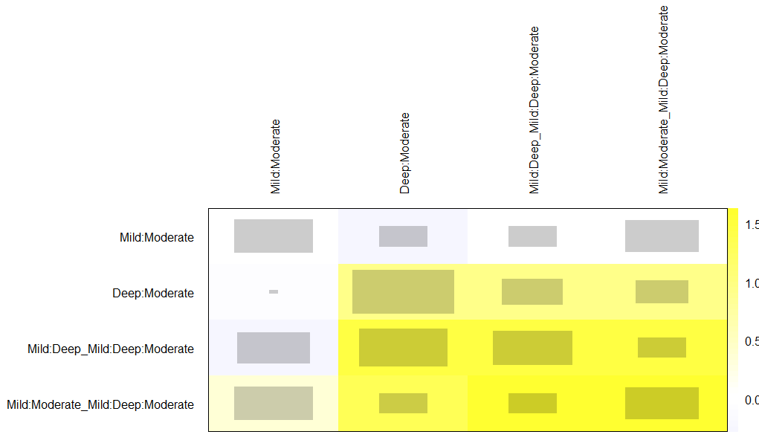

Supplementary Figure S1. Quadratic net heat map to evaluate and visualize the inconsistency in the network model for the outcome operative mortality.

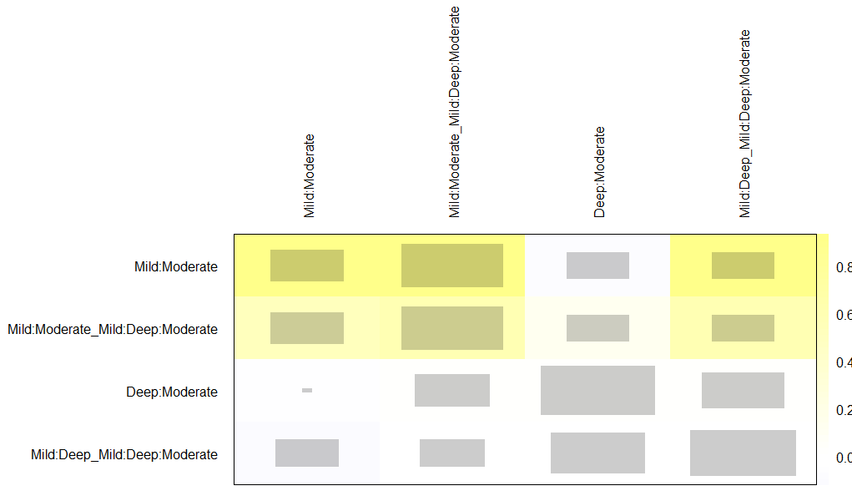

Supplementary Figure S2. Quadratic net heat map to evaluate and visualize the inconsistency in the network model for the outcome postoperative stroke.

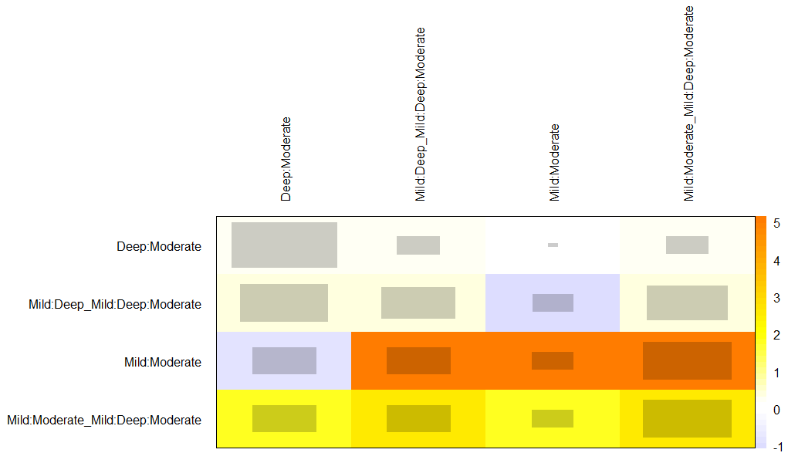
Supplementary Figure S3. Quadratic net heat map to evaluate and visualize the inconsistency in the network model for the outcome postoperative acute kidney injury.

Supplementary Table 5. Baseline characteristics of randomized controlled and propensity score matched studies
 | DHCA (<20) |  | MHCA (20-25) |  | Mild HCA (>25)
Characteristic | Pooled estimate | N studies | Pooled estimate | N studies | Pooled estimate | N studies
Age | 57.8 | 8 | 56.8 | 11 | 55.7 | 4
Male | 70.1% | 8 | 70.2 | 11 | 69.1% | 4
Acute aortic dissection | 64.7% | 8 | 64.2% | 13 | 66.5% | 5
Chronic dissection | 3.2% | 8 | 4.2% | 11 | 0% | 4
Degenerative | 31.2% | 8 | 42.6% | 11 | 33.5% | 4
Other | 0.9% | 8 | 0.43% | 11 | 0% | 4
Hypertension | 74.2% | 5 | 71.7% | 8 | 67.9% | 4
Emergency | 34.9% | 3 | 33.4% | 4 | 26.6% | 2
History of CVA | 7.8% | 4 | 9.2% | 6 | 8.8% | 3
Marfan | 5.0 % | 5 | 5.9% | 6 | 4.7% | 1
COPD | 8.3 % | 5 | 10.7% | 8 | 12.3% | 4
Previous cardiac surgery | 12.3% | 7 | 17.7% | 9 | 12.6% | 3
CAD | 15.4% | 4 | 14.6% | 6 | 12.2% | 3
DM | 6.6% | 4 | 7.4% | 7 | 7.7% | 4
No cerebral perfusion | 5.3% | 7 | 0% | 9 | 0% | 3
Unilateral ACP | 60.9% | 7 | 47.6% | 9 | 79.4% | 3
Bilateral ACP | 11.9% | 7 | 13.9% | 9 | 20.6% | 3
RCP | 21.8% | 7 | 38.5% | 9 | 0% | 3
Concomitant CABG | 35.6% | 5 | 13.1% | 6 | 11.1% | 4
Hemiarch replacement | 46.0% | 7 | 72.5% | 9 | 82.9% | 3
Total arch replacement | 42.3% | 8 | 36.5% | 11 | 47.8% | 4
Aortic root replacement | 29.8% | 4 | 35.5% | 7 | 27.3% | 4
Aortic valve replacement | 26.7% | 3 | 22.0% | 5 | 20.2% | 3
ET | 0.6% | 8 | 0.5% | 10 | 0% | 3
FET | 35.6% | 7 | 30.0% | 10 | 30.6% | 4
Lowest rectal temperature | 18.6 | 8 | 23.5 | 10 | 30.5 | 4
Intraoperative outcome
CPB time (min) (SD) | 188.3 (51.5) | 7 | 189.0 (56.5) | 10 | 172.1 (58.6) | 4
ACC time (min) (SD) | 109.0 (29.6) | 7 | 130.2 (54.4) | 9 | 131.3 (59.0) | 3
HCA time (min) (SD) | 25.8 (7.2) | 8 | 31.2 (8.7) | 10 | 28.0 (11.7) | 4
ACP time (min) (SD) | 36.9 | 2 | 53.1 | 3 | 48.5 | 1
RCP time (min) (SD) | - | 0 | 25 | 1 | - | 0
ACP, antegrade cerebral perfusion; ACC, aortic cross clamp; CABG, coronary artery bypass grafting; CAD, coronary artery disease; COPD, chronic obstructive pulmonary disorder; CPB, cardiopulmonary bypass; CVA, cerebrovascular accident; DHCA, deep hypothermic circulatory arrest; DM, diabetes mellitus; HCA, hypothermic circulatory arrest; ET, elephant trunk; FET, frozen elephant trunk; MHCA, moderate hypothermic circulatory arrest; RCP, retrograde cerebral perfusion; SD, standard deviation.

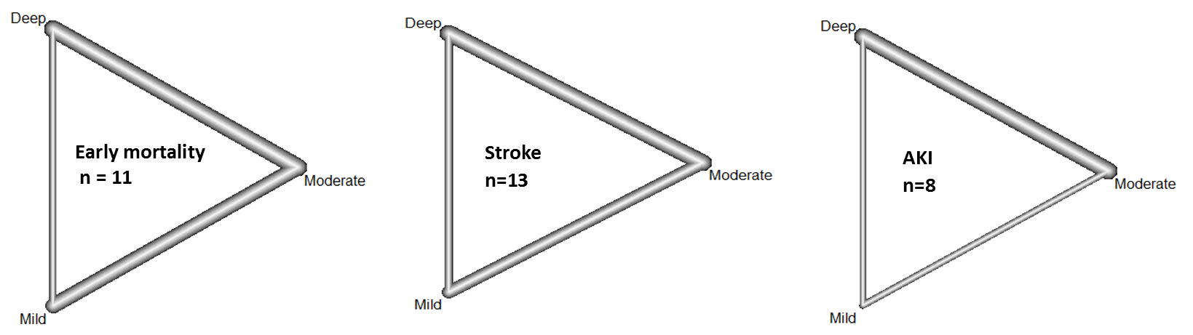

Supplementary Figure S4. Network graphs for all comparisons of the reported outcomes. The thickness of the beams indicates how commonly a comparison was found in the network analysis, in relation to the other comparisons (randomized controlled trials and propensity score matched studies).

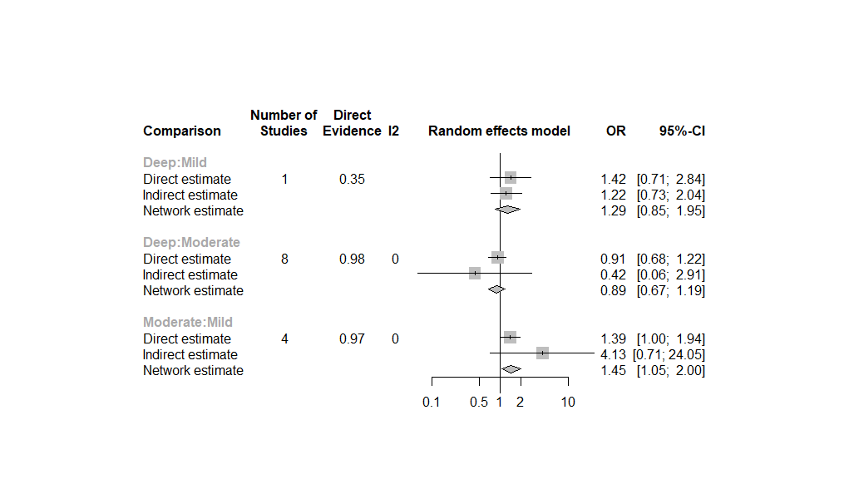
Supplementary Figure S5. Forest plot of net split results of direct, indirect evidence and network estimates for operative mortality (randomized controlled trials and propensity score matched studies).

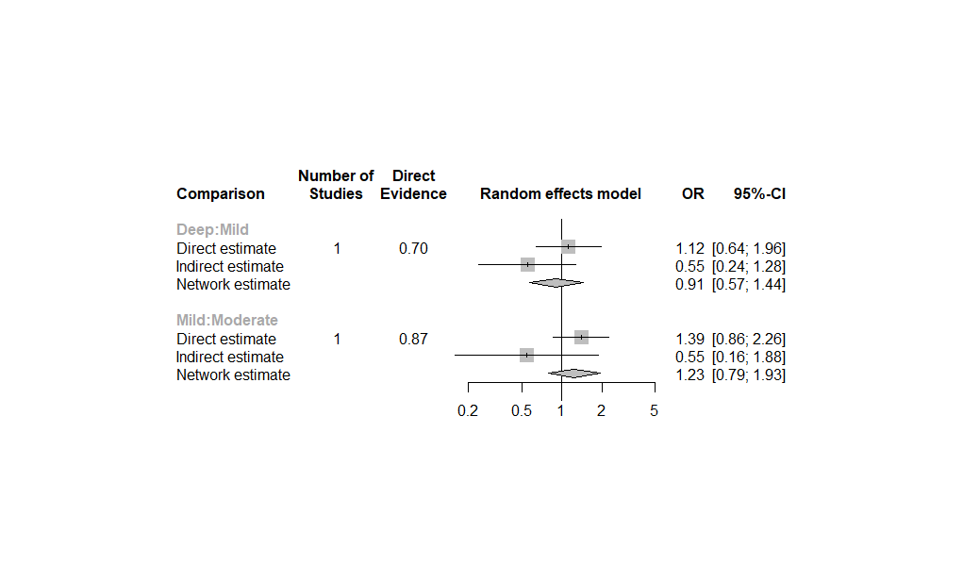
Supplementary Figure S6. Forest plot of net split results of direct, indirect evidence and network estimates for the postoperative incidence of acute kidney insufficiency (randomized controlled trials and propensity score matched studies).

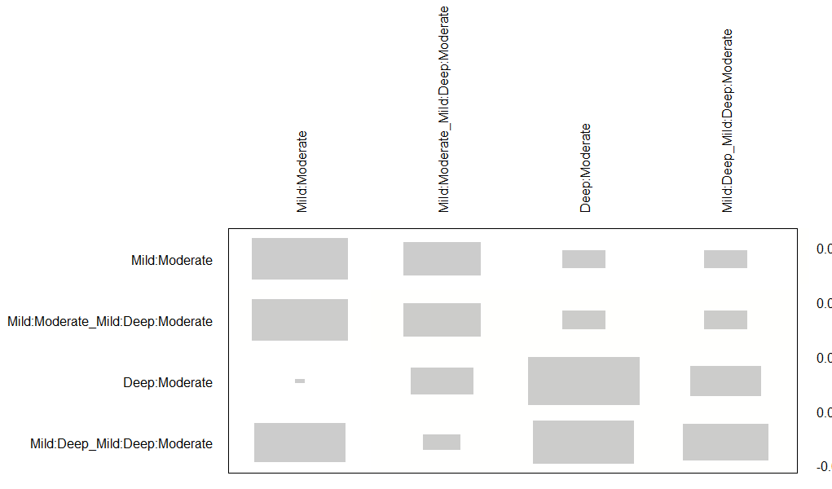
Supplementary Figure S7. Quadratic net heat map to evaluate and visualize the inconsistency in the network model for the outcome postoperative stroke of randomised controlled trials and propensity score matched studies.
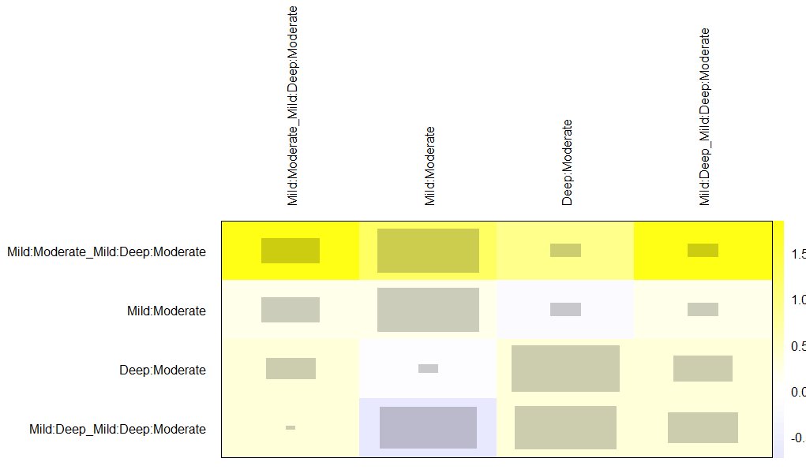
Supplementary Figure S7. Quadratic net heat map to evaluate and visualize the inconsistency in the network model for the outcome operative mortality of randomised controlled trials and propensity score matched studies.

Supplementary text 1: Search terms
aortic arch replacement circulatory arrest perfusion
embase.com | 2591 | 2563
Medline Ovid | 1934 | 226
Web of science | 1634 | 298
Cochrane CENTRAL | 70 | 30
Google scholar | 200 | 45
Total | 6429 | 3162

embase.com
('aortic arch surgery'/de OR 'aortic arch anomaly'/exp/dm_su OR 'aortic trauma'/exp/dm_su OR (('aortic disease'/exp/dm_su OR 'aortic surgery'/exp OR 'aortic reconstruction'/exp OR 'aortic trauma'/exp OR 'aortic arch anomaly'/exp) AND ('thoracic aorta'/de OR 'aortic arch'/de OR 'ascending aorta'/de)) OR (((arch* OR hemiarch*) NEAR/10 (surg* OR reconstruct* OR repair* OR replace* OR graft* OR operat* OR reoperat*)) OR (Elephant* NEAR/3 Trunk*)):ab,ti) AND ('deep hypothermic circulatory arrest'/exp OR 'moderate hypothermic circulatory arrest'/de OR 'mild hypothermic circulatory arrest'/de OR (('heart arrest'/de OR 'brain perfusion'/de) AND ('hypothermia'/de OR 'induced hypothermia'/de)) OR (((circulator*) NEAR/3 arrest*) OR ((hypotherm*) NEAR/6 (heart OR cardiac) NEAR/6 (arrest)) OR ((hypotherm*) NEAR/6 (brain OR cerebral OR antegrade OR retrograde) NEAR/6 (perfusion)) OR ((deep OR moderate OR mild) NEAR/3 hypotherm*) OR aort*-arch-replace*):ab,ti) NOT (juvenile/exp NOT adult/exp) NOT ([animals]/lim NOT [humans]/lim) NOT ([Conference Abstract]/lim AND [1800-2015]/py) AND [English]/lim

Medline Ovid
(exp Aortic Arch Syndromes/su OR ((exp Aortic Diseases/su) AND (Aorta, Thoracic/)) OR (((arch* OR hemiarch*) ADJ10 (surg* OR reconstruct* OR repair* OR replace* OR graft* OR operat* OR reoperat*)) OR (Elephant* ADJ3 Trunk*)).ab,ti.) AND (Circulatory Arrest, Deep Hypothermia Induced/ OR ((Brain/) AND (Perfusion/) AND (Hypothermia/ OR Hypothermia, Induced/)) OR (((circulator*) ADJ3 arrest*) OR ((hypotherm*) ADJ6 (heart OR cardiac) ADJ6 (arrest)) OR ((hypotherm*) ADJ6 (brain OR cerebral OR antegrade OR retrograde) ADJ6 (perfusion)) OR ((deep OR moderate OR mild) ADJ3 hypotherm*) OR aort*-arch-replace*).ab,ti.) NOT ((exp child/ OR exp infant/ OR adolescent/) NOT exp adult/) NOT (exp animals/ NOT humans/) AND english.la.
Web of science
TS=(((((arch* OR hemiarch*) NEAR/10 (surg* OR reconstruct* OR repair* OR replace* OR graft* OR operat* OR reoperat*)) OR (Elephant* NEAR/2 Trunk*))) AND ((((circulator*) NEAR/2 arrest*) OR ((hypotherm*) NEAR/5 (heart OR cardiac) NEAR/5 (arrest)) OR ((hypotherm*) NEAR/5 (brain OR cerebral OR antegrade OR retrograde) NEAR/5 (perfusion)) OR ((deep OR moderate OR mild) NEAR/2 hypotherm*) OR aort*-arch-replace*)) NOT ((animal* OR rat OR rats OR mouse OR mice OR murine OR dog OR dogs OR canine OR cat OR cats OR feline OR rabbit OR cow OR cows OR bovine OR rodent* OR sheep OR ovine OR pig OR swine OR porcine OR veterinar* OR chick* OR zebrafish* OR baboon* OR nonhuman* OR primate* OR cattle* OR goose OR geese OR duck OR macaque* OR avian* OR bird* OR fish*) NOT (human* OR patient* OR women OR woman OR men OR man)) NOT ((child* OR infant* OR adolescen*) NOT (adult*))) AND DT=(article) AND LA=(english)
Cochrane CENTRAL
((((arch* OR hemiarch*) NEAR/10 (surg* OR reconstruct* OR repair* OR replace* OR graft* OR operat* OR reoperat*)) OR (Elephant* NEAR/3 Trunk*)):ab,ti) AND ((((circulator*) NEAR/3 arrest*) OR ((hypotherm*) NEAR/6 (heart OR cardiac) NEAR/6 (arrest)) OR ((hypotherm*) NEAR/6 (brain OR cerebral OR antegrade OR retrograde) NEAR/6 (perfusion)) OR ((deep OR moderate OR mild) NEAR/3 hypotherm*) OR aort* NEXT arch NEXT replace*):ab,ti)
Google scholar
"arch reconstruction|repair|replacement|operation|surgery" "deep|moderate|mild hypothermic| hypothermia" arrest

Supplementary References
[1] Abdelgawad A, Arafat H. Moderate versus deep hypothermic circulatory arrest for ascending aorta and aortic arch surgeries using open distal anastomosis technique. Journal of the Egyptian Society of Cardio-Thoracic Surgery 2017;25:323-30.
[2] Algarni KD, Yanagawa B, Rao V, Yau TM. Profound hypothermia compared with moderate hypothermia in repair of acute type A aortic dissection. J Thorac Cardiovasc Surg 2014;148:2888-94.
[3] Arnaoutakis GJ, Vallabhajosyula P, Bavaria JE, Sultan I, Siki M, Naidu S et al. The Impact of Deep Versus Moderate Hypothermia on Postoperative Kidney Function After Elective Aortic Hemiarch Repair. Ann Thorac Surg 2016;102:1313-21.
[4] Bashir M, Field M, Shaw M, Fok M, Harrington D, Kuduvalli M et al. Influences on Early and Medium-Term Survival Following Surgical Repair of the Aortic Arch. Aorta (Stamford) 2014;2:56-73.
[5] Cook RC, Gao M, Macnab AJ, Fedoruk LM, Day N, Janusz MT. Aortic arch reconstruction: safety of moderate hypothermia and antegrade cerebral perfusion during systemic circulatory arrest. J Card Surg 2006;21:158-64.
[6] Fang Z, Wang G, Liu Q, Zhou H, Zhou S, Lei G et al. Moderate and deep hypothermic circulatory arrest has a comparable effect on acute kidney injury after total arch replacement with frozen elephant trunk procedure in type A aortic dissection. Interact Cardiovasc Thorac Surg 2019;29:130-36.
[7] Hata M, Suzuki M, Sezai A, Niino T, Yoshitake I, Unosawa S et al. Outcome of less invasive proximal arch replacement with moderate hypothermic circulatory arrest followed by aggressive rapid re-warming in emergency surgery for type A acute aortic dissection. Circ J 2009;73:69-72.
[8] Hata M, Orime Y, Wakui S, Umeda T, Akiyama K, Tanaka M. Efficacy of modified less invasive quick replacement using mild hypothermic arrest and partial retrograde cerebral perfusion for type A acute aortic dissection. Gen Thorac Cardiovasc Surg 2018;66:33-37.
[9] Kaneda T, Saga T, Onoe M, Kitayama H, Nakamoto S, Matsumoto T et al. Antegrade selective cerebral perfusion with mild hypothermic systemic circulatory arrest during thoracic aortic surgery. Scand Cardiovasc J 2005;39:87-90.
[10] Keenan JE, Wang H, Gulack BC, Ganapathi AM, Andersen ND, Englum BR et al. Does moderate hypothermia really carry less bleeding risk than deep hypothermia for circulatory arrest? A propensity-matched comparison in hemiarch replacement. J Thorac Cardiovasc Surg 2016;152:1559-69 e2.
[11] Lee JH, Chung CH, Kang JK, Choo SJ, Song H, Lee JW. Unilateral antegrade selective cerebral perfusion in aortic surgery: clinical outcomes at different levels of hypothermia. J Korean Med Sci 2009;24:807-11.
[12] Legras A, Bruzzi M, Nakashima K, Hillion ML, Loisance D, Kirsch M. Colder is better during hypothermic circulatory arrest for acute type A aortic dissection. Scand Cardiovasc J 2013;47:121-8.
[13] Leshnower BG, Myung RJ, Thourani VH, Halkos ME, Kilgo PD, Puskas JD et al. Hemiarch replacement at 28°C: an analysis of mild and moderate hypothermia in 500 patients. Ann Thorac Surg 2012;93:1910-5; discussion 15-6.
[14] Leshnower BG, Thourani VH, Halkos ME, Sarin EL, Keeling WB, Lamias MJ et al. Moderate Versus Deep Hypothermia With Unilateral Selective Antegrade Cerebral Perfusion for Acute Type A Dissection. Ann Thorac Surg 2015;100:1563-8; discussion 68-9.
[15] Livesay JJ, Cooley DA, Reul GJ, Walker WE, Frazier OH, Duncan JM et al. Resection of aortic arch aneurysms: a comparison of hypothermic techniques in 60 patients. Ann Thorac Surg 1983;36:19-28.
[16] Mauduit M, Anselmi A, Soulami RB, Tomasi J, Flecher E, Langanay T et al. Early and long-term results of hypothermic circulatory arrest in aortic surgery: a 20-year single-centre experience. Journal of Cardiovascular Medicine 2021;22:572-78.
[17] Milewski RK, Pacini D, Moser GW, Moeller P, Cowie D, Szeto WY et al. Retrograde and antegrade cerebral perfusion: results in short elective arch reconstructive times. Ann Thorac Surg 2010;89:1448-57.
[18] Miyamoto S, Takahashi S, Okahara S, Takahashi H, Katayama K, Watanabe M et al. Abdominal organ protection strategy for aortic arch aneurysm surgery. Perfusion 2018;33:512-19.
[19] Müller D, Fieguth HG, Wimmer-Greinecker G, Wöhleke T, Kleine P, Moritz A. Neurologic outcome after surgery of the aortic arch: Comparison of deep hypothermic arrest, antegrade and retrograde cerebral perfusion. Indian Journal of Thoracic and Cardiovascular Surgery 2004;20:72-76.
[20] Numata S, Tsutsumi Y, Monta O, Yamazaki S, Seo H, Sugita R et al. Aortic arch repair with antegrade selective cerebral perfusion using mild to moderate hypothermia of more than 28°C. Ann Thorac Surg 2012;94:90-5; discussion 95-6.
[21] Perreas K, Samanidis G, Thanopoulos A, Georgiopoulos G, Antoniou T, Khoury M et al. Antegrade or Retrograde Cerebral Perfusion in Ascending Aorta and Hemiarch Surgery? A Propensity-Matched Analysis. Ann Thorac Surg 2016;101:146-52.
[22] Preventza O, Coselli JS, Akvan S, Kashyap SA, Garcia A, Simpson KH et al. The impact of temperature in aortic arch surgery patients receiving antegrade cerebral perfusion for >30 minutes: How relevant is it really? J Thorac Cardiovasc Surg 2017;153:767-76.
[23] Pupovac SS, Hemli JM, Bavaria JE, Patel HJ, Trimarchi S, Pacini D et al. Moderate Versus Deep Hypothermia in Type A Acute Aortic Dissection Repair: Insights from the International Registry of Acute Aortic Dissection. Ann Thorac Surg 2021;112:1893-99.
[24] Samanidis G, Kanakis M, Khoury M, Balanika M, Antoniou T, Giannopoulos N et al. Antegrade and Retrograde Cerebral Perfusion During Acute Type A Aortic Dissection Repair in 290 Patients. Heart Lung Circ 2021;30:1075-83.
[25] Seese L, Chen EP, Badhwar V, Thibault D, Habib RH, Jacobs J et al. Optimal circulatory arrest temperature for aortic hemiarch replacement with antegrade brain perfusion. J Thorac Cardiovasc Surg 2021.
[26] Shen K, Zhou X, Tan L, Li F, Xiao J, Tang H. An innovative arch-first surgical procedure under moderate hypothermia for acute type A aortic dissection. The Journal of cardiovascular surgery 2018.
[27] Sundt TM, 3rd, Orszulak TA, Cook DJ, Schaff HV. Improving results of open arch replacement. Ann Thorac Surg 2008;86:787-96; discussion 87-96.
[28] Watanabe G, Ohtake H, Tomita S, Yamaguchi S, Kimura K, Yashiki N. Tepid hypothermic (32° C) circulatory arrest for total aortic arch replacement: a paradigm shift from profound hypothermic surgery. Interact Cardiovasc Thorac Surg 2011;12:952-5.
[29] Wiedemann D, Kocher A, Dorfmeister M, Vadehra A, Mahr S, Laufer G et al. Effect of cerebral protection strategy on outcome of patients with Stanford type A aortic dissection. J Thorac Cardiovasc Surg 2013;146:647-55 e1.
[30] Wu Y, Xiao L, Yang T, Wang L, Chen X. Aortic arch reconstruction: deep and moderate hypothermic circulatory arrest with selective antegrade cerebral perfusion. Perfusion 2017;32:389-93.
[31] Wu J, Qiu J, Fang Z, Luo Q, Huang Y, Yu C et al. Optimal Degree of Hypothermia in Total Arch Replacement for Type A Aortic Dissection. Frontiers in Cardiovascular Medicine 2021;8.
[32] Zierer A, Aybek T, Risteski P, Dogan S, Wimmer-Greinecker G, Moritz A. Moderate hypothermia (30 degrees C) for surgery of acute type A aortic dissection. Thorac Cardiovasc Surg 2005;53:74-9.
[33] Harrington DK, Walker AS, Kaukuntla H, Bracewell RM, Clutton-Brock TH, Faroqui M et al. Selective Antegrade Cerebral Perfusion Attenuates Brain Metabolic Deficit in Aortic Arch Surgery. Circulation 2004;110:II-231-II-36.
[34] Kamenskaya OV, Klinkova AS, Chernyavsky AM, Lomivorotov VV, Meshkov IO, Karaskov AM. Deep Hypothermic Circulatory Arrest vs. Antegrade Cerebral Perfusion in Cerebral Protection during the Surgical Treatment of Chronic Dissection of the Ascending and Arch Aorta. J Extra Corpor Technol 2017;49:16-25.

