The Prognostic Value of Elevated Perioperative Neutrophil-Lymphocyte Ratio in Predicting Postoperative Acute Kidney Injury Following Cardiac Surgery: A Systematic Review and Meta-Analysis

Online Supplement
Table of Contents
Search Strategies 2
MEDLINE 2
Embase 2
Cochrane Library 3
Assessment of Methodological Quality 4
GRADE evaluation tables 5
Meta-regression Tables 6
Preoperative NLR: Acute Kidney Injury 6
Publication Bias Funnel Plots 7

Search Strategies

MEDLINE
- exp neutrophil/ or neutrophil.mp.
- exp lymphocyte/ or lymphocyte.mp.
- ratio.mp.
- 1 and 2 and 3
- (neutrophil lymphocyte ratio or NLR or neutrophil-lymphocyte-ratio or neutrophil:lymphocyte ratio).mp.
- 4 or 5
- exp Coronary Artery Bypass/ or coronary artery bypass graft.mp.
- heart valve surgery.mp. or exp Cardiac Surgical Procedures/
- valve surgery.mp.
- cardiac surgery.mp.
- 7 or 8 or 9 or 10
- (Stratification or ROC Curve or Discrimination or Discriminate or c-statistic or c statistic or Area under the curve or AUC or Calibration or Indices or Algorithm or Multivariable).mp.
- Validat$.mp. or Predct$.ti. or Rule$.mp. or (Predict$ and (Outcomes$ or Risk$ or Model$)).mp. or ((History or Variable$ or Criteria or Scor$ or Characteristic$ or Finding$ or Factor$) and (Predict$ or Model$ or Decision$ or Identif$ or Prognos$)).mp. or (Decision$.mp. and ((Model$ or Clinical$).mp. or Logistic Models/)) or (Prognostic and (History or Variable$ or Criteria or Scor$ or Characteristic$ or Finding$ or Factor$ or Model$)).mp.
- 12 or 13
- 6 and 11 and 14

Embase
- exp neutrophil/ or neutrophil.mp.
- exp lymphocyte/ or lymphocyte.mp.
- ratio.mp.
- 1 and 2 and 3
- (neutrophil lymphocyte ratio or NLR or neutrophil-lymphocyte-ratio or neutrophil:lymphocyte ratio).mp.
- 4 or 5
- heart surgery.mp. or exp heart surgery/
- coronary artery bypass graft$.mp. or exp coronary artery bypass graft/
- exp mitral valve surgery/ or exp heart valve surgery/ or valve surgery.mp.
- 7 or 8 or 9
- (Stratification or ROC Curve or Discrimination or Discriminate or c-statistic or c statistic or Area under the curve or AUC or Calibration or Indices or Algorithm or Multivariable).mp.
- Validat$.mp. or Predct$.ti. or Rule$.mp. or (Predict$ and (Outcomes$ or Risk$ or Model$)).mp. or ((History or Variable$ or Criteria or Scor$ or Characteristic$ or Finding$ or Factor$) and (Predict$ or Model$ or Decision$ or Identif$ or Prognos$)).mp. or (Decision$.mp. and ((Model$ or Clinical$).mp. or Logistic Models/)) or (Prognostic and (History or Variable$ or Criteria or Scor$ or Characteristic$ or Finding$ or Factor$ or Model$)).mp.
- 11 or 12
- 6 and 10 and 13

Cochrane Library
#1 MeSH descriptor: [Thoracic Surgery] explode all trees
#2 cardiac surgery OR coronary arterial bypass surgery OR valvular surgery OR valve replacement
#3 #1 or #2
#4 MeSH descriptor: [Neutrophils] explode all trees
#5 MeSH descriptor: [Lymphocytes] explode all trees
#6 #4 or #5
#7 #3 and #6

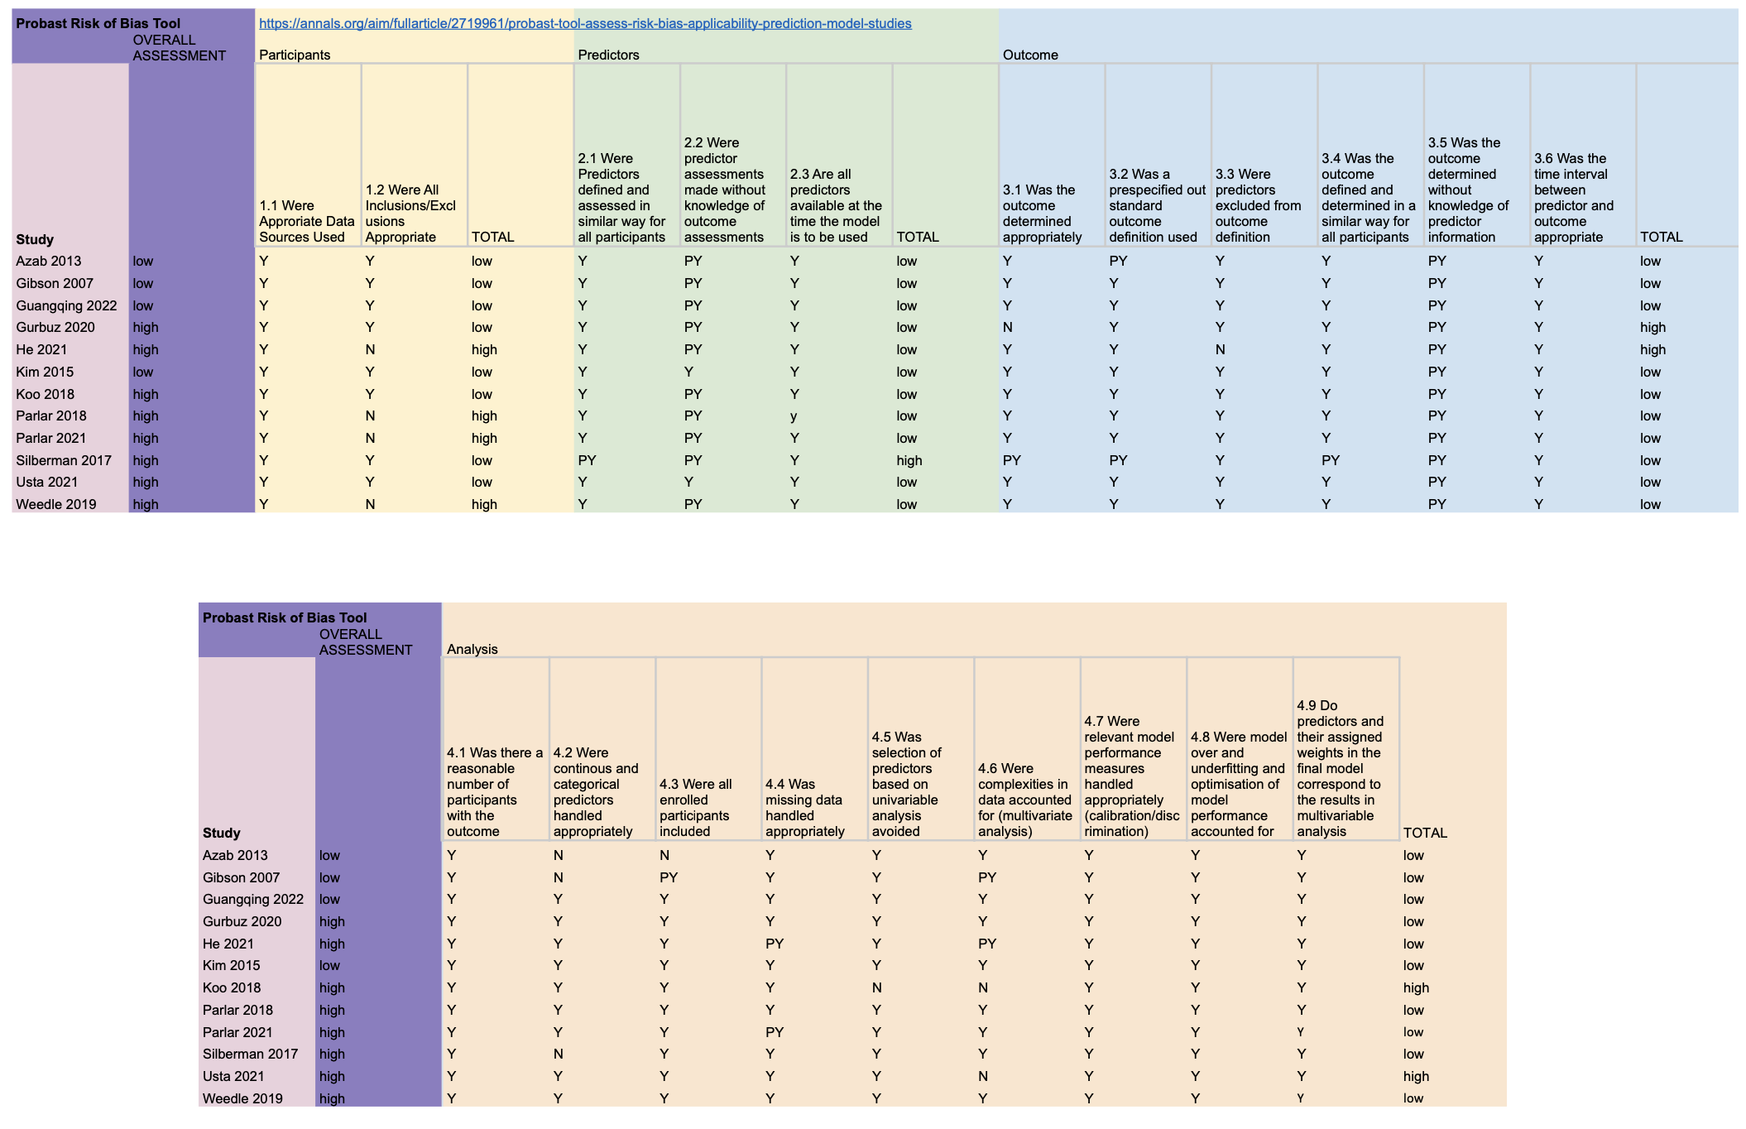
Assessment of Methodological Quality

GRADE evaluation tables
Supplementary Table 1: Adapted Grading of Recommendations Assessment, Development and Evaluation (GRADE) table for systematic reviews with meta-analysis of prognostic studies for Outcome: Acute Kidney Injury
Outcome: Acute Kidney Injury
 |  |  | Univariate |  |  | Multivariate |  |  | GRADE factors
Potential prognostic factors identified | Number of participants | Number of studies | + | 0 | - | + | 0 | - | Phase | Study limitations | Inconsistency | Indirectness | Imprecision | Publication bias | Moderate/large effect size | Dose effect | Overall Quality
Preoperative NLR | 7660 | 10 ⁴⁹⁻⁵⁰ | 8 | 2 | 0 | 1 | 3 | 0 | 2 | ✓ | ✕ | ✓ | ✓ | ✕ | ✓ | ✓ | +++
Immediate postoperative NLR | 1780 | 3 ^{42,43,50} | 2 | 1 | 0 | 1 | 1 | 0 | 2 | ✓ | ✕ | ✓ | ✕ | ✕ | ✕ | ✕ | +
Postoperative day 1 NLR | 3637 | 6 ^{42-45,47,48} | 4 | 2 | 0 | 1 | 2 | 0 | 2 | ✓ | ✕ | ✓ | ✓ | ✕ | ✕ | ✓ | ++
Postoperative day 2 NLR | 2401 | 3 ^{43,44,48} | 3 | 0 | 0 | 1 | 0 | 0 | 2 | ✓ | ✕ | ✓ | ✓ | ✕ | ✕ | ✓ | ++
Phase, phase of investigation. For uni- and multivariate analyses: +, number of significant effects with a positive value; 0, number of non-significant effects; -, number of significant effects with a negative value. For
GRADE factors: ✓, no serious limitations; ✕, serious limitations (or not present for moderate/large effect size, dose effect); unclear, unable to rate item based on available information. For overall quality of evidence:
+, very low; ++, low; +++, moderate; ++++, high.

Supplementary Table 2: Adapted Grading of Recommendations Assessment, Development and Evaluation (GRADE) table for systematic reviews with meta-analysis of prognostic studies for Outcome: Renal Replacement Therapy
Outcome: Renal Replacement Therapy
 |  |  | Univariate |  |  | Multivariate |  |  | GRADE factors
Potential prognostic factors identified | Number of participants | Number of studies | + | 0 | - | + | 0 | - | Phase | Study limitations | Inconsistency | Indirectness | Imprecision | Publication bias | Moderate/large effect size | Dose effect | Overall Quality
Preoperative NLR | 3654 | 3 ^{39,40,46} | 1 | 2 | 0 | 0 | 1 | 0 | 1 | ✓ | ✕ | ✕ | ✓ | ✕ | ✕ | unclear | +
Phase, phase of investigation. For uni- and multivariate analyses: +, number of significant effects with a positive value; 0, number of non-significant effects; -, number of significant effects with a negative value. For
GRADE factors: ✓, no serious limitations; ✕, serious limitations (or not present for moderate/large effect size, dose effect); unclear, unable to rate item based on available information. For overall quality of evidence:
+, very low; ++, low; +++, moderate; ++++, high.

Meta-regression Tables

Preoperative NLR: Acute Kidney Injury

Covariate | k | Regression coefficient – magnitude of effect size modification | p-value | 95% CI (lb, ub) | Heterogeneity accounted for | Residual Heterogeneity (I²)
Hypertension prevalence | 8 | 1.9272 | 0.1059 | -0.4089 4.2633 | 35.17% | 86.19%
NLR threshold selection method | 8 | 0.1576 | 0.1311 | -0.0470 0.3621 | 22.22% | 88.08%
Diabetes prevalence | 8 | 1.4316 | 0.1817 | -0.6692 3.5324 | 14.49% | 89.74%
Number of study centres | 8 | 0.4555 | 0.2450 | -0.3123 1.2233 | 7.68% | 94.66%
Risk of bias | 8 | 0.4555 | 0.2450 | -0.3123 1.2233 | 7.68% | 94.66%
NLR Threshold | 6 | -0.4541 | 0.3993 | -1.5099 0.6017 | 0.00% | 73.38%
Percentage male | 8 | 0.3571 | 0.7772 | -2.1161 2.8302 | 0.00% | 88.45%
Surgical case mix | 8 | 0.2055 | 0.5209 | -0.4220 0.8330 | 0.00% | 89.23%
Average age | 8 | -0.0065 | 0.8944 | -0.1025 0.0895 | 0.00% | 90.07%
Number of significant adjusted variables | 8 | -0.0945 | 0.2876 | -0.2687 0.0797 | 0.00% | 90.82%
Study year | 8 | -0.0289 | 0.6428 | -0.1508 0.0931 | 0.00% | 92.11%
Number of variables adjusted in multivariable analysis | 8 | -0.0103 | 0.9114 | -0.1922 0.1716 | 0.00% | 93.15%
Sample size | 8 | 0.0000 | 0.7613 | -0.0002 0.0003 | 0.00% | 94.87%
Number of quantiles | 8 | 0.0616 | 0.6814 | -0.2323 0.3555 | 0.00% | 95.49%
Study design (prospective vs retrospective) | 8 | Unable to meta-regress as all included studies retrospective.

Publication Bias Funnel Plots

Funnel plot of the association between preoperative NLR and postoperative AKI.

Contour-enhanced funnel plot of the association between preoperative NLR and postoperative AKI.

