Supplementary appendix

Supplementary to: Zeng H, Yuan C, Morze J, et al. New onset of type 2 diabetes after colorectal cancer diagnosis: results from three prospective US cohort studies, systematic review, and meta-analysis
Text S1. Methods for deriving T2D risk score
Table S1. Sensitivity analysis between CRC exposure and risk of type 2 diabetes in three cohorts
Table S2. Sensitivity analysis between CRC exposure and risk of type 2 diabetes in three cohorts using maximum BMI in place of updated BMI as covariate in multivariable analysis
Table S3. Sensitivity analysis between CRC exposure and risk of type 2 diabetes in three cohorts using different classification of CRC duration
Table S4. Meta-analysis of three cohorts using fixed-effect model (no heterogeneity among cohorts)
Table S5. Systematic review search strategy
Table S6. Assessment of risk of bias using the Newcastle-Ottawa Scale
Table S7. Influence analysis for the association between colorectal cancer and risk of type 2 diabetes by exclusion of one study at a time
Figure S1. Flowchart of the study population for the cohort analysis
Figure S2. Funnel plot for assessment of publication bias for the association between CRC and risk of T2D.

Text S1. Methods for deriving T2D risk score
We derived a T2D risk score based on information on the following components- family history, BMI, smoking, physical activity, alcohol assumption and diet. For each of the components, we defined a binary criterion, by which the individuals receive a score of 1 if he/she met the criterion and 0 otherwise. The T2D risk score comprised family history of diabetes, BMI ≥25 kg/m², ever/current smoking, physical activity MET ≤7.5 h/wk, AHEI score in the upper 40 percentile with in each cohort, and status of hypertension. We summed up the scores of the six components to get a final score ranging from 0 to 6, with 0 to 2 indicating a low-risk, with 3-4 indicating a mid-risk and 5-6 indicating a high-risk.

Table S1. Sensitivity analysis between CRC exposure and risk of type 2 diabetes in three cohorts
 | Exposure status | Model 1  HR (95% CI) | Model 2  HR (95% CI) | Model 3  HR (95% CI)
S1-Excluded  T2D cases diagnosed within the first six months after CRC diagnosis | CRC
 | No | 1 (Referent) | 1 (Referent) | 1 (Referent)
 | Yes | 1·27 (1·10, 1·46) | 1·21 (1·06, 1·40) | 1·19 (1·04, 1·37)
 | CRC duration
 | No CRC | 1 (Referent) | 1 (Referent) | 1 (Referent)
 | 6 mo to 5 y | 1·23 (0·99, 1·54) | 1·18 (0·95, 1·48) | 1·16 (0·93, 1·46)
 | 5·1-10 y | 1·35 (1·05, 1·73) | 1·26 (0·98, 1·61) | 1·24 (0·97, 1·60)
 | >10 y | 1·24 (0·96, 1·59) | 1·21 (0·94, 1·56) | 1·18 (0·92, 1·52)
S2-S1+further excluded CRC cases who died within the first two years after diagnosis | CRC
 | No | 1 (Referent) | 1 (Referent) | 1 (Referent)
 | Yes | 1·28 (1·11, 1·47) | 1·22 (1·06, 1·41) | 1·20 (1·04, 1·38)
 | CRC duration
 | No CRC | 1 (Referent) | 1 (Referent) | 1 (Referent)
 | 6 mo to 5 y | 1·25 (1·00, 1·57) | 1·20 (0·96, 1·51) | 1·18 (0·94, 1·48)
 | 5·1-10 y | 1·35 (1·05, 1·73) | 1·26 (0·98, 1·61) | 1·24 (0·97, 1·59)
 | >10 y | 1·24 (0·96, 1·59) | 1·21 (0·94, 1·56) | 1·18 (0·92, 1·52)
S3- Excluded  T2D cases diagnosed within the first year after CRC diagnosis | CRC
 | No | 1 (Referent) | 1 (Referent) | 1 (Referent)
 | Yes | 1·26 (1·09, 1·44) | 1·19 (1·03, 1·36) | 1·17 (1·01, 1·34)
 | CRC duration
 | No CRC | 1 (Referent) | 1 (Referent) | 1 (Referent)
 | 6 mo to 5 y | 1·17 (0·93, 1·47) | 1·09 (0·86, 1·37) | 1·07 (0·85, 1·34)
 | 5·1-10 y | 1·39 (1·09, 1·77) | 1·29 (1·01, 1·65) | 1·28 (1, 1·63)
 | >10 y | 1·24 (0·97, 1·59) | 1·22 (0·95, 1·56) | 1·19 (0·92, 1·52)

Multivariable adjusted hazard ratios were estimated from Cox proportional regression model.
Model 1: stratified by age (<60, 60-64, 65-69, 70-74, ≥75 years), cohort and follow-up cycle (2-year interval)
Model 2: Model 1+ age (<60, 60-64, 65-69, 70-74, ≥75 years), race (white, other), family history of myocardial infarction (no, yes), smoking status (never, former, current), body mass index as a continuous variable, alcohol intake alcohol intake (0, 0·1-4·9,5-14·9,15-29·9, ≥30 g/day), physical activity MET (quintiles), multivitamin use (no, yes), aspirin use (no, yes), AHEI-2010 (quintiles) and family history of diabetes (no, yes)
Model 3: Model 2+ hypertension status (no, yes) and hypercholesterolemia status (no, yes)

Table S2. Sensitivity analysis between CRC exposure and risk of type 2 diabetes in three cohorts using maximum BMI in place of updated BMI as covariate in multivariable analysis
Exposure status | Model 1 HR (95% CI) | Model 2 HR (95% CI) | Model 3 HR (95% CI)
CRC
No | 1 (Referent) | 1 (Referent) | 1 (Referent)
Yes | 1·26 (1·10, 1·45) | 1·19 (1·03, 1·36) | 1·16 (1·01, 1·33)
CRC duration
No CRC | 1 (Referent) | 1 (Referent) | 1 (Referent)
≤5 y | 1·22 (0·99, 1·51) | 1·16 (0·93, 1·43) | 1·13 (0·91, 1·40)
5·1-10 y | 1·35 (1·05, 1·73) | 1·26 (0·98, 1·62) | 1·24 (0·97, 1·59)
>10 y | 1·24 (0·96, 1·59) | 1·16 (0·90, 1·49) | 1·12 (0·87, 1·45)
Multivariable adjusted hazard ratios were estimated from Cox proportional regression model
Model 1: stratified by age (<60, 60-64, 65-69, 70-74, ≥75 years), cohort and follow-up cycle (2-year interval)
Model 2: Model 1+ age (<60, 60-64, 65-69, 70-74, ≥75 years), race (white, other), family history of myocardial infarction (no, yes), smoking status (never, former, current), life-time body mass index as a continuous variable, alcohol intake alcohol intake (0, 0·1-4·9,5-14·9,15-29·9, ≥30 g/day), physical activity MET (quintiles), multivitamin use (no, yes), aspirin use (no, yes), AHEI-2010 (quintiles) and family history of diabetes (no, yes)
Model 3: Model 2+ hypertension status (no, yes) and hypercholesterolemia status (no, yes)

Table S3. Sensitivity analysis between CRC exposure and risk of type 2 diabetes in three cohorts using different classification of CRC duration
Exposure status | Model 1 HR (95% CI) | Model 2 HR (95% CI) | Model 3 HR (95% CI)
No CRC | 1 (Referent) | 1 (Referent) | 1 (Referent)
≤1 y | 1·31 (0·86, 1·99) | 1·26 (0·83, 1·91) | 1·25 (0·82, 1·89)
1·1-3 y | 1·34 (0·98, 1·83) | 1·28 (0·93, 1·75) | 1·24 (0·91, 1·7)
>3y | 1·25 (1·07, 1·47) | 1·19 (1·01, 1·4) | 1·17 (1, 1·37)
Multivariable adjusted hazard ratios were estimated from Cox proportional regression model
Model 1: stratified by age (<60, 60-64, 65-69, 70-74, ≥75 years), cohort and follow-up cycle (2-year interval)
Model 2: Model 1+ age (<60, 60-64, 65-69, 70-74, ≥75 years), race (white, other), family history of myocardial infarction (no, yes), smoking status (never, former, current), life-time body mass index as a continuous variable, alcohol intake alcohol intake (0, 0·1-4·9,5-14·9,15-29·9, ≥30 g/day), physical activity MET (quintiles), multivitamin use (no, yes), aspirin use (no, yes), AHEI-2010 (quintiles) and family history of diabetes (no, yes)
Model 3: Model 2+ hypertension status (no, yes) and hypercholesterolemia status (no, yes)

Table S4. Meta-analysis of three cohorts using fixed-effect model (no heterogeneity among cohorts)
Exposure status | Model 1 HR (95% CI) | Model 2 HR (95% CI) | Model 3 HR (95% CI)
CRC
No | 1 (Referent) | 1 (Referent) | 1 (Referent)
Yes | 1·27 (1·11, 1·46) | 1·21 (1·05, 1·39) | 1·19 (1·04, 1·36)
CRC duration
No CRC | 1 (Referent) | 1 (Referent) | 1 (Referent)
≤5 y | 1·23 (0·99, 1·52) | 1·16 (0·94, 1·43) | 1·14 (0·92, 1·41)
5·1-10 y | 1·36 (1·06, 1·75) | 1·27 (0·99, 1·63) | 1·25 (0·98, 1·61)
>10 y | 1·27 (0·99, 1·63) | 1·24 (0·97, 1·60) | 1·21 (0·94, 1·55)
Multivariable adjusted hazard ratios were estimated from Cox proportional regression model
Model 1: stratified by age (<60, 60-64, 65-69, 70-74, ≥75 years), cohort and follow-up cycle (2-year interval)
Model 2: Model 1+ age (<60, 60-64, 65-69, 70-74, ≥75 years), race (white, other), family history of myocardial infarction (no, yes), smoking status (never, former, current), body mass index as a continuous variable, alcohol intake alcohol intake (0, 0·1-4·9,5-14·9,15-29·9, ≥30 g/day), physical activity MET (quintiles), multivitamin use (no, yes), aspirin use (no, yes), AHEI-2010 (quintiles) and family history of diabetes (no, yes)
Model 3: Model 2+ hypertension status (no, yes) and hypercholesterolemia status (no, yes)

Table S5. Systematic review search strategy

Database | Step | Terms | Results
PubMed | #1 | ('colorectal cancer' [tiab] OR CRC[tiab]) AND (survivor*[tiab] OR development[tiab]) | 16 095
PubMed | #2 | 'patients with CRC' [tiab] OR 'patients with colorectal' [tiab] | 3431
PubMed | #3 | diabet*[tiab] | 674 572
PubMed | #4 | follow-up[tiab] OR study[tiab] OR cohort[tiab] OR prospective[tiab] OR longitudinal[tiab] OR 'nested case-control' [tiab] | 9 073 016
PubMed | #5 | (#1 OR #2 OR colorectal neoplasms/co[mh]) AND #3 AND #4 | 326
Embase | #1 | ('colorectal cancer':ab,ti OR crc:ab,ti) AND ( survivor:ti,ab OR development:ab,ti) | 22 002
Embase | #2 | 'patients with crc':ab, ti OR 'patients with colorectal':ab,ti OR 'colorectal tumor':ab | 24 876
Embase | #3 | 'diabetes':ti,ab | 851 224
Embase | #4 | 'follow up':ab,ti OR study:ab,ti OR cohort:ab,ti OR prospective:ab,ti OR longitudinal:ab,ti OR 'nested case-control':ab,ti OR 'case cohort':ab,ti | 12 083 651
Embase | #5 | (#1 OR #2) AND #3 AND #4 | 444
Web of Science | #1 | TS=( ( ( ((colorectal cancer OR CRC) AND ( survivor OR development) ) ) ) AND diabetes AND (Prospective or Cohort or Longitudinal or Follow-up or Case-cohort or Nested Case-control) ) | 258

Table S6. Assessment of risk of bias using the Newcastle-Ottawa Scale*

First author, year | Selection |  |  |  |  | Comparability |  |  | Outcome |  |  |  | Total | Quality
First author, year | Representativeness of the exposed cohort | Selection of the non-exposed cohort | Ascertainment of exposure | Outcome of interest not present at start of the study |  | Control for primary confounders | Control for secondary confounders |  | Assessment of outcome | Duration of follow-up | Adequacy of follow-up |  | Total | Quality
Khan, 2011 | 1 | 1 | 1 | 1 |  | 1 | 1 |  | 1 | 1 | 1 |  | 9 | Good
Singh, 2016 | 1 | 1 | 1 | 1 |  | 0 | 1 |  | 1 | 1 | 1 |  | 8 | Good
Hwangbo, 2018 | 1 | 1 | 1 | 1 |  | 1 | 1 |  | 1 | 1 | 1 |  | 9 | Good
Hawkins, 2020 | 1 | 1 | 1 | 0 |  | 1 | 1 |  | 1 | 1 | 1 |  | 8 | Good
NHS | 1 | 1 | 1 | 1 |  | 1 | 1 |  | 1 | 1 | 1 |  | 9 | Good
NHS Ⅱ | 1 | 1 | 1 | 1 |  | 1 | 1 |  | 1 | 1 | 1 |  | 9 | Good
HPFS | 1 | 1 | 1 | 1 |  | 1 | 1 |  | 1 | 1 | 1 |  | 9 | Good
*Representativeness of the exposed cohort: 1 point awarded if represents for a regional population; Selection of the non-exposed cohort: 1 point awarded if drawn from the same population as the cohort; Ascertainment of exposure: 1 point awarded if colorectal cancer assessed at baseline and at least one time during follow-up; Outcome of interest not present at start of the study: 1 point awarded if individuals with T2D at baseline were excluded; Control for primary confounders: 1 point awarded if adjustment for age, sex and BMI; Control for secondary confounders: 1 point awarded if adjustment for smoking and/or frequency of alcohol and/or comorbidity score and/or hypertension and/or cardiovascular events; Assessment of outcome: 1 point awarded if T2D was confirmed by medical records; Duration of follow-up: 1 point awarded if follow-up ≥ 1 years; Adequacy of follow-up: 1 point awarded if loss to follow-up<20%

Table S7. Influence analysis for the association between colorectal cancer and risk of type 2 diabetes by exclusion of one study at a time
Study excluded | Meta HR (95% CI)
Khan et al· 2011 | 1·20 (1·09, 1·32)
Singh et al· 2016 | 1·16 (1·08, 1·24)
Hwangbo et al· 2018 | 1·25 (1·15, 1·35)
Hawkins et al· 2020 | 1·23 (1·10, 1·37）
NHS | 1·22 (1·09, 1·35)
NHS II | 1·21 (1·10, 1·32)
HPFS | 1·23 (1·12, 1·35)

Figure S1. Flowchart of the study population for the cohort analysis
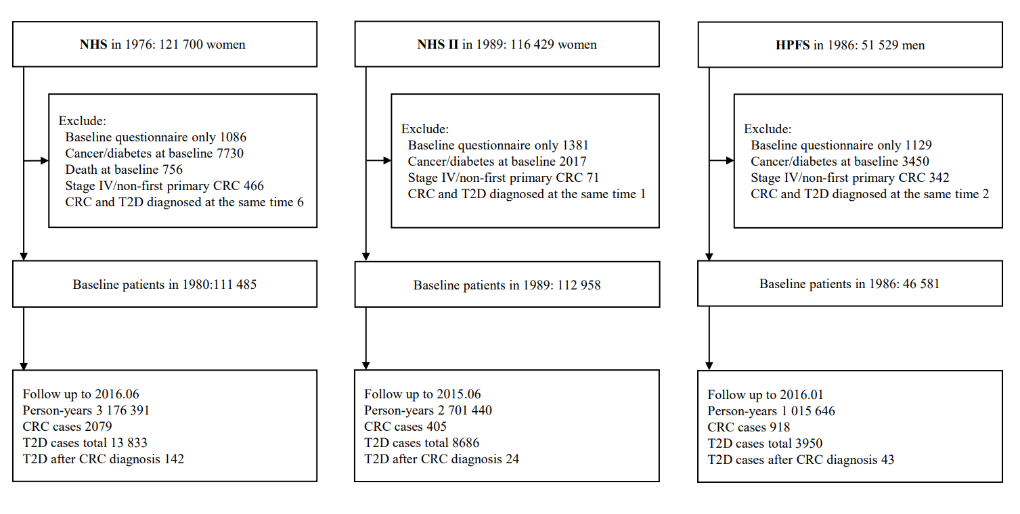

Figure S2. Funnel plot for assessment of publication bias for the association between CRC and risk of T2D.
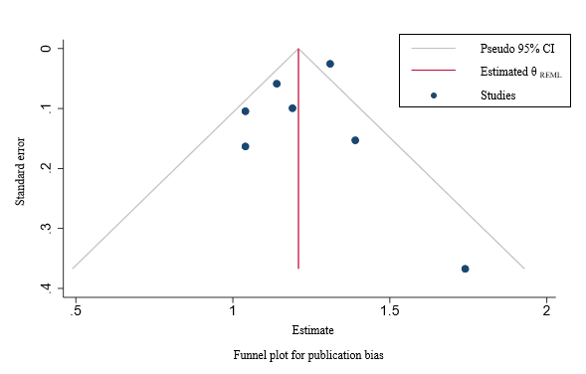
Publication bias: Egger’s test: P=0·58; Begg’s test: P= 0·76

