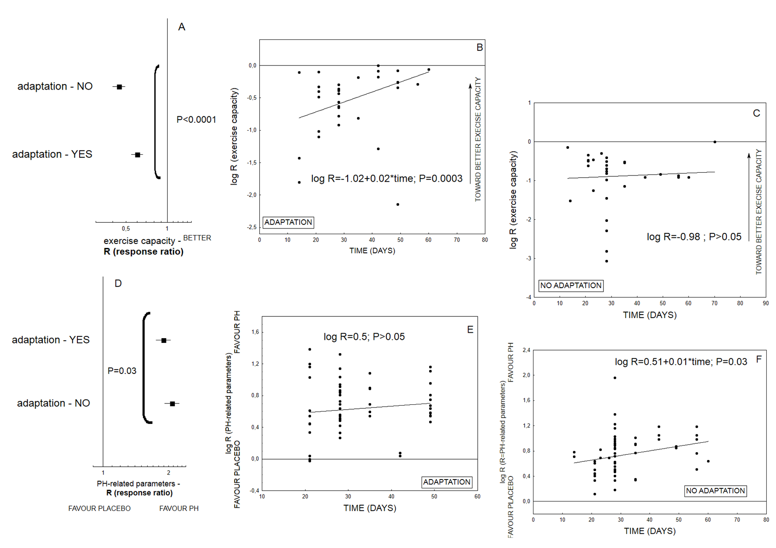
S1 Fig. The influence of the adaptation procedure on the resultant exercise endurance of animals with pulmonary hypertension and disease development. The overall effect was expressed as response ratio (R), according to alterations in both hemodynamic (RVSP, mPAP) and remodeling parameters (Fulton index, PA muscularization), as well as animal exercise capacity. The increased values of response ratio (R) reveal worsening of PH-related parameters and better exercise endurance. A statistically significant Q measure indicates heterogeneity among two or more analysed subgroups (n= 1955 animals)

