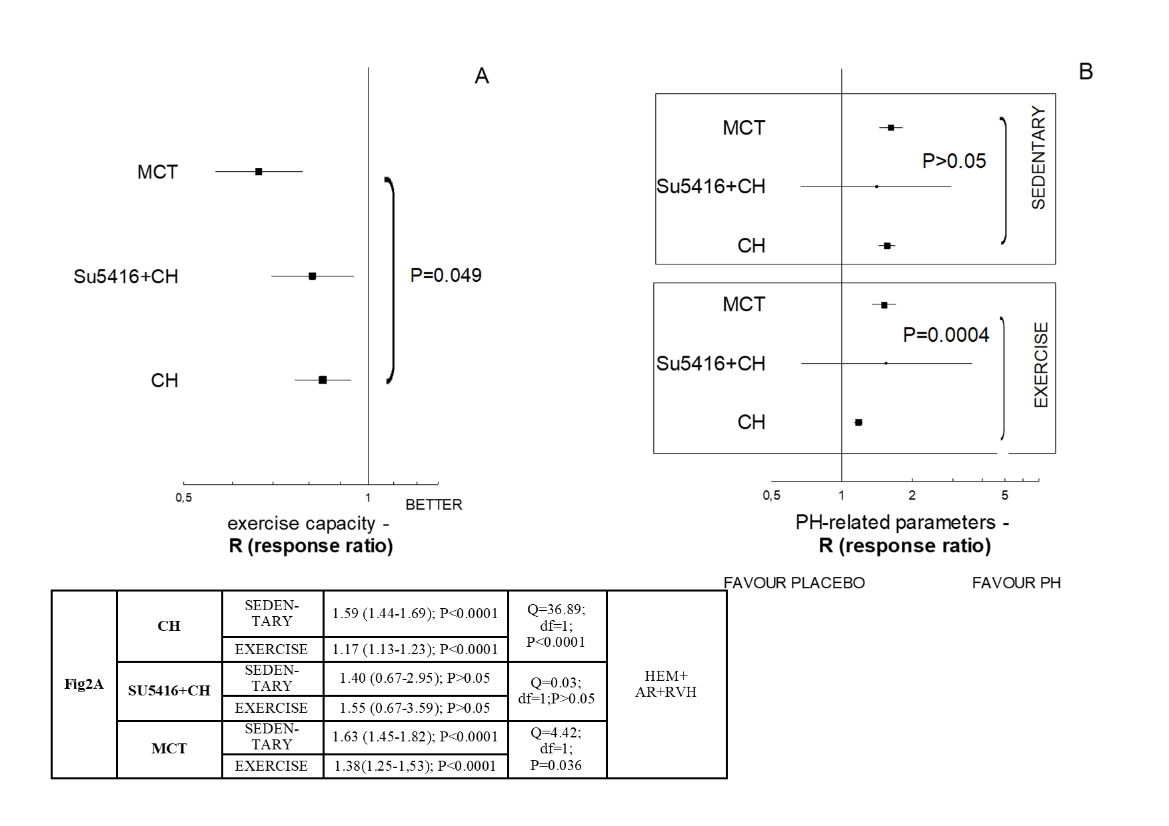
S2 Fig. Tree plot (A) demonstrates a slight (P=0.049) relationship between the animal model of pulmonary hypertension and resultant exercise capacity achieved in a test by sedentary animals. Tree-plot (B) and the annotation below show that the training program had a significant impact on the improvement of PH-related parameters according to method of PH induction. The training animals demonstrated different severities of PH-related lesions (P=0.0004). PH prevention (or reversal) were observed for the trained animals with chronic hypoxia (P<0.0001), but were less pronounced for the MCT-based model (P=0.036). AR – artery remodeling; HEM – haemodynamic parameter; RVH – right ventricle hypertrophy.

