S3 Fig. Funnel plots showing the distribution of published study outcomes (filled squares) vs. unpublished outcomes (open circles) estimated by Trim and Fill analysis. The dashed line represents the mean and 95% CI with the added, potentially unpublished, studies and solid line represents the published studies included into meta-analysis. The vertical dashed line represents the global estimate of efficacy. Exercise endurance (sedentary animals): overall effect size (D) for Vehicle -70.75 (-75.24–(-66.26)) vs. -2.75 (-7.10–1.61) – 54 potentially missing studies were added (A); overall effect size (R) for Vehicle 0.52 (0.48–0.56) – 0 missing studies (B); PH-related parameters (sedentary animals): overall effect size (D) for Vehicle 1.39 (1.31–1.47) vs. 0.25 (0.15–0.34) – 64 missing studies (C); overall effect size (R) for Vehicle 1.99 (1.88–2.11) – 0 missing studies (D); Exercise endurance (training animals): effect size (D) for Vehicle -16.05 (-22.98–(-9.11)) vs. -9.32 (-17.45–(-1.18) – one missing study (E); effect size (R) for Vehicle: 0.83 (0.78–0.89) – 0 missing studies (F); PH-related parameters (training animals) effect size (D) for Vehicle 0.23 (0.19–0.26) vs. 0.20 (0.16–0.24) – 5 missing studies (G); effect size (R) for Vehicle 1.43 (1.34–1.52) – 0 missing studies (H). Visual inspection and the results of Egger’s test suggest missing studies and publication bias.

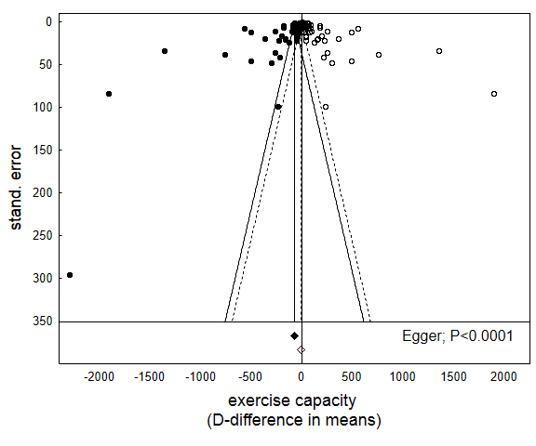
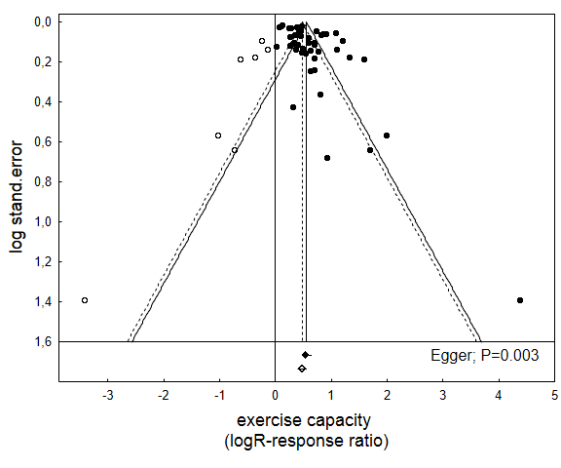
A

B

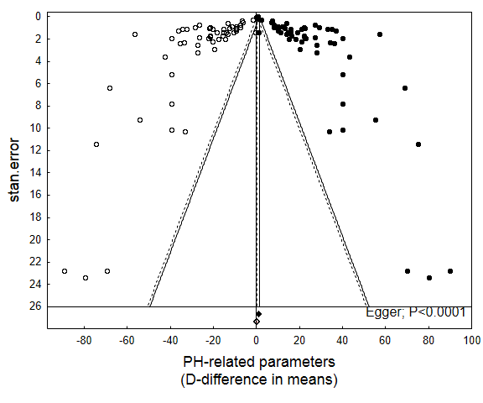
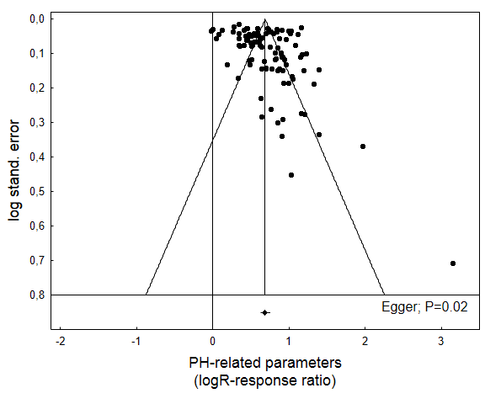
C
D

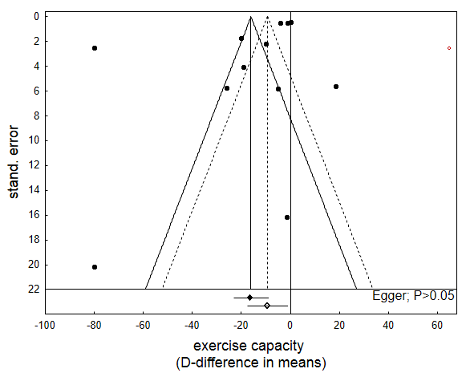
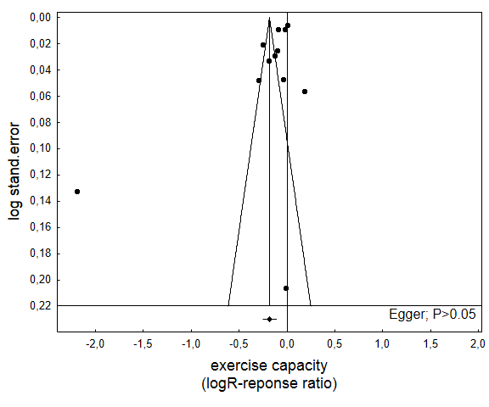
E

F

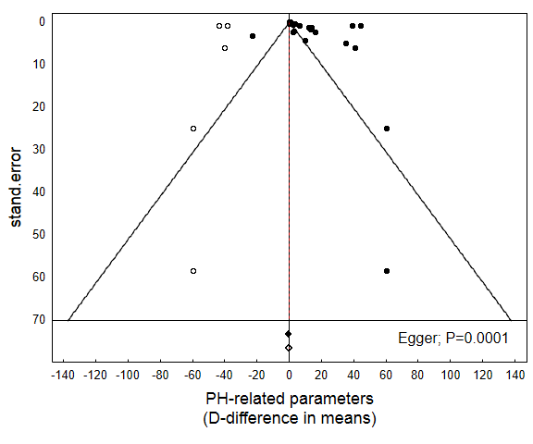
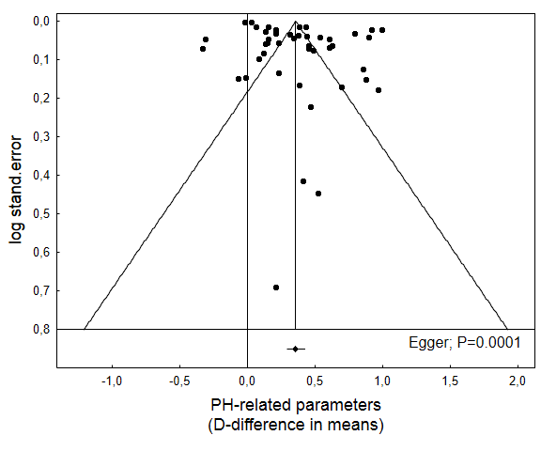
G

H

