\

Table 1 Characteristics of included studies
Study ID | Country/District | No. of sites | Type of patient | No. of patients | Length of follow-up (Months) | Age(Years) | Parity | Intervention | Control
Chen a 2018¹⁸ | China | 1 | Adenomyosis | 56 | 6 | 38.6 | NR | LNG-IUS | Methyltestosterone
Chen b 2018³² | China | 1 | Adenomyosis | 80 | 1.3.6 | 37.8 | NR | LNG-IUS | Mifepristone
Cheng 2018⁵⁹ | China | 1 | Adenomyosis | 32 | 12 | 36.6 | 2.9 | LNG-IUS | Blank control
Dou 2019⁶³ | China | 1 | Adenomyosis | 102 | 6 | 35.9 | 2.6 | LNG-IUS | Mifepristone
Feng 2018⁴⁶ | China | 1 | Adenomyosis | 106 | 3.6 | 36.7 | NR | LNG-IUS | Gestrinone
Huang 2018⁶⁰ | China | 1 | Adenomyosis | 62 | 6 | 39.3 | NR | LNG-IUS | Drospirosterone ethinyl estradiol
Jiang 2017⁵⁰ | China | 1 | Adenomyosis | 100 | 6 | 36.5 | NR | LNG-IUS | Mifepristone
Jin 2017²⁰ | China | 1 | Adenomyosis | 160 | 3 | NR | NR | LNG-IUS | Mifepristone
Kang 2018¹² | China | 1 | Adenomyosis | 106 | 12 | 43.9 | NR | LNG-IUS | Gestrinone
Kong 2015⁴⁰ | China | 1 | Adenomyosis | 100 | 6.12.18 | NR | NR | LNG-IUS | Mifepristone
Li a 2018⁵⁶ | China | 1 | Adenomyosis | 60 | 6 | 35.1 | NR | LNG-IUS | desogestrel-E2
Li b 2018⁴⁵ | China | 1 | Adenomyosis | 80 | 1.6.12 | 39.3 | NR | LNG-IUS | Methyltestosterone
Li f 2017⁴¹ | China | 1 | Adenomyosis | 168 | 12 | 44.3 | NR | LNG-IUS | Gestrinone
Li g 2018⁵⁵ | China | 1 | Adenomyosis | 84 | 1.3.6 | 36.6 | NR | LNG-IUS | Blank control
Li h 2016⁶⁵ | China | 1 | Adenomyosis | 40 | 6 | 38.1 | NR | LNG-IUS | Methyltestosterone
Li i 2015²⁷ | China | 1 | Adenomyosis | 98 | 3.6.9.12 | 39.5 | NR | LNG-IUS | Blank control
Li j 2015¹³ | China | 1 | Adenomyosis | 84 | 6 | 39.3 | 2.6 | LNG-IUS | Gestrinone
Liu a 2017⁶⁶ | China | 1 | Adenomyosis | 70 | 12 | 37.3 | 1.1 | LNG-IUS | Mifepristone
Liu c 2016³¹ | China | 1 | Adenomyosis | 172 | 6 | 36.8 | NR | LNG-IUS | Methyltestosterone
Ma a 2016³⁵ | China | 1 | Adenomyosis | 90 | 3.6 | 35.0 | NR | LNG-IUS | Gestrinone
Ma b 2014⁶⁷ | China | 1 | Adenomyosis | 92 | 3 | 37.4 | NR | LNG-IUS | Mifepristone
Meng 2018¹⁵ | China | 1 | Adenomyosis | 86 | 6 | 44.0 | NR | LNG-IUS | Gestrinone
Re 2019⁹ | China | 1 | Adenomyosis | 62 | 6.12 | 42.8 | NR | LNG-IUS | Mifepristone
Ren 2017⁵¹ | China | 1 | Adenomyosis | 114 | 6 | NR | NR | LNG-IUS | Mifepristone
Shang 2014⁴² | China | 1 | Adenomyosis | 200 | 1.3.6 | NR | NR | LNG-IUS | Gestrinone
Shi 2016³³ | China | 1 | Adenomyosis | 100 | 6 | 32.4 | 2.2 | LNG-IUS | Mifepristone
Sun a 2017⁴⁹ | China | 1 | Adenomyosis | 82 | 6 | 34.2 | NR | LNG-IUS | Mifepristone
Sun b 2018⁵⁴ | China | 1 | Adenomyosis | 66 | 3.6.9 | 35.6 | NR | LNG-IUS | Blank control
Tao a 2019¹⁹ | China | 1 | Adenomyosis | 30 | 6 | 36.8 | NR | LNG-IUS | Methyltestosterone
Tu 2012⁶² | China | 1 | Adenomyosis | 40 | 1.3.6 | NR | NR | LNG-IUS | Triptorelin
Tu 2016²⁹ | China | 1 | Adenomyosis | 180 | 3 | 37.2 | NR | LNG-IUS | Mifepristone
Wang a 2017 | China | 1 | Adenomyosis | 60 | 3.6.12 | 40.2 | NR | LNG-IUS | Blank control
Wang b 2017²⁸ | China | 1 | Adenomyosis | 110 | 6 | 32.4 | NR | LNG-IUS | Drospirosterone ethinylestradiol
Wang c 2019⁸ | China | 1 | Adenomyosis | 86 | 6 | 32.2 | NR | LNG-IUS | Gestrinone
Wang f 2018⁶⁹ | China | 1 | Adenomyosis | 200 | 3 | 40.0 | 2.2 | LNG-IUS | desogestrel-E2
Wang h 2014³⁴ | China | 1 | Adenomyosis | 48 | 1.3.6 | 36.4 | NR | LNG-IUS | Methyltestosterone
Wang i 2015³⁰ | China | 1 | Adenomyosis | 112 | 3.6.12 | 36.2 | NR | LNG-IUS | Mifepristone
Wu 2017²⁶ | China | 1 | Adenomyosis | 90 | 3.6.12.24 | 38.2 | 2.1 | LNG-IUS | Gestrinone
Wu 2018³⁴ | China | 1 | Adenomyosis | 100 | 6 | 31.6 | NR | LNG-IUS | Gestrinone
Yang 2016⁷⁰ | China | 1 | Adenomyosis | 47 | 12 | 43.0 | NR | LNG-IUS | Mifepristone
Yao 2018⁴⁴ | China | 1 | Adenomyosis | 60 | 6 | 34.9 | NR | LNG-IUS | Methyltestosterone
You 2017⁶⁸ | China | 1 | Adenomyosis | 60 | 6 | 40.7 | NR | LNG-IUS | Mifepristone
Yu 2016 ¹¹ | China | 1 | Adenomyosis | 85 | 6 | 39.3 | 2.7 | LNG-IUS | Gestrinone
Zeng 2016⁵² | China | 1 | Adenomyosis | 100 | 6 | 27.6 | NR | LNG-IUS | Gestrinone
Zhang a 2018⁴³ | China | 1 | Adenomyosis | 40 | 6 | 36.1 | NR | LNG-IUS | Methyltestosterone
Zhang c 2017²⁵ | China | 1 | Adenomyosis | 120 | 3.12 | 35.8 | NR | LNG-IUS | Gestrinone
Zhang e 2015⁴⁸ | China | 1 | Adenomyosis | 80 | 6 | 43.5 | NR | LNG-IUS | Gestrinone
Zhou a 2018¹⁰ | China | 1 | Adenomyosis | 82 | 6 | 36.1 | NR | LNG-IUS | Methyltestosterone
Omar M. Shaaban1 2015⁷⁶ | Egypt | 1 | Adenomyosis | 62 | 1.3.6 | 39.3 | NR | LNG-IUS | Drospirosterone ethinyl estradiol
Nelsilene Carvalho 2018⁷² | Brazil | 1 | Endometriosis | 103 | 6 | 34.1 | NR | LNG-IUS | ENG implant
Petta 2005⁷⁵ | Brazil | 3 | Endometriosis | 82 | 6 | 30.0 | NR | LNG-IUS | GnRH analogue
Chen 2017⁷³ | China, Taiwan | 1 | Endometriosis | 80 | 30 | 34.0 | NR | LNG-IUS | Blank control
Wu 2020⁷⁸ | China | 1 | Adenomyosis | 251 | 18 | 36.3 | NR | LNG-IUS | GnRH analogue
Prasong 2012⁷⁷ | Thailand | 1 | Endometriosis | 50 | 12 | 32.7 | NR | LNG-IUS | Expectant therapy
Yesim 2010⁷¹ | Turkey | 1 | Endometriosis | 40 | 1.3.6.12 | 37.6 | NR | LNG-IUS | GnRH analogue
Rui Alberto 2007⁷⁴ | Brazil | 1 | Endometriosis | 22 | 6 | 30.9 | NR | LNG-IUS | GnRH analogue
Fu 2014⁵⁸ | China | 1 | Adenomyosis | 108 | 24 | NR | NR | LNG-IUS | GnRH analogue
Li c 2019⁵⁷ | China | 1 | Adenomyosis | 90 | 6 | 39.2 | NR | LNG-IUS | GnRH analogue
Li d 2018³⁹ | China | 1 | Adenomyosis | 82 | 3 | 39.5 | NR | LNG-IUS | Mifepristone
Li e 2018²³ | China | 1 | Adenomyosis | 100 | 24 | 40.4 | NR | LNG-IUS | Blank control
Liu b 2014⁶⁴ | China | 1 | Endometriosis | 60 | 6.12.24 | NR | NR | LNG-IUS | Gestrinone
Sun c 2018²¹ | China | 1 | Adenomyosis | 88 | 6 | 41.1 | NR | LNG-IUS | Blank control
Tao b 2016³⁶ | China | 1 | Adenomyosis | 140 | 6.12.24 | 38.8 | NR | LNG-IUS | Blank control
Tian 2017²⁴ | China | 1 | Endometriosis | 80 | 6.12.18 | NR | NR | LNG-IUS | Gestrinone
Wang d 2016²² | China | 1 | Endometriosis | 108 | 12 | 32.7 | NR | LNG-IUS | Expectant therapy
Wang e 2015³⁸ | China | 1 | Adenomyosis | 40 | 3.6 | 36.4 | NR | LNG-IUS | Blank control
Wang g 2018¹⁴ | China | 1 | Adenomyosis | 76 | 6.12 | 38.4 | NR | LNG-IUS | Blank control
Zhang b 2016⁵³ | China | 1 | Adenomyosis | 106 | 1.3.6.12 | NR | NR | LNG-IUS | Blank control
Zhang d 2019⁴⁷ | China | 1 | Adenomyosis | 114 | 12 | 36.3 | NR | LNG-IUS | Blank control
Zhao 2019⁶¹ | China | 1 | Adenomyosis | 60 | 12 | 35.4 | NR | LNG-IUS | GnRH analogue
Zhu 2019¹⁷ | China | 1 | Adenomyosis | 82 | 12 | 38.8 | NR | LNG-IUS | Blank control
NR: Not reported; LNG-IUS: levonorgestrel-releasing intrauterine system; GnRh: Gonadotropin-releasing hormone

Table 2 Results of risk of bias assessment of included studies
Author(year) | Adequate randomization sequence generation | Adequate allocation concealment | Blinding of participants | Blinding of caregivers | Blinding of outcome assessors | Free of infrequent missing outcome data | Free of selective outcome reporting | Free of other sources of bias
Chen a 2018¹⁸ | Unclear | Unclear | Unclear | Unclear | Unclear | Unclear | Low risk | Low risk
Chen b 2018³² | Unclear | Low risk | Unclear | Unclear | Unclear | Unclear | Low risk | Low risk
Cheng 2018⁵⁹ | Unclear | Unclear | Unclear | Unclear | Unclear | Unclear | Low risk | Low risk
Dou 2019⁶³ | Low risk | Unclear | Unclear | Unclear | Unclear | Unclear | Low risk | Low risk
Feng 2018⁴⁶ | Unclear | Unclear | Unclear | Unclear | Unclear | Unclear | Low risk | Low risk
Huang 2018⁶⁰ | Unclear | Unclear | Unclear | Unclear | Unclear | High risk | Low risk | Low risk
Jiang 2017⁵⁰ | Unclear | Unclear | Unclear | Unclear | Unclear | Unclear | Low risk | Low risk
Jin 2017²⁰ | Unclear | Unclear | Unclear | Unclear | Unclear | Unclear | Low risk | Low risk
Kang 2018¹² | Unclear | Unclear | Unclear | Unclear | Unclear | Unclear | Low risk | Low risk
Kong 2015⁴⁰ | Unclear | Unclear | Unclear | Unclear | Unclear | Unclear | Low risk | Low risk
Li a 2018⁵⁶ | Low risk | Unclear | Unclear | Unclear | Unclear | Unclear | Low risk | Low risk
Li b 2018⁴⁵ | Low risk | Unclear | Unclear | Unclear | Unclear | Unclear | Low risk | Low risk
Li f 2017⁴¹ | Low risk | Unclear | Unclear | Unclear | Unclear | Unclear | Low risk | Low risk
Li g 2018⁵⁵ | Low risk | Unclear | Unclear | Unclear | Unclear | Unclear | Low risk | Low risk
Li h 2016⁶⁵ | Unclear | Unclear | Unclear | Unclear | Unclear | Unclear | Low risk | Low risk
Li i 2015²⁷ | Unclear | Unclear | Unclear | Unclear | Unclear | Unclear | Low risk | Low risk
Li j 2015¹³ | Unclear | Unclear | Unclear | Unclear | Unclear | Unclear | Low risk | Low risk
Liu a 2017⁶⁶ | Low risk | Unclear | Unclear | Unclear | Unclear | Unclear | Low risk | Low risk
Liu c 2016³¹ | Unclear | Unclear | Unclear | Unclear | Unclear | Unclear | Low risk | Low risk
Ma a 2016³⁵ | Unclear | Unclear | Unclear | Unclear | Unclear | Unclear | Low risk | Low risk
Ma b 2014⁶⁷ | Unclear | Unclear | Unclear | Unclear | Unclear | Unclear | Low risk | Low risk
Meng 2018¹⁵ | Unclear | Unclear | Unclear | Unclear | Unclear | Unclear | Low risk | Low risk
Re 2019⁹ | Unclear | Unclear | Unclear | Unclear | Unclear | Unclear | Low risk | Low risk
Ren 2017⁵¹ | Low risk | Unclear | Unclear | Unclear | Unclear | Unclear | Low risk | Low risk
Shang 2014⁴² | Unclear | Unclear | Unclear | Unclear | Unclear | Unclear | Low risk | Low risk
Shi 2016³³ | Unclear | Unclear | Unclear | Unclear | Unclear | Unclear | Low risk | Low risk
Sun a 2017⁴⁹ | Unclear | Unclear | Unclear | Unclear | Unclear | Unclear | Low risk | Low risk
Sun b 2018⁵⁴ | Unclear | Unclear | Unclear | Unclear | Unclear | Unclear | Low risk | Low risk
Tao a 2019¹⁹ | Low risk | Unclear | Unclear | Unclear | Unclear | Unclear | Low risk | Low risk
Tu 2012⁶² | Unclear | Unclear | Unclear | Unclear | Unclear | Unclear | Low risk | Low risk
Tu 2016²⁹ | Low risk | Unclear | Unclear | Unclear | Unclear | Unclear | Low risk | Low risk
Wang a 2017 | Unclear | Unclear | Unclear | Unclear | Unclear | Unclear | Low risk | Low risk
Wang b 2017²⁸ | Unclear | Unclear | Unclear | Unclear | Unclear | Unclear | Low risk | Low risk
Wang c 2019⁸ | Low risk | Unclear | Unclear | Unclear | Unclear | Unclear | Low risk | Low risk
Wang f 2018⁶⁹ | Unclear | Unclear | Unclear | Unclear | Unclear | Unclear | Low risk | Low risk
Wang h 2014³⁴ | Unclear | Unclear | Unclear | Unclear | Unclear | Unclear | Low risk | Low risk
Wang i 2015³⁰ | Unclear | Unclear | Unclear | Unclear | Unclear | Unclear | Low risk | Low risk
Wu 2017²⁶ | Low risk | Unclear | Unclear | Unclear | Unclear | Unclear | Low risk | Low risk
Wu 2018³⁴ | Low risk | Unclear | Unclear | Unclear | Unclear | Unclear | Low risk | Low risk
Yang 2016⁷⁰ | Unclear | Unclear | Unclear | Unclear | Unclear | Unclear | Low risk | Low risk
Yao 2018⁴⁴ | Low risk | Unclear | Unclear | Unclear | Unclear | Unclear | Low risk | Low risk
You 2017⁶⁸ | Unclear | Unclear | Unclear | Unclear | Unclear | Unclear | Low risk | Low risk
Yu 2016 ¹¹ | Low risk | Unclear | Unclear | Unclear | Unclear | Unclear | Low risk | Low risk
Zeng 2016⁵² | Low risk | Unclear | Unclear | Unclear | Unclear | Unclear | Low risk | Low risk
Zhang a 2018⁴³ | Low risk | Unclear | Unclear | Unclear | Unclear | Unclear | Low risk | Low risk
Zhang c 2017²⁵ | Unclear | Unclear | Unclear | Unclear | Unclear | Unclear | Low risk | Low risk
Zhang e 2015⁴⁸ | Unclear | Unclear | Unclear | Unclear | Unclear | Unclear | Low risk | Low risk
Zhou a 2018¹⁰ | Unclear | Unclear | Unclear | Unclear | Unclear | Unclear | Low risk | Low risk
Omar M. Shaaban1 2015⁷⁶ | Low risk | Low risk | Unclear | Unclear | Unclear | High risk | Low risk | Unclear
Nelsilene Carvalho 2018⁷² | Low risk | Low risk | High risk | High risk | High risk | High risk | Low risk | Unclear
Petta 2005⁷⁵ | Low risk | Low risk | Unclear | Unclear | Unclear | Low risk | Low risk | Low risk
Chen 2017⁷³ | Low risk | Low risk | Unclear | Unclear | Unclear | Unclear | Low risk | Low risk
Wu 2020⁷⁸ | Unclear | Unclear | Unclear | Unclear | Unclear | Unclear | Low risk | Unclear
Prasong 2012⁷⁷ | Low risk | Low risk | Low risk | Unclear | Unclear | High risk | Low risk | Low risk
Yesim 2010⁷¹ | Low risk | Low risk | Unclear | Unclear | Low risk | Unclear | Low risk | Low risk
Rui Alberto 2007⁷⁴ | Low risk | Low risk | Unclear | Unclear | Unclear | Unclear | Low risk | Unclear
Fu 2014⁵⁸ | Unclear | Unclear | Unclear | Unclear | Unclear | Unclear | Low risk | Low risk
Li c 2019⁵⁷ | Unclear | Unclear | Unclear | Unclear | Unclear | Unclear | Low risk | Low risk
Li d 2018³⁹ | Low risk | Unclear | Unclear | Unclear | Unclear | Unclear | Low risk | Low risk
Li e 2018²³ | Unclear | Unclear | Unclear | Unclear | Unclear | Unclear | Low risk | Low risk
Liu b 2014⁶⁴ | Unclear | Unclear | Unclear | Unclear | Unclear | Unclear | Low risk | Low risk
Sun c 2018²¹ | Unclear | Unclear | Unclear | Unclear | Unclear | Unclear | Low risk | Low risk
Tao b 2016³⁶ | Unclear | Unclear | Unclear | Unclear | Unclear | High risk | Low risk | Low risk
Tian 2017²⁴ | Unclear | Unclear | Unclear | Unclear | Unclear | Unclear | Low risk | Low risk
Wang d 2016²² | Low risk | Unclear | Unclear | Unclear | Unclear | Unclear | Low risk | Low risk
Wang e 2015³⁸ | Unclear | Unclear | Unclear | Unclear | Unclear | Unclear | Low risk | Low risk
Wang g 2018¹⁴ | Low risk | Unclear | Unclear | Unclear | Unclear | Unclear | Low risk | Low risk
Zhang b 2016⁵³ | Unclear | Unclear | Unclear | Unclear | Unclear | Unclear | Low risk | Low risk
Zhang d 2019⁴⁷ | Low risk | Unclear | Unclear | Unclear | Unclear | Unclear | Low risk | Low risk
Zhao 2019⁶¹ | Low risk | Unclear | Unclear | Unclear | Unclear | Unclear | Low risk | Low risk
Zhu 2019¹⁷ | Low risk | Unclear | Unclear | Unclear | Unclear | Unclear | Low risk | Low risk

Table 3 Sensitivity analyses of included studies based on VAS score at 6 months
 | Number of studies included | SMD (95%CI) | P value
Adenomyosis women
Primary pooling result | 35 | -1.25(-1.58, -0.92) | <0.0001
Pooling result of studies with low risk of bias from randomization | 11 | -1.24(-1.64, -0.84) | <0.001
Pooling result of studies’ sample size less than 50 | 12 | -0.93 (-1.44, -0.43) | <0.00001
Endometriosis women
Primary pooling result | 6 | -0.27(-0.97, 0.43) | 0.45
Pooling result of studies with low risk of bias from randomization | 4 | -0.38(-1.22, 0.47) | 0.38

Table 4 Results of subgroup analysis based on VAS score at 6 months
 | No. of studies | SMD (95%CI) | P value of interaction test
Subgroup by drug type
Mifepristone | 8 | -1.7 (-2.51, -0.89) | <0.001
Gestrinone | 8 | --1.29 (-1.62, -0.96) | <0.001
Drospirosterone ethinylestradiol | 3 | -1.29 (-3.11, 0.52) | <0.001
desogestrel-E2 | 1 | -0.08 (-0.59, 0.43) | <0.001
Triptorelin | 1 | 2.17 (1.37, 2.96) | <0.001
Methyltestosterone | 3 | -1.82 (-2.11, 1.52) | <0.001
Blank control | 3 | -1.07(-1.66, -0.48) | <0.001
Status of surgery in adenomyosis women
Nooperation |  | -1.25 (-1.6, -0.9) | 0.91
Postoperation |  | -1.30(-2.18, -0.42) | 0.91
Status of surgery in endometriosis women
Nooperation |  | 0.00 (-0.3, 0.3) | 0.42
Postoperation |  | -0.69(-2.36, 0.98) | 0.42

Table 5 Results of publication bias (Egger’s test)
Outcomes | No. of studies | P
VAS score at 3 months of adenomyosis women | 11 | 0.17
VAS score at 6 months of adenomyosis women | 27 | 0.65
VAS score at 12 months of adenomyosis women | 11 | 0.21
PBAC score at 6 months of adenomyosis women | 10 | 0.09
Menstrual blood loss at 6 months of adenomyosis women | 15 | 0.73
Acne of adenomyosis women | 11 | 0.36
Irregular vaginal bleeding of adenomyosis women | 12 | 0.27

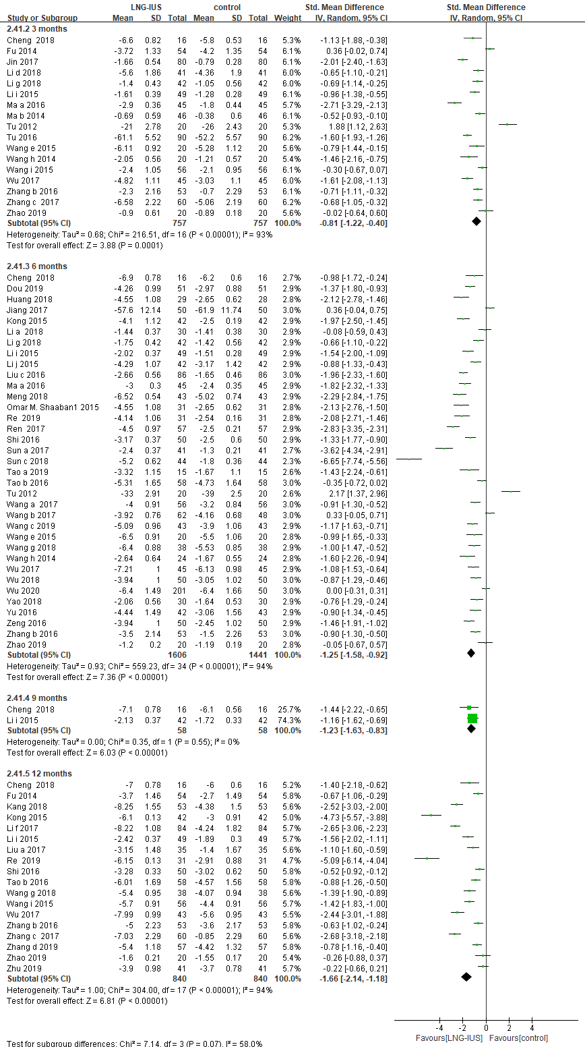
Figure 2 VAS score among adenomyosis patients receiving treatment of LNG-IUS versus medication in randomized controlled study

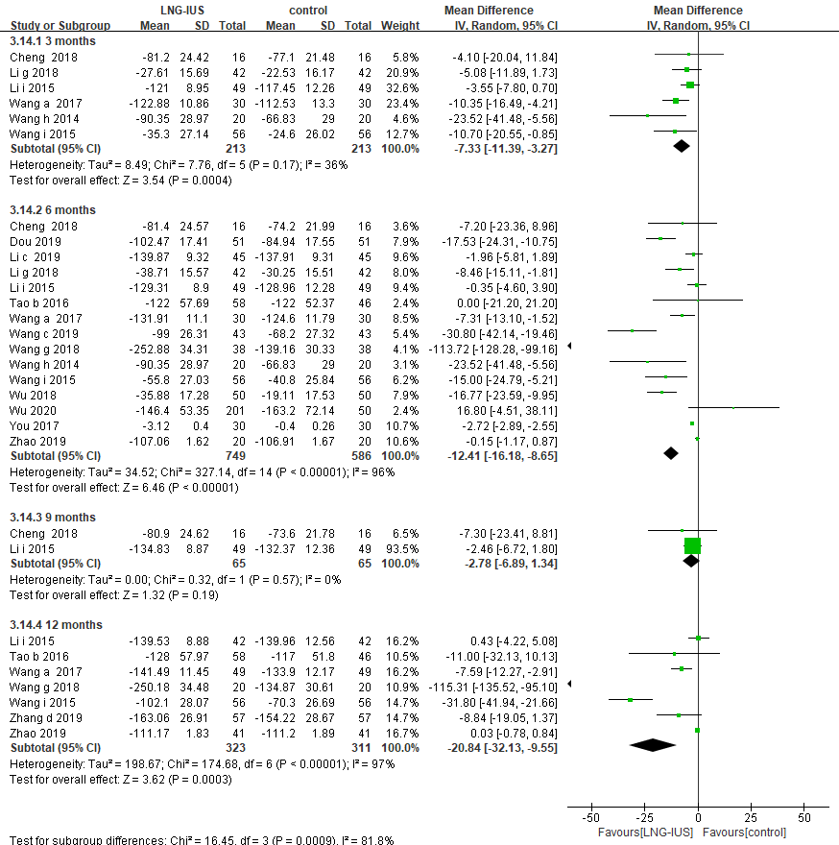
Figure 3 PBAC among adenomyosis patients receiving treatment of LNG-IUS versus medication in randomized controlled study

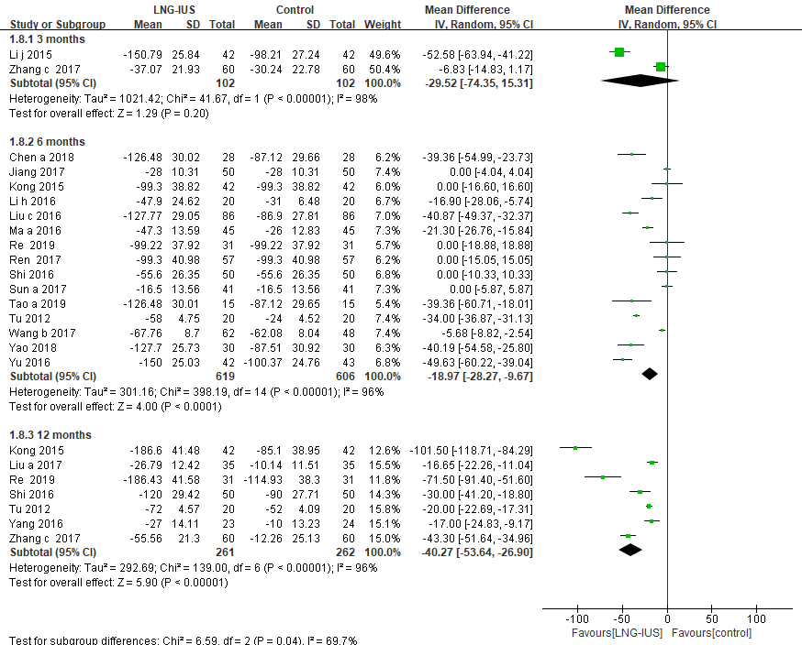
Figure 4 Menstrual blood loss among adenomyosis patients receiving treatment of LNG-IUS versus medication in randomized controlled study
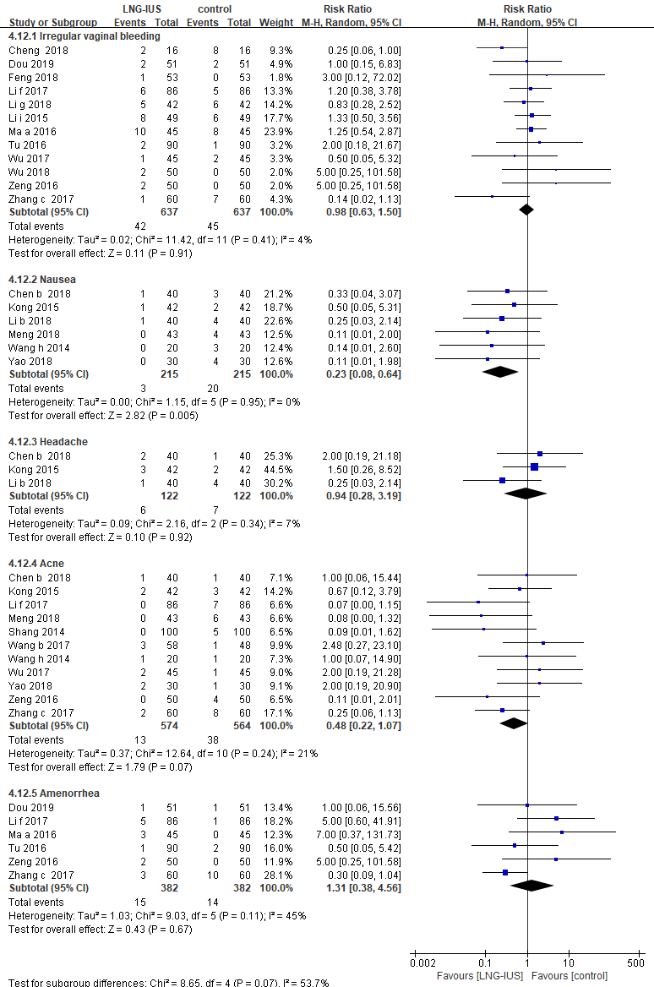
Figure 5 Adverse events among adenomyosis patients receiving treatment of LNG-IUS versus medication in randomized controlled study

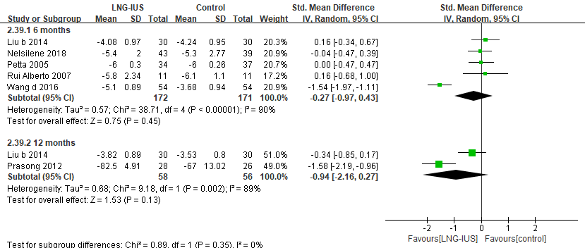
Figure 6 VAS score among endometriosis patients receiving treatment of LNG-IUS versus medication in randomized controlled study

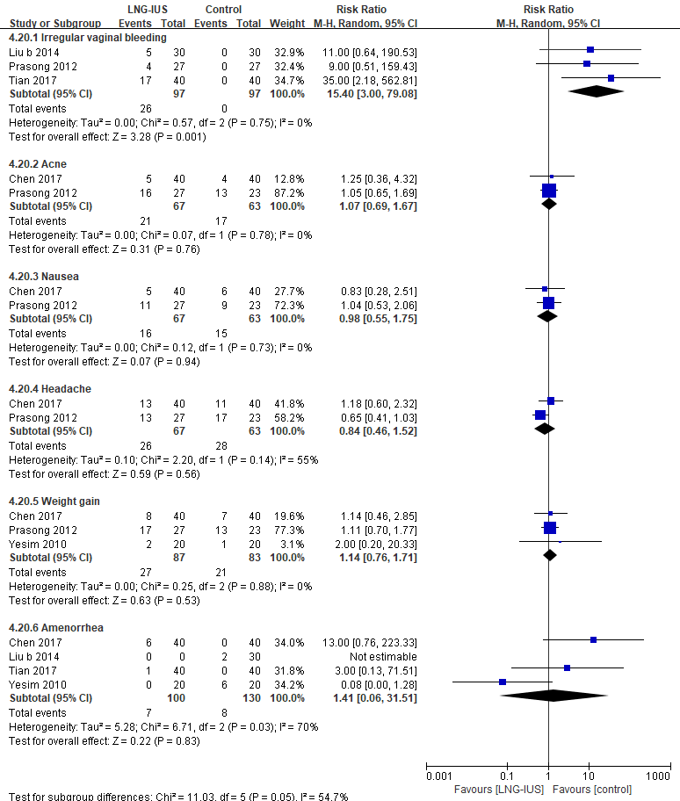
Figure 7 Adverse events among endometriosis patients receiving LNG-IUS versus medication

Search strategy
- Pubmed
1. mirena
2. levonorgestrel releasing intrauterine system
3. LNG-IUS
4. levonorgestrel intrauterine system
5. 1 or 2 or 3 or 4
6. dysmenorrhea
7. painful menses
8. menstrual pain
9. dyspareunia
10. chronic pelvic pain
11. 6 or 7 or 8 or 9 or 1o
12. 5 and 11

- EMBASE
1. mirena.mp. or mirena/
2. levonorgestrel releasing intrauterine system/ or levonorgestrel releasing intrauterine system.mp.
3. LNG-IUS.mp. or LNG-IUS/
4. levonorgestrel intrauterine system.mp. or levonorgestrel intrauterine system/
5. 1 or 2 or 3 or 4
6. dysmenorrhea mp. or dysmenorrhea/
7. painful menses mp. or painful menses/
8. dyspareunia mp. or dyspareunia/
9. menstrual pain mp. or menstrual pain/
10. chronic pelvic pain mp. or chronic pelvic pain/
11. 6 or 7 or 8 or 9 or 10
12. 5 and 11

- CNKI
(SU='Mirena'+ 'LNG-IUS') AND (SU='dysmenorrhea'+ 'chronic pelvic pain')

- Wanfang Data
(SU='Mirena'+ 'LNG-IUS') AND (SU='dysmenorrhea'+ 'chronic pelvic pain')

