Contents of Supplement Data
Appendix 1 Search strategies
Appendix 2 Baseline Characteristic
eTable 1 Location of tumors in included studies
Appendix 3 Modified Newcastle-Ottawa quality scale
Appendix 4 Overall outcome of the included studies
eTable 2 Outcome data of postoperative morality and 1-, 2-, 3-, 4-, and 5-year survival rate
Appendix 5 Outcome data of 5-year survival rate according to various clinical parameters
eTable 3 Clinical parameters: age
eTable 4 Clinical parameters: gender
eTable 5 Clinical parameters: smoking status
eTable 6 Clinical parameters: FEV1
eTable 7 Clinical parameters: number of
eTable 8 Clinical parameters: tumor
eTable 9 Clinical parameters: tumor size
eTable 10 Clinical parameters: surgery methods
eTable 11 Clinical parameters: tumor histology
eTable 12 Clinical parameters: lymph node metastasis status
eTable 13 Clinical parameters: postoperative adjunctive therapy
Appendix 6 Outcome data of OS (HRs and 95%CIs) according to various clinical parameters
eTable 14 Clinical parameters: age
eTable 15 Clinical parameters: gender
eTable 16 Clinical parameters: smoking status
eTable 17 Clinical parameters: FEV1
eTable 18 Clinical parameters: number of tumors
eTable 19 Clinical parameters: tumor location
eTable 20 Clinical parameters: tumor size
eTable 21 Clinical parameters: surgery methods
eTable 22 Clinical parameters: tumor histology
eTable 23 Clinical parameters: lymph node metastasis status
eTable 24 Clinical parameters: postoperative adjunctive therapy
Appendix 7 eTable 25: Quality assessment results of included studies
Appendix 8 Forest chart for characteristics of synchronous MPLC
eFigure 1 Characteristics: age
eFigure 2 Characteristics: gender ratio
eFigure 3 Characteristics: the proportion of more than 2 tumors
eFigure 4 Characteristics: the proportion of tumors located in unilateral lung
eFigure 5 Characteristics: the proportion of tumors with identical histology
Appendix 9 Forest chart for the proportion of sMPLC in lung cancer
eFigure 6 Forest chart of meta-analysis for the proportion of sMPLC in lung caner
eFigure 7 Forest chart of subgroup analysis for the proportion of sMPLC according to publication year
eFigure 8 Forest chart of subgroup analysis for the proportion of sMPLC according to study quality
eFigure 9 Sensitivity analysis for the proportion of sMPLC in lung cancer
Appendix 10 Forest chart for postoperative mortality
eFigure 10 Forest chart of meta-analysis for postoperative mortality
eFigure 11 Forest chart of subgroup analysis for postoperative mortality according to publication year
eFigure 12 Forest chart of subgroup analysis for the postoperative mortality according to study quality
eFigure 13 Sensitivity analysis for the postoperative mortality
Appendix 11 Forest chart for the survival rate of sMPLC
eFigure 14 Forest chart of meta-analysis for 1-year survival rate
eFigure 15 Forest chart of meta-analysis for 2-year survival rate
eFigure 16 Forest chart of meta-analysis for 3-year survival rate
eFigure 17 Forest chart of meta-analysis for 5-year survival rate
eFigure 18 Forest chart of subgroup analysis for 5-year survival rate according to publication year
eFigure 19 Forest chart of subgroup analysis for 5-year survival rate according to study quality
eFigure 20 Sensitivity analysis for 5-year survival rate
Appendix 12 Effect of various clinical parameters on 5-year survival rate
eFigure 21 Clinical parameters: age
eFigure 22 Clinical parameters: gender
eFigure 23 Clinical parameters: smoking status
eFigure 24 Clinical parameters: FEV1
eFigure 25 Clinical parameters: number of tumors
eFigure 26 Clinical parameters: tumor location
eFigure 27 Clinical parameters: tumor size
eFigure 28 Clinical parameters: surgery methods
eFigure 29 Clinical parameters: tumor histology status
eFigure 30 Clinical parameters: lymph node metastasis
eFigure 31 Clinical parameters: postoperative adjunctive therapy
Appendix 13 Effect of various clinical parameters on overall survival
eFigure 32 Clinical parameters: age
eFigure 33 Clinical parameters: gender
eFigure 34 Clinical parameters: smoking status
eFigure 35 Clinical parameters: FEV1
eFigure 36 Clinical parameters: number of tumors
eFigure 37 Clinical parameters: tumor location
eFigure 38 Clinical parameters: tumor size
eFigure 39 Clinical parameters: surgery methods
eFigure 40 Clinical parameters: tumor histology
eFigure 41 Clinical parameters: lymph node metastasis
eFigure 42 Clinical parameters: postoperative adjunctive therapy
Appendix 14 Publication bias
eFigure 43 Publication bias for sMPLC
eFigure 44 Publication bias for postoperative mortality
eFigure 45 Publication bias for 5-years survival rate

Appendix 1: Search strategies
#1 "lung cancer"[All Fields]
#2 "lung carcinoma"[All Fields]
#3 "lung cancers"[All Fields]
#4 "Lung Neoplasms"[MeSH Terms]
#5 OR/ (#1-4)
#6 "surgery"[Subheading]
#7 "surgical procedures, operative"[MeSH Terms]
#8 "operative surgical procedures"[All Fields]
#9 surgery"[All Fields]
#10 lobectomy [All Fields]
#11 "pneumonectomy"[MeSH Terms]
#12 "pneumonectomy"[All Fields]
#13 resection [All Fields]
#14 OR (#6-13)
#15 "survival"[MeSH Terms]
#16 "survival"[All Fields]
#17 "mortality"[MeSH Terms]
#18 "mortality"[All Fields]
#19 "prognosis"[MeSH Terms]
#20 "prognosis"[All Fields]
#21 OR (#14-19)
#22 synchronous [Title/Abstract]
#23 multiple [Title/Abstract]
#24 OR (#21-23)
#25 #5 AND #14 AND #21 AND #24

Appendix 2 Baseline Characteristic
eTable 1 Characteristic of included studies
Study ID | Tumor location
Adebonojo 1997 | Unilateral (10), bilateral (5)
Andriolo 2012 | NA
Angeletti 1995 | Unilateral (10), bilateral (8)
Antakli 1995 | Same lobe (4), unilateral different lobe (12), bilateral (10)
Aziz 2002 | Unilateral (6), bilateral (4)
Bae 2012 | Unilateral (12), bilateral (7)
Chang 2007 | Same lobe (55), unilateral different lobe (26), bilateral (11)
Chen 2015 | Same lobe (27), unilateral different lobe (56), bilateral (20)
Cheng 2017 | NA
De Leyn 2008 | Bilateral (36)
Deschamps 1990 | NA
Fabian 2011 | Unilateral (23), bilateral (44)
Feng 2005 | Same lobe (8), unilateral different lobe (16), bilateral (7)
Finley 2010 | Same lobe (27), unilateral different lobe (78), bilateral (70)
Guo 2017 | Same lobe (132), unilateral different lobe (128), bilateral (97)
Hardavella 2018 | NA
Hsu 2016 | Same lobe (0), unilateral different lobe (18), bilateral (17)
Ishikawa2014 | Same lobe (31), unilateral different lobe (36), bilateral (26)
Jung 2011 | Same lobe (8), unilateral different lobe (15), bilateral (9)
Kocaturk 2011 | Unilateral (14), bilateral (12)
Li 2011 | Same lobe (12), unilateral different lobe (35), bilateral (25)
Li 2017 | Same lobe (5); unilateral different lobe (8); bilateral (23)
Lin 2014 | Same lobe (23), unilateral different lobe (20), bilateral (21)
Liu 2016 | Unilateral (86), bilateral (36)
Liu 2017 | NA
lv 2018 | NA
Mun2007 | NA
Okada 1998 | Unilateral (21), bilateral (7)
Peng 2017 | Unilateral (29), bilateral (14)
Pommier 1996 | NA
Rea 2001 | Same lobe (0), Unilateral different lobes (9), bilateral (10)
Ribet 1995 | Unilateral (9), bilateral (15)
Riquet 2008 | Same lobe (57), unilateral different lobe (51), bilateral (10)
Rosengart 1991 | Same lobe (12), unilateral different lobe (13), bilateral (8)
Rostad 2008 | Same lobe (48), unilateral different lobe (42), bilateral (4)
Shah 2012 | Bilateral (47)
Takamochi 2012 | Same lobe (13), different lobe (18)
Tanvetyanon 2010 | Unilateral different lobe (57), bilateral (59)
Trousse 2007 | Same lobe (63), unilateral different lobe (28), bilateral (34)
Tsunezuka 2004 | Bilateral 19
Tung 2003 | Unilateral different lobes (20)
van Rens 2000 | Same lobe (16), unilateral different lobe (26), bilateral (43)
Vansteenkiste 2001 | Same lobe (11), unilateral different lobe (17), bilateral (7)
Verhagen 1994 | Same lobe (1), unilateral different lobe (9), bilateral (5)
Voltolini 2010 | Same lobe (0), Unilateral different lobe (15), bilateral (28)
Wang 2001 | Same lobe (3), unilateral different lobe (6), bilateral (3)
Wang 2008 | same lobe (10), unilateral different lobe (6), bilateral (0)
Wu 1987 | Unilateral (9), bilateral (1)
Xiao 2017 | Unilateral (28), bilateral (24)
Yu 2013 | Same lobe (39), unilateral different lobe (46), bilateral (12)
Zhang 2016 | Same lobe (55), unilateral different lobe (136), bilateral (94)
Zuin 2013 | Unilateral (14), bilateral (9)
SMPLC=synchronous multiple primary lung cancer; LC=lung cancer; NA=Not available.

Appendix 3: Modified Newcastle-Ottawa quality scale
(1) Sample representativeness:
1 point: Population with sMPLC selected from patients receiving surgery.
0 points: sMPLC selection not reported.
(2) Ascertainment of sMPLC?
1 point: Definition of sMPLC described in the study.
0 points: Definition of sMPLC not reported.
(3) Sample size:
1 point: Sample size was greater than or equal to 30 participants.
0 points: Sample size was less than 30 participants.
(4) Assessment of outcomes (postoperative mortality and survival)
1 point: according to medical records or follow-up.
0 points: not reported.
(5) Enough long follow-up:
1 point: follow-up longer than or equal to 5 years.
0 points: follow-up less than 5 years.
(6) Quality of descriptive statistics reporting:
1 point: The study reported proper statistics to describe the patients’ characteristics (e.g. age, gender, tumor location, number of tumors, identical histology rate) and outcomes (postoperative mortality and 5-year survival rate)
0 points: The study did not report descriptive statistics, incompletely reported descriptive statistics, or did not report measures of dispersion.
(7) Clinical parameter analysis on the prognosis of sMPLC.
1 point: The study reported the estimated effect of clinical parameters on the sMPLC prognosis.
0 points: The study did not explore the effect of clinical parameters on the sMPLC prognosis.

Appendix 4 Overall outcome of the included studies
eTable 2: Outcome data of postoperative morality and 1-, 2-, 3-, and 5-year survival rate
Study ID | Postoperative mortality | Patient for prognosis analysis | 1-year survival rate | 2-year survival rate | 3-year survival rate | 5-year survival rate
Adebonojo 1997 | 0/15 | 15 | 86.7% | 73.2% | 58% | 0
Andriolo 2012 | NA | 13 | NA | NA | NA | 50%
Angeletti 1995 | 0/18 | 18 | 81.2% | 69.0% | 61.6% | 46.2%
Antakli 1995 | NA | 26 | 72.5 | 12.5 | 12.5 | 12.5%
Aziz 2002 | 0/10 | 10 | 50% | 40% | 40% | 10%
Bae 2012 | 2/19 | 19 | 79.0% | 73.2% | 60.0% | 51.4%
Chang 2007 | 1/92 | 92 | NA | NA | NA | 35.3%
Chen 2015 | 0/103 | 103 | 100% | 100% | 87.30% | 68.60%
Cheng 2017 | 0/45 | 45 | 100% | 93.40% | 88.90% | 72%
De Leyn 2008 | 1/36 | 36 | NA | 73.1% | NA | 38.1%
Deschamps 1990 | 2/36 | 36 | NA | NA | NA | 15.70%
Fabian 2011 | 2/67 | 67 | 91.1% | 74% | 64% | 53%
Feng 2005 | 0/31 | 31 | 52% | NA | 29% | 20%
Finley 2010 | 2/175 | 175 | 87.9% | 75.3% | 64% | 51.8%
Guo 2017 | 0/357 | 357 | NA | NA | 91.93% | 84.37%
Hardavella 2018 | 0/8 | 8 | 100% | NA | NA | NA
Hsu 2016 | 0/35 | 35 | NA | NA | 91.5% | 75%
Ishikawa2014 | 0/93 | 93 | 98.1% | 95.8% | 93.6% | 87.0%
Jung 2011 | 3/32 | 32 | 84.0% | 80% | 69.6% | 60.9%
Kocaturk 2011 | 2/26 | 26 | 88.1% | 68.8% | 62.0% | 49.7%
Li 2011 | 0/72 | 72 | 81.20% | 70.70% | 53.70% | 43.00%
Li 2017 | 0/36 | 36 | 97.05% | 97.05% | 97.05% | 86.10%
Lin 2014 | 0/64 | 64 | NA | NA | NA | 95.8%
Liu 2016 | 4/122 | 122 | NA | NA | NA | 40.5%
Liu 2017 | NA | 438 | NA | NA | NA | 59.48%
lv 2018 | NA | 48 | 95.8%% | 89.70% | 89.7%% | NA
Mun2007 | 0/19 | 19 | NA | NA | 94.7% | 75.8%
Okada 1998 | 0/28 | 28 | 83.7% | 77.3% | 72.8% | 70.3%
Peng 2017 | 0/43 | 43 | 97.00% | NA | 76.70% | NA
Pommier 1996 | 0/27 | 27 | NA | NA | NA | 24%
Rea 2001 | 1/19 | 19 | 100% | 68.5% | 49.8% | 20%
Ribet 1995 | 1/24 | 15 | 86.7% | 46.7% | 6.7% | 0%
Riquet 2008 | 6/118 | 118 | 66.6% | 53.5% | 40.1% | 26%
Rosengart 1991 | NA | 33 | 81.6% | 68.3% | 54.0% | 44%
Rostad 2008 | 8/94 | 94 | NA | NA | NA | 27.6%
Shah 2012 | 1/47 | 47 | 69.6% | 51.6% | 35% | 29%
Takamochi 2012 | NA | 31 | 96.5% | 86.6% | 82.1% | 77.3%
Tanvetyanon 2010 | 5/116 | 116 | NA | NA | NA | NA
Trousse 2007 | 6/125 | 125 | 76.5% | 61.6% | 48.4% | 34%
Tsunezuka 2004 | NA | 19 | 94.5% | 88.6% | 80.8% | 69%
Tung 2003 | NA | 20 | 60.00% | 39.30% | 28.10% | 28.10%
van Rens 2000 | 12/73 | 73 | 71.6% | 51.7% | 34.6% | 19%
Vansteenkiste 2001 | 3/35 | 35 | 68.4% | 54% | 48.5% | 33%
Verhagen 1994 | 3/15 | 15 | 66% | 33.1% | 26% | 15%
Voltolini 2010 | 3/43 | 43 | 86.1% | 58.5% | 41% | 34%
Wang 2001 | 0/12 | 12 | 80% | NA | 77.70% | 14.30%
Wang 2008 | 0/16 | 16 | NA | NA | NA | 16.90%
Wu 1987 | 0/10 | 10 | 70% | 48% | 48% | 35%
Xiao 2017 | 0/52 | 52 | 96.10% | 90.20% | 75.50% | 40.60%
Yu 2013 | 0/97 | 97 | 96.7% | 93.1% | 84.8% | 69.6%
Zhang 2016 | NA | 285 | NA | NA | NA | 77.6%,
Zuin 2013 | NA | 23 | 91.4% | 64.2% | 55.0% | 40%
NA, not available

Appendix 5 Outcome data of 5-year survival rate according to various clinical parameters
eTable 3: Outcome data of 5-year survival rate according to age
Study ID | Comparison | Subgroup | N | 5-year survival rate
Hsu 2016 | ≥65yrs vs. <65yrs | Older | 20 | 62.2%
Hsu 2016 | ≥65yrs vs. <65yrs | Young | 15 | 88.9%
Ishikawa2014 | ≥70yrs vs. <70yrs | Older | 40 | 92%
Ishikawa2014 | ≥70yrs vs. <70yrs | Young | 53 | 83.8%
Jung 2011 | ≥65yrs vs. <65yrs | Older | 17 | 36%
Jung 2011 | ≥65yrs vs. <65yrs | Young | 15 | 85.7%
Liu 2016 | >60yrs vs. <=60yrs | Older | 57 | 45.4%
Liu 2016 | >60yrs vs. <=60yrs | Young | 65 | 38.8%
Takamochi 2012 | >65 vs.<=65yrs | Older | 19 | 75.8%
Takamochi 2012 | >65 vs.<=65yrs | Young | 12 | 80.2%
Voltolini 2010 | ≥67yrs vs. <67yrs | Older | 22 | 36.6%
Voltolini 2010 | ≥67yrs vs. <67yrs | Young | 21 | 27.6%
Yu 2013 | ≥65yrs vs. <65yrs | Older | 53 | 64%
Yu 2013 | ≥65yrs vs. <65yrs | Young | 44 | 77.4%
eTable 4: Outcome data of 5-year survival rate according to gender
Study ID | Subgroup | N | 5-year survival rate
Fabian 2011 | Male | 30 | 53%
Fabian 2011 | Female | 37 | 50%
Hsu 2016 | Male | 11 | 57.1%
Hsu 2016 | Female | 24 | 85.1%
Ishikawa 2014 | Male | 36 | 77.4%
Ishikawa 2014 | Female | 57 | 93.1%
Jung 2011 | Male | 22 | 44.6%
Jung 2011 | Female | 10 | 100%
Kocaturk 2011 | Male | 26 | 49.7%
Liu 2016 | Male | 54 | 46.6%
Liu 2016 | Female | 68 | 39.2%
Takamochi 2012 | Male | 14 | 58.6%
Takamochi 2012 | Female | 17 | 94.1%
Voltolini 2010 | Male | 40 | 33.4%
Voltolini 2010 | Female | 3 | 50%
Yu 2013 | Male | 42 | 62.2%
Yu 2013 | Female | 55 | 75.5%
eTable 5: Outcome data of 5-year survival rate according to smoking status
Study ID | Subgroup | N | 5-year survival rate
Guo 2017 | Never smoker | 296 | 90.7%
Guo 2017 | Smoker | 61 | 63.1%
Hsu 2016 | Never smoker | 27 | 71.8%
Hsu 2016 | Smoker | 8 | 85.7%
Ishikawa 2014 | Never smoker | 60 | 90%
Ishikawa 2014 | Smoker | 33 | 81.8%
Jung 2011 | Never smoker | 10 | 100%
Jung 2011 | Smoker | 22 | 44.6%
Liu 2016 | Never smoker | 76 | 55.6%
Liu 2016 | Smoker | 46 | 30.8%
Takamochi 2012 | Never smoker | 13 | 92.3%
Takamochi 2012 | Smoker | 18 | 66.5%
Yu 2013 | never smoker | 58 | 77.8%
Yu 2013 | smoker | 39 | 58.5%
eTable 6: Outcome data of 5-year survival rate according to FEV1
Study ID | FEV1 | Subgroup | N | 5-year survival rate
Bae 2012 | ＜80% | Low | 7 | 35.7%
Bae 2012 | ≥80% | High | 12 | 48.1%
Hsu 2016 | ＜80% | Low | 12 | 57.1%
Hsu 2016 | ≥80% | High | 23 | 83.6%
Jung 2011 | ＜70% | Low | 8 | 25%
Jung 2011 | ≥70% | High | 24 | 76%
Yu 2013 | ＜80% | Low | 18 | 66.9%
Yu 2013 | ≥80% | High | 79 | 70.7%
Xiao 2017 | ＜80% | Low | 17 | 9.7%
Xiao 2017 | >=80 | High | 35 | 47.6%
eTable 7: Outcome data of 5-year survival rate according to the number of tumors
Study ID | Subgroup | N | 5-year survival rate
Ishikawa 2014 | <3 | 71 | 90.7%
Ishikawa 2014 | >=3 | 22 | 71.1%
Liu 2016 | <3 | 101 | 43.9%
Liu 2016 | >=3 | 21 | 36.8%
Rostad 2008 | <3 | 67 | 27.1%
Rostad 2008 | >=3 | 27 | 29%
eTable 8: Outcome data of 5-year survival rate according to tumor location
Study ID | Location | Subgroup | N | 5-year survival rate
Bae 2012 | Unilateral (same+different) | Unilateral | 12 | 64.2%
Bae 2012 | Bilateral | Bilateral | 7 | 22.2%
Fabian 2011 | Same lobe | Unilateral | 5 | 78%
Fabian 2011 | Ipsilateral different lobe | Unilateral | 18 | 43%
Fabian 2011 | Bilateral | Bilateral | 44 | 54%
Hsu 2016 | Ipsilateral different lobe | Unilateral | 18 | 76.2%
Hsu 2016 | Bilateral | Bilateral | 17 | 76.6%
Ishikawa 2014 | Unilateral (same+different) | Unilateral | 67 | 90.9
Ishikawa 2014 | Bilateral | Bilateral | 26 | 76.9%
Jung 2011 | Same lobe | Unilateral | 8 | 50%
Jung 2011 | Ipsilateral different lobe | Unilateral | 15 | 62.2%
Jung 2011 | Bilateral | Bilateral | 9 | 57.1%
Kocaturk 2011 | Unilateral (same+different) | Unilateral | 14 | 40.6%
Kocaturk 2011 | Bilateral | Bilateral | 12 | 62.8%
Liu 2016 | Unilateral (same+different) | Unilateral | 86 | 41.5%
Liu 2016 | Bilateral | Bilateral | 36 | 36.8%
Riquet 2008 | Same lobe | Unilateral | 57 | 29.9%
Riquet 2008 | Ipsilateral different lobe | Unilateral | 51 | 15.6%
Trousse 2007 | Same lobe | Unilateral | 63 | 32.7%
Trousse 2007 | Ipsilateral different lobe | Unilateral | 28 | 24.3%
Trousse 2007 | Bilateral | Bilateral | 34 | 44.3%
Tsunezuka 2004 | Bilateral | Bilateral | 19 | 69%
Tung 2003 | Ipsilateral different lobe | Unilateral | 20 | 28.1%
van Rens 2000 | Same lobe | Unilateral | 16 | 29%
van Rens 2000 | Different lobe | Bilateral | 69 | 16%
Vansteenkiste 2001 | Same lobe | Unilateral | 11 | 23%
Vansteenkiste 2001 | Ipsilateral different lobe | Unilateral | 17 | 18%
Vansteenkiste 2001 | Bilateral | Bilateral | 7 | 43%
Voltolini 2010 | Unilateral (same+different) | Unilateral | 15 | 43%
Voltolini 2010 | Bilateral | Bilateral | 28 | 27%
Wang 2008 | Same lobe | Unilateral | 9 | 30.4%
Yu 2013 | Same lobe | Unilateral | 39 | 60.6%
Yu 2013 | Ipsilateral different lobe | Unilateral | 46 | 76.3%
Yu 2013 | Bilateral | Bilateral | 12 | 68.8%
eTable 9: Outcome data of 5-year survival rate according to tumor size
Study ID | Subgroup | N | 5-year survival rate
Hsu 2016 | Largest tumor size<=3cm | 17 | 100%
Hsu 2016 | Largest tumor size>3cm | 18 | 62.1%
Ishikawa 2014 | Largest tumor size<=3cm | 72 | 84.5%
Ishikawa 2014 | Largest tumor size>3cm | 21 | 95.2%
Jung 2011 | Largest tumor size<=3cm | 19 | 84.2%
Jung 2011 | Largest tumor size>3cm | 13 | 24.4%
Liu 2016 | Largest tumor size<=3cm | 73 | 41.2%
Liu 2016 | Largest tumor size>3cm | 49 | 38.5%
Yu 2013 | Largest tumor size<=3cm | 29 | 85.9%
Yu 2013 | Largest tumor size>3cm | 68 | 62.3%
Xiao 2017 | Largest tumor size<=3cm | 27 | 50.5%
Xiao 2017 | Largest tumor size>3cm | 25 | 16.8%
Guo 2017 | Largest tumor size<=2cm | 244 | 96.8%
Guo 2017 | Largest tumor size>2cm | 113 | 68.5%
eTable 10: Outcome data of 5-year survival rate according to surgery methods
Study ID | Surgery method | Subgroup1 | Subgroup2 | N | 5-year survival rate
Bae 2012 | Pneumonectomy | Pneumonectomy | Extended | 6 | 50%
Bae 2012 | Non-pneumonectomy | Limited | Limited | 13 | 47.9%
De Leyn 2008 | Limited resection | Limited | Limited | 26 | 36.7%
De Leyn 2008 | Bilateral lobectomy | Anatomical | Extended | 10 | 40%
Ishikawa 2014 | Segmentectomy | Limited | Limited | 18 | 82.1%
Ishikawa 2014 | Wedge resection | Limited | Limited | 36 | 80.4%
Ishikawa 2014 | Lobectomy | Anatomical | Extended | 39 | 92.5%
Jung 2011 (1) | Pneumonectomy | pneumonectomy | Extended | 5 | 30%
Jung 2011 (1) | Non-pneumonectomy | Limited | Limited | 27 | 73%
Jung 2011 (2) | Limited resection | Limited | Limited | 17 | 79.4%
Jung 2011 (2) | No limited resection | Anatomical | Extended | 15 | 51.2%
Kocaturk 2011 | Pneumonectomy | pneumonectomy | Extended | 11 | 27%
Kocaturk 2011 | Non-pneumonectomy | Limited | Limited | 15 | 71.1%
Liu 2016 | Pneumonectomy | pneumonectomy | Extended | 14 | 10.4%
Liu 2016 | Limited resection | Limited | Limited | 26 | 42.7%
Liu 2016 | Lobectomy and limited resection | Limited | Limited | 48 | 50.7%
Liu 2016 | Lobectomy | Anatomical | Extended | 34 | 38.8%
Liu 2017 | Pneumonectomy | Pneumonectomy | Extended | 14 | 45.9%
Liu 2017 | Sublobar resection | Limited | Limited | 233 | 53.8%
Liu 2017 | Lobectomy | Anatomical | Extended | 174 | 70.5%
Pommier 1996 | Incompletely | Limited | Limited | 13 | 0%
Pommier 1996 | Resected completely | Anatomical | Extended | 14 | 45%
Vansteenkiste 2001 | Limited resection | Limited | Limited | 8 | 37%
Vansteenkiste 2001 | Non-limited resection | Anatomical | Extended | 27 | 27%
Voltolini 2010 | Sublobar resection | Limited | Limited | 28 | 29%
Voltolini 2010 | Lobar resection | Anatomical | Extended | 15 | 42%
Xiao 2017 | Limited | Limited | Limited | 43 | 41.1%
Xiao 2017 | Extended | Anatomical | Extended | 9 | 8.5%
Yu 2013 | Sublobar+sublobar | Limited | Limited | 13 | 64.7%
Yu 2013 | Lobect+lobect/sublobar | Limited | Limited | 45 | 79.7%
Yu 2013 | Lobectomy | Anatomical | Extended | 39 | 60.6%
eTable 11: Outcome data of 5-year survival rate according to tumor histology
Study ID | Subgroup | N | 5-year survival rate
Angeletti 1995 | Same | 6 | 16.7%
Angeletti 1995 | Different | 12 | 0%
Bae 2012 | Same | 8 | 75%
Bae 2012 | Different | 11 | 20.8%
De Leyn 2008 | Same | 18 | 31.1%
De Leyn 2008 | Different | 18 | 45.5%
Jung 2011 | Same | 14 | 100%
Jung 2011 | Different | 18 | 35.6%
Kocaturk 2011 | Same | 17 | 25%
Kocaturk 2011 | Different | 9 | 78%
Liu 2016 | Same | 88 | 46.9%
Liu 2016 | Different | 34 | 24.8%
Liu 2017 | Same | 339 | 65%
Liu 2017 | Different | 99 | 41.7%
Pommier 1996 | Same | 15 | 33%
Pommier 1996 | Different | 12 | 17%
Rea 2001 | Same | 13 | 15%
Rea 2001 | Different | 6 | 33%
Riquet 2008 | Same | 60 | 32.5%
Riquet 2008 | Different | 58 | 20.2%
Rostad 2008 | Same | 85 | 29.2%
Rostad 2008 | Different | 9 | 12.7%
Shah 2012 | Same | 19 | 23%
Shah 2012 | Different | 17 | 40%
Vansteenkiste 2001 | Same | 30 | 31%
Vansteenkiste 2001 | Different | 5 | 20%
Voltolini 2010 | Same | 27 | 34%
Voltolini 2010 | Different | 16 | 33%
Yu 2013 | Same | 38 | 64.9%
Yu 2013 | Different | 59 | 74%
eTable 12: Outcome data of 5-year survival rate according to lymph node metastasis
Study ID | Subgroup | N | 5-year survival rate
Chang 2007 | N0 | 50 | 52.5%
Chang 2007 | N1+ | 42 | 15.5%
Hsu 2016 | N0 | 32 | 73.6%
Hsu 2016 | N1+ | 3 | 100%
Ishikawa2014 | N0 | 75 | 93.4%
Ishikawa2014 | N1 | 10 | 75%
Ishikawa2014 | N2 | 8 | 41.7%
Jung 2011 | N0 | 25 | 64.5%
Jung 2011 | N1+ | 7 | 53.6%
Vansteenkiste 2001 | N0 | 20 | 33%
Vansteenkiste 2001 | N1 | 8 | 25%
Vansteenkiste 2001 | N2 | 7 | 17%
Voltolini 2010 | N0 | 25 | 57%
Voltolini 2010 | N1+ | 18 | 0%
Yu 2013 | N0 | 75 | 71.7%
Yu 2013 | N1+ | 22 | 59.7%
Tung 2003 | N0 | 6 | 66.7%
Tung 2003 | N1+ | 12 | 10.3%
Guo 2017 | N0 | 319 | 88.7%
Guo 2017 | N1+ | 38 | 54.8%
Takamochi 2012 | N0 | 24 | 81.3%
Takamochi 2012 | N1+ | 7 | 66.7%
eTable 13: Outcome data of 5-year survival rate according to postoperative adjunctive therapy
Study ID | Subgroup | N | 5-year survival rate
Bae 2012 | Yes | 8 | 31.2%
Bae 2012 | No | 11 | 71.4%
Hsu 2016 | Yes | 24 | 71.5%
Hsu 2016 | No | 11 | 87.5%
Ishikawa 2014 | No | 12 | 50%
Ishikawa 2014 | Yes | 6 | 83.3%
Jung 2011 | No | 20 | 45%
Jung 2011 | Yes | 12 | 90%
Trousse 2007 | Yes | 58 | 47.2%
Trousse 2007 | No | 67 | 52.8%
Yu 2013 | No | 39 | 62.5%
Yu 2013 | Yes | 58 | 73.7%

Appendix 6 Outcome data of OS (HRs and 95%CIs) according to various clinical parameters
eTable 14: Outcome data of OS according to clinical parameters: age
Study ID | Comparison | HRs with 95%CI
Guo 2017 | >60yrs vs. ≤60yrs | 2.951(1.222-7.126)
Rostad 2008 | >70yrs vs.≤70yrs | 1.91 (1.15-3.19)
Trousse-2007 | ≥60yrs vs. <60yrs | 1.89 (1.10-3.23)
Voltolini 2010 | ≥67yrs vs. <67yrs | 1.499 (0.466-4.831)
Zhang 2016 | ≥60yrs vs. <60yrs | 1.51 (0.72–3.15)
eTable 15: Outcome data of OS according to clinical parameters: gender
Study ID | Comparison | HRs with 95%CI
Voltolini 2010 | Male vs. Female | 3.05 (0.327-28.477)
Zhang 2016 | Male vs. Female | 2.56 (1.16-5.68)
Trousse-2007 | Male vs. Female | 2.5 (1.15-5.42)
Rostad 2008 | Male vs. Female | 1.70 (1.01-2.86)
Tanvetyanon 2010 | Male vs. Female | 1.69 (1.01-2.86)
Guo 2017 | Male vs. Female | 5.09 (2.105-12.31)
Finley 2010 | Male vs. Female | 2.21 (1.45-3.38)
eTable 16: Outcome data of OS according to clinical parameters: smoking status
Study ID | Comparison | HRs with 95%CI
Finley 2010 | Current smoker vs. Non-smoker | 1.85 (0.68 -5)
Guo 2017 | Smoker vs. Non-smoker | 4.771 (2.249-7.293)
Liu 2016 | Smoker vs. Non-smoker | 5.021 (3.007-22.332)
Voltolini 2010 | Smoker vs. Non-smoker | 1.959 (0.188-20.412)
Zhang 2016 | Light smoker vs. Non-smoker | 0.84 (0.11-6.42)
Zhang 2016 | Moderate smoker vs. Non-smoker | 2.63 (1.1-6.27)
Zhang 2016 | Heavy smoker vs. Non-smoker | 2.06 (0.87-4.93)
eTable 17: Outcome data of OS according to clinical parameters: FEV1
Study ID | Comparison | HRs with 95%CI
Tanvetyanon 2010 | High vs. Low | 0.49 (0.26－0.94
Trousse 2007 | High vs. Low | 0.95 (0.93－0.98)
Xiao 2017 | High vs. Low | 0.315 (0.118-0.847)
eTable 18: Outcome data of OS according to clinical parameters: number of tumors
Study ID | Comparison | HRs with 95%CIs
Zhang 2016 | ≥3 vs. <3 | 0.7 (0.25-2.01)
Guo 2017 | ≥3 vs. <3 | 4.44 (0.98-20.41)
eTable 19: Outcome data of OS to clinical parameters: tumor location
Study ID | Comparison | HRs with 95%CIs
Finley 2010 | Ipsilateral different vs. Same | 1.4 (0.73-2.7)
Finley 2010 | Bilateral vs. Same | 1.31 (0.68-2.51)
Guo 2017 | Ipsilateral different vs. Same | 2.55 (0.9-7.26)
Guo 2017 | Bilateral vs. Same | 1.55 (0.49-4.89)
Ishikawa2014 | Bilateral vs. Unilateral | 4.63 (1.148-18.666)
Tanvetyanon 2010 | Bilateral vs. Unilateral | 0.89 (0.37-2.19)
Tanvetyanon 2010 | Bilateral vs. Unilateral | 0.71 (0.4-1.25)
Voltolini 2010 | Bilateral vs. Unilateral | 1.675 (0.631-4.444)
Zhang 2016 | Bilateral vs. Unilateral | 0.62 (0.29-1.33)
Zhang 2016 | Bilateral vs. Same | 0.87 (0.21-3.66)
eTable 20: Outcome data of OS according to clinical parameters: tumor size
Study ID | Comparison | HRs with 95%CIs
Finley 2010 | Largest tumor size (per cm increase) | 1.11 (1.01–1.23)
Guo 2017 (1) | >2cm vs. ≤ 2cm | 6.737 (2.579-10.895)
Guo 2017 (2) | sum of tumor size >3 cm vs. ≤ 3cm | 8.419 (2.497-28.394)
Hsu 2016 | >3cm vs. ≤ 3cm | 42.83 (0.04-46804)
Tanvetyanon 2010 (1) | largest tumor size (per cm increase) | 1.17 (1.06-1.3)
Tanvetyanon 2010 (2) | sum of tumor size (per cm increase) | 1.15 (1.05-1.26)
Xiao 2017 | >3cm vs. ≤ 3cm | 2.62 (1.15–5.98)
Zhang 2016 (1) | >2, ≤ 3cm vs. ≤ 2cm | 2.24 (0.70–7.13)
Zhang 2016 (2) | >3, ≤ 5cm vs. ≤ 2cm | 3.85 (1.22–12.09)
Zhang 2016 (3) | >5 vs. ≤ 2cm | 8.55 (2.40–30.54)
eTable 21: Outcome data of OS according to clinical parameters: surgery methods
Study ID | Comparison | HRs with 95%CIs
Guo 2017 (1) | Limited vs. Anatomical | 1.253 (0.464-3.385)
Guo 2017 (2) | Limited vs. Anatomical | 2.079 (0.760-5.690)
Ishikawa2014 | Limited vs. Anatomical | 4.425 (1.054–18.580)
Kocaturk 2011 | Pneumonectomy vs. no | 1.68 (0.96-30.2)
Liu 2016 | Pneumonectomy vs. no | 5.623 (3.067-27.855)
Liu 2017 | Limited vs. Anatomical | 1.41 (1.07-1.89)
Liu 2017 | pneumonectomy vs. no | 1.91 (1.0-3.7)
Rostad 2008 | pneumonectomy vs. no | 1.96 (1.18-3.26)
Shah 2012 | Limited vs. Anatomical | 1.19 (0.52-2.78)
Tanvetyanon 2010 | Pneumonectomy vs. no | 1.36 (0.58-3.18)
Trousse 2007 | Pneumonectomy vs. no | 6.6 (3.34-13.1)
van Rens 2000 | Limited vs. Anatomical | 1.44 (0.86-2.4)
Voltolini 2010 | Limited vs. Anatomical | 1.048 (0.389-2.823)
Xiao 2017 | Limited vs. Anatomical | 0.32 (0.108-0.952)
Zhang 2016 (1) | Limited vs. Anatomical | 1 (0.44-2.3)
Zhang 2016 (2) | Limited vs. Anatomical | 1.22 (0.45-3.27)
eTable 22: Outcome data of OS according to clinical parameters: tumor histology
Study ID | Comparison | HRs with 95%CIs
Finley 2010 | Different vs. same | 1.64 (0.99-2.74)
Kocaturk 2011 | Different vs. same | 0.38 (0.07-1.83)
Tanvetyanon 2010 | Different vs. same | 0.81 (0.47-1.41)
Voltolini 2010 | Different vs. same | 1.927 (0.688-5.405)
Guo 2017 | Different vs. same | 7.87 (3.41-18.18)
eTable 23: Outcome data of OS according to clinical parameters: lymph node metastasis
Study ID | Comparison | HRs with 95%CIs
Chang 2007 | N1+ vs. N0 | 2.367 (1.196-4.682)
Finley 2010 | N1 vs. N0 | 1.96 (1.11-3.47)
Finley 2010 | N2 vs. N0 | 1.96 (1.08-3.53)
Guo 2017 | N1+ vs. N0 | 3.753 (2.229-5.277)
Ishikawa2014 | N1+ vs. N0 | 10.56 (2.142-52.076)
Liu 2016 | N1+ vs. N0 | 6.036 (4.614-94.917)
Tanvetyanon 2010 | N1+ vs. N0 | 1.42 (0.74-2.73)
Trousse 2007 | N1+ vs. N0 | 2.9 (1.2-6.9)
Voltolini 2010 | N1+ vs. N0 | 4.95 (1.83-13.33)
Xiao 2017 | N1+ vs. N0 | 1.71 (0.71-4.13)
Zhang 2016 | N1 vs. N0 | 2.33 (0.88-6.15)
Zhang 2016 | N2 vs. N0 | 5.48 (2.36-12.74)
eTable 24: Outcome data of OS according to clinical parameters: postoperative adjunctive therapy
Study ID | Comparison | HRs with 95%CIs
Kocaturk 2011 | No vs. Yes | 1.8 (0.88-41.97)
Trousse-2007 | No vs. Yes | 1.8 (1.02-3.33)
Voltolini 2010 | No vs. Yes | 0.603 (0.195-1.862)
Zhang 2016 | No vs. Yes | 0.61 (0.3-1.23)

Appendix 7 eTable 25: Quality assessment results of included studies
Study ID | Study type | Representativeness | Ascertainment of sMPLC | Sample Size >=30 | Assessment of outcomes | Enough long follow-up | Quality of descriptive statistics reporting | Clinical parameter on the prognosis of sMPLC | Total score
Adebonojo 1997 | longitudinal | 1 | 1 | 0 | 1 | 1 | 0 | 0 | 4
Angeletti 1995 | longitudinal | 1 | 1 | 0 | 1 | 1 | 1 | 0 | 5
Antakli 1995 | longitudinal | 1 | 1 | 0 | 1 | 1 | 0 | 0 | 4
Aziz 2002 | longitudinal | 1 | 1 | 0 | 1 | 1 | 1 | 0 | 5
Bae 2012 | longitudinal | 1 | 1 | 0 | 1 | 1 | 1 | 1 | 6
Chang 2007 | longitudinal | 1 | 1 | 1 | 1 | 1 | 1 | 0 | 6
De Leyn 2008 | longitudinal | 1 | 0 | 1 | 1 | 1 | 1 | 1 | 6
Fabian 2011 | longitudinal | 0 | 1 | 1 | 1 | 1 | 1 | 1 | 6
Feng 2005 | longitudinal | 1 | 1 | 1 | 1 | 1 | 1 | 0 | 6
Finley 2010 | longitudinal | 0 | 1 | 1 | 1 | 1 | 1 | 1 | 6
Hsu 2016 | longitudinal | 1 | 1 | 1 | 1 | 1 | 1 | 1 | 7
Ishikawa2014 | longitudinal | 1 | 1 | 1 | 1 | 1 | 1 | 1 | 7
Jung 2011 | longitudinal | 1 | 1 | 1 | 1 | 1 | 1 | 1 | 7
Kocaturk 2011 | longitudinal | 1 | 1 | 0 | 1 | 1 | 1 | 1 | 6
Lin 2014 | longitudinal | 1 | 0 | 1 | 1 | 1 | 1 | 0 | 5
Liu 2016 | longitudinal | 1 | 1 | 1 | 1 | 1 | 1 | 1 | 7
Mun2007 | longitudinal | 1 | 1 | 0 | 1 | 1 | 1 | 0 | 5
Okada 1998 | longitudinal | 1 | 1 | 0 | 1 | 1 | 1 | 0 | 5
Pommier 1996 | longitudinal | 1 | 1 | 0 | 1 | 1 | 1 | 1 | 6
Rea 2001 | longitudinal | 0 | 1 | 0 | 1 | 1 | 0 | 1 | 4
Ribet 1995 | longitudinal | 1 | 1 | 0 | 1 | 1 | 1 | 0 | 5
Riquet 2008 | longitudinal | 1 | 1 | 1 | 1 | 1 | 1 | 1 | 7
Rosengart 1991 | longitudinal | 0 | 1 | 1 | 1 | 1 | 1 | 0 | 5
Rostad 2008 | longitudinal | 1 | 0 | 1 | 1 | 1 | 1 | 1 | 6
Shah 2012 | longitudinal | 0 | 0 | 1 | 1 | 1 | 1 | 1 | 5
Tanvetyanon 2010 | longitudinal | 1 | 1 | 1 | 1 | 0 | 1 | 1 | 6
Trousse 2007 | longitudinal | 1 | 1 | 1 | 1 | 1 | 1 | 1 | 7
Tsunezuka 2004 | longitudinal | 1 | 1 | 0 | 1 | 1 | 1 | 0 | 5
van Rens 2000 | longitudinal | 1 | 1 | 1 | 1 | 1 | 1 | 1 | 7
Vansteenkiste 2001 | longitudinal | 0 | 0 | 1 | 1 | 1 | 1 | 1 | 5
Verhagen 1994 | longitudinal | 1 | 1 | 0 | 1 | 1 | 0 | 0 | 4
Voltolini 2010 | longitudinal | 1 | 0 | 1 | 1 | 1 | 1 | 1 | 6
Wu 1987 | longitudinal | 1 | 1 | 0 | 1 | 1 | 1 | 0 | 5
Yu 2013 | longitudinal | 1 | 1 | 1 | 1 | 1 | 1 | 1 | 7
Zhang 2016 | longitudinal | 0 | 1 | 1 | 1 | 1 | 1 | 1 | 6
Zuin 2013 | longitudinal | 1 | 1 | 0 | 1 | 1 | 1 | 0 | 5
Andriolo 2012 | longitudinal | 0 | 1 | 0 | 1 | 1 | 0 | 0 | 3
Deschamps 1990 | longitudinal | 0 | 0 | 1 | 1 | 1 | 0 | 0 | 3
Hardavella 2018 | longitudinal | 0 | 0 | 0 | 1 | 0 | 0 | 0 | 1
Liu 2017 | longitudinal | 0 | 1 | 1 | 1 | 1 | 0 | 1 | 5
Chen 2015 | longitudinal | 1 | 1 | 1 | 1 | 1 | 1 | 0 | 6
Li 2011 | longitudinal | 0 | 1 | 1 | 1 | 1 | 1 | 0 | 5
Wang 2001 | longitudinal | 1 | 1 | 0 | 1 | 1 | 1 | 0 | 5
Wang 2008 | longitudinal | 1 | 1 | 0 | 1 | 1 | 1 | 1 | 6
Tung 2003 | longitudinal | 1 | 0 | 0 | 1 | 1 | 1 | 1 | 5
Cheng 2017 | longitudinal | 1 | 1 | 1 | 1 | 1 | 1 | 0 | 6
Xiao 2017 | longitudinal | 1 | 1 | 1 | 1 | 1 | 1 | 1 | 7
Guo 2017 | longitudinal | 1 | 1 | 1 | 1 | 1 | 1 | 1 | 7
Peng 2017 | longitudinal | 0 | 1 | 1 | 1 | 0 | 1 | 0 | 4
Li 2017 | longitudinal | 1 | 1 | 1 | 1 | 1 | 1 | 0 | 6
lv 2018 | longitudinal | 1 | 1 | 1 | 1 | 0 | 1 | 0 | 5
Takamochi 2012 | longitudinal | 1 | 1 | 1 | 1 | 1 | 1 | 1 | 7

Appendix 8 Forest chart for characteristics of synchronous MPLC
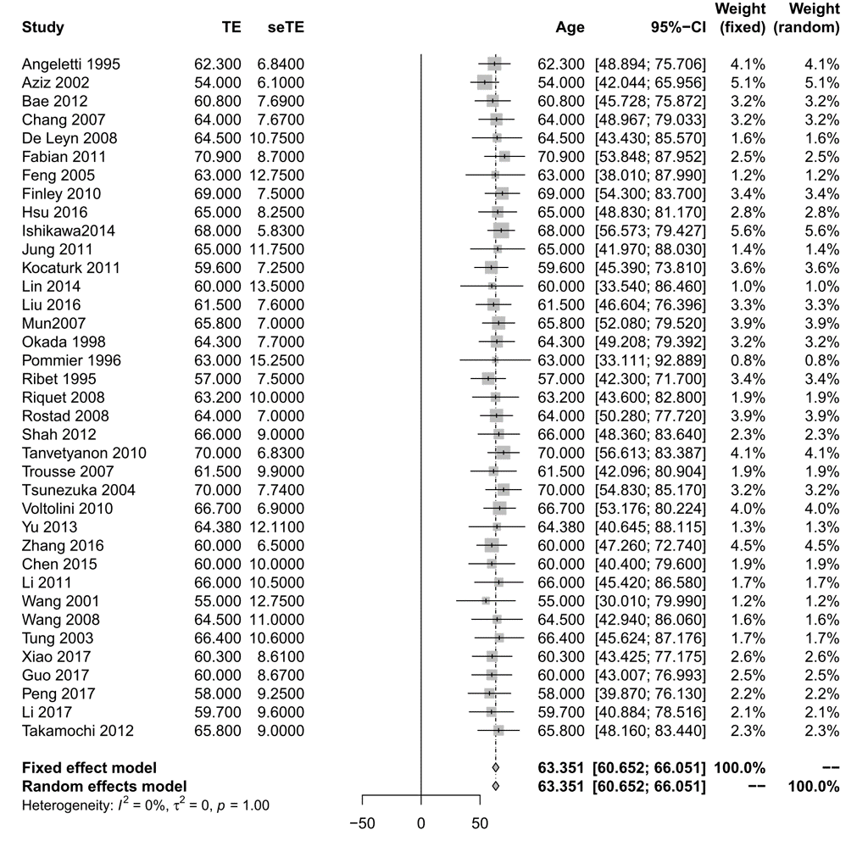
eFigure 1 Forest chart of meta-analysis for characteristics of synchronous MPLC: age
Result from random-effects model is used.

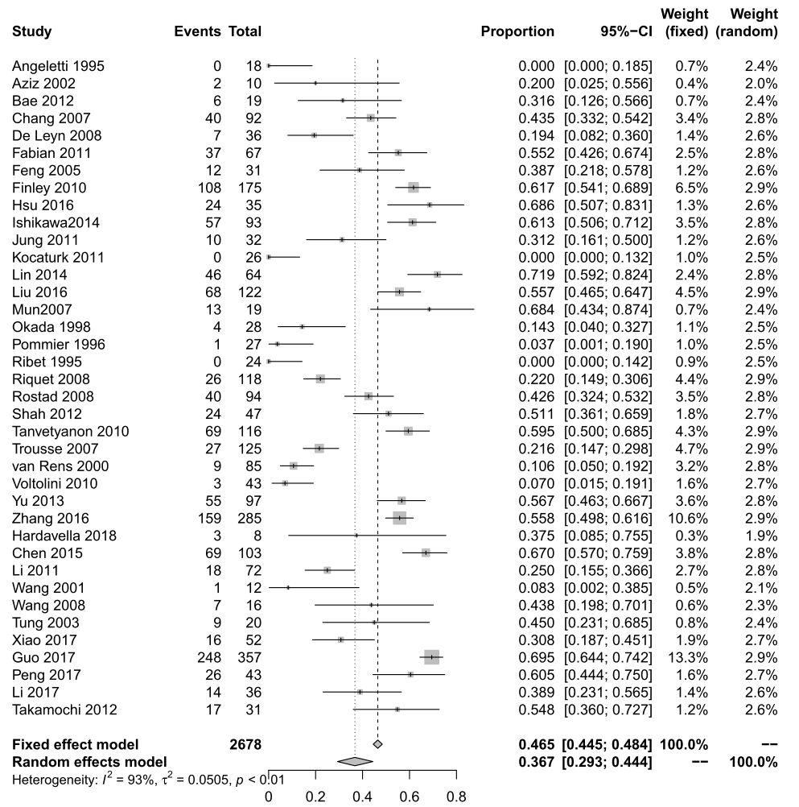
eFigure 2 Forest chart of meta-analysis for characteristics of synchronous MPLC: gender ratio
Result from random-effects model is used.

eFigure 3 Forest chart of meta-analysis for characteristics of synchronous MPLC: the proportion of more than 2 tumors
Result from random-effects model is used.

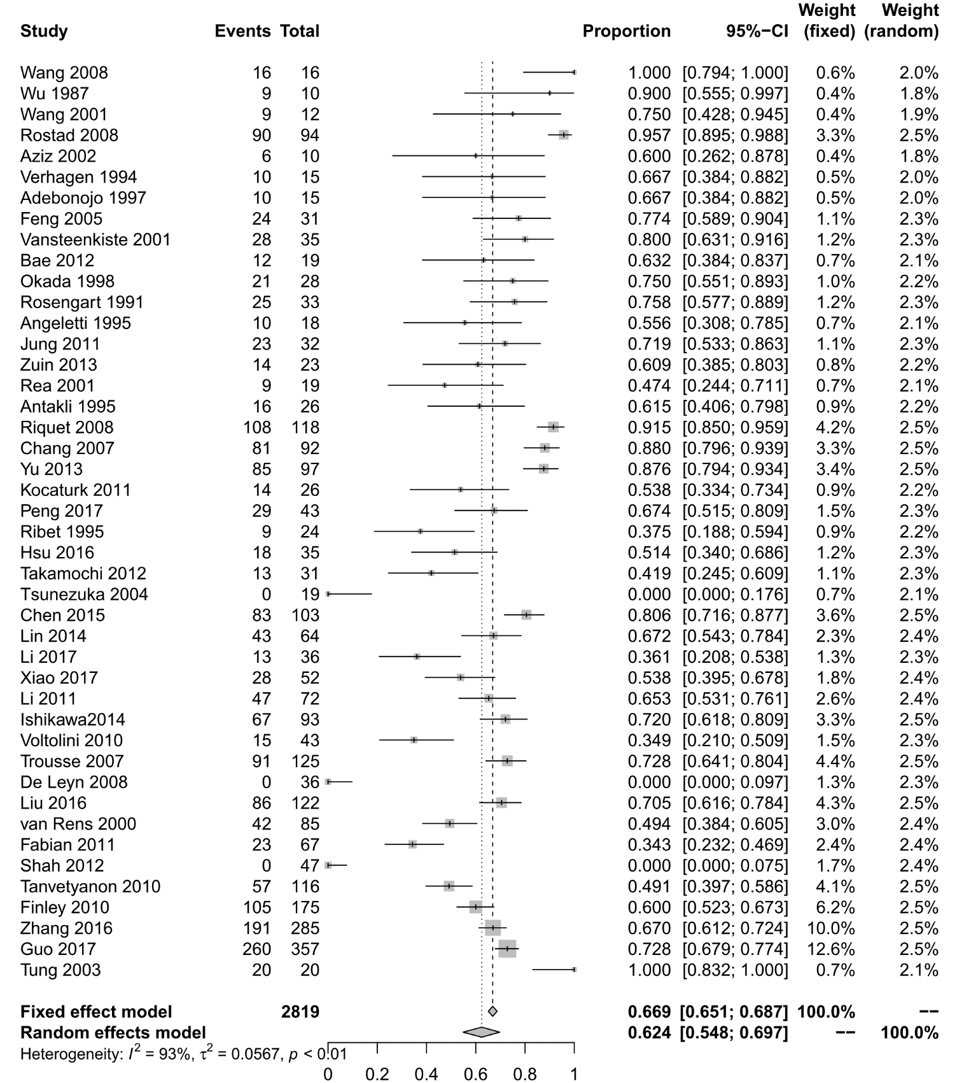
eFigure 4 Forest chart of meta-analysis for characteristics of synchronous MPLC: proportion of tumors located in unilateral lung
Result from random-effects model is used.

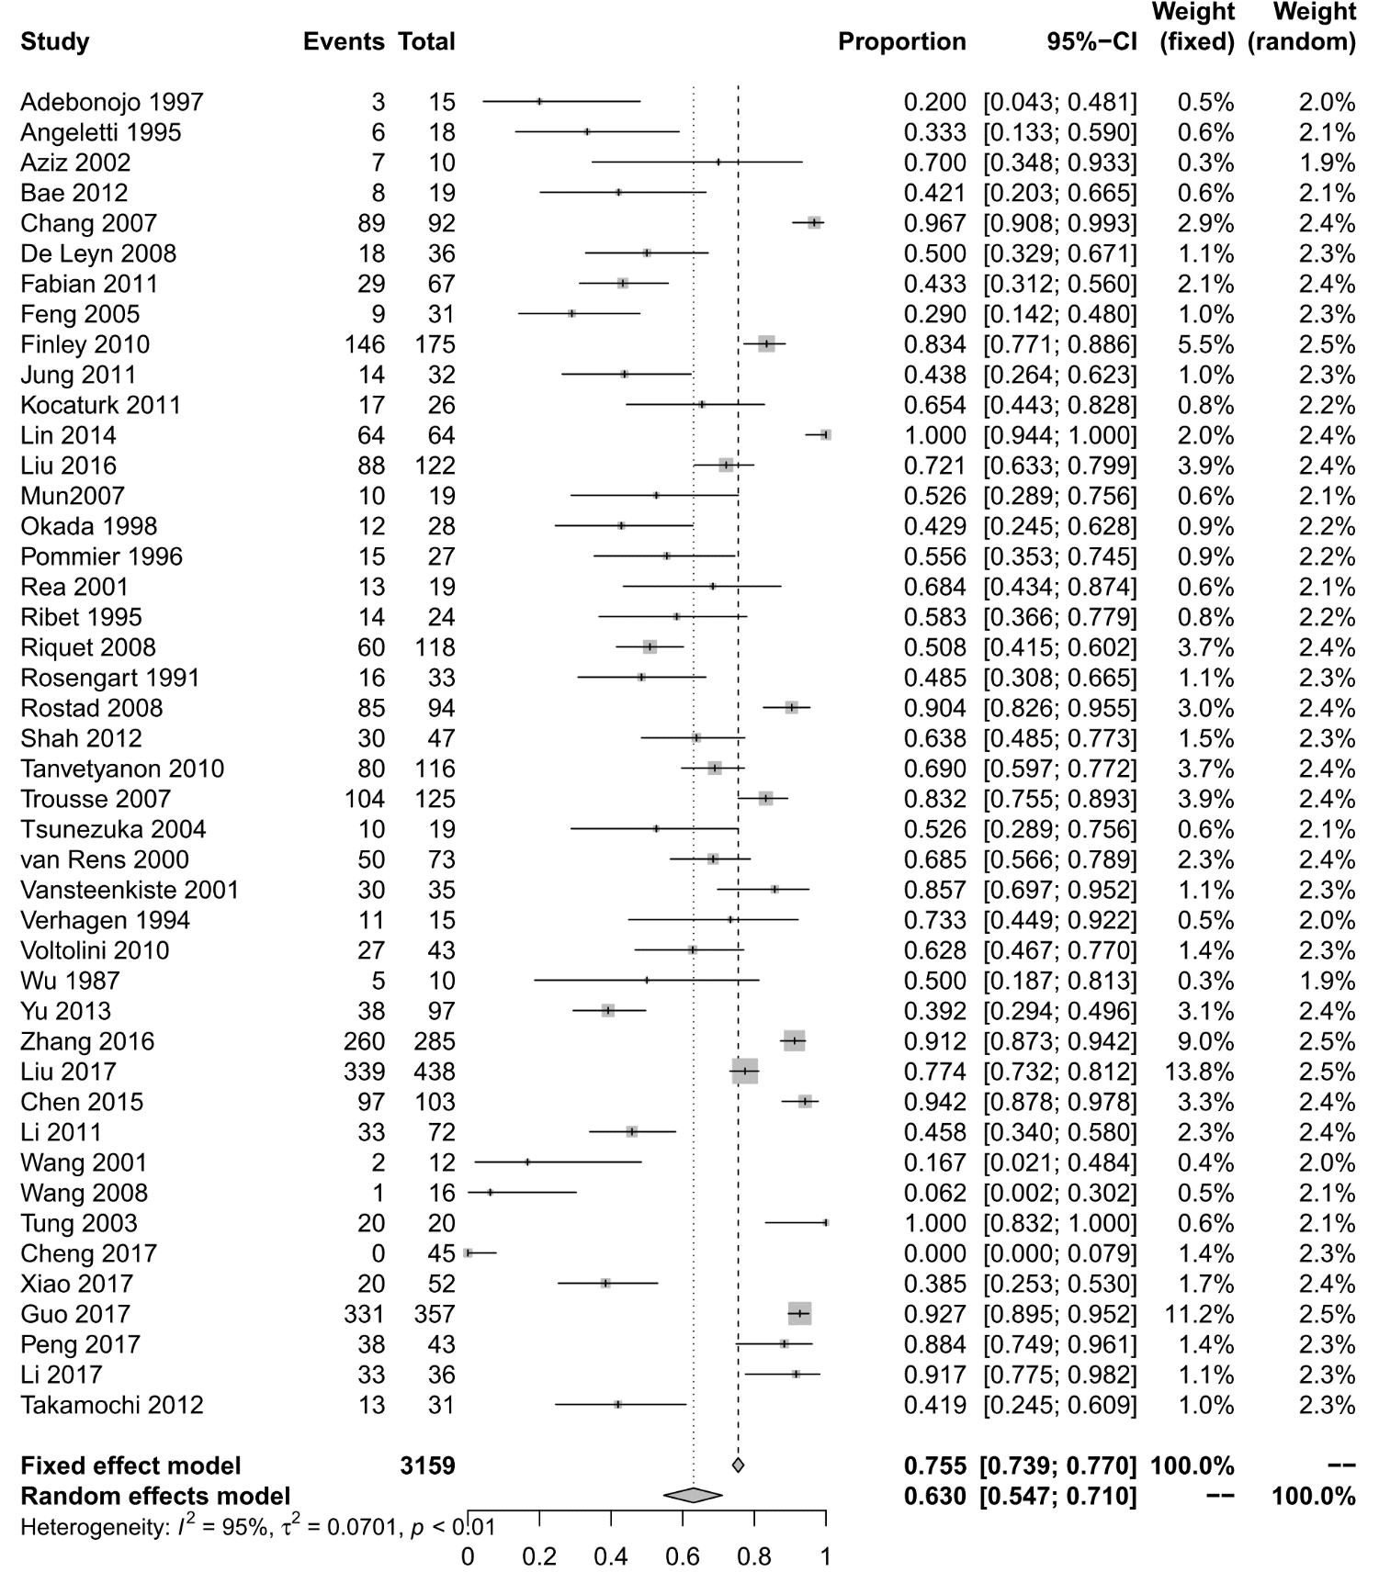
eFigure 5 Forest chart of meta-analysis for characteristics: the proportion of tumors with identical histology
Result from random-effects model is used.

Appendix 9 Forest chart for the proportion of sMPLC in lung cancer
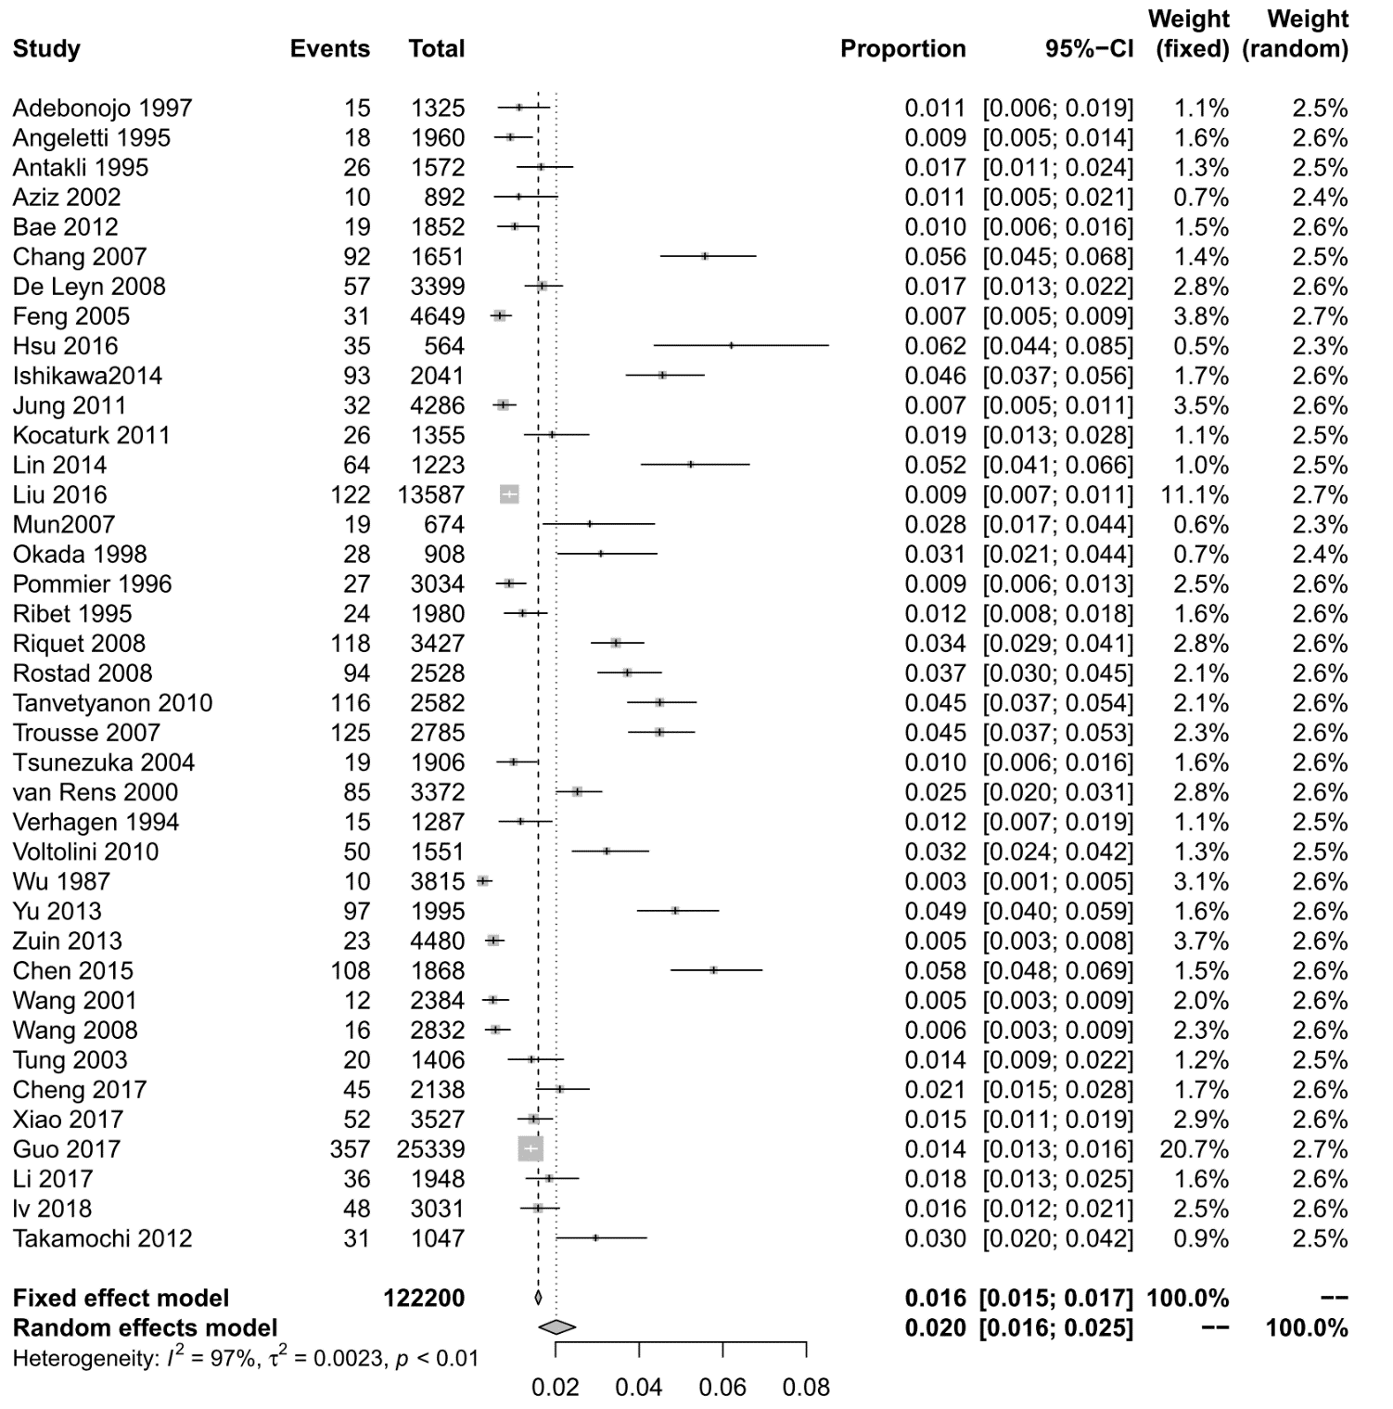
eFigure 6 Forest chart of meta-analysis for the proportion of sMPLC in lung cancer
Result from random-effects model is used.

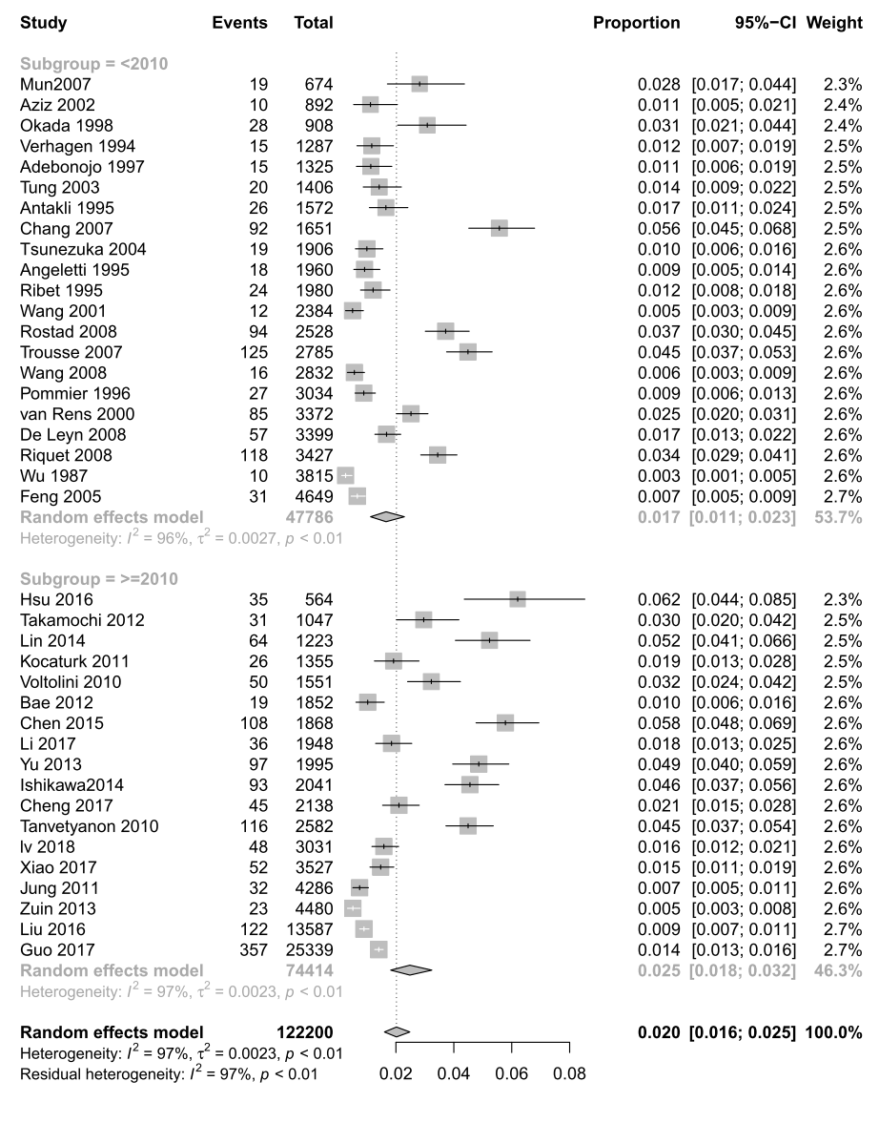
eFigure 7 Forest chart of subgroup analysis for the proportion of sMPLC according to publication year

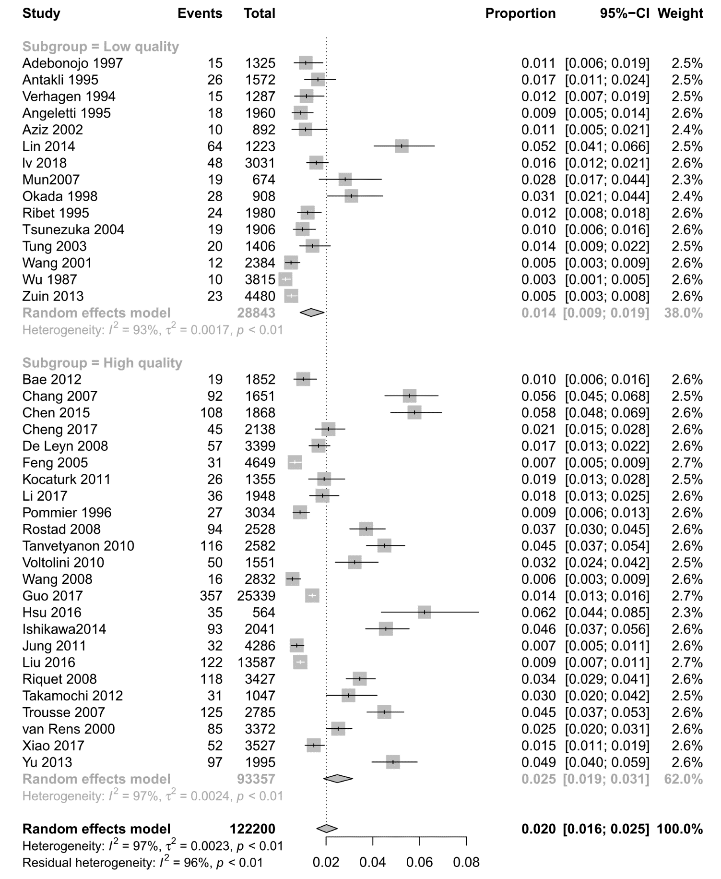
eFigure 8 Forest chart of subgroup analysis for the proportion of sMPLC according to study quality

eFigure 9 Sensitivity analysis for the proportion of sMPLC in lung cancer
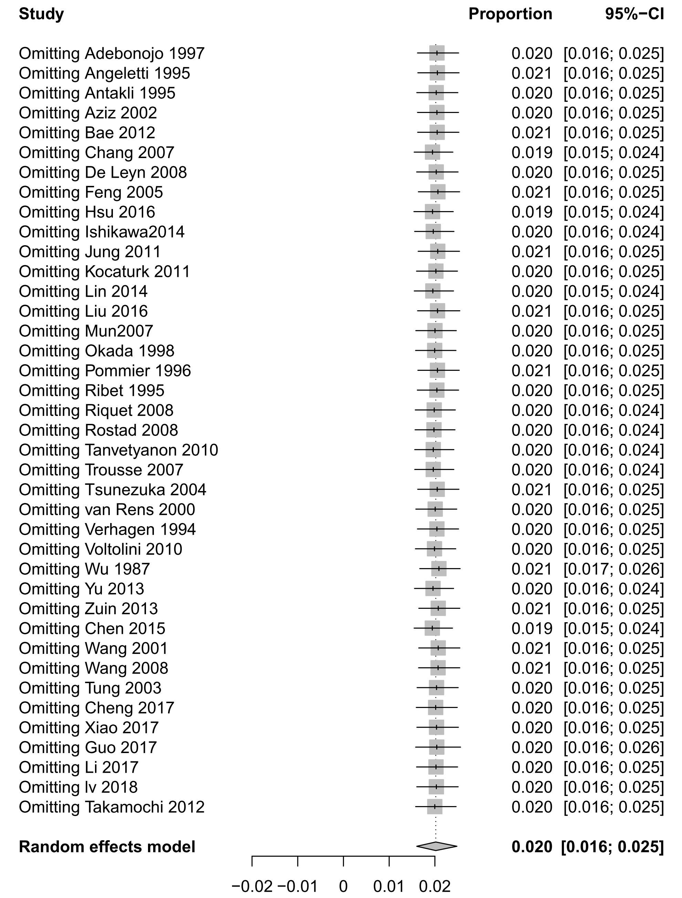

Appendix 10 Forest chart for postoperative mortality
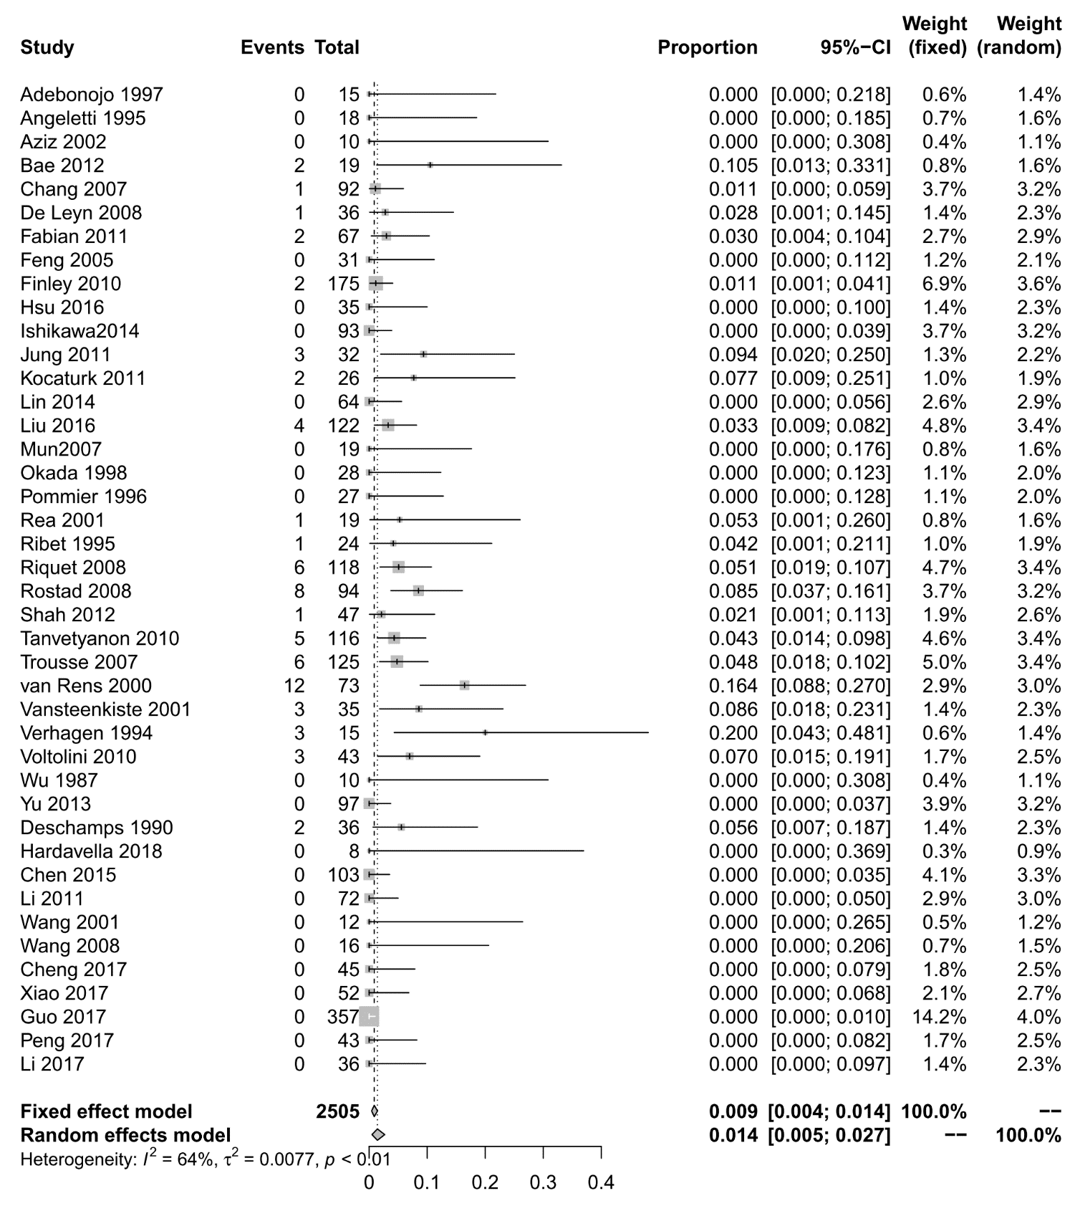
eFigure 10 Forest chart of meta-analysis for postoperative mortality
Result from random-effects model is used.

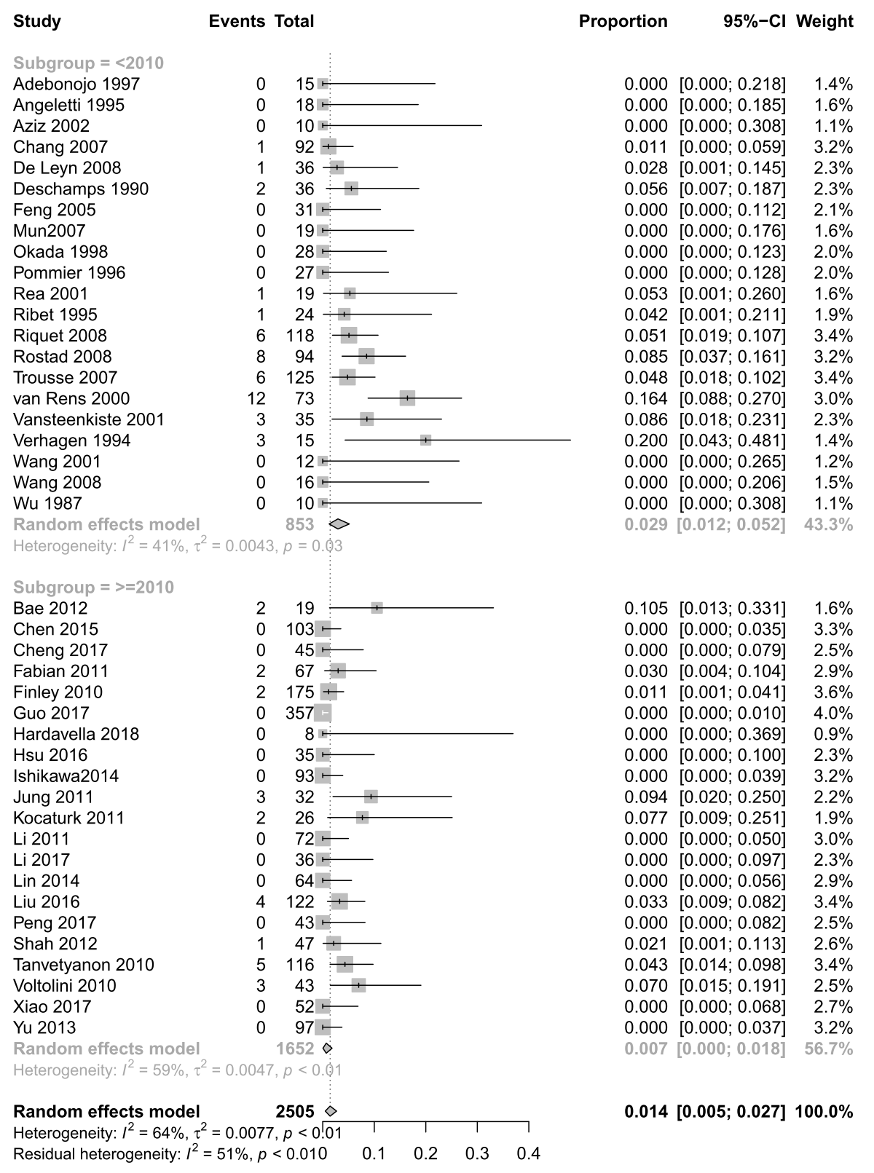
eFigure 11 Forest chart of subgroup analysis for postoperative mortality according to publication year

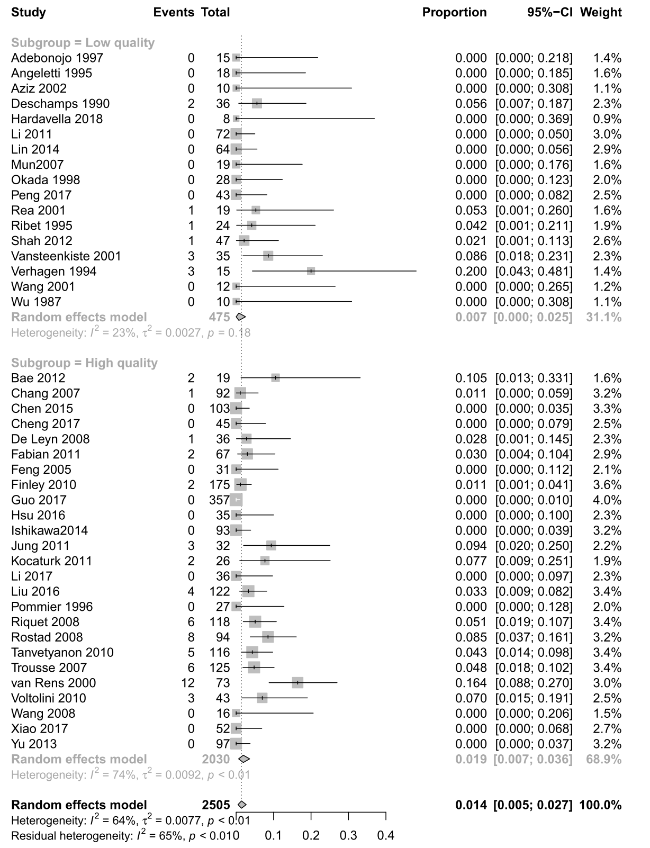
eFigure 12 Forest chart of subgroup analysis for the postoperative mortality according to study quality

eFigure 13 Sensitivity analysis for the postoperative mortality
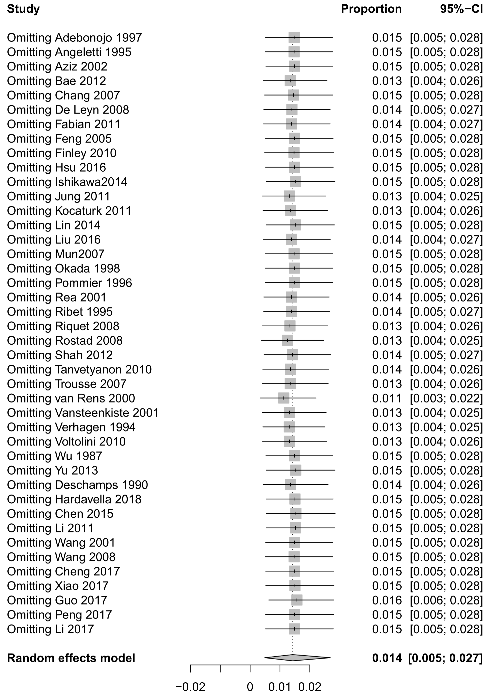
Appendix 11 Forest chart for the survival rate of sMPLC
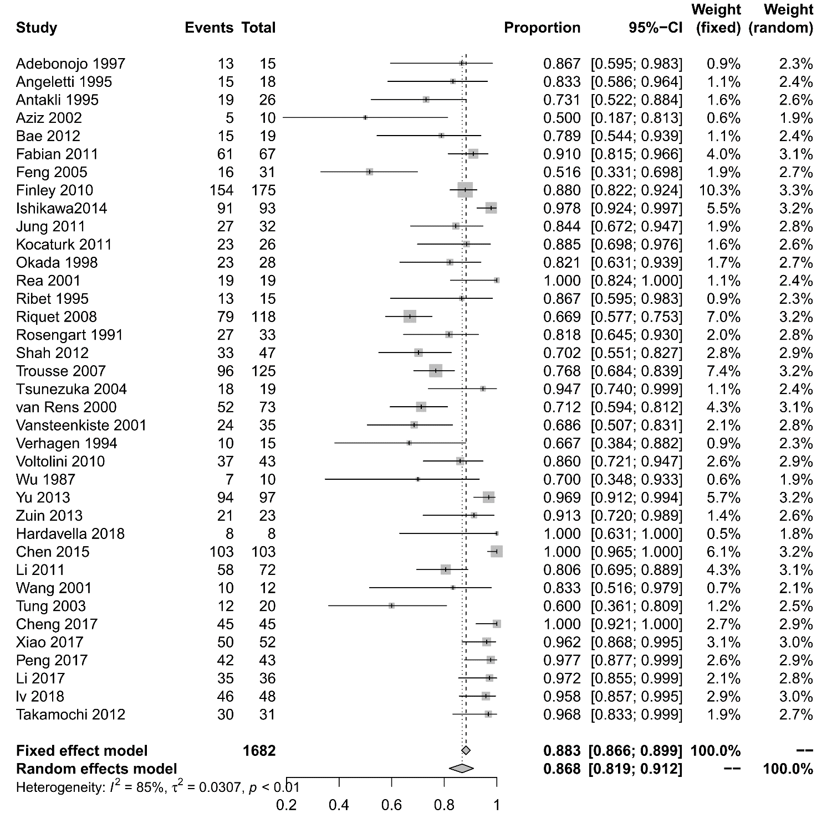
eFigure 14 Forest chart of meta-analysis for 1-year survival rate
Result from random-effects model is used.

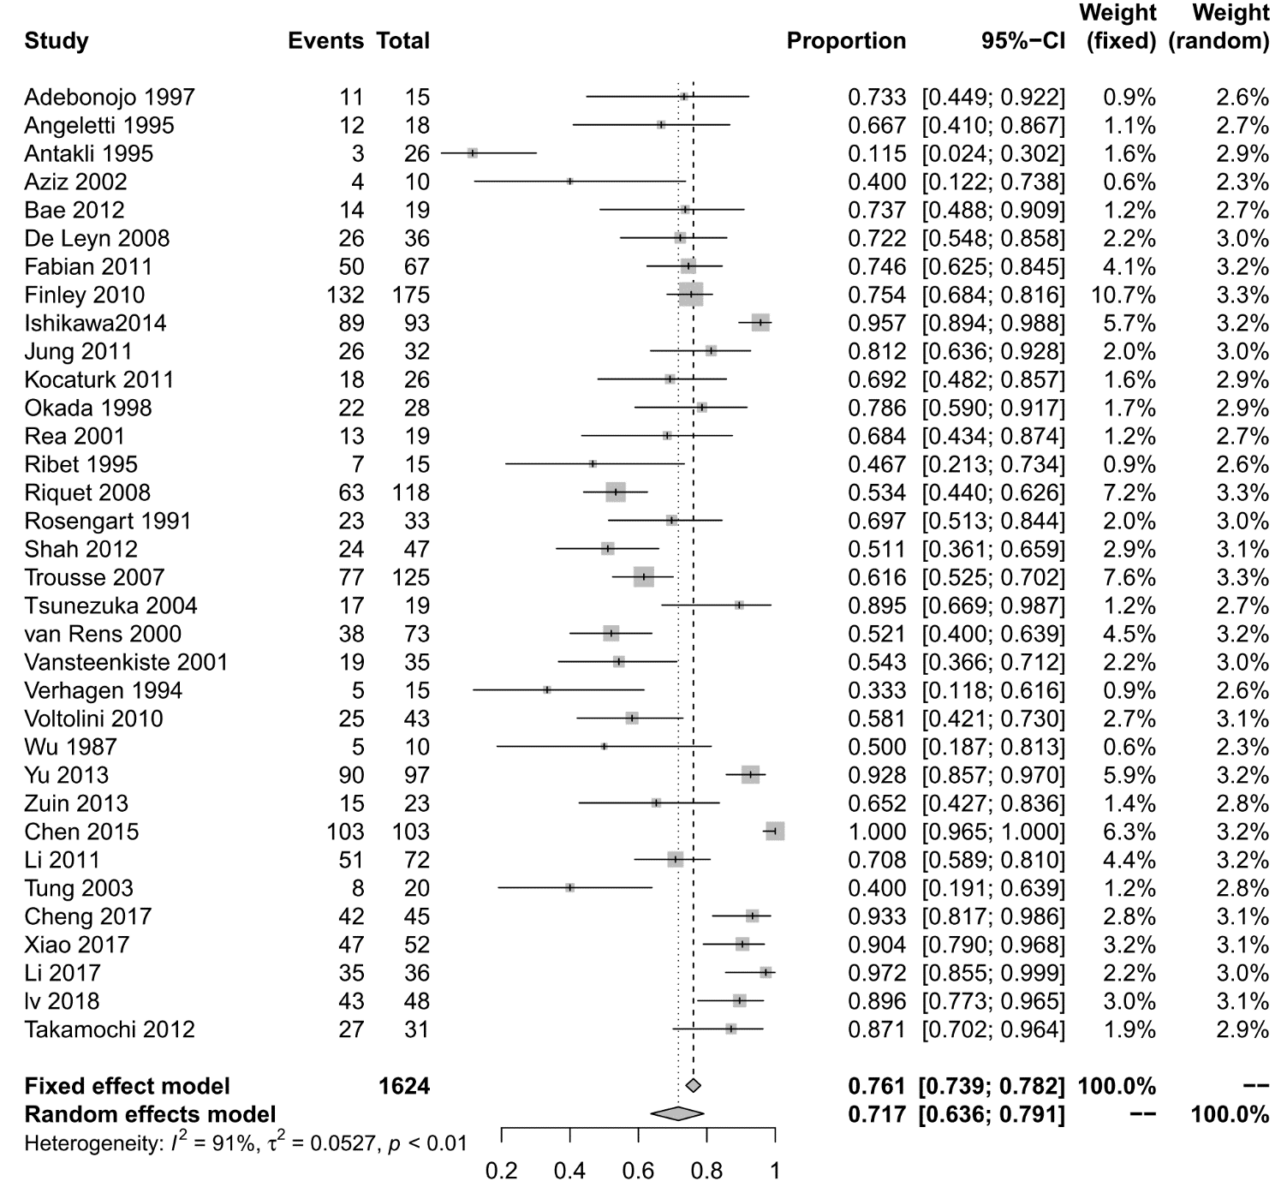
eFigure 15 Forest chart of meta-analysis for 2-year survival rate
Result from random-effects model is used.

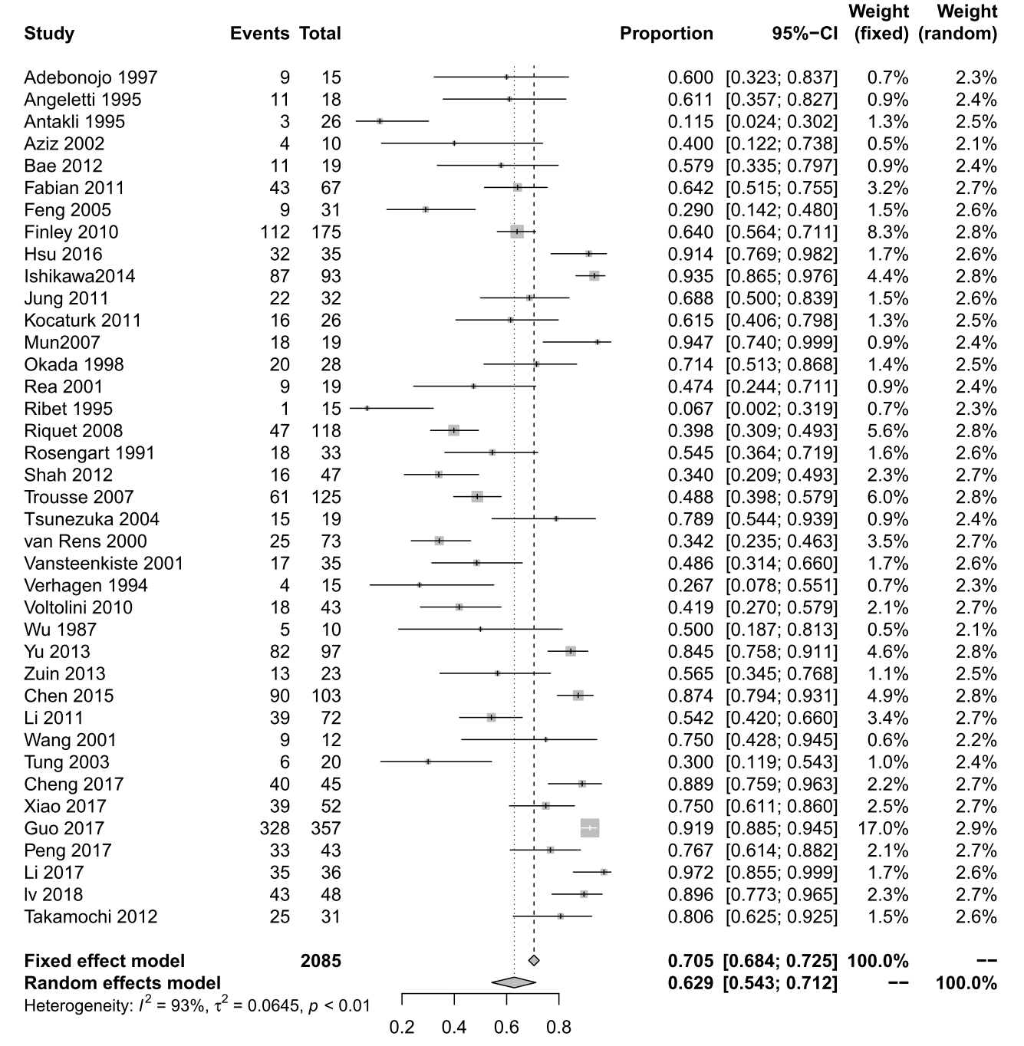
eFigure 16 Forest chart of meta-analysis for 3-year survival rate
Result from random-effects model is used.

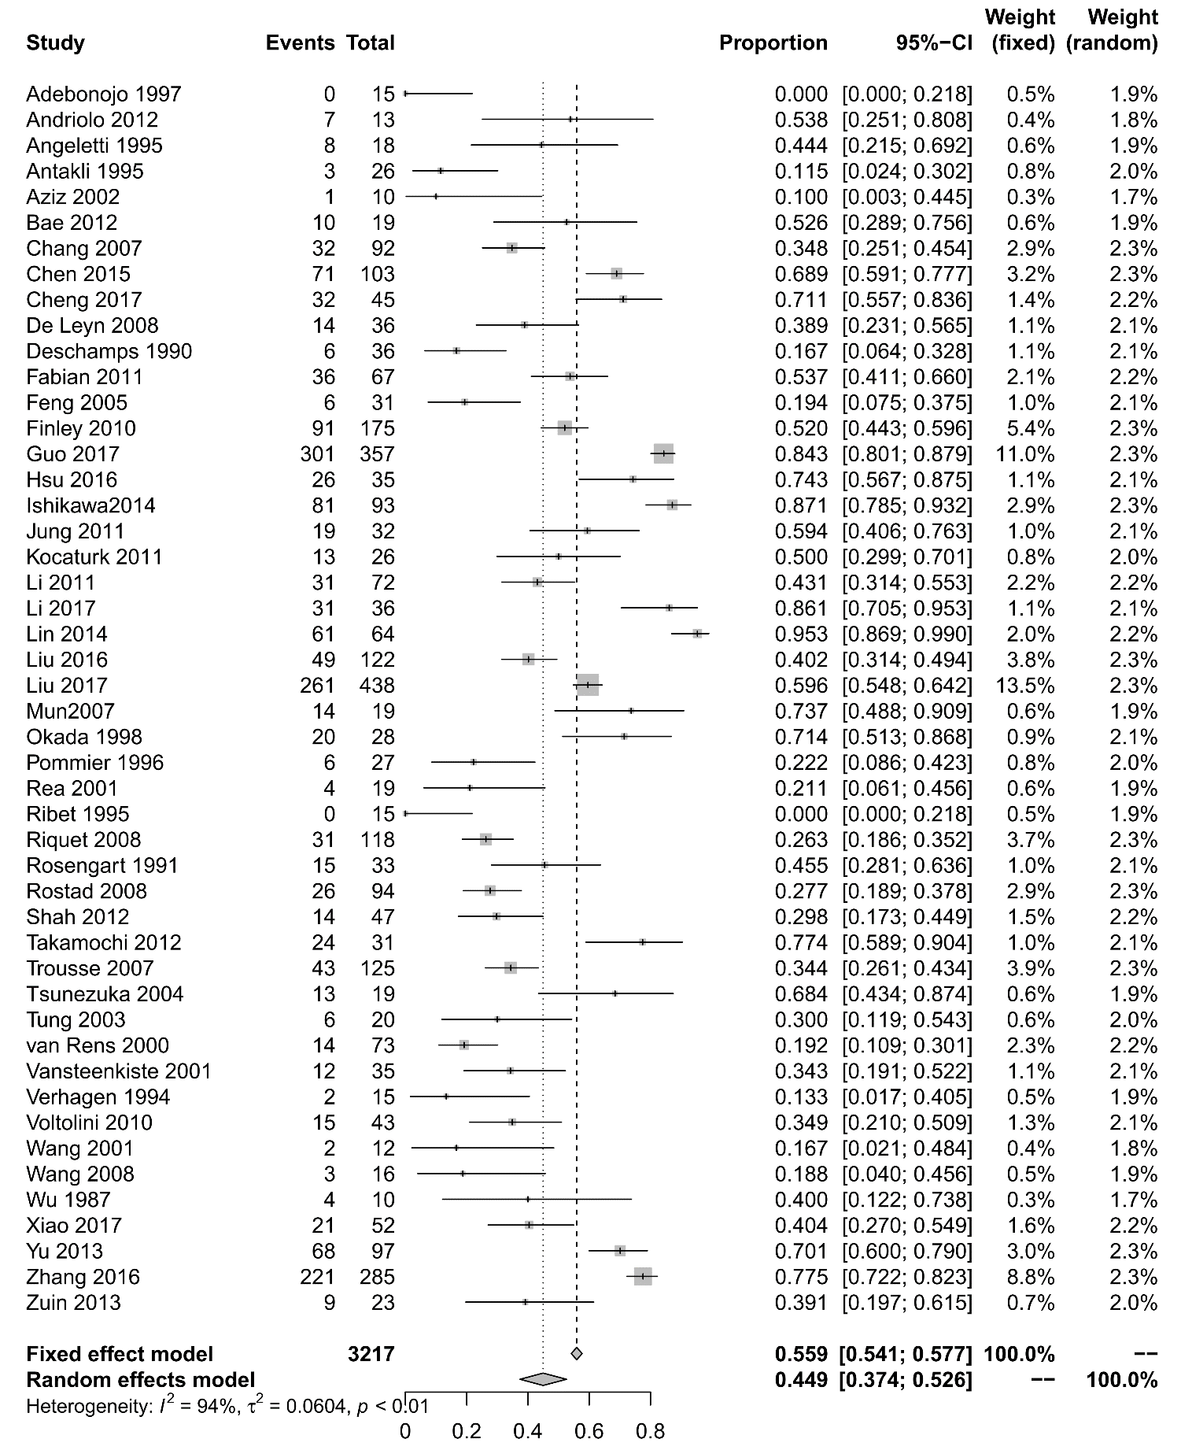
eFigure 17 Forest chart of meta-analysis for 5-year survival rate
Result from random-effects model is used.

eFigure 18 Forest chart of subgroup analysis for 5-year survival rate according to publication year
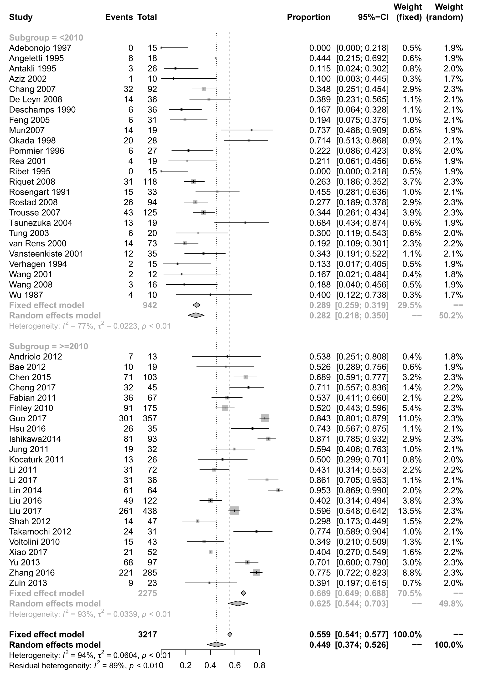 Result from random-effects model is used.
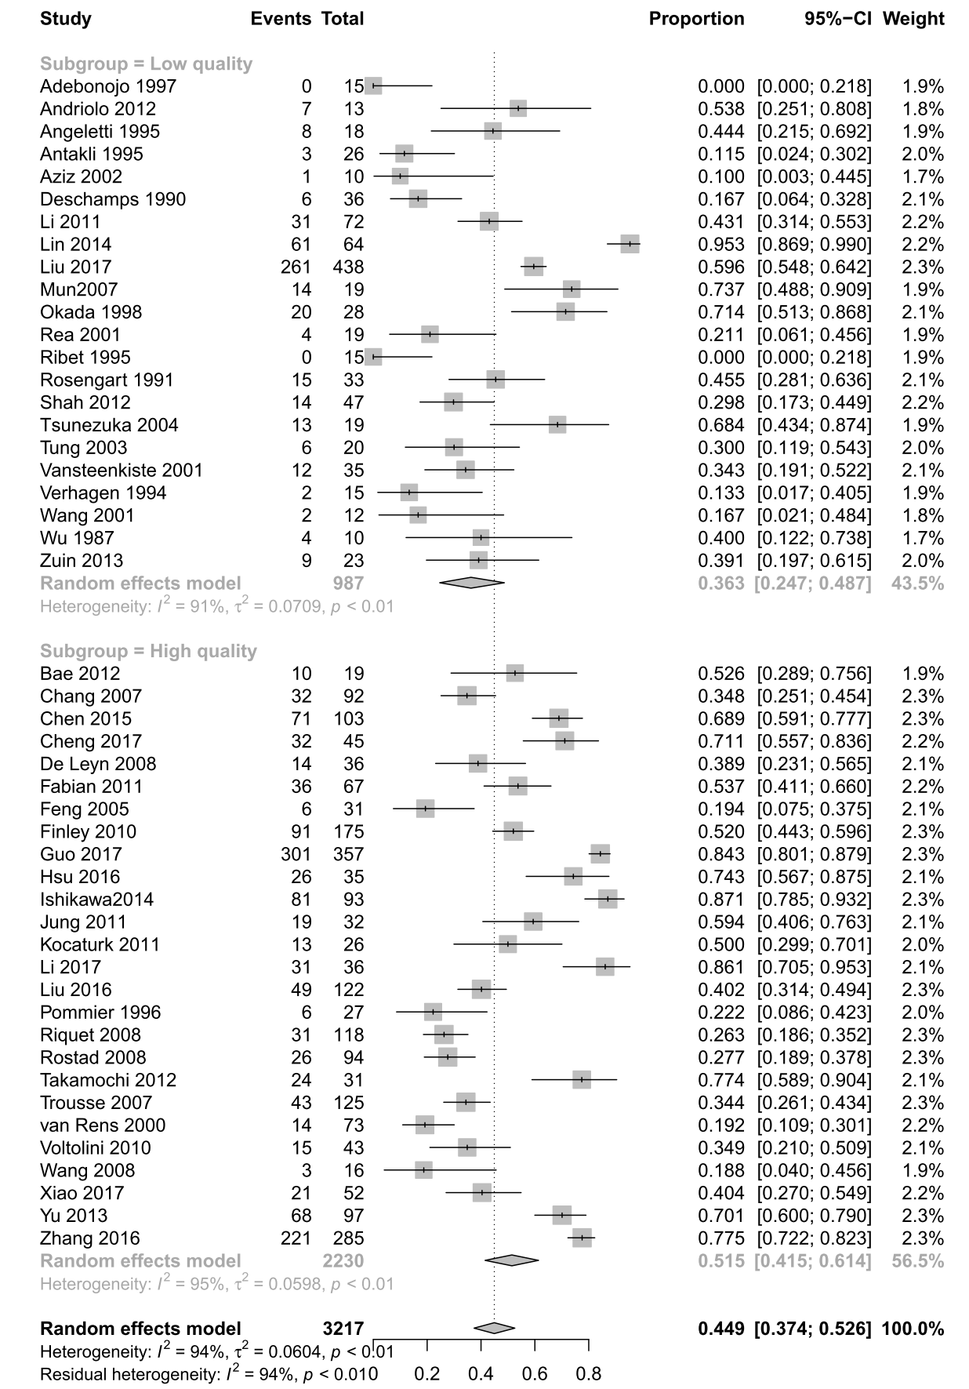
eFigure 19 Forest chart of subgroup analysis for 5-year survival rate according to study quality
eFigure 20 Sensitivity analysis for 5-year survival rate
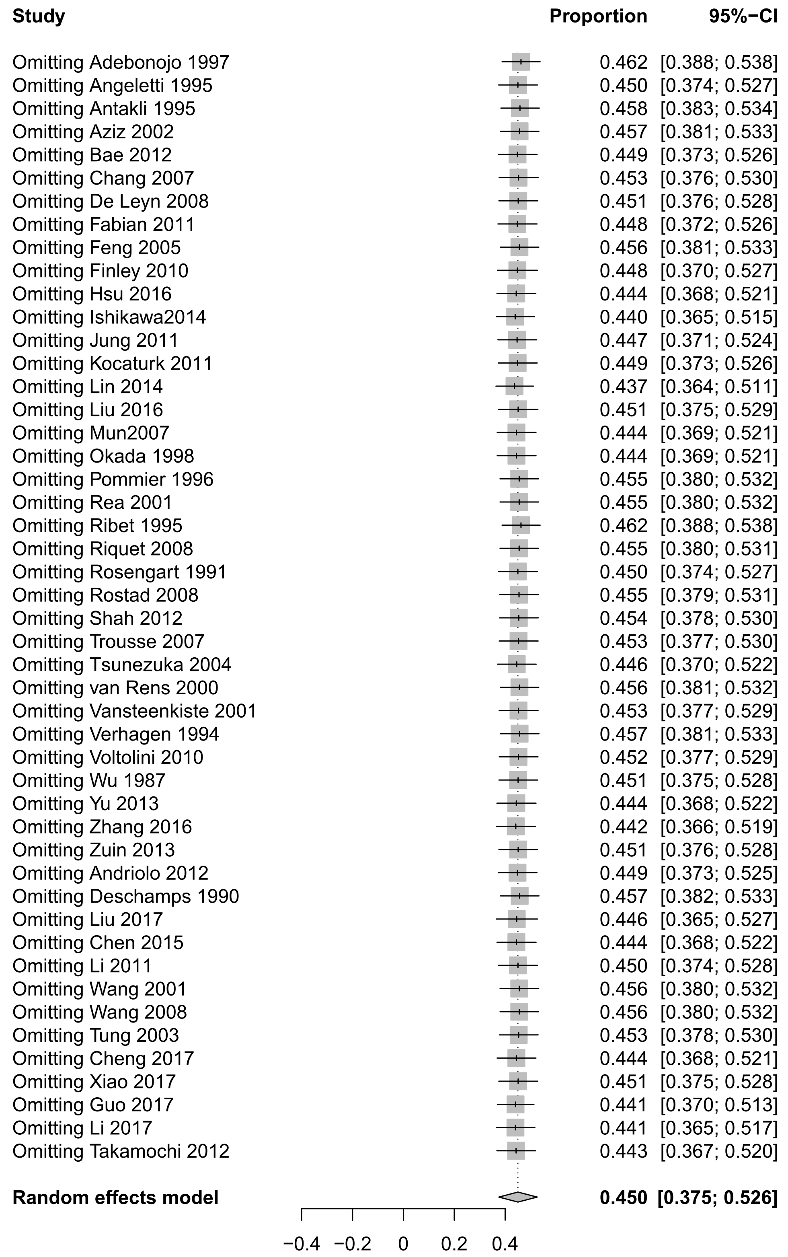
Appendix 12 Effect of various clinical parameters on 5-year survival rate
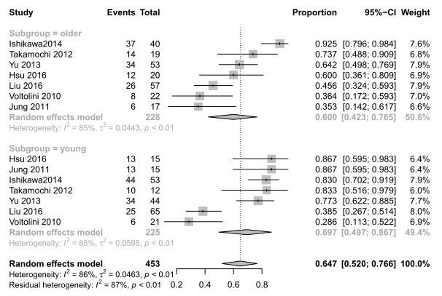
eFigure 21 Forest chart of additional analysis for 5-year survival rate according to clinical parameters: age

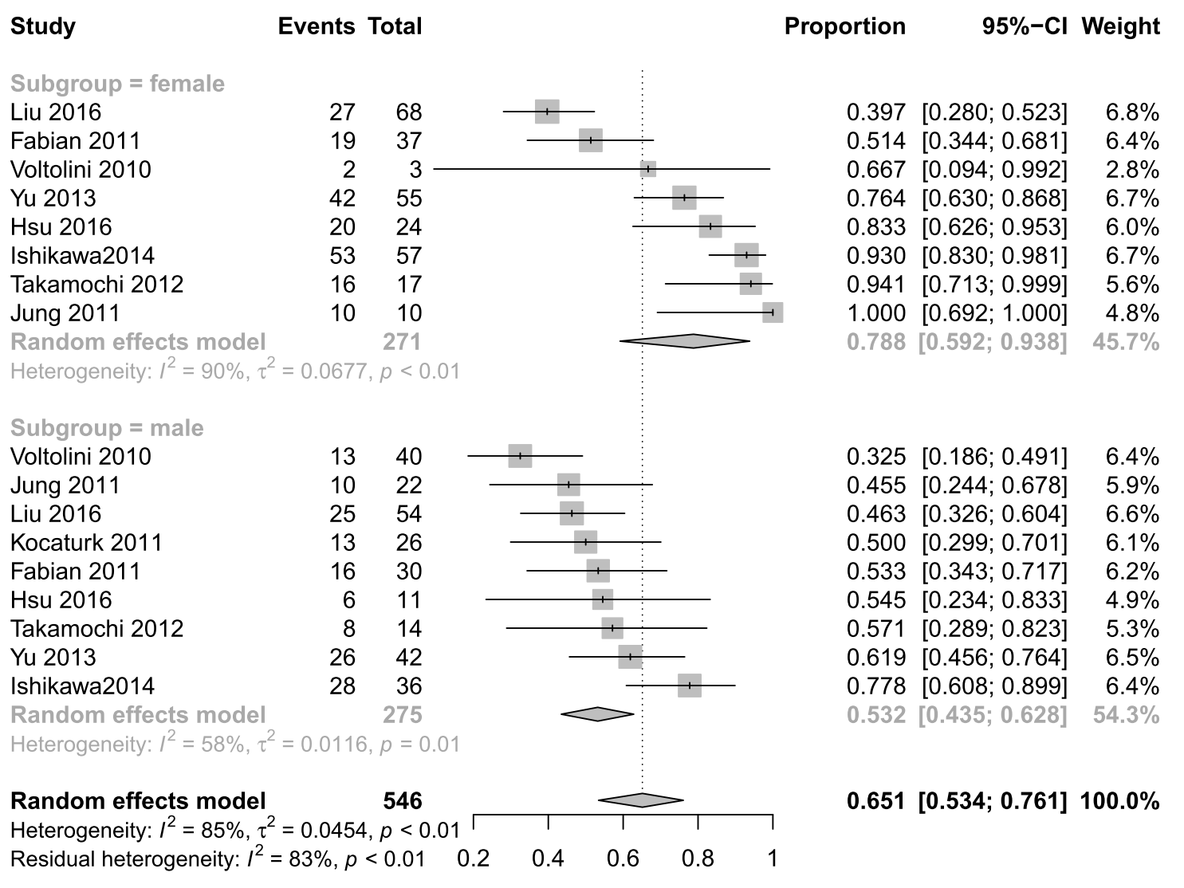
eFigure 22 Forest chart of additional analysis for 5-year survival rate according to clinical parameters: gender

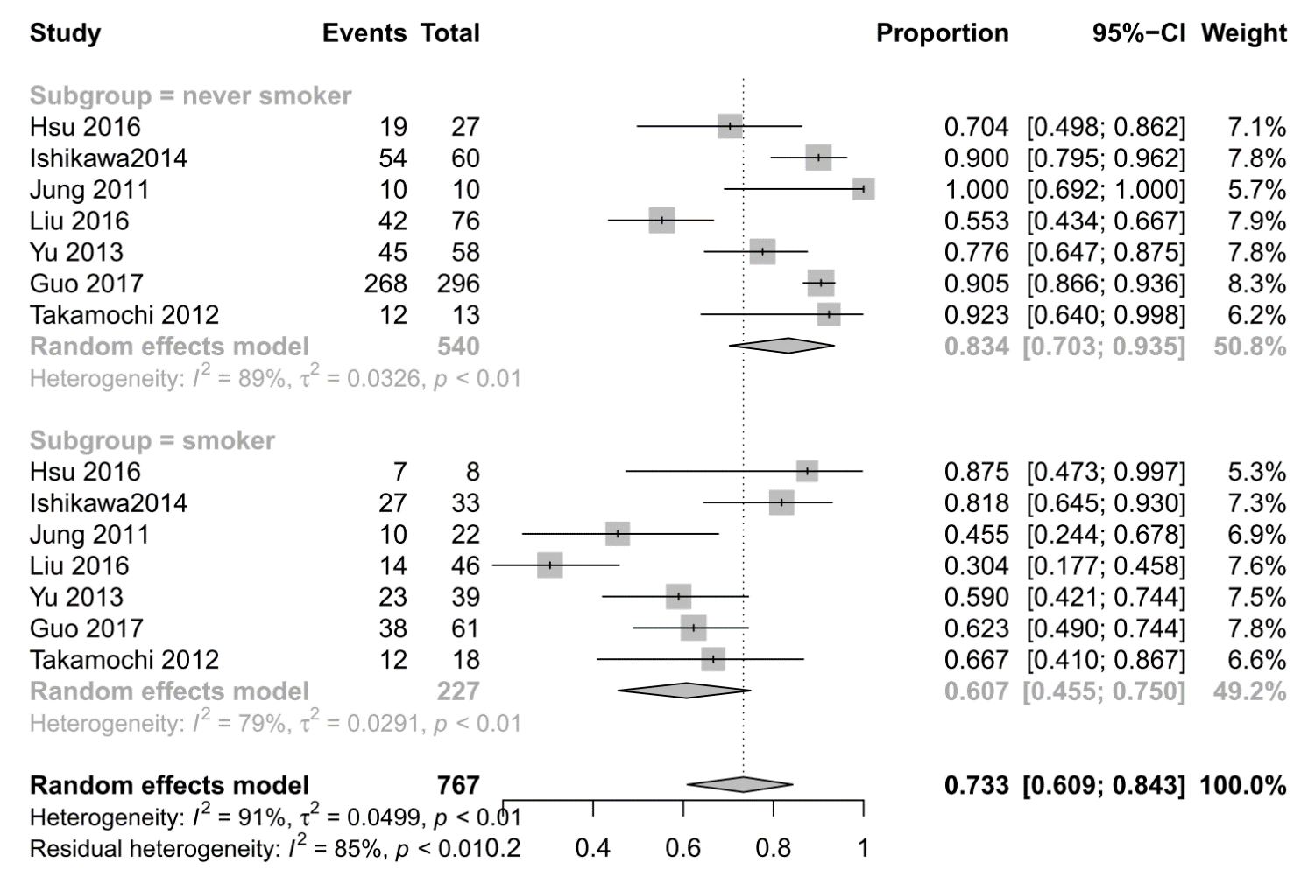
eFigure 23 Forest chart of additional analysis for 5-year survival rate according to clinical parameters: smoking status

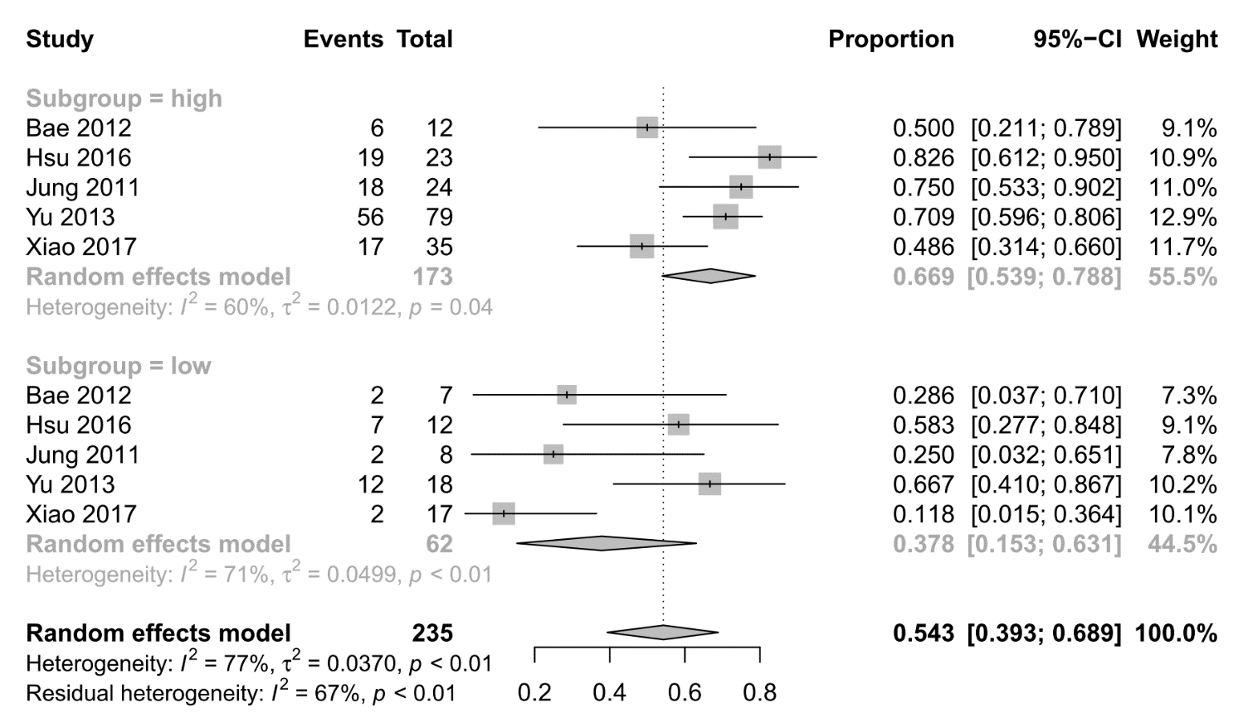
eFigure 24 Forest chart of additional analysis for 5-year survival rate according to clinical parameters: FEV1

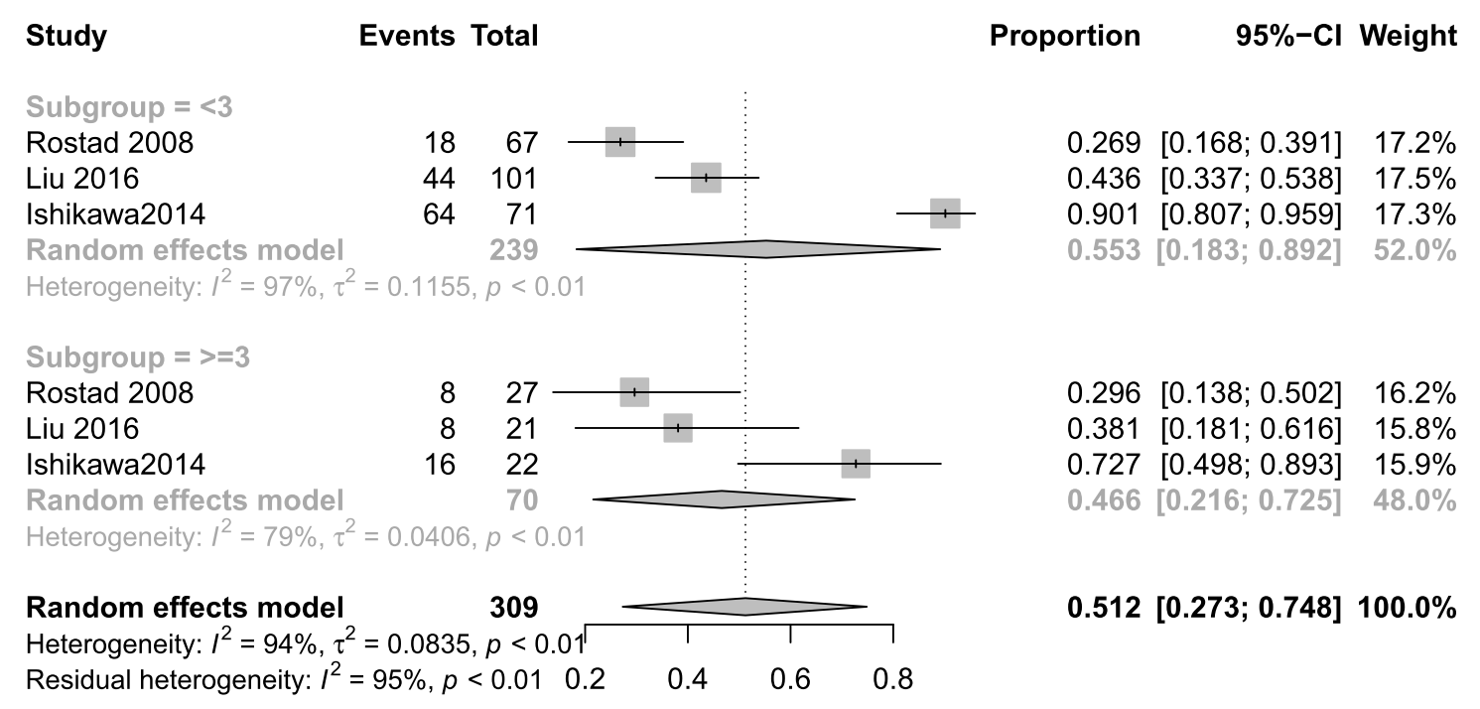
eFigure 25 Forest chart of additional analysis for 5-year survival rate according to clinical parameters: number of tumors

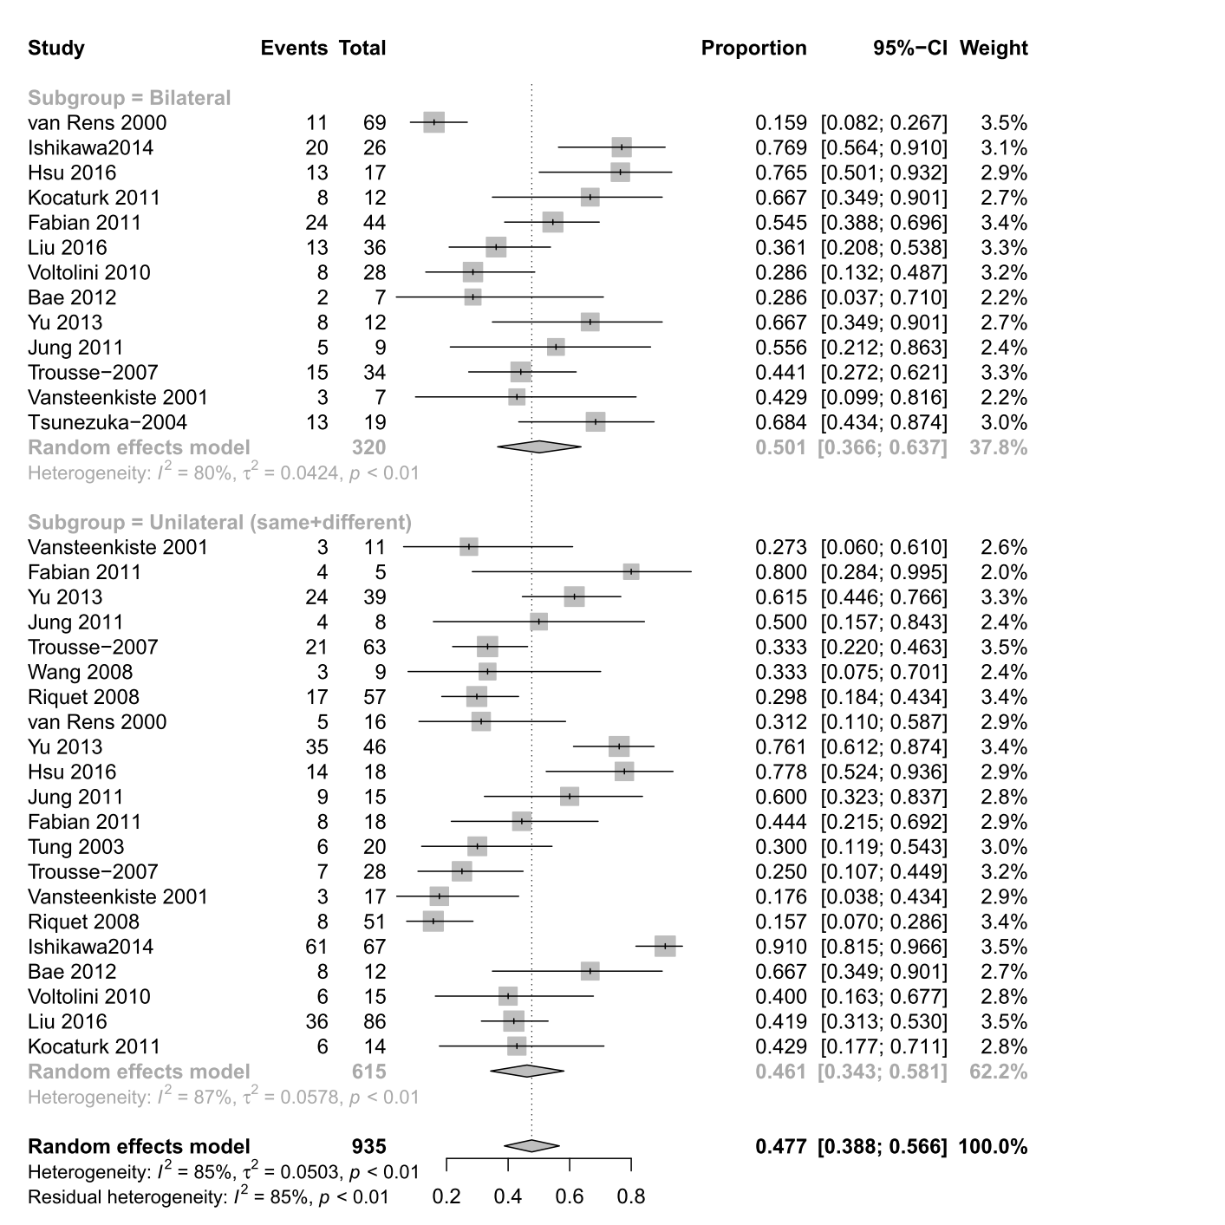
eFigure 26 Forest chart of additional analysis for 5-year survival rate according to clinical parameters: tumor location

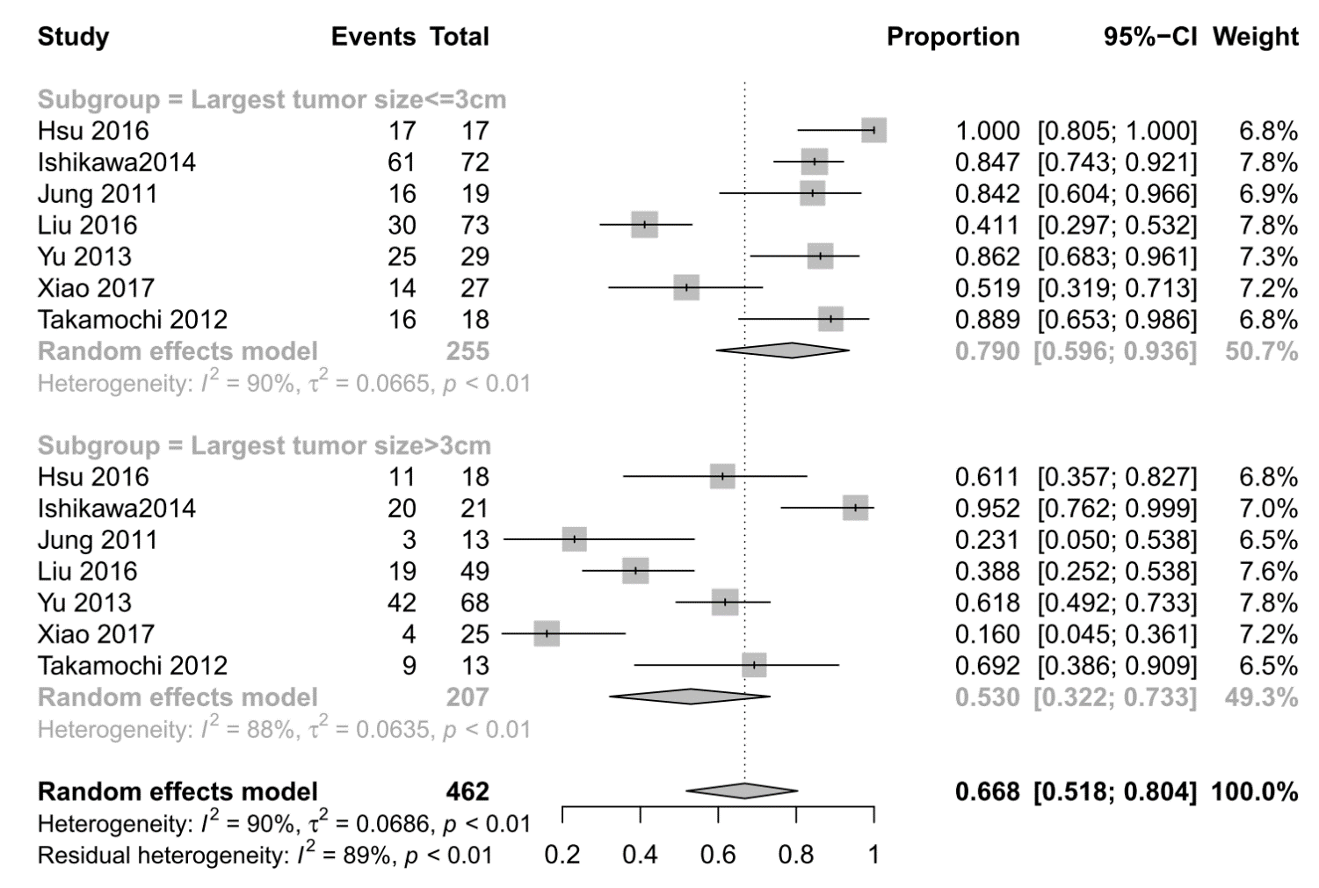
eFigure 27 Forest chart of additional analysis for 5-year survival rate according to clinical parameters: tumor size

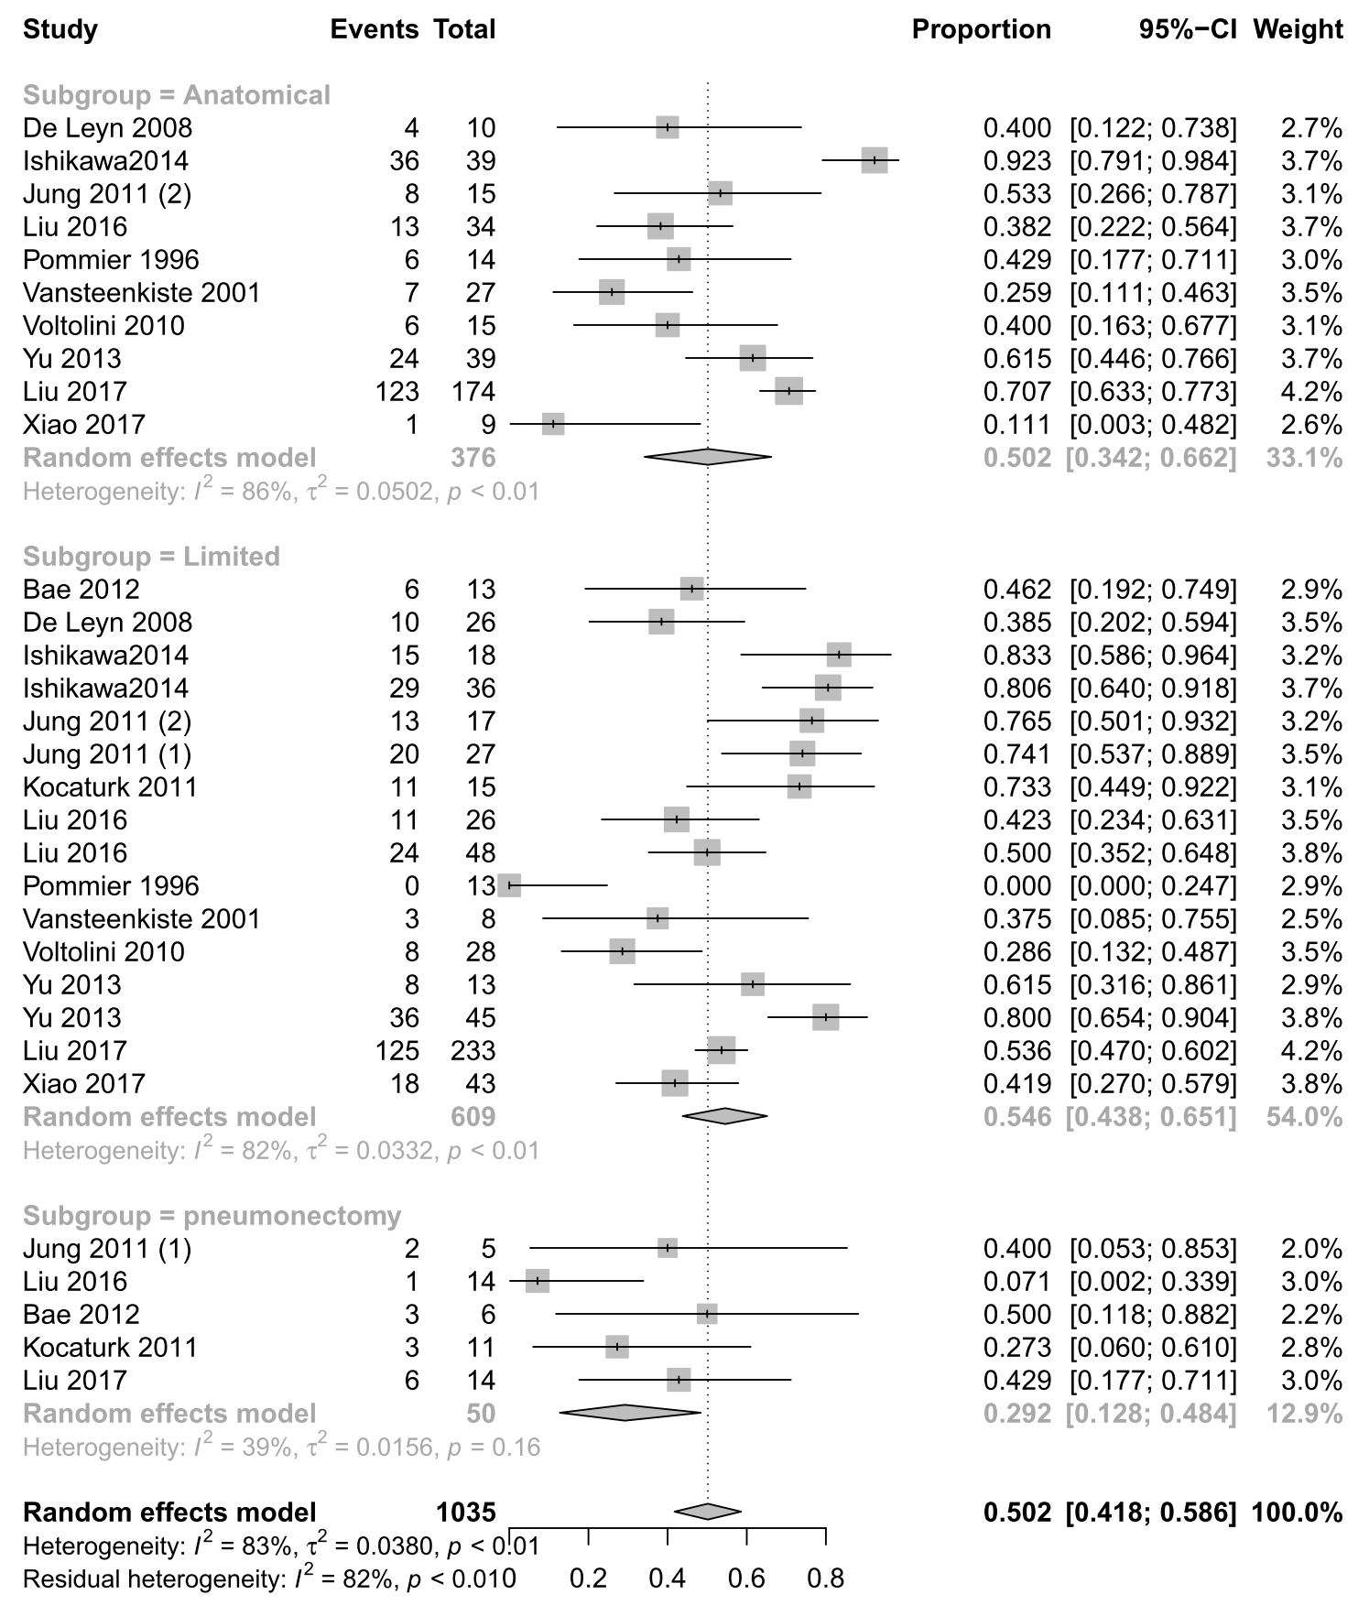
eFigure 28 Forest chart of additional analysis for 5-year survival rate according to clinical parameters: surgery methods

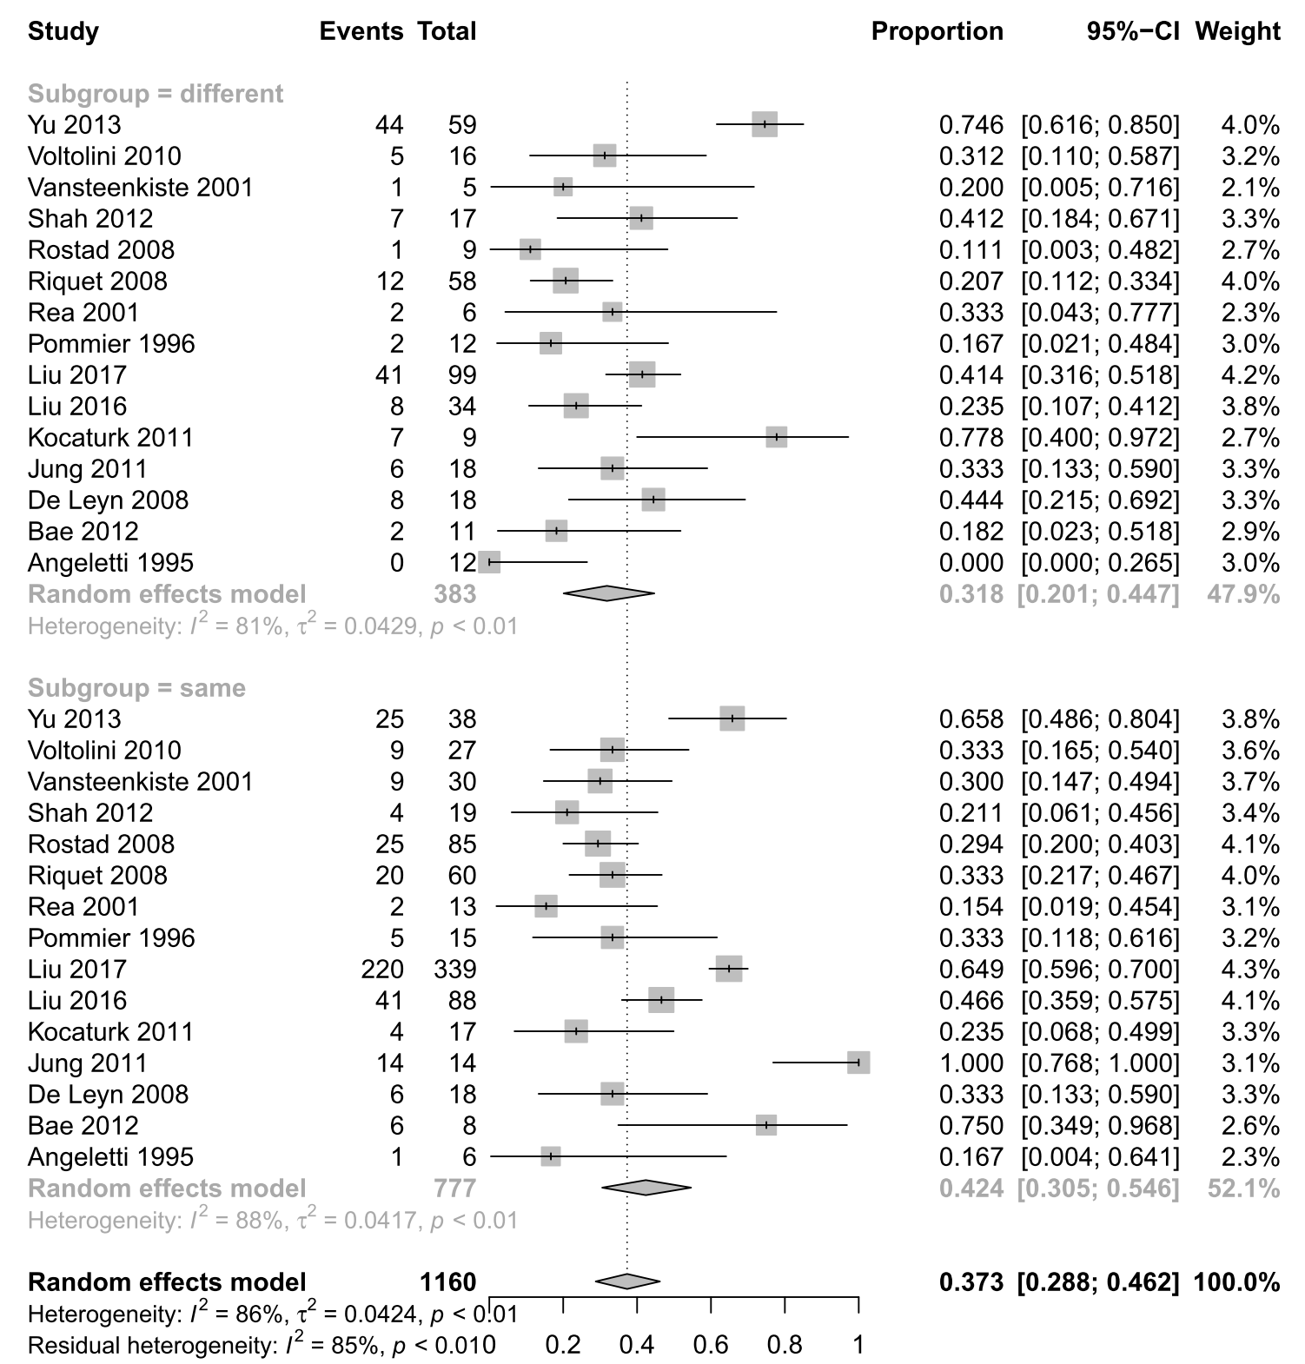
eFigure 29 Forest chart of additional analysis for 5-year survival rate according to clinical parameters: tumor histology

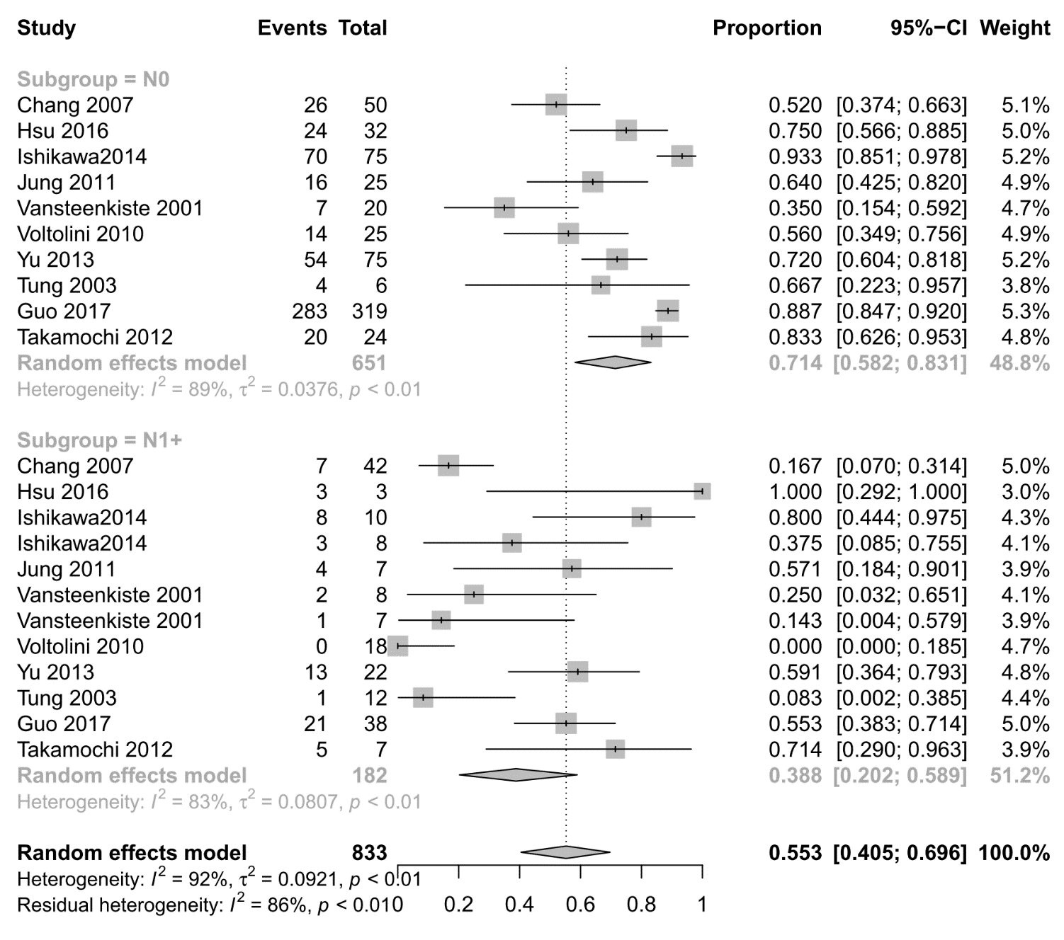
eFigure 30 Forest chart of additional analysis for 5-year survival rate according to clinical parameters: lymph node metastasis

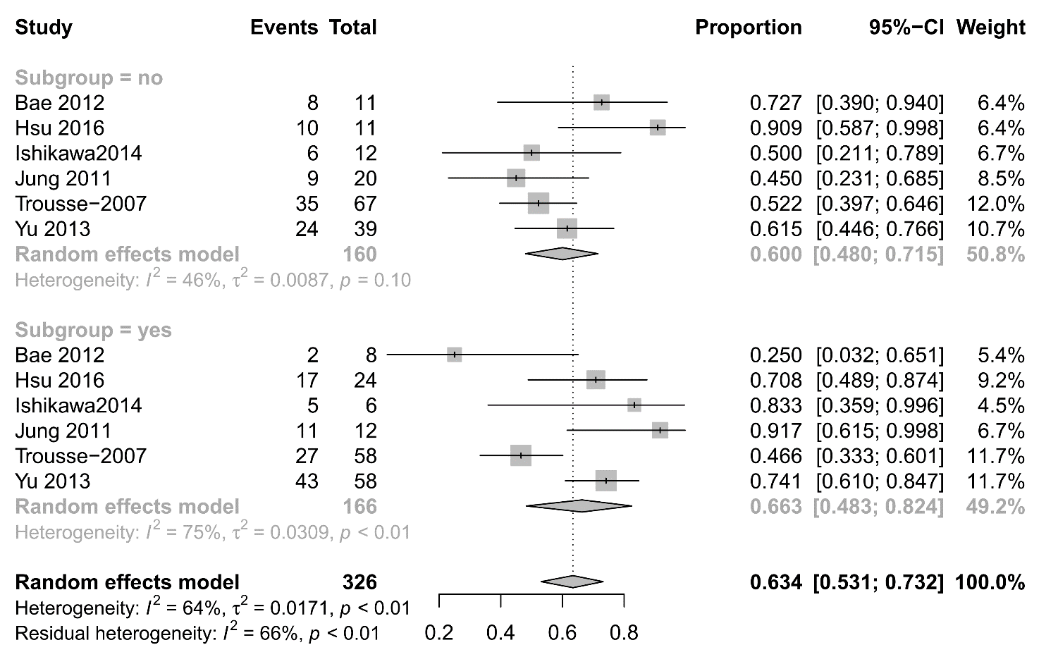
eFigure 31 Forest chart of additional analysis for 5-year survival rate according to clinical parameters: postoperative adjunctive therapy

Appendix 13 Effect of various clinical parameters on overall survival
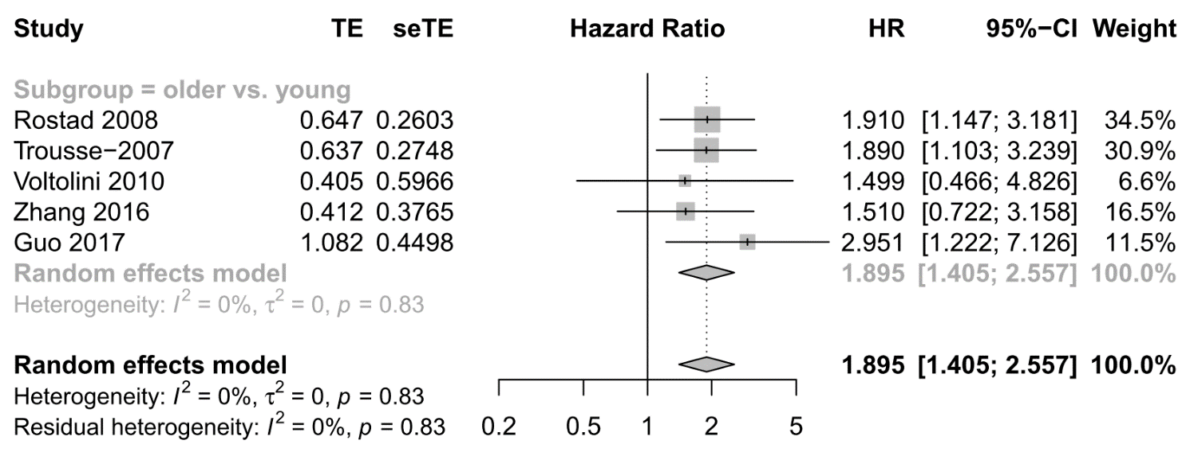
eFigure 32 Forest chart of additional analysis for overall survival according to clinical parameters: age

eFigure 33 Forest chart of additional analysis for overall survival according to clinical parameters: gender
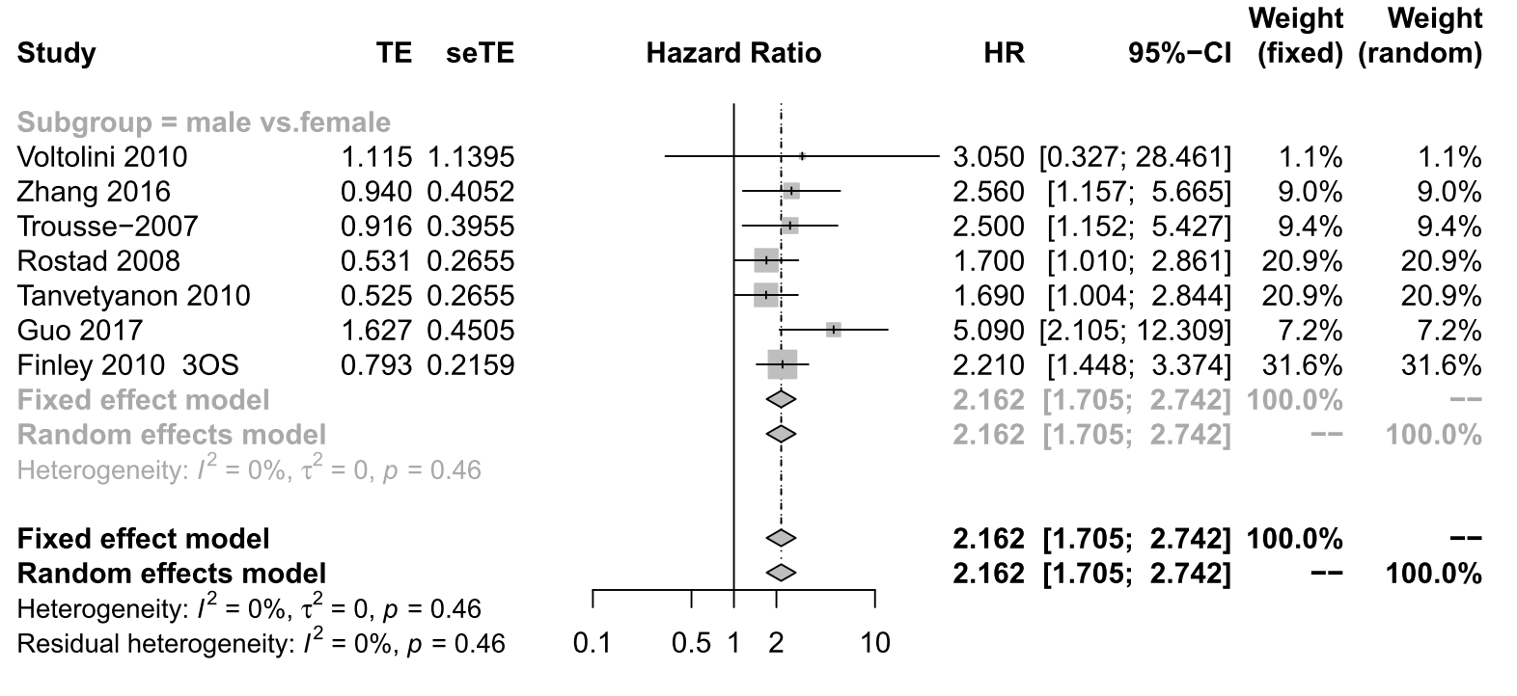 Result from random-effects model is used.

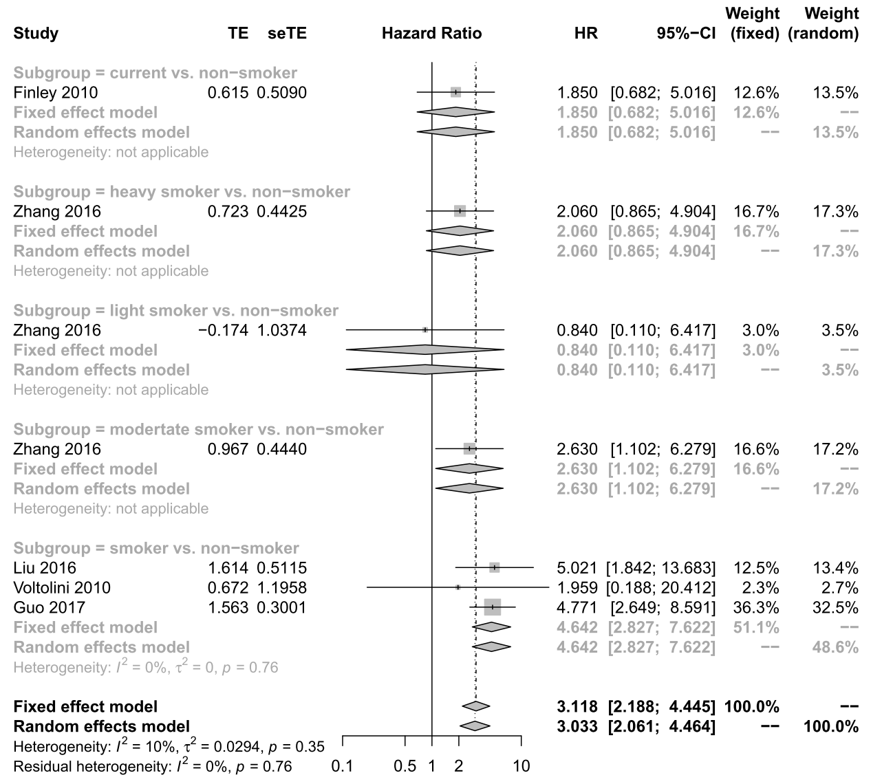
eFigure 34 Forest chart of additional analysis for overall survival according to clinical parameters: smoking status
Result from random-effects model is used.

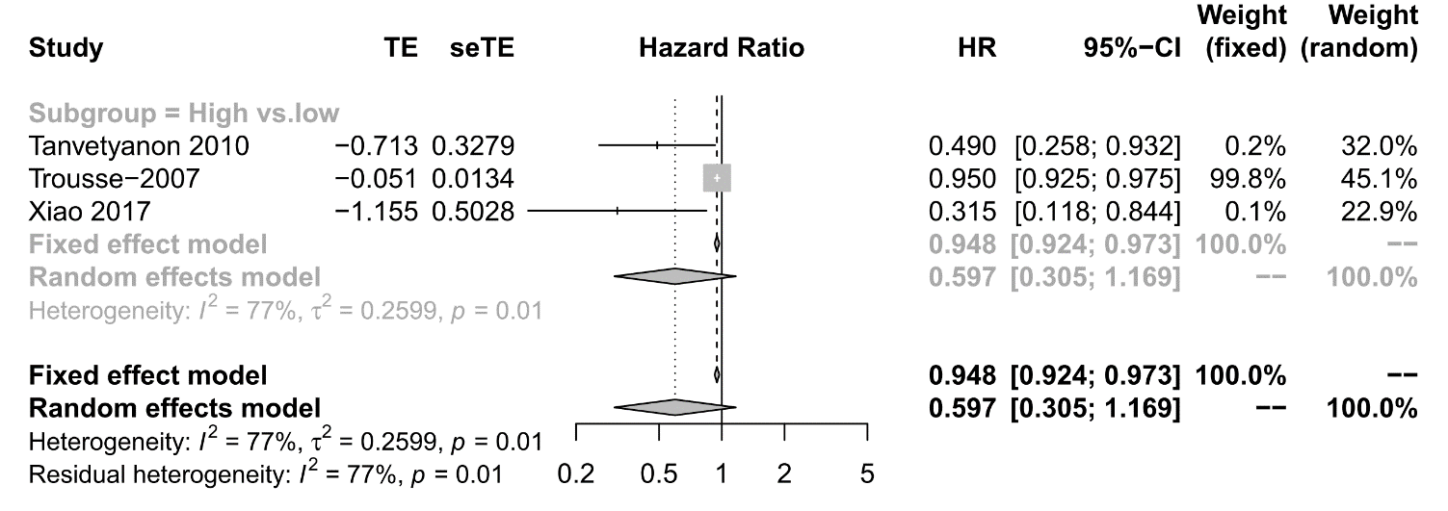
eFigure 35 Forest chart of additional analysis for overall survival according to clinical parameters: FEV1
Result from random-effects model is used.

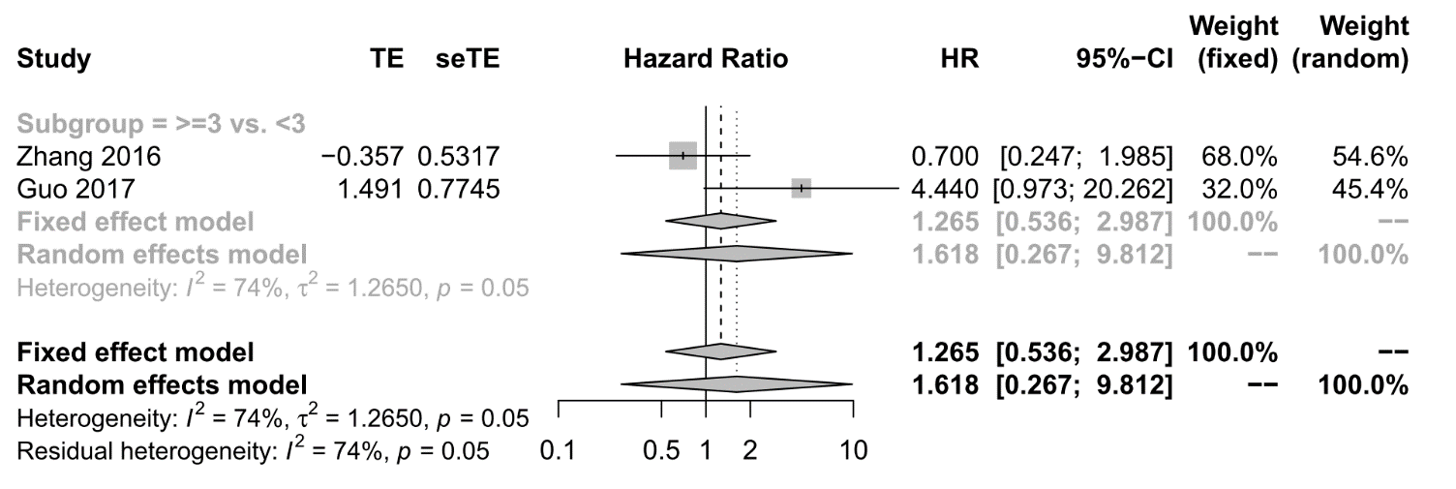
eFigure 36 Forest chart of additional analysis for overall survival according to clinical parameters: number of tumors
Result from random-effects model is used.

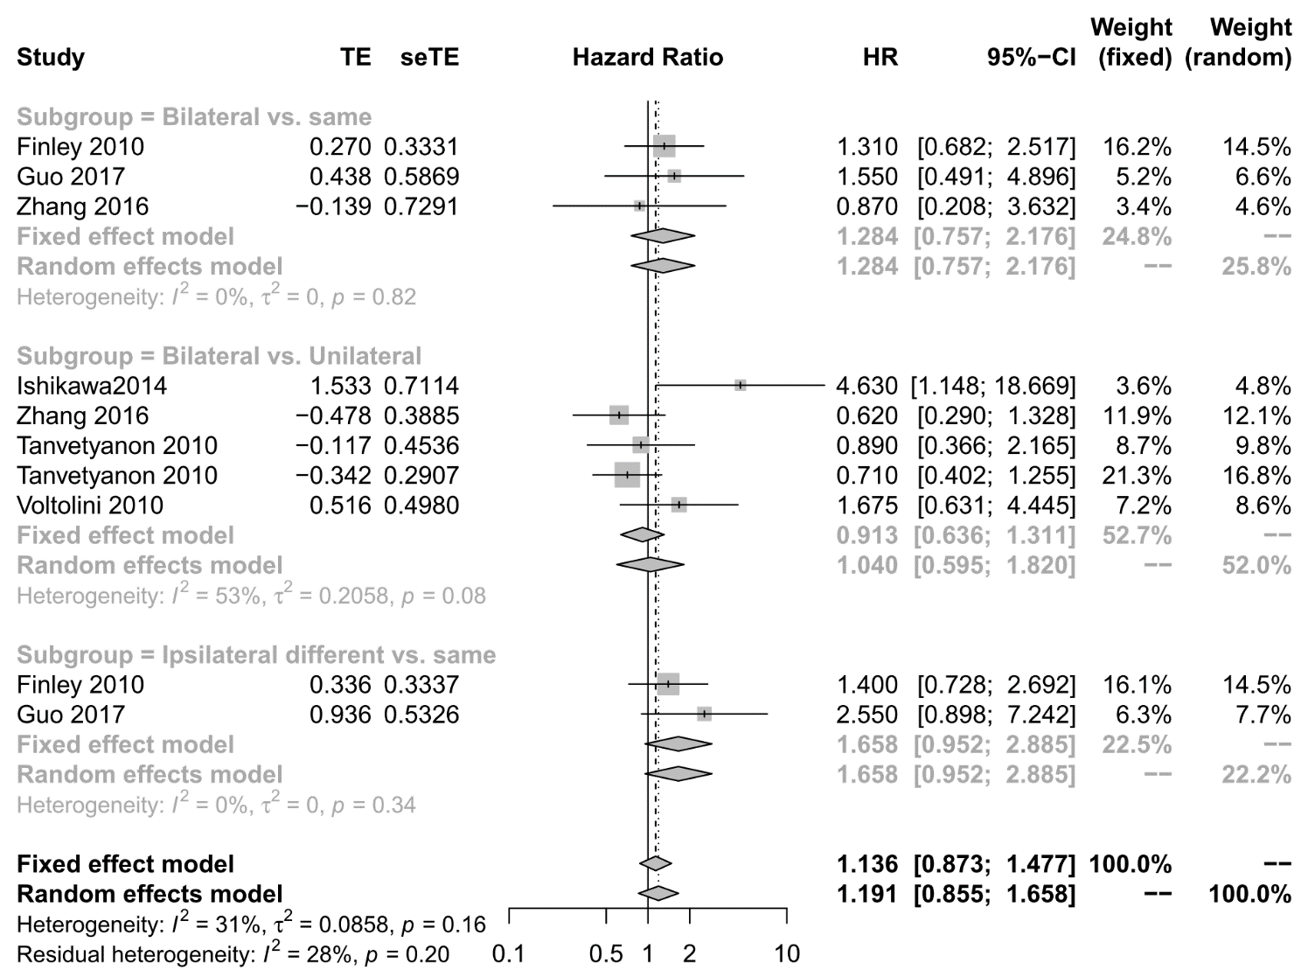
eFigure 37 Forest chart of additional analysis for overall survival according to clinical parameters: tumor location
Result from random-effects model is used.

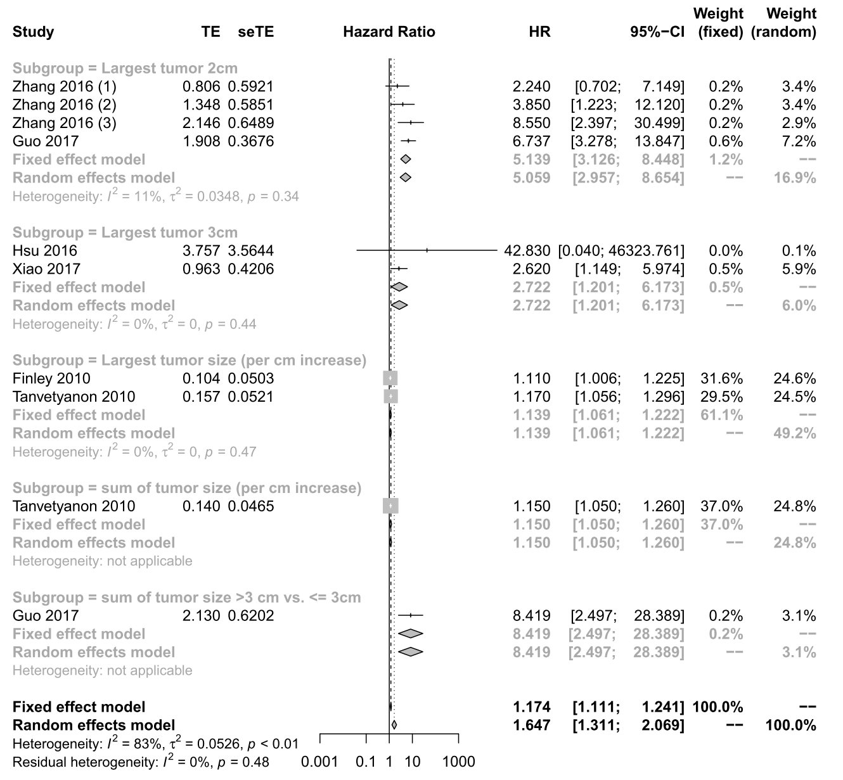
eFigure 38 Forest chart of additional analysis for overall survival according to clinical parameters: tumor size
Result from random-effects model is used.

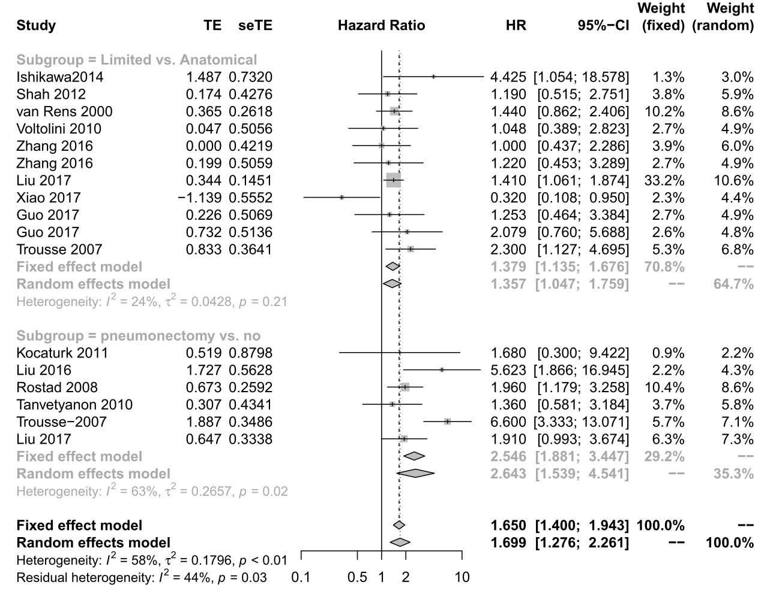
eFigure 39 Forest chart of additional analysis for overall survival according to clinical parameters: surgery methods
Result from random-effects model is used.

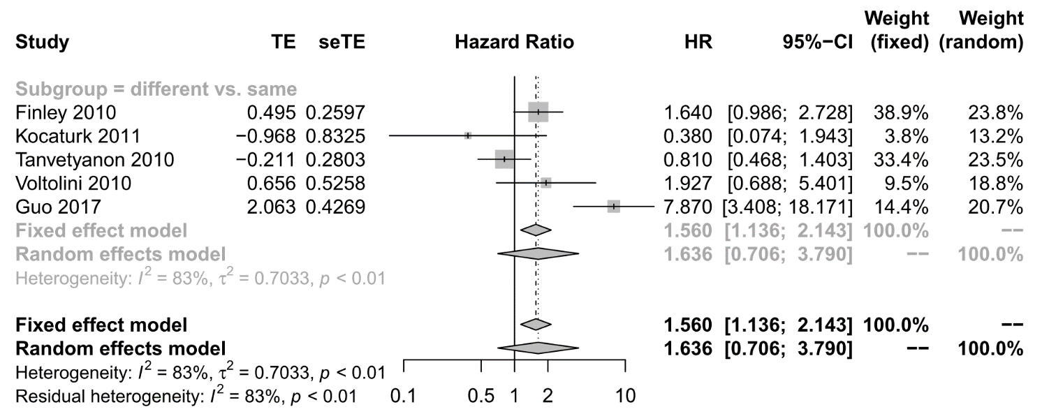
eFigure 40 Forest chart of additional analysis for overall survival according to clinical parameters: tumor histology
Result from random-effects model is used.

eFigure 41 Forest chart of additional analysis for overall survival according to clinical parameters: lymph node metastasis
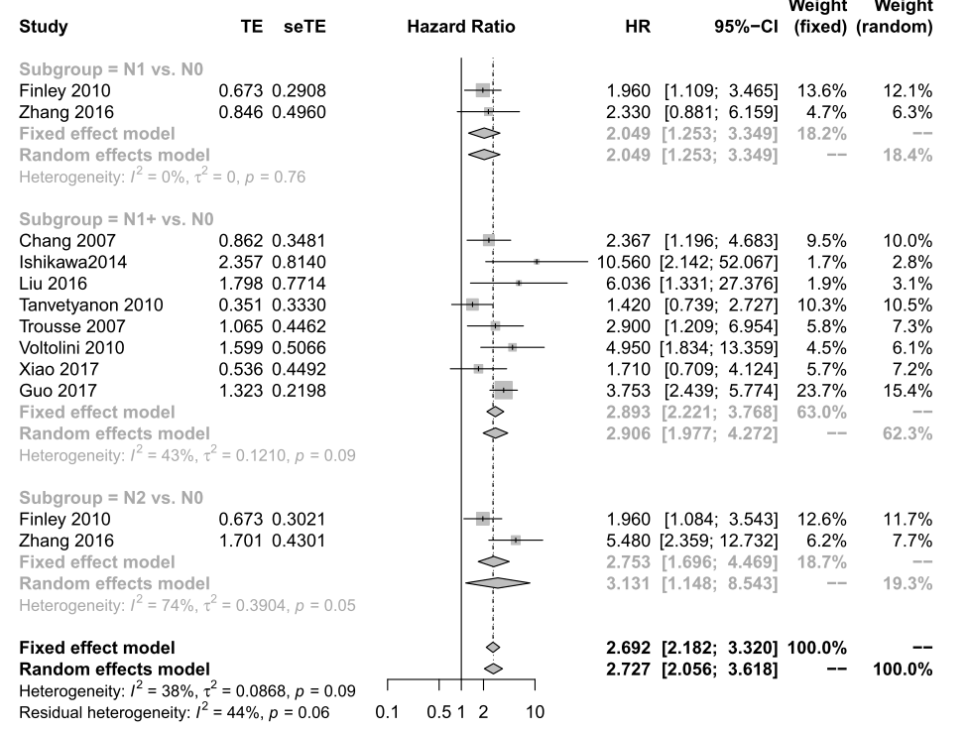 Result from random-effects model is used.
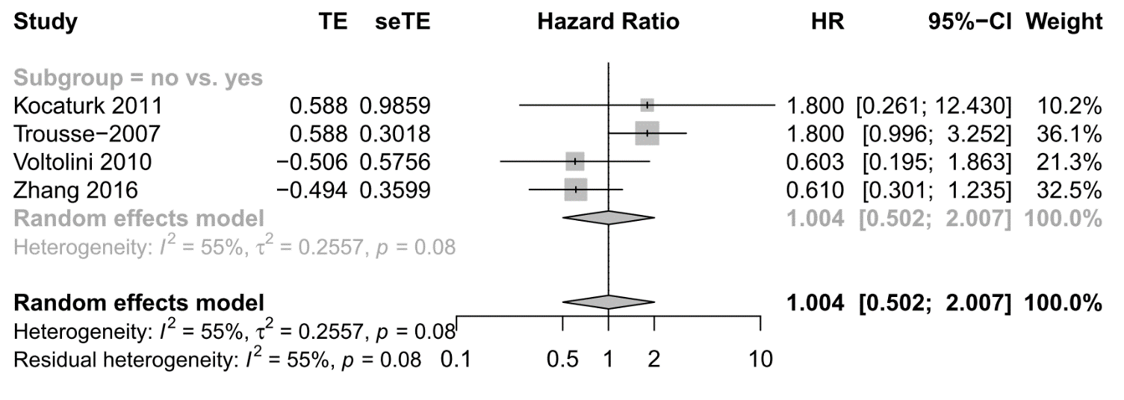
eFigure 42 Forest chart of additional analysis for overall survival according to clinical parameters: postoperative adjunctive therapy

Appendix 14 Publication bias
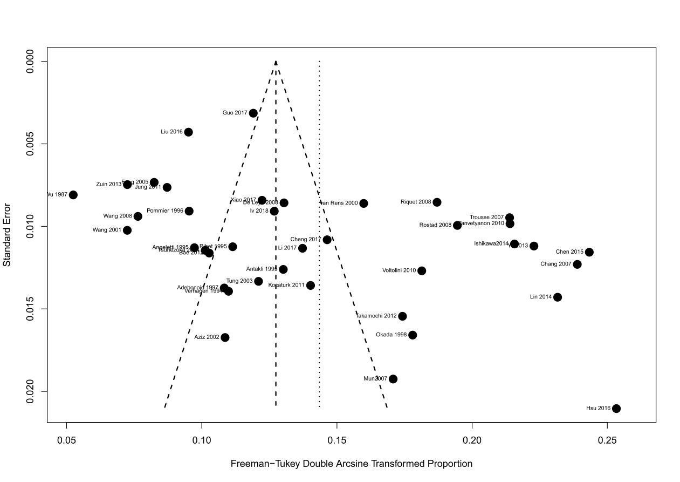
eFigure 43 Publication bias for sMPLC (Egger’s test P =.011)
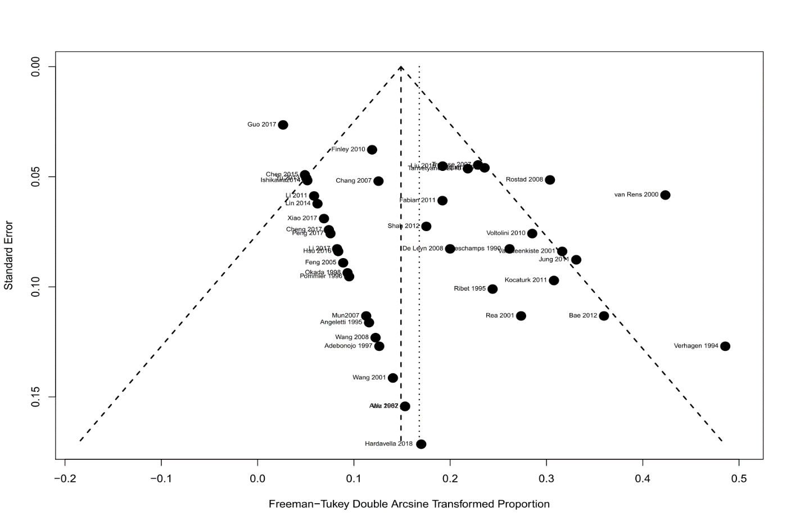
eFigure 44 Publication bias for postoperative mortality (Egger’s test P =.044)
eFigure 45 Publication bias for 5-years survival rate (Egger’s test P =0.001).

