Figure S1. Study selection flow chart
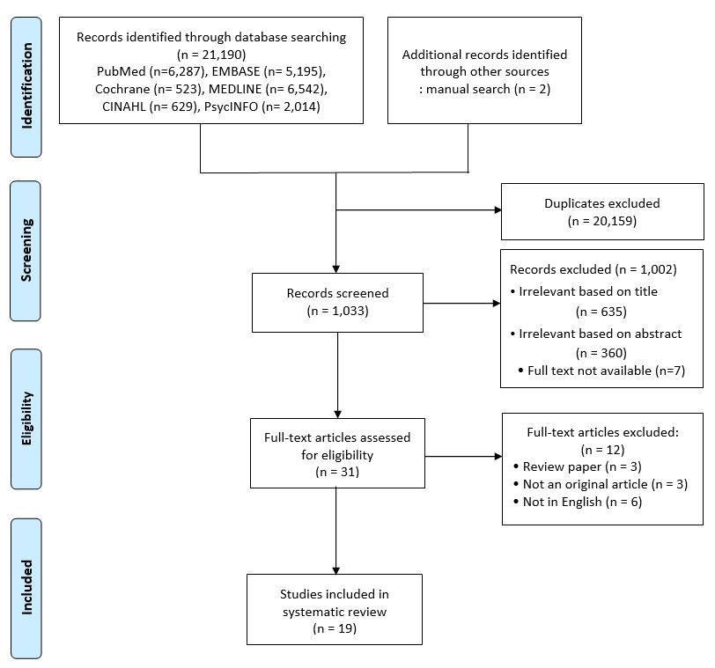

Table S1. Search strategy example: MEDLINE complete
 | Search Strategy | Articles Retrieved
1 | homebound persons [Mesh terms] | 668
2 | home-bound | 1,264
3 | house bound | 691
4 | outdoor* | 24,365
5 | 1 or 2 or 3 or 4 | 26,232
6 | Aged [Mesh terms] | 5,421,500
7 | older adults | 112,288
8 | elderly | 272,867
9 | 6 or 7 or 8 | 5,496,309
10 | 5 and 9 | 6,542
A 9-step MEDLINE search strategy was conducted. The example and search terminology were used as a framework for the subsequent PubMed, EMBASE, Cochrane Library, CINAHL, and PsycINFO database searches.

Table S2. Quality appraisal of the studies
 | 1. Were the criteria for inclusion in the sample clearly defined? | 2. Were the study subjects and the setting described in detail? | 3. Was the exposure measured in a valid and reliable way? | 4. Were objective, standard criteria used for measurement of the condition? | 5. Were confounding factors identified? | 6. Were strategies to deal with confounding factors stated? | 7. Were the outcomes measured in a valid and reliable way? | 8. Was appropriate statistical analysis used? | Overall appraisal
Cohen-Mansfield et al (2010) | Unclear | Yes | Yes | Yes | Yes | Yes | Yes | Yes | Include
Cohen-Mansfield et al (2012) | Unclear | Yes | Yes | Yes | No | No | Yes | Yes | Include
De-Rosende Celeiro et al (2017) | Yes | Yes | Yes | Yes | No | No | Yes | Yes | Include
Fujita et al (2006) | Yes | Yes | Yes | Yes | Yes | Yes | Yes | Yes | Include
Ganguli et al (1996) | Yes | Yes | Yes | Yes | No | No | Unclear | Yes | Include
Herr et al (2013) | No | Yes | Unclear | Yes | Yes | Yes | Unclear | Yes | Include
Ida et al (2020) | Yes | Yes | Unclear | Yes | No | No | Yes | Yes | Include
Inoue & Matsumoto (2001) | Yes | Yes | Unclear | Yes | No | No | Yes | Yes | Include
Jacobs et al (2008) | Yes | Yes | Unclear | Yes | Yes | Yes | Yes | Yes | Include
Jing et al (2017) | Yes | Yes | Yes | Yes | No | No | Yes | Yes | Include
Kono et al (2004) | Yes | Yes | Unclear | Yes | Yes | Yes | Yes | Yes | Include
Kono & Kanagawa, (2001) | Yes | Yes | Unclear | Yes | Yes | Yes | Yes | Yes | Include
Lindesay & Thompson (1993) | No | Yes | Unclear | Yes | Yes | Yes | Yes | Yes | Include
Murayama et al (2012) | Unclear | Yes | Unclear | Yes | Yes | Yes | Yes | Yes | Include
Musich et al (2015) | Yes | Yes | Unclear | Yes | Yes | Yes | Yes | Yes | Include
Negron-Blanco et al (2016) | Yes | Yes | Unclear | Yes | Yes | Yes | Yes | Yes | Include
Ornstein et al (2015) | Unclear | Yes | Unclear | Yes | Yes | Yes | Yes | Yes | Include
Sakurai et al  (2019) | Yes | Yes | Unclear | Yes | Yes | Yes | Yes | Yes | Include
Soones et al  (2017) | Yes | Yes | Unclear | Yes | Yes | Yes | Yes | Yes | Include

Table S3. Characteristics of the included cross-sectional studies
Author (year),  country | Purpose | N, sample description | Age  Mean (SD) | Gender  n or % (female) | Prevalence of homebound status | Measurement of homebound status | Definition of homebound | Factors related to homebound status | Impacts of homebound status
De-Rosende Celeiro et al. (2017), Spain | To examine the prevalence of homebound status and identify its determinants | 221, community-dwelling persons aged 50 years and over | 84* | 154 | 39.8% | Asked participants how many days they left home during the previous week | Remaining inside one’s home during the previous week or leaving only for health care purposes | Old age, walking ability limitations, decreased functional status, presence of architectural barriers near the home entrance, and heavy doors | NA
Ganguli et al. (1996), United States | To determine the frequency and characteristics of homebound older adults | 878, rural community-dwelling older adults | 76.3 (5.2) | 58.8% | 10.3% | Asked participants how often they left the house | Leaving the house once or less than once a week | Old age, female, weight loss, low IADLs, decreased cognition, depression, comorbidity, falls, recent acute hospitalization and use of home health, and social services. | NA
Ida et al (2020), Japan | To investigate factors associated with being homebound in older patients with diabetes | 558, patients with diabetes and aged 65 years and over who visited the outpatient clinic | Homebound: 75.4 (6.5) | 238 | 15.6% | Asked participants how often they go out | Going out less than once a day | Old age, longer duration of diabetes, comorbidity, low functional capacity including low IADLs, intellectual activities and social roles, insulin use | NA
Inoue & Matsumoto (2001), Japan | To investigate the association of sociodemographic, health-related factors with homebound status | 866, rural community-dwelling population aged 65 years and over | <70 (31.2%)  70-79 (46.2%)  >80 (22.6%) † | 503 | 34.8% | Asked participants if they went out without the assistance of others | Remaining inside or just outside the home in daily life | Old age, female, sensory impairment, decreased functional status, movement indoors and bathing, and use of a portable toilet | NA
Jing et al. (2017), China | To assess the occurrence of and factors influencing homebound elderly individuals | 2015, randomly selected community-dwelling elderly individuals | Male: 71.74 (8.18)  Female: 72.00 (8.61) | 1,223 | 15.5% | Asked participants how often they left the house | Leaving the house less than once a week | Old age, female, poor ADL performance, depression, loneliness, hearing impairment, no exercise, BMI, and low social support | NA
Kono & Kanagawa, (2001), Japan | To describe characteristics of homebound elderly individuals by their mobility levels | 321, community-dwelling disabled elderly individuals | Range: 67-97 | 199 | 26.5% | Asked participants about behaviors related to leaving the house within the previous week | Not leaving the house less than once a week | Old age, caregiving, autonomy social networks, decreased mobility, physical and cognitive disabilities | NA
Lindesay & Thompson (1993), United Kingdom | To examine various factors associated with being homebound in elderly individuals | 890, urban community-dwelling elderly individuals | Homebound: 81.6 (7.93) | Not reported | 3.5% | Asked participants how often they had not been beyond their door for at least one month and had interviewers assess participants’ homebound status | Not going beyond the door for at least one month prior to interview | Old age, physical health, depression, household tenure, raised entry floors, and no access to a car | NA
Murayama et al. (2012), Japan | To examine the association between the neighborhood environment and homebound status | 588, 72 small districts of suburban city-dwelling elderly individuals | 72.1 (6.2) | 50.2% | 10.7% | Asked participants how often they went outdoors | Going outdoors once a week or less | Old age, male, lack of employment, low income, low education level, self-rated poor health, low mobility level, lack of regular exercise, and no participation in community activities | NA
Musich et al. (2015), United States | To estimate prevalence rates of homebound status among older adults, the characteristics of homebound older adults and the impact of homebound status | 25,725, individuals who enrolled in AARP Medicare Supplement plans in five states in the United States | 69.4 | 59.6% | 19.6% | Asked participants about ambulatory disabilities | Having an ambulatory disability | Old age, female, cognitive impairment, depression, anxiety, more chronic conditions, more medications, and multiple hospitalizations. | Health care utilization and expenditures, compliance with medication adherence and care pattern rules
Negron-Blanco et al. (2016), Spain | To measure the prevalence of and factors associated with homebound status | 1622, urban and rural community-dwelling persons aged 50 years and over | 50-64 (663)  65-79 (660)  ≥80 (299) † | 920 | 9.8% | Asked participants if they had severe or extreme difficulty leaving the house | Having severe or extreme difficulty leaving the house in the last 30 days | Old age, female, low education level, high number of diseases, poor cognition, and high degree of disability | NA
Ornstein et al. (2015), United States | To develop measures of the frequency of leaving home and the ability to leave the home, and to estimate the number of homebound people | 7609, national sample of noninstitutionalized Medicare beneficiaries aged 65 and over | 75.3(70.17) | 56.6% | 5.6% | Asked participants how often they left the house and how much difficulty or help they needed when leaving home. | Leaving home never or rarely in the past month | Old age, female, non-white ethnicity, low education, low income, more chronic conditions, depression, possible or probable dementia, and receiving primary care at home | NA
* Represents the median (interquartile range) in the original study. † Represents the range in the original study
SD=Standard deviation; NA=Not applicable; ADLs=Activities of daily living; IADLs=Instrumental activities of daily living; BMI=Body mass index

Table S4. Characteristics of the included longitudinal studies
Author (year),  country | Purpose | N, sample description | Age  Mean (SD) | Gender  n or % (female) | Prevalence of homebound | Measurement of homebound status | Definition of homebound | Factors related to homebound status | Impacts of homebound status | Follow-up
Cohen-Mansfield et al (2010), Israel | To examine the impact of homebound status | CSS: 1191  LS: 621, random sample of the national older Jewish population | CSS: 83.10 (5.3) | NA | NA | Asked participants how often they left their homes | Leaving the house once a week or less | Old age, female, obesity or underweight, depression, low ADLs and IADLs, cognitive difficulties, presence of stairs, and lack of elevator | Mortality | 20 years
Cohen-Mansfield et al (2012), Israel | To examine the prevalence and correlates of homebound status | CSS: 1191  LS: 418, random sample of the national older Jewish population | CSS: 83.10 (5.3)  LS: 83.13 (5.2) | NA | 19.0% | Asked participants how often they left their homes | Leaving the house once a week or less | Old age, female, comorbidity, obesity or underweight, depression, low IADLs, presence of stairs, and lack of elevator | NA | 3.5 years
Fujita et al. (2006), Japan | To describe the frequency of going outdoors and to examine its predictive value for incident physical disability and recovery | 1522, community-dwelling older adults living in rural area | Homebound: 80∙4 (7.7) | 915 | 10.6% | Asked participants how often they usually went outside the house | Not specified. The authors categorized the frequency of going outdoors as ‘once a day or more’, ‘once per 2-3 days’, or ‘once a week or less often’. | Old age, chronic medical conditions, history of hospitalization in the previous month, walking ability, climbing upstairs, mobility disability, depressive mood, poor subjective health, low cognition, functional limitation and impairment | Incident physical disability and recovery | 2 years
Herr et al. (2013), France | To examine the prevalence and the role of homebound status on mortality | 7497, national sample aged 65 years and over | 81.9 (0.07) | 75.4% | 4.7% | Asked participants if they stayed permanently inside the home and assessed their bedridden status | Staying permanently inside the home, except for an accident or a temporary illness | Female, living alone, physical and mental impairments | Mortality | 2 years
Jacobs et al (2008), Israel | To examine the association between frequency of going outdoors and health and functional status | 343, community-dwelling older adults at age 70 | 70 | Goes out daily: 52.1%, goes out less than daily: 47.9% | 19.5% going outdoors nearly daily, 7.0% two to four times per week, and 2.5% once a week or less | Asked participants about their frequency of going outdoors | Not specified. The authors categorized leaving the house as a dichotomous variable, with going out daily considered as high frequency in contrast to all other responses | Female, education level. loneliness, self-rated health, physical activity, and comorbidity | - Functional status  - Mortality | - 7 years  - 12 years
Kono et al. (2004), Japan | To investigate the relationship between the frequency of going outdoors and subsequent functional and psychosocial changes over time | 112, rural community-dwelling frail elderly individuals aged 65 years and over | 83.4 | 73.2% | 19.0% | Asked participants how often they usually left the house | Not specified. The authors categorized the frequency of going outdoors as ‘more than 4 times a week’, ‘1-3 times a week’, or ‘less than once a week’ | Old age, decreased functional status, low intellectual activity, depression, and low self-efficacy | NA | 9 months
Sakurai et al  (2019), Japan | To examine whether social isolation and homebound status increase the risk of mortality | 1,023, community-dwelling older adults | 72.3 | 59.2% | 26.0% | Asked participants about the frequency of going outdoors | Going outdoors either every few days or less | Old age, living alone, low annual income, depression, and poor subjective health | Mortality | 6 years
Soones et al  (2017), United States | To describe the prevalence of homebound status among older adults and to examine its impacts on two-year mortality | 6,400, nationally representative sample aged 65 years and over | 84.0 (homebound) | 73% (homebound) | 7.5% | Asked participants how often they went out and how much difficulty they had when they went out. | Going outdoors never or less than one day per week in the last month | Old age, female, race, living alone, having Medicaid or ling-term care insurance, chronic diseases, higher rates of probable dementia and depression, hospitalization in the last 12 months, and dependent in self-care activity and household activity | Mortality | 2 years
* Represents the median (interquartile range) in the original study. † Represents the range in the original study
* SD=Standard deviation; CSS=Cross-sectional Study; LS=Longitudinal Study; NA=Not applicable; ADLs=Activities of daily living; IADLs=Instrumental activities of daily living; BMI=Body mass index

Table S5. Classification of factors related to homebound status
Constructs | Characteristics | Factors | Number of studies (n)
Individual | Demographic | Old age | 15
 |  | Female | 12
 |  | Male | 1
 |  | Nonwhite | 1
 |  | Low education | 5
 |  | Living alone | 5
 |  | Low income | 2
 |  | Lack of employment | 1
 | Biological | Obesity | 3
 |  | Weight loss | 3
 |  | Comorbidity | 8
 | Psychological | Depression | 7
 |  | Low intellectual activities | 2
 |  | Low self-efficacy | 1
 | Functional | Low level of activities of daily living | 7
 |  | Low level of instrumental activities of daily living | 5
 |  | Cognitive impairment | 9
 |  | Sensory function impairment | 2
 |  | Physical disability | 4
 |  | Decreased mobility | 6
 |  | Poor subjective health | 2
 | Health-related | Multiple medications | 1
 |  | Hospitalization | 3
 |  | Falls | 1
Structural | Architectural environmental | Home entry and exit complications | 9
 |  | Use of a portable toilet | 1
 |  | Householder tenure | 2
 | Social | Use of home health | 2
 |  | Use of social services | 1
 |  | Limited social support | 3
 | Community | Social networks | 2
 |  | No participation in community activity | 1

