Supplementary materials

PRISMA Checklist
Section/topic | # | Checklist item | Reported on page #
TITLE
Title | 1 | Identify the report as a systematic review, meta-analysis, or both. | 1
ABSTRACT
Structured summary | 2 | Provide a structured summary including, as applicable: background; objectives; data sources; study eligibility criteria, participants, and interventions; study appraisal and synthesis methods; results; limitations; conclusions and implications of key findings; systematic review registration number. | 2
INTRODUCTION
Rationale | 3 | Describe the rationale for the review in the context of what is already known. | 3-5
Objectives | 4 | Provide an explicit statement of questions being addressed with reference to participants, interventions, comparisons, outcomes, and study design (PICOS). | 5-9
METHODS
Protocol and registration | 5 | Indicate if a review protocol exists, if and where it can be accessed (e.g., Web address), and, if available, provide registration information including registration number. | 5
Eligibility criteria | 6 | Specify study characteristics (e.g., PICOS, length of follow-up) and report characteristics (e.g., years considered, language, publication status) used as criteria for eligibility, giving rationale. | 5-9 (and supplementary materials)
Information sources | 7 | Describe all information sources (e.g., databases with dates of coverage, contact with study authors to identify additional studies) in the search and date last searched. | 6-7
Search | 8 | Present full electronic search strategy for at least one database, including any limits used, such that it could be repeated. | 6 (and supplementary materials)
Study selection | 9 | State the process for selecting studies (i.e., screening, eligibility, included in systematic review, and, if applicable, included in the meta-analysis). | 5-9
Data collection process | 10 | Describe method of data extraction from reports (e.g., piloted forms, independently, in duplicate) and any processes for obtaining and confirming data from investigators. | 7-8 (and supplementary materials)
Data items | 11 | List and define all variables for which data were sought (e.g., PICOS, funding sources) and any assumptions and simplifications made. | 6-7
Risk of bias in individual studies | 12 | Describe methods used for assessing risk of bias of individual studies (including specification of whether this was done at the study or outcome level), and how this information is to be used in any data synthesis. | 7
Summary measures | 13 | State the principal summary measures (e.g., risk ratio, difference in means). | 7-9
Synthesis of results | 14 | Describe the methods of handling data and combining results of studies, if done, including measures of consistency (e.g., I²) for each meta-analysis. | 7-9

Page 1 of 2
Section/topic | # | Checklist item | Reported on page #
Risk of bias across studies | 15 | Specify any assessment of risk of bias that may affect the cumulative evidence (e.g., publication bias, selective reporting within studies). | 7
Additional analyses | 16 | Describe methods of additional analyses (e.g., sensitivity or subgroup analyses, meta-regression), if done, indicating which were pre-specified. | 8-10
RESULTS
Study selection | 17 | Give numbers of studies screened, assessed for eligibility, and included in the review, with reasons for exclusions at each stage, ideally with a flow diagram. | 10 and 22 (and supplementary materials)
Study characteristics | 18 | For each study, present characteristics for which data were extracted (e.g., study size, PICOS, follow-up period) and provide the citations. | 10 (and table 1)
Risk of bias within studies | 19 | Present data on risk of bias of each study and, if available, any outcome level assessment (see item 12). | Table 1
Results of individual studies | 20 | For all outcomes considered (benefits or harms), present, for each study: (a) simple summary data for each intervention group (b) effect estimates and confidence intervals, ideally with a forest plot. | Tables 1-6 and figures 1-3
Synthesis of results | 21 | Present results of each meta-analysis done, including confidence intervals and measures of consistency. | 11-13 (and tables 1-4 and figures 1-3
Risk of bias across studies | 22 | Present results of any assessment of risk of bias across studies (see Item 15). | 12 (and table 1 and figures 1-4 in supplementary materials)
Additional analysis | 23 | Give results of additional analyses, if done (e.g., sensitivity or subgroup analyses, meta-regression [see Item 16]). | 11-13
DISCUSSION
Summary of evidence | 24 | Summarize the main findings including the strength of evidence for each main outcome; consider their relevance to key groups (e.g., healthcare providers, users, and policy makers). | 14-16
Limitations | 25 | Discuss limitations at study and outcome level (e.g., risk of bias), and at review-level (e.g., incomplete retrieval of identified research, reporting bias). | 16-18
Conclusions | 26 | Provide a general interpretation of the results in the context of other evidence, and implications for future research. | 14-16
FUNDING
Funding | 27 | Describe sources of funding for the systematic review and other support (e.g., supply of data); role of funders for the systematic review. | 18

Table S1: Study Inclusion and Exclusion Criteria
Inclusion | Exclusion
- Measured the prevalence of alcohol misuse using a standardised measure of alcohol use, dependence or CMD (for example Alcohol Use Disorder Identification Test or Diagnostic and Statistical Manual diagnostic instruments  - CMD defined as major depressive disorder, dysthymia, generalised anxiety disorder, panic disorder, phobias, post-traumatic stress disorder, obsessive compulsive disorder, or social anxiety disorder  - Studies conducted in the adult general population  - Reported the prevalence of alcohol misuse in those with and without a CMD  - Observational, cross-sectional, cohort or case-control design | - Did not report the prevalence of alcohol misuse in those with and without a CMD  - Included treatment-seeking populations  - Included populations who experienced a specific traumatic event (e.g. military populations)  - Included populations with a specific health condition (e.g. epilepsy)  - Review or intervention design

Table S2: Full Search Terms
Topic | Terms used
Alcohol misuse | alcohol* or drinking*
CMD | AND dysthymia or depression or depress* or generalized anxiety disorder or GAD or social anxiety* or panic disorder or social phobia or phobias or phobic disorder or obsessive-compulsive disorder or OCD or post-traumatic stress disorder or PTSD or stress disorder or psychiatric disorder
Comorbidity | AND comorbidity or comorbid*
Methods | AND prevalence or epidemiology or incidence
Population | AND population
Other topics | NOT gambling*

Table S3: Associations of Moderate/Severe AUD Among Those With an Anxiety or Mood Disorder Compared to Those Without (N=210,121)
Moderate/severe AUD | OR | 95% CI lower | 95% CI upper | Weight | Heterogeneity (I²) | p
Anxiety disorder
Batelaan et al 2012 | 2.89 | 1.53 | 5.45 | 9.69
de Castro Longo et al 2020 | 5.46 | 3.11 | 9.58 | 10.26
Kinley et al 2009 | 3.63 | 2.66 | 4.94 | 12.05
Marquenie et al 2007 | 2.08 | 1.64 | 2.64 | 12.42
Muller et al 2014 | 1.90 | 1.27 | 2.84 | 11.45
Pacek et al 2013 | 0.97 | 0.83 | 1.13 | 12.77
Park et al 2013 | 2.06 | 1.42 | 2.98 | 11.67
Patel et al 2002 | 0.94 | 0.37 | 2.41 | 7.45
Van Ameringan et al 2008 | 1.93 | 1.46 | 2.53 | 12.24
Subtotal | 2.12 | 1.43 | 3.14 | 100.00 | 92.20% | 0.01
Mood disorder
Crum et al 2005 | 1.98 | 1.50 | 2.62 | 17.26
Currie et al 2005 | 1.68 | 1.31 | 2.15 | 18.22
Davis et al 2020 | 1.70 | 1.60 | 1.81 | 22.37
Husky et al 2018 | 1.74 | 0.77 | 3.96 | 6.08
Markkula et al 2016 | 2.42 | 1.68 | 3.51 | 14.55
Tebeka et al 2018 | 2.68 | 2.83 | 3.01 | 21.53
Subtotal | 2.02 | 1.60 | 2.57 | 100.00 | 89.60% | 0.01

Table S4: Associations of Any AUD Among Those With Any Anxiety Disorder (excluding PTSD and OCD) and Among Those with PTSD (N=137,916)
Any AUD | OR | 95% CI lower | 95% CI upper | Weight | Heterogeneity (I²) | p
Any Anxiety Disorder (excluding PTSD and OCD)
Batelaan et al 2012 | 2.89 | 1.53 | 5.45 | 18.49
Kinley et al 2009 | 3.63 | 2.66 | 4.94 | 21.83
Pacek et al 2013 | 0.97 | 0.83 | 1.13 | 22.79
Park et al 2013 | 1.42 | 1.05 | 1.91 | 21.91
Patel et al 2002 | 0.95 | 0.37 | 2.41 | 14.98
Subtotal | 1.71 | 0.93 | 3.16 | 100.00 | 93.90% | 0.01
PTSD
De Castro Longo et al 2020 | 3.39 | 2.15 | 5.34 | 27.68
Muller et al 2014 | 1.90 | 1.27 | 3.84 | 31.21
Van Ameringan et al 2008 | 1.93 | 1.46 | 2.53 | 41.11
Subtotal | 2.24 | 1.60 | 3.13 | 100.00 | 59.10% | 0.18

Table S5: Associations of Any AUD Among Those With a CMD Compared to Those Without Stratified by Continent (N=365,331)
Continent | OR | 95% CI lower | 95% CI upper | Weight | Heterogeneity (I²) | p
Europe
Batelaan et al 2012 | 2.89 | 1.53 | 5.45 | 7.72
Davis et al 2020 | 1.70 | 1.60 | 1.81 | 19.57
Husky et al 2018 | 1.72 | 0.93 | 3.18 | 8.02
Markkula et al 2016 | 2.42 | 1.67 | 3.51 | 12.90
Marquenie et al 2007 | 2.08 | 1.64 | 2.64 | 16.23
Muller et al 2014 | 1.90 | 1.27 | 3.84 | 12.20
Patel et al 2002 | 0.95 | 0.37 | 2.41 | 4.50
Tebeka et al 2018 | 2.68 | 2.38 | 3.01 | 18.86
Subtotal | 2.06 | 1.65 | 2.59 | 100.00 | 86.40% | 0.01
North America
Crum et al 2005 | 1.98 | 1.50 | 2.62 | 15.68
Currie et al 2005 | 1.66 | 1.44 | 1.90 | 17.71
Kessler et al 1997 | 1.81 | 1.64 | 2.00 | 18.08
Kinley et al 2009 | 3.63 | 2.66 | 4.94 | 15.18
Pacek et al 2013 | 0.97 | 0.83 | 1.13 | 17.56
Van Ameringan et al 2008 | 1.93 | 1.46 | 2.53 | 15.79
Subtotal | 1.82 | 1.37 | 2.42 | 100.00 | 93.70% | 0.01

Table S6: Associations of Any AUD Among Those With a CMD Compared to Those Without Stratified by the Decade Data was Collected (N=224,835)
Decade in which data was collected | OR | 95% CI lower | 95% CI upper | Weight | Heterogeneity (²) | p
1990's
Batelaan et al 2012 | 2.89 | 1.53 | 5.45 | 3.95
Crum et al 2005 | 1.98 | 1.50 | 2.62 | 17.05
Kessler et al 1997 | 1.81 | 2.64 | 2.00 | 55.56
Marquenie et al 2007 | 2.08 | 1.64 | 2.64 | 21.57
Patel et al 2002 | 0.95 | 0.37 | 2.41 | 1.87
Subtotal | 1.91 | 1.68 | 2.17 | 100.00 | 22.20% | 0.38
2000's
de Castro Longo et al 2020 | 3.39 | 2.15 | 5.34 | 8.16
Chong et al 2012 | 3.47 | 2.61 | 4.60 | 9.37
Currie et al 2005 | 1.66 | 1.44 | 1.90 | 10.09
Husky et al 2018 | 1.72 | 0.93 | 3.18 | 6.95
Kinley et al 2009 | 3.63 | 2.66 | 4.94 | 9.21
Markkula et al 2016 | 2.42 | 1.67 | 3.51 | 8.77
Muller et al 2014 | 1.90 | 1.27 | 3.84 | 8.56
Pacek et al 2013 | 0.97 | 0.83 | 1.13 | 10.04
Park et al 2013 | 1.42 | 1.05 | 1.91 | 9.28
Tebeka et al 2018 | 2.68 | 2.38 | 3.01 | 10.15
Van Ameringan et al 2008 | 1.93 | 1.46 | 2.53 | 9.43
Subtotal | 2.11 | 1.59 | 3.26 | 100.00 | 93.80% | 0.01

Figure S1: A funnel plot illustrating the heterogeneity of having any alcohol use disorder (AUD) among those with any common mental disorder (CMD) (N=382,201)

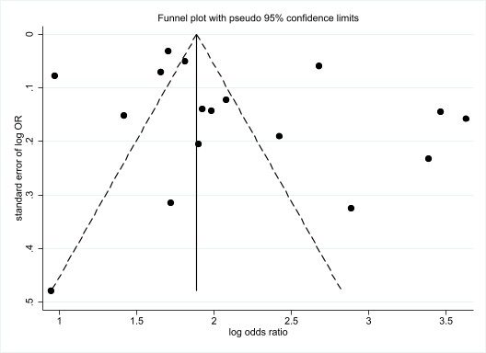

Figure S2: A funnel plot illustrating the heterogeneity of having any alcohol use disorder (AUD) among those with any common mental disorder (CMD) stratified by the decade in which the study was conducted (N=224,835)
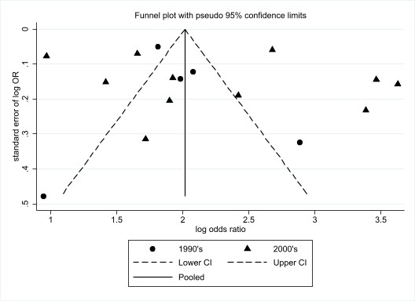

Figure S3: A funnel plot illustrating the heterogeneity of having any alcohol use disorder (AUD) among those with any common mental disorder (CMD) stratified by the continent in which the study was conducted in (N=382,201)
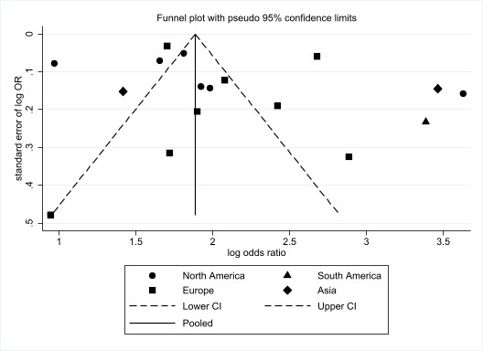

Figure S4: A funnel plot illustrating the heterogeneity of having any alcohol use disorder (AUD) among those with any common mental disorder (CMD) stratified by each study’s bias score (N=382,201)
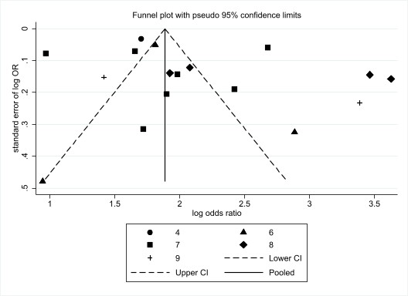

Figure S5: 12-month and lifetime associations of alcohol use disorder (AUD) among those with a common mental disorder (CMD), compared to those without, after removing Kinley et al 2009 study (N=353,660)
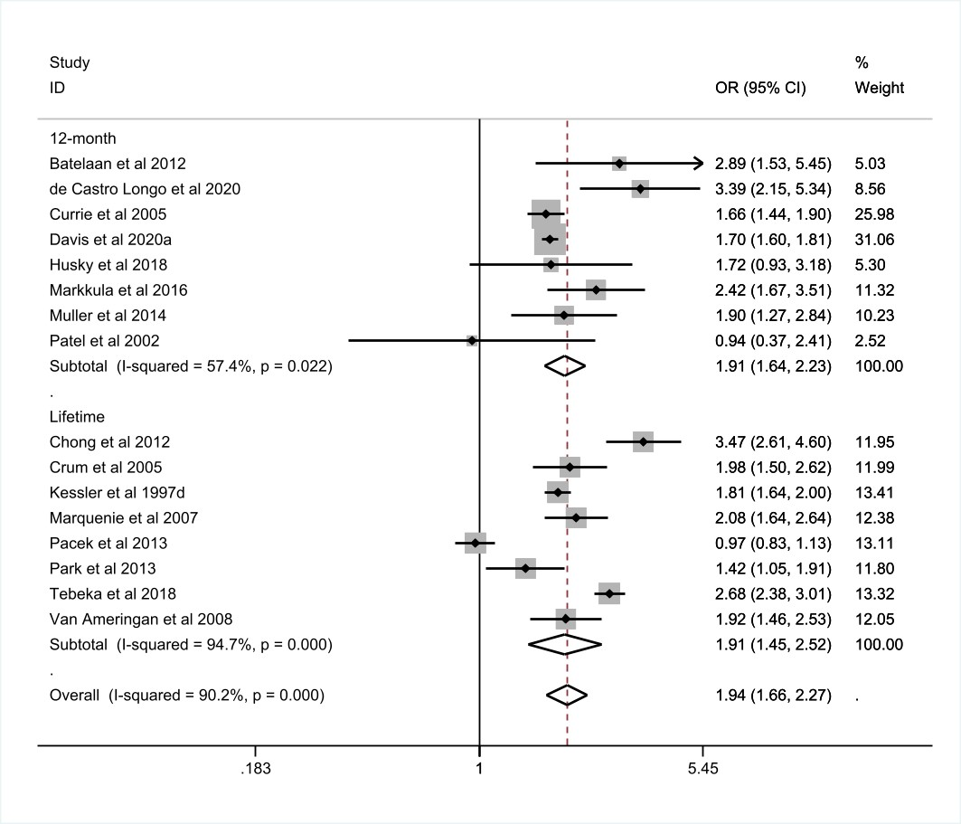

Figure S6: 12-month and lifetime associations of any alcohol use disorder (AUD) stratified by type of common mental disorder (CMD), compared to those without, after removing Patel et al 2002 study (N=373,637)
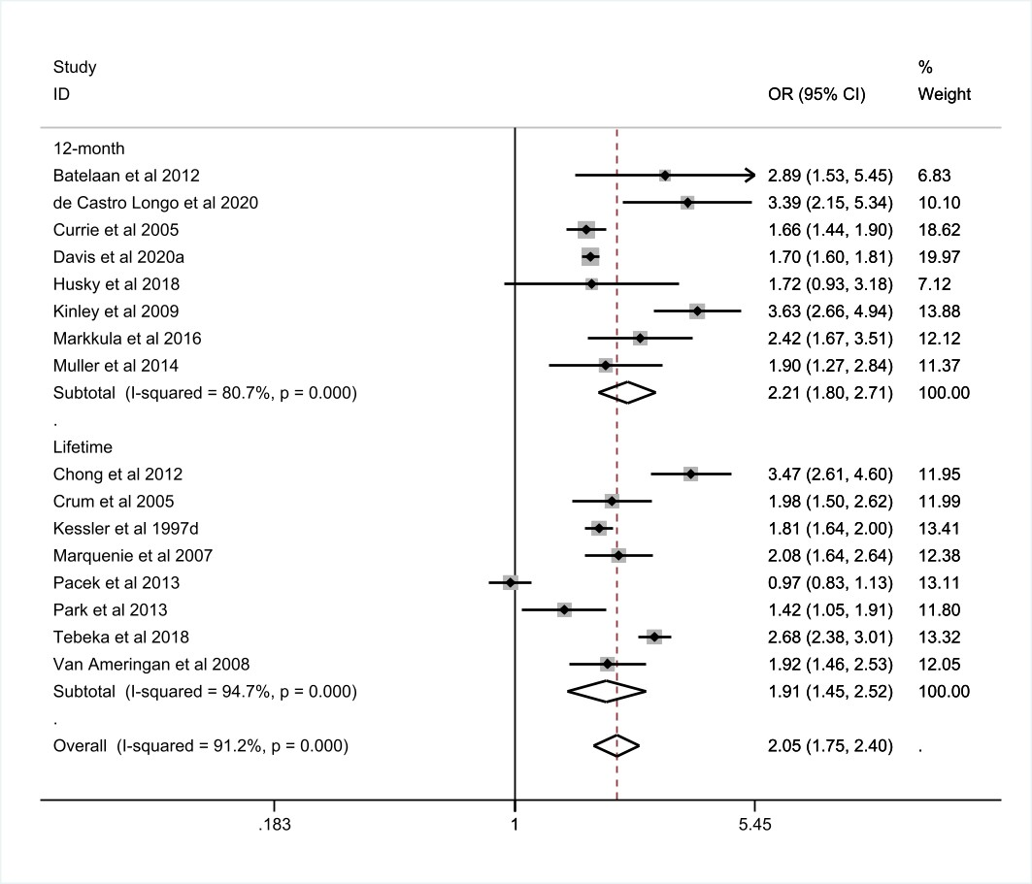

Figure S7: Funnel plot to explore publication bias


