Supplementary Material

Content

Supplementary Table 1 2
Supplementary Table 2 3
Supplementary Figure 1 4
Supplementary Figure 2 7
Supplementary Figure 3 10
Supplementary Figure 4 11
Supplementary Figure 5 12
Supplementary Figure 6 13
Supplementary Figure 7 14
Supplementary Figure 8 15
Supplementary Figure 9 16
Supplementary Figure 10 17
Supplementary Figure 11 18

Supplementary Table 1
Search strategies
No | Term
PubMed
#1 | (clinical trial[Title/Abstract]) OR (trial[Title/Abstract]) OR (randomized controlled trial[Title/Abstract]) OR (phase[Title/Abstract])
#2 | (non-small cell lung cancer[Title]) OR (non-small-cell lung cancer[Title]) OR (non small-cell lung cancer[Title]) OR (non small cell lung carcinoma[Title]) OR (NSCLC[Title])
#3 | (immune checkpoint inhibitor[Title]) OR (PD-1[Title]) OR (PD-L1[Title]) OR (CTLA-4[Title]) OR (pembrolizumab[Title]) OR (atezolizumab[Title]) OR (nivolumab[Title]) OR (ipilimumab[Title]) OR (durvalumab[Title]) OR (tremelimumab[Title]) OR (camrelizumab[Title]) OR (tislelizumab[Title]) OR (sintilimab[Title]) OR (Toripalimab[Title]) OR (Cemiplimab[Title]) OR (Sugemalimab[Title])
Medline
#1 | TS=('clinical trial' OR 'trial' OR 'randomized controlled trial' OR 'phase')
#2 | TI=('non-small cell lung cancer' OR 'non-small-cell lung cancer' OR 'non small-cell lung cancer' OR 'non small cell lung carcinoma' OR 'NSCLC')
#3 | TI=('immune checkpoint inhibitor' OR 'PD-1' OR 'PD-L1' OR 'CTLA-4' OR 'pembrolizumab' OR 'atezolizumab' OR 'nivolumab' OR 'ipilimumab' OR 'durvalumab' OR 'tremelimumab' OR 'camrelizumab' OR 'tislelizumab' OR 'sintilimab' OR 'Toripalimab' OR 'Cemiplimab' OR 'Sugemalimab')
Embase
#1 | clinical trial':ti,ab,kw OR 'trial':ti,ab,kw OR 'randomized controlled trial':ti,ab,kw OR 'phase':ti,ab,kw
#2 | non-small cell lung cancer':ti OR 'non-small-cell lung cancer':ti OR 'non small-cell lung cancer':ti OR 'non small cell lung carcinoma':ti OR 'NSCLC':ti
#3 | immune checkpoint inhibitor':ti OR 'PD-1':ti OR 'PD-L1':ti OR 'CTLA-4':ti OR 'pembrolizumab':ti OR 'atezolizumab':ti OR 'nivolumab':ti OR 'ipilimumab':ti OR 'durvalumab':ti OR 'tremelimumab':ti OR 'camrelizumab':ti OR 'tislelizumab':ti OR 'sintilimab':ti OR 'Toripalimab':ti OR 'Cemiplimab':ti OR 'Sugemalimab':ti
#4 | #1 AND #2 AND #3
#5 | #4 AND ([controlled clinical trial]/lim OR [randomized controlled trial]/lim) AND ([article]/lim OR [article in press]/lim OR [conference abstract]/lim OR [conference paper]/lim)

Supplementary Table 2
Life-years gained of patients in subgroup analysis of NCCN recommended treatments
Intervention | LE_5y | Intervention | LE_3y
che | 18.04 | che | 6.91
ipi+niv | 21.94 | niv+ipi+che | 9.69
niv+ipi+che | 21.85 | ate+che | 11.37
ate+che | 21.03 | bev+che | 9.30
bev+che | 17.97 | ate+bev+che | 14.63
ate+bev+che | 21.54 | pem+che | 13.18
Che: chemotherapy; niv+ipi: nivolumab plus ipilimumab; ate+che: atezolizumab plus chemotherapy; niv+ipi+che: nivolumab plus ipilimumab plus chemotherapy; ate+bev+che: atezolizumab plus bevacizumab plus chemotherapy; bev+che: bevacizumab plus chemotherapy; pem+che: pembrolizumab plus chemotherapy; OS: overall survival; PFS: progression-free survival. LE_5Y: life-years gained of OS in 5 years; LE_3Y: life-years gained of PFS in 3 years. LE_5Y: life-years gained of OS in 5 years; LE_3Y: life-years gained of PFS in 3 years.

Supplementary Figure 1
Log Cumulative Hazard Plot
OS
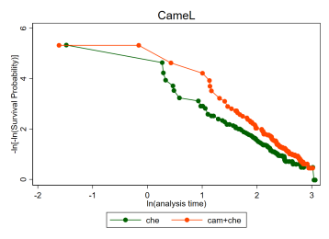 | 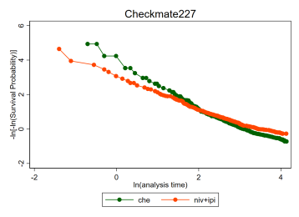 | 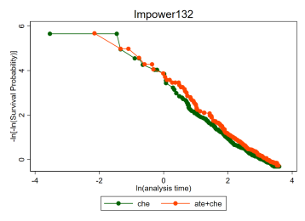
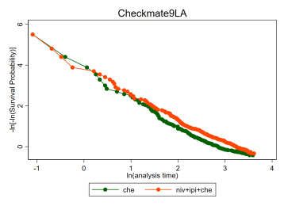 | 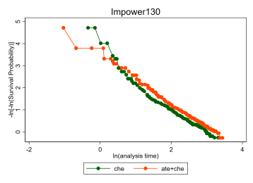 | 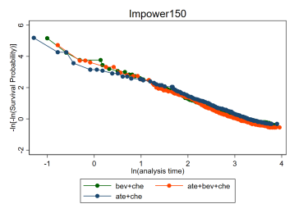
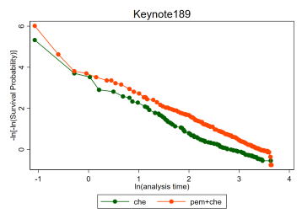 | 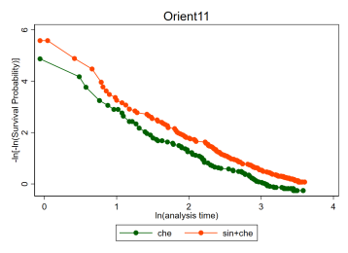 | 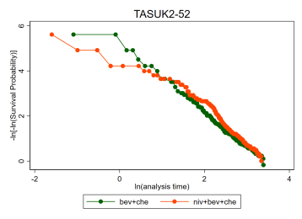
PFS
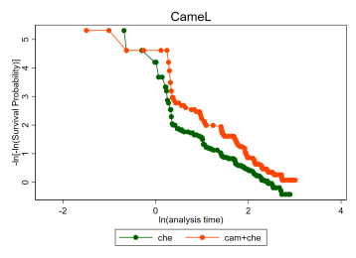 | 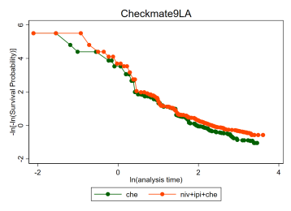 | 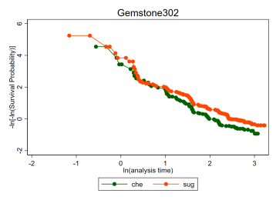
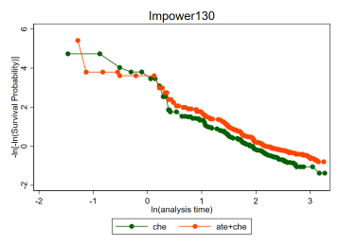 | 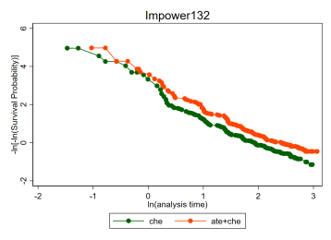 | 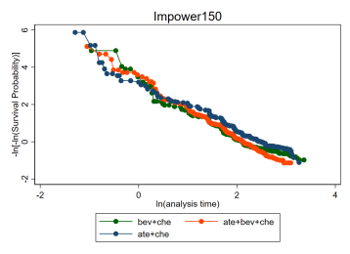
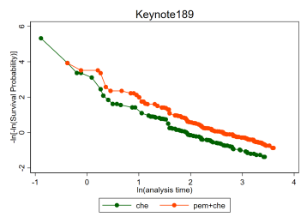 | 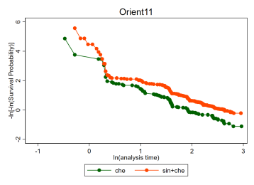 | 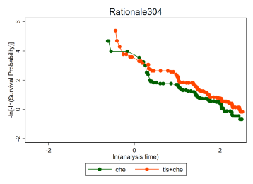
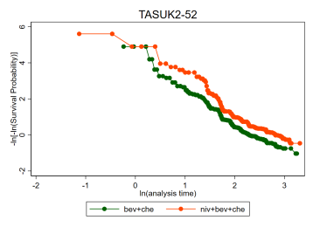
OS, PD-L1 expression ≥ 50%
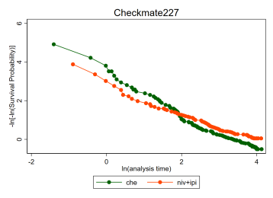 | 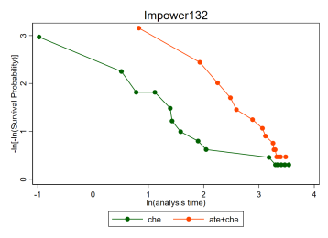 | 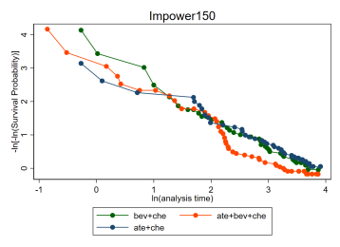
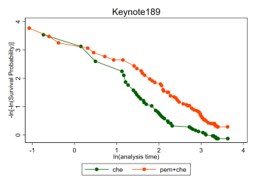
OS, PD-L1 expression < 1%
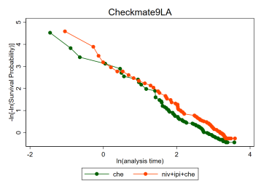 | 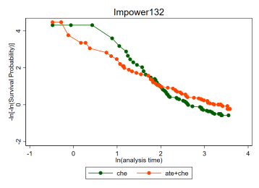 | 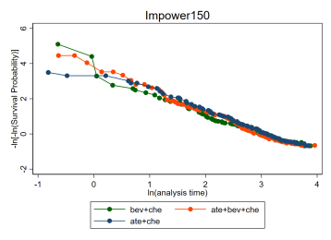
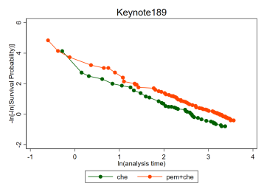
PFS, PD-L1 expression ≥ 50%
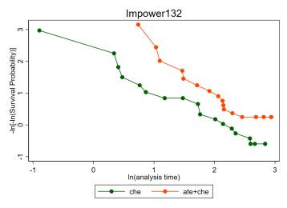 | 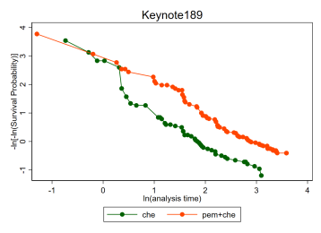 | 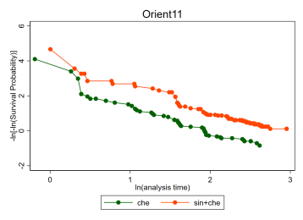
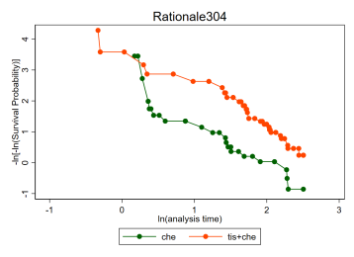
PFS, PD-L1 expression < 1%
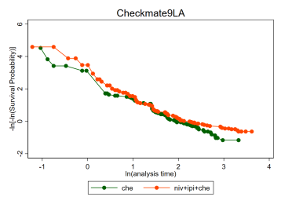 | 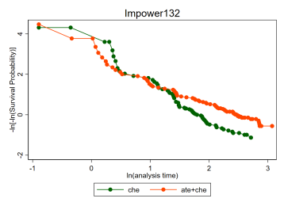 | 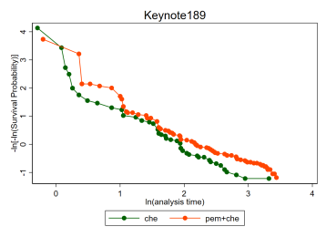
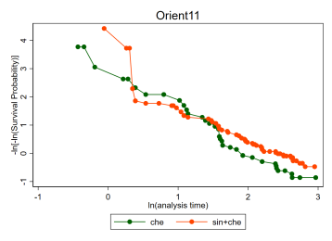 | 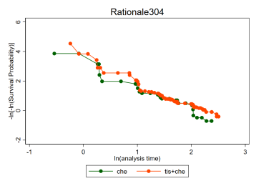

Supplementary Figure 2
Schoenfeld residual test Plot
OS
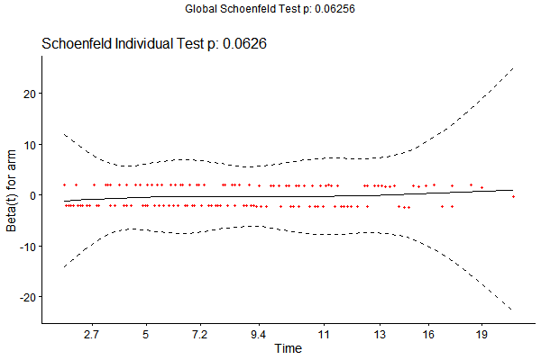 | 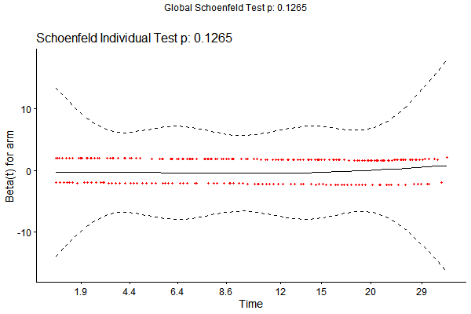 | 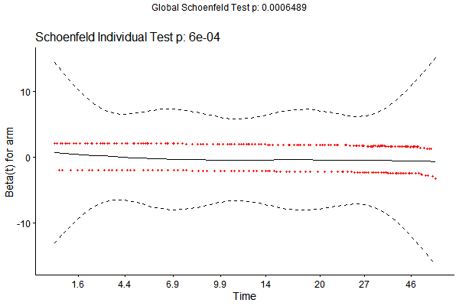
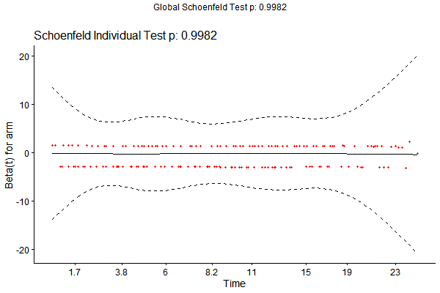 | 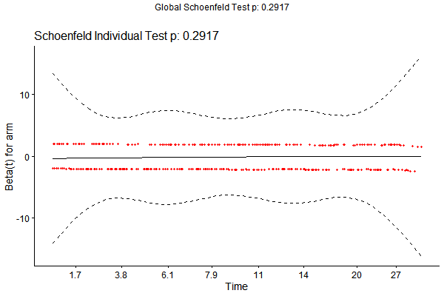 | 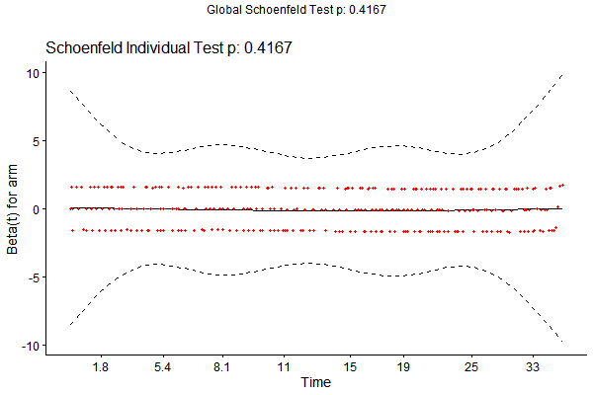
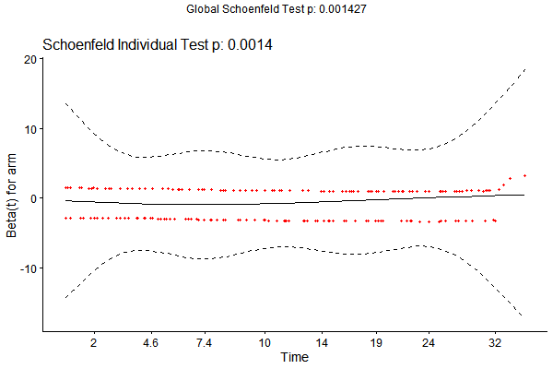 | 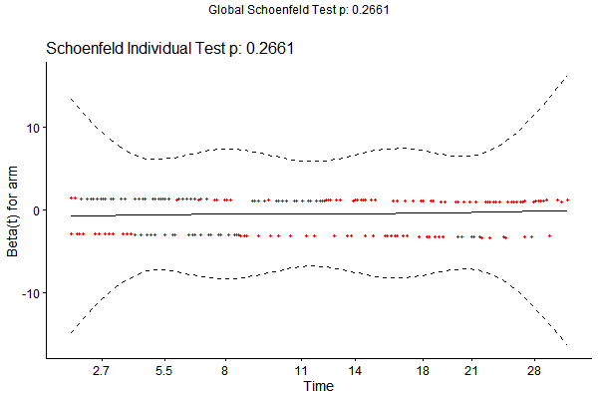 | 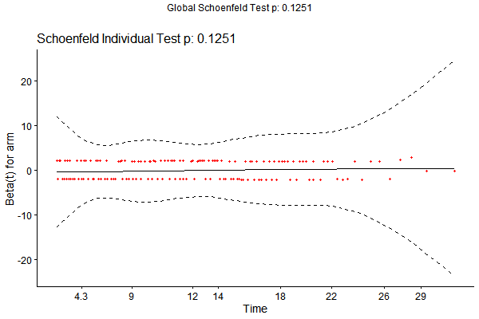
PFS
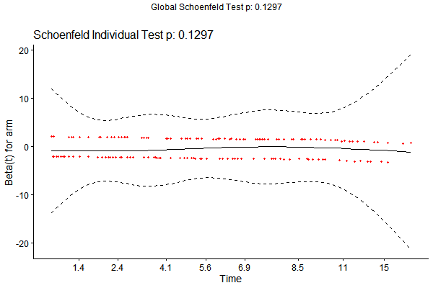 | 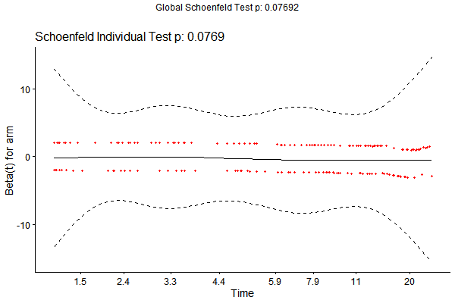 | 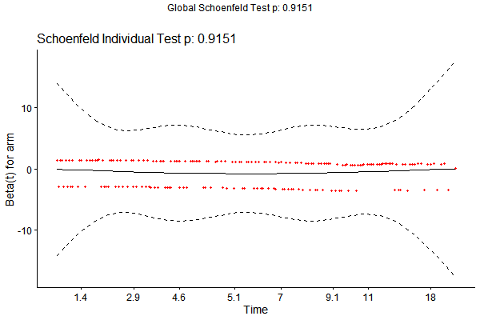
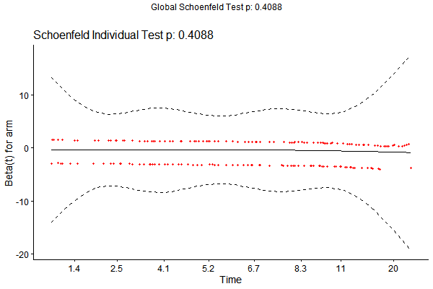 | 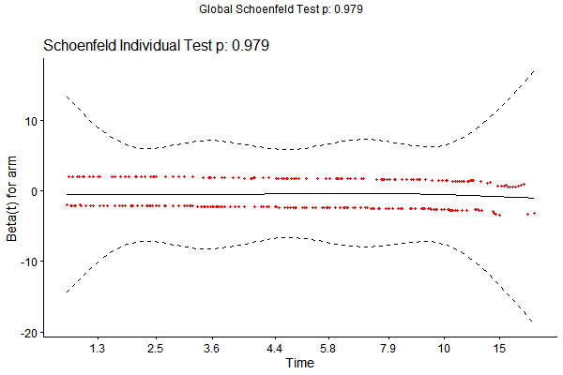 | 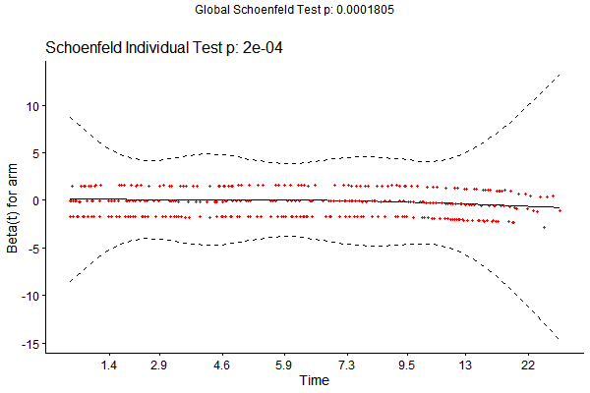
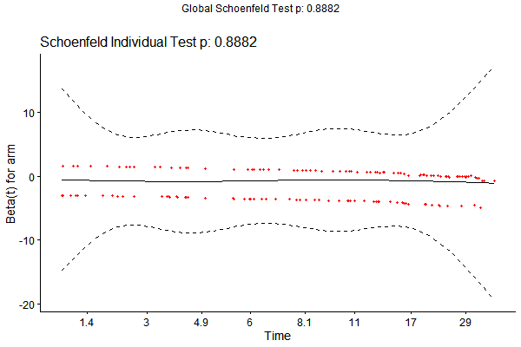 | 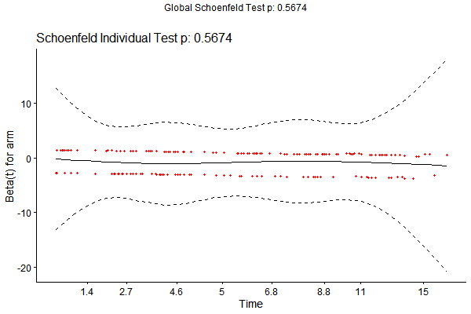 | 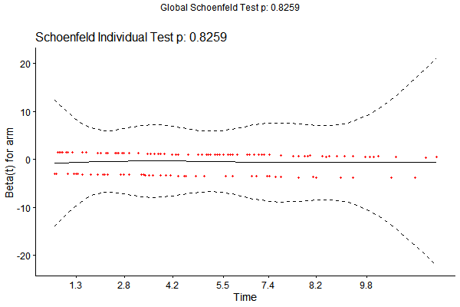
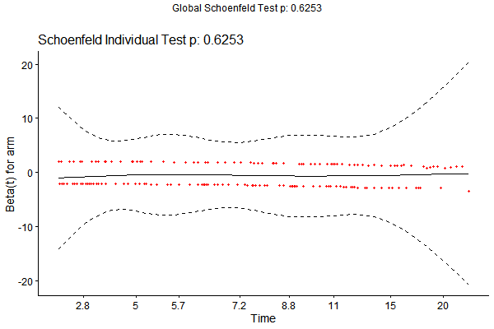
OS, PD-L1 expression ≥ 50%
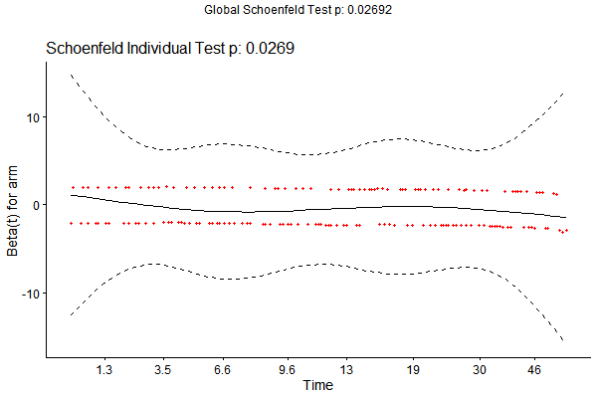 | 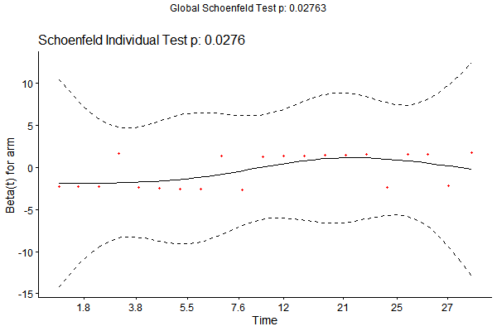 | 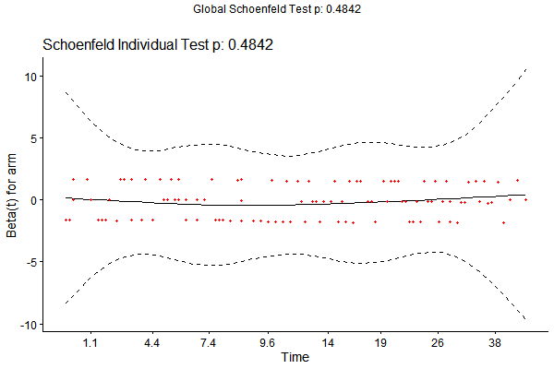
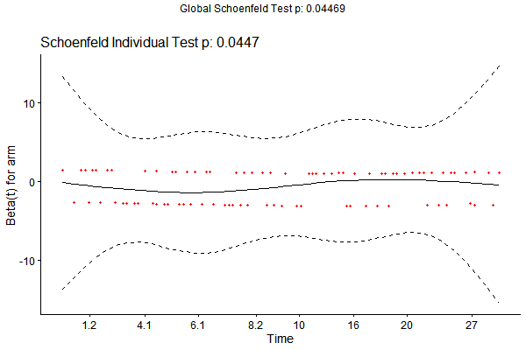
OS, PD-L1 expression < 1%
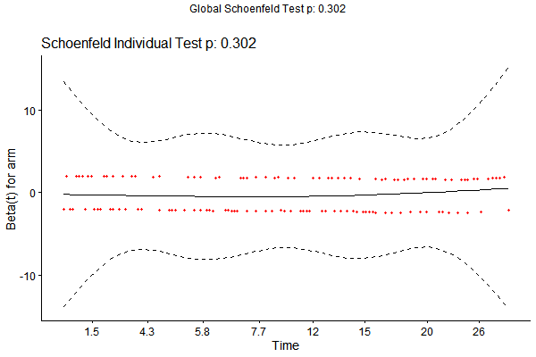 | 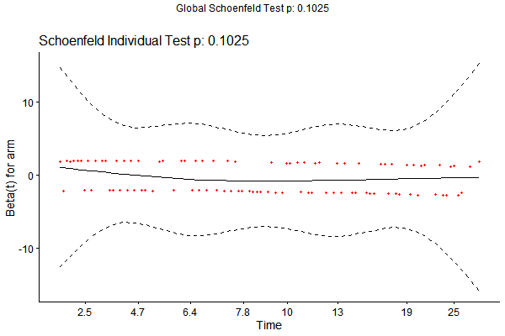 | 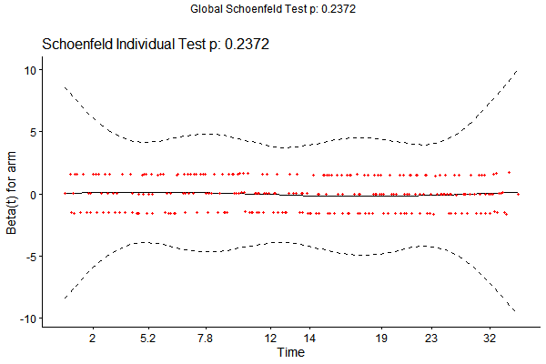
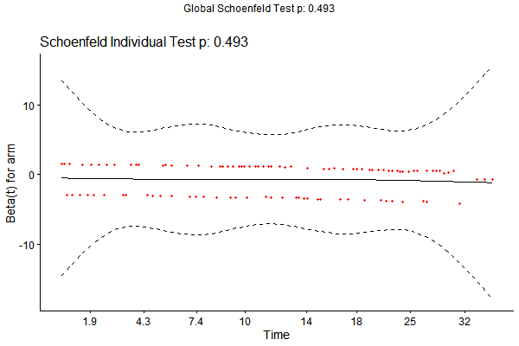
PFS, PD-L1 expression ≥ 50%
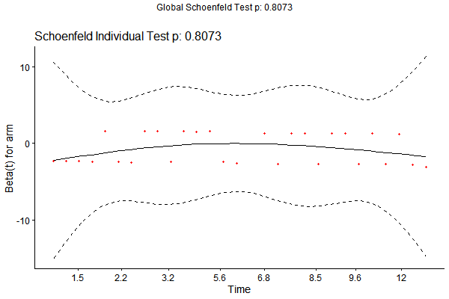 | 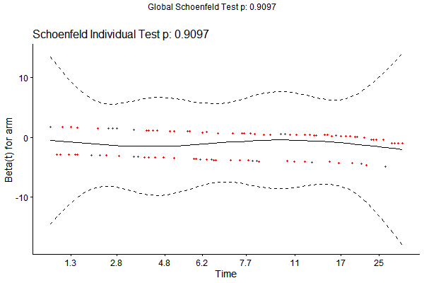 | 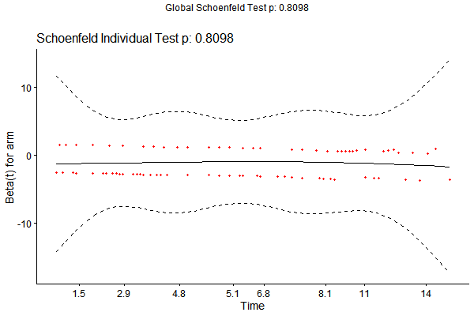
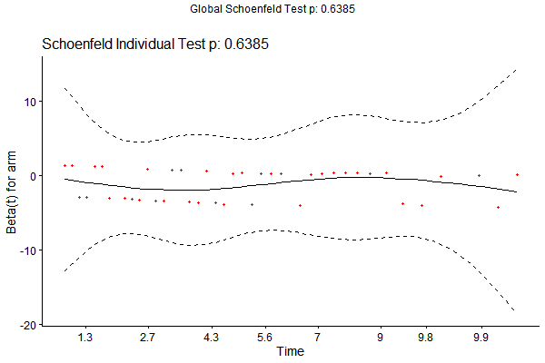
PFS, PD-L1 expression < 1%
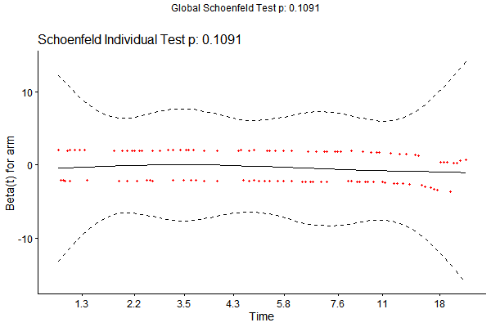 | 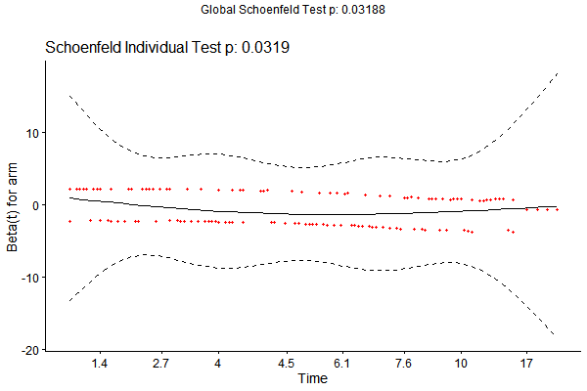 | 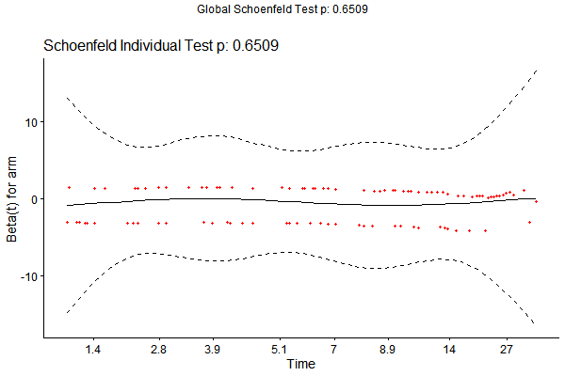
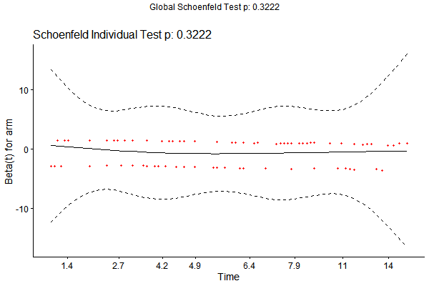 | 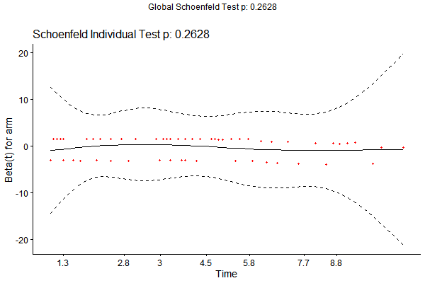

Supplementary Figure 3
Figure of risk of bias assessment
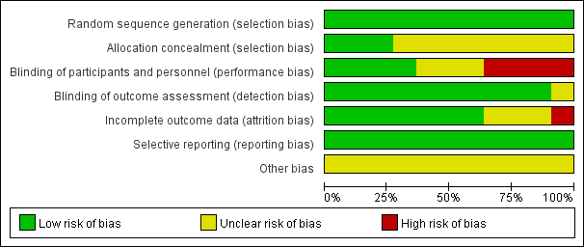
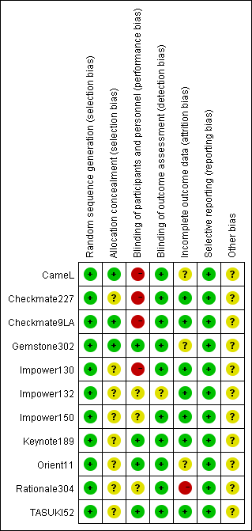

Supplementary Figure 4
Funnel plot to detect the publication bias of included studies
OS  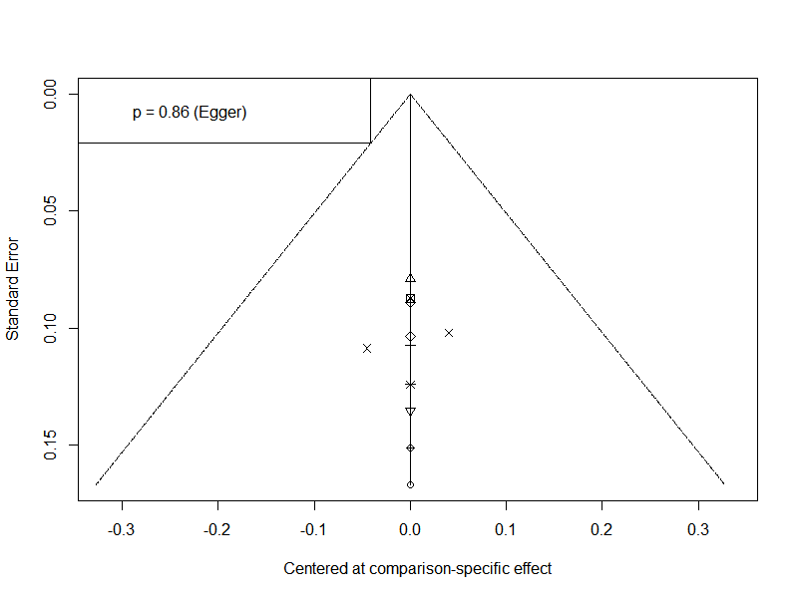 | PFS  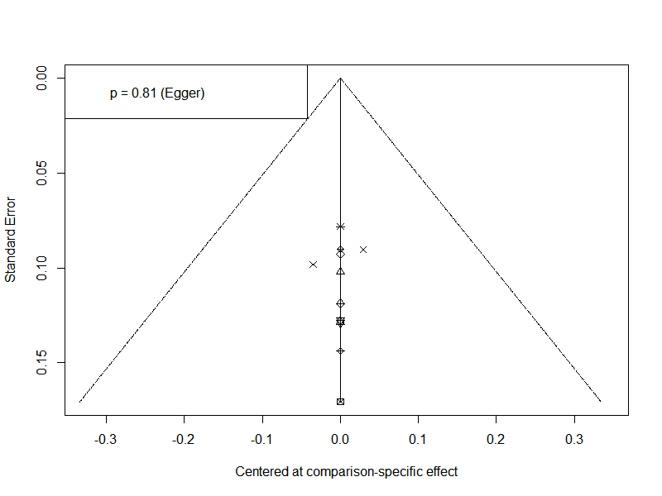
OS: overall survival; PFS: progression-free survival

Supplementary Figure 5
Forest plot of safety
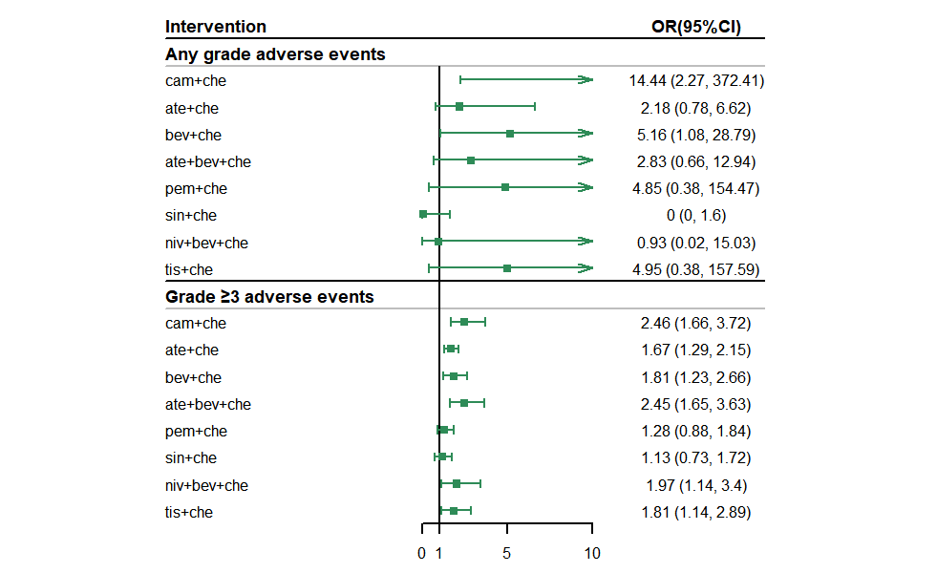
Che: chemotherapy; ate+che: atezolizumab plus chemotherapy; cam+che: camrelizumab plus chemotherapy; ate+bev+che: atezolizumab plus bevacizumab plus chemotherapy; bev+che: bevacizumab plus chemotherapy; niv+bev+che: nivolumab plus bevacizumab plus chemotherapy; pem+che: pembrolizumab plus chemotherapy; tis+che: tislelizumab plus chemotherapy; sin+che: sintilimab plus chemotherapy; OS: overall survival; PFS: progression-free survival; OR: Odds ratio. Reference treatment arm in this forest plot is chemotherapy.

Supplementary Figure 6
Survival plot of RP models for subgroup analysis of PD-L1 expression
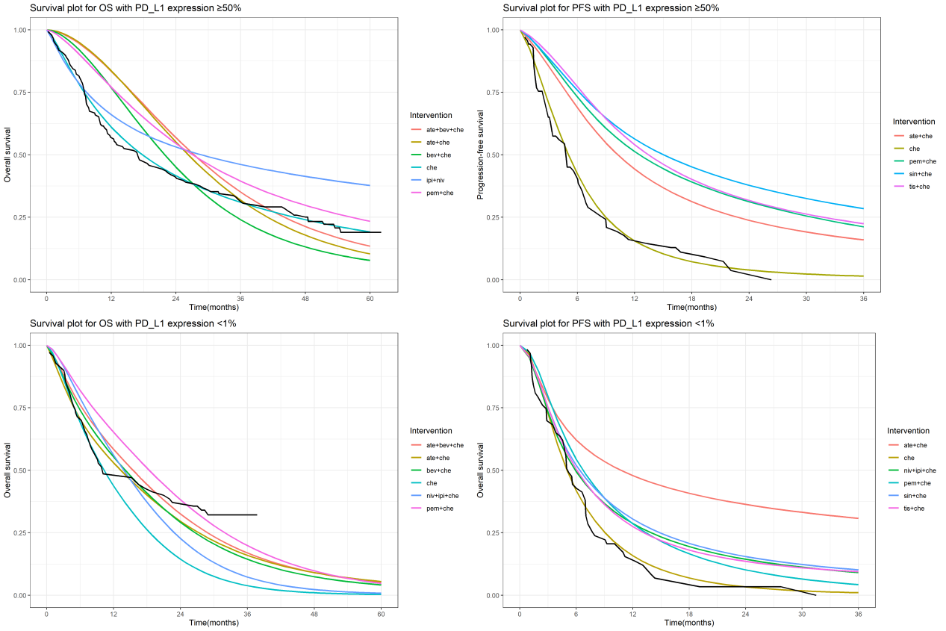
Che: chemotherapy; niv+ipi: nivolumab plus ipilimumab; ate+che: atezolizumab plus chemotherapy; cam+che: camrelizumab plus chemotherapy; niv+ipi+che: nivolumab plus ipilimumab plus chemotherapy; ate+bev+che: atezolizumab plus bevacizumab plus chemotherapy; bev+che: bevacizumab plus chemotherapy; pem+che: pembrolizumab plus chemotherapy; tis+che: tislelizumab plus chemotherapy; sin+che: sintilimab plus chemotherapy; OS: overall survival; PFS: progression-free survival. Black line in survival plots indicated the KM curves of the reference chemotherapy.

Supplementary Figure 7
Rank plot of RP models for subgroup analysis of PD-L1 expression
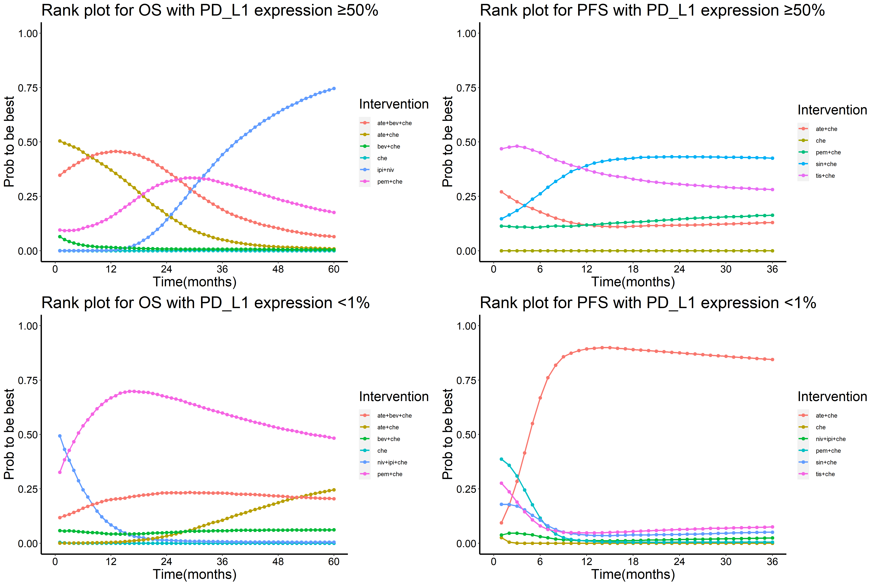
Che: chemotherapy; niv+ipi: nivolumab plus ipilimumab; ate+che: atezolizumab plus chemotherapy; cam+che: camrelizumab plus chemotherapy; niv+ipi+che: nivolumab plus ipilimumab plus chemotherapy; ate+bev+che: atezolizumab plus bevacizumab plus chemotherapy; bev+che: bevacizumab plus chemotherapy; pem+che: pembrolizumab plus chemotherapy; tis+che: tislelizumab plus chemotherapy; sin+che: sintilimab plus chemotherapy; OS: overall survival; PFS: progression-free survival. Prob to be best: probability to be best at each month during 36/60 months.

Supplementary Figure 8
Rank plot of RMST for subgroup analysis of PD-L1 expression
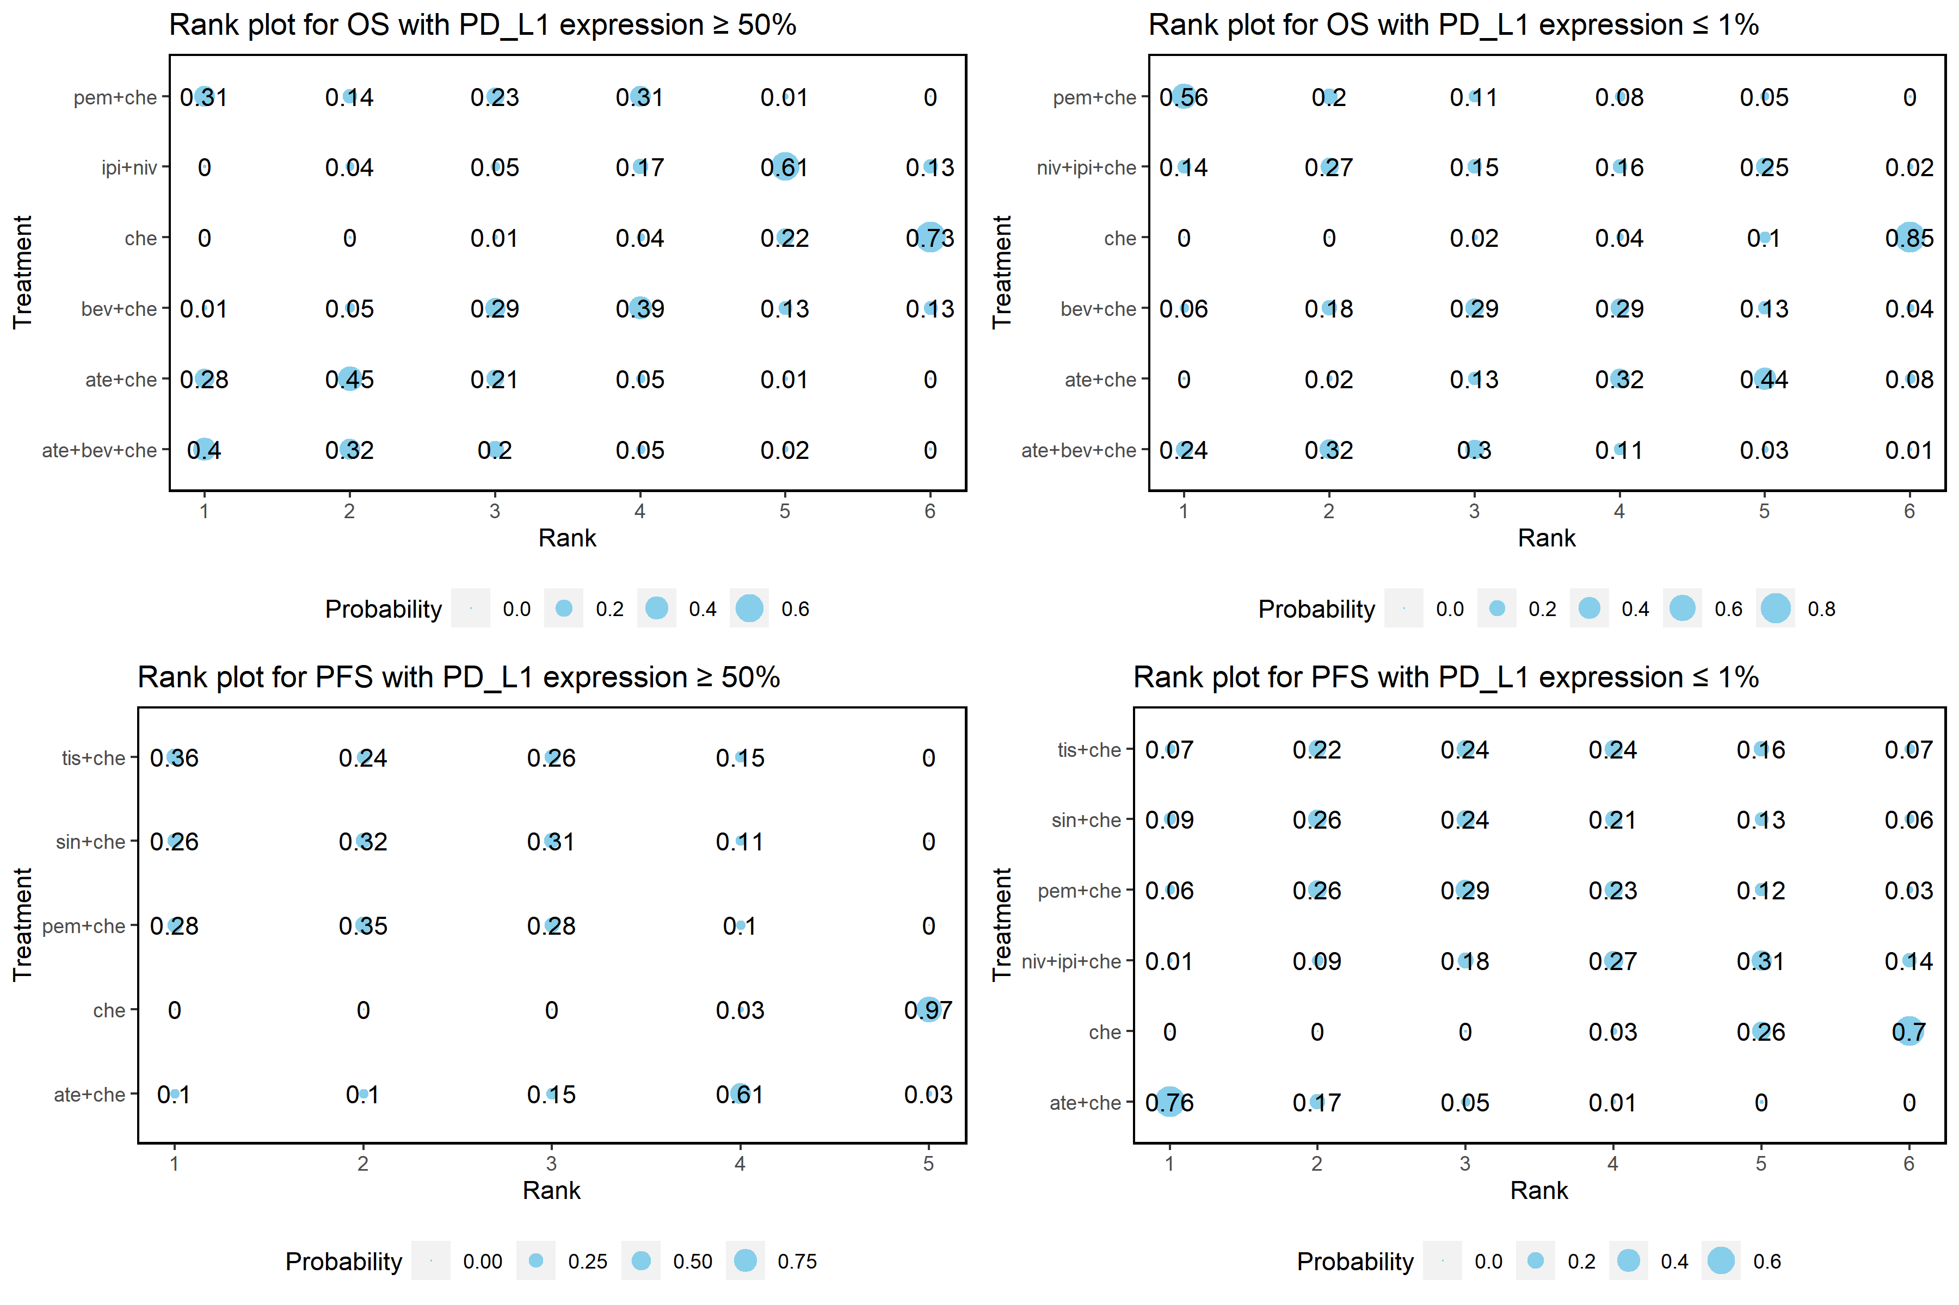
In rank plot, size of each point is proportional to the probability. Che: chemotherapy; niv+ipi: nivolumab plus ipilimumab; ate+che: atezolizumab plus chemotherapy; cam+che: camrelizumab plus chemotherapy; niv+ipi+che: nivolumab plus ipilimumab plus chemotherapy; ate+bev+che: atezolizumab plus bevacizumab plus chemotherapy; bev+che: bevacizumab plus chemotherapy; pem+che: pembrolizumab plus chemotherapy; tis+che: tislelizumab plus chemotherapy; sin+che: sintilimab plus chemotherapy; OS: overall survival; PFS: progression-free survival. Probability: probability to be best at 12/18th month.

Supplementary Figure 9
Forest plot of subgroup analysis of NCCN recommended treatments
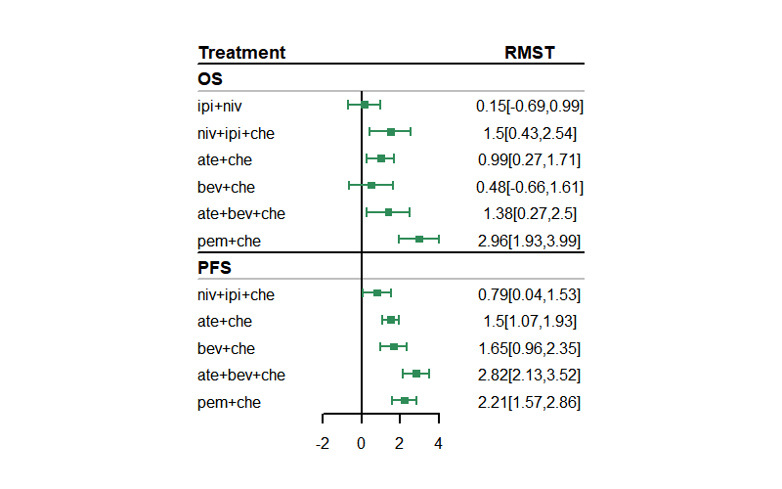
Che: chemotherapy; niv+ipi: nivolumab plus ipilimumab; ate+che: atezolizumab plus chemotherapy; niv+ipi+che: nivolumab plus ipilimumab plus chemotherapy; ate+bev+che: atezolizumab plus bevacizumab plus chemotherapy; bev+che: bevacizumab plus chemotherapy; pem+che: pembrolizumab plus chemotherapy; OS: overall survival; PFS: progression-free survival.

Supplementary Figure 10
Survival plots and rank plots for subgroup analysis of NCCN recommended treatments
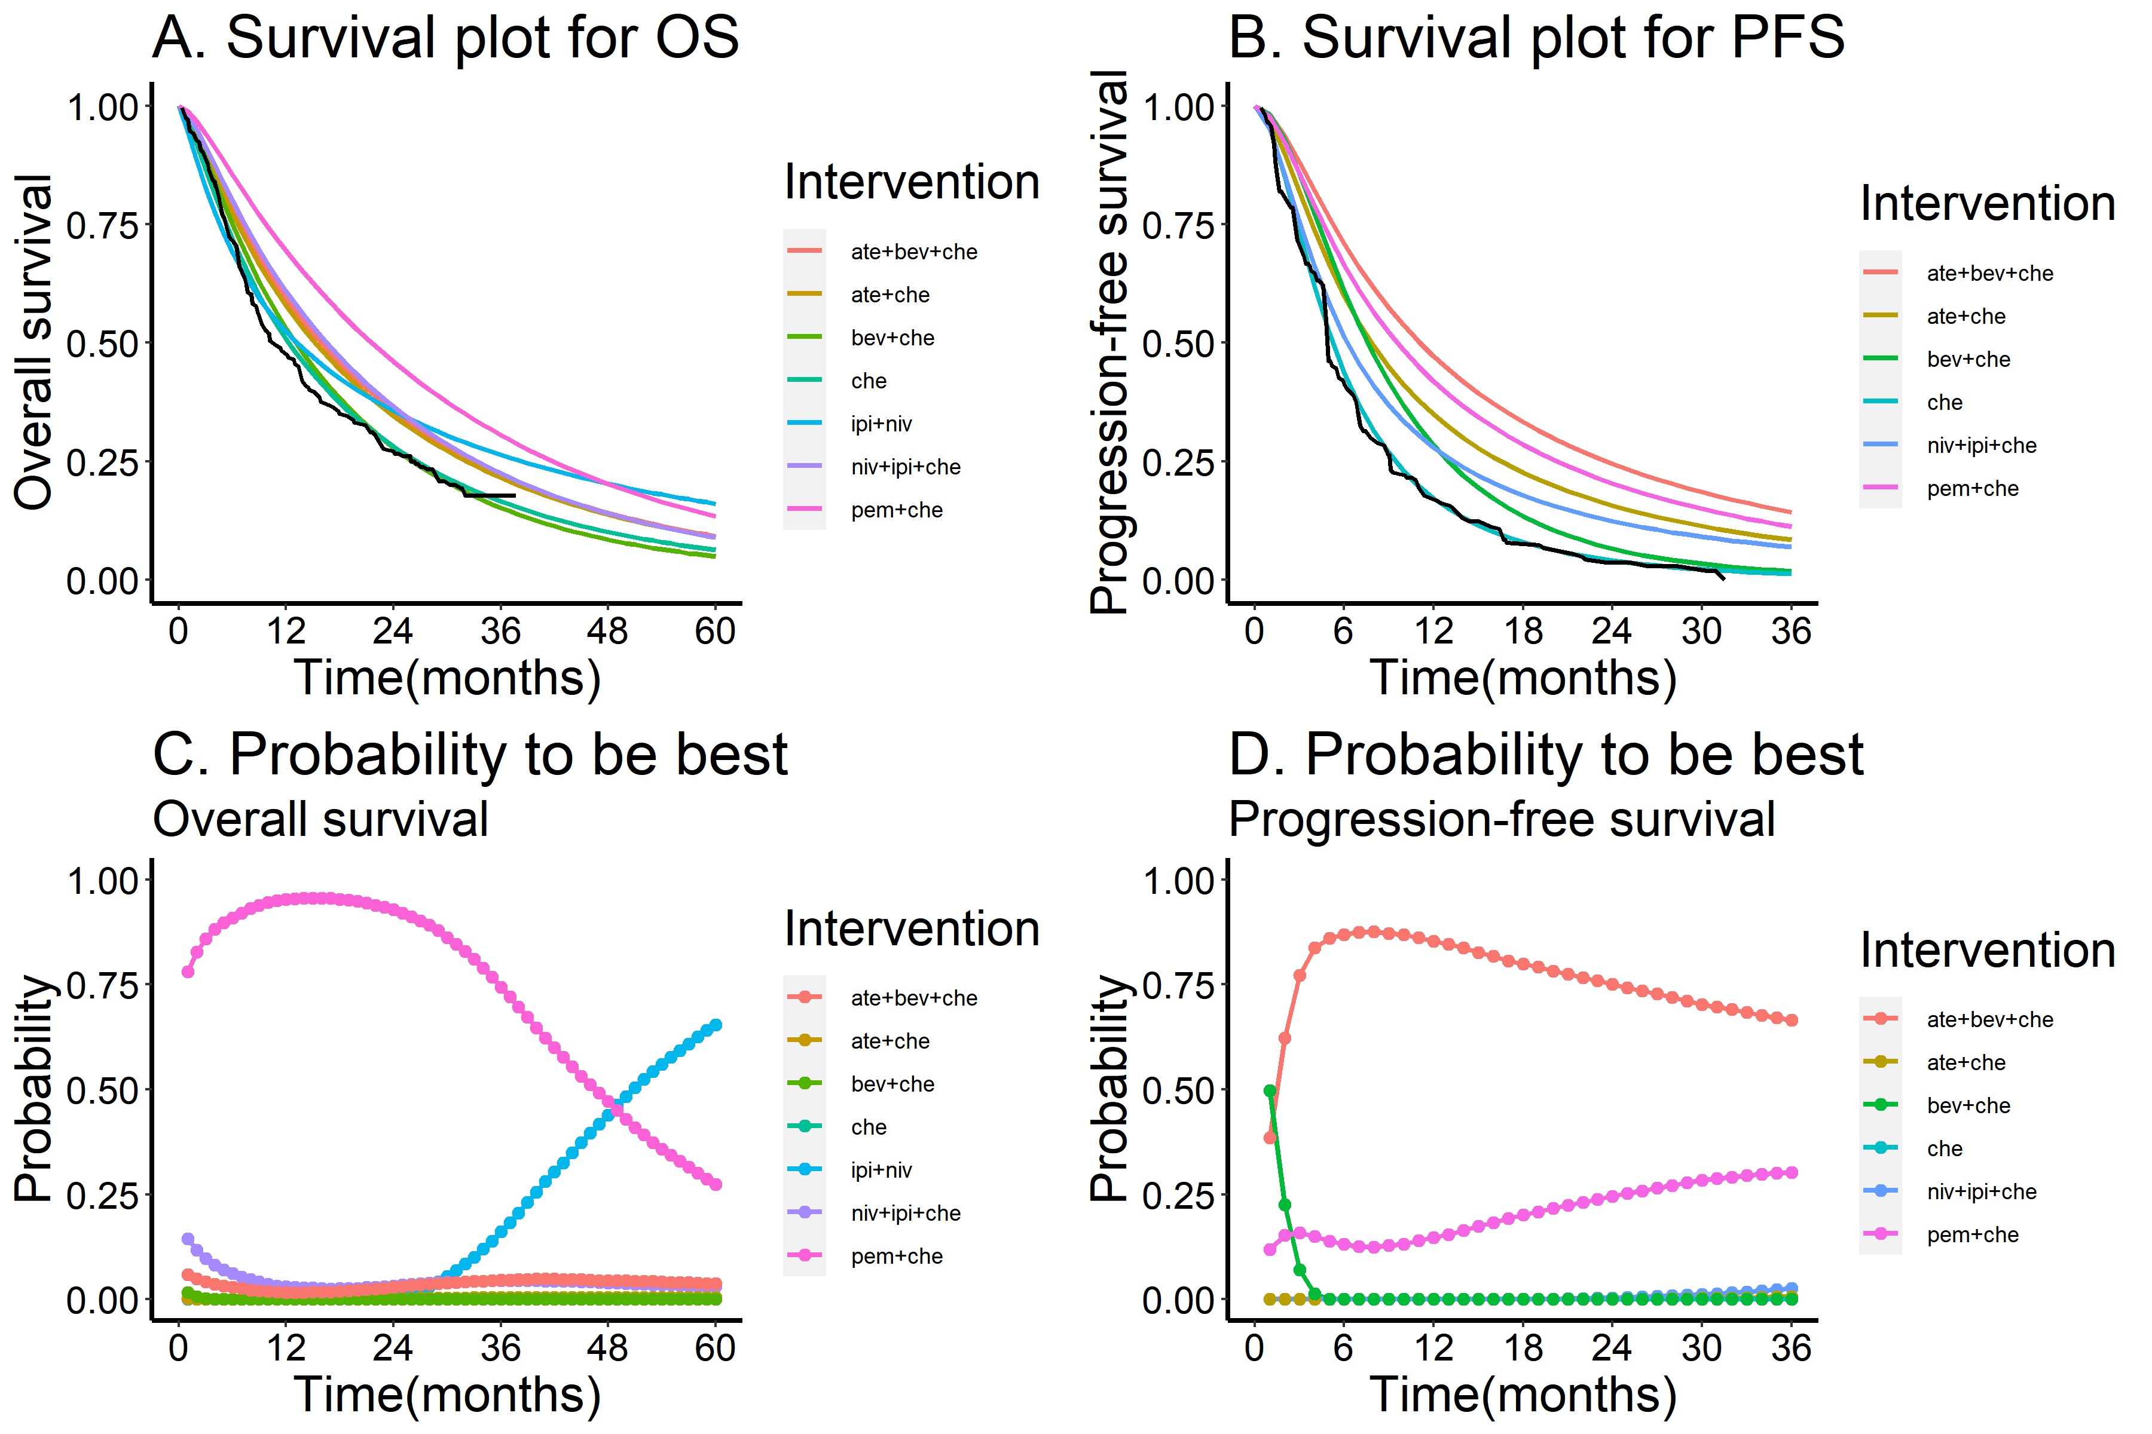
Che: chemotherapy; niv+ipi: nivolumab plus ipilimumab; ate+che: atezolizumab plus chemotherapy; niv+ipi+che: nivolumab plus ipilimumab plus chemotherapy; ate+bev+che: atezolizumab plus bevacizumab plus chemotherapy; bev+che: bevacizumab plus chemotherapy; pem+che: pembrolizumab plus chemotherapy; OS: overall survival; PFS: progression-free survival. Black line in survival plots indicated the KM curves of the reference chemotherapy. Probability: probability to be best at each month during 36/60 months.

Supplementary Figure 11
Results of pairwise meta-analysis
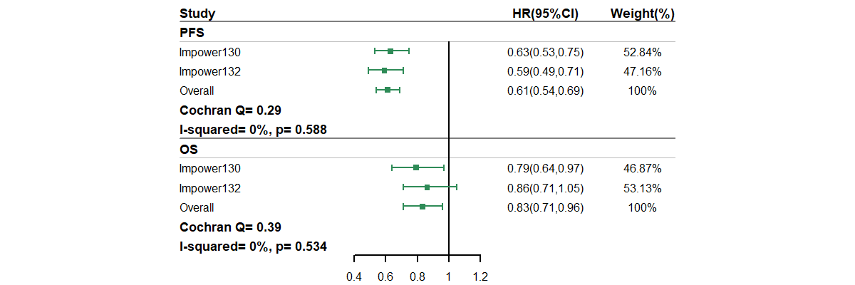
OS: overall survival; PFS: progression-free survival. HR: hazard ratio.

