Supplements
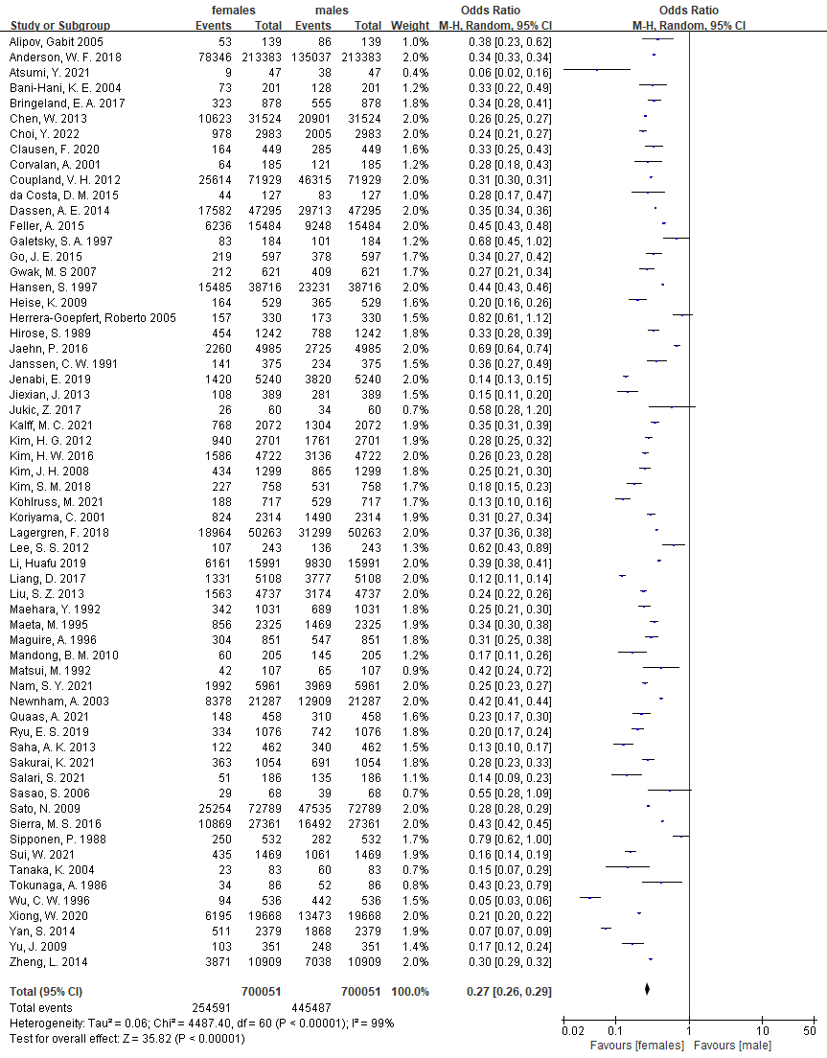
Figure S1 Meta-analysis of female ratio of total patients.

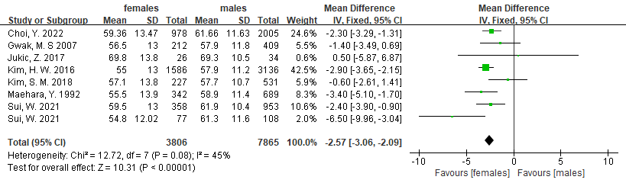
Figure S2 Meta-analysis of age between female and male group.

A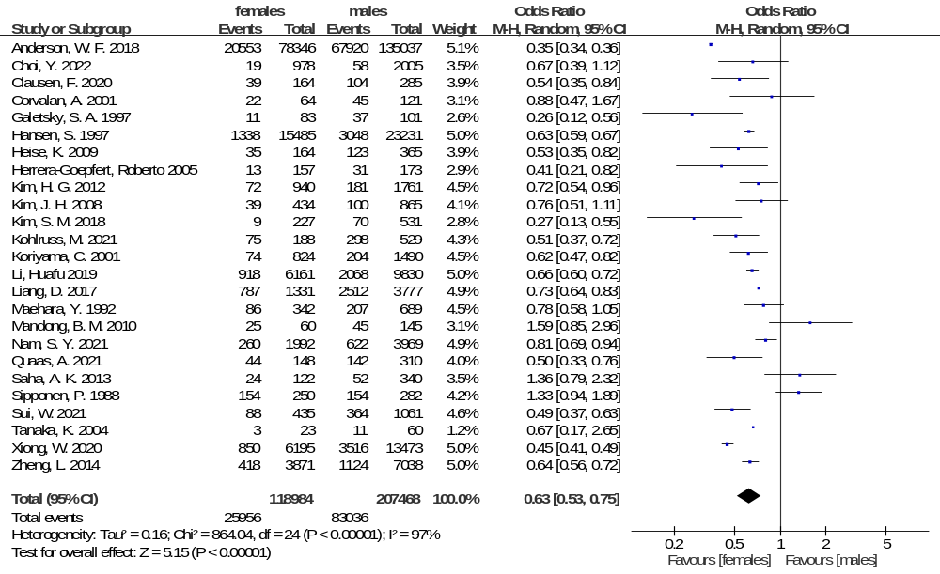
B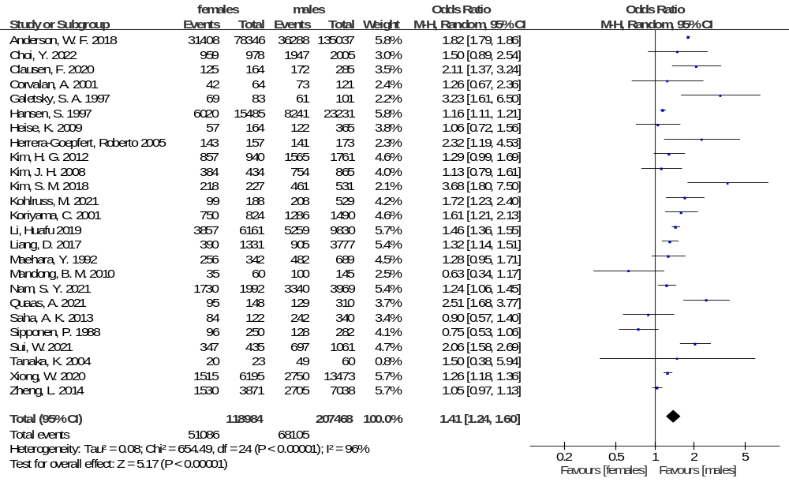
C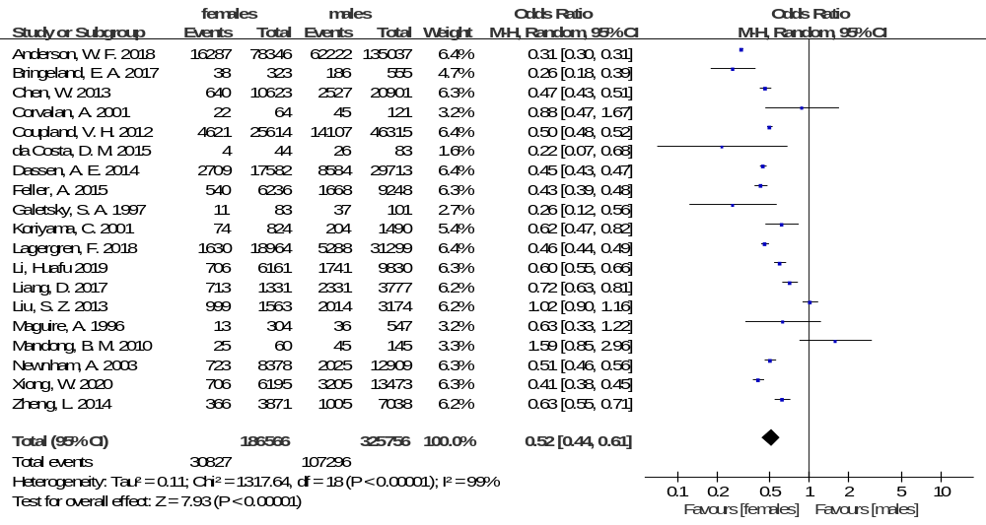D
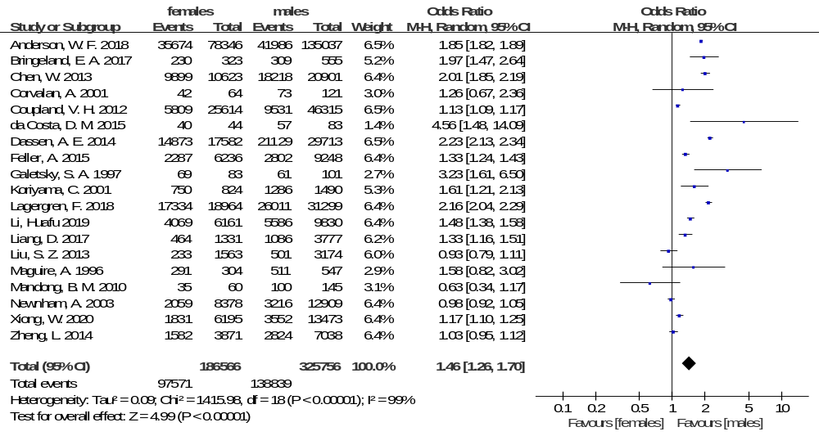E
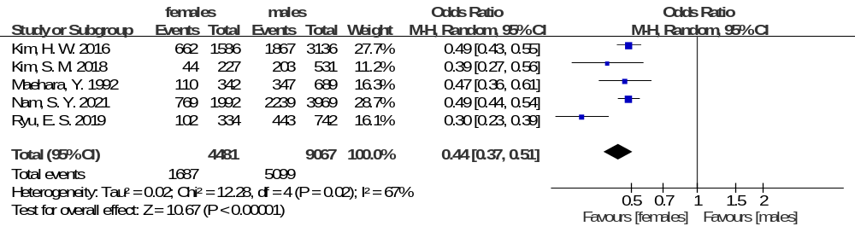F
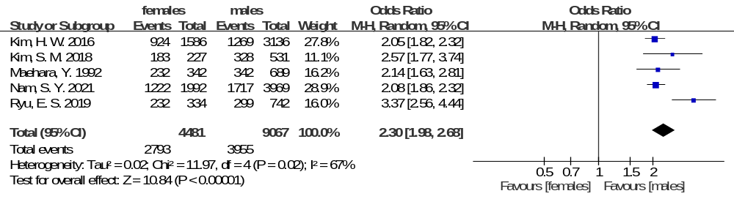G
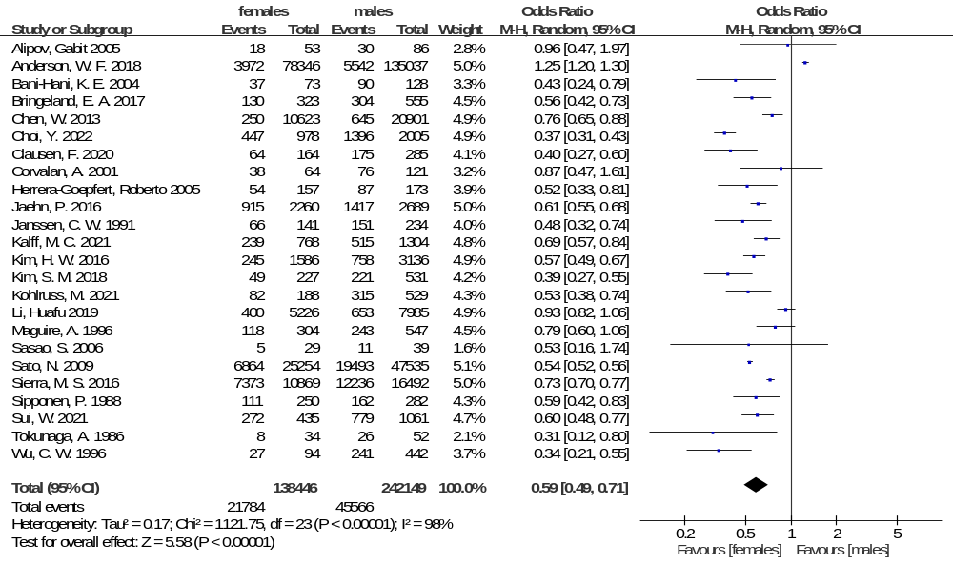H
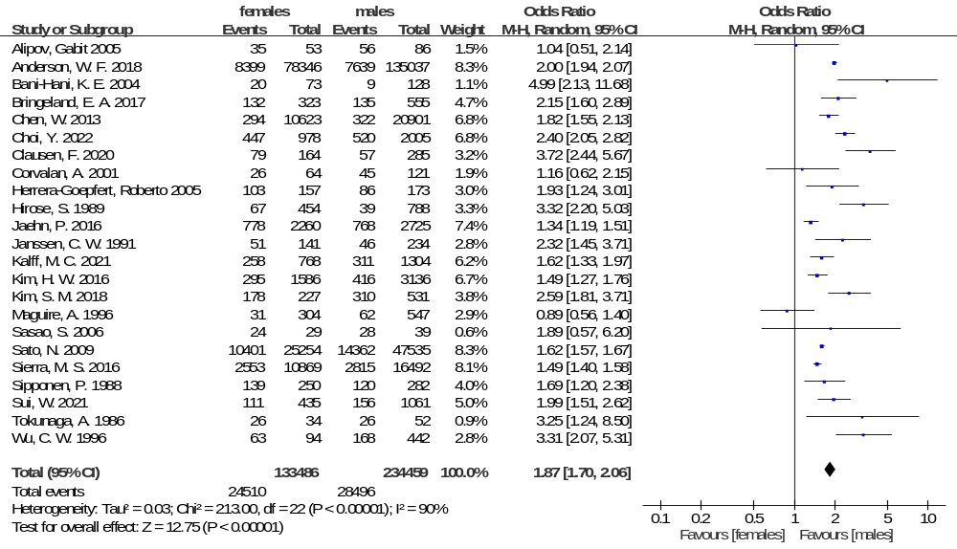I
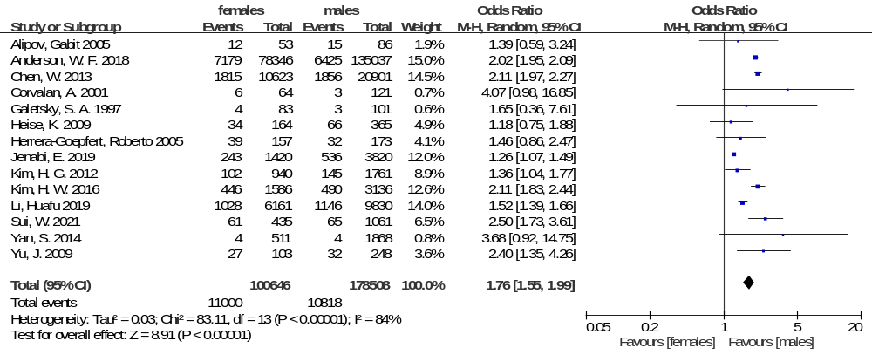Figure S3 The proportion of clinicopathologic feature between female and male group. A, Meta-analysis of proximal cancer; B, meta-analysis of distal cancer; C, meta-analysis of cardia cancer; D, meta-analysis of non-cardia cancer; E, meta-analysis of differentiation; F, meta-analysis of undifferentiation; G, meta-analysis of intestinal type; H, meta-analysis of diffuse type; I, meta-analysis of signet ring cell carcinoma.

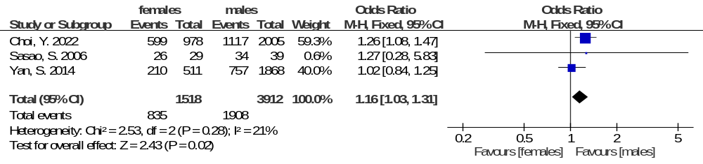
Figure S4 Meta-analysis of the proportion of Hp infection history between female and male group.

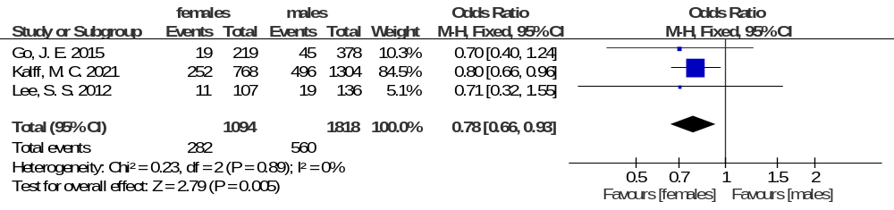
Figure S5 Meta-analysis of the proportion of postoperative complications between female and male group.

A
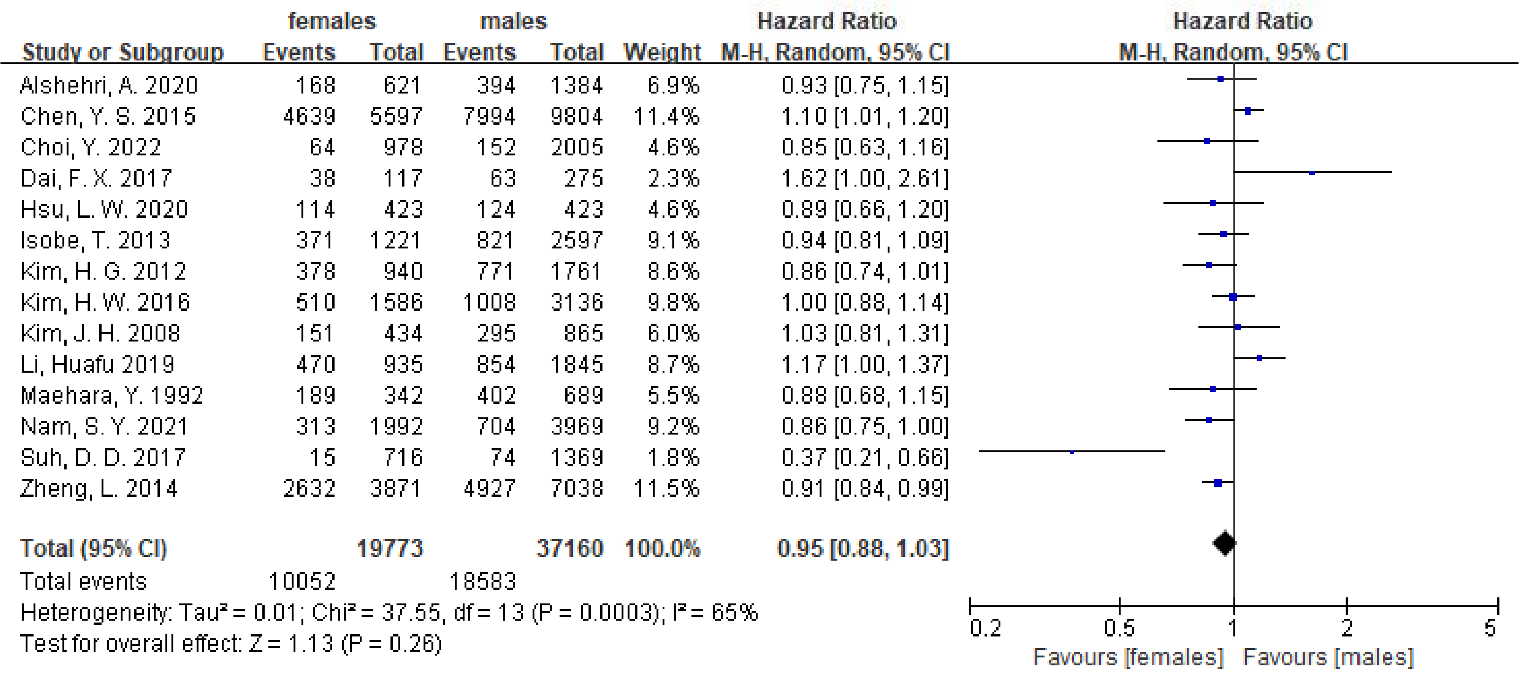
B
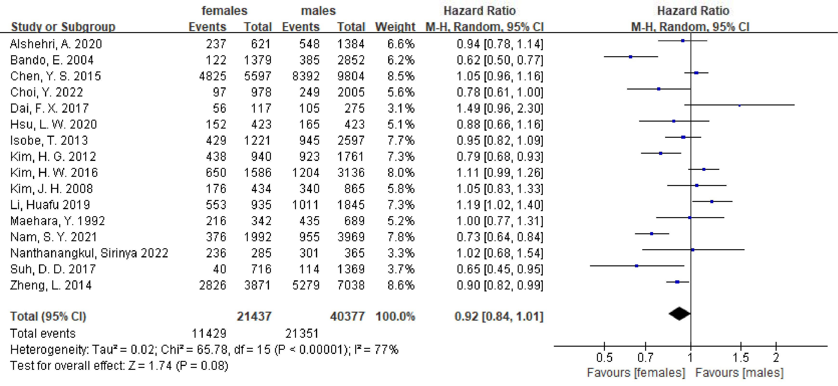
Figure S6 The 3-year and 5-year overall survival for gastric cancer between female and male group among Asian gastric cancer patients. A, The 3-year overall survival of Asian patients; B, the 5-year overall survival of Asian patients.

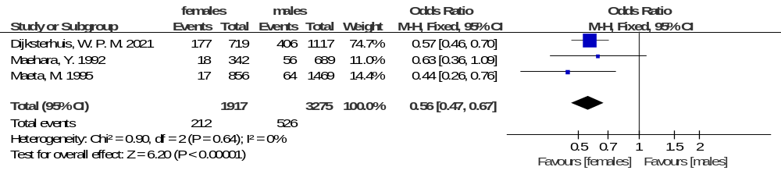
Figure S7 Meta-analysis of the proportion of hepatic metastasis between female and male group
Table S1 Clinicopathological characteristics of the included studies
Authors | Year | No. | Group |  | Proximal |  | Distal | Cardia | Non-cardia | Differentiation | undifferentiated | Intestinal | Diffuse | Signet-ring cell |  | Tumor location |  | TNM stage |  |  |  | Complication | Hepatic metastasis | Hp infection
 |  |  |  |  |  |  |  |  |  |  |  |  |  |  |  | Proximal | Distal | I | II | III | IV | Complication | Hepatic metastasis | Hp infection
Tokunaga, A.[50] | 1986 | 86 | F | 34 | - | - |  | - | - | - | - | 8 | 26 |  | - | - | - | - | - | - | - | - | - | -
Tokunaga, A.[50] | 1986 | 86 | M | 52 | - | - |  | - | - | - | - | 26 | 26 |  | - | - | - | - | - | - | - | - | - | -
Sipponen, P.[51] | 1988 | 532 | F | 250 | 154 | 96 |  | - | - | - | - | 111 | 139 |  | - | 154 | 96 | - | - | - | - | - | - | -
Sipponen, P.[51] | 1988 | 532 | M | 282 | 154 | 128 |  | - | - | - | - | 162 | 120 |  | - | 154 | 128 | - | - | - | - | - | - | -
Hirose, S.[52] | 1989 | 1242 | F | 454 | - | - |  | - | - | - | - | - | 67 |  | - | - | - | - | - | - | - | - | - | -
Hirose, S.[52] | 1989 | 1242 | M | 788 | - | - |  | - | - | - | - | - | 39 |  | - | - | - | - | - | - | - | - | - | -
Janssen, C. W.[53] | 1991 | 375 | F | 141 | - | - |  | - | - | - | - | 66 | 51 |  | - | - | - | - | - | - | - | - | - | -
Janssen, C. W.[53] | 1991 | 375 | M | 234 | - | - |  | - | - | - | - | 151 | 46 |  | - | - | - | - | - | - | - | - | - | -
Maehara, Y.[23] | 1992 | 1031 | F | 342 | 86 | 256 |  | - | - | 110 | 232 | - | - |  | - | 86 | 256 | - | - | - | - | - | 18 | -
Maehara, Y.[23] | 1992 | 1031 | M | 689 | 207 | 482 |  | - | - | 347 | 342 | - | - |  | - | 207 | 482 | - | - | - | - | - | 56 | -
Maeta, M.[49] | 1995 | 2325 | F | 856 | - | - |  | - | - | - | - | - | - |  | - | - | - | - | - | - | - | - | 17 | -
Maeta, M.[49] | 1995 | 2325 | M | 1469 | - | - |  | - | - | - | - | - | - |  | - | - | - | - | - | - | - | - | 64 | -
Wu, C. W.[56] | 1996 | 536 | F | 94 | - | - |  | - | - | - | - | 27 | 63 |  | - | - | - | - | - | - | - | - | - | -
Wu, C. W.[56] | 1996 | 536 | M | 442 | - | - |  | - | - | - | - | 241 | 168 |  | - | - | - | - | - | - | - | - | - | -
Maguire, A.[9] | 1996 | 851 | F | 304 | - | - |  | 13 | 291 | - | - | 118 | 31 |  | - | - | - | - | - | - | - | - | - | -
Maguire, A.[9] | 1996 | 851 | M | 547 | - | - |  | 36 | 511 | - | - | 243 | 62 |  | - | - | - | - | - | - | - | - | - | -
Galetsky, S. A.[57] | 1997 | 184 | F | 83 | 11 | 69 |  | 11 | 69 | - | - | - | - |  | 4 | 11 | 69 | - | - | - | - | - | - | -
Galetsky, S. A.[57] | 1997 | 184 | M | 101 | 37 | 61 |  | 37 | 61 | - | - | - | - |  | 3 | 37 | 61 | - | - | - | - | - | - | -
Hansen, S.[69] | 1997 | 38716 | F | 15485 | 1338 | 6020 |  | - | - | - | - | - | - |  | - | 1338 | 6020 | - | - | - | - | - | - | -
Hansen, S.[69] | 1997 | 38716 | M | 23231 | 3048 | 8241 |  | - | - | - | - | - | - |  | - | 3048 | 8241 | - | - | - | - | - | - | -
Koriyama, C.[58] | 2001 | 2314 | F | 824 | 74 | 750 |  | 74 | 750 | - | - | - | - |  | - | 74 | 750 | - | - | - | - | - | - | -
Koriyama, C.[58] | 2001 | 2314 | M | 1490 | 204 | 1286 |  | 204 | 1286 | - | - | - | - |  | - | 204 | 1286 | - | - | - | - | - | - | -
Corvalan, A.[59] | 2001 | 185 | F | 64 | 22 | 42 |  | 22 | 42 | - | - | 38 | 26 |  | 6 | 22 | 42 | - | - | - | - | - | - | -
Corvalan, A.[59] | 2001 | 185 | M | 121 | 45 | 73 |  | 45 | 73 | - | - | 76 | 45 |  | 3 | 45 | 73 | - | - | - | - | - | - | -
Newnham, A.[70] | 2003 | 21287 | F | 8378 | - | - |  | 723 | 2059 | - | - | - | - |  | - | - | - | - | - | - | - | - | - | -
Newnham, A.[70] | 2003 | 21287 | M | 12909 | - | - |  | 2025 | 3216 | - | - | - | - |  | - | - | - | - | - | - | - | - | - | -
Bani-Hani, K. E.[71] | 2004 | 201 | F | 73 | - | - |  | - | - | - | - | 37 | 20 |  | - | - | - | - | - | - | - | - | - | -
Bani-Hani, K. E.[71] | 2004 | 201 | M | 128 | - | - |  | - | - | - | - | 90 | 9 |  | - | - | - | - | - | - | - | - | - | -
Tanaka, K.[67] | 2004 | 83 | F | 23 | 3 | 20 |  | - | - | - | - | - | - |  | - | 3 | 20 | - | - | - | - | - | - | -
Tanaka, K.[67] | 2004 | 83 | M | 60 | 11 | 49 |  | - | - | - | - | - | - |  | - | 11 | 49 | - | - | - | - | - | - | -
Alipov, Gabit[72] | 2005 | 139 | F | 53 | - | - |  | - | - | - | - | 18 | 35 |  | 12 | - | - | - | - | - | - | - | - | -
Alipov, Gabit[72] | 2005 | 139 | M | 86 | - | - |  | - | - | - | - | 30 | 56 |  | 15 | - | - | - | - | - | - | - | - | -
Herrera-Goepfert, Roberto[73] | 2005 | 330 | F | 157 | 13 | 143 |  | - | - | - | - | 54 | 103 |  | 39 | 13 | 143 | - | - | - | - | - | - | -
Herrera-Goepfert, Roberto[73] | 2005 | 330 | M | 173 | 31 | 141 |  | - | - | - | - | 87 | 86 |  | 32 | 31 | 141 | - | - | - | - | - | - | -
Sasao, S.[60] | 2006 | 134 | F | 53 | - | - |  | - | - | - | - | 5 | 24 |  | - | - | - | - | - | - | - | - | - | 26
Sasao, S.[60] | 2006 | 134 | M | 81 | - | - |  | - | - | - | - | 11 | 28 |  | - | - | - | - | - | - | - | - | - | 34
Gwak, M. S.[61] | 2007 | 621 | F | 212 | - | - |  | - | - | - | - | - | - |  | - | - | - | - | - | - | - | - | - | -
Gwak, M. S.[61] | 2007 | 621 | M | 409 | - | - |  | - | - | - | - | - | - |  | - | - | - | - | - | - | - | - | - | -
Kim, J. H.[24] | 2008 | 1299 | F | 434 | 39 | 384 |  | - | - | - | - | - | - |  | - | 39 | 384 | 197 | 61 | 123 | 53 | - | - | -
Kim, J. H.[24] | 2008 | 1299 | M | 865 | 100 | 754 |  | - | - | - | - | - | - |  | - | 100 | 754 | 321 | 104 | 230 | 210 | - | - | -
Heise, K.[11] | 2009 | 529 | F | 164 | 35 | 57 |  | - | - | - | - | - | - |  | 34 | 35 | 57 | 1 | 11 | 15 | 83 | - | - | -
Heise, K.[11] | 2009 | 529 | M | 365 | 123 | 122 |  | - | - | - | - | - | - |  | 66 | 123 | 122 | 8 | 9 | 38 | 214 | - | - | -
Yu, J.[62] | 2009 | 351 | F | 103 | - | - |  | - | - | - | - | - | - |  | 27 | - | - | - | - | - | - | - | - | -
Yu, J.[62] | 2009 | 351 | M | 248 | - | - |  | - | - | - | - | - | - |  | 32 | - | - | - | - | - | - | - | - | -
Sato, N.[63] | 2009 | 72789 | F | 25254 | - | - |  | - | - | - | - | 6864 | 10401 |  | - | - | - | - | - | - | - | - | - | -
Sato, N.[63] | 2009 | 72789 | M | 47535 | - | - |  | - | - | - | - | 19493 | 14362 |  | - | - | - | - | - | - | - | - | - | -
Mandong, B. M.[74] | 2010 | 205 | F | 60 | 25 | 35 |  | 25 | 35 | - | - | - | - |  | - | 25 | 35 | - | - | - | - | - | - | -
Mandong, B. M.[74] | 2010 | 205 | M | 145 | 45 | 100 |  | 45 | 100 | - | - | - | - |  | - | 45 | 100 | - | - | - | - | - | - | -
Kim, H. G.[12] | 2012 | 2701 | F | 940 | 72 | 857 |  | - | - | - | - | - | - |  | 102 | 72 | 857 | 444 | 194 | 255 | 47 | - | - | -
Kim, H. G.[12] | 2012 | 2701 | M | 1761 | 181 | 1565 |  | - | - | - | - | - | - |  | 145 | 181 | 1565 | 797 | 367 | 485 | 112 | - | - | -
Lee, S. S.[30] | 2012 | 243 | F | 107 | - | - |  | - | - | - | - | - | - |  | - | - | - | 80 | 27 | - | - | 11 | - | -
Lee, S. S.[30] | 2012 | 243 | M | 136 | - | - |  | - | - | - | - | - | - |  | - | - | - | 113 | 23 | - | - | 19 | - | -
Coupland, V. H.[75] | 2012 | 71929 | F | 25614 | - | - |  | 4621 | 5809 | - | - | - | - |  | - | - | - | - | - | - | - | - | - | -
Coupland, V. H.[75] | 2012 | 71929 | M | 46315 | - | - |  | 14107 | 9531 | - | - | - | - |  | - | - | - | - | - | - | - | - | - | -
Saha, A. K.[76] | 2013 | 462 | F | 122 | 24 | 84 |  | - | - | - | - | - | - |  | - | 24 | 84 | - | - | - | - | - | - | -
Saha, A. K.[76] | 2013 | 462 | M | 340 | 52 | 242 |  | - | - | - | - | - | - |  | - | 52 | 242 | - | - | - | - | - | - | -
Chen, W.[78] | 2013 | 31524 | F | 10623 | - | - |  | 640 | 9899 | - | - | 250 | 294 |  | 1815 | - | - | - | - | - | - | - | - | -
Chen, W.[78] | 2013 | 31524 | M | 20901 | - | - |  | 2527 | 18218 | - | - | 645 | 322 |  | 1856 | - | - | - | - | - | - | - | - | -
Liu, S. Z.[79] | 2013 | 4737 | F | 1563 | - | - |  | 999 | 233 | - | - | - | - |  | - | - | - | - | - | - | - | - | - | -
Liu, S. Z.[79] | 2013 | 4737 | M | 3174 | - | - |  | 2014 | 501 | - | - | - | - |  | - | - | - | - | - | - | - | - | - | -
Yan, S.[80] | 2014 | 2379 | F | 511 | - | - |  | - | - | - | - | - | - |  | 4 | - | - | - | - | - | - | - | - | 210
Yan, S.[80] | 2014 | 2379 | M | 1868 | - | - |  | - | - | - | - | - | - |  | 4 | - | - | - | - | - | - | - | - | 757
Zheng, L.[42] | 2014 | 10909 | F | 3871 | 418 | 1530 |  | 366 | 1582 | - | - | - | - |  | - | 418 | 1530 | 207 | 364 | 451 | 522 | - | - | -
Zheng, L.[42] | 2014 | 10909 | M | 7038 | 1124 | 2705 |  | 1005 | 2824 | - | - | - | - |  | - | 1124 | 2705 | 394 | 721 | 902 | 982 | - | - | -
Dassen, A. E.[81] | 2014 | 47295 | F | 17582 | - | - |  | 2709 | 14873 | - | - | - | - |  | - | - | - | - | - | - | - | - | - | -
Dassen, A. E.[81] | 2014 | 47295 | M | 29713 | - | - |  | 8584 | 21129 | - | - | - | - |  | - | - | - | - | - | - | - | - | - | -
Feller, A.[82] | 2015 | 15484 | F | 6236 | - | - |  | 540 | 2287 | - | - | - | - |  | - | - | - | - | - | - | - | - | - | -
Feller, A.[82] | 2015 | 15484 | M | 9248 | - | - |  | 1668 | 2802 | - | - | - | - |  | - | - | - | - | - | - | - | - | - | -
da Costa, D. M.[64] | 2015 | 127 | F | 44 | - | - |  | 4 | 40 | - | - | - | - |  | - | - | - | - | - | - | - | - | - | -
da Costa, D. M.[64] | 2015 | 127 | M | 83 | - | - |  | 26 | 57 | - | - | - | - |  | - | - | - | - | - | - | - | - | - | -
Go, J. E.[31] | 2015 | 597 | F | 219 | - | - |  | - | - | - | - | - | - |  | - | - | - | 182 | 26 | 11 | - | 19 | - | -
Go, J. E.[31] | 2015 | 597 | M | 378 | - | - |  | - | - | - | - | - | - |  | - | - | - | 340 | 36 | 2 | - | 45 | - | -
Jaehn, P.[83] | 2016 | 4985 | F | 2260 | - | - |  | - | - | - | - | 915 | 778 |  | - | - | - | - | - | - | - | - | - | -
Jaehn, P.[83] | 2016 | 4985 | M | 2725 | - | - |  | - | - | - | - | 1417 | 768 |  | - | - | - | - | - | - | - | - | - | -
Sierra, M. S.[84] | 2016 | 27361 | F | 10869 | - | - |  | - | - | - | - | 7373 | 2553 |  | - | - | - | - | - | - | - | - | - | -
Sierra, M. S.[84] | 2016 | 27361 | M | 16492 | - | - |  | - | - | - | - | 12236 | 2815 |  | - | - | - | - | - | - | - | - | - | -
Kim, H. W.[35] | 2016 | 4722 | F | 1586 | - | - |  | - | - | 662 | 924 | 245 | 295 |  | 446 | - | - | 897 | 65 | 623 | - | - | - | -
Kim, H. W.[35] | 2016 | 4722 | M | 3136 | - | - |  | - | - | 1867 | 1269 | 758 | 416 |  | 490 | - | - | 1858 | 119 | 1159 | - | - | - | -
Liang, D.[85] | 2017 | 5108 | F | 1331 | 787 | 390 |  | 713 | 464 | - | - | - | - |  | - | 787 | 390 | - | - | - | - | - | - | -
Liang, D.[85] | 2017 | 5108 | M | 3777 | 2512 | 905 |  | 2331 | 1086 | - | - | - | - |  | - | 2512 | 905 | - | - | - | - | - | - | -
Jukic, Z.[65] | 2017 | 60 | F | 26 | - | - |  | - | - | - | - | - | - |  | - | - | - | - | - | - | - | - | - | -
Jukic, Z.[65] | 2017 | 60 | M | 34 | - | - |  | - | - | - | - | - | - |  | - | - | - | - | - | - | - | - | - | -
Bringeland, E. A.[86] | 2017 | 878 | F | 323 | - | - |  | 38 | 230 | - | - | 130 | 132 |  | - | - | - | - | - | - | - | - | - | -
Bringeland, E. A.[86] | 2017 | 878 | M | 555 | - | - |  | 186 | 309 | - | - | 304 | 135 |  | - | - | - | - | - | - | - | - | - | -
Kim, S. M.[7] | 2018 | 758 | F | 227 | 9 | 218 |  | - | - | 44 | 183 | 49 | 178 |  | - | 9 | 218 | 137 | 45 | 39 | 6 | - | - | -
Kim, S. M.[7] | 2018 | 758 | M | 531 | 70 | 461 |  | - | - | 203 | 328 | 221 | 310 |  | - | 70 | 461 | 328 | 80 | 117 | 6 | - | - | -
Anderson, W. F.[87] | 2018 | 142783 | F | 63746 | 20553 | 31408 |  | 16287 | 35674 | - | - | 3972 | 8399 |  | 7179 | 20553 | 31408 | - | - | - | - | - | - | -
Anderson, W. F.[87] | 2018 | 142783 | M | 79037 | 67920 | 36288 |  | 62222 | 41986 | - | - | 5542 | 7639 |  | 6425 | 67920 | 36288 | - | - | - | - | - | - | -
Lagergren, F.[88] | 2018 | 50263 | F | 18964 | - | - |  | 1630 | 17334 | - | - | - | - |  | - | - | - | - | - | - | - | - | - | -
Lagergren, F.[88] | 2018 | 50263 | M | 31299 | - | - |  | 5288 | 26011 | - | - | - | - |  | - | - | - | - | - | - | - | - | - | -
Jenabi, E.[89] | 2019 | 5240 | F | 1420 | - | - |  | - | - | - | - | - | - |  | 243 | - | - | - | - | - | - | - | - | -
Jenabi, E.[89] | 2019 | 5240 | M | 3820 | - | - |  | - | - | - | - | - | - |  | 536 | - | - | - | - | - | - | - | - | -
Ryu, E. S.[47] | 2019 | 1076 | F | 334 | - | - |  | - | - | 102 | 232 | - | - |  | - | - | - | - | - | - | - | - | - | -
Ryu, E. S.[47] | 2019 | 1076 | M | 742 | - | - |  | - | - | 443 | 299 | - | - |  | - | - | - | - | - | - | - | - | - | -
Li, Huafu[44] | 2019 | 15991 | F | 6161 | 918 | 3857 |  | 706 | 4069 | - | - | 400 | - |  | 1028 | 918 | 3857 | 449 | 1597 | 3907 | 211 | - | - | -
Li, Huafu[44] | 2019 | 15991 | M | 9830 | 2068 | 5259 |  | 1741 | 5586 | - | - | 653 | - |  | 1146 | 2068 | 5259 | 639 | 2930 | 5913 | 348 | - | - | -
Clausen, F.[40] | 2020 | 449 | F | 164 | 39 | 125 |  | - | - | - | - | 64 | 79 |  | - | 39 | 125 | 29 | 42 | 54 | 39 | - | - | -
Clausen, F.[40] | 2020 | 449 | M | 285 | 104 | 172 |  | - | - | - | - | 175 | 57 |  | - | 104 | 172 | 45 | 59 | 135 | 46 | - | - | -
Xiong, W.[90] | 2020 | 19668 | F | 6195 | 850 | 1515 |  | 706 | 1831 | - | - | - | - |  | - | 850 | 1515 | - | - | - | - | - | - | -
Xiong, W.[90] | 2020 | 19668 | M | 13473 | 3516 | 2750 |  | 3205 | 3552 | - | - | - | - |  | - | 3516 | 2750 | - | - | - | - | - | - | -
Kalff, M. C.[32] | 2021 | 2072 | F | 768 | - | - |  | - | - | - | - | 239 | 258 |  | - | - | - | - | - | - | - | 252 | - | -
Kalff, M. C.[32] | 2021 | 2072 | M | 1304 | - | - |  | - | - | - | - | 515 | 311 |  | - | - | - | - | - | - | - | 496 | - | -
Quaas, A.[14] | 2021 | 458 | F | 148 | 44 | 95 |  | - | - | - | - | - | - |  | - | 44 | 95 | 29 | 40 | 40 | 20 | - | - | -
Quaas, A.[14] | 2021 | 458 | M | 310 | 142 | 129 |  | - | - | - | - | - | - |  | - | 142 | 129 | 63 | 74 | 97 | 41 | - | - | -
Sui, W.[48] | 2021 | 1496 | F | 435 | 88 | 347 |  | - | - | - | - | 272 | 111 |  | 61 | 88 | 347 | - | - | - | - | - | - | -
Sui, W.[48] | 2021 | 1496 | M | 1061 | 364 | 697 |  | - | - | - | - | 779 | 156 |  | 65 | 364 | 697 | - | - | - | - | - | - | -
Nam, S. Y.[41] | 2021 | 5961 | F | 1992 | 260 | 1730 |  | - | - | 769 | 1222 | - | - |  | - | 260 | 1730 | 1452 | 163 | 148 | 222 | - | - | -
Nam, S. Y.[41] | 2021 | 5961 | M | 3969 | 622 | 3340 |  | - | - | 2239 | 1717 | - | - |  | - | 622 | 3340 | 2828 | 357 | 300 | 468 | - | - | -
Kohlruss, M.[15] | 2021 | 717 | F | 188 | 75 | 99 |  | - | - | - | - | 82 | - |  | - | 75 | 99 | - | - | - | - | - | - | -
Kohlruss, M.[15] | 2021 | 717 | M | 529 | 298 | 208 |  | - | - | - | - | 315 | - |  | - | 298 | 208 | - | - | - | - | - | - | -
Dijksterhuis, W. P. M.[22] | 2021 | 1836 | F | 719 | - | - |  | - | - | - | - | - | - |  | - | - | - | - | - | - | - | - | 177 | -
Dijksterhuis, W. P. M.[22] | 2021 | 1836 | M | 1117 | - | - |  | - | - | - | - | - | - |  | - | - | - | - | - | - | - | - | 406 | -
Choi, Y.[16] | 2022 | 2983 | F | 978 | 19 | 959 |  | - | - | - | - | 447 | 447 |  | - | 19 | 959 | - | - | - | - | - | - | 599
Choi, Y.[16] | 2022 | 2983 | M | 2005 | 58 | 1947 |  | - | - | - | - | 1396 | 520 |  | - | 58 | 1947 | - | - | - | - | - | - | 1117

