Supplementary material
Appendix A | Search strategy
Appendix B | Study characteristics
Appendix C | Subgroup analysis and Meta regression
Figure 1 | One-stage hip revision
Figure 2 | Two-stage hip revision
Figure 3 | One-stage knee revision
Figure 4 | Two-stage knee revision

Appendix A. Systematic search strategy.
We queried studies published between April 2015 and December 2020 in Medline, Embase, and the Cochrane library. No language restrictions were applied. Each search was transformed according to each specific database.
PUBMED SEARCH
1.1 Domain: infection
Infection[MeSH] OR Infecti*[tiab] OR Reinfection[tiab] OR Re-infection[tiab] OR Prosthesis Infection[tiab] OR Prosthesis-Related Infections[tiab] OR PJI[tiab] OR Periprosthetic Joint Infection[tiab] OR Peri-prosthetic Joint Infection[tiab] OR Periprosthetic Knee Infection[tiab] OR
Periprosthetic Hip Infection[tiab] OR Implant infection[tiab] OR Implant related infection[tiab] OR Arthoplasty Infection[tiab] OR Sepsis[MeSH] OR Sepsis[tiab]

AND

2.1 Determinant: Arthroplasty
Arthroplasty, Replacement[MeSH] OR Joint Prosthesis[MeSH] OR Knee Prosthesis[tiab] OR Hip Prosthesis[tiab] OR Arthroplasty[tiab] OR Hip Replacement[tiab] OR Knee Replacement[tiab]
AND

2.2 Determinant: Operation
1-stage[tiab] OR 2-stage[tiab] OR one-stage[tiab] OR two-stage[tiab] OR single stage[tiab] OR single-stage[tiab] OR Reoperation[MeSH] OR Reoperation[tiab] OR Revision Surg*[tiab] OR Joint Revision[tiab] OR Repeat Surgery[tiab] OR Replantation[MeSH] OR Reimplant*[tiab] OR Staged Revision[tiab] OR Revision Arthroplasty[tiab] OR Replacement[tiab] OR exchange[tiab]

(1.1 Domain: infection AND 2.1 Determinant: Arthroplasty AND 2.2 Determinant: Operation)

EMBASE SEARCH

  - Domain: infection
'infection'/exp OR ‘infecti*’:ti,ab,kw OR ‘Reinfection’:ti,ab,kw OR 'sepsis'/exp OR ‘Sepsis’:ti,ab,kw
AND
2.1 Determinant: Arthroplasty
'arthroplasty'/exp OR 'hip prosthesis'/exp OR 'knee prosthesis'/exp OR ‘Knee Prosthesis’:ti,ab,kw OR ‘Hip Prosthesis’:ti,ab,kw OR ‘Arthroplasty’:ti,ab,kw OR ‘Hip Replacement’:ti,ab,kw OR ‘Knee Replacement’:ti,ab,kw

AND
2.2 Determinant: Operation
'reoperation'/exp OR 'reimplantation'/exp OR ‘1-stage’:ti,ab,kw OR ‘2-stage’:ti,ab,kw OR ‘one-stage’:ti,ab,kw OR ‘two-stage’:ti,ab,kw OR ‘single-stage’:ti,ab,kw OR ‘Reoperation’:ti,ab,kw OR ‘Revision Surg*’:ti,ab,kw OR ‘Joint Revision’:ti,ab,kw OR ‘Repeat Surgery’:ti,ab,kw OR ‘Reimplant*’:ti,ab,kw OR ‘Staged Revision’:ti,ab,kw OR ‘Revision Arthroplasty’:ti,ab,kw OR ‘Replacement’:ti,ab,kw OR ‘exchange’:ti,ab,kw

(1.1 Domain: infection AND 2.1 Determinant: Arthroplasty AND 2.2 Determinant: Operation)

COCHRANE SEARCH

1.1 Domain: infection
MeSH descriptor: [Infections] explode all trees OR (infecti*):ti,ab,kw OR Reinfection:ti,ab,kw OR PJI:ti,ab,kw
AND
2.1 Determinant: Arthroplasty
MeSH descriptor: [Arthroplasty] explode all trees OR MeSH descriptor: [Joint Prosthesis] explode all trees OR Knee Prosthesis:ti,ab,kw OR Hip Prosthesis:ti,ab,kw OR Arthroplasty:ti,ab,kw OR Hip Replacement:ti,ab,kw OR Knee Replacement:ti,ab,kw

AND
2.2 Determinant: Operation
MeSH descriptor: [Reoperation] explode all trees OR MeSH descriptor: [Replantation] explode all trees OR one-stage:ti,ab,kw OR two-stage:ti,ab,kw OR single stage:ti,ab,kw OR Reoperation:ti,ab,kw OR Revision Surg*:ti,ab,kw OR Joint Revision:ti,ab,kw OR Repeat Surgery:ti,ab,kw OR Reimplant*:ti,ab,kw OR Staged Revision:ti,ab,kw OR Revision Arthroplasty:ti,ab,kw OR Replacement:ti,ab,kw OR Exchange:ti,ab,kw
(1.1 Domain: infection AND 2.1 Determinant: Arthroplasty AND 2.2 Determinant: Operation)

Appendix B.
Table B.1: Summary characteristics for hip revision arthroplasty;
Study characteristics of hip revision arthroplasty are displayed using the number of patients, number of reinfections, the mean age in years, mean follow-up in months, and the percentage of males in each study. N: number of patients F/U: follow-up; NS: not specified;

Study | Study Period | Age in years | %Male | F/U in months | Stage | N | Reinfection | Minors
Ebied, 2016 | 2006-2011 | 61 | 60.1 | 72 | One | 33 | 1 | 14
Ilchman, 2016 | 1996-2011 | NS | 51.3 | 79.2 | One | 39 | 0 | 13
Rahman, 2017 | 1997-2012 | 58.9 | 40 | 102.8 | One | 15 | 1 | 12
Whiteside, 2017 | 2002-2013 | 67 | 71.4 | 63 | One | 21 | 1 | 14
Lange, 2018 | 2009-2014 | 72 | 55 | 48 | One | 56 | 5 | 15
Abdelhaziz, 2019 | 2009-2017 | 67.5 | 55 | 66 | One | 121 | 19 | 13
Ebied, 2019 | 2009-2014 | NS | NS | 60 | One | 54 | 1 | 15
Ji, 2019 | 2010-2016 | 58.7 | 54 | 58 | One | 126 | 4 | 14
Svensson, 2019 | 1979-2015 | 70 | 60.9 | 130.8 | One | 404 | 28 | 12
Wolf, 2019 | 1993-2008 | 36.8 | 61.5 | 180 | One | 32 | 1 | 11
Zahar, 2019 | 2006-2007 | 66 | 63.5 | 126 | One | 85 | 5 | 12
Chieffo, 2020 | 2010-2015 | 69 | 62 | 32 | One | 42 | 5 | 12
Greenfield, 2020 | 2006-2015 | 70.1 | 59 | 51.6 | One | 105 | 8 | 13
Ji, 2020 | 2009-2016 | 62.7 | 43.2 | > 24 | One | 104 | 6 | 13
Berend, 2015 | 2006-2013 | 62 | 52 | 36 | Two | 84 | 11 | 12
Camurcu, 2015 | 2005-2011 | 62 | 56 | 54 | Two | 44 | 1 | 12
Dieckmann, 2015 | 2000-2020 | 66 | 49 | 46.3 | Two | 43 | 4 | 12
El-Ganzoury, 2015 | 2006-2015 | 45 | NS | 48 | Two | 23 | 0 | 14
Fazatto, 2015 | 1999-2013 | NS | NS | 95 | Two | 37 | 2 | 12
Born, 2016 | 1993-2012 | NS | NS | 60 | Two | 53 | 0 | 12
Drexler, 2016 | 2010-2013 | 67 | 49 | 31 | Two | 47 | 3 | 12
Fink, 2016 | 2004-2016 | 70.7 | 53.3 | 51.2 | Two | 81 | 5 | 14
Hoberg, 2016 | 2004-2008 | NS | NS | 55 | Two | 45 | 1 | 11
Lange, 2016 | 2003-2008 | 68 | 57 | 94.8 | Two | 117 | 12 | 13
Marczak, 2016 | 2006-2014 | 59.4 | NS | 52.2 | Two | 99 | 9 | 12
Henry, 2017 | 2009-2014 | 65 | 40 | >24 | Two | 144 | 11 | 12
Jhan, 2017 | 2005-2012 | 57 | 69.3 | 68.4 | Two | 62 | 11 | 12
Marczak, 2017 | 2006-2014 | 63.3 | 60.2 | 52.2 | Two | 99 | 9 | 12
Staats, 2017 | 2001-2014 | 64.3 | 54.3 | 46 | Two | 46 | 9 | 13
Su, 2017 | 2001-2012 | 47.3 | 60 | 36 | Two | 30 | 4 | 12
Taniguchi, 2017 | 2008-2012 | 69.4 | 57.1 | 58.8 | Two | 14 | 0 | 13
Triantafyllopoulos, 2017 | 1998-2014 | 65.4 | 51.6 | 132.2 | Two | 282 | 24 | 13
Chalmers, 2018 | 2005-2013 | 65 | 58 | 60 | Two | 131 | 8 | 14
Dwyer, 2018 | 2000-2014 | 63.4 | 51.7 | 62.4 | Two | 73 | 17 | 12
Ford, 2018 | 2004-2014 | 61.1 | NS | 39.6 | Two | 24 | 2 | 12
Ibrahim, 2018 | 2007-2012 | 72.5 | 46 | >60 | Two | 100 | 6 | 15
Kang, 2018 | 1996-2015 | 66.5 | NS | 88.8 | Two | 85 | 1 | 11
Vcelak, 2018 | 2000-2015 | 61.2 | 59.9 | >24 | Two | 57 | 6 | 12
Wang, 2018 | 2003-2016 | 65 | 50 | 68.5 | Two | 61 | 4 | 13
Akgun, 2019 | 2013-2015 | 70 | NS | 33.1 | Two | 93 | 9 | 15
Ascione, 2019 | 2009-2016 | 66 | 46 | >24 | Two | 120 | 16 | 15
Emfremov, 2019 | NS | 74.8 | 56 | >24 | Two | 30 | 5 | 13
Garcia-Oltra, 2019 | 2002-2010 | 70.4 | 52.2 | 57.2 | Two | 57 | 4 | 11
Jones, 2019 | 2004-2014 | 64 | 58 | 78 | Two | 185 | 20 | 12
Karczweski, 2019 | 2009-2017 | 67 | 43.6 | >24 | Two | 89 | 8 | 13
Matar, 2019 | NS | 63 | 55.2 | 60 | Two | 29 | 1 | 12
Mcalister, 2019 | 2000-2014 | 65.2 | 55 | 60 | Two | 515 | 49 | 13
Petis, 2019 | 1991-2006 | 68 | 65 | 144 | Two | 162 | 23 | 15
Sigmeund, 2019 | 2006-2014 | 76 | 48.4 | 42.7 | Two | 93 | 9 | 11
Svensson, 2019 | 1979-2015 | 68 | 60.3 | 94.8 | Two | 1250 | 107 | 12
Winkler, 2019 | 2013-2013 | 68.4 | 36.8 | 39.5 | Two | 18 | 0 | 16
Zagra, 2019 | 2013-2015 | 64.4 | 55.6 | 32.4 | Two | 54 | 4 | 13
Barton, 2020 | 2008-2015 | 64 | 56.2 | 56.3 | Two | 27 | 2 | 13
Carrega, 2020 | 2010-2012 | 68 | 49 | >24 | Two | 55 | 3 | 12
Crawford, 2020 | 2003-2016 | 66 | 43.5 | 85.2 | Two | 53 | 11 | 12
Sotiriou, 2020 | 2002-2016 | 68 | NS | >24 | Two | 46 | 0 | 12
Theil, 2020 | 2012-2016 | 70 | 49 | 42 | Two | 25 | 93 | 13
Wichern, 2020 | NS | 65.3 | 57.8 | 67 | Two | 54 | 2 | 12
Yang, 2020 | NS | 63.1 | 61.3 | >24 | Two | 63 | 12 | 16

Table B.2: Summary characteristics for knee revision arthroplasty;
Study characteristics for knee revision arthroplasty are displayed using the number of patients, the number of reinfections, the mean age in years, mean follow-up in months, and the percentage of males in each study. N: number of patients F/U: follow-up; NS: not specified;

Study | Study Period | Age in years | %Male |  | F/U in months | Stage | N |  | Reinfection | Minors
Jenny, 2016 | NS | 70 | 48.1 | 38 |  | One | 131 | 25 |  | 14
Massin, 2016 | 2005-2010 | 71 | 49 | 44 |  | One | 108 | 25 |  | 11
Leta, 2019 | 1994-2016 | 67 | 37.5 | 61.2 |  | One | 72 | 10 |  | 14
Siddiqi, 2019 | 2012-2017 | NS | 52.6 | 52.9 |  | One | 57 | 8 |  | 13
Ji, 2020 | 2009-2016 | 62.7 | 43.2 | >24 |  | One | 139 | 10 |  | 13
Pellegrini, 2020 | 2009-2016 | 67.6 | 45 | 74.4 |  | One | 20 | 0 |  | 14
Berend, 2015 | 2005-2013 | 64 | 48 | 36 |  | Two | 182 | 28 |  | 12
Cha, 2015 | 1998-2011 | 66.5 | 25 | 30.3 |  | Two | 88 | 18 |  | 12
Sakkellariou, 2015 | 2000-2011 | 64.3 | 46.7 | >24 |  | Two | 110 | 15 |  | 15
Wilke, 2015 | 1994-2002 | 67 | 45.3 | 90 |  | Two | 75 | 19 |  | 13
Chen, 2016 | 1999-2012 | 71.1 | 22.2 | >24 |  | Two | 19 | 4 |  | 12
Drexler, 2016 | 2006-2012 | 68 | 52.4 | 36 |  | Two | 93 | 12 |  | 16
Hoell, 2016 | 2004-2008 | 73 | 54.2 | 49.2 |  | Two | 59 | 16 |  | 12
Juul, 2016 | 2010-2013 | 65.7 | 45.5 | 37.6 |  | Two | 22 | 4 |  | 11
Lackey, 2016 | 2005-2013 | NS | NS | >24 |  | Two | 74 | 6 |  | 13
Lindberg-Larsen, 2016 | 2011-2013 | 69 | 60 | 38.4 |  | Two | 205 | 50 |  | 14
Marczak, 2016 | 2008-2012 | 68.5 | 28.6 | 52 |  | Two | 56 | 5 |  | 14
Massin, 2016 | 2005-2010 | 67 | 45 | 55 |  | Two | 177 | 55 |  | 11
Vasso, 2016 | 2000-2010 | 69 | 30.4 | 144 |  | Two | 46 | 2 |  | 13
Buyuk, 2017 | 2005-2012 | 70 | 16 | 39.8 |  | Two | 31 | 0 |  | 12
Triantafyllopoulos, 2017 | 1998-2014 | 65.4 | 51.6 | 132.2 |  | Two | 266 | 24 |  | 13
Dwyer, 2018 | 2000-2014 | 63.4 | 51.7 | 62.4 |  | Two | 132 | 39 |  | 12
Ford, 2018 | 2004-2014 | 65.4 | NS | 39.6 |  | Two | 56 | 16 |  | 12
Henry, 2018 | 2009-2014 | 66 | 63 | >24 |  | Two | 159 | 24 |  | 12
Ma, 2018 | 2005-2015 | 70.5 | 27.4 | 67.2 |  | Two | 106 | 16 |  | 11
Perry, 2018 | 2000-2012 | 64 | 59 | 78 |  | Two | 54 | 3 |  | 11
Akhtar, 2019 | 2009-2015 | 75.2 | 52.2 | 44.2 |  | Two | 44 | 4 |  | 10
Ascione, 2019 | 2009-2016 | 66 | 46 | >24 |  | Two | 92 | 11 |  | 15
Chang, 2019 | 2003-2013 | 73.3 | 46.6 | 46.2 |  | Two | 58 | 13 |  | 11
Emfremov, 2019 | NS | 71.2 | 53 | >24 |  | Two | 32 | 4 |  | 13
Garceau, 2019 | 2001-2018 | 67.9 | 53.3 | 75 |  | Two | 137 | 28 |  | 15
Grzelecki, 2019 | 2007-2015 | 67.9 | 23.5 | 53.3 |  | Two | 143 | 38 |  | 15
Karczweski, 2019 | 2009-2017 | 68.3 | 43.6 | >24 |  | Two | 86 | 19 |  | 13
Leta, 2019 | 1994-2016 | 69 | 43.2 | 61.2 |  | Two | 243 | 28 |  | 14
Ma, 2019 | 2003-2009 | 70.3 | 32.8 | 75.3 |  | Two | 66 | 14 |  | 14
Petis, 2019 | 1991-2006 | 68 | 50 | 168 |  | Two | 245 | 42 |  | 15
Siddiqi, 2019 | 2012-2017 | NS | 35.8 | 54.7 |  | Two | 137 | 33 |  | 13
Sukontahong, 2019 | 2003-2013 | 66.7 | 41.9 | >24 |  | Two | 40 | 4 |  | 12
Tsai, 2019 | 2015-2015 | 73.3 | 43.8 | 36.9 |  | Two | 32 | 4 |  | 13
Winkler, 2019 | 2013-2013 | 68.4 | 36.8 | 39.5 |  | Two | 20 | 0 |  | 16
Barton, 2020 | 2008-2015 | 64 | 56.2 | 56.3 |  | Two | 62 | 7 |  | 13
Barry, 2020 | 2005-2016 | 66.3 | 45.1 | 42 |  | Two | 31 | 10 |  | 11
Bongers, 2020 | 2003-2013 | 67 | 45 | 94 |  | Two | 113 | 23 |  | 15
Caglar, 2020 | 1999-2009 | 61 | 28.1 | 84 |  | Two | 42 | 2 |  | 12
Carrega, 2020 | 2010-2012 | 68 | 49 | >24 |  | Two | 47 | 3 |  | 12
Chen, 2020 | 2003-2013 | 69.5 | 51.7 | 65.1 |  | Two | 58 | 13 |  | 13
Faschingbauer, 2020 | 2002-2010 | 69.9 | 53.1 | >24 |  | Two | 137 | 18 |  | 13
Gogelioglu, 2020 | 2011-2017 | 67 | 37.5 | 48 |  | Two | 56 | 10 |  | 12
Kim, 2020 | 2011-2016 | 69 | 17.1 | 32.9 |  | Two | 70 | 17 |  | 11
Ma, 2020 | 2003-2009 | 70.3 | 32.8 | 75.3 |  | Two | 66 | 14 |  | 12
Nahhas, 2020 | 2011-2016 | 65.3 | 46.9 | 42 |  | Two | 68 | 3 |  | 15
Seo, 2020 | 2009-2013 | 70.7 | 59.6 | >36 |  | Two | 14 | 0 |  | 14
Theil, 2020 | 2012-2016 | 70 | 49 | 42 |  | Two | 111 | 44 |  | 13
Yang, 2020 | NS | 63.1 | 61.3 | >24 |  | Two | 79 | 17 |  | 16
Zamora, 2020 | 2012-2017 | 69 | 49 | >24 |  | Two | 47 | 8 |  | 12

Appendix C. Subgroup Analysis and Meta regression:
A p-value <0.05 was considered significant
One-stage hip revision
By region:
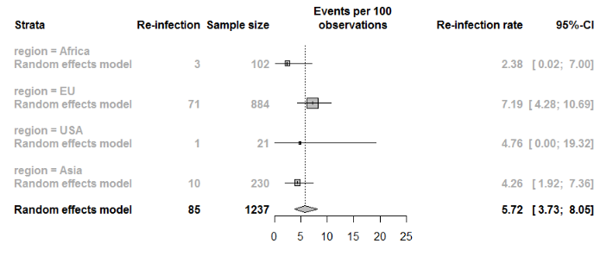
Meta-regression P-value = 0.49
Figure C.1 Re-infection rates of one-stage hip revision grouped by region

By age:
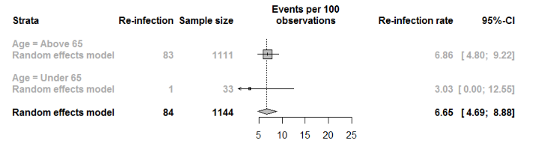
Meta-regression P-value = 0.45
Figure C.2 Re-infection rates of one-stage hip revision grouped by age (different values for re-infection and sample size due to missing data)

By study size:
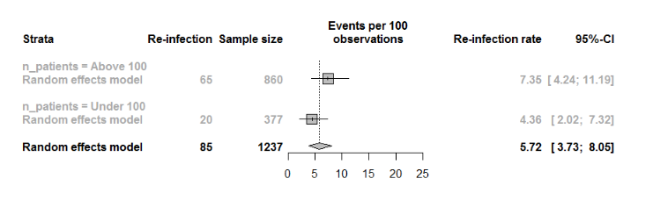
Meta-regression P-value = 0.35
Figure C.3 Re-infection rates of one-stage hip revision grouped by study size

By MINORS score:
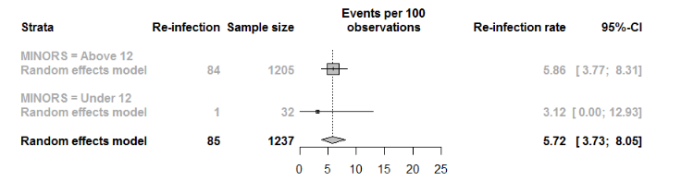
Meta-regression P-value = 0.63
Figure C.4 Re-infection rates of one-stage hip revision grouped by MINORS-score

Two-stage hip revision
By region:
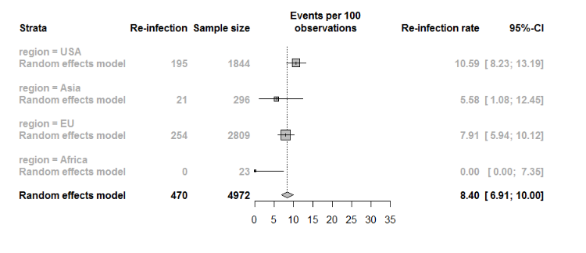
Meta-regression P-value = 0.09
Figure C.5 Re-infection rates of two-stage hip revision grouped by region (different values for re-infection and sample size due to missing data)

By age:
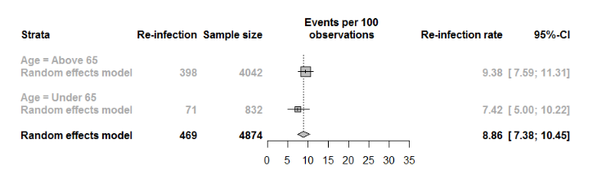
Meta-regression P-value = 0.45
Figure C.6 Re-infection rates of two-stage hip revision grouped by age (different values for re-infection and sample size due to missing data)

By study size:
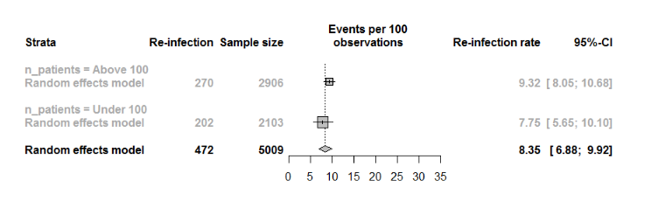
Meta-regression P-value = 0.53
Figure C.7 Re-infection rates of two-stage hip revision grouped by study size

By MINORS score:
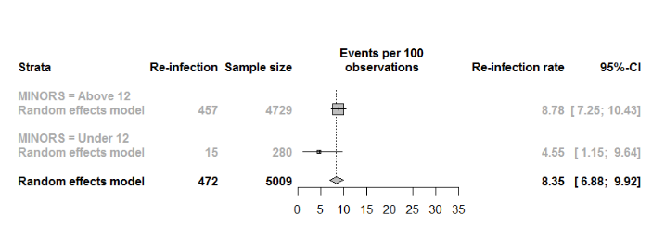
Meta-regression P-value = 0.07
Figure C.8 Re-infection rates of two-stage hip revision grouped by MINORS score

By publication year:
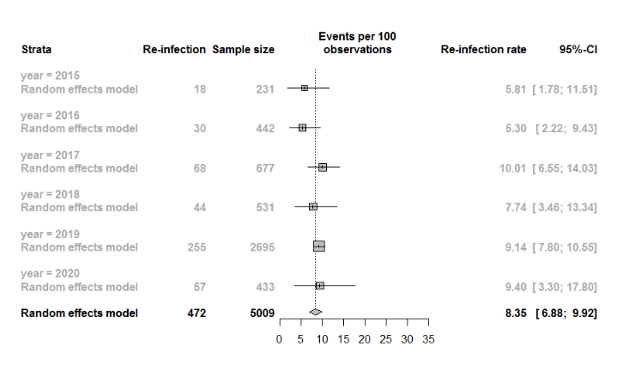
Meta-regression P-value = 0.10
Figure C.9 Re-infection rates of two-stage hip revision grouped by publication year

One-stage knee revision
By region:
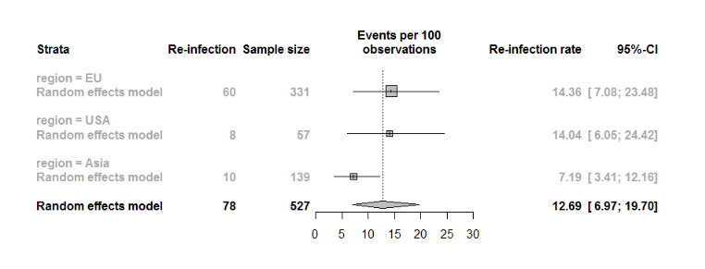
Meta-regression P-value = 0.59
Figure C.10 Re-infection rates of two-stage knee revision grouped by region

By age:
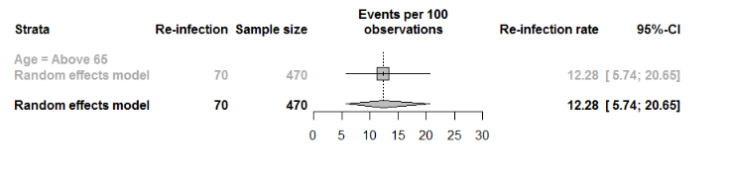
Only 1-strata
Figure C.11 Re-infection rates of two-stage hip revision grouped by age (different values for re-infection and sample size due to missing data)

By study size:
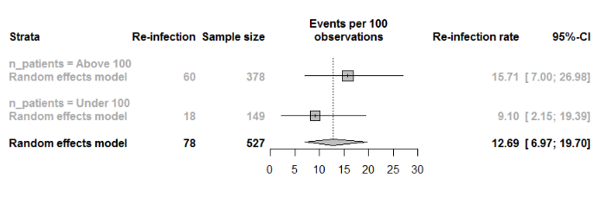
Meta-regression P-value = 0.39
Figure C.12 Re-infection rates of two-stage hip revision grouped by study size

By MINORS score
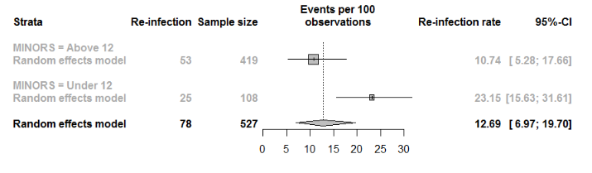
Meta-regression P-value = 0.16
Figure C.13 Re-infection rates of two-stage hip revision grouped by MINORS score

Two-stage knee revision
By region:
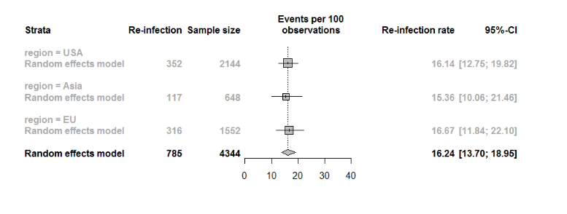
Meta-regression P-value = 0.93
Figure C.14 Re-infection rates of two-stage hip revision grouped by region
By age:
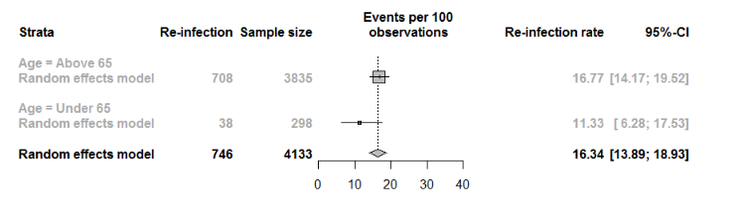
Meta-regression P-value = 0.21
Figure C.15 Re-infection rates of two-stage hip revision grouped by age (different values for re-infection and sample size due to missing data)

By study size:
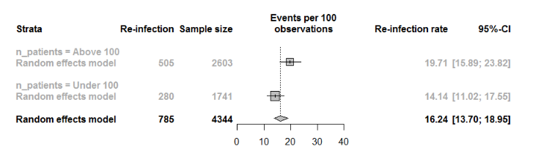
Meta-regression P-value = 0.06
Figure C.16 Re-infection rates of two-stage hip revision grouped by study size

By MINORS score:
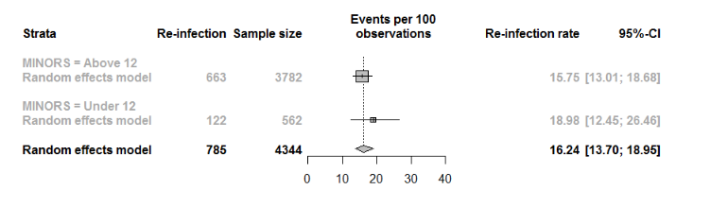
Meta-regression P-value = 0.36
Figure C.17 Re-infection rates of two-stage hip revision grouped by MINORS score

By publication year
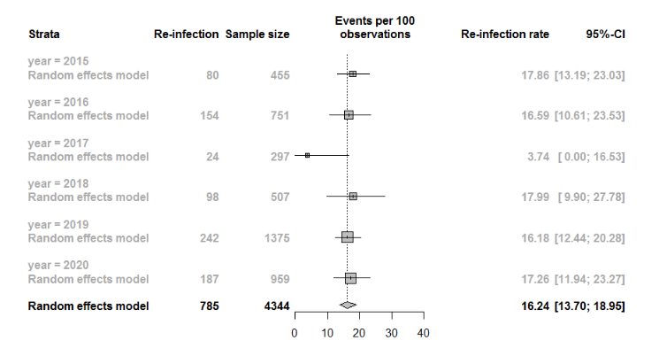
Meta-regression P-value = 0.91
Figure C.18 Re-infection rates of two-stage hip revision grouped by publication year

