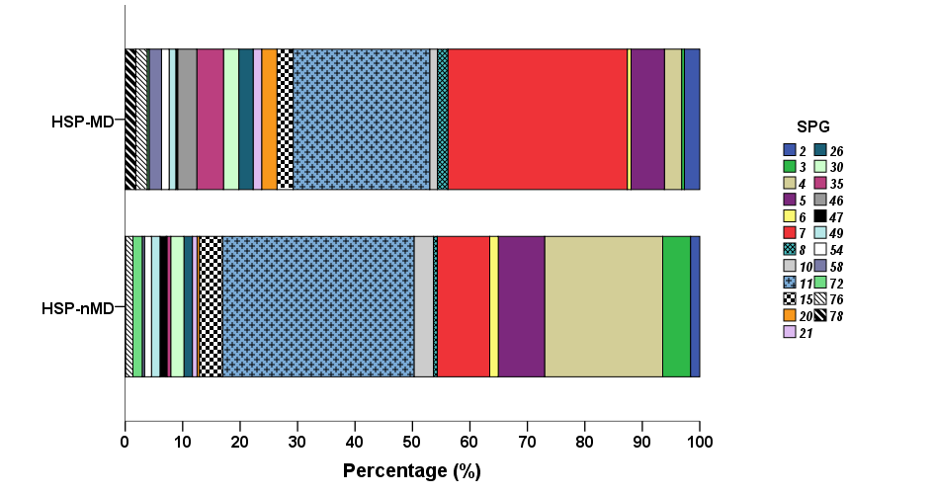

SUPPLEMENTARY FIGURE 1. Frequency of different genotypes (SPGs) of hereditary spastic paraplegia (HSP) in patients with (HSP-MD) and without (HSP-nMD) movement disorders (All SPGs have at least n = 10 reported cases)

