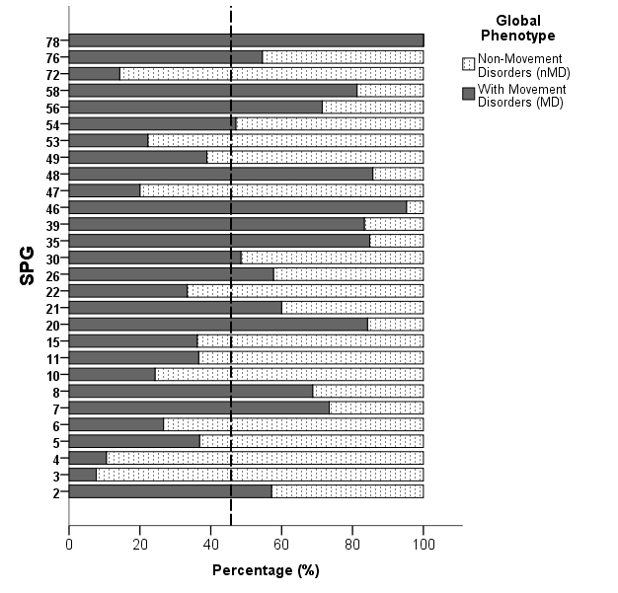

SUPPLEMENTARY FIGURE 2. Frequency of major global phenotypes (with or without a movement disorder) in patients with hereditary spastic paraplegia (HSP) with different genotypes (SPGs) (All SPGs have at least n = 5 reported cases, dotted line demonstrates 45.7% as the overall prevalence of HSP-MD in the entire population)

