Supplementary materials

Contents
Figure S1: Results of meta-analysis of direct comparison 2
Figure S2: Rank plot 6
Figure S3: Comparison-adjusted funnel plot for the network of functional outcome 8
Figure S4: Assessment of transitivity 9
Figure S5: Additional analysis 10
Table S1: Electronic search strategy 13
Table S2: Risk of bias assessment for the included trials 17
Table S3: Results of network meta-analysis (netleague table) 18
Table S4: SUCRA value 20
Table S5: Assessment of inconsistency 21

This supplementary material has been provided by the authors to give readers additional information about their work

Figure S1: Results of meta-analysis of direct comparison
Figure S1a: Pairwise meta-analysis of odds ratio (95% CI) for cognitive impairment
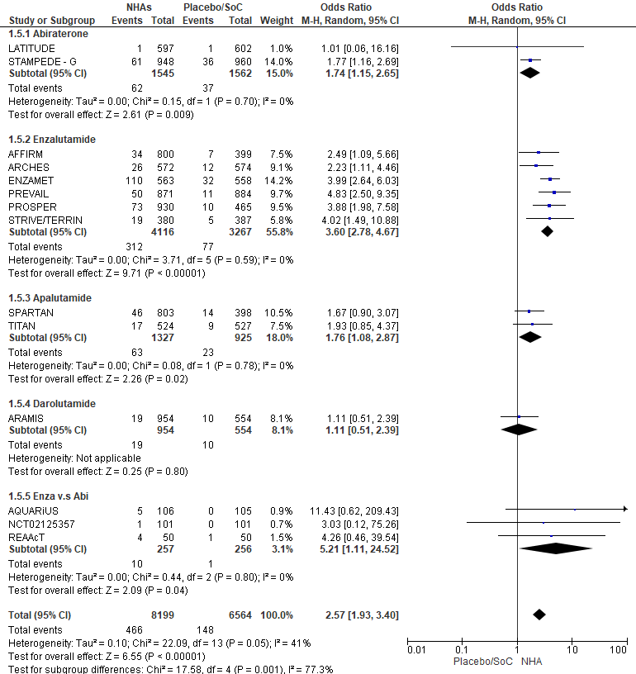
Figure S1b: Pairwise meta-analysis of incidence rate ratio (95% confidence intervals) for cognitive impairment
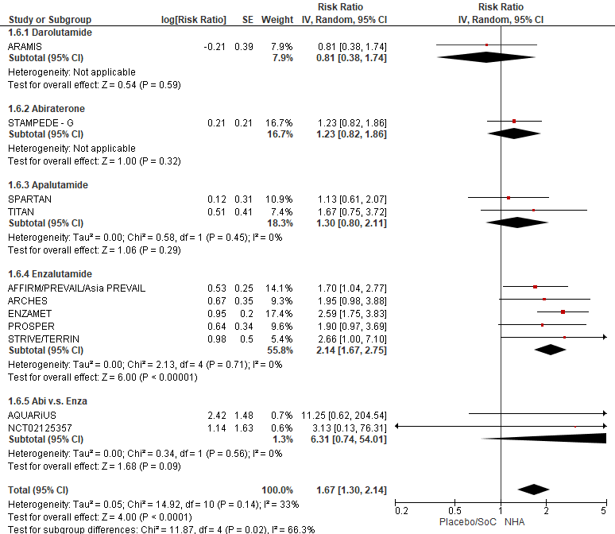
Figure S1c: Pairwise meta-analysis of odds rate (95% confidence intervals) for cognitive impairment (only RCT)

Figure S1d: Pairwise meta-analysis of odds rate (95% confidence intervals) for falls

Figure S2: Rank plot
Figure S2a: rank plot of NMA and placebo for cognitive impairment and falls
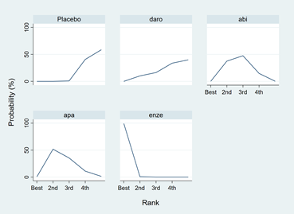 | 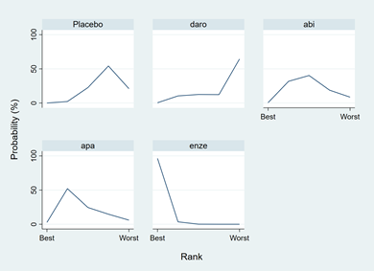
Odds ratio for cognitive impairment |  | Incidence rate ratio for cognitive impairment
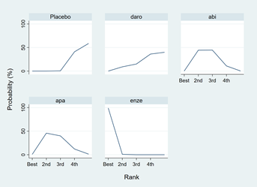 |  | 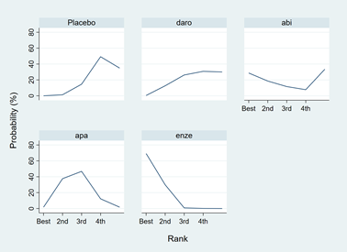
Odds ratio for cognitive impairment (Only RCT) | Odds ratio for falls

Figure S2b: cumulative rank plot of NMA and placebo for cognitive impairment and falls
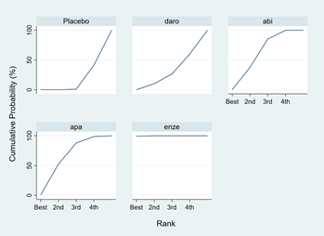 | 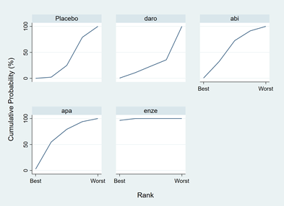
Odds ratio for cognitive impairment |  | Incidence rate ratio for cognitive impairment
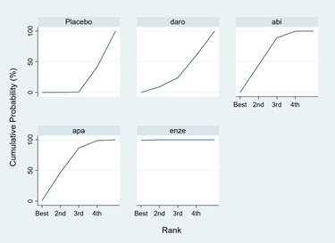 | 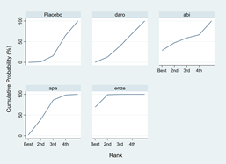
Odds ratio for cognitive impairment (Only RCT) | Odds ratio for falls

Figure S3: Comparison-adjusted funnel plot for the network of functional outcome
A: placebo/standard care B: Darolutamide C: Abiraterone D: Apalutamide E: Enzalutamide
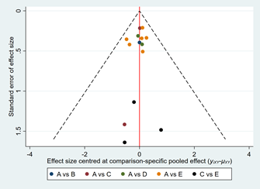 | 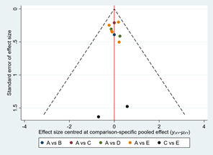
Odds ratio for cognitive impairment | Incidence rate ratio for cognitive impairment
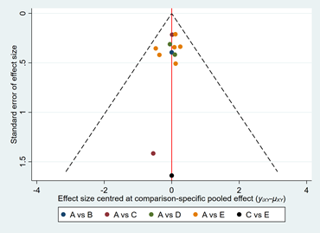 | 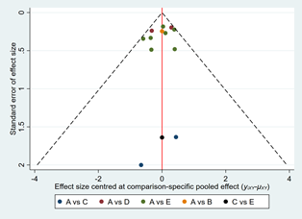
Odds ratio for cognitive impairment  (Only RCT) | Odds ratio for falls

Figure S4: Assessment of transitivity
A: placebo/standard care B: Darolutamide C: Abiraterone D: Apalutamide E: Enzalutamide
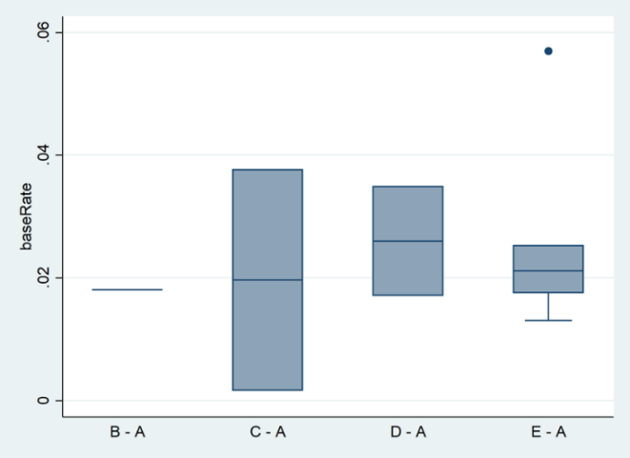
Event rate for cognitive impairment | Incidence rate for cognitive impairment
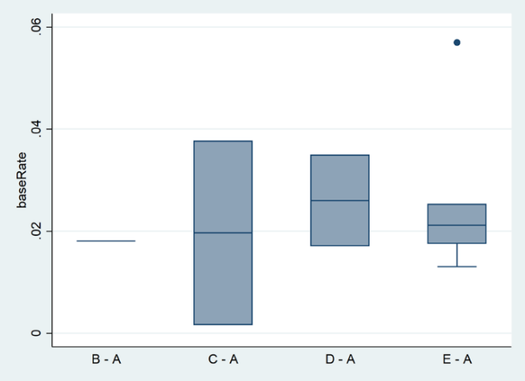 | 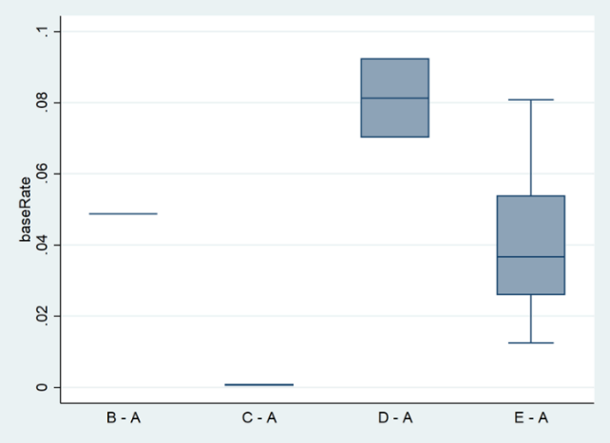
Event rate for cognitive impairment  (only RCT) | Event rate for falls

Figure S5: Additional analysis
Figure S5a: network odds ratio for cognitive impairment, difference between patient reported outcome and investigator assessed, interim and final report
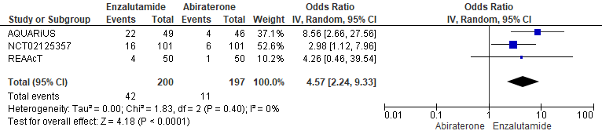
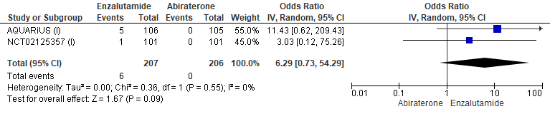
Patient reported outcome vs investigator assessed
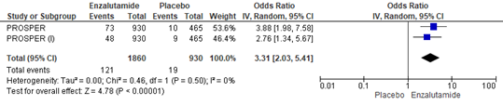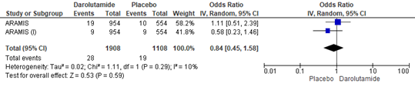
Interim vs final report
Figure S5b: subgroup analysis stratified by median treatment duration, disease status and age
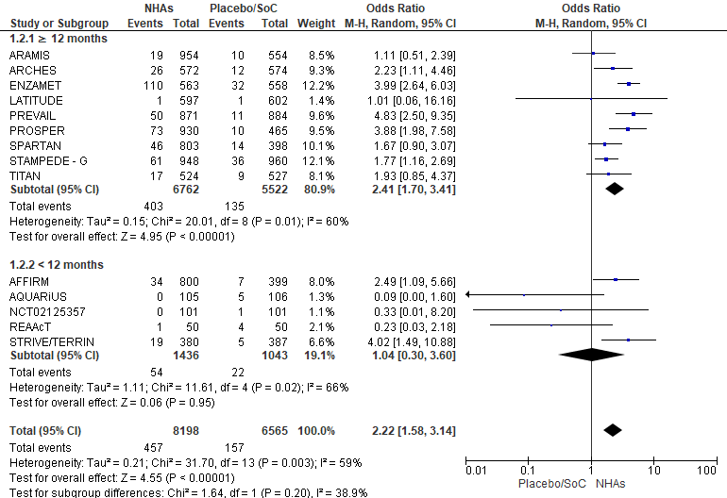

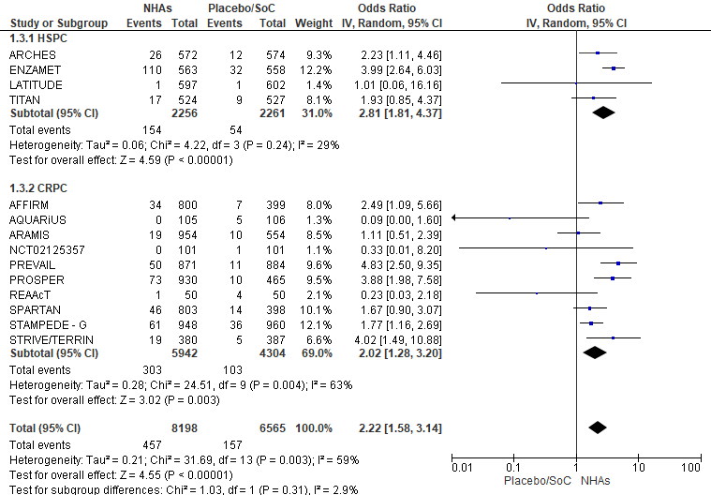
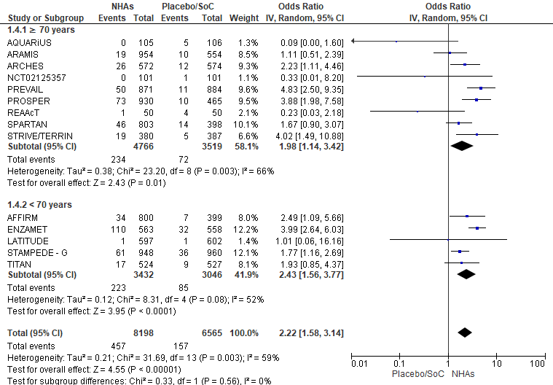

Table S1: Electronic search strategy
Database | NHA | Result | Searching key word (PCa + NHAs) | Result | Searching key word  (NHAs + cogniti*)
Embase | Abiraterone | 973 | prostate cancer':ab,ti AND abiraterone:ab,ti AND ([controlled clinical trial]/lim OR [randomized controlled trial]/lim) | 48 | abiraterone:ab,ti AND cogniti*:ab,ti
Embase | Enzalutamide | 863 | prostate cancer':ab,ti AND enzalutamide:ab,ti AND ([controlled clinical trial]/lim OR [randomized controlled trial]/lim) | 58 | enzalutamide:ab,ti AND cogniti*:ab,ti
Embase | Apalutamide | 154 | prostate cancer':ab,ti AND apalutamide:ab,ti AND ([controlled clinical trial]/lim OR [randomized controlled trial]/lim) | 10 | apalutamide:ab,ti AND cogniti*:ab,ti
Embase | Darolutamide | 67 | prostate cancer':ab,ti AND darolutamide :ab,ti AND ([controlled clinical trial]/lim OR [randomized controlled trial]/lim) | 18 | darolutamide:ab,ti AND cogniti*:ab,ti
PubMed | Abiraterone | 192 | ("prostate cancer"[Title/Abstract] AND "Abiraterone"[Title/Abstract]) AND (clinicaltrial[Filter] OR randomizedcontrolledtrial[Filter]) | 18 | (Abiraterone[Title/Abstract]) AND (cogniti*[Title/Abstract])
PubMed | Enzalutamide | 130 | ("prostate cancer"[Title/Abstract] AND "Enzalutamide"[Title/Abstract]) AND (clinicaltrial[Filter] OR randomizedcontrolledtrial[Filter]) | 18 | (Enzalutamide[Title/Abstract]) AND (cogniti*[Title/Abstract])
PubMed | Apalutamide | 16 | ("prostate cancer"[Title/Abstract] AND "Apalutamide"[Title/Abstract]) AND (clinicaltrial[Filter] OR randomizedcontrolledtrial[Filter]) | 4 | (Apalutamide[Title/Abstract]) AND (cogniti*[Title/Abstract])
PubMed | Darolutamide | 7 | ("prostate cancer"[Title/Abstract] AND "Darolutamide"[Title/Abstract]) AND (clinicaltrial[Filter] OR randomizedcontrolledtrial[Filter]) | 5 | (Darolutamide[Title/Abstract]) AND (cogniti*[Title/Abstract])
Scopus | Abiraterone | 2000 | ( TITLE-ABS-KEY ( prostate AND cancer ) AND TITLE-ABS-KEY ( abiraterone ) ) AND ( LIMIT-TO ( DOCTYPE , "ar" ) ) AND ( LIMIT-TO ( SRCTYPE , "j" ) ) AND ( LIMIT-TO ( SUBJAREA , "MEDI" ) ) | 63 | ( TITLE-ABS-KEY ( abiraterone ) AND TITLE-ABS-KEY ( cogniti* ) )
Scopus | Enzalutamide | 1767 | ( TITLE-ABS-KEY ( prostate AND cancer ) AND TITLE-ABS-KEY ( enzalutamide ) ) AND ( LIMIT-TO ( DOCTYPE , "ar" ) ) AND ( LIMIT-TO ( SRCTYPE , "j" ) ) AND ( LIMIT-TO ( SUBJAREA , "MEDI" ) ) | 62 | ( TITLE-ABS-KEY ( enzalutamide ) AND TITLE-ABS-KEY ( cogniti* ) )
Scopus | Apalutamide | 141 | ( TITLE-ABS-KEY ( prostate AND cancer ) AND TITLE-ABS-KEY ( apalutamide ) ) AND ( LIMIT-TO ( DOCTYPE , "ar" ) ) AND ( LIMIT-TO ( SRCTYPE , "j" ) ) AND ( LIMIT-TO ( SUBJAREA , "MEDI" ) ) | 23 | ( TITLE-ABS-KEY ( apalutamide ) AND TITLE-ABS-KEY ( cogniti* ) )
Scopus | Darolutamide | 53 | ( TITLE-ABS-KEY ( prostate AND cancer ) AND TITLE-ABS-KEY (darolutamide ) ) AND ( LIMIT-TO ( DOCTYPE , "ar" ) ) AND ( LIMIT-TO ( SRCTYPE , "j" ) ) AND ( LIMIT-TO ( SUBJAREA , "MEDI" ) ) | 19 | ( TITLE-ABS-KEY ( darolutamide ) AND TITLE-ABS-KEY ( cogniti* ) )  Edit Save Set alert
CINAHL | Abiraterone | 40 | prostate cancer AND abiraterone; Limiters - Research Article; Exclude MEDLINE records; Human; Gender: Male; Expanders - Apply equivalent subjects; Search modes - Find all my search terms | 9 | AB abiraterone AND AB cogniti*
CINAHL | Enzalutamide | 27 | prostate cancer AND Enzalutamide; Limiters - Research Article; Exclude MEDLINE records; Human; Gender: Male; Expanders - Apply equivalent subjects; Search modes - Find all my search terms | 8 | AB enzalutamide AND cogniti*
CINAHL | Apalutamide | 1 | prostate cancer AND Apalutamide; Limiters - Research Article; Exclude MEDLINE records; Human; Gender: Male; Expanders - Apply equivalent subjects; Search modes - Find all my search terms | 2 | AB apalutamide AND cogniti*
CINAHL | Darolutamide | 5 | prostate cancer AND Darolutamide; Limiters - Research Article; Exclude MEDLINE records; Human; Gender: Male; Expanders - Apply equivalent subjects; Search modes - Find all my search terms | 3 | AB darolutamide AND cogniti*
Web of Science | Abiraterone | 2108 | TOPIC: (prostate cancer) AND TOPIC: (Abiraterone) Refined by: DOCUMENT TYPES: ( ARTICLE ) Timespan: All years. Indexes: SCI-EXPANDED, SSCI, A&HCI, ESCI. | 17 | Abiraterone (Abstract) and cogniti* (Abstract)
Web of Science | Enzalutamide | 1836 | TOPIC: (prostate cancer) AND TOPIC: (Enzalutamide) Refined by: DOCUMENT TYPES: ( ARTICLE ) Timespan: All years. Indexes: SCI-EXPANDED, SSCI, A&HCI, ESCI. | 16 | Enzalutamide (Abstract) and cogniti* (Abstract)
Web of Science | Apalutamide | 100 | TOPIC: (prostate cancer) AND TOPIC: (Apalutamide) Refined by: DOCUMENT TYPES: ( ARTICLE ) Timespan: All years. Indexes: SCI-EXPANDED, SSCI, A&HCI, ESCI. | 3 | Apalutamide (Abstract) and cogniti* (Abstract)
Web of Science | Darolutamide | 40 | TOPIC: (prostate cancer) AND TOPIC: (Darolutamide) Refined by: DOCUMENT TYPES: ( ARTICLE ) Timespan: All years. Indexes: SCI-EXPANDED, SSCI, A&HCI, ESCI. | 4 | Darolutamide (Abstract) and cogniti* (Abstract)
Clinicaltrials.gov | Abiraterone | 327 | Condition or disease: Prostate cancer, Other terms : Abiraterone
Clinicaltrials.gov | Enzalutamide | 273 | Condition or disease: Prostate cancer, Other terms : Enzalutamide
Clinicaltrials.gov | Apalutamide | 78 | Condition or disease: Prostate cancer, Other terms : Apalutamide
Clinicaltrials.gov | Darolutamide | 31 | Condition or disease: Prostate cancer, Other terms : Darolutamide
European Medicines Agency | Abiraterone | 3 | Abiraterone
European Medicines Agency | Enzalutamide | 3 | Enzalutamide
European Medicines Agency | Apalutamide | 1 | Apalutamide
European Medicines Agency | Darolutamide | 1 | Darolutamide
Food and Drug Administration | Abiraterone | 3 | Abiraterone
Food and Drug Administration | Enzalutamide | 2 | Enzalutamide
Food and Drug Administration | Apalutamide | 2 | Apalutamide
Food and Drug Administration | Darolutamide | 1 | Darolutamide

Table S2: Risk of bias assessment for the included trials
Risk of bias assessment of randomization trials
Study | NHAs | Comparator | Randomization  process | Deviation  from intended  intervention | Missing  outcome data | Measurement  of outcome | Selection of  reported results | Overall
ARAMIS | DARO | Placebo | Low | Low | Low | Low | Low
ARCHES | ENZA | Placebo | Low | Low | Low | Low | Low | Low
ENZAMET | ENZA | Standard of care | Low | Low | Low | Low | Low | Low
LATITUDE | AAP | Placebo | Low | Low | Low | Low | Low | Low
PROSPER | ENZA | Placebo | Low | Low | Low | Low | Low | Low
SPARTAN | APA | Placebo | Low | Low | Low | Low | Low | Low
STAMPEDE - G | AAP | Standard of care | Low | Low | Low | Low | Low | Low
TITAN | APA | Placebo | Low | Low | Low | Low | Low | Low
AFFIRM | ENZA | Placebo | Low | Low | Low | Low | Low | Low
PREVAIL | ENZA | Placebo | Low | Low | Low | Low | Low | Low
STRIVE | ENZA | Bicalutamide | Low | Low | Low | Low | Low | Low
TERRIN | ENZA | Bicalutamide | Low | Low | Low | Low | Low | Low
NCT02125357 | AAP | ENZA | Low | Low | Low | Some concerns | Low | Some concerns
Risk of bias assessment of non-intervention trials
Study | NHAs | Comparator | Cofounding | Participant selection | intervention classification | Deviation from intended interventions | Missing data | Outcomes measurement | Result reporting | Overall
AQUARiUS | AAP | ENZA | Moderate | low | Moderate | low | low | Moderate | low | Moderate
REAAcT | AAP | ENZA | Moderate | low | Moderate | low | low | Moderate | low | Moderate

Table S3: Results of network meta-analysis (netleague table)
Estimated are presented as Odds ratio (incidence rate ratio) and 95% confidence intervals. Comparison between treatments should be read from column to row and the estimate is in the cell in common between the column-defining treatment and the row-defining treatment. Significant results are in bold and underlined.
Table S3a: network estimated odds ratio (95% confidence intervals) of event rate of cognitive impairment
Placebo | 1.10  (0.51,2.39) | 1.61  (1.08,2.42) | 1.76  (1.08,2.87) | 3.68  (2.85,4.75)
0.91  (0.42,1.96) | Darolutamide | 1.46  (0.61,3.50) | 1.59  (0.64,3.98) | 3.33  (1.48,7.52)
0.62  (0.41,0.93) | 0.68  (0.29,1.64) | Abiraterone | 1.09 (0.58,2.05) | 2.28  (1.43,3.64)
0.57  (0.35,0.93) | 0.63  (0.25,1.57) | 0.92  (0.49,1.73) | Apalutamide | 2.09  (1.20,3.63)
0.27  (0.21,0.35) | 0.30  (0.13,0.68) | 0.44  (0.27,0.70) | 0.48  (0.28,0.83) | Enzalutamide

Table S3b: network estimated incidence rate ratio (95% confidence intervals) of cognitive impairment
Placebo | 0.81  (0.38,1.75) | 1.18  (0.79,1.77) | 1.30  (0.80,2.10) | 2.28  (1.74,2.99)
1.23  (0.57,2.65) | Darolutamide | 1.45  (0.61,3.45) | 1.60  (0.65,3.94) | 2.81  (1.25,6.32)
0.85  (0.57,1.27) | 0.69  (0.29,1.64) | Abiraterone | 1.10  (0.59,2.06) | 1.93  (1.20,3.13)
0.77  (0.48,1.25) | 0.63  (0.25,1.55) | 0.91  (0.49,1.71) | Apalutamide | 1.76  (1.01,3.06)
0.44  (0.33,0.57) | 0.36  (0.16,0.80) | 0.52  (0.32,0.84) | 0.57  (0.33,0.99) | Enzalutamide

Table S3c: network estimated odds ratio (95% confidence intervals) of event rate of cognitive impairment (only RCT)
Placebo | 1.11  (0.51,2.39) | 1.73  (1.14,2.62) | 1.76  (1.08,2.87) | 3.57  (2.84,4.49)
0.90  (0.42,1.96) | Darolutamide | 1.57  (0.65,3.76) | 1.59  (0.64,3.97) | 3.23  (1.44,7.23)
0.58  (0.38,0.87) | 0.64  (0.27,1.53) | Abiraterone | 1.01  (0.53,1.93) | 2.06  (1.29,3.30)
0.57  (0.35,0.93) | 0.63  (0.25,1.57) | 0.99  (0.52,1.87) | Apalutamide | 2.03  (1.18,3.49)
0.28  (0.22,0.35) | 0.31  (0.14,0.69) | 0.49  (0.30,0.78) | 0.49  (0.29,0.84) | Enzalutamide

Table S3d: network estimated odds ratio (95% confidence intervals) of event rate of falls
Placebo | 1.08  (0.54,2.14) | 1.42  (0.19,10.35) | 1.49  (0.94,2.35) | 2.55  (1.90,3.42)
0.93  (0.47,1.84) | Darolutamide | 1.32  (0.16,10.76) | 1.38  (0.61,3.14) | 2.36  (1.12,4.97)
0.70  (0.10,5.14) | 0.76  (0.09,6.21) | Abiraterone | 1.05  (0.14,8.05) | 1.80  (0.24,13.16)
0.67  (0.43,1.06) | 0.72  (0.32,1.65) | 0.95  (0.12,7.33) | Apalutamide | 1.71  (1.00,2.94)
0.39  (0.29,0.53) | 0.42  (0.20,0.89) | 0.56  (0.08,4.09) | 0.58  (0.34,1.00) | Enzalutamide

Table S4: SUCRA value
 | Odds ratio for cognitive impairment | Incidence rate ratio for cognitive impairment | Falls | Odds ratio of event rate for CI (only RCT)
Placebo | 10.6 | 26.4 | 20.6 | 10.5
Darolutamide | 24.5 | 17.4 | 30.7 | 23.6
Abiraterone | 54.7 | 49.3 | 50.3 | 57.3
Apalutamide | 60.3 | 57.5 | 56.3 | 58.8
Enzalutamide | 99.8 | 99.4 | 92.1 | 99.8

Table S5: Assessment of inconsistency
Table S5a: Design inconsistency
 | chi-square | P value for test of global inconsistency
odds rate of event rate for cognitive impairment | 1.22 | 0.27
Incidence rate ratio for cognitive impairment | 1.24 | 0.27
odds ratio of event rate for falling down | 0.16 | 0.69

Table S5b: side-splitting methods
Only Placebo/standard care, Abiraterone, Enzalutamide comparisons formed a closed loop and had direct with indirect evidence simultaneously. Other comparisons only had either direct or indirect evidence.
Abiraterone/Enzalutamide Comparison | Direct (SE) | Indirect (SE) | Difference coef ( SE) | p-value
odds rate for cognitive impairment | 1.65  (0.79) | 0.72  (0.25) | 0.93  (0.83) | 0.27
Incidence rate ratio for cognitive impairment | 1.85  (1.18) | 0.55  (0.25) | 1.25  (1.12) | 0.27
odds rate for cognitive impairment （Only RCT） | 1.11  (1.64) | 0.72  (0.24) | 0.39  (1.66) | 0.81
odds ratio for falls | 1.10  (1.68) | 0.26  (1.29) | 0.84  (2.10) | 0.25

