SUPPLEMENTARY MATERIAL

Search Strategy
PubMed from inception to December 31, 2021
tuberculosis
tuberculosis[MeSH Terms]
tuberculosis-related
tuberculosis disease
mycobacterium tuberculosis[MeSH Terms]
exp tuberculosis/
TB
suspect* (TB or Tuberculosis)
presumpt* (TB or Tuberculosis)
probabl* (TB or Tuberculosis)

AND

cytomegalovirus
CMV
human cytomegalovirus
HCMV

Cochrane Library 1996 to December 31, 2021
tuberculosis
tuberculosis-related
tuberculosis disease
mycobacterium tuberculosis[MeSH Terms]
TB
suspect* (TB or Tuberculosis)
presumpt* (TB or Tuberculosis)
probabl* (TB or Tuberculosis)

AND

cytomegalovirus
CMV
human cytomegalovirus
HCMV

AMED (Allied and Complementary Medicine) 1985 to December 2021, Embase Classic+Embase 1947 to 2021 December 10, Global Health 1973 to 2021 Week 49, Ovid MEDLINE(R) 1946 to December 10, 2021, APA PsycInfo 1806 to November Week 5 2021
Tuberculosis.mp.
tuberculosis-related.mp.
tuberculosis disease.mp.
mycobacterium tuberculosis.mp.
TB.mp.

AND

Cytomegalovirus.mp.
CMV.mp.
human cytomegalovirus.mp.
HCMV.mp.

Supplementary Figure 1: Risk of bias assessment of follow-up cohort studies according to the ROBINS-I tool.
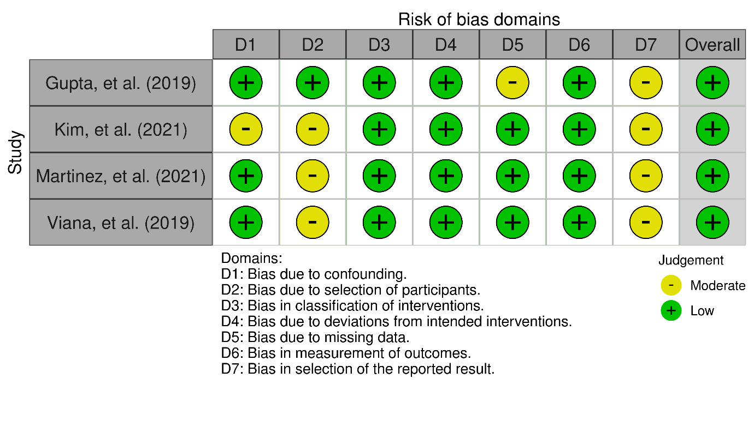

Supplementary Figure 2: Risk of bias assessment of case-control studies according to the risk of bias tool developed by the Clarity Group of McMaster University.
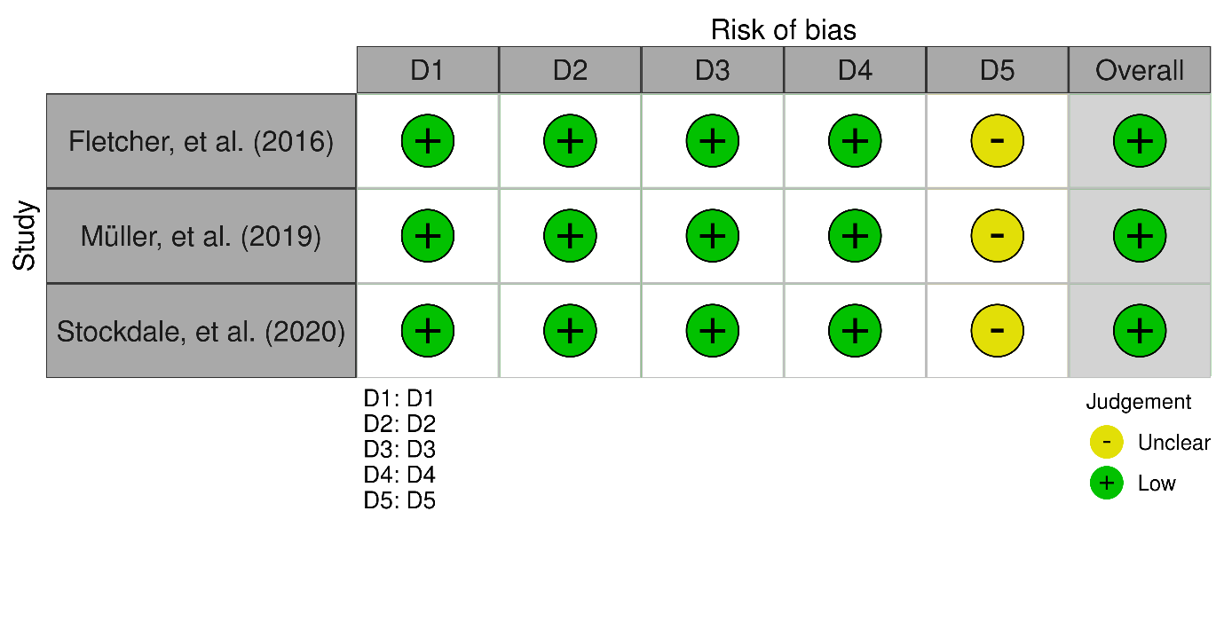Domains:
D1: Can we be confident in the assessment of exposure?
D2: Can we be confident that cases had developed the outcome of interest and controls had not?
D3: Were the cases (those who were exposed and developed the outcome of interest) properly selected?
D4: Were the controls (those who were exposed and did not develop the outcome of interest) properly selected?
D5: Were cases and controls matched according to important prognostic variables or was statistical adjustment carried out for those variables?

Supplementary Figure 3: Risk of bias assessment of cross-sectional studies according to the risk of bias tool developed by the Agency for Healthcare Research and Quality (AHRQ).
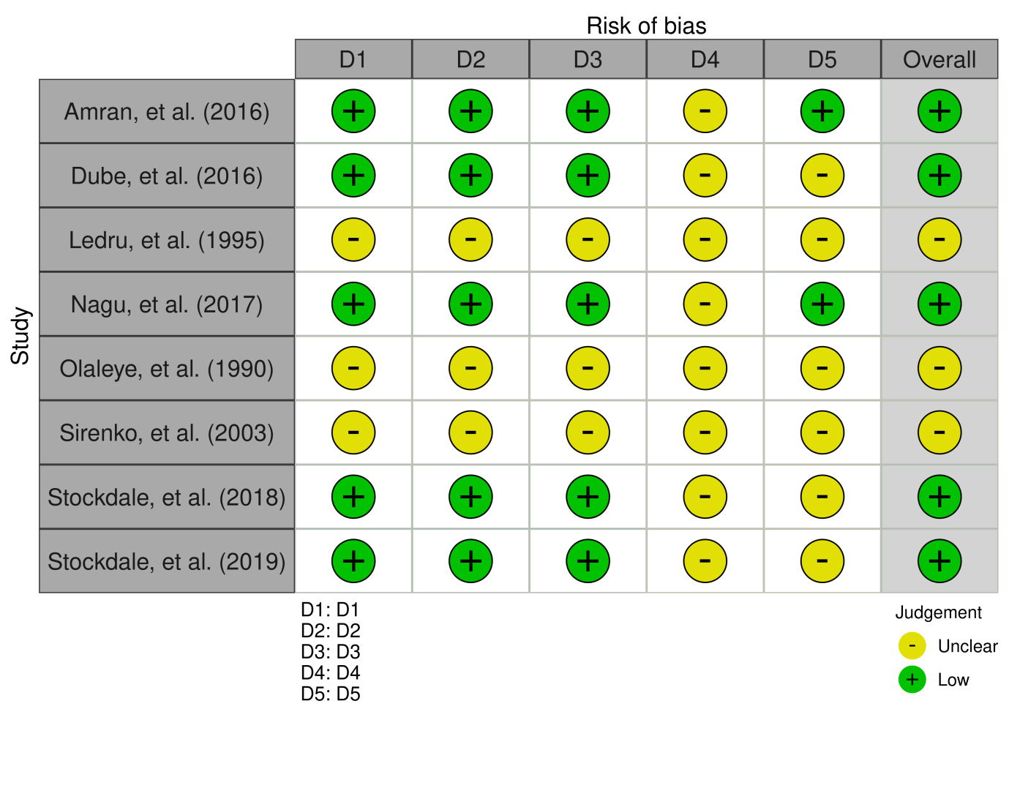
Domains:
D1: Selection bias - Did the study apply inclusion/exclusion criteria uniformly to all comparison groups? Does the design or analysis control account for important confounding and modifying variables through matching, stratification, multivariable analysis, or other approaches?
D2: Performance bias - Did researchers rule out any impact from a concurrent intervention or an unintended exposure that might bias results?
D3: Attrition bias - If attrition (overall or differential nonresponse, dropout, loss to follow-up, or exclusion of participants) was a concern, were missing data handled appropriately (e.g., intention-to-treat analysis and imputation)?
D4: Detection bias - Were the outcome assessors blinded to the intervention or exposure status of participants? Were interventions/exposures assessed/defined using valid and reliable measures, implemented consistently across all study participants? Were outcomes assessed/defined using valid and reliable measures, implemented consistently across all study participants? Were confounding variables assessed using valid and reliable measures, implemented consistently across all study participants?
D5: Reporting bias - Were the potential outcomes prespecified by the researchers? Are all prespecified outcomes reported?

Supplementary Figure 4: Funnel plot of tuberculosis cases. Vertical line represents the combined effect observed in the analysis.

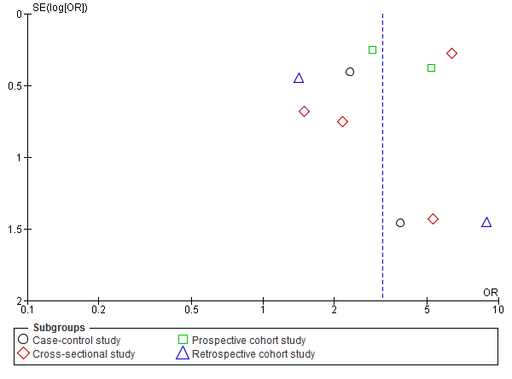

Supplementary Figure 5: Risk of tuberculosis disease among individuals with cytomegalovirus infection using risk ratio as the relative measure of association.

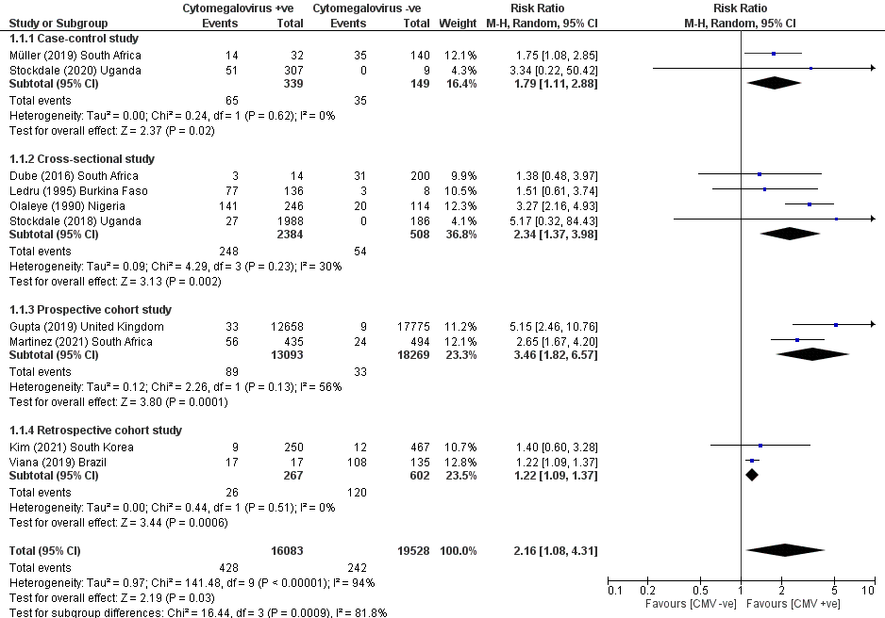

Supplementary Figure 6: Risk of tuberculosis disease among individuals with cytomegalovirus infection using subgroup analysis based on national burden of tuberculosis.

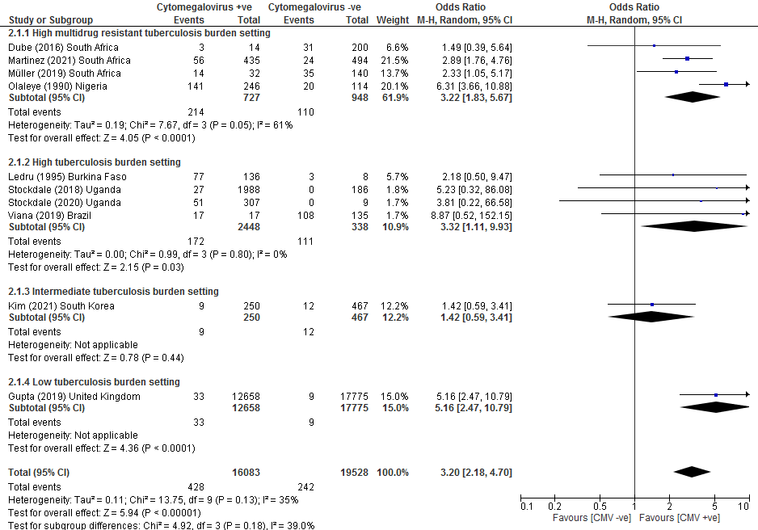

Supplementary Figure 7: Risk of tuberculosis disease among individuals with cytomegalovirus infection using subgroup analysis based on age.

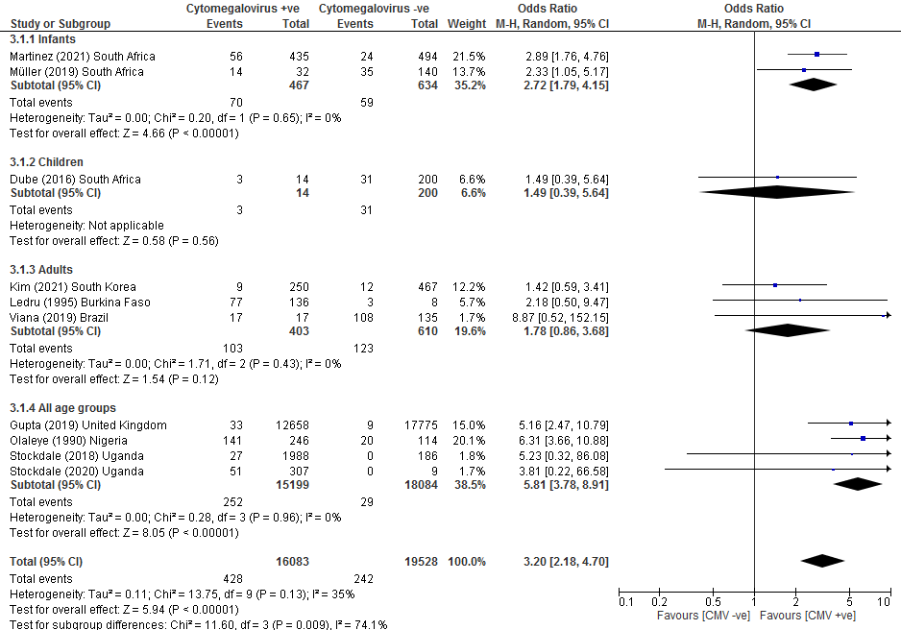

Supplementary Figure 8: Risk of tuberculosis disease among individuals with cytomegalovirus infection using subgroup analysis based on risk of bias in individual studies.

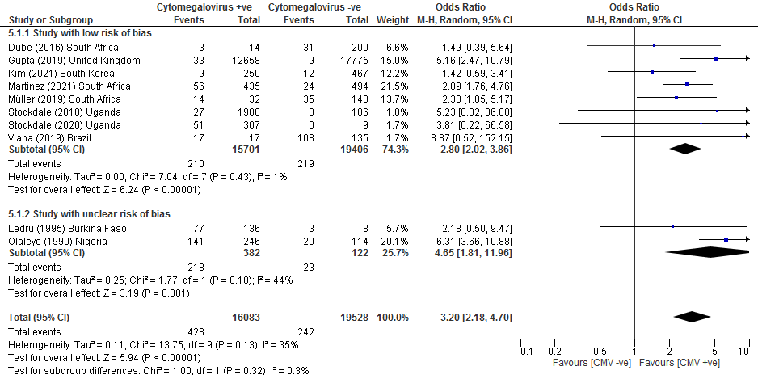

Supplementary Figure 9: Risk of tuberculosis disease among individuals with cytomegalovirus infection using subgroup analysis based on diagnostic method of cytomegalovirus infection.

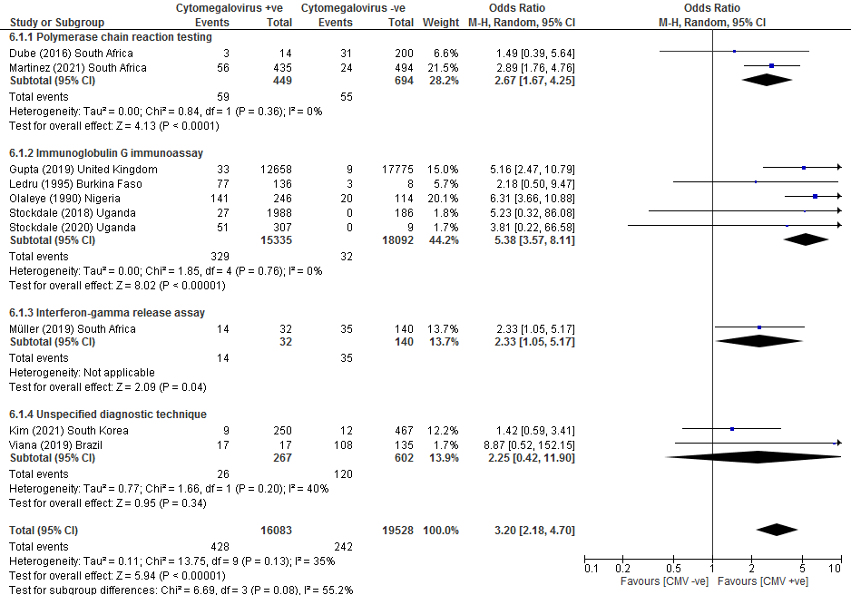

Supplementary Figure 10: Risk of tuberculosis disease among individuals with cytomegalovirus infection using subgroup analysis based on study continent.



