Supplementary Data

Table S1. Complete search strategy for each database
Database | Search strategy | Articles searched
PubMed | ((P wave) OR (P waves) OR (interatrial block) OR (interatrial conduction)) AND ((AF recurrences) OR (atrial fibrillation) OR (AF)) | 179
Embase | ((P wave) OR (P waves) OR (interatrial block) OR (interatrial conduction)) AND ((AF recurrences) OR (atrial fibrillation) OR (AF)) | 153
ClinicalTrials.gov | ((P wave) OR (P waves) OR (interatrial block) OR (interatrial conduction)) AND ((AF recurrences) OR (atrial fibrillation) OR (AF)) * completed trials | 19

Table S2. Methodological quality assessment using the Newcastle-Ottawa Scale.
Publication | Selection |  |  |  | Comparability | Outcome |  |  | Total | FUP notes
 | S1 | S2 | S3 | S4 | C | O1 | O2 | O3
Ogawa et al.² | 1 | 1 | 1 | 1 | 1 | 1 | 1 | 1 | 8
Okumura et al.³ | 1 | 1 | 1 | 1 | 1 | 1 | 0 | 0 | 6 | 3 months
Masuda et al.⁴ | 1 | 1 | 1 | 1 | 1 | 1 | 1 | 1 | 8
Blanche et al.⁵ | 1 | 1 | 1 | 1 | 1 | 1 | 1 | 1 | 8
Caldwell et al.⁶ | 1 | 1 | 1 | 1 | 1 | 1 | 1 | 1 | 8
Salah et al.⁷ | 1 | 1 | 1 | 1 | 1 | 1 | 1 | 0 | 7 | 9 mths, FUP loss
Park et al.⁸ | 1 | 1 | 1 | 1 | 1 | 1 | 1 | 1 | 8
Wu et al.⁹ | 1 | 1 | 1 | 1 | 1 | 1 | 1 | 1 | 8
Knecht et al.¹⁰ | 1 | 1 | 1 | 1 | 1 | 1 | 1 | 1 | 8
Arroja et al.¹¹ | 1 | 1 | 1 | 1 | 1 | 1 | 1 | 1 | 8
Kanzaki et al.¹² | 1 | 1 | 1 | 1 | 1 | 1 | 1 | 1 | 8
Gul et al.¹³ | 1 | 1 | 1 | 1 | 1 | 1 | 1 | 1 | 8
Mugnai et al.¹⁴ | 1 | 1 | 1 | 1 | 1 | 1 | 1 | 1 | 8
Doi et al.¹⁵ | 1 | 1 | 1 | 1 | 1 | 1 | 1 | 1 | 8
Jadidi et al.¹⁶ | 1 | 1 | 1 | 1 | 1 | 1 | 1 | 1 | 8
Kaypakli et al.¹⁷ | 1 | 1 | 1 | 1 | 1 | 1 | 1 | 1 | 8
Higuchi et al.¹⁸ | 1 | 1 | 1 | 1 | 1 | 1 | 1 | 1 | 8
Wu et al.¹⁹ | 1 | 1 | 1 | 1 | 1 | 1 | 1 | 1 | 8
Nakatani et al.²⁰ | 1 | 1 | 1 | 1 | 1 | 1 | 1 | 1 | 8
Chen et al.²¹ | 1 | 1 | 1 | 1 | 1 | 1 | 1 | 1 | 8
Zink et al.²² | 1 | 1 | 1 | 1 | 1 | 1 | 0 | 0 | 6 | 3 months
Yang et al.²³ | 1 | 1 | 1 | 1 | 1 | 1 | 1 | 1 | 8

FUP= Follow-up, mths= months
A. Studies reporting only on ECG
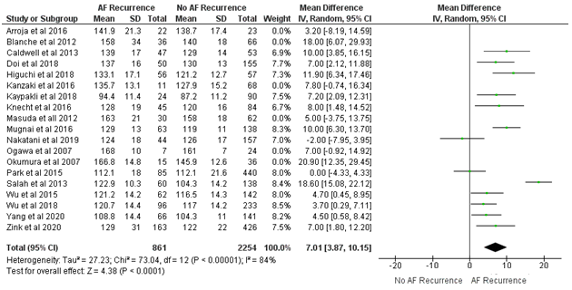
B. Studies reporting only on SAECG
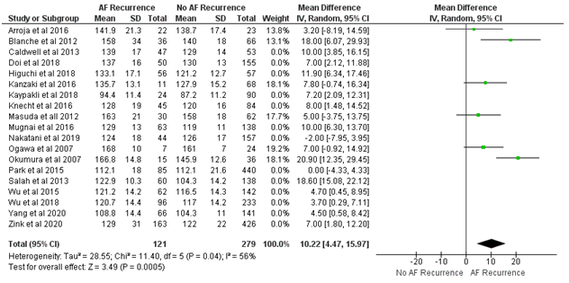

C. Studies reporting only on paroxysmal AF
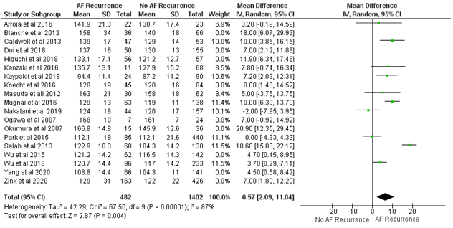
D. Studies reporting only on persistent AF
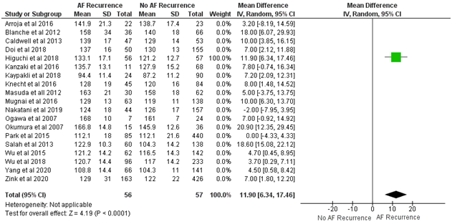
Figure S1. Baseline difference (mean  SD) of PWD in patients with and without atrial fibrillation (AF) recurrence after catheter ablation for studies reporting only on A. ECG measurements, B.SAECG, C. paroxysmal and C. persistent AF. The forest plot shows weighted mean difference and 95%CI of baseline PWD between the two groups.
A. Studies reporting only on paroxysmal AF
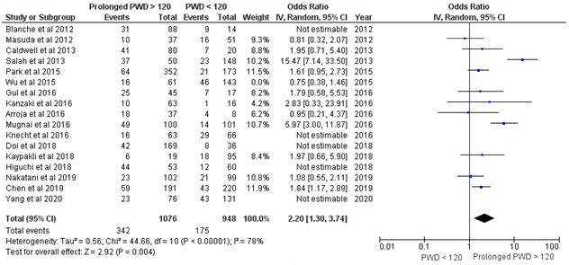
B. Studies reporting only on persistent AF
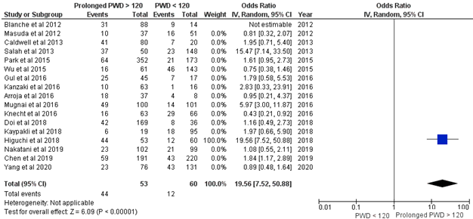
Figure S2. Sub-group analysis with Forrest plots demonstrating the effect of P wave duration (PWD) for the prediction of atrial fibrillation recurrence (AFr) after catheter ablation in studies reporting only on paroxysmal and persistent AF.

