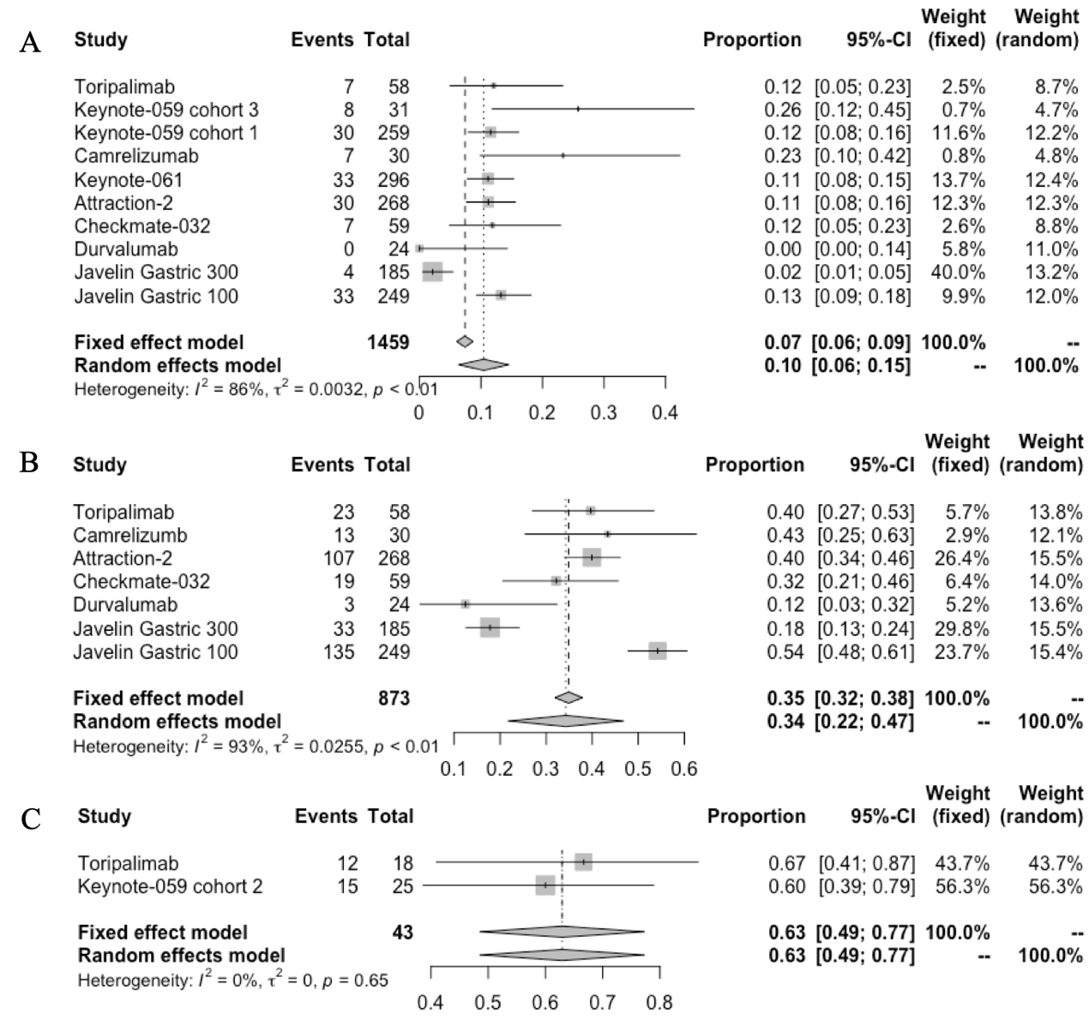
Figure S1: Forest plot of (A) ORR and (B) DCR in all-over population receiving single agent immunotherapy. (C) ORR of all-over population receiving combined immunotherapy.
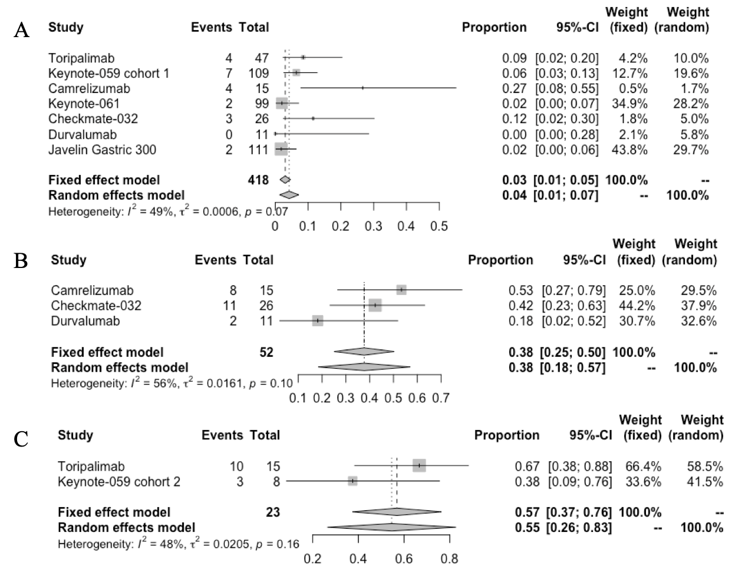
Figure S2: Forest plot of (A) ORR and (B) DCR in PD-L1 negative population receiving single agent immunotherapy. (C) Forest plot of ORR in PD-L1 negative population receiving combined immunotherapy.
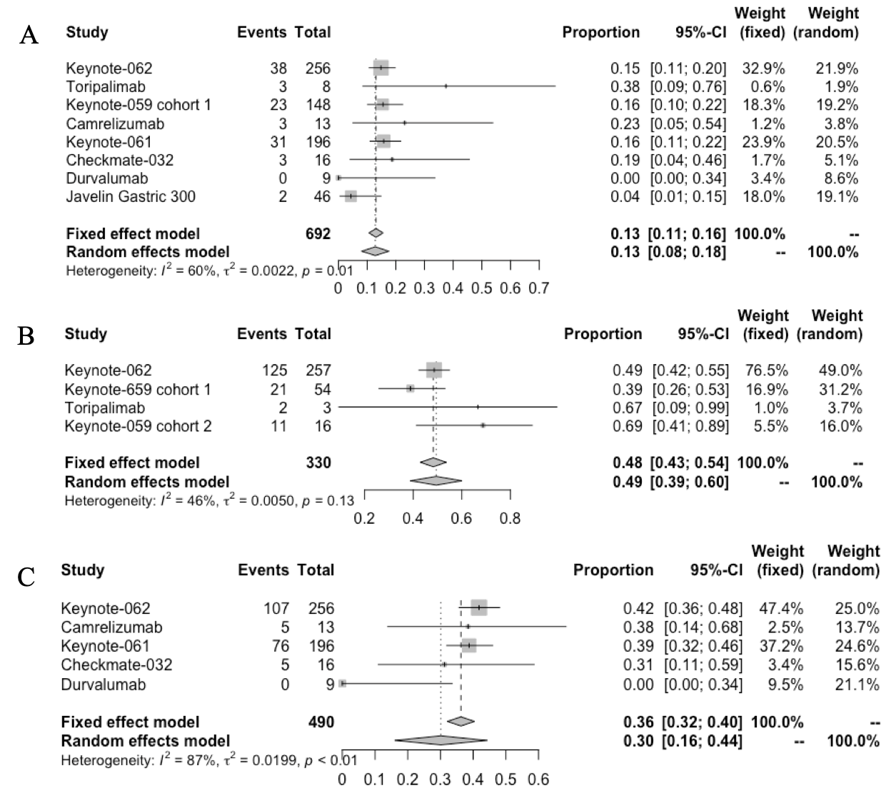
Figure S3: Forest plot of ORR in patients with PD-L1 CPS ≥ 1 receiving (A) ICI monotherapy or (B) combined immunotherapy.

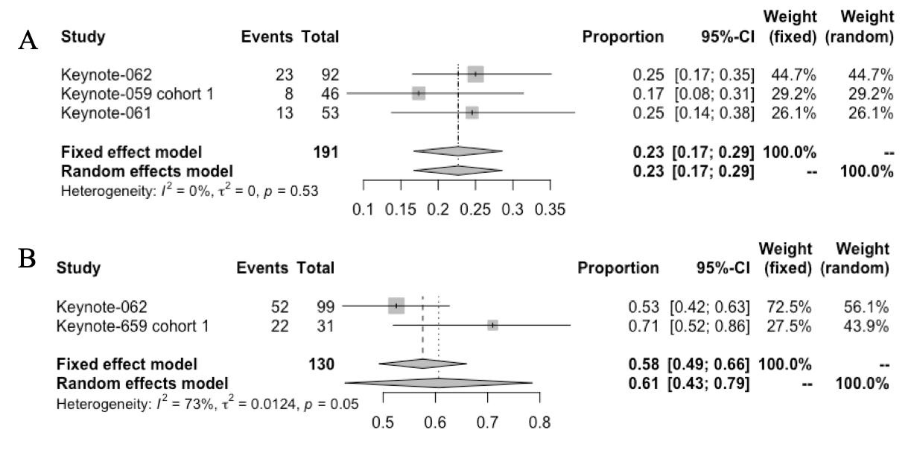
Figure S4: Forest plot of ORR in patients with PD-L1 CPS ≥10 receiving (A) single agent immunotherapy or (B) combined immunotherapy.

