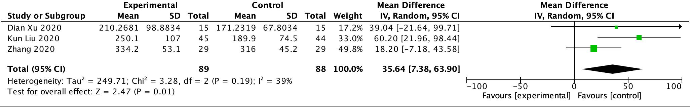
Figure 7: Forest plot of the PaO₂/FiO₂ ratio during at 0.5h of one-lung ventilation

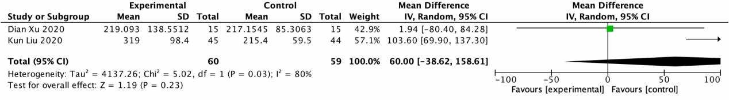
Figure 8: Forest plot of the PaO₂/FiO₂ ratio during at 1h of one-lung ventilation

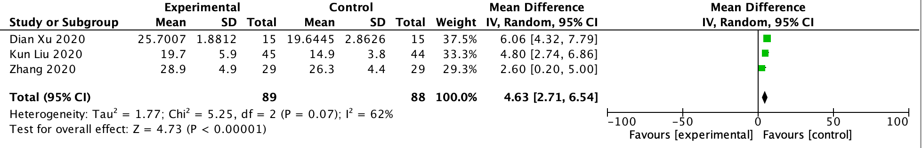
Figure 9: Forest plot of respiratory system compliance at 0.5h during one-lung ventilation.

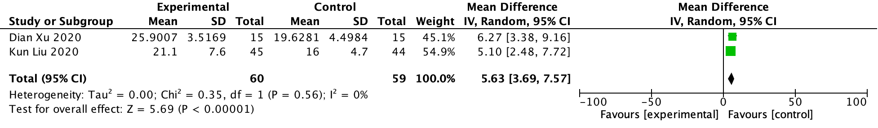
Figure 10: Forest plot of respiratory system compliance at 1h during one-lung ventilation.

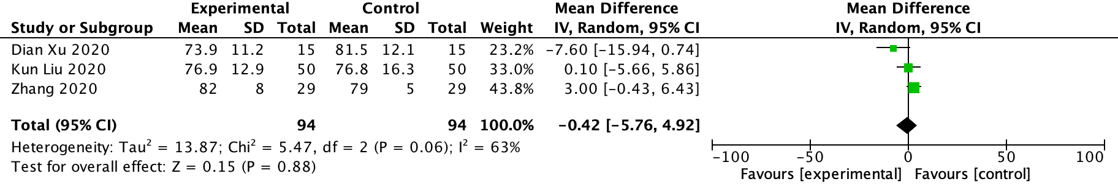
Figure 11: Forest plot of mean arterial pressure at 0.5h during one-lung ventilation

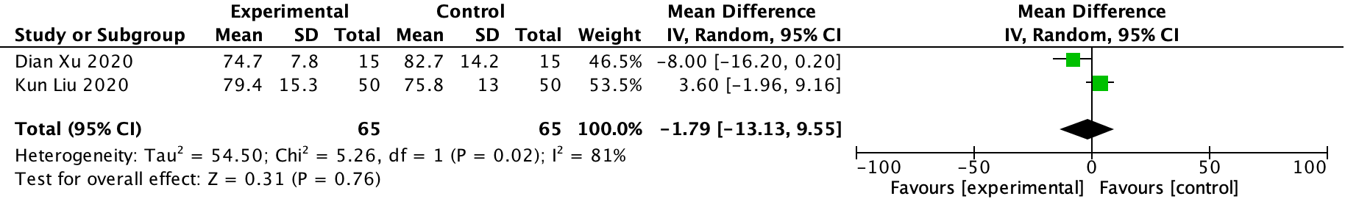
Figure 12: Forest plot of mean arterial pressure at 1h during one-lung ventilation

