Supplementary Table 1. The search strategies of this meta-analysis

Databases | Queries | Number of studies
PubMed
#1 | "novel oral anticoagulants"[Title/Abstract] OR "non vitamin k oral anticoagulants"[Title/Abstract] OR "direct oral anticoagulants"[Title/Abstract] OR "apixaban"[Title/Abstract] OR "edoxaban"[Title/Abstract] OR "dabigatran"[Title/Abstract] OR "rivaroxaban"[Title/Abstract] | 14,296
#2 | "vitamin k antagonists"[Title/Abstract] OR "warfarin"[Title/Abstract] | 30,177
#3 | "atrial fibrillation"[Title/Abstract] | 83,681
#4 | #1 and #2 and #3 | 3,626
Embase
#1 | 'novel oral anticoagulants':ab,ti OR 'non-vitamin k oral anticoagulants':ab,ti OR 'direct oral anticoagulants':ab,ti OR 'apixaban':ab,ti OR 'edoxaban':ab,ti OR 'dabigatran':ab,ti OR 'rivaroxaban':ab,ti | 27,030
#2 | 'vitamin k antagonists':ab,ti OR 'warfarin':ab,ti | 49,792
#3 | 'atrial fibrillation':ab,ti | 146,067
#4 | #1 and #2 and #3 | 6,863
Cochrane
#1 | (novel oral anticoagulants):ti,ab,kw OR (non-vitamin k oral anticoagulants):ti,ab,kw OR (direct oral anticoagulants):ti,ab,kw OR (apixaban):ti,ab,kw OR (edoxaban):ti,ab,kw OR (edoxaban):ti,ab,kw OR (rivaroxaban):ti,ab,kw | 4,320
#2 | (vitamin k antagonists):ti,ab,kw OR (warfarin):ti,ab,kw | 5,591
#3 | (atrial fibrillation):ti,ab,kw | 14,065
#4 | #1 and #2 and #3 | 1,189

Supplementary figure 1. Forest plot of intraocular bleeding events in patients with AF with NOACs versus warfarin after excluding the study by Granger et al.
Abbreviations:NOACs=novel oral anticoagulants;CI=confidence interval;

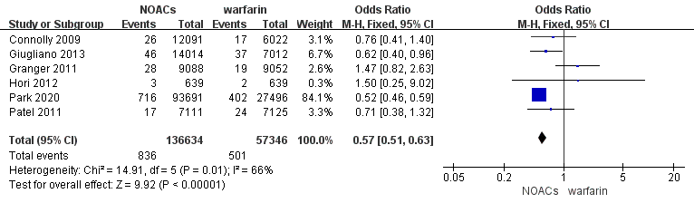
Supplementary figure 2. Forest plot of intraocular bleeding events in patients with AF with NOACs versus warfarin using the fixed-effects model
Abbreviations:NOACs=novel oral anticoagulants;CI=confidence interval;

