Supplementary Material
Supplementary Table 1. Methodological quality of included studies based on the JBI critical appraisal tools for each study design.
Author | Study Design | Item  1 | Item  2 | Item  3 | Item  4 | Item  5 | Item  6 | Item  7 | Item  8 | Item  9 | Item 10 | Item 11 | Quality
Alhumaid | Cohort | √ | √ | √ | √ | ↔ | √ | √ | NA | NA | NA | √ | Mod
Alkindi | Cohort | √ | √ | √ | √ | X | √ | √ | √ | NA | NA | √ | Good
Boga | Cohort | √ | √ | √ | ↔ | X | √ | √ | √ | √ | X | √ | Good
Devarashetty | Cohort | √ | √ | √ | X | X | √ | √ | NA | NA | NA | √ | Mod
Minniti | Cohort | √ | √ | √ | √ | √ | √ | √ | √ | √ | √ | √ | Good
Sewaralthahab | Cohort | √ | √ | √ | X | X | √ | √ | NA | NA | NA | √ | Mod
Yurtsever | Cohort | √ | √ | √ | √ | √ | √ | √ | √ | NA | NA | √ | Good
Anusim | Case Series | ↔ | √ | ↔ | √ | √ | √ | √ | √ | √ | NA | - | Good
Balanchivadze | Case Series | √ | √ | √ | √ | √ | √ | √ | √ | √ | NA | - | Good
McCloskey | Case Series | √ | √ | √ | √ | √ | √ | √ | √ | ↔ | NA | - | Good
Ramachandran | Case Series | √ | √ | √ | √ | √ | √ | √ | √ | √ | NA | - | Good
√, Yes; X, No; ↔, Unclear; NA, not applicable
Good: 70% and above
Moderate: 50-69%
Poor: 0-49%

Supplementary Table 2. Underlying comorbidities in patients with SCD admitted for COVID-19 infection.
Underlying Medical Conditions [N=321] | n (%)
None | 187 (58.3)
SCD-related
History of acute chest syndrome / vaso occlusive crises | 134 (41.7)
History of splenectomy | 35 (10.9)
Cardiology
Pulmonary hypertension | 20 (6.2)
Hypertension | 19 (5.9)
Congestive heart failure | 10 (3.1)
Coronary artery disease | 1 (0.3)
Aortic coarctation | 1 (0.3)
Valvular heart disease | 1 (0.3)
Arrhythmia | 1 (0.3)
Unspecified | 2 (0.6)
Respiratory
Asthma | 13 (4.0)
Chronic obstructive pulmonary disease | 3 (0.9)
Pulmonary embolism | 2 (0.6)
Neurology
Stroke | 33 (10.3)
Transient ischemic attack | 15 (4.7)
Trigeminal neuralgia | 1 (0.3)
Renal
End stage renal disease / chronic kidney disease | 36 (11.2)
Endocrine
Diabetes | 15 (4.7)
Obesity | 16 (5.0)
Musculoskeletal
Joint necrosis | 41 (12.8)
Hepatobiliary
Gallstone disease | 16 (5.0)
Chronic liver disease | 11 (3.4)
Vascular
Venous thromboembolism | 35 (10.9)
Oncology
Malignancy | 5 (1.6)
Ophthalmology
Sickle cell retinopathy | 7 (2.2)
n, number; SCD, sickle cell disease
Supplementary Figure 1. Funnel plots of (A) ICU admission, (B) mortality and (C) serum ferritin on admission for COVID-19 infection.

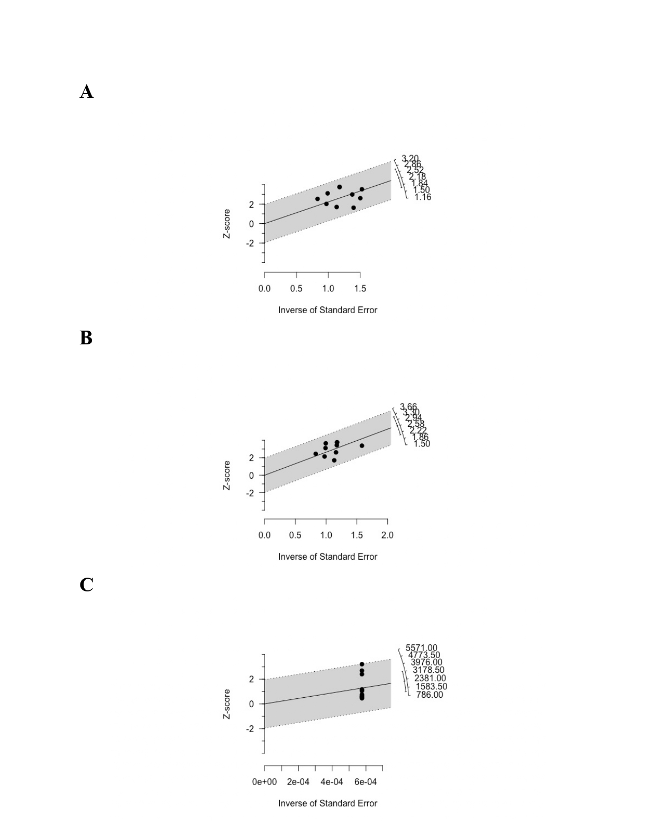Supplementary Figure 2. Galbraith plots of (A) ICU admission, (B) mortality and (C) serum ferritin on admission for COVID-19 infection.

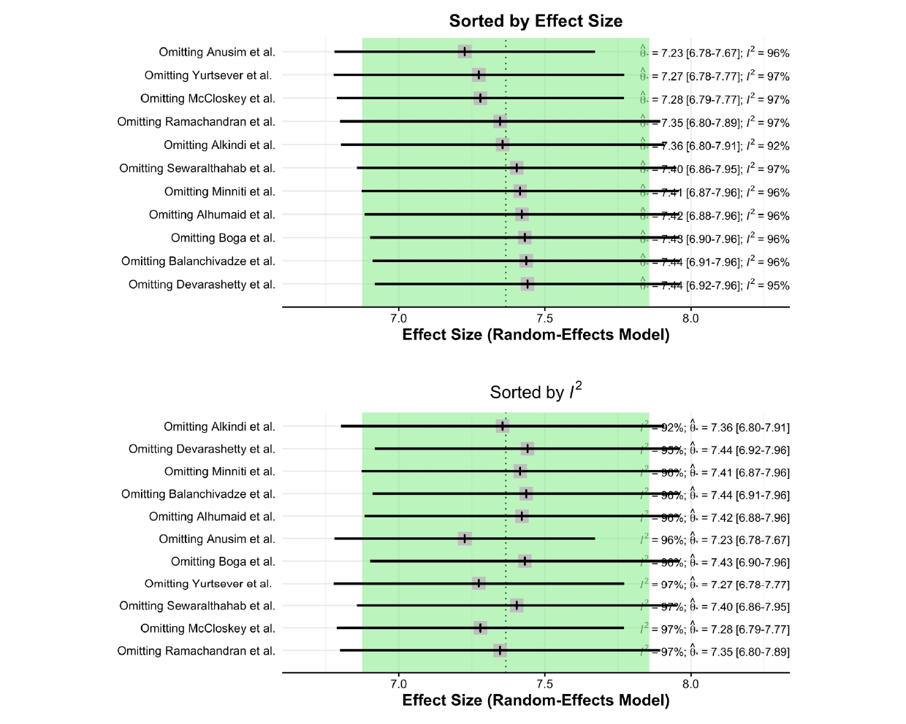Supplementary Figure 3. Sensitivity analysis of serum ferritin on admission.

