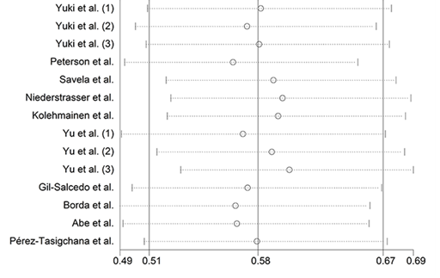
Figure S1. Sensitivity analyses on the association between physical activity and the risk of frailty by excluding one study each time.

