S7 File
Sensitivity analysis using Fixed effect model for the primary outcome
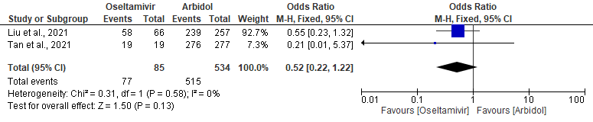
Figure 1: graphical presentation of the meta-analysis comparing the survival of the Oseltamivir group to the Arbidol group
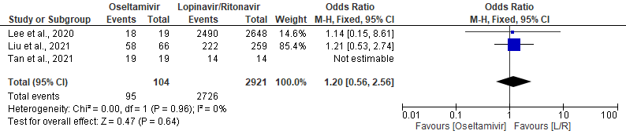
Figure 2: Forest plot of the meta-analysis comparing the survival of the Oseltamivir group to the Lopinavir/Ritonavir group
Figure 3: Prediction interval plot comparing Oseltamivir to other drugs.
Figure 4: PI plot for the sensitivity analysis.

Figure 5: PI plot for duration of hospitalisation.
Figure 6: PI plot for duration of hospitalisation sensitivity

