Supplementary Materials
S1 Fig. Risk of bias graph for included studies
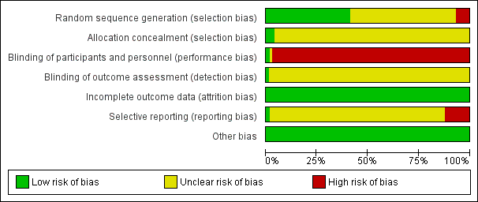
S2. Fig. Risk of bias summary for individual studies

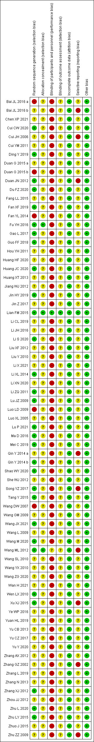

S3 Fig. Funnel plot of Fuling formulae plus hypoglycaemic agents versus hypoglycaemic agents alone for fasting blood glucose

S4 Fig. Funnel plot of Fuling formulae plus hypoglycaemic agents versus hypoglycaemic agents alone for 2-hour postprandial blood glucose

S5 Fig. Funnel plot of Fuling formulae plus hypoglycaemic agents versus hypoglycaemic agents alone for hemoglobin A1c

S6 Fig. Forest plot of total cholesterol level at end of treatment, Fuling formulae plus hypoglycaemic agents versus hypoglycaemic agents alone, results of meta-analysis.

S7 Fig. Funnel plot of Fuling formulae plus hypoglycaemic agents versus hypoglycaemic agents alone for total cholesterol

S8 Fig. Forest plot of triglyceride level at end of treatment, Fuling formulae plus hypoglycaemic agents versus hypoglycaemic agents alone, results of meta-analysis.

S9 Fig. Funnel plot of Fuling formulae plus hypoglycaemic agents versus hypoglycaemic agents alone for triglyceride

S10 Fig. Forest plot of low density lipoprotein level at end of treatment, Fuling formulae plus hypoglycaemic agents versus hypoglycaemic agents alone, results of meta-analysis.

S11 Fig. Funnel plot of Fuling formulae plus hypoglycaemic agents versus hypoglycaemic agents alone for low density lipoprotein

S12 Fig. Forest plot of high density lipoprotein level at end of treatment, Fuling formulae plus hypoglycaemic agents versus hypoglycaemic agents alone, results of meta-analysis.

S13 Fig. Funnel plot of Fuling formulae plus hypoglycaemic agents versus hypoglycaemic agents alone for high density lipoprotein

S14 Fig. Forest plot of fasting insulin level at end of treatment, Fuling formulae plus hypoglycaemic agents versus hypoglycaemic agents alone, results of meta-analysis.

S15 Fig. Funnel plot of Fuling formulae plus hypoglycaemic agents versus hypoglycaemic agents alone for fasting insulin levels

S16 Fig. Forest plot of homeostatic model assessment of insulin resistance at end of treatment, Fuling formulae plus hypoglycaemic agents versus hypoglycaemic agents alone, results of meta-analysis.

S17 Fig. Funnel plot of Fuling formulae plus hypoglycaemic agents versus hypoglycaemic agents alone for the homeostatic model assessment of insulin resistance

S18 Fig. Forest plot of insulin resistance at end of treatment, Fuling formulae plus hypoglycaemic agents versus hypoglycaemic agents alone, results of meta-analysis.

S19 Fig. Forest plot of body mass index at end of treatment, Fuling formulae plus hypoglycaemic agents versus hypoglycaemic agents alone, results of meta-analysis.

S20 Fig. Forest plot of adverse events at end of treatment, Fuling formulae plus hypoglycaemic agents versus hypoglycaemic agents alone, results of meta-analysis.

