Supplementary material
Supplementary table I. Overall Review PICO assessment.
Review PICO Assesment
Patient | Patients with suspected or pathologically proven bladder cancer
Intervention | Multiparametric MRI of the Bladder and VI-RADS (Vesical Imaging-Reporting And Data  System) scoring
Comparison | Pathological assessment (any of the following scenarios: TURBT, Radical or partial Cystectomy
Outcome | VIRADS score performance and reproducibility to diagnose muscle invasive bladder cancer

Supplementary table II. Risk Of Bias Assessment.
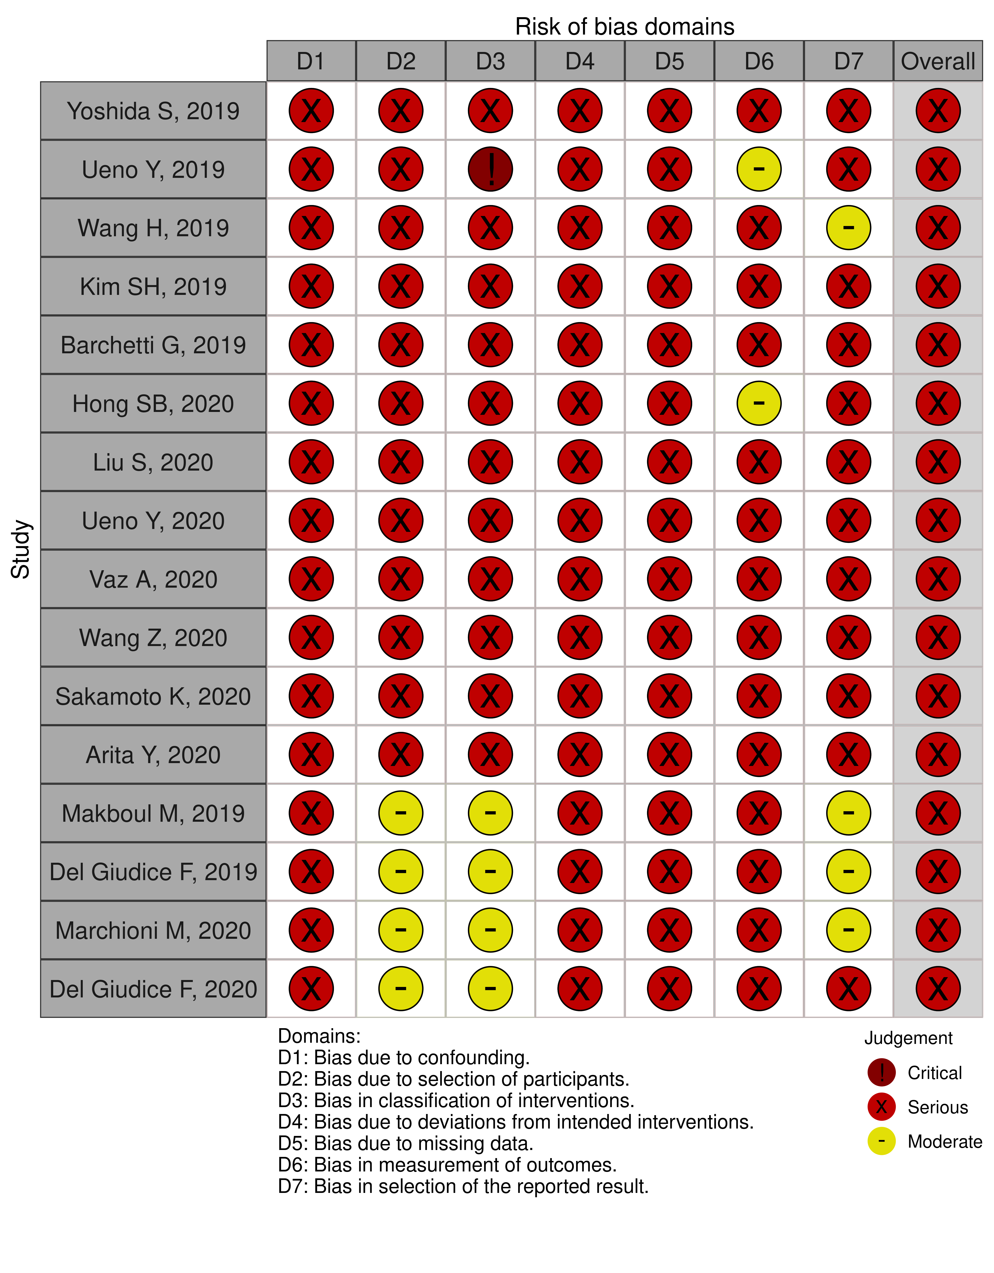

Supplementary table III. Definition of each score according to the mpMRI sequence used.
Score | Structural Category ranging (T2WI). | CE category ranging (DCE). | DW category ranging (DWI and ADC map). | Final scoring
SCORE 1 | Uninterrupted low signal intensity line representing the integrity of muscularis propria (lesion <1 cm; exophytic tumor with or without stalk and/or thickened inner layer) | No early enhancement of the muscularis propria (lesions corresponding to SC 1 findings) | Muscularis propria with intermediate continuous SI on DWI (lesion <1 cm, hyperintense on DWI and hypointense on ADC, with or without stalk and/ or low SI thickened inner layer on DWI) | VI-RADS 1  (muscle invasion is highly unlikely): SC, CE, and DW category 1
SCORE 2 | Uninterrupted low SI line representing the integrity of muscularis propria (lesion >1 cm; exophytic tumor with stalk and/or high S thickened inner layer, when present, or sessile/broad-based tumor with high SI thickened inner layer, when present) | No early enhancement of muscularis propria with early enhancement of inner layer (lesions corresponding to SC 2 findings) | Muscularis propria with continuous intermediate SI on DWI (lesion >1 cm, hyperintense on DWI and hypointense on ADC, with low SI stalk and/or low SI thickened inner layer on DWI, or broad-based/ sessile tumor with low/intermediate SI thickened inner layer on DWI) | VI-RADS 2  (muscle invasion is unlikely to be present): SC, CE, and DW category 2; both CE and DW category 2 with SC category 3
SCORE 3 | Lack of category 2 findings with associated presence of an exophytic tumor without stalk, or sessile/broad-based tumor without high SI thickened inner layer but with no clear disruption of low SI muscularis propria | Lack of category 2 findings (lesions corresponding to SC category 3 findings) but with no clear disruption of low SI muscularis propria | Lack of category 2 findings (lesions corresponding to T2 category 3 findings) but with no clear disruption of low SI muscularis propria. | VI-RADS 3  (the presence of muscle invasion is equivocal): SC, CE, and DW category 3; SC category 3, CE or DW category 3, the remaining sequence category 2
SCORE 4 | Interruption of low SI line suggesting extension of the intermediate SI tumor tissue to muscularis propria | Tumor early enhancement extends focally to muscularis propria | High SI tumor on DWI and low SI tumor on ADC extending focally to muscularis propria | VI-RADS 4  (muscle invasion is likely): at least SC and/or DW and CE category 4; the remaining category 3 or 4; SC category 3 plus DW and/or CE category 4; SC category 5 plus DW and/or CE category 4
SCORE 5 | Extension of intermediate SI tumor to extravesical fat, representing the invasion of the entire bladder wall and extravesical tissues | Tumor early enhancement extends to the entire bladder wall and to extravesical fat | High SI tumor on DWI and low SI tumor on ADC extending to the entire bladder wall and extravesical fat | VI-RADS 5  (invasion of muscle and beyond the bladder is very likely): at least SC plus DW and/or CE category 5; the remaining category 4 or 5

