Supplemental Table 1. Search Strategies

Embase
1. (dementia or Cognitive impairment or Alzheimer* or mild cognitive impair* or MCI or Parkinson's disease or dementia with lewy* body or vascular*).af.
2. (drawing test or digital draw* or computerized draw* or digital cognitive test or computerized cognitive test or clock drawing test or CDT or pentagon or cube draw or Rey Osterrieth or ROCF or tree draw or house draw or Spiral or infinity loops).af
3. 1+2
PsycINFO
1. (dementia or Cognitive impairment or Alzheimer* or mild cognitive impair* or MCI or Parkinson's disease or dementia with lewy* body or vascular*).af.
2. (drawing test or digital draw* or computerized draw* or digital cognitive test or computerized cognitive test or clock drawing test or CDT or pentagon or cube draw or Rey Osterrieth or ROCF or tree draw or house draw or Spiral or infinity loops).af
3. 1+2
CINAHL
1. TX (dementia or Cognitive impairment or Alzheimer* or mild cognitive impair* or MCI or Parkinson's disease or dementia with lewy* body or vascular* )
2. TX (drawing test or digital draw* or computerized draw* or digital cognitive test or computerized cognitive test or clock drawing test or CDT or pentagon or cube draw or Rey Osterrieth or ROCF or tree draw or house draw or Spiral or infinity loops )
3. 1+2
Medline search via Ebscohost
1. TX (dementia or Cognitive impairment or Alzheimer* or mild cognitive impair* or MCI or Parkinson's disease or dementia with lewy* body or vascular* )
2. TX (drawing test or digital draw* or computerized draw* or digital cognitive test or computerized cognitive test or clock drawing test or CDT or pentagon or cube draw or Rey Osterrieth or ROCF or tree draw or house draw or Spiral or infinity loops)
3. 1+2

SupplementaryTable 2. Characteristics of Included Studies

Study | Region | Age | Male % | Type of Test | No. of Participants | Type of Patients | Quality Score
Aguilar-Navarro 2018 | Mexico | 75 | NA | Paper-and-pencil CDT – Detailed | 167 | MCI | 8
Alty 2015 | USA, UK | 71 | 68% | Paper-and-pencil Pentagon | 63 | MCI & Dementia | 6
Aprahamian 2010 | Brazil | 78 | 59% | Paper-and-pencil CDT – Brief | 220 | Dementia | 8
Aprahamian 2011 | Brazil | 80 | 29% | Paper-and-pencil CDT – Brief | 106 | Dementia | 8
Beinhoff 2005 | German | 66 | 48% | Paper-and-pencil CDT – Brief | 171 | MCI | 7
Berger 2008 | Germany | 74 | 34% | Paper-and-pencil CDT – Brief | 419 | Dementia | 7
Biundo 2013 | Italy | 64 | 53% | Paper-and-pencil ROCF | 104 | MCI | 8
Brodaty 1997 | Australia | 73 | 32% | Paper-and-pencil CDT – Brief | 56 | Dementia | 6
Cacho 2010 | Spain | 74 | 33% | Paper-and-pencil CDT – Detailed | 163 | MCI | 8
Cahn 1996 | USA | 84 | 40% | Paper-and-pencil CDT – Detailed | 279 | Dementia | 7
Carnero-Pardo 2013 | Spain | 76 | 31% | Paper-and-pencil CDT – Brief | 307 | MCI & Dementia | 8
Cecato 2016 | Brazile | 76 | 36% | Paper-and-pencil Pentagon | 22 | Dementia | 8
Chan 2005 | Hong Kong | 79 | 43% | Paper-and-pencil CDT – Detailed | 85 | Dementia | 8
Charernboon 2017 | Thailand | 70 | 40% | Paper-and-pencil CDT – Brief, Cube | 142 | MCI | 8
Cheah 2019 | Taiwan | 68 | 48% | Digital ROCF | 118 | MCI | 7
Chen 2018 | China | 85 | 35% | Paper-and-pencil CDT – Brief | 361 | MCI | 7
Chiu 2008 | Taiwan | 74 | 59% | Paper-and-pencil CDT – Detailed | 116 | MCI & Dementia | 8
Connor 2005 | USA | 73 | NA | Paper-and-pencil CDT – Detailed | 100 | Dementia | 8
Cormack 2004 | UK | 78 | 88% | Paper-and-pencil Pentagon | 145 | Dementia | 7
Davis 2014 | UK | NA | NA | Digital CDT | 636 | Dementia | 4
Donnelly 2008 | USA | 78 | 99% | Paper-and-pencil CDT – Detailed | 100 | MCI | 8
Ehreke 2011a | Germany | 85 | 4% | Paper-and-pencil CDT – Brief | 428 | MCI | 8
Ehreke 2011b | Germany | 85 | 17% | Paper-and-pencil CDT – Brief | 384 | Dementia | 7
Emek-savas 2018 | Turkey | 71 | NA | Paper-and-pencil CDT – Detailed | 80 | Dementia | 7
Esteban-Santillan 1998 | USA | 72 | 50% | Paper-and-pencil CDT – Detailed | 196 | Dementia | 8
Forti 2010 | Italy | 74 | 33% | Paper-and-pencil CDT – Detailed | 423 | MCI | 8
Fuchs 2012 | Germany | 82 | 39% | Paper-and-pencil CDT – Detailed | 52 | Dementia | 7
Garre-Olmo 2017 | Spain | 64 | NA | Digital CDT, House, Pentagon, Spiral | 102 | MCI | 8
Ghose 2019 | India | 68 | 53% | Paper-and-pencil CDT – Detailed | 114 | MCI | 8
Heinik 2003 | Israel | 78 | 51% | Paper-and-pencil CDT – Detailed | 92 | Dementia | 8
Heymann 2018 | Germany | 69 | 29% | Digital Tree | 140 | MCI & Dementia | 7
Jagar 2003 | UK | 76 | 41% | Paper-and-pencil CDT – Detailed | 231 | MCI | 6
Jorgensen 2014 | Denmark | 77 | 40% | Paper-and-pencil CDT – Brief | 356 | Dementia | 8
Jouk 2012 | Canada | 79 | 49% | Paper-and-pencil CDT – Brief | 104 | Dementia | 7
Kalman 1995 | Hungary | 80 | 53% | Paper-and-pencil CDT – Detailed | 669 | Dementia | 7
Kanchanatawan 2006 | Thailand | NA | NA | Paper-and-pencil CDT – Detailed | 45 | Dementia | 7
Karrasch 2005 | Finland | 72 | 27% | Paper-and-pencil CDT – Brief | 255 | Dementia | 8
Kato 2013 | Japan | 79 | 27% | Paper-and-pencil CDT – Detailed | 56 | Dementia | 7
Kim 2010 | Korea | 71 | NA | Paper-and-pencil CDT – Detailed | 564 | Dementia | 8
Kirby 2001 | Ireland | 80 | NA | Paper-and-pencil CDT – Detailed | 101 | Dementia | 7
Korner 2012 | Denmark | 81 | 38% | Paper-and-pencil CDT – Brief | 247 | Dementia | 8
Ladeira 2009 | Brazil | 70 | NA | Paper-and-pencil CDT – Detailed | 465 | MCI | 8
Lee 2008 | Korea | 72 | 38% | Paper-and-pencil CDT – Detailed | 152 | MCI | 7
Lepeleire 2005 | Belgium | 80 | 53% | Paper-and-pencil CDT – Brief | 364 | Dementia | 6
Lessig 2008 | USA | 78 | 35% | Paper-and-pencil CDT – Detailed | 132 | Dementia | 7
Leung 2005 | Hong Kong | 75 | NA | Paper-and-pencil CDT – Brief | 403 | Dementia | 8
Lin 2003 | Taiwan | 74 | 47% | Paper-and-pencil CDT – Detailed | 211 | Dementia | 8
Lourenço 2008 | Brazil | 74 | 24% | Paper-and-pencil CDT – Brief | 390 | Dementia | 8
Martinelli 2018 | Brazil | 79 | 26% | Paper-and-pencil Pentagon | 176 | Dementia | 8
Matsuoka 2014 | Japan | 80 | 31% | Paper-and-pencil CDT – Detailed | 502 | Dementia | 7
Milian 2012 | Germany | 75 | 37% | Paper-and-pencil CDT – Brief | 299 | Dementia | 7
Moriyama 2016 | Japan | 80 | NA | Paper-and-pencil CDT – Detailed | 70 | MCI & Dementia | 8
Muller 2017 | Germany | 65 | 50% | Digital CDT | 381 | MCI | 6
Muller 2019 | Germany | 65 | 50% | Digital CDT | 157 | MCI | 7
Nair_Anil 2010 | USA | 72 | 46% | Paper-and-pencil CDT – Detailed | 150 | MCI | 7
Nunes 2008 | Brazil | 70 | 30% | Paper-and-pencil CDT – Detailed | 100 | Dementia | 7
Ota 2015 | Japan | 78 | NA | Paper-and-pencil CDT – Detailed, Cube | 132 | Dementia | 8
Parsey 2011 | USA | 71 | 36% | Paper-and-pencil CDT – Detailed | 692 | MCI | 7
Patocskai 2014 | Hungary | 78 | 32% | Paper-and-pencil CDT – Detailed | 75 | Dementia | 8
Powlishta 2002 | USA | 75 | 33% | Paper-and-pencil CDT – Detailed | 188 | Dementia | 8
Rakusa 2018 | Slovenia | 75 | NA | Paper-and-pencil CDT – Brief | 140 | MCI | 8
Ramlall 2013 | South Africa | 77 | 18% | Paper-and-pencil CDT – Detailed | 744 | Dementia | 6
Ravaglia 2003 | Italy | 73 | NA | Paper-and-pencil CDT – Detailed | 190 | Dementia | 8
Ravaglia 2005 | Italy | 76 | 39% | Paper-and-pencil CDT – Detailed | 264 | MCI | 6
Ricci 2016 | Italy | 77 | NA | Paper-and-pencil CDT – Brief | 873 | Dementia | 8
Riedel 2008 | Germany | NA | 63% | Paper-and-pencil CDT – Brief | 177 | Dementia | 8
Robens 2019 | Germany | 68 | 45% | Paper-and-pencil CDT – Brief | 96 | MCI & Dementia | 8
Robert 2003 | France | 78 | 81% | Paper-and-pencil CDT – Brief | 74 | Dementia | 8
Roudsari 2018 | Iran | NA | NA | Paper-and-pencil CDT – Brief | 96 | Dementia | 8
Rubinova 2014 | Czech | 75 | 52% | Paper-and-pencil CDT – Detailed | 142 | MCI | 8
Russo 2014 | Argentina | NA | 30% | Paper-and-pencil CDT – Detailed | 80 | MCI & Dementia | 6
Scanlan 2002 | USA | NA | NA | Paper-and-pencil CDT – Detailed | 369 | Dementia | 6
Schmidtke 2006 | Germany | 76 | 34% | CDT-brief | 337 | Dementia | 6
Seigerschmidt 2002 | Germany | 75 | 37% | Paper-and-pencil CDT – Detailed | 190 | MCI | 5
Shigemori 2015 | Japan | NA | NA | Digital CDT | 127 | MCI | 7
Storey 2001 | Australia | 79 | 29% | Paper-and-pencil CDT – Brief | 93 | Dementia | 8
Storey 2002 | Australia | 80 | 33% | Paper-and-pencil CDT – Brief | 150 | Dementia | 7
Sunderland 1989 | USA | 68 | NA | Paper-and-pencil CDT – Detailed | 50 | Dementia | 7
Todd 1995 | USA | 58 | NA | Paper-and-pencil CDT – Detailed | 215 | Dementia | 8
Trenkle 2007 | USA | 75 | 53% | Paper-and-pencil CDT – Detailed | 465 | Dementia | 6
Tsoi 2018 | Hong Kong | 80 | NA | Digital Pentagon | 473 | Dementia | 8
Van de Burg 2004 | Belgium | 65 | NA | Paper-and-pencil CDT – Brief | 187 | Dementia | 8
Vyhnalek 2017 | Czech Republic | 76 | 57% | Paper-and-pencil CDT – Detailed | 76 | MCI | 7
Watson 1993 | USA | 76 | 19% | Paper-and-pencil CDT – Detailed | 224 | Dementia | 7
Wiechmann 2010 | USA | 75 | 30% | Paper-and-pencil CDT – Brief | 277 | Dementia | 6
Wolf-Klein 1989 | USA | 79 | NA | Paper-and-pencil CDT – Brief | 219 | Dementia | 7
Yamamoto 2004 | Japan | 75 | 44% | Paper-and-pencil CDT – Detailed | 2015 | MCI | 8
Yang 2016 | China | 84 | 36% | Paper-and-pencil CDT – Brief | 148 | Dementia | 8
Yap 2007 | Singapore | 78 | 38% | Paper-and-pencil CDT – Detailed | 160 | Dementia | 7
Zhou 2008 | China | 66 | 70% | Paper-and-pencil CDT – Detailed | 167 | MCI | 8
Abbveiations: CDT, Clock Drawing Test, MCI, Mild Cognitive Impariment; NA, Not Avaliable

Supplementary Table 3. Risk of Bias of Included Studies

Study & Year | 1. Patient selection | 2. Execution of the index test | 3. Execution of the ref. standard | 4. Flow and timing
Aguilar-Navarro 2018 | L | L | L | L
Alty 2015 | L | H | H | L
Aprahamian 2010 | L | L | L | L
Aprahamian 2011 | L | U | L | L
Beinhoff_2005 | L | U | L | L
Berger 2008 | L | L | L | L
Biundo 2013 | L | U | L | L
Brodaty 1997 | L | U | U | L
Cacho 2010 | L | U | U | L
Cahn 1996 | L | L | L | L
Carnero-Pardo 2013 | L | L | L | L
Cecato 2016 | U | U | L | U
Chan_2005 | L | U | L | U
Charernboon 2017 | L | U | L | U
Cheah 2019 | H | L | H | L
Chen 2018 | L | L | U | U
Chiu_ 2008 | L | U | L | L
Connor2005 | L | L | L | L
Cormack 2004 | L | L | L | U
Davis 2014 | H | U | L | H
Donnelly 2008 | L | L | L | L
Ehreke_2011a | L | L | L | L
Ehreke 2011b | L | L | L | L
Emek-savas 2018 | L | L | L | L
Esteban-Santillan 1998 | H | L | L | L
Forti 2010 | L | U | L | L
Fuchs 2012 | L | U | L | L
Garre-Olmo 2017 | L | L | L | L
Ghose_2019 | L | U | L | L
Heinik_2003 | L | L | L | U
Heymann_2018 | L | L | L | L
Jagar_2003 | L | U | L | L
Jorgensen 2014 | L | L | H | U
Jouk 2012 | L | L | L | L
Kalman 1995 | U | L | L | L
Kanchanatawan 2006 | U | U | L | L
Karrasch 2005 | U | U | L | U
Kato 2013 | L | L | L | L
Kim 2010 | U | L | L | L
Kirby 2001 | U | L | L | U
Korner 2012 | U | L | L | U
Ladeira_2009 | L | U | U | L
Lee 2008 | L | L | L | L
Lepeleire 2005 | L | U | U | U
Lessig 2008 | L | U | L | U
Leung 2005 | L | L | L | L
Lin 2003 | U | L | L | L
Lourenço 2008 | U | L | L | L
Martinelli 2018 | U | U | L | L
Matsuoka 2014 | L | L | L | L
Milian 2012 | L | U | L | L
Moriyama 2016 | U | L | L | L
Muller_2017 | U | L | L | L
Muller_2019 | U | L | L | U
Nair_Anil 2010 | L | L | L | L
Nunes 2008 | U | L | L | U
Ota 2015 | H | L | L | L
Parsey 2011 | U | L | L | L
Patocskai 2014 | U | L | L | U
Powlishta 2002 | U | L | L | H
Rakusa 2018 | L | L | L | L
Ramlall 2013 | L | L | L | L
Ravaglia 2003 | L | L | U | L
Ravaglia 2005 | L | L | L | L
Ricci 2016 | L | L | U | U
Riedel 2008 | L | L | L | L
Robens 2019 | L | L | U | L
Robert 2003 | L | L | U | L
Roudsari 2018 | L | L | L | L
Rubinova 2014 | L | L | U | U
Russo 2014 | L | L | L | L
Scanlan 2002 | L | L | L | U
Schmidtke 2006 | L | L | L | L
Seigerschmidt 2002 | L | L | U | U
Shigemori 2015 | H | L | U | H
Storey 2001 | L | L | U | U
Storey 2002 | U | U | L | L
Sunderland 1989 | U | L | L | L
Todd 1995 | L | L | L | L
Trenkle 2007 | L | L | L | L
Tsoi 2018 | L | L | U | L
Van de Burg 2004 | L | L | L | L
Vyhnalek_2017 | L | L | L | L
Watson 1993 | L | L | L | L
Wiechmann 2010 | H | L | L | H
Wolf-Klein 1989 | L | U | L | U
Yamamoto 2004 | L | L | L | L
Yang 2016 | L | U | L | L
Yap 2007 | L | L | L | L
Zhou 2008 | U | L | L | L
Abbreviations: L, Low riks; H, High risk; U, Uncertain risk
Supplementary Table 4. Description of Results of Included Studies

Study & Year | Patient Type | Type of test | True Positive | False Negative | False Negative | True Positive
Aguilar-Navarro 2018 | MCI | Paper-and-pencil CDT – Detailed | 21 | 17 | 31 | 41
Aguilar-Navarro_2018 | Dementia | Paper-and-pencil CDT – Detailed | 51 | 3 | 6 | 55
Alty2015 | Dementia | Pentagon | 8 | 5 | 23 | 27
Aprahamian 2010 | Dementia | Paper-and-pencil CDT – Brief | 104 | 33 | 17 | 66
Aprahamian 2011 | Dementia | Paper-and-pencil CDT – Brief | 44 | 7 | 22 | 33
Beinhoff_2005 | MCI | Paper-and-pencil CDT – Brief | 19 | 23 | 29 | 34
Beinhoff_2005 | Dementia | Paper-and-pencil CDT – Brief | 47 | 3 | 19 | 54
Berger 2008 | Dementia | Paper-and-pencil CDT – Brief | 301 | 56 | 33 | 72
Biundo_2013 | MCI | ROCF | 20 | 2 | 14 | 53
Brodaty_1997 | Dementia | Paper-and-pencil CDT – Brief | 24 | 1 | 4 | 27
Cacho 2010 | MCI | Paper-and-pencil CDT – Detailed | 16 | 20 | 5 | 46
Cacho 2010 | Dementia | Paper-and-pencil CDT – Detailed | 48 | 2 | 18 | 64
Cahn_1996 | Dementia | Paper-and-pencil CDT – Detailed | 35 | 66 | 7 | 171
Cecato_2016 | Dementia | Pentagon | 14 | 8 | 0 | 14
Chan_2005 | Dementia | Paper-and-pencil CDT – Detailed | 46 | 18 | 5 | 16
Charernboon_2017 | MCI | Cube | 23 | 28 | 12 | 32
Charernboon_2017 | MCI | Paper-and-pencil CDT – Brief | 20 | 18 | 15 | 42
Cheah_2019 | MCI | Digital ROCF | 45 | 8 | 14 | 51
chen_2018 | MCI | Paper-and-pencil CDT – Brief | 97 | 39 | 21 | 94
chen_2018 | Dementia | Paper-and-pencil CDT – Brief | 102 | 39 | 8 | 94
Chiu_2008 | mci | Paper-and-pencil CDT – Detailed | 25 | 17 | 9 | 23
Chiu_2008 | Dementia | Paper-and-pencil CDT – Detailed | 24 | 6 | 18 | 34
Connor_2005 | Dementia | Paper-and-pencil CDT – Detailed | 37 | 6 | 13 | 44
Cormack_2004 | Dementia | Pentagon | 37 | 13 | 13 | 68
Davis 2014 | Dementia | Digital CDT | 48 | 84 | 28 | 476
Donnelly_2008 | MCI | Paper-and-pencil CDT – Detailed | 17 | 45 | 3 | 35
Ehreke 2011a | Dementia | Paper-and-pencil CDT – Brief | 19 | 125 | 9 | 231
Ehreke_2011b | MCI | Paper-and-pencil CDT – Brief | 44 | 155 | 14 | 215
Emek-savas_2018 | Dementia | Paper-and-pencil CDT – Detailed | 97 | 25 | 11 | 83
Emek-savas_2018 | MCI | Paper-and-pencil CDT – Detailed | 101 | 25 | 24 | 100
Esteban-Santillan 1998 | Dementia | Paper-and-pencil CDT – Detailed | 38 | 23 | 3 | 16
Forti 2010 | MCI | Paper-and-pencil CDT – Detailed | 88 | 23 | 44 | 41
Fuchs 2012 | Dementia | Paper-and-pencil CDT – Detailed | 19 | 66 | 2 | 336
Garre-Olmo_2017 | MCI | Digital CDT | 11 | 0 | 1 | 17
Garre-Olmo_2017 | Dementia | Digital CDT | 29 | 4 | 6 | 13
Garre-Olmo_2017 | Dementia | Digital Pentagon | 26 | 0 | 3 | 23
Garre-Olmo_2017 | Dementia | Digital Spiral | 25 | 2 | 4 | 21
Garre-Olmo_2017 | Dementia | Digital house | 24 | 0 | 5 | 23
Ghose_2019 | MCI | Paper-and-pencil CDT – Detailed | 32 | 22 | 8 | 40
Heinik_2003 | Dementia | Paper-and-pencil CDT – Detailed | 75 | 3 | 13 | 23
Heymann_2018 | Dementia | Digital Tree | 61 | 8 | 7 | 16
Heymann_2018 | Dementia | Digital CDT | 50 | 0 | 18 | 24
Jagar_2003 | MCI | Paper-and-pencil CDT – Detailed | 22 | 28 | 7 | 23
Jagar_2003 | Dementia | Paper-and-pencil CDT – Detailed | 54 | 15 | 6 | 36
Jorgensen_2014 | Dementia | Paper-and-pencil CDT – Brief | 88 | 19 | 48 | 76
Jouk_2012 | Dementia | Paper-and-pencil CDT – Brief | 65 | 88 | 15 | 188
Kalman 1995 | Dementia | Paper-and-pencil CDT – Detailed | 35 | 5 | 10 | 54
Kanchanatawan 2006 | Dementia | Paper-and-pencil CDT – Detailed | 22 | 167 | 3 | 477
Karrasch_2005 | Dementia | Paper-and-pencil CDT – Brief | 5 | 2 | 10 | 13
Kato 2013 | Dementia | Paper-and-pencil CDT – Detailed | 121 | 6 | 25 | 43
Kato 2013 | MCI | Paper-and-pencil CDT – Detailed | 30 | 6 | 30 | 43
Kim_2010 | Dementia | Paper-and-pencil CDT – Detailed | 16 | 3 | 12 | 25
Kirby 2001 | Dementia | Paper-and-pencil CDT – Detailed | 31 | 99 | 10 | 424
Korner 2012 | Dementia | Paper-and-pencil CDT – Brief | 61 | 4 | 11 | 25
Ladeira_2009 | MCI | Paper-and-pencil CDT – Detailed | 25 | 10 | 58 | 73
Ladeira_2009 | Dementia | Paper-and-pencil CDT – Detailed | 49 | 10 | 32 | 73
Lee 2008 | MCI | Paper-and-pencil CDT – Detailed | 91 | 41 | 133 | 200
Lee 2008 | MCI | Paper-and-pencil CDT – Brief | 96 | 35 | 128 | 206
lepeleire_2005 | Dementia | Paper-and-pencil CDT – Brief | 34 | 17 | 17 | 85
Lessig_2008 | Dementia | Paper-and-pencil CDT – Detailed | 199 | 40 | 27 | 98
Leung 2005 | Dementia | Paper-and-pencil CDT – Brief | 52 | 24 | 14 | 42
Lin_2003 | Dementia | Paper-and-pencil CDT – Detailed | 96 | 66 | 48 | 193
Lourenço 2008 | Dementia | Paper-and-pencil CDT – Brief | 44 | 61 | 24 | 82
Martinelli 2018 | Dementia | Pentagon | 253 | 67 | 13 | 57
Matsuoka 2014 | Dementia | Paper-and-pencil CDT – Detailed | 80 | 7 | 51 | 38
Matsuoka 2014 | Dementia | Paper-and-pencil CDT – Brief | 80 | 7 | 51 | 38
Milian 2012 | Dementia | Paper-and-pencil CDT – Brief | 342 | 2 | 96 | 62
Muller_2017 | MCI | Digital CDT | 20 | 6 | 4 | 14
Muller_2017 | MCI | Paper-and-pencil CDT – Brief | 20 | 6 | 4 | 14
Muller_2017 | Dementia | Digital CDT | 17 | 3 | 3 | 17
Muller_2019 | MCI | Digital CDT | 118 | 31 | 20 | 106
Muller_2019 | Dementia | Digital CDT | 97 | 8 | 9 | 129
Nair_Anil 2010 | MCI | Paper-and-pencil CDT – Detailed | 41 | 27 | 9 | 23
Nair_Anil 2010 | Dementia | Paper-and-pencil CDT – Detailed | 42 | 12 | 8 | 38
Nunes 2008 | Dementia | Paper-and-pencil CDT – Detailed | 25 | 21 | 5 | 41
Nunes 2008 | MCI | Paper-and-pencil CDT – Detailed | 34 | 21 | 31 | 41
Ota 2015 | Dementia | Paper-and-pencil CDT – Detailed | 54 | 16 | 16 | 14
Ota 2015 | Dementia | Cube | 52 | 15 | 18 | 15
Parsey 2011 | MCI | Paper-and-pencil CDT – Detailed | 13 | 8 | 20 | 58
Patocskai_2014 | Dementia | Paper-and-pencil CDT – Detailed | 229 | 140 | 34 | 151
Powlishta 2002 | Dementia | Paper-and-pencil CDT – Detailed | 45 | 3 | 15 | 12
Powlishta 2002 | Dementia | Paper-and-pencil CDT – Brief | 42 | 2 | 18 | 13
Rakusa 2018 | MCI | Paper-and-pencil CDT – Brief | 34 | 4 | 15 | 39
Rakusa 2018 | Dementia | Paper-and-pencil CDT – Brief | 48 | 4 | 6 | 39
Ramlall_2013 | Dementia | Paper-and-pencil CDT – Detailed | 5 | 10 | 6 | 81
Ravaglia 2003 | Dementia | Paper-and-pencil CDT – Detailed | 34 | 28 | 9 | 673
Ravaglia 2003 | Dementia | Paper-and-pencil CDT – Brief | 37 | 49 | 6 | 652
Ravaglia_2005 | MCI | Paper-and-pencil CDT – Detailed | 23 | 8 | 34 | 47
Ravaglia_2005 | MCI | Paper-and-pencil CDT – Brief | 4 | 6 | 14 | 49
Ricci 2016 | Dementia | Paper-and-pencil CDT – Brief | 167 | 34 | 16 | 304
Ricci 2016 | MCI | Paper-and-pencil CDT – Brief | 150 | 54 | 48 | 284
Riedel_2008 | Dementia | Paper-and-pencil CDT – Brief | 178 | 191 | 72 | 432
Robens_2019 | MCI | Digital Tree | 36 | 11 | 28 | 56
Robens_2019 | Dementia | Digital Tree | 48 | 12 | 8 | 55
Robert_2003 | Dementia | Paper-and-pencil CDT – Brief | 27 | 6 | 22 | 41
Roudsari_2018 | Dementia | Paper-and-pencil CDT – Brief | 36 | 9 | 4 | 25
Rubinova 2014 | MCI | Paper-and-pencil CDT – Detailed | 30 | 18 | 18 | 30
Russo 2014 | MCI | Paper-and-pencil CDT – Detailed | 67 | 1 | 50 | 29
Russo 2014 | Dementia | Paper-and-pencil CDT – Detailed | 36 | 1 | 20 | 29
Scanlan 2002 | Dementia | Paper-and-pencil CDT – Detailed | 33 | 2 | 10 | 23
Schmidtke_2006 | Dementia | Paper-and-pencil CDT – Brief | 113 | 14 | 17 | 50
Seigerschmidt 2002 | MCI | Paper-and-pencil CDT – Detailed | 66 | 48 | 33 | 91
Shigemori_2015 | MCI | Digital CDT | 2 | 2 | 1 | 90
Shigemori_2015 | Dementia | Digital CDT | 94 | 20 | 6 | 90
Storey 2001 | Dementia | Paper-and-pencil CDT – Brief | 67 | 25 | 5 | 30
Storey 2002 | Dementia | Paper-and-pencil CDT – Brief | 38 | 18 | 11 | 26
Sunderland_1989 | Dementia | Paper-and-pencil CDT – Detailed | 52 | 3 | 15 | 80
Todd_1995 | Dementia | Paper-and-pencil CDT – Detailed | 22 | 4 | 1 | 23
Trenkle_2007 | Dementia | Paper-and-pencil CDT – Detailed | 30 | 43 | 21 | 27
Tsoi_2018 | Dementia | Digital Pentagon | 151 | 78 | 43 | 193
Van de Burg 2004 | Dementia | Paper-and-pencil CDT – Brief | 372 | 50 | 15 | 36
Vyhnalek_2017 | MCI | Paper-and-pencil CDT – Detailed | 34 | 33 | 15 | 55
Vyhnalek_2017 | Dementia | Paper-and-pencil CDT – Detailed | 46 | 33 | 4 | 55
Watson_1993 | Dementia | Paper-and-pencil CDT – Detailed | 35 | 6 | 5 | 30
Wiechmann 2010 | Dementia | Paper-and-pencil CDT – Brief | 200 | 7 | 0 | 17
Wolf-Klein_1989 | Dementia | Paper-and-pencil CDT – Brief | 105 | 14 | 16 | 177
Yamamoto_2004 | MCI | Paper-and-pencil CDT – Detailed | 36 | 10 | 12 | 31
Yang_2016 | Dementia | Paper-and-pencil CDT – Brief | 404 | 286 | 40 | 1285
Yap_2007 | Dementia | Paper-and-pencil CDT – Detailed | 55 | 15 | 18 | 60
Zhou 2008 | MCI | Paper-and-pencil CDT – Detailed | 55 | 17 | 25 | 63
Abbveiations: CDT, Clock Drawing Test, MCI, Mild Cognitive Impariment;

Supplementary Table 5. Sensitivity Anlyais of Sensitivity and Specificity of Commonly Used Scoring Methods of Paper-and-Pencil Clock Drawing Tests

Paper-and-Pencil CDT | No. of study | Sensitivity  (95% CI) | Specificity  95% CI) | LR+ | LR- | DOR | AUC
Brief Scoring
5-point | 4 | 0.78 (0.64 – 0.88) | 0.83 (0.71 – 0.90) | 4.47 (2.43 – 8.22) | 0.26 (0.14 – 0.48) | 16.9 95.68 – 50.3) | 88% (84%-90%)
6-point | 22 | 0.80 (0.74 – 0.85) | 0.75 (0.67 – 0.82) | 3.27 (2.46 – 4.35) | 0.26 (0.20 – 0.34) | 12.6 (8.00 – 19.8) | 85% (82%-88%)
Detailed Scoring
10-point | 23 | 0.79 (0.75 – 0.83) | 0.80 (0.73 – 0.86) | 4.01 (2.92 – 5.51) | 0.26 (0.21 – 0.31) | 15.6 (10.5 – 23.2) | 86% (82%-88%)
14-point | 4 | 0.75 (0.46 – 0.92) | 0.81 (0.56 – 0.94) | 4.04 (1.53 – 10.7) | 0.30 (0.12 – 0.76) | 13.3 (2.94 – 60.4) | 85% (82%-88%)
15-point | 7 | 0.75 (0.65 – 0.82) | 0.71 (0.58 – 0.81) | 0.36 (0.23 – 0.55) | 0.36 (0.23 – 0.55) | 7.31 (3.11 – 17.2) | 79% (76%-83%)

Supplementary Figure 1. HSROC for the Pooled Sensitivity and Specificity of Digital and Paper-and Pencil Clock Drawing Test for the Screening of MCI

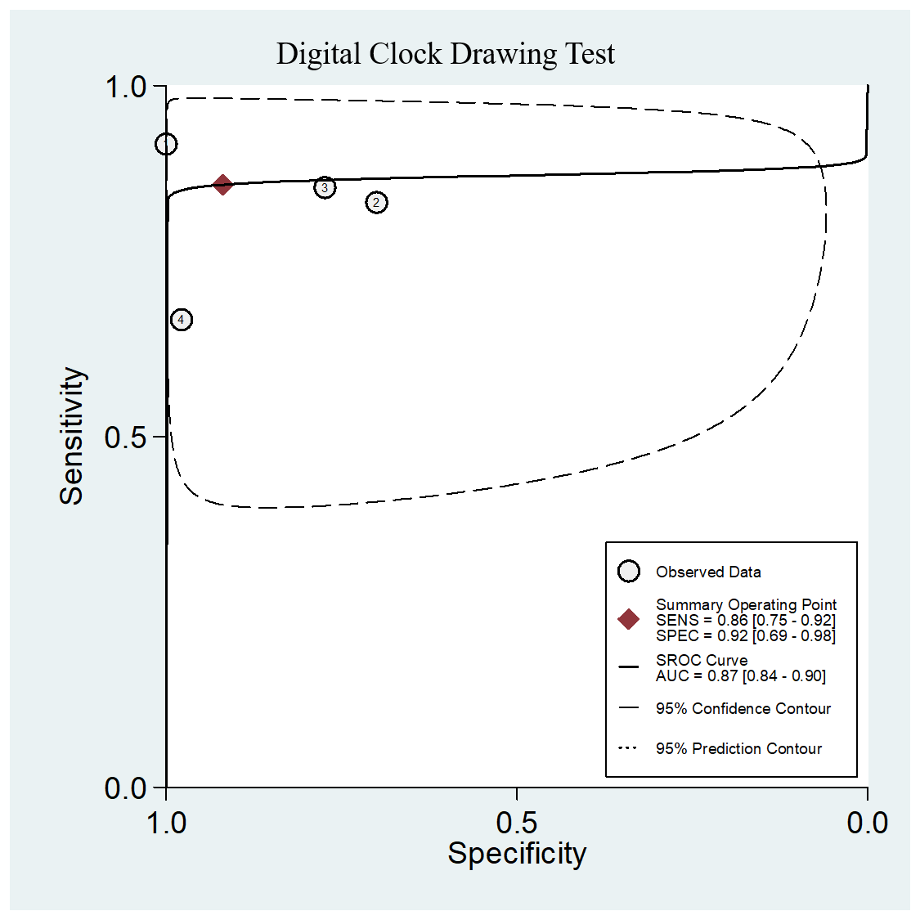
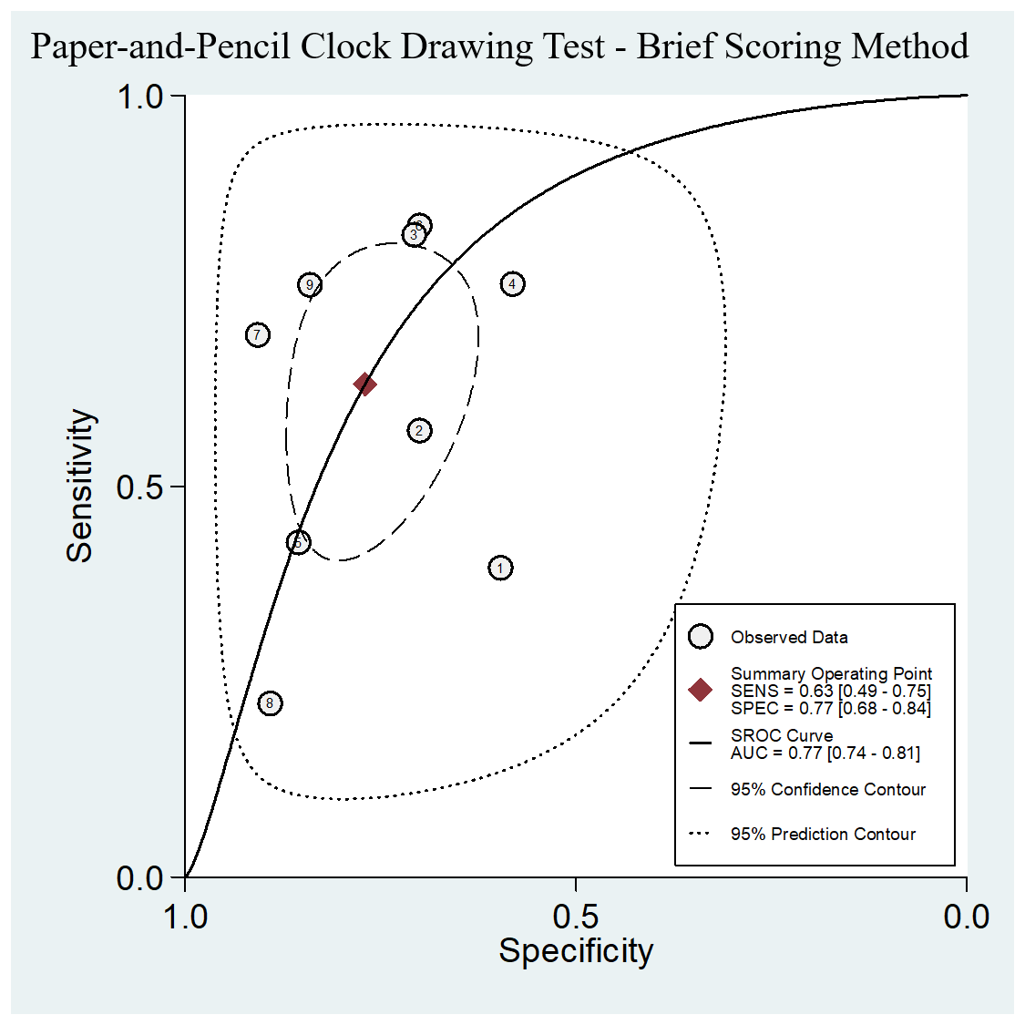
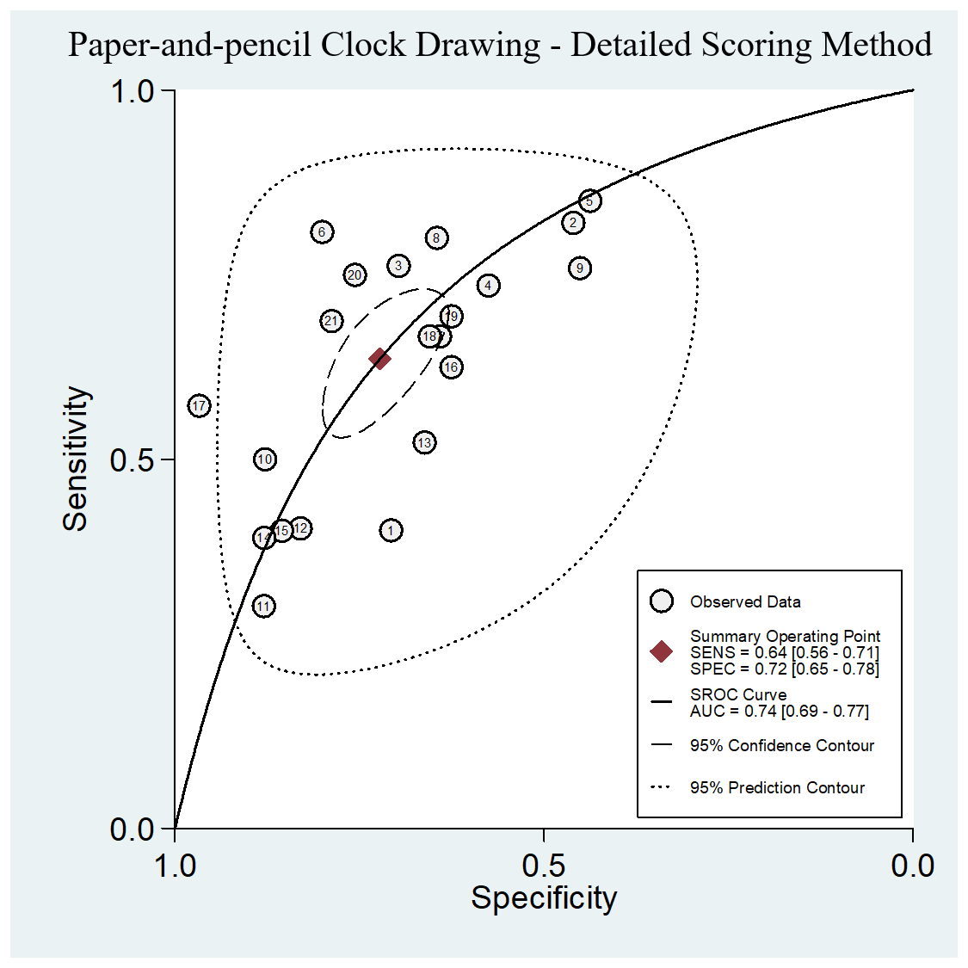

Supplementary Figure 2. Funnel Plots of Publication Bias

a. Funnel Plot of Digital CDT for the screening of MCI

b. Funnel Plot of Paper-and-pencil CDT – Brief scoring method for the screening of MCI

c. Funnel Plot of Paper-and-pencil CDT – Detailed scoring method for the screening of MCI

d. Funnel Plot of Digital CDT for the screening of dementia

e. Funnel Plot of Paper-and-pencil CDT – Brief scoring method for the screening of dementia
f. Funnel Plot of Paper-and-pencil CDT – Detailed scoring method for the screening of dementia

Supplementary Figure 3. HSROC for the Pooled Sensitivity and Specificity of Digital and Paper-and Pencil Clock Drawing Test for the Screening of Dementia



