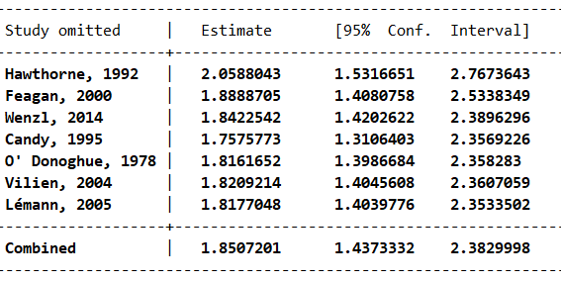

Supplementary Figure 1A Results of the sensitivity analyses in the withdrawal of immunomodulator monotherapy group within 24-month of follow-up

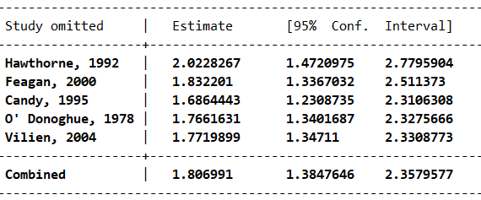

Supplementary Figure 1B Results of the sensitivity analyses in the withdrawal of immunomodulator monotherapy group within 12-month of follow-up

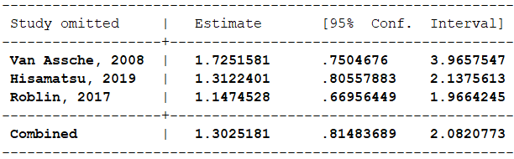

Supplementary Figure 1C Results of the sensitivity analyses in the withdrawal of immunomodulator from combination therapy group

