Supplementary Figure 2 Results of the trial sequential analysis of relapse rate
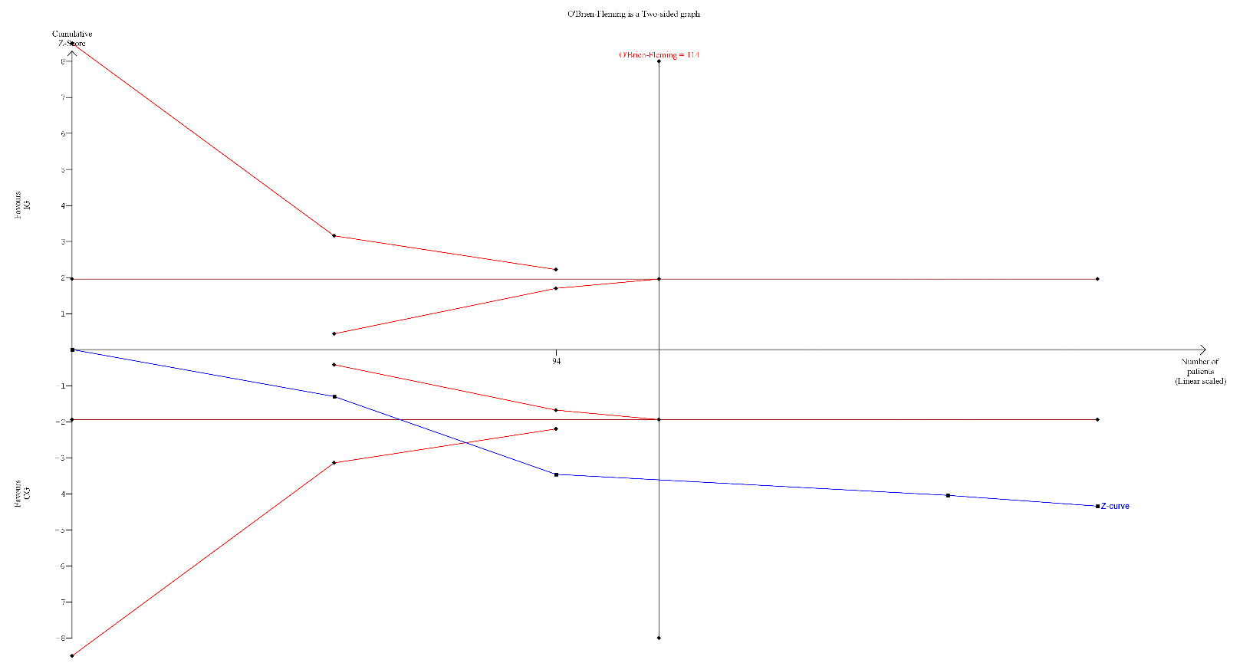
Supplementary Figure 2A Results of the trial sequential analysis of relapse rate in the immunomodulator monotherapy withdrawal group with 12-month follow-up in patients with Crohn’s disease
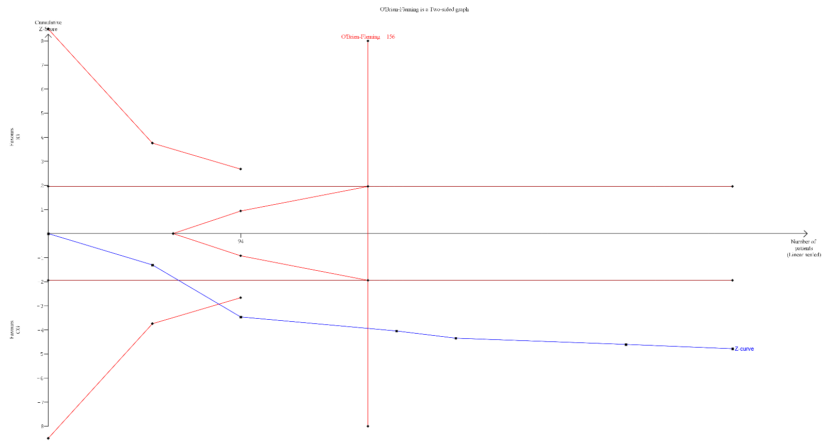
Supplementary Figure 2B Results of the trial sequential analysis of relapse rate in the immunomodulator monotherapy withdrawal group with 24-month follow-up in patients with Crohn’s disease
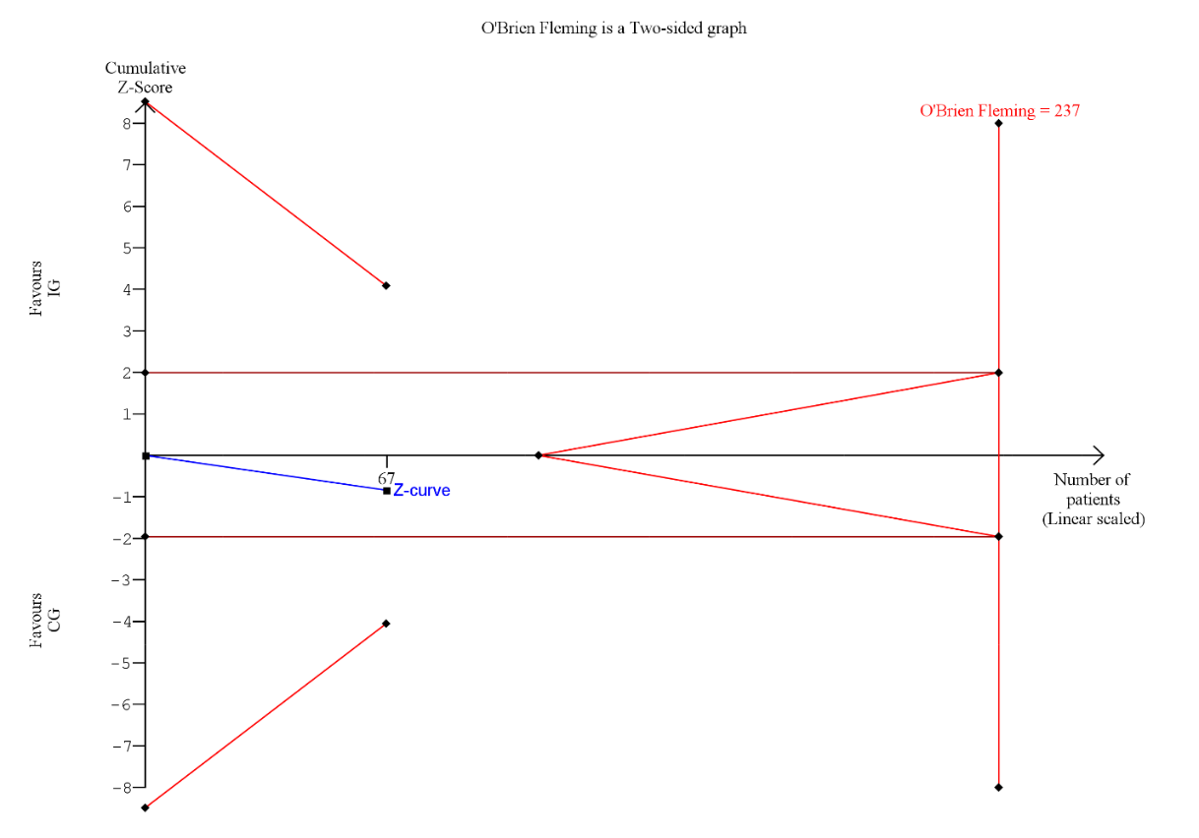
Supplementary Figure 2C Results of the trial sequential analysis of relapse rate in the immunomodulator monotherapy withdrawal group with 12-month follow-up in patients with ulcerative colitis
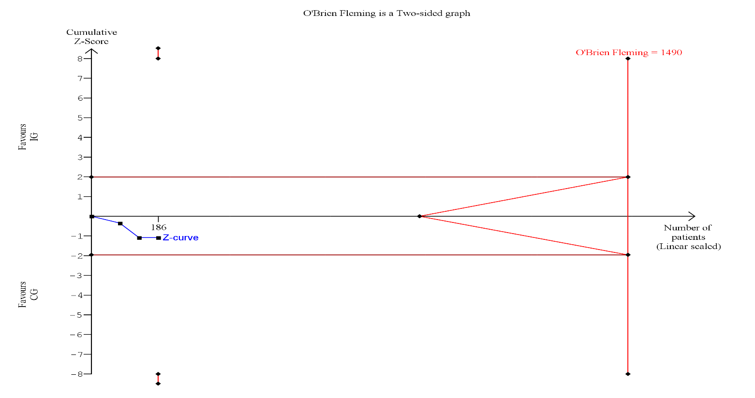
Supplementary Figure 2D Results of the trial sequential analysis of relapse rate in the immunomodulator withdrawal from combination therapy group
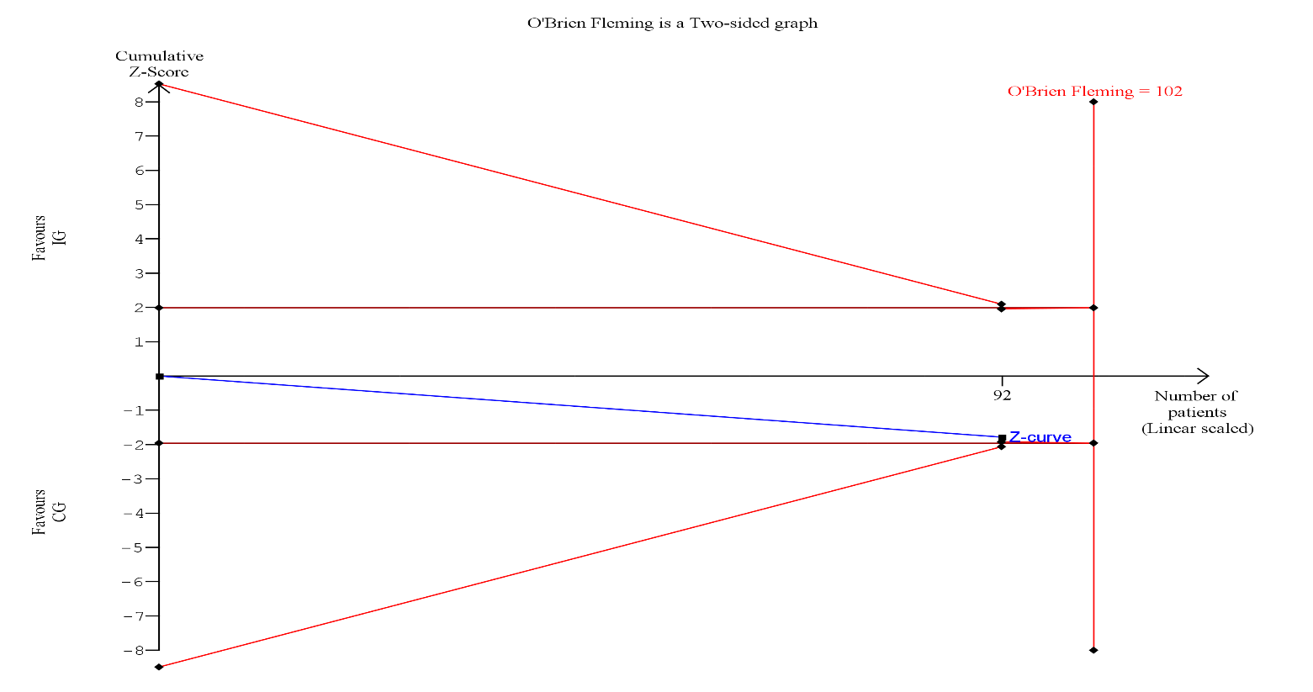 Supplementary Figure 2E Results of the trial sequential analysis of relapse rate in the biological monotherapy withdrawal group
The cumulative Z curve (blue line) represents the studies involved. Horizontal red lines represent the threshold of significance. When the blue line crosses the horizontal red line, it is evaluated as a significant effect (p < 0.05). The trial sequential boundaries include the significance boundaries (converged red lines) and the futility boundaries (diverged red lines), representing the thresholds for statistical conclusions. The O’Brien Fleming line (vertical red line) indicates the required meta-analysis sample size, which is calculated to conclude whether the analysis can draw a convincing conclusion or not.

