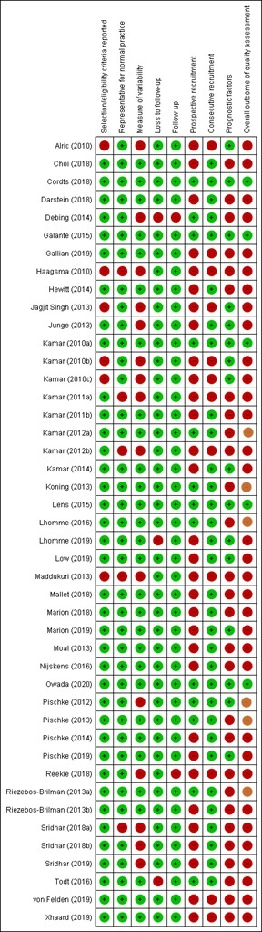
Figure S2: Risk of bias summary, individual parameters
and overall outcome per study

= low risk of bias
= high risk of bias
= intermediate risk of bias

