SUPPLEMENTARY DATA:

Figure S1. Flow chart of study section.
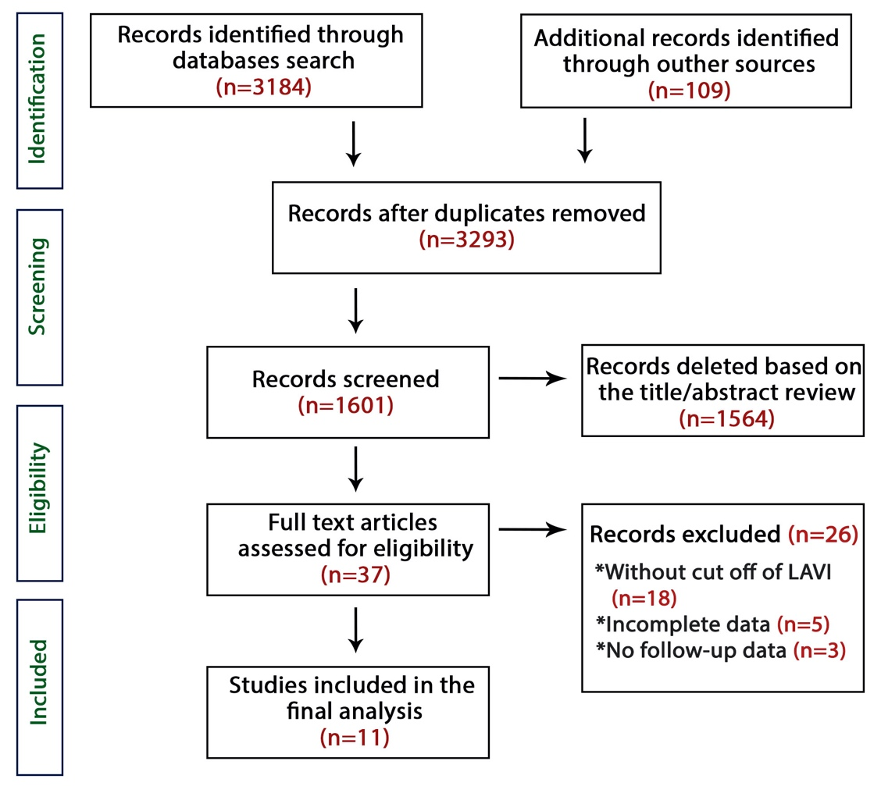

Figure S2. Baseline WMD of LV systolic and diastolic function between two patients groups; a) LVEDD b) LVESD; c) LVEF; d) E/e’ ratio

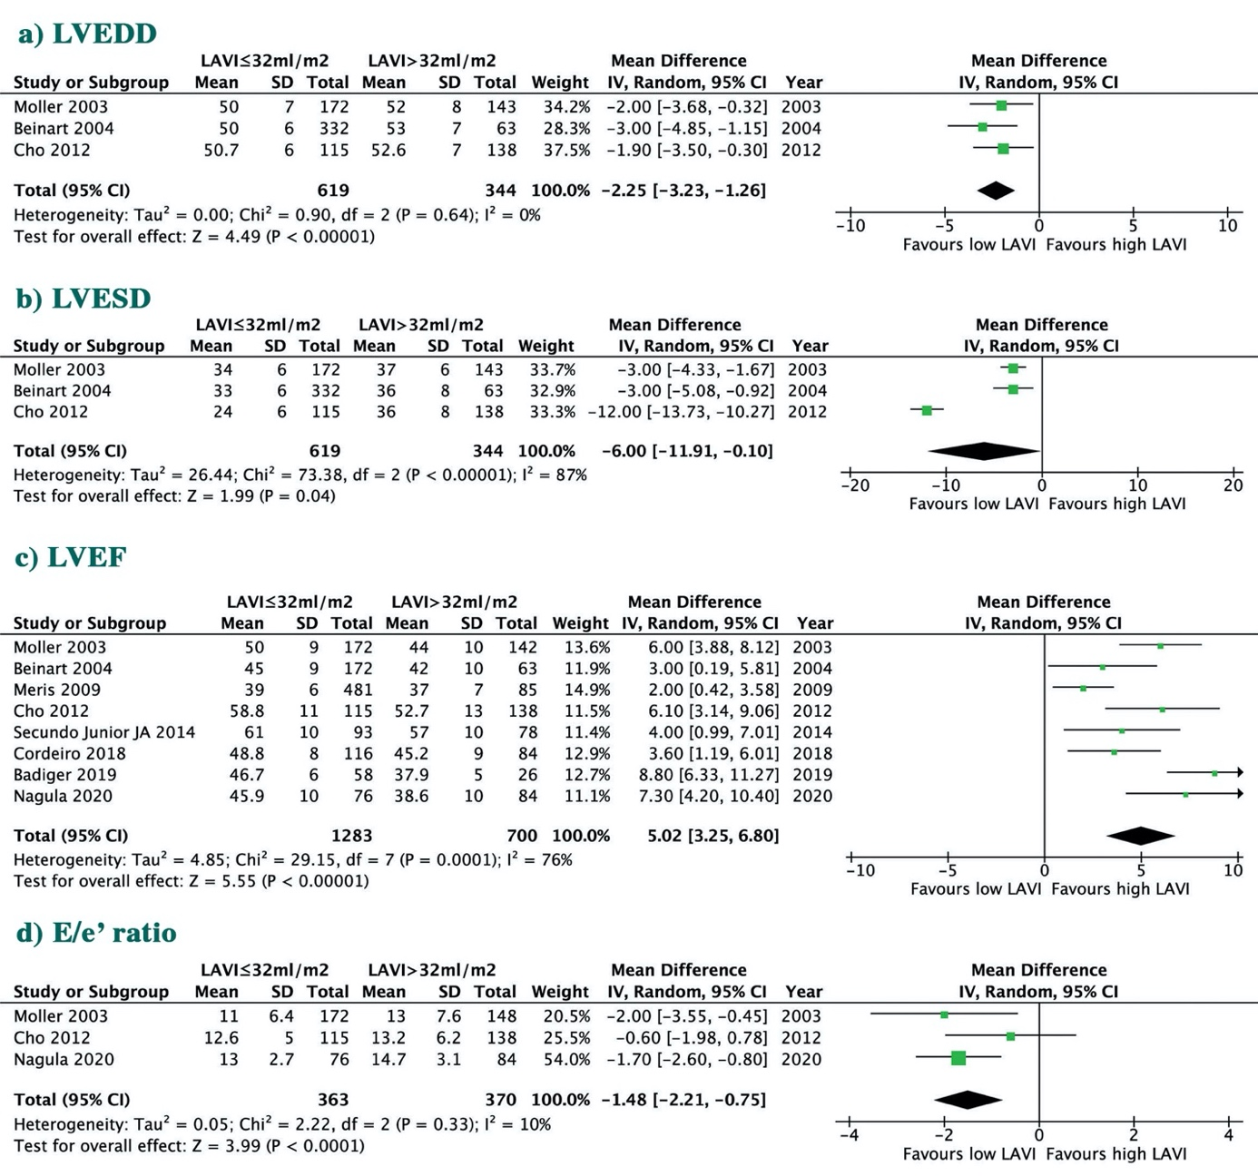

LVEDD: Left ventricle end-diastolic dimensions; LVESD: Left ventricle end-systolic dimensions; LVEF: left ventricle ejection fraction

Figure S3. Baseline WMD between two patients groups a) MR b) MVD; c) Killip ≥ 2; d) WMS

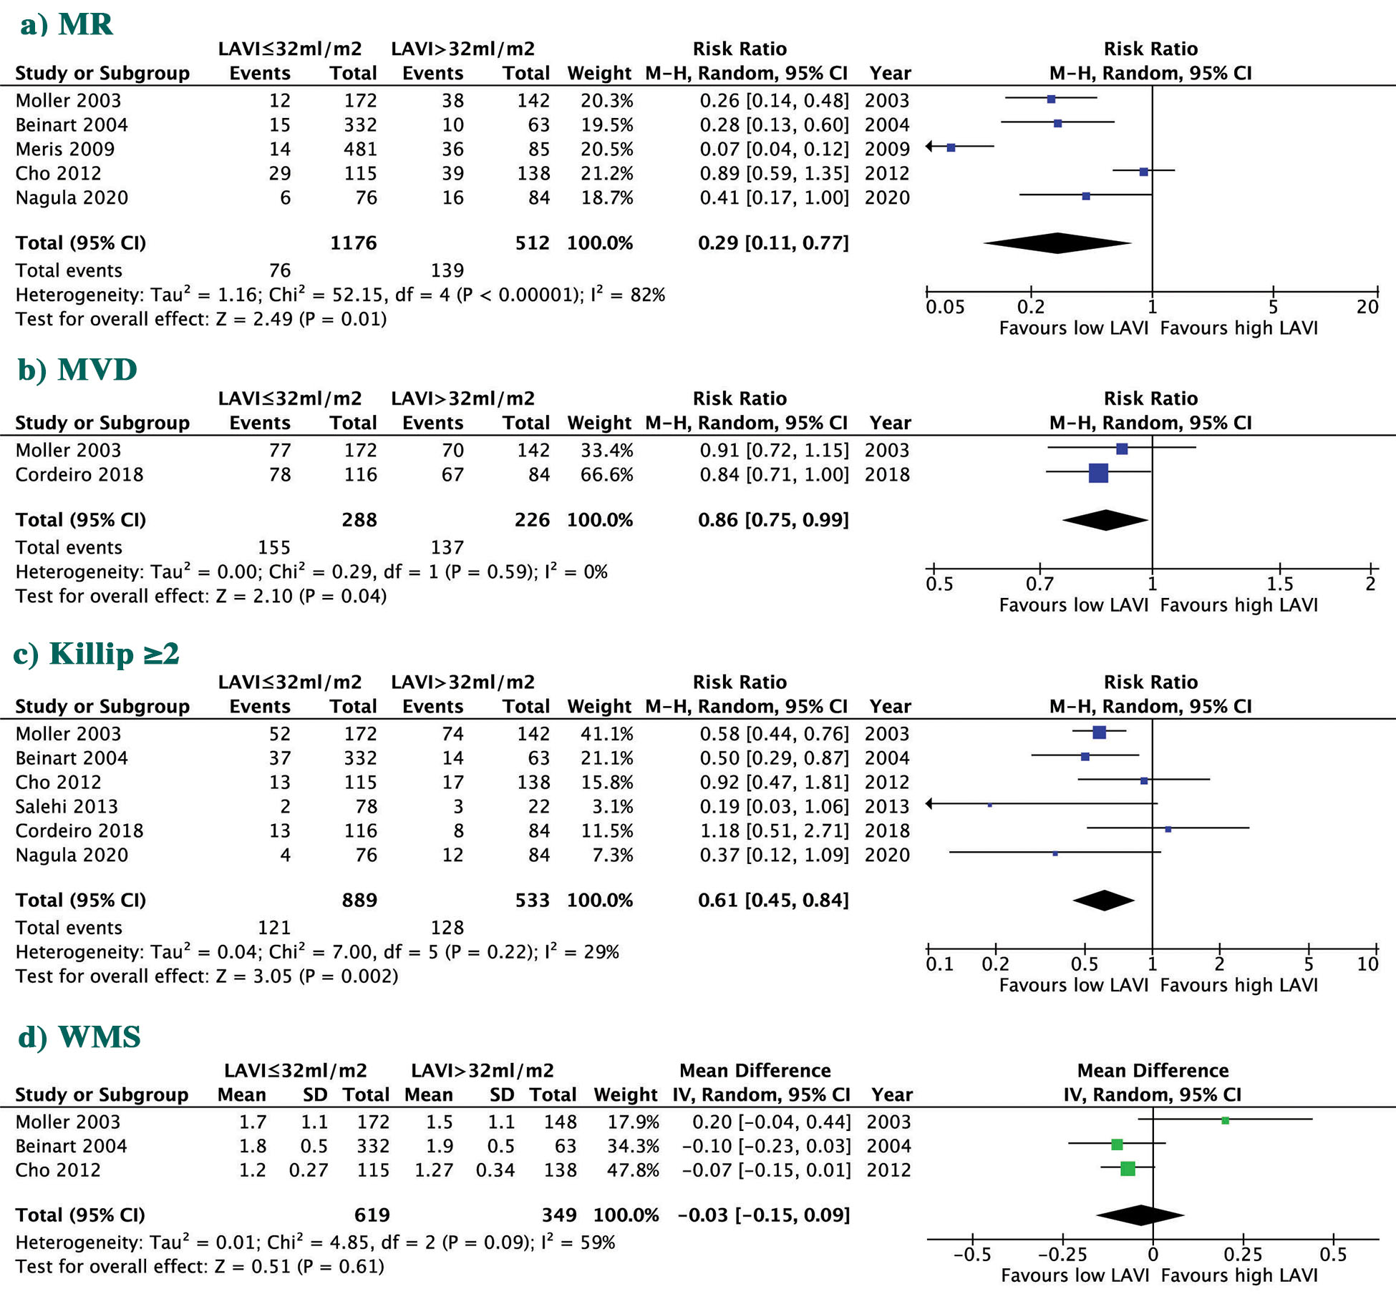

MR: mitral regurgitation; MVD; multivessel disease; WMS: wall motion score

Table S1. Main characteristics of patients enrolled among trials included in the study
Study (year) | Groups | Age | Female | HTN | DM | Dyslipidemia | Smoking | Prior
 |  | year | % | % | % | % | % | MI | PCI | CABG
Møller 2003 | LAVI ≤32ml/m² | 64.5 ± 6.3 | 44 | 49.7 | 16 | 42 | 27 | 20 | NR | NR
 | LAVI >32ml/m² | 75 ± 4.3 | 59 | 64 | 26 | 47 | 16 | 27 | NR | NR
Beinart 2004 | LAVI ≤32ml/m² | 60±12 | 20.1 | 38.3 | 23.2 | 32.8 | 41.0 | 20.1 | 10.2 | 3.4
 | LAVI >32ml/m² | 69±11 | 31.7 | 52.4 | 22.2 | 44.4 | 17.5 | 28.3 | 13.3 | 5.0
Meris 2009 | LAVI ≤32ml/m² | 64.5±11.4 | 30.1 | 54.8 | 24.9 | NR | 65.6 | NR | NR | NR
 | LAVI >32ml/m² | 70.2 ± 9.7 | 37.6 | 67.1 | 34.1 | NR | 61.2 | NR | NR | NR
Antoni 2011 | LAVI ≤32ml/m² | 60±12 * | 31* | 30* | 8* | 20* | 53* | 4* | NR | NR
 | LAVI >32ml/m²
Sakaguchi 2011 | LAVI ≤32ml/m² | 63±13 | 37 | 67 | 36 | 64 | 47.8 | 19.4 | 21.5 | NR
 | LAVI >32ml/m² | 70±13 | 48 | 87 | 48 | 75 | 42.3 | 37.2 | 43.6 | NR
Cho 2012 | LAVI ≤32ml/m² | 64.5±12.9 | 31.3 | 42.6 | 28.7 | 5.2 | 58.3 | 9.6 | NR | NR
 | LAVI >32ml/m² | 65.1±14.1 | 31.2 | 48.6 | 29.7 | 3.6 | 57.2 | 13.8 | NR | NR
Salehi 2013 | LAVI ≤32ml/m² | 63±12 | 17.9 | 30.8 | 11.5 | 15.4 | 37.2 | 9 | NR | NR
 | LAVI >32ml/m² | 58±10 | 17.2 | 54.5 | 9.1 | 18.2 | 45.5 | 13.6 | NR | NR
Secundo Junior JA | LAVI ≤32ml/m² | 63±13 | 37.6 | 67.7 | 36.8 | 64.5 | 47.8 | 19.4 | 21.5 | NR
2014 | LAVI >32ml/m² | 70±13 | 48.7 | 87.2 | 48.8 | 75.6 | 42.3 | 37.2 | 43.6 | NR
Cordeiro 2018 | LAVI ≤34ml/m² | 62 ±13 | 39.3 | 58.6 | 28.4 | 56.9 | 28.4 | NR | 3.4 | 0.0
 | LAVI >34ml/m² | 65± 12 | 24.1 | 64.6 | 25.5 | 49.8 | 34.8 | NR | 7.7 | 3.4
Badiger 2019 | LAVI ≤32ml/m² | 68.1±9.8 | 10 | 63.6 | 59.1 | NR | 65 | NR | NR | NR
 | LAVI >32ml/m² | 53.2±11.6 | 23 | 36.4 | 40.9 | NR | 35 | NR | NR | NR
Nagula 2020 | LAVI ≤34ml/m² | 54.5 | 24 | 45 | 40 | NR | 44 | NR | NR | NR
 | LAVI >34ml/m² | 55 | 26 | 61 | 47 | NR | 49 | NR | NR | NR
Abbreviations: HTN: hypertension; DM: diabetes mellitus; MI: myocardial infarction; PCI: percutaneous coronary intervention; CABG: coronary artery by-pass grafting; NR: non-reported. (*) whole group

Table S2. Assessment of risk of bias in the included studies using Newcastle-Ottawa Quality Assessment Scale (NOS) for cohort (observational) studies.
Study, year | Selection | Selection | Selection | Selection | Comparability | Exposure | Exposure | Exposure | Quality
 | 1 | 2 | 3 | 4 | 1 | 1 | 2 | 3
Møller 2003 | a) | a) | b) | a) | a) | b) | a) | b) | Good
Beinart 2004 | a) | a) | a) | a) | b) | a) | a) | a) | Good
Meris 2009 | a) | b) | a) | a) | b) | a) | b) | b) | Good
Antoni 2011 | b) | c) | a) | a) | b) | b) | a) | b) | Fair
Sakaguchi 2011 | b) | a) | b) | b) | a) | a) | b) | b) | Fair
Cho 2012 | a) | b) | b) | a) | b) | b) | a) | b) | Good
Salehi 2013 | a) | b) | a) | b) | b) | a) | b) | a) | Good
Secundo Junior JA 2014 | a) | a) | a) | b) | b) | a) | b) | a) | Good
Cordeiro 2018 | a) | a) | b) | b) | a) | a) | b) | a) | Good
Badiger 2019 | a) | b) | a) | b) | a) | b) | b) | b) | Fair
Nagula 2020 | a) | a) | b) | a) | a) | a) | b) | a) | Good

Legend: NOS: Selection- 1: a),b) one star, c), d) no star; Selection- 2: a) one star, b, c) no star; Selection- 3: a), b) one star, c), d), e) no star, Selection- 4: a) one star, b) no star; Comparability: a), b) one star, c) no star; Exposure-1: a),b) one star, c), d), e) no star; Exposure-2: a) one star, b) no star; Exposure-2: a),b) one star, c), d), no star.
Good quality: 3 or 4 stars in selection domain AND 1 or 2 stars in comparability domain AND 2 or 3 stars in outcome/exposure domain
Fair quality: 2 stars in selection domain AND 1 or 2 stars in comparability domain AND 2 or 3 stars in outcome/exposure domain
Poor quality: 0 or 1 star in selection domain OR 0 stars in comparability domain OR 0 or 1 stars in outcome/exposure domain

