Supplementary Table 1 – Risk of bias in randomized controlled human trials assessing the role of freeze-dried plasma for trauma.
 | Selection bias |  | Performance bias | Detection bias | Attrition bias | Reporting bias | Other bias
 | Random sequence generation | Allocation concealment
Garrigue 2018 (52)
Ranking | Low risk | Low risk | N/A | N/A | High risk | Low risk | High risk
Explanation | Randomized | Concealment done | No blinding | No blinding | 6/48 excluded for predefined exclusion criteria | Protocol registered on clinicaltrials.gov | Single center. Small sample size. Surrogate endpoints.

Supplementary Table 2 – Risk of bias in observational cohort studies assessing the role of freeze-dried plasma for trauma.
Reference | Representativeness  of the exposed cohort | Selection of  Non-exposed  Cohort | Ascertainment  of Exposure | Outcome not present  at start | Comparability  of controls | Assessment  of outcome | Adequate  follow up | Loss to  follow up | Total  score
Martinaud 2011 (32) | * | - | * | * | - | - | * | - | 4/9
Sailliol 2014 (50) | * | - | * | * | - | * | * | - | 5/9
Sunde 2015 (43) | * | - | - | * | - | - | * | * | 4/9
Benov 2015 (51) | * | - | * | * | - | - | * | - | 4/9
Shlaifer 2017 (22) | * | - | * | * | - | * | * | - | 5/9
Vitalis 2017 (49) | - | - | * | * | - | - | * | - | 3/9
Nguyen 2018 (53) | * | * | * | * | - | - | * | * | 6/9
Oakeshott 2018 (54) | * | * | * | * | - | - | * | * | 6/9
Shlaifer 2019 (55) | * | * | * | * | ** | * | * | - | 8/9
Benov 2019 (56) | * | - | * | * | - | - | * | * | 5/9
Cuenca 2020 (48) | * | * | - | * | - | - | - | - | 3/9

Supplementary Table 3 – Risk of bias in animal studies.
Reference | Random Allocation | Allocation concealment | Blind-ing | Inclusion /exclusion criteria | Sample  size  calculation | Compliance with animal requirements | Conflicts of interest disclosed | Statistical model explained | Animals without comorbidity | Test animal details | Every animal accounted | Dose-response model | Optimal time window used | Totals
Shuja 2008 (45) | NR | N/A | No | Yes | No | Yes | Yes | Yes | Yes | Yes | Yes | No | Yes | 8/13
Spoerke 2009 (57) | Yes | N/A | No | Yes | No | Yes | Yes | Yes | Yes | Yes | Yes | No | Yes | 9/13
Hamilton 2011 (33) | Yes | No | No | No | No | Yes | No | Yes | No | Yes | Yes | No | Yes | 6/13
Alam 2011 (34) | Yes | No | No | No | No | Yes | No | Yes | Yes | Yes | Yes | No | Yes | 7/13
Van 2011 (35) | Yes | No | No | No | No | Yes | No | Yes | No | No | Yes | No | Yes | 5/13
Imam 2013 (36) | Yes | No | No | Yes | No | Yes | Yes | Yes | Yes | Yes | Yes | No | Yes | 9/13
Lee 2013 (37) | Yes | No | No | No | No | Yes | Yes | Yes | No | Yes | Yes | No | Yes | 7/13
Lee 2013 (38) | Yes | No | No | No | No | Yes | Yes | Yes | No | Yes | Yes | No | Yes | 7/13
Lee 2013 (39) | Yes | No | No | Yes | No | Yes | Yes | Yes | Yes | Yes | Yes | No | Yes | 9/13
McCully 2014 (46) | Yes | N/A | Yes | Yes | Yes | Yes | Yes | Yes | Yes | Yes | Yes | No | Yes | 11/13
McCully 2015 (40) | Yes | N/A | Yes | Yes | No | Yes | Yes | Yes | Yes | Yes | Yes | Yes | Yes | 11/13
Potter 2015 (47) | NR | N/A | No | Yes | No | Yes | Yes | Yes | Yes | Yes | Yes | No | Yes | 8/13
Halaweish 2016 (41) | Yes | No | No | No | No | Yes | Yes | Yes | No | Yes | Yes | No | Yes | 7/13
Georgoff 2017 (42) | Yes | No | No | No | No | Yes | Yes | Yes | No | Yes | Yes | No | Yes | 7/13
Pati 2018 (44) | NR | N/A | Yes | Yes | No | Yes | Yes | Yes | Yes | Yes | Yes | No | Yes | 9/13
Supplementary Table 4 – GRADE quality assessment profile for mortality and exposure to allogeneic blood products and summary of findings.
Certainty assessment |  |  |  |  |  |  | № of patients |  | Effect |  | Certainty | Importance
№ of studies | Study design | Risk of bias | Inconsistency | Indirectness | Imprecision | Other considerations | FDP | FFP | Relative  (95% CI) | Absolute  (95% CI) | Certainty | Importance
30-day mortality
2 | Randomised trial and  Observational study | RCT: not seriousª  Non RCT: serious^{b} | Not serious | Not serious | Serious^{d} | All plausible residual confounding would reduce the reported effect in the observational study | 16/66 (24.2%) | 17/53 (32.1%) | OR 0.66  (0.29 to 1.49) | 83 fewer per 1,000  (from 200 fewer to 92 more) | ⨁⨁◯◯  LOW^{e} | CRITICAL
Exposure to RBC
2 | Randomised trial and  Observational study | RCT: not seriousª  Non RCT: serious^{b} | Serious^{c} | Not serious | Serious^{d} | All plausible residual confounding would reduce the reported effect in the observational study | 66 | 53 | - | Mean 2.83 units fewer  (4.9 fewer to 0.77 fewer) | ⨁⨁◯◯  LOW^{e} | IMPORTANT
Exposure to FFP
2 | Randomised trial and  Observational study | RCT: not seriousª  Non RCT: serious^{b} | Not serious | Not serious | Serious^{d} | All plausible residual confounding would reduce the reported effect in the observational study | 66 | 53 | - | Mean 1.08 units fewer  (2.35 fewer to 0.18 more) | ⨁⨁◯◯  LOW^{e} | CRITICAL
Exposure to PLT
2 | Randomised trial and  Observational study | RCT: not seriousª  Non RCT: serious^{b} | Not serious | Not serious | Serious^{d} | All plausible residual confounding would reduce the reported effect in the observational study | 66 | 53 | - | Mean 0.76 units fewer  (1.44 fewer to 0.08 fewer) | ⨁⨁◯◯  LOW^{e} | IMPORTANT
Exposure to FC
2 | Randomised trial and  Observational study | RCT: not seriousª  Non RCT: serious^{b} | Serious^{c} | Not serious | Serious^{d} | All plausible residual confounding would reduce the reported effect in the observational study | 66 | 53 | - | Mean 0.66 units fewer  (1.97 fewer to 0.66 more) | ⨁⨁◯◯  LOW^{e} | IMPORTANT
Table legend: CI – confidence interval; OR: odds ratio
Explanations:
a. Study not penalized for not blinding as intervention cannot be blinded.
b. Risk of bias due to lack to adjust for confounders.
c. Inconsistency due to high heterogeneity, large variation of effect size, no overlapping of confidence intervals.
d. Imprecision due to low number of events, small sample sizes, and large confidence interval with potential for harm or benefit.
e. Further research is likely to have an important impact on our confidence in the estimate of effect and is likely to change the estimate.
Supplementary Figure 1 – Exposure to RBC.
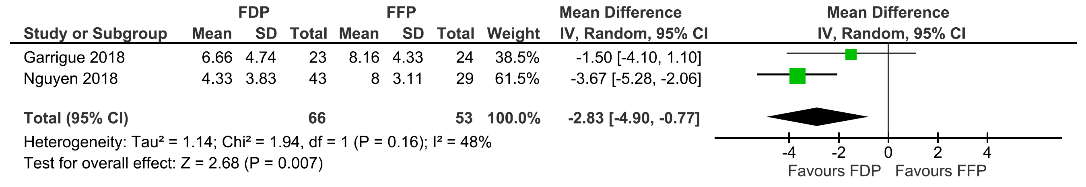

Supplementary Figure 2 – Exposure to FP.
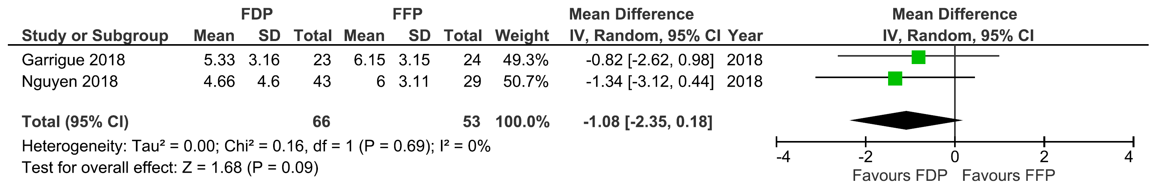

Supplementary Figure 3 – Exposure to PLT.
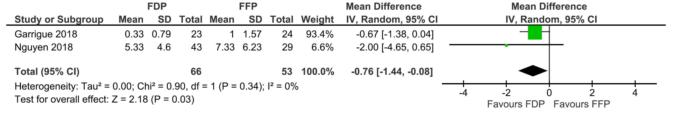

Supplementary Figure 4 – Exposure to FC.


