Supplemental Digital Content 2. Funnel plots

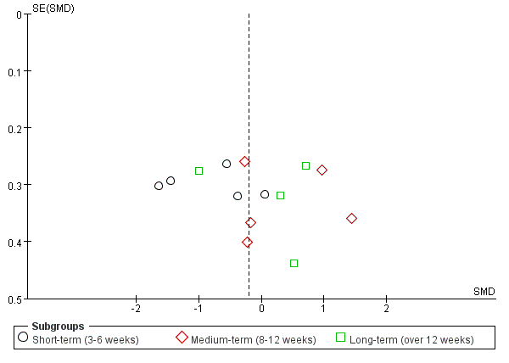
Supplemental Figure A1: Funnel plot for the function.

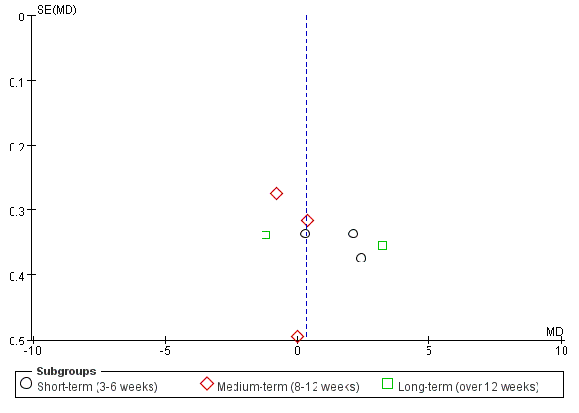
Supplemental Figure A2: Funnel plot for the pain.

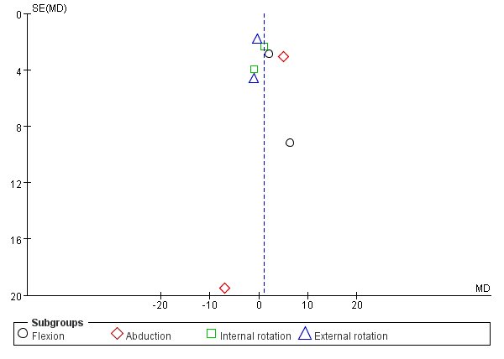
Supplemental Figure A3: Funnel plot for the ROM.

