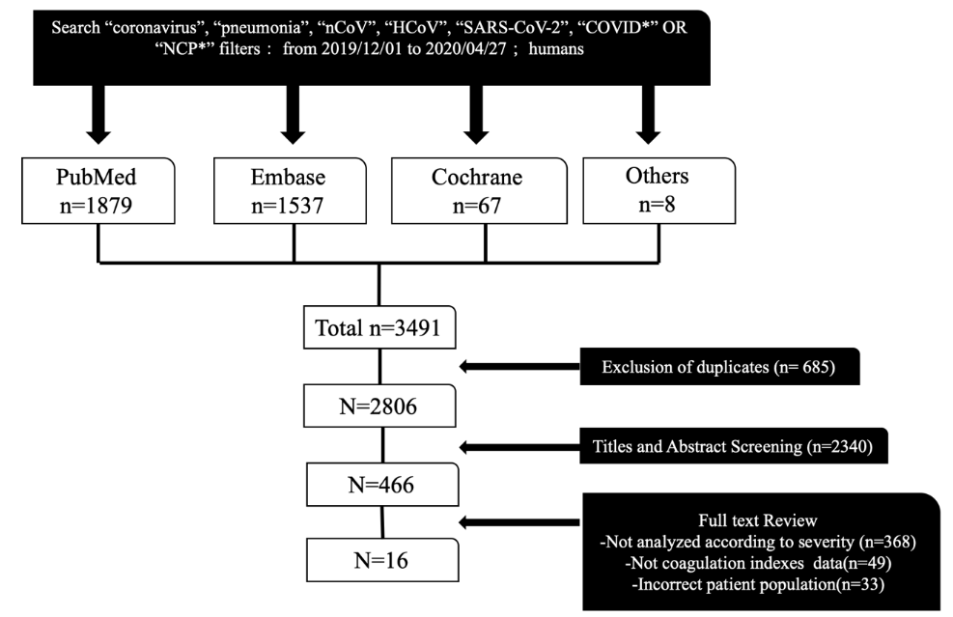

Figure S1. Search strategy and screening process

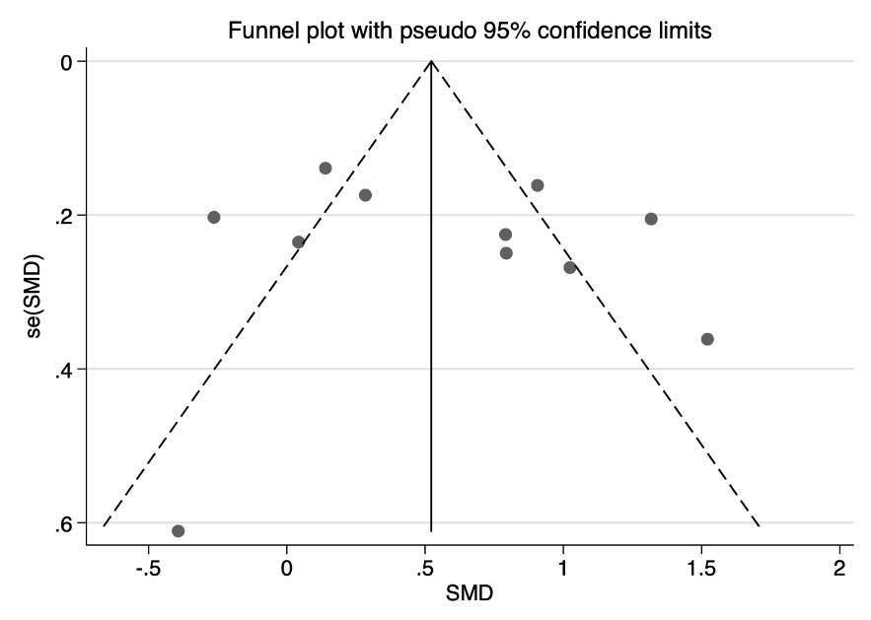

Figure S2. Egger’s funnel plot showing publication bias regarding severity of COVID-19 on coagulation indexes (P░=░0.565).

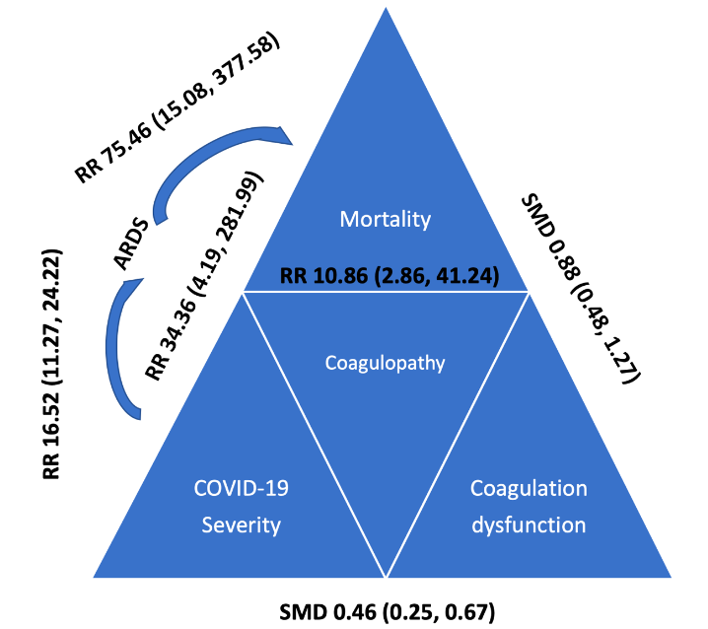

Figure S3. The schematic diagram about COVID-19 on coagulation dysfunction.

